CUET General Test - Quantitative Aptitude
Slot: CUET_SLOT_1 | Section: QUANT | Subject: MATHEMATICS
Upload this Word file together with the matching Excel mapping file.

Comprehension - CUET-QUANT-CHART-001
The bar chart represents practice questions solved by four study groups during one week. Group A solved 120 questions, Group B solved 150, Group C solved 180, and Group D solved 210. Use these values for Questions 1 to 3.
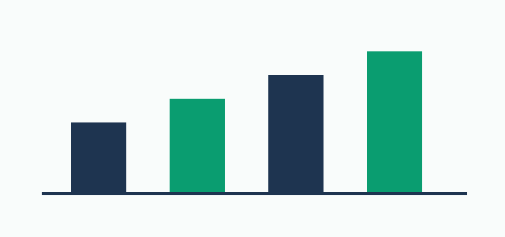

Question - CUET-QUANT-TEST-001
How many more questions did Group D solve than Group A?

Answer Rules
Correct Option
Accepted Answers | 90
Numeric Tolerance | 0
Case Sensitive | No

Explanation
210 minus 120 equals 90.

Question - CUET-QUANT-TEST-002
What was the percentage increase from Group A to Group B?

Answer Rules
Correct Option
Accepted Answers | 25|25.0
Numeric Tolerance | 0.01
Case Sensitive | No

Explanation
The increase is 30; 30 divided by 120 and multiplied by 100 equals 25%.

Question - CUET-QUANT-TEST-003
Find the average number of questions solved by the four groups.

Answer Rules
Correct Option
Accepted Answers | 165
Numeric Tolerance | 0
Case Sensitive | No

Explanation
(120 + 150 + 180 + 210) divided by 4 equals 165.

Standalone Questions

Question - CUET-QUANT-TEST-004
The diagram shows a rectangle of length 12 cm and width 8 cm. What is its area?


Options
A | 20 cm²
B | 40 cm²
C | 96 cm²
D | 120 cm²

Answer Rules
Correct Option | C
Accepted Answers
Numeric Tolerance
Case Sensitive | No

Explanation
Area equals length multiplied by width: 12 × 8 = 96 cm².

Question - CUET-QUANT-TEST-005
Name the quadrilateral shown in the diagram using one word.


Answer Rules
Correct Option
Accepted Answers | rectangle|Rectangle
Numeric Tolerance
Case Sensitive | No

Explanation


