CMPE-257 Machine Learning
Project Progress Report
Real-Time ASL Sign Language Translation System
____________________________________
Team Members: Anurag Bodapally, Abhinand Vijayakumar Binsu, Jonathan Chen, Niveditha Nandakumar Kamath
Date: March 28, 2026

1. Project Overview
Project Title: Real-Time ASL Sign Language Translation System
Course: CMPE-257 Machine Learning
Goal: Build a two-part machine learning system that translates American Sign Language (ASL) hand gestures into text in real time. Part 1 classifies static hand signs into individual letters/digits (A–Z, 0–9). Part 2 (in progress) will recognize full ASL words from video sequences.
Problem Statement: Approximately 70 million deaf and hard-of-hearing people worldwide rely on sign language as their primary communication method. However, real-time human interpreters are scarce, expensive, and unavailable in many everyday situations. This project aims to bridge this communication gap by developing an ML-powered system that translates ASL gestures captured via a standard webcam into readable text, enabling accessible communication without external dependencies.
Why this is important: Current assistive solutions (human interpreters, writing on paper, text-based apps) are either too slow, too expensive, or unavailable in real-time scenarios like classroom lectures, medical consultations, or casual conversations. A lightweight, webcam-based solution running locally on a laptop could dramatically improve accessibility.

Approach
- Part 1 (Letter Classification): Use MediaPipe to extract hand landmark features from static images, then train and compare multiple ML classifiers (SVM, Random Forest, MLP, CNN)
- Part 2 (Word Recognition — in progress): Use video sequences with LSTM-based models to recognize full ASL words
- Real-time inference via webcam with OpenCV for live demonstration

2. Dataset Investigation and Analysis

Dataset Source
Name: Ayuraj ASL Dataset
Source: Kaggle (https://www.kaggle.com/datasets/ayuraj/asl-dataset)
Format: Static RGB images organized in folders by class label

Dataset Summary
Property | Value
Total Images | ~2,515 (after filtering)
Number of Classes | 36 (letters a–z + digits 0–9)
Images per Class | ~70 (fairly balanced)
Image Format | JPG / JPEG / PNG
Features (raw) | RGB pixel values
Features (processed) | 63-dimensional landmark vectors (21 keypoints × 3 coordinates)
Target Variable | Letter/digit class (36 classes)
Data Types | float32 (features), int64 (labels)
Class Balance | Approximately balanced (~70 images per class)
Missing Values | None in raw data; some images fail MediaPipe hand detection and are skipped
Duplicates | None detected
Outliers / Inconsistencies | Nested asl_dataset/ subfolder required filtering; some low-quality images fail landmark extraction

Exploratory Data Analysis
We performed detailed EDA in our Jupyter notebook (01_EDA.ipynb), which included:
- Class distribution analysis — verified approximately uniform distribution across all 36 classes
- Sample image visualization — generated grids showing 2 sample images per ASL letter to understand visual diversity
- MediaPipe detection rate analysis — measured per-class hand detection success rates to identify challenging gesture classes
- Feature distribution analysis — examined normalized landmark feature value ranges, means, and standard deviations after preprocessing

3. Preprocessing Completed
All preprocessing steps have been implemented and executed. The pipeline is fully automated in preprocessing.py:

Hand Landmark Extraction
- Used Google MediaPipe Hand Landmarker (Tasks API) to detect 21 hand keypoints per image
- Each keypoint provides (x, y, z) coordinates → 21 × 3 = 63 features per sample
- Images where no hand was detected are gracefully skipped (not included in training data)

Normalization
- Translation invariance: All landmarks normalized relative to wrist position (landmark 0 set to origin)
- Scale invariance: Coordinates scaled by the distance from wrist to middle finger MCP joint (landmark 9)
- This ensures the model is robust to different hand positions, distances from camera, and hand sizes

Image Preprocessing (for CNN)
- Images resized to 64×64 pixels (RGB)
- Pixel values normalized to [0, 1] range
- White padding (30% ratio) added to tightly cropped images to give MediaPipe sufficient context

Train/Validation/Test Split
- 70% training / 15% validation / 15% test
- Stratified split to maintain class distribution across all splits
- Separate test sets saved for landmark-based models and CNN

Output Files
File | Description
X.npy | Feature matrix (2515 × 63) — normalized hand landmarks
y.npy | Label vector (integer indices 0–35)
label_map.npy | Dictionary mapping index → letter/digit name

4. Current Progress

Completed Work

a) Data Loading Pipeline & EDA
- Dataset downloaded from Kaggle and organized into class folders
- Comprehensive EDA notebook (01_EDA.ipynb) with class distribution, sample visualizations, and MediaPipe detection rate analysis

b) Full Preprocessing Pipeline
- Automated preprocessing script (preprocessing.py) extracts, normalizes, and saves hand landmark features
- Handles edge cases: missing hands, tight crops, nested directories

c) Model Training & Comparison
Four different classifiers were trained and evaluated:
Model | Input | Test Accuracy | Key Details
SVM (RBF) | 63 landmarks | 90.1% | C=10, gamma=scale
Random Forest | 63 landmarks | 90.7% | 300 trees
MLP | 63 landmarks | 87.1% | 256→128 neurons, ReLU
CNN (Best) | 64×64 images | 93.4% | 3 conv blocks, PyTorch

d) Evaluation & Visualizations
- Generated confusion matrices for all 4 models to identify commonly confused letter pairs
- Created model comparison bar chart (accuracy + macro F1 score)
- All results saved in results/ directory

e) Real-Time Webcam Demo
- Built demo.py — opens webcam, detects hand, predicts letter in real time
- Supports live model switching (press 1/2/3 for SVM/RF/MLP)
- Includes prediction stabilization via rolling buffer (7 frames) with majority voting
- Displays: hand skeleton overlay, predicted letter, confidence bar, FPS counter

f) Version Control
- Project pushed to GitHub: https://github.com/Anuragbo/ML_signLangDetection

Model Comparison Chart
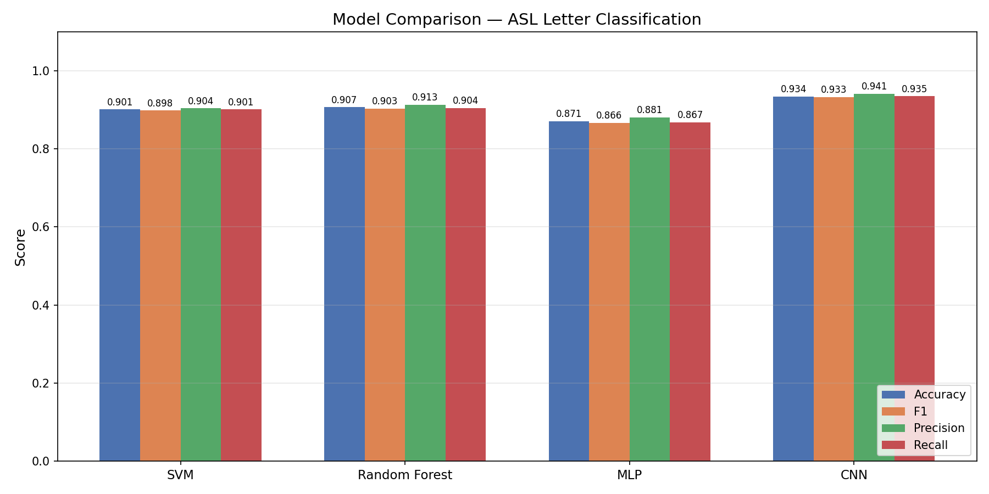

Confusion Matrices
The following confusion matrices show per-class prediction accuracy for each model on the test set:

SVM Confusion Matrix
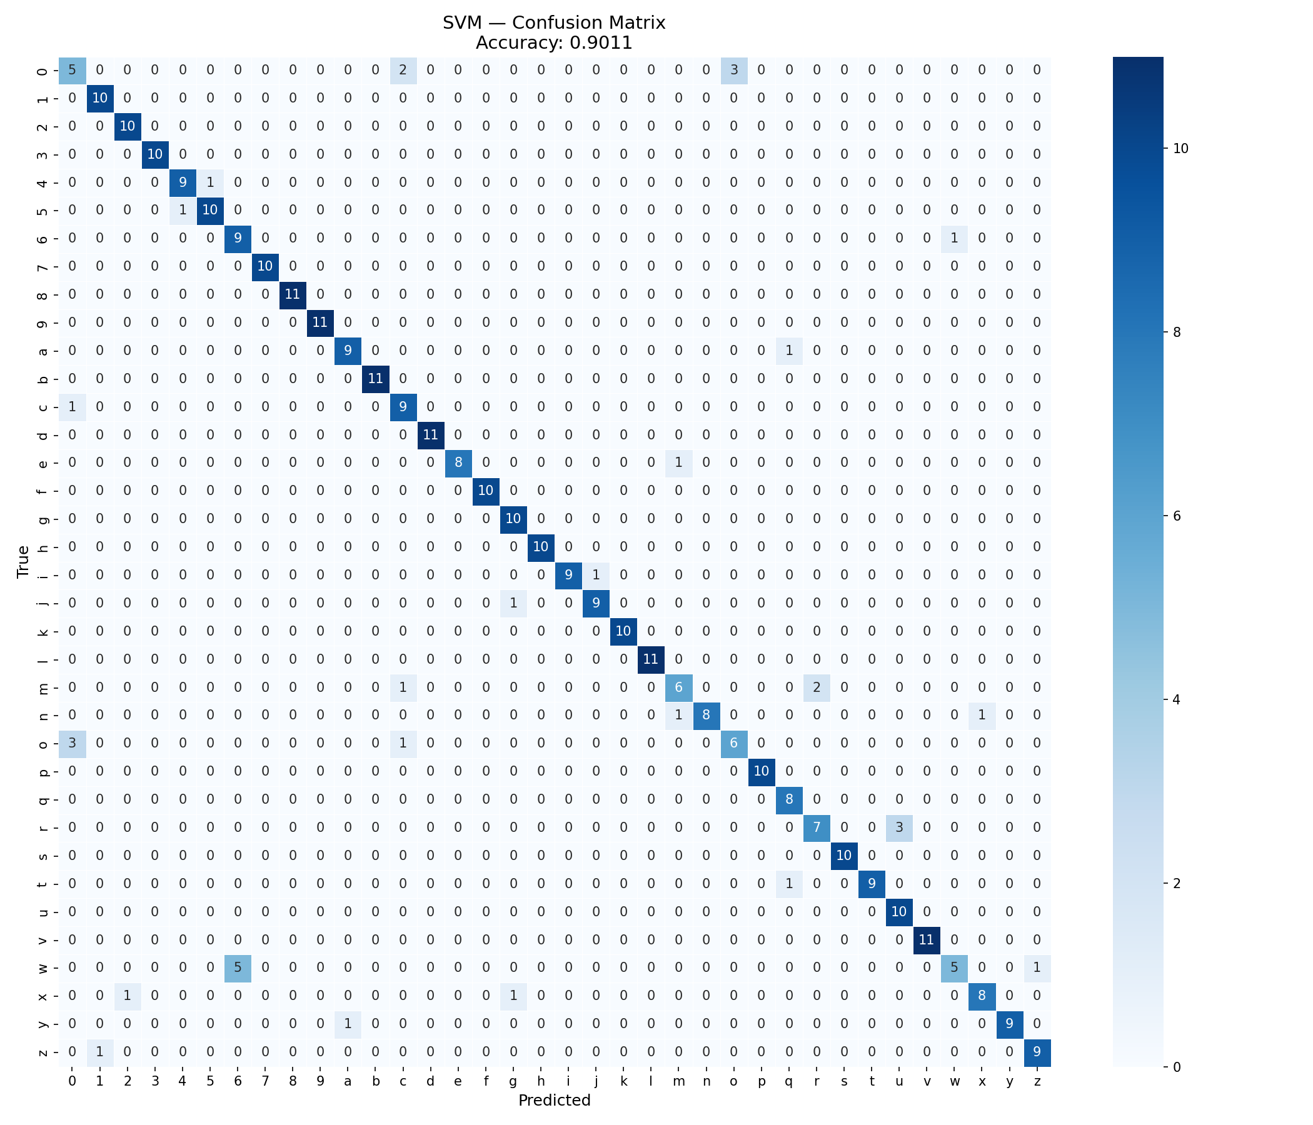

Random Forest Confusion Matrix
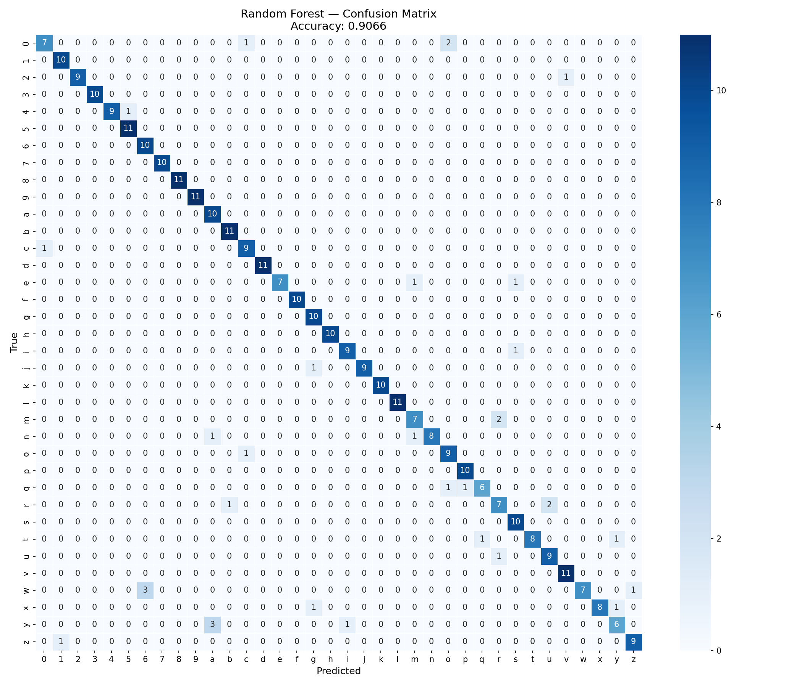

MLP Confusion Matrix
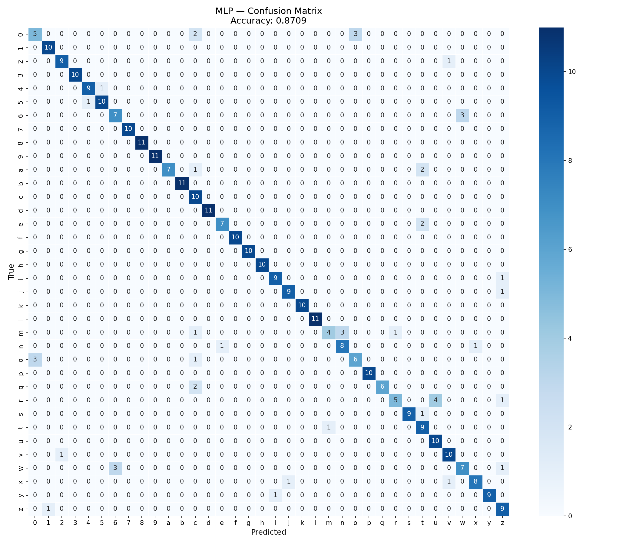

CNN Confusion Matrix
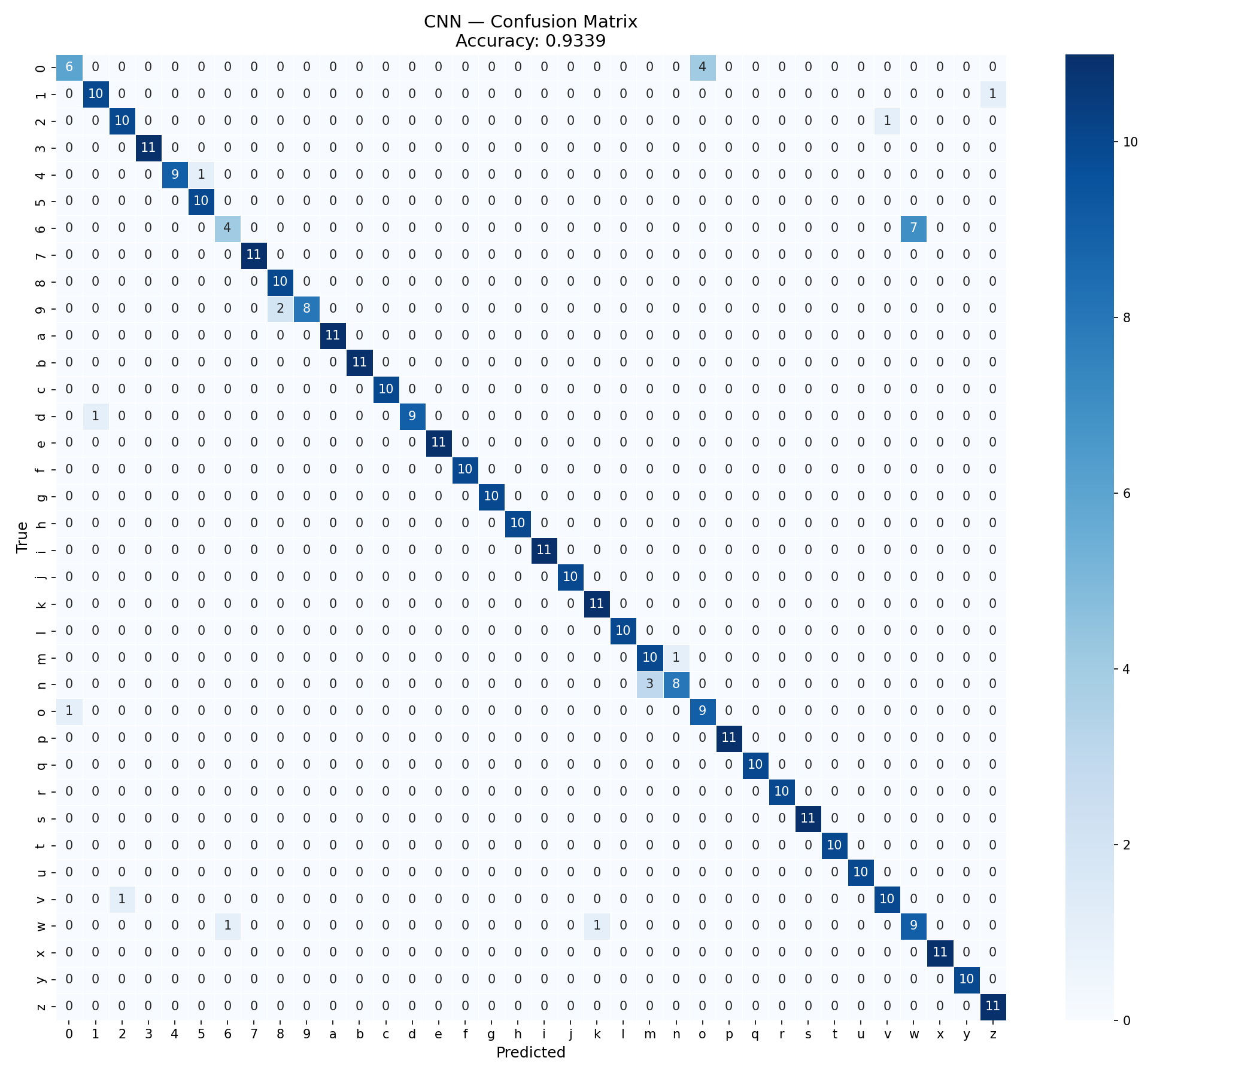

Work In Progress
Part 2 — Word-Level Sign Recognition: Planning phase. Will use the WLASL-100 dataset (top 100 ASL words from video clips) with a Bidirectional LSTM model trained on temporal sequences of hand landmarks.

5. Challenges Faced

1. TensorFlow Incompatibility with Python 3.14
Challenge: TensorFlow (our original CNN framework) does not support Python 3.14, which is installed on our development machines. Installation fails with “No matching distribution found.”
Impact: Blocked CNN training entirely until resolved.
Solution: Migrated the CNN from TensorFlow/Keras to PyTorch, which supports Python 3.14. Rewrote the model architecture, training loop, and evaluation code accordingly.

2. MediaPipe API Version Mismatch
Challenge: The demo code used mp.solutions.hands.HAND_CONNECTIONS for drawing hand skeletons, but this attribute does not exist in the newer MediaPipe Tasks API that we use for detection.
Impact: The webcam demo crashed with an AttributeError as soon as a hand was detected — detection worked fine, but the visualization code failed.
Solution: Replaced the mp.solutions reference with a hardcoded list of hand connection pairs, making the code work consistently across MediaPipe versions.

3. Nested Dataset Directory Structure
Challenge: The Kaggle dataset extracted with a nested asl_dataset/asl_dataset/ subfolder, causing the data loader to create a duplicate 37th class for the nested directory.
Impact: Models trained on 37 classes instead of 36, with one garbage class containing mixed data, reducing accuracy.
Solution: Added a filter in the data loader to only process folders whose names are single alphanumeric characters (0–9, a–z), automatically skipping the nested directory.

4. MediaPipe Hand Detection Failures
Challenge: Not all images in the dataset produce successful hand landmark detections. Some images have unusual angles, poor lighting, or occlusion that prevent MediaPipe from identifying the hand.
Impact: Reduces the effective dataset size slightly (from ~2,800 raw images to ~2,515 usable samples).
Solution: Handled gracefully by skipping failed detections during preprocessing. The remaining dataset is still sufficient for training. We also added white padding around tight crops to improve detection rates.

5. Real-Time Prediction Flickering
Challenge: During the webcam demo, raw frame-by-frame predictions fluctuated rapidly between different letters, even when the user held a steady hand sign. This made the output unreadable.
Impact: Poor user experience — the predicted letter changed multiple times per second, making it impossible to confirm correct recognition.
Solution: Implemented a rolling prediction buffer (7 frames) with majority voting. A prediction is only displayed if at least 3 out of 7 recent frames agree on the same letter, combined with a 60% confidence threshold. This dramatically stabilized the output.

