CMPE 260 Project Check-in 1
Does Self-Play on Text Games Teach Reasoning at Small Scale?
Replicating SPIRAL at 4B and Testing Its Limits at 1.7B
Anurag Bodapally (019094218) · Shubham Baid (018221333) · Syed Hassan Muzammil (018768243)
Repository: [paste GitHub URL here] · October 13, 2026

Summary
- Data sources identified: the Kuhn Poker game environment, two Qwen3 base models, SPIRAL’s released checkpoint, and SPIRAL’s six math benchmarks. We downloaded and profiled five of the six benchmarks (1,517 problems) and explored the environment with 180,000 scripted matches across three variants of the game.
- The effect we need to detect is small. SPIRAL’s gain on MATH-500 at 4B is 3.0 points. A paired before/after comparison on MATH-500 alone resolves only about ±2.5–3.5 points, so we make a pooled test across the benchmark suite (about ±1.7 points) our primary statistic.
- The game rewards less strategy than real Kuhn Poker. In both implementations a bet does not change what is at stake, so a trivial “never fold” policy beats the textbook equilibrium in 64.9% and 59.3% of matches. When we restore standard stakes, the advantage disappears (49.6%). In SPIRAL’s version, the winner of the final hand also wins the whole match in 100% of games.
- Specification changes: GSM8K is replaced by SPIRAL’s math suite, we train on SPIRAL’s own environment rather than the library default, the scripted opponent is “never fold”, and answers are graded by symbolic equivalence (Section 2).

1. Tentative Abstract
Reinforcement learning is now a central method for improving reasoning in language models, but most approaches depend on curated problem sets with verifiable answers. SPIRAL showed that reasoning can improve without such data: a model trained only to win zero-sum text games such as Kuhn Poker also improves on mathematical reasoning benchmarks it never saw during training. To our knowledge, this transfer has been tested only on models with 4B or more parameters, so it is unknown whether it persists in smaller models, which may learn to win by memorizing a shallow game policy instead of reasoning. We train Qwen3-4B-Base and Qwen3-1.7B-Base on Kuhn Poker using REINFORCE with role-conditioned advantage estimation and LoRA adapters. The 4B model matches SPIRAL’s model and game and serves as a positive control for our pipeline. We adapt two of SPIRAL’s ablations, replacing self-play with a scripted fixed opponent and role-conditioned advantages with a shared baseline, and run three seeds per condition. Before training, we estimate the smallest effect our evaluation can detect. We then measure game performance, accuracy on MATH-500 and SPIRAL’s other math benchmarks using paired statistical tests, and reasoning-trace length, and we audit game transcripts. We hypothesize that both models learn to win, but that transfer weakens at 1.7B and is accompanied by shorter reasoning traces.

2. Finalized Specifications
Item | Specification
Research question | Does self-play on a zero-sum text game improve math reasoning at 1.7B parameters, as SPIRAL reports at 4B?
Training game | SPIRAL’s KuhnPoker-v1 (5 hands per match), registered in UnstableBaselines
Models | Qwen3-1.7B-Base; Qwen3-4B-Base (SPIRAL’s model, used as the positive control)
Algorithm | REINFORCE with role-conditioned advantage estimation (RAE) [1]; LoRA adapters [3]
Framework | UnstableBaselines (LoRA-first self-play library for TextArena games) [11]
Conditions | Self-play vs. a scripted fixed opponent (“never fold”); RAE vs. a shared baseline
Runs | 2 model sizes × 2 advantage estimators × 3 seeds = 12 self-play runs, plus scripted-opponent control runs; each run targets SPIRAL’s 400 training steps
Evaluation | MATH-500 (primary), OlympiadBench, Minerva Math, AIME 2024, AIME 2025, AMC 2023; win rate against fixed opponents; reasoning-trace length; transcript audit
Statistics | Minimum detectable effect estimated before training; paired bootstrap over problems, pooled across the suite; 95% confidence intervals across seeds
Compute | Colab for development; SJSU COE HPC for training runs

Changes since the proposal
Item | Change | Reason (evidence in Section 4)
Benchmarks | GSM8K replaced by SPIRAL’s six math benchmarks | SPIRAL never reports GSM8K, so it cannot validate the 4B positive control; Qwen3-4B-Base already scores 87.8% on it [4]
Environment | SPIRAL’s KuhnPoker-v1 instead of the UnstableBaselines default | The default (TextArena 0.7.4) is a different game: 3 hands, decided by chip total. SPIRAL’s is 5 hands, decided by the final hand
Scripted opponent | “Never fold” | Strongest simple policy in this game; the textbook equilibrium is exploitable here (Fig. 2)
Answer checking | Symbolic-equivalence grader, validated on SPIRAL’s released checkpoint | 37% of MATH-500 and 77% of Minerva answers are not integers
Primary statistic | Pooled paired test across the suite; MATH-500 reported separately | MATH-500 alone is at the edge of detecting a 3-point effect (Fig. 1)
Hardware claim | “Single GPU” withdrawn until verified | The UnstableBaselines example used three GPUs; we test feasibility in Phase 1

3. Data Sources
The project has no static training dataset: the training data are the matches the policy plays. The data sources are the environment, the models, and the evaluation benchmarks.
Source | Origin | Size | Role
Kuhn Poker (SPIRAL KuhnPoker-v1) | github.com/spiral-rl/spiral (Apache-2.0), TextArena 0.6.4 | 5 hands per match | Training
Kuhn Poker (TextArena) | PyPI textarena 0.7.4 [2] | 3 hands per match | Comparison only
Qwen3-1.7B-Base, Qwen3-4B-Base | Hugging Face (Qwen) [4] | 1.7B / 4B params | Trained policies
Spiral-RL/Spiral-Qwen3-4B | Hugging Face (SPIRAL authors) [1] | 4B params | Evaluation check
MATH-500 | OpenAI PRM800K split [5, 6] | 500 problems | Primary benchmark
OlympiadBench (math, English) | Qwen2.5-Math evaluation data [7] | 675 problems | Benchmark
Minerva Math | Qwen2.5-Math evaluation data [8] | 272 problems | Benchmark
AIME 2024 / AMC 2023 | Qwen2.5-Math evaluation data | 30 / 40 problems | Benchmark
AIME 2025 | Hugging Face (to fetch on Colab) | 30 problems | Benchmark

4. Data Exploration

4.1 Evaluation benchmarks
We downloaded five benchmarks (MATH-500 verified against its published SHA-256 checksum) and profiled problem length and answer format. Answer format matters because the grader must decide whether a model’s answer is correct.
Benchmark | Problems | Median words | Non-integer answers | Notes
MATH-500 | 500 | 26 | 187 (37%) | 7 subjects; levels 1–5 hold 43 / 90 / 105 / 128 / 134 problems
OlympiadBench | 675 | 38 | 276 (41%) | 94 problems have multiple answers; 33 tuples, 6 intervals
Minerva Math | 272 | 54 | 209 (77%) | Answers sit in \boxed{} inside the solution; 9 university courses
AIME 2024 | 30 | 55 | 0 | Integer answers
AMC 2023 | 40 | 45 | 0 | Answers stored as floats (e.g. “27.0”); must be normalized
Total downloaded | 1,517 |  |  | AIME 2025 (30) still to fetch
Two consequences follow. First, exact string matching would mark many correct answers wrong, so we will use a symbolic-equivalence grader and check it by reproducing the reported scores of SPIRAL’s released checkpoint. Second, AIME and AMC are too small to say much on their own (Fig. 1), which is why SPIRAL’s largest relative gains on AIME should be read cautiously.

4.2 How small an effect can we detect?
SPIRAL reports an average math improvement of 8.6% for Qwen3-4B-Base trained on Kuhn Poker alone. On MATH-500 specifically, its Table 1 shows 73.4 → 76.4, a gain of 3.0 points [1]. Figure 1 shows how precisely a before/after accuracy difference can be estimated on the same set of problems.
On MATH-500 alone the interval is about ±2.5–3.5 points, roughly the size of the effect SPIRAL reports at 4B. Pooling all five downloaded benchmarks narrows it to about ±1.7 points. We therefore make the pooled paired test the primary statistic, sample several answers per problem, and measure the actual change rate d on the base models in Phase 1, before committing training compute.
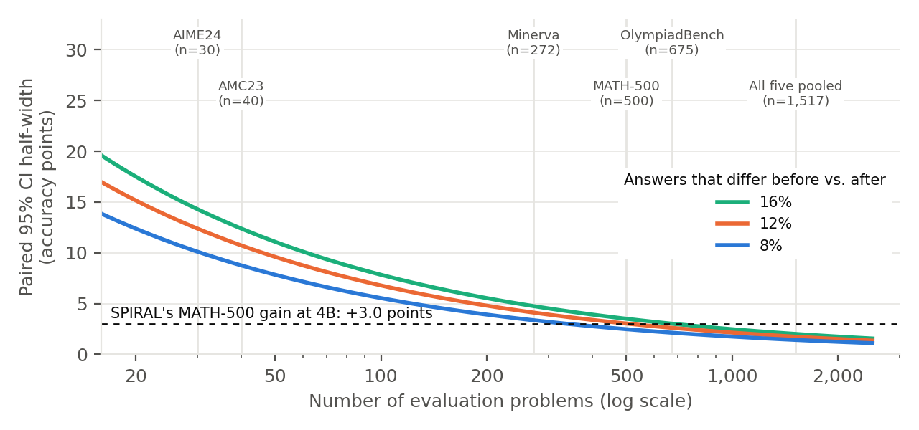
Figure 1. Half-width of a paired 95% confidence interval for a before/after accuracy difference, by number of problems. Approximation: 1.96·√(d/n), where d is the fraction of problems whose correctness changes between checkpoints. Assumes one sample per problem and one seed; more samples and seeds narrow it further.

4.3 The Kuhn Poker environment
Because the environment is the training data, we explored it directly. We wrote four scripted policies (the textbook Kuhn Poker equilibrium with α = 1/6, “never fold”, a calling station, and uniform random) and played 10,000 matches per pairing, alternating seats, in two implementations: the current PyPI release of TextArena (0.7.4), which UnstableBaselines installs by default, and SPIRAL’s own KuhnPoker-v1 running on SPIRAL’s pinned TextArena 0.6.4. As a control we also ran TextArena 0.7.4 with the stakes fix from TextArena’s GitHub main branch, in which a bet or call adds a chip to the pot, as in standard Kuhn Poker. Win rates are the share of decisive (non-drawn) matches won.
Property | TextArena 0.7.4 (PyPI) | SPIRAL KuhnPoker-v1 | Corrected stakes (control)
Hands per match | 3 | 5 | 3
Does a called bet change the stakes? | No: every hand is ±1 chip | No: every hand is ±1 chip | Yes: a bet and a call each add a chip
Match winner decided by | Chip total (100%) | Final hand only (100%); agrees with chip total in 70.5% | Chip total (100%); draws possible
Model decisions per match | 6.8 on average (6–9) | 11.3 on average (10–15) | 6.8 on average (6–9)
Never fold vs. equilibrium | 64.9% | 59.3% | 49.6%
Uniform random vs. equilibrium | 53.4% | 51.7% | 45.1%
Uniform random vs. never fold | 23.6% | 30.8% | 27.3%
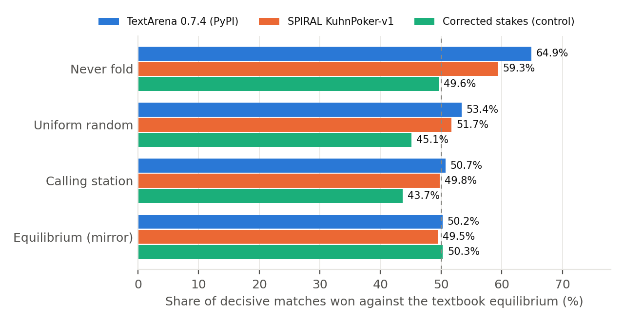
Figure 2. Share of decisive matches won by four scripted policies against the textbook Kuhn Poker equilibrium (10,000 matches per bar; 95% interval about ±1–1.2 points). Only the corrected-stakes control behaves like standard Kuhn Poker: no policy wins more than half.
In standard Kuhn Poker a called bet doubles the pot, which is what makes bluffing and expected-value reasoning necessary. In both implementations the pot stays at the two-chip ante, so calling never loses more than folding. As a result “never fold” beats the textbook equilibrium, and even uniform random play beats it (53.4% and 51.7%). Restoring the stakes removes the effect: “never fold” falls to 49.6% and random play to 45.1%, so the anomaly comes from the stakes, not from our scripted policies. In SPIRAL’s version the earlier hands do not affect the result: the winner of the final hand wins the match. TextArena’s GitHub main branch now adds bets to the pot, but the fix is not in the PyPI release.

4.4 What this changes in our design
- Fidelity. We train on SPIRAL’s KuhnPoker-v1 for both model sizes. Using the UnstableBaselines default would silently change the game we are replicating.
- Opponent and baseline. “Never fold” is the scripted fixed opponent. Uniform random play wins 30.8% of matches against it, which gives a chance-level reference line for training curves.
- Interpretation. SPIRAL attributes part of the transfer to expected-value reasoning. Since betting carries no extra stakes here, we will measure fold and bet frequencies in transcripts to see what the trained policies actually learn. A corrected-stakes variant is a stretch condition, not a commitment.
- Compute. SPIRAL’s run uses 400 steps × 128 = 51,200 game transitions [1]. At 11.3 decisions per match that is about 4,500 matches per run, or about 614,000 model generations across 12 runs before evaluation. We will measure generation throughput in Phase 1.
- Action parsing. UnstableBaselines extracts the last \boxed{} answer; without one, the environment takes the first bracketed action anywhere in the text. In TextArena 0.7.4 an invalid move gets one retry and a second loses the match. We log format errors separately from game losses.

Not done yet
Steps that need a GPU and Hugging Face access are next, on Colab: running the base models in the environment (format-error rate), base-model accuracy on the suite, the check against SPIRAL’s released checkpoint, and downloading AIME 2025.

5. Repository
GitHub: [paste GitHub URL here]. The instructor and TA are invited as collaborators. All exploration in this check-in is reproducible from the repository (README, Reproducing the exploration).
Folder | Contents
explore/ | benchmark_stats.py, kuhn_env_explore.py, make_figures.py (no GPU needed)
results/ | JSON outputs behind every number in Section 4
data/ | fetch_benchmarks.sh (raw data is downloaded, not committed)
third_party/ | SPIRAL’s Kuhn Poker environment (Apache-2.0, unmodified)
tests/ | Unit tests for the exploration code (pytest)
docs/ | Proposal, check-ins, report drafts

6. Report Outline
- Abstract
- Introduction: whether game self-play teaches reasoning, and why model size matters
- Related work: SPIRAL [1] and follow-ups (STRATAGEM [9], MARSHAL [10]); TextArena [2] and UnstableBaselines [11]; RL with LoRA (Tina [3])
- Environment: Kuhn Poker as implemented, and how it differs from the standard game
- Method: REINFORCE with RAE, LoRA, self-play vs. scripted opponent, experimental grid
- Evaluation setup: benchmarks, grader validation, minimum detectable effect, statistics
- Results: game performance, transfer to math benchmarks, reasoning-trace length
- Analysis: transcript audit (what the policies learn), memorization vs. reasoning
- Limitations: LoRA vs. full fine-tuning, compute, environment fidelity
- Conclusion and future work

7. Next Steps and Roles
Task | Owner | When
Run Qwen3 base models in KuhnPoker-v1 via UnstableBaselines; log format-error rate | Anurag Bodapally | Weeks 1–2
Verify single-GPU feasibility and HPC GPU types | Anurag Bodapally | Week 2
Base-model and Spiral-Qwen3-4B accuracy on the suite (5 samples); measure change rate d and the detectable effect | Shubham Baid | Weeks 1–2
Scripted “never fold” opponent; shared-baseline formatter for the RAE ablation | Syed Hassan Muzammil | Weeks 2–3
Gate A: is SPIRAL’s effect above our detectable threshold? | All | End of week 2
UnstableBaselines’ RoleAdvantageByEnvFormatter already implements RAE as a per-role moving-average baseline (τ = 0.001); the shared-baseline ablation needs a small new formatter.

References
[1] B. Liu et al., “SPIRAL: Self-Play on Zero-Sum Games Incentivizes Reasoning via Multi-Agent Multi-Turn Reinforcement Learning,” ICLR 2026. arXiv:2506.24119.
[2] L. Guertler et al., “TextArena,” arXiv:2504.11442, 2025.
[3] S. Wang et al., “Tina: Tiny Reasoning Models via LoRA,” arXiv:2504.15777, 2025.
[4] Qwen Team, “Qwen3 Technical Report,” arXiv:2505.09388, 2025.
[5] D. Hendrycks et al., “Measuring Mathematical Problem Solving With the MATH Dataset,” NeurIPS 2021. arXiv:2103.03874.
[6] H. Lightman et al., “Let’s Verify Step by Step,” arXiv:2305.20050, 2023.
[7] C. He et al., “OlympiadBench,” ACL 2024. arXiv:2402.14008.
[8] A. Lewkowycz et al., “Solving Quantitative Reasoning Problems with Language Models,” NeurIPS 2022. arXiv:2206.14858.
[9] STRATAGEM: Learning Transferable Reasoning via Trajectory-Modulated Game Self-Play, ACL 2026. arXiv:2604.17696.
[10] MARSHAL: Incentivizing Multi-Agent Reasoning via Self-Play with Strategic LLMs, arXiv:2510.15414, 2025.
[11] UnstableBaselines, github.com/LeonGuertler/UnstableBaselines (accessed October 13, 2026).

