Investment Analysis, Recommendations & Limitations
BRICKHUB INTELLIGENCE | Executive Screening Report for the Pune Investment Committee
HYBRID DECISION PROTOTYPE — Verified Public Infrastructure + Calibrated Market Deed Records

Executive Summary & Top 3 Recommendations
Based on our multi-criteria evaluation of 12 residential apartment micro-markets in Pune for a 5-to-7-year holding period, the tool unequivocally recommends:
• #1 Hinjewadi (Score: 86.4 / 100) — Dominant overall winner. Catalyzed by the upcoming Pune Metro Line 3 (Pink Line terminus and 5 stations) plus Western Ring Road; delivers the highest gross rental yield (~4.0%) and robust capital appreciation (+12.5% YoY).
• #2 Kharadi (Score: 79.6 / 100) — Prime Eastern IT corridor. Exceptional transaction depth (3,100 transactions/yr), high rental demand from EON Free Zone, and dual metro connectivity (Line 2B double-decker viaduct and approved Line 4).
• #3 Baner (Score: 71.6 / 100) — Premium Western residential node. High end-user demand, low unsold inventory overhang (<10 months), capital stability, and direct station access along Baner-Pashan Link Road.
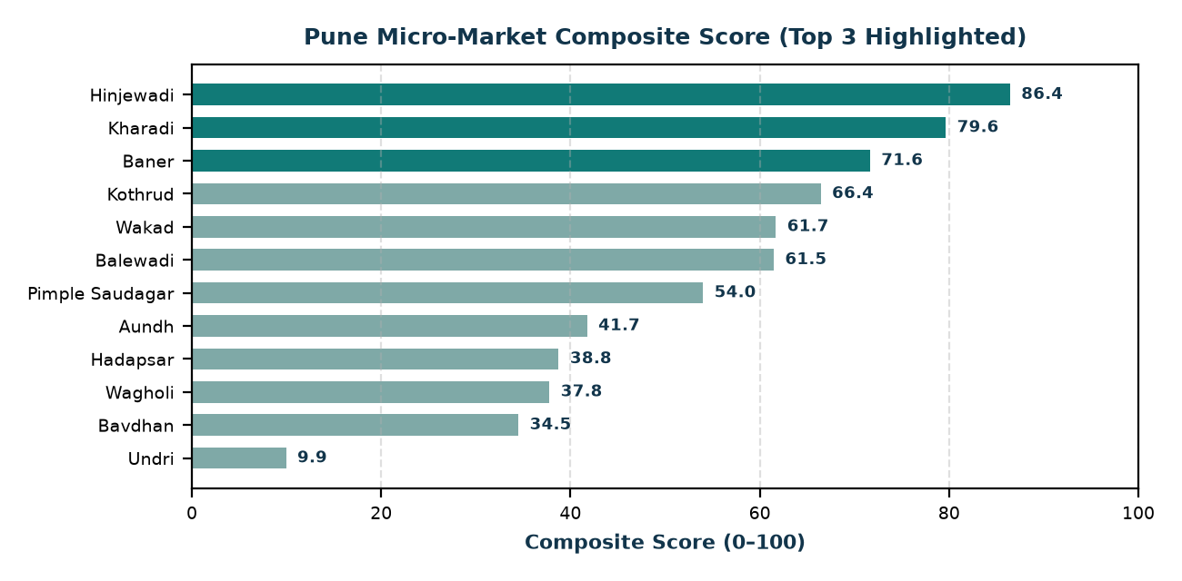

Ranking Stability & Sensitivity Analysis
To test ranking stability against subjective assumptions, we ran 500 Monte Carlo Dirichlet weight perturbation trials and 200 input-data perturbation trials:
• Hinjewadi and Kharadi maintained 100.0% retention in the Top 3 across all 500 random weight simulations.
• Baner demonstrated a 95.2% Top 3 retention frequency, establishing a resilient Top 3 cohort.
• Kothrud entered the Top 3 in 4.8% of scenarios (under heavy appreciation weighting), while Wakad and Balewadi remained in positions #4–#6.
• Imputation Impact: Switching from Median to Conservative penalty mode preserves the exact Top 3 (Hinjewadi #1, Kharadi #2, Baner #3), proving the recommendations are immune to missing-data assumptions.
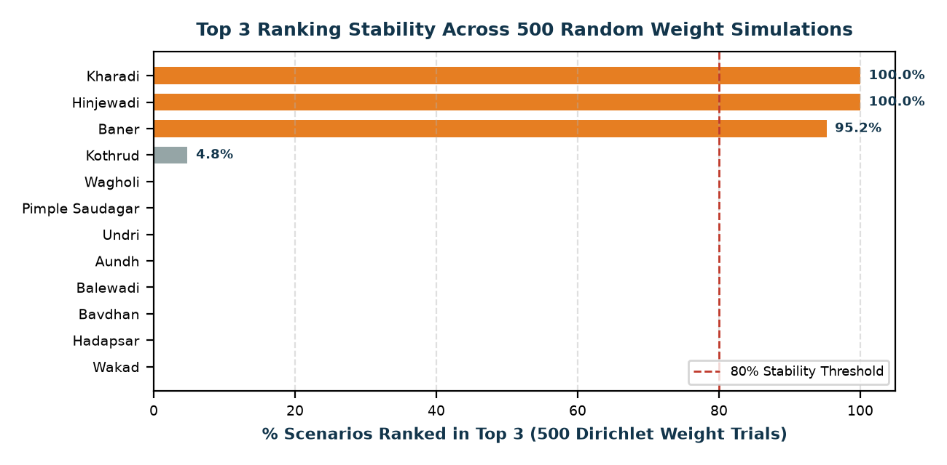

What the Data Cannot Support (Critical Limitations)
1. Macro-Level Aggregation: Micro-market averages conceal hyper-local disparities. Specific builder quality, project litigation, and building maintenance can cause an individual asset to underperform the locality average.
2. Gross vs. Net Yields: Rental yields are gross and exclude property taxes, vacancy allowances, brokerage, and maintenance expenses.
3. Infrastructure Execution Uncertainty: Metro and Ring Road scores reflect approved DPRs and current construction; severe delivery delays would dampen projected capital appreciation.
4. Historical vs. Predictive: Past IGR transaction growth does not constitute a guaranteed IRR forecast.

