**Fully Convolutional Network (FCN)**

an Device of semantic Picture segmentation is implemented in order to support autonomous driving of autonomous vehicles using Deep-Learning based Algorithm . The application is performed by Fully FCN architectures obtained by making changes in CNN architectures. Autonomous vehicles combine a variety of sensors to perceive their surroundings, including radar, computer vision, and GPS, among others. And identity navigation paths, avoid obstacles and read relevant markers, like road signs.

Every car driving on the road will generate about as much data as about 2,000 people, And just a million autonomous cars will generate 40 million people's worth of data,

**Deep Learning Architectures for Semantic Segmentation**

Prior to deep learning architectures, semantic segmentation models relied on hand crafted features fed into classifiers like Random Forests, Support vector machine, etc., these Deep learning architectures started being used by researchers as a backbone for semantic segmentation tasks. We introduce one such pioneering work below called *Fully FCN* on the basis of which all future models are roughly based.

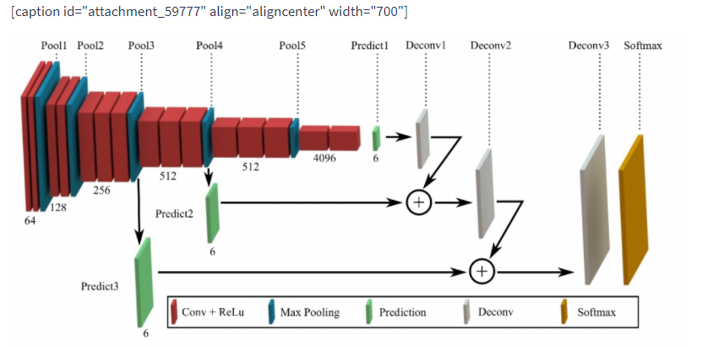

### Real-Time Semantic Segmentation

Post FCN, various other networks such as [DeepLab](https://arxiv.org/abs/1606.00915) , [UNet](https://arxiv.org/abs/1505.04597)  structure, etc., have made pioneering contributions to the field of semantic [semantic segmentation](https://blog.playment.io/semantic-segmentation-models-autonomous-vehicles/). On the basis of the aforementioned networks, various state-of-the-art models like [RefineNet](https://arxiv.org/abs/1611.06612), [DeepLabv3](https://arxiv.org/abs/1706.05587) etc.

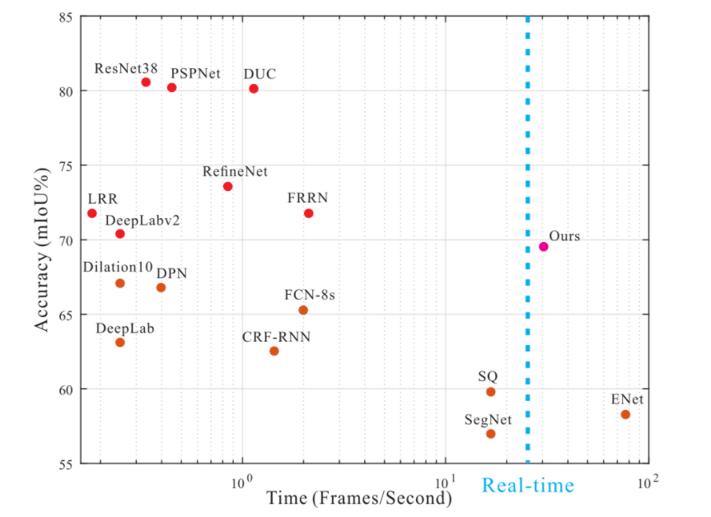

Segnet-Using encoder pooling parameters at the decoder for machine training

U_Net -intensive data augmentation centric encoder-decoder architecture to segment biomedical images

ENET -light network with reduced inference time using asymmetric encoder-decoder architecture.

We introduce one such pioneering work below called Fully FCN on the basis of which all future models are roughly based.

* Auto-driving vehicles are vehicle in which man drivers are never required to take control to safely control the vehicle.
* An autonomous or driverless cars, they combine sensors and software to control, navigate, and drive the vehicle.
* Reduce traffic congestion (40% fewer vehicles on the road)
* Cut transportation costs by 50% (in terms of vehicles, fuel, and infrastructure)
* Improve walkability and livability.
* Free up parking lots for other uses (college, parks, community centers)