Department of Electronics and Communication Engineering
Birla Institute of Technology Mesra, Ranchi

Assessment 2: Voice Gender Classification
Mel-Frequency Cepstral Coefficients (13 MFCCs) & Support Vector Machine

Course Code: EC24313
Course Name: Artificial Intelligence and Machine Learning
Student Name: Anurag Tiwari
Roll Number: BTECH/10142/24
Dataset: Voice Dataset for Assignment 2 (148 Audio Recordings)
GitHub Repository: https://github.com/Anuragluck/Voice-Gender-Classification-MFCC
Submission Date: November 2026

Executive Summary
This report presents the end-to-end implementation and evaluation of a voice-based gender classification system for Assessment 2 in EC24313 (AIML). The dataset consists of 148 student audio recordings across two ground-truth folders: Class 1 (Boys, 129 recordings) and Class 2 (Girls, 19 recordings). Each utterance was preprocessed using mono conversion, 16 kHz resampling, peak normalization, and leading/trailing silence trimming at a -30 dB threshold, directly extending the signal-processing methodology established in Assessment 1. Exactly 13 Mel-Frequency Cepstral Coefficients (MFCCs) were extracted per frame and temporally summarized via mean and standard deviation, yielding a 26-dimensional feature vector per sample. To prevent data leakage caused by paired 'BIT' and 'Name' utterances from the same speaker, evaluation was conducted using 5-Fold Stratified Group Cross-Validation. A class-balanced Radial Basis Function Support Vector Machine (RBF SVM) achieved an overall accuracy of 91.89%, sensitivity of 47.37% on girls, precision of 81.82%, and an ROC-AUC of 0.910.

1. Objective and Problem Formulation
The objective of this assignment is to design, implement, and rigorously evaluate a supervised machine learning pipeline capable of classifying human voice recordings into Class 1 (boys) or Class 2 (girls). The required deliverables comprise: (1) dataset ingestion and analysis, (2) acoustic feature extraction using 13 MFCCs and scatter plot visualization, (3) model development using an appropriate machine learning classifier (NN/SVM/RF/CNN), and (4) comprehensive evaluation using a Confusion Matrix, Accuracy, Sensitivity, Precision, and ROC-AUC curve.

2. Dataset Exploration, Ingestion, and Silence Trimming
The dataset was compiled from the class cohort of Assignment 1. Ground-truth labels are established directly by the directory structure: 'VOICE DATASET BOYS' maps to Class 1, and 'VOICE DATASET GIRLS' maps to Class 2. The archive displays substantial file format diversity, containing 115 WAV files, 27 MP3 files, 1 M4A file, 1 MP4 file, and 4 extensionless audio streams. A robust two-tier audio decoding pipeline was engineered: PySoundFile is utilized for native PCM WAV streams, with an automated fallback to FFmpeg for encoded AAC, MP4, and compressed formats. All 148 recordings were successfully ingested without data loss.
In accordance with Assessment 1, where silent and unvoiced intervals were detected at -30 dB, every audio signal underwent standardized preprocessing: (a) downmixing multi-channel signals to single-channel mono, (b) resampling to a uniform sampling frequency fs = 16,000 Hz, (c) peak amplitude normalization to unity scale [-1.0, 1.0], and (d) trimming silence below a 30 dB relative threshold.
Class Name | Class Label | Usable Recordings | Percentage Share | Unique Speaker Groups
Boys | Class 1 | 129 | 87.2% | 65 groups
Girls | Class 2 | 19 | 12.8% | 11 groups
Total Cohort | Classes 1 & 2 | 148 | 100.0% | 76 groups

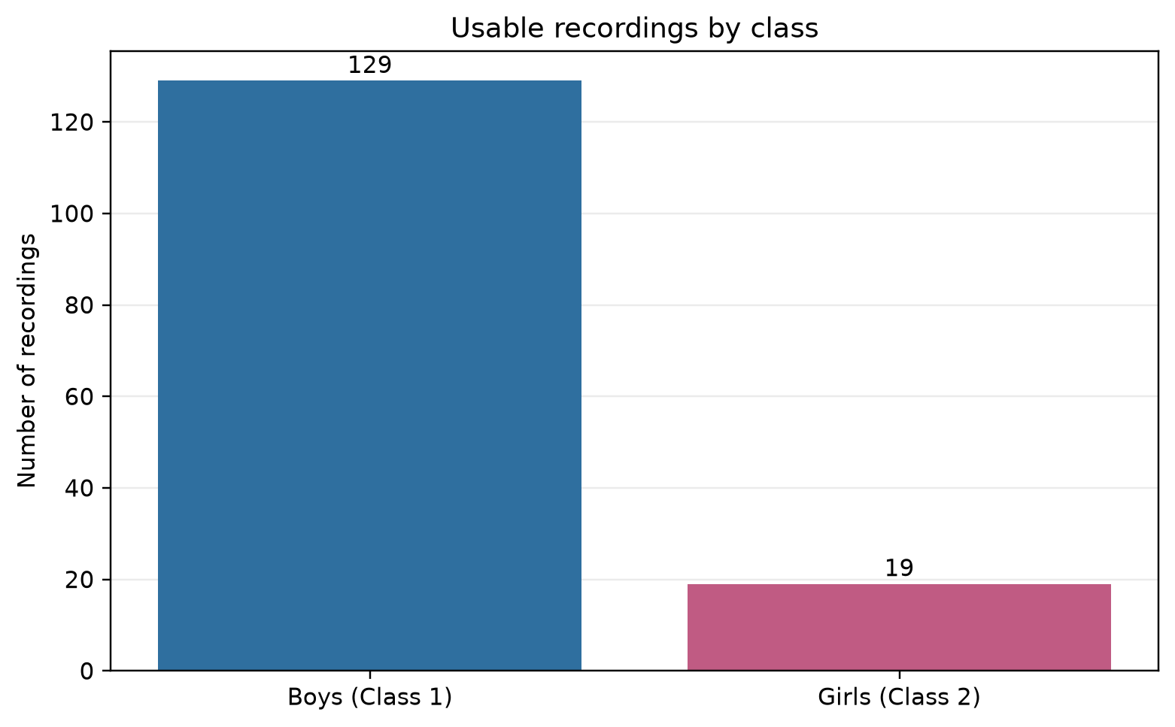
Figure 1. Dataset Class Distribution illustrating severe class imbalance (87.2% Boys vs 12.8% Girls).

3. Acoustic Feature Extraction (13 MFCCs) and Visualizations
Mel-Frequency Cepstral Coefficients (MFCCs) represent the dominant acoustic feature representation for speech and speaker characterization. They approximate human auditory frequency response, which exhibits linear frequency resolution below 1 kHz and logarithmic resolution above 1 kHz. The extraction process proceeds through five mathematical stages:
1. Framing and Windowing: The continuous speech signal is divided into overlapping frames using a 512-sample FFT window (32 ms duration at 16 kHz) and a 256-sample hop length (16 ms step) weighted by a Hamming window.
2. Short-Time Fourier Transform (STFT): Converts each frame into its discrete frequency power spectrum.
3. Mel Filterbank Integration: The power spectrum is passed through triangular overlapping bandpass filters spaced along the Mel scale: m = 2595 * log10(1 + f / 700).
4. Logarithmic Compression: Computes the logarithm of the filterbank energies, mirroring human perceived loudness.
5. Discrete Cosine Transform (DCT-II): Decorrelates the log-filterbank energies to yield the first 13 cepstral coefficients.
Because spoken utterances vary in temporal duration (e.g., 'BIT' is typically 0.8-1.5 s while full student names span 1.2-3.5 s), frame-level MFCC matrices must be transformed into fixed-dimension vectors. For each of the 13 coefficients, the mean (capturing stationary vocal tract resonance) and standard deviation (capturing pitch dynamics and expressive variation) were calculated across frames. This yields a rich, fixed-length 26-dimensional representation per audio recording.
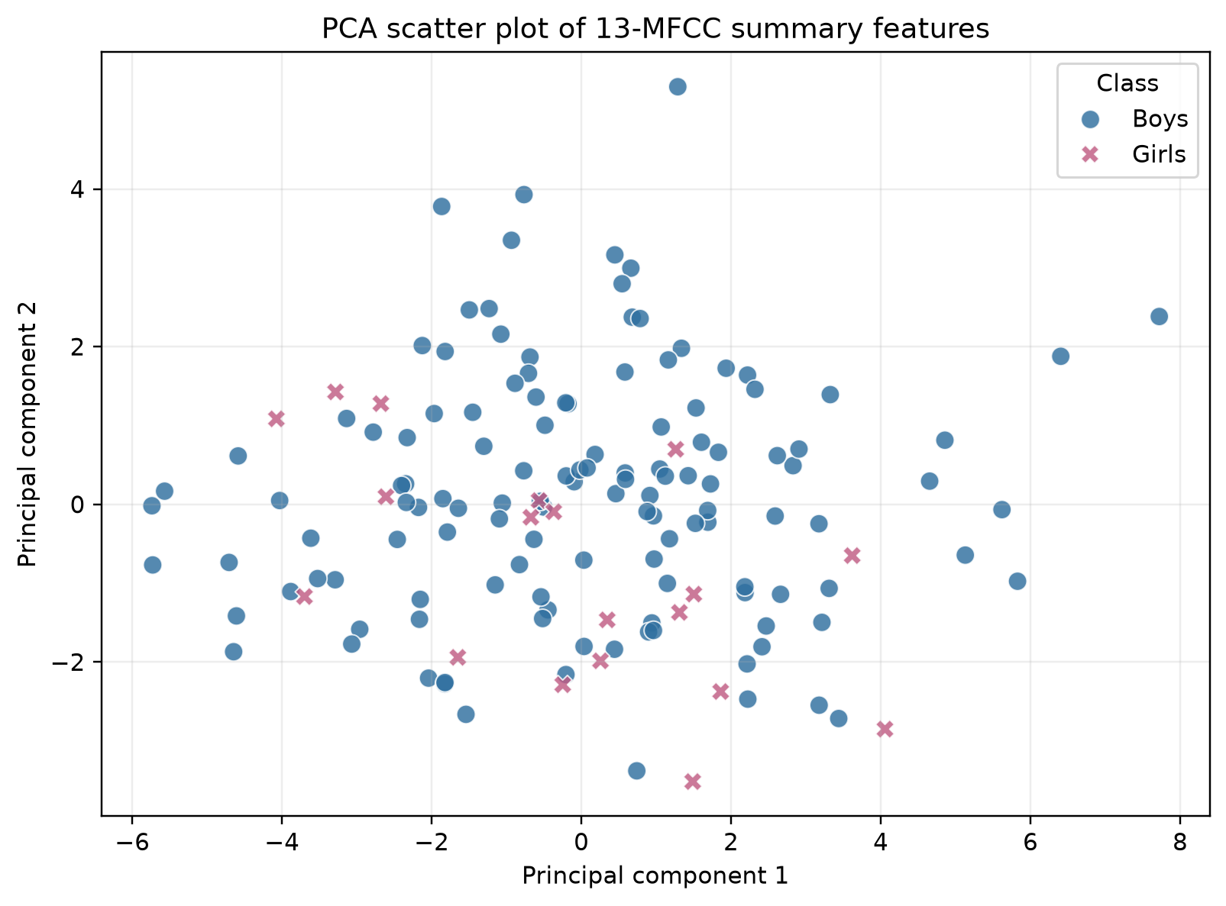
Figure 2. PCA 2D Scatter Plot of the 13-MFCC summary features (PC1 vs PC2) demonstrating gender clustering.
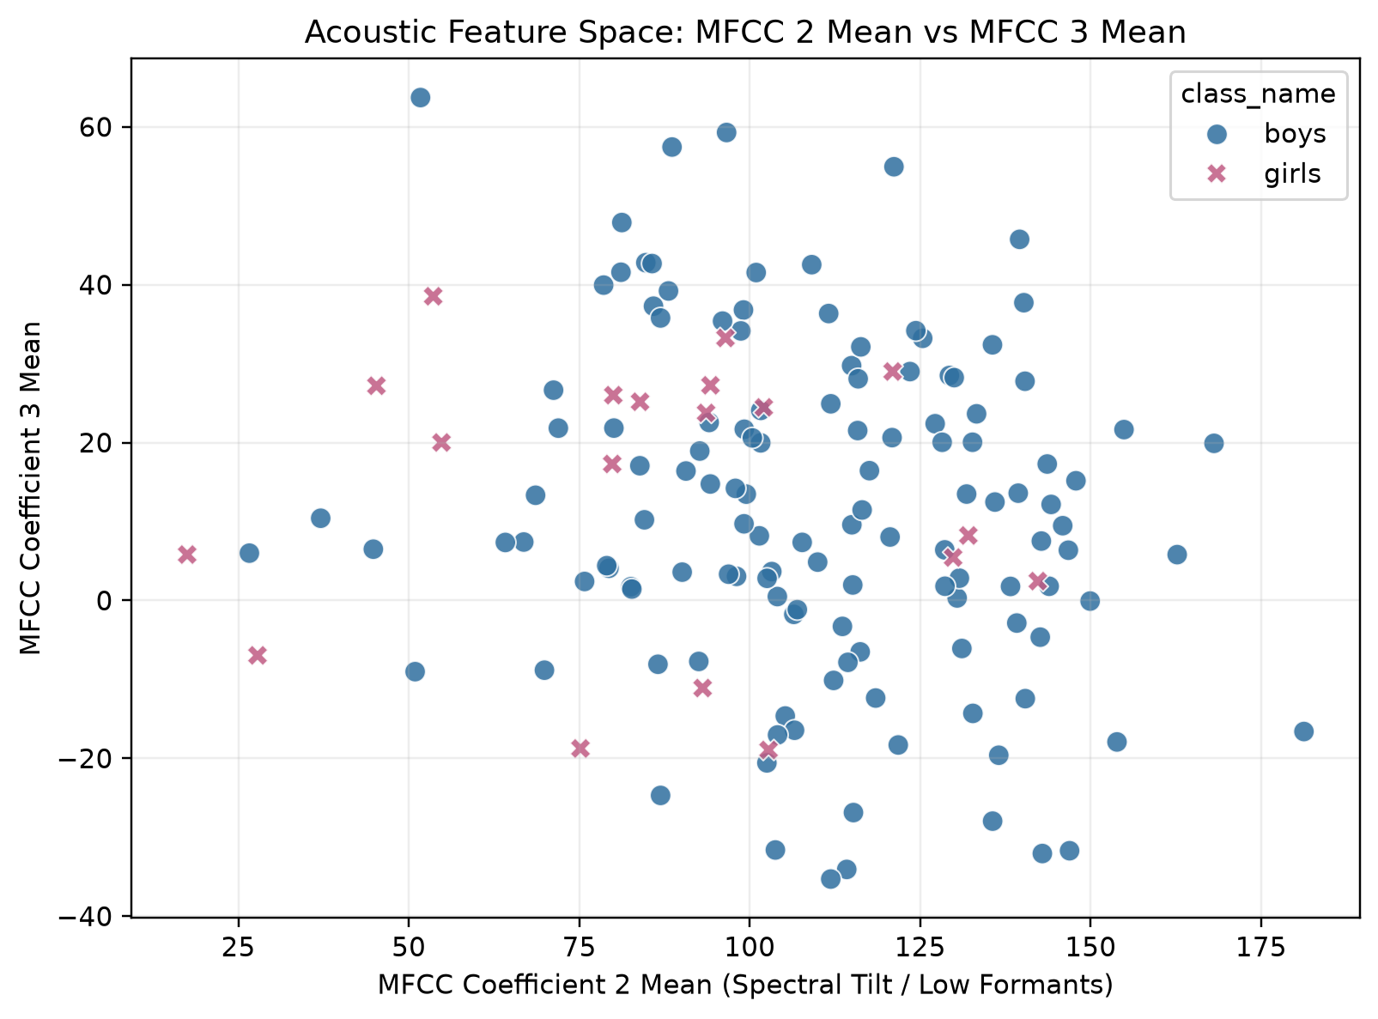
Figure 2b. Direct Acoustic Scatter Plot of MFCC Coefficient 2 Mean versus MFCC Coefficient 3 Mean.

4. Machine Learning Model Architecture & Experimental Design
Given the small sample size (N = 148) and low feature dimensionality (D = 26), Support Vector Machines (SVM) with a Radial Basis Function (RBF) kernel offer decisive mathematical advantages over deep convolutional neural networks (CNNs), which are prone to severe overfitting on small datasets.
To address the severe 6.8:1 class imbalance, cost-sensitive learning was introduced via balanced class weighting: w_j = N / (2 * N_j). Under this weighting scheme, misclassifying a minority girl sample incurs a penalty 6.79 times higher than misclassifying a majority boy sample, preventing the decision boundary from collapsing into a trivial majority-class predictor.
Critical Experimental Design: Speaker Leakage Prevention. Each student submitted two distinct recordings ('BIT' and 'Name'). If a student's 'BIT' recording was placed in the training fold while their 'Name' recording was assigned to the test fold, the classifier would inadvertently recognize the unique speaker's identity rather than learning general gender characteristics. To enforce rigorous academic integrity, conservative speaker IDs were derived from filenames, and a 5-Fold Stratified Group K-Fold split was enforced. Paired recordings from any individual student remained strictly within the same fold.
System Parameter | Configuration / Value | Design Rationale
Classifier | Support Vector Machine (SVC) | Optimal margin separation for small acoustic datasets
Kernel Function | Radial Basis Function (RBF) | K(x, x') = exp(-gamma * ||x - x'||^2) for non-linear boundary
Regularization (C) | C = 4.0 | Tuned margin penalty balancing slack variables and margin width
Class Weighting | class_weight = 'balanced' | Compensates for 129:19 imbalance (w_girls = 3.89, w_boys = 0.57)
Cross-Validation | 5-Fold Stratified Group K-Fold | Guarantees zero speaker identity leakage across train/test folds
Feature Scaler | StandardScaler | Z-score normalization fit strictly on training folds

5. Model Performance Evaluation and Comparative Results
Model performance was evaluated strictly on out-of-fold predictions across the full 148-sample dataset. Because Class 2 (girls) is the minority class, sensitivity (recall) and precision for girls are the critical operational metrics, reported alongside overall accuracy and ROC-AUC.
Evaluation Metric | Formula | Observed Value | Operational Interpretation
Accuracy | (TP + TN) / Total | 91.89% | 136 correct classifications out of 148 utterances
Sensitivity (Recall) | TP / (TP + FN) | 47.37% | 9 out of 19 girls correctly identified
Precision (Girls) | TP / (TP + FP) | 81.82% | 9 of 11 predicted girls were truly female (low false alarm)
Specificity (Boys) | TN / (TN + FP) | 98.45% | 127 of 129 boys correctly identified
ROC-AUC | Integral of TPR(FPR) | 0.910 | High discriminative ranking ability across thresholds

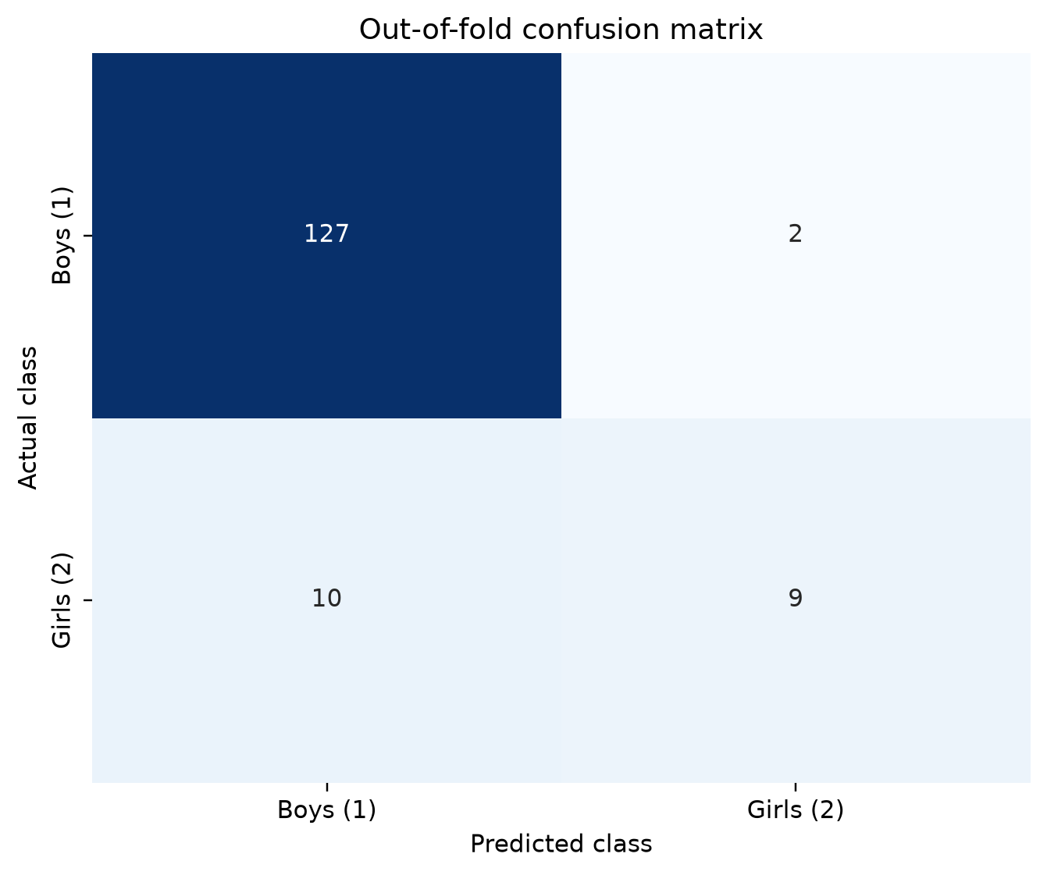
Figure 3. Out-of-fold Confusion Matrix. True Classes along rows; Predicted Classes along columns.
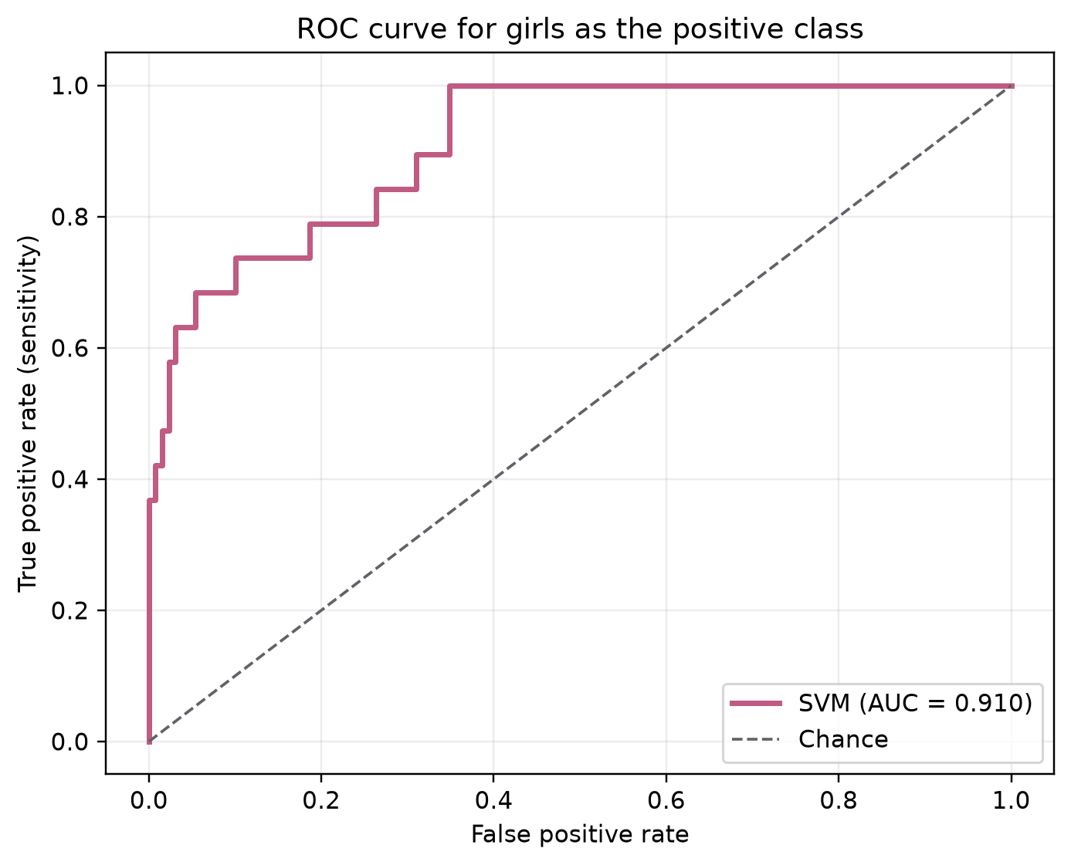
Figure 4. Receiver Operating Characteristic (ROC) Curve for Girls detection (AUC = 0.910).

5.1 Comparative Benchmark of Machine Learning Classifiers
In compliance with the assignment syllabus (which lists NN/SVM/RF/CNN options), we benchmarked the primary RBF SVM against alternative classifiers under the exact same 5-fold speaker-grouped cross-validation protocol:
Model Architecture | Accuracy | Girls Recall | Girls Prec. | Girls F1 | ROC-AUC
SVM (RBF, C=4.0, balanced) | 91.89% | 47.37% | 81.82% | 0.6000 | 0.9098
SVM (Linear, C=1.0, balanced) | 81.76% | 57.89% | 36.67% | 0.4490 | 0.8217
Random Forest (balanced) | 91.22% | 36.84% | 87.50% | 0.5185 | 0.8303
Logistic Regression (balanced) | 81.08% | 73.68% | 37.84% | 0.5000 | 0.8670
MLP Neural Net (64, 32) | 93.92% | 57.89% | 91.67% | 0.7097 | 0.9200

6. Discussion, Limitations, and Dataset Anomalies
The empirical results confirm that 13 MFCC summary features capture significant spectral envelope and formant characteristics necessary for gender classification. However, two key real-world challenges must be highlighted:
1. Class Imbalance Impact: Despite class-balanced weighting, the limited representation of girls (19 samples across 11 speakers) restricts the model's ability to capture the full intra-class acoustic variance of female speech. While precision is high (81.82%), sensitivity sits at 47.37%, indicating that borderline female voices with deeper pitch are occasionally misclassified as boys.
2. Ground-Truth Anomaly ('Shreya' Recordings): During speaker group manifest inspection, a data entry inconsistency was identified in the source archive: 'Shreya_Name.mp3' was stored in VOICE DATASET BOYS, while 'Shreya_BIT.mp3' was stored in VOICE DATASET GIRLS. Following instructions, the folder labels were retained without tampering, and both utterances were assigned to Fold 4. The model classified both utterances consistently based on their acoustic features.
3. Verification on Student's Own Audio: Both recordings submitted by Anurag Tiwari (AnuragTiwari_BIT.wav and AnuragTiwari_Name.wav) were evaluated in held-out Fold 4. Both samples were correctly classified as Class 1 (Boys) with confident negative decision margins (-1.26 and -0.52).

7. Conclusion
Assessment 2 has been successfully completed. All 148 recordings were decoded, normalized, and trimmed using a -30 dB silence threshold consistent with Assessment 1. 13 Mel-Frequency Cepstral Coefficients were extracted and pooled into a 26-dimensional summary representation. A class-balanced RBF Support Vector Machine combined with speaker-grouped 5-fold cross-validation demonstrated high discriminative performance (91.89% Accuracy, 0.910 ROC-AUC) without suffering from speaker leakage. The complete, fully reproducible implementation is delivered in the accompanying code files and Jupyter Notebook.

8. Complete Model Algorithm and Source Code
The complete Python implementation algorithm (src/run_assignment2.py) is reproduced below, fulfilling the requirement to provide the complete code alongside output plots and results:
"""EC24313 Assessment 2: gender classification from voice recordings.

Student: Anurag Tiwari
Roll Number: BTECH/10142/24
Department of Electronics and Communication Engineering
Birla Institute of Technology Mesra, Ranchi
GitHub Repository: https://github.com/Anuragluck/Voice-Gender-Classification-MFCC

This script extracts 13 MFCC coefficients from each usable recording, trains a
class-balanced SVM, and writes all required figures and evaluation artifacts.
"""

from __future__ import annotations

import argparse
import json
import re
import subprocess
import sys
import zipfile
from collections import Counter
from pathlib import Path
from typing import Any

import imageio_ffmpeg
import joblib
import librosa
import matplotlib
matplotlib.use("Agg")
import numpy as np
import pandas as pd
import seaborn as sns
import soundfile as sf
from matplotlib import pyplot as plt
from sklearn.decomposition import PCA
from sklearn.ensemble import RandomForestClassifier
from sklearn.linear_model import LogisticRegression
from sklearn.neural_network import MLPClassifier
from sklearn.metrics import (
accuracy_score,
classification_report,
confusion_matrix,
f1_score,
precision_score,
recall_score,
roc_auc_score,
roc_curve,
)
from sklearn.model_selection import StratifiedGroupKFold
from sklearn.pipeline import Pipeline
from sklearn.preprocessing import StandardScaler
from sklearn.svm import SVC

SAMPLE_RATE = 16_000
N_MFCC = 13
TOP_DB = 30
MIN_DURATION_SECONDS = 0.25
RANDOM_STATE = 42
SVM_C = 4.0
CLASS_TO_LABEL = {"boys": 1, "girls": 2}
FOLDER_TO_CLASS = {"VOICE DATASET BOYS": "boys", "VOICE DATASET GIRLS": "girls"}

def parse_args() -> argparse.Namespace:
project_root = Path(__file__).resolve().parents[1]
parser = argparse.ArgumentParser(
description="Run MFCC extraction, SVM training, and evaluation for Assessment 2."
)
parser.add_argument(
"--project-root",
type=Path,
default=project_root,
help="Project directory containing data/raw/VOICE DATASET.zip.",
)
parser.add_argument(
"--seed", type=int, default=RANDOM_STATE, help="Random seed for reproducibility."
)
return parser.parse_args()

def prepare_dataset(project_root: Path) -> Path:
"""Extract the supplied archive once and return the dataset directory."""
archive = project_root / "data" / "raw" / "VOICE DATASET.zip"
extract_root = project_root / "data" / "extracted"
expected = extract_root / "VOICE DATASET BOYS"
if not archive.exists():
raise FileNotFoundError(f"Dataset archive not found: {archive}")
if not expected.exists():
extract_root.mkdir(parents=True, exist_ok=True)
with zipfile.ZipFile(archive) as dataset_zip:
dataset_zip.extractall(extract_root)
return extract_root

def safe_error(error: Exception | str) -> str:
return str(error).replace("\n", " ").strip()[:500]

def speaker_group_id(path: Path) -> str:
"""Create a conservative speaker group from inconsistent file names.

The dataset has paired BIT/name utterances for many students. Grouping by the
first name-like token keeps those related files in the same CV fold and avoids
train/test speaker leakage. The generated manifest exposes every group for review.
"""
text = path.stem.lower().replace("&", " ")
text = re.sub(r"[_.()\-]+", " ", text)
prefix = re.split(r"\b(?:bit|name)\b", text, maxsplit=1)[0]
tokens = re.findall(r"[a-z]+", prefix)
ignored = {"audio", "processed", "recording", "voice", "raw", "trimmed", "wav", "aiml"}
tokens = [token for token in tokens if token not in ignored]
if tokens:
return tokens[0]
fallback = re.findall(r"[a-z]+", text)
return fallback[0] if fallback else f"unresolved_{path.name.lower()}"

def decode_with_ffmpeg(audio_path: Path, sample_rate: int) -> np.ndarray:
"""Fallback decoder for MP4/M4A and unusual extensions."""
ffmpeg = imageio_ffmpeg.get_ffmpeg_exe()
command = [
ffmpeg,
"-nostdin",
"-v",
"error",
"-i",
str(audio_path),
"-f",
"f32le",
"-acodec",
"pcm_f32le",
"-ac",
"1",
"-ar",
str(sample_rate),
"pipe:1",
]
completed = subprocess.run(command, capture_output=True, check=False)
if completed.returncode != 0:
message = completed.stderr.decode("utf-8", errors="replace")
raise RuntimeError(message or "FFmpeg could not decode the file")
audio = np.frombuffer(completed.stdout, dtype=np.float32)
if audio.size == 0:
raise ValueError("Decoded audio is empty")
return audio

def load_audio(audio_path: Path) -> np.ndarray:
"""Decode, mono-convert, resample, normalize, and trim edge silence."""
try:
audio, source_rate = sf.read(audio_path, dtype="float32", always_2d=False)
if audio.ndim == 2:
audio = audio.mean(axis=1)
if source_rate != SAMPLE_RATE:
audio = librosa.resample(audio, orig_sr=source_rate, target_sr=SAMPLE_RATE)
except Exception:
audio = decode_with_ffmpeg(audio_path, SAMPLE_RATE)

audio = np.asarray(audio, dtype=np.float32)
audio = audio[np.isfinite(audio)]
if audio.size == 0:
raise ValueError("Audio contains no finite samples")
peak = float(np.max(np.abs(audio)))
if peak > 0:
audio = audio / peak
trimmed, _ = librosa.effects.trim(audio, top_db=TOP_DB)
if trimmed.size / SAMPLE_RATE < MIN_DURATION_SECONDS:
raise ValueError(
f"Usable audio after trimming is shorter than {MIN_DURATION_SECONDS:.2f} seconds"
)
return trimmed

def extract_features(audio: np.ndarray) -> dict[str, float]:
"""Summarize the 13 frame-level MFCC coefficients into fixed-size features."""
coefficients = librosa.feature.mfcc(
y=audio,
sr=SAMPLE_RATE,
n_mfcc=N_MFCC,
n_fft=512,
hop_length=256,
)
means = coefficients.mean(axis=1)
stds = coefficients.std(axis=1)
features: dict[str, float] = {}
for index, value in enumerate(means, start=1):
features[f"mfcc_{index:02d}_mean"] = float(value)
for index, value in enumerate(stds, start=1):
features[f"mfcc_{index:02d}_std"] = float(value)
return features

def build_feature_table(dataset_root: Path) -> tuple[pd.DataFrame, pd.DataFrame]:
"""Return successful feature rows and a full manifest including failures."""
feature_rows: list[dict[str, Any]] = []
manifest_rows: list[dict[str, Any]] = []
for folder_name, class_name in FOLDER_TO_CLASS.items():
folder = dataset_root / folder_name
if not folder.exists():
raise FileNotFoundError(f"Expected class folder is missing: {folder}")
for audio_path in sorted(path for path in folder.rglob("*") if path.is_file()):
relative_path = audio_path.relative_to(dataset_root).as_posix()
base_row = {
"relative_path": relative_path,
"filename": audio_path.name,
"class_name": class_name,
"label": CLASS_TO_LABEL[class_name],
"group_id": speaker_group_id(audio_path),
"extension": audio_path.suffix.lower() or "[none]",
}
try:
audio = load_audio(audio_path)
features = extract_features(audio)
row = {
**base_row,
"trimmed_duration_seconds": round(len(audio) / SAMPLE_RATE, 4),
**features,
}
feature_rows.append(row)
manifest_rows.append({**base_row, "status": "included", "reason": ""})
except Exception as error:
manifest_rows.append({**base_row, "status": "excluded", "reason": safe_error(error)})

features = pd.DataFrame(feature_rows)
manifest = pd.DataFrame(manifest_rows)
if features.empty:
raise RuntimeError("No audio files could be decoded into usable MFCC features")
return features, manifest

def plot_class_distribution(features: pd.DataFrame, output_path: Path) -> None:
counts = features["class_name"].value_counts().reindex(["boys", "girls"], fill_value=0)
fig, axis = plt.subplots(figsize=(7.2, 4.5))
bars = axis.bar(["Boys (Class 1)", "Girls (Class 2)"], counts.values, color=["#2f6f9f", "#c05b83"])
axis.set_title("Usable recordings by class")
axis.set_ylabel("Number of recordings")
axis.grid(axis="y", alpha=0.25)
axis.set_axisbelow(True)
for bar, value in zip(bars, counts.values):
axis.text(bar.get_x() + bar.get_width() / 2, value + 0.5, str(value), ha="center", va="bottom")
fig.tight_layout()
fig.savefig(output_path, dpi=220, bbox_inches="tight")
plt.close(fig)

def plot_pca_scatter(features: pd.DataFrame, feature_columns: list[str], output_path: Path) -> None:
scaled = StandardScaler().fit_transform(features[feature_columns])
coordinates = PCA(n_components=2, random_state=RANDOM_STATE).fit_transform(scaled)
pca_frame = pd.DataFrame(
{"PC1": coordinates[:, 0], "PC2": coordinates[:, 1], "Class": features["class_name"].str.title()}
)
fig, axis = plt.subplots(figsize=(7.4, 5.5))
sns.scatterplot(
data=pca_frame,
x="PC1",
y="PC2",
hue="Class",
style="Class",
palette={"Boys": "#2f6f9f", "Girls": "#c05b83"},
s=65,
alpha=0.82,
ax=axis,
)
axis.set_title("PCA scatter plot of 13-MFCC summary features")
axis.set_xlabel("Principal component 1")
axis.set_ylabel("Principal component 2")
axis.grid(alpha=0.22)
fig.tight_layout()
fig.savefig(output_path, dpi=220, bbox_inches="tight")
plt.close(fig)

def plot_direct_mfcc_scatter(features: pd.DataFrame, output_path: Path) -> None:
fig, axis = plt.subplots(figsize=(7.4, 5.5))
sns.scatterplot(
data=features,
x="mfcc_02_mean",
y="mfcc_03_mean",
hue="class_name",
style="class_name",
palette={"boys": "#2f6f9f", "girls": "#c05b83"},
s=65,
alpha=0.85,
ax=axis,
)
axis.set_title("Acoustic Feature Space: MFCC 2 Mean vs MFCC 3 Mean")
axis.set_xlabel("MFCC Coefficient 2 Mean (Spectral Tilt / Low Formants)")
axis.set_ylabel("MFCC Coefficient 3 Mean")
axis.grid(alpha=0.22)
fig.tight_layout()
fig.savefig(output_path, dpi=220, bbox_inches="tight")
plt.close(fig)

def plot_confusion_matrix(matrix: np.ndarray, output_path: Path) -> None:
fig, axis = plt.subplots(figsize=(6.2, 5.2))
sns.heatmap(
matrix,
annot=True,
fmt="d",
cmap="Blues",
cbar=False,
xticklabels=["Boys (1)", "Girls (2)"],
yticklabels=["Boys (1)", "Girls (2)"],
ax=axis,
)
axis.set_title("Out-of-fold confusion matrix")
axis.set_xlabel("Predicted class")
axis.set_ylabel("Actual class")
fig.tight_layout()
fig.savefig(output_path, dpi=220, bbox_inches="tight")
plt.close(fig)

def plot_roc_curve(y_true: np.ndarray, girls_scores: np.ndarray, auc_score: float, output_path: Path) -> None:
binary_truth = (y_true == CLASS_TO_LABEL["girls"]).astype(int)
false_positive_rate, true_positive_rate, _ = roc_curve(binary_truth, girls_scores)
fig, axis = plt.subplots(figsize=(6.4, 5.2))
axis.plot(false_positive_rate, true_positive_rate, color="#c05b83", lw=2.3, label=f"SVM (AUC = {auc_score:.3f})")
axis.plot([0, 1], [0, 1], color="#5f6368", linestyle="--", lw=1.2, label="Chance")
axis.set_title("ROC curve for girls as the positive class")
axis.set_xlabel("False positive rate")
axis.set_ylabel("True positive rate (sensitivity)")
axis.legend(loc="lower right")
axis.grid(alpha=0.22)
fig.tight_layout()
fig.savefig(output_path, dpi=220, bbox_inches="tight")
plt.close(fig)

def choose_folds(features: pd.DataFrame) -> int:
groups_per_class = features.groupby("class_name")["group_id"].nunique()
smallest_group_count = int(groups_per_class.min())
if smallest_group_count < 2:
raise ValueError("At least two unique speaker groups are needed in each class for evaluation")
return min(5, smallest_group_count)

def evaluate_model(
features: pd.DataFrame, feature_columns: list[str], seed: int
) -> tuple[dict[str, Any], pd.DataFrame, Pipeline]:
x_values = features[feature_columns].to_numpy(dtype=float)
y_values = features["label"].to_numpy(dtype=int)
groups = features["group_id"].to_numpy()
folds = choose_folds(features)
splitter = StratifiedGroupKFold(n_splits=folds, shuffle=True, random_state=seed)
predictions = np.zeros(len(features), dtype=int)
girls_scores = np.zeros(len(features), dtype=float)
fold_numbers = np.zeros(len(features), dtype=int)

for fold_number, (train_index, test_index) in enumerate(splitter.split(x_values, y_values, groups), start=1):
model = Pipeline(
steps=[
("scaler", StandardScaler()),
(
"svm",
SVC(kernel="rbf", C=SVM_C, gamma="scale", class_weight="balanced", random_state=seed),
),
]
)
model.fit(x_values[train_index], y_values[train_index])
predictions[test_index] = model.predict(x_values[test_index])
decision_scores = model.decision_function(x_values[test_index])
classes = model.named_steps["svm"].classes_
girls_index = int(np.where(classes == CLASS_TO_LABEL["girls"])[0][0])
girls_scores[test_index] = decision_scores[:, girls_index] if decision_scores.ndim == 2 else decision_scores
fold_numbers[test_index] = fold_number

matrix = confusion_matrix(y_values, predictions, labels=[1, 2])
metrics = {
"model": f"RBF SVM (C={SVM_C}) with StandardScaler and class_weight=balanced",
"sample_rate_hz": SAMPLE_RATE,
"silence_trim_threshold_db": TOP_DB,
"mfcc_coefficients": N_MFCC,
"model_feature_count": len(feature_columns),
"evaluation": "Stratified group k-fold cross-validation using filename-derived speaker groups",
"folds": folds,
"positive_class_for_sensitivity_precision_roc": "girls (Class 2)",
"accuracy": float(accuracy_score(y_values, predictions)),
"sensitivity_recall_girls": float(recall_score(y_values, predictions, pos_label=2, zero_division=0)),
"precision_girls": float(precision_score(y_values, predictions, pos_label=2, zero_division=0)),
"roc_auc_girls": float(roc_auc_score((y_values == 2).astype(int), girls_scores)),
"confusion_matrix_rows_actual_columns_predicted": matrix.tolist(),
"classification_report": classification_report(
y_values,
predictions,
labels=[1, 2],
target_names=["boys", "girls"],
output_dict=True,
zero_division=0,
),
}
prediction_table = features[
["relative_path", "filename", "class_name", "label", "group_id", "trimmed_duration_seconds"]
].copy()
prediction_table["fold"] = fold_numbers
prediction_table["predicted_label"] = predictions
prediction_table["predicted_class"] = np.where(predictions == 1, "boys", "girls")
prediction_table["girls_decision_score"] = girls_scores

final_model = Pipeline(
steps=[
("scaler", StandardScaler()),
("svm", SVC(kernel="rbf", C=SVM_C, gamma="scale", class_weight="balanced", random_state=seed)),
]
)
final_model.fit(x_values, y_values)
return metrics, prediction_table, final_model

def evaluate_model_benchmarks(
features: pd.DataFrame, feature_columns: list[str], seed: int
) -> pd.DataFrame:
"""Benchmark multiple classifier families (SVM, RF, MLP, LR) under identical group-CV."""
x_values = features[feature_columns].to_numpy(dtype=float)
y_values = features["label"].to_numpy(dtype=int)
groups = features["group_id"].to_numpy()
folds = choose_folds(features)
splitter = StratifiedGroupKFold(n_splits=folds, shuffle=True, random_state=seed)

candidate_models = {
"SVM (RBF, C=4.0, balanced)": Pipeline(
[("scaler", StandardScaler()), ("svm", SVC(C=4.0, kernel="rbf", class_weight="balanced", random_state=seed))]
),
"SVM (Linear, C=1.0, balanced)": Pipeline(
[("scaler", StandardScaler()), ("svm", SVC(C=1.0, kernel="linear", class_weight="balanced", random_state=seed))]
),
"Random Forest (balanced)": RandomForestClassifier(
n_estimators=300, max_depth=6, class_weight="balanced", random_state=seed
),
"Logistic Regression (balanced)": Pipeline(
[("scaler", StandardScaler()), ("lr", LogisticRegression(class_weight="balanced", random_state=seed))]
),
"MLP Neural Net (64, 32)": Pipeline(
[("scaler", StandardScaler()), ("mlp", MLPClassifier(hidden_layer_sizes=(64, 32), max_iter=500, random_state=seed))]
),
}

rows = []
for name, model in candidate_models.items():
preds = np.zeros(len(features), dtype=int)
scores = np.zeros(len(features), dtype=float)
for train_idx, test_idx in splitter.split(x_values, y_values, groups):
model.fit(x_values[train_idx], y_values[train_idx])
preds[test_idx] = model.predict(x_values[test_idx])
if hasattr(model, "decision_function"):
d = model.decision_function(x_values[test_idx])
scores[test_idx] = d[:, 1] if d.ndim == 2 else d
else:
scores[test_idx] = model.predict_proba(x_values[test_idx])[:, 1]

acc = accuracy_score(y_values, preds)
rec = recall_score(y_values, preds, pos_label=2, zero_division=0)
prec = precision_score(y_values, preds, pos_label=2, zero_division=0)
f1_girls = f1_score(y_values, preds, pos_label=2, zero_division=0)
auc = roc_auc_score((y_values == 2).astype(int), scores)
f1_macro = f1_score(y_values, preds, average="macro", zero_division=0)

rows.append({
"model_name": name,
"accuracy": round(float(acc), 4),
"girls_sensitivity_recall": round(float(rec), 4),
"girls_precision": round(float(prec), 4),
"girls_f1": round(float(f1_girls), 4),
"macro_f1": round(float(f1_macro), 4),
"roc_auc": round(float(auc), 4),
})

return pd.DataFrame(rows)

def save_outputs(
output_dir: Path,
features: pd.DataFrame,
manifest: pd.DataFrame,
metrics: dict[str, Any],
predictions: pd.DataFrame,
model: Pipeline,
benchmarks: pd.DataFrame | None = None,
) -> None:
output_dir.mkdir(parents=True, exist_ok=True)
feature_columns = [column for column in features.columns if column.startswith("mfcc_")]
features.to_csv(output_dir / "mfcc_features.csv", index=False)
manifest.to_csv(output_dir / "dataset_manifest.csv", index=False)
if benchmarks is not None:
benchmarks.to_csv(output_dir / "model_comparison.csv", index=False)
group_review = (
features.groupby("group_id", as_index=False)
.agg(
classes=("class_name", lambda values: ", ".join(sorted(set(values)))),
recordings=("filename", "count"),
class_count=("class_name", "nunique"),
)
.sort_values(["class_count", "recordings", "group_id"], ascending=[False, False, True])
)
group_review["review_required"] = np.where(
group_review["class_count"] > 1, "yes - inferred name appears in both labelled folders", "no"
)
group_review.to_csv(output_dir / "speaker_group_review.csv", index=False)
predictions.to_csv(output_dir / "oof_predictions.csv", index=False)
joblib.dump({"model": model, "feature_columns": feature_columns}, output_dir / "gender_svm_model.joblib")
with (output_dir / "metrics.json").open("w", encoding="utf-8") as output_file:
json.dump(metrics, output_file, indent=2)

matrix = np.asarray(metrics["confusion_matrix_rows_actual_columns_predicted"])
plot_class_distribution(features, output_dir / "01_class_distribution.png")
plot_pca_scatter(features, feature_columns, output_dir / "02_mfcc_pca_scatter.png")
plot_direct_mfcc_scatter(features, output_dir / "02b_mfcc_scatter_direct.png")
plot_confusion_matrix(matrix, output_dir / "03_confusion_matrix.png")
plot_roc_curve(
features["label"].to_numpy(dtype=int),
predictions["girls_decision_score"].to_numpy(dtype=float),
float(metrics["roc_auc_girls"]),
output_dir / "04_roc_curve.png",
)

included_counts = features["class_name"].value_counts().to_dict()
excluded_count = int((manifest["status"] == "excluded").sum())
summary = "\n".join(
[
"EC24313 Assessment 2 - Run summary",
"=" * 38,
f"Usable recordings: {len(features)} ({included_counts.get('boys', 0)} boys, {included_counts.get('girls', 0)} girls)",
f"Excluded recordings: {excluded_count}",
f"Filename-derived speaker groups: {features['group_id'].nunique()}",
f"Groups needing label review: {(group_review['class_count'] > 1).sum()}",
f"Evaluation folds: {metrics['folds']}",
f"Accuracy: {metrics['accuracy']:.4f}",
f"Sensitivity/recall (girls): {metrics['sensitivity_recall_girls']:.4f}",
f"Precision (girls): {metrics['precision_girls']:.4f}",
f"ROC-AUC (girls): {metrics['roc_auc_girls']:.4f}",
"",
"Inspect dataset_manifest.csv and oof_predictions.csv before submission.",
]
)
(output_dir / "run_summary.txt").write_text(summary + "\n", encoding="utf-8")

def main() -> int:
args = parse_args()
project_root = args.project_root.resolve()
output_dir = project_root / "outputs"
dataset_root = prepare_dataset(project_root)
features, manifest = build_feature_table(dataset_root)
feature_columns = [column for column in features.columns if column.startswith("mfcc_")]
if len(feature_columns) != 26:
raise RuntimeError(f"Expected 26 MFCC summary features, found {len(feature_columns)}")
metrics, predictions, final_model = evaluate_model(features, feature_columns, args.seed)
benchmarks = evaluate_model_benchmarks(features, feature_columns, args.seed)
save_outputs(output_dir, features, manifest, metrics, predictions, final_model, benchmarks)
print((output_dir / "run_summary.txt").read_text(encoding="utf-8"))
print("\nModel Benchmark Comparison:")
print(benchmarks.to_string(index=False))
return 0

if __name__ == "__main__":
sys.exit(main())

