Old Photograph Restoration System
Using Digital Image Processing
Project Report
A classical Digital Image Processing project built with Python, Streamlit, OpenCV, and NumPy.

Abstract
Old photographs often suffer from fading, low contrast, dust, impulse noise, and soft edges. This project provides a browser-based restoration system using only classical digital image processing. The system applies filtering, local contrast enhancement, sharpening, interpolation, and frequency-domain processing while preserving the original image and supporting comparison of named variants.

Objectives
Restore moderate image degradation without AI or machine learning. Preserve colour by default, provide both automatic and step-by-step workflows, keep per-photo variants, and prevent avoidable errors through validation and safe retry.

Algorithms
Median filtering removes impulse noise. Gaussian smoothing suppresses fine random noise. CLAHE enhances local contrast on the CIELAB luminance channel. Unsharp masking and Laplacian enhancement recover edge detail. Bilinear interpolation resizes images. Low-pass and high-pass FFT masks demonstrate frequency-domain restoration.

System Design
The Streamlit dashboard validates uploads, stores every photo and variant in temporary session state, invokes the OpenCV/NumPy restoration engine, then provides comparison, analysis, and PNG/ZIP export. The original image is retained separately from all results.

Safety and Reliability
The app accepts at most five images and caps upload size at 20 MB. Dimension and output-pixel limits protect memory. Destructive actions require confirmation. If an automatic operation fails, the engine retries once with lower-impact settings and reports only the final outcome. Previous variants are never overwritten by a failure.

Evaluation
Automated tests check shape preservation, filtering, Fourier filtering, metrics, retry behavior, and enlargement protection. Manual acceptance checks cover upload validation, session variants, confirmations, downloads, and continued batch use after an individual failure.

Conclusion
The project demonstrates explainable, colour-aware photograph restoration with classical DIP. It gives students direct control over processing parameters while offering a safe balanced starting point for practical restoration.

Sample Result
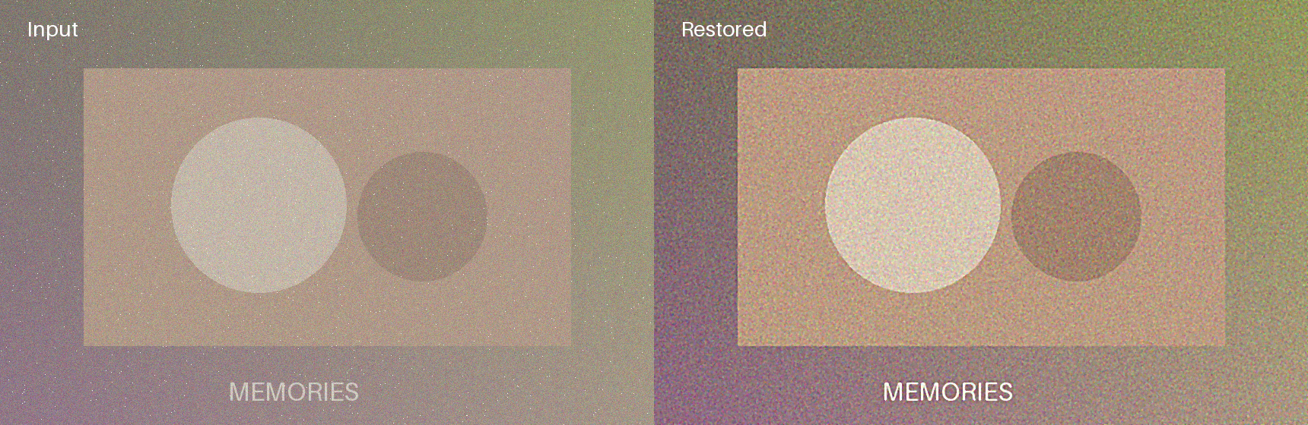
Figure 1. Synthetic faded input (left) and balanced restoration output (right).

Run Instructions
Install the packages in requirements.txt, then run: streamlit run app.py

