STEPS:

1. Register to the Azure account.
2. After Registering displays like this

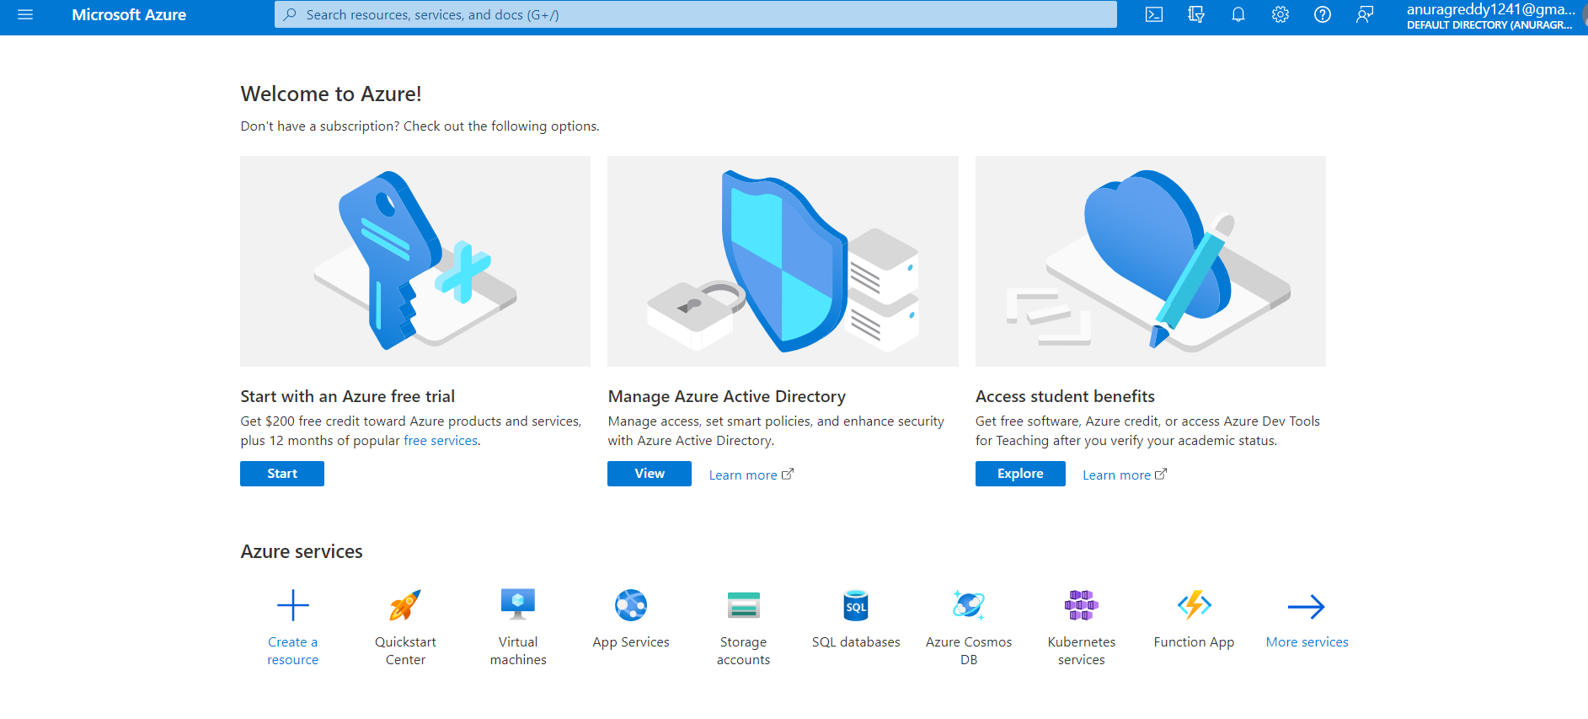

1. Click on “Create a resource”

Displays like this

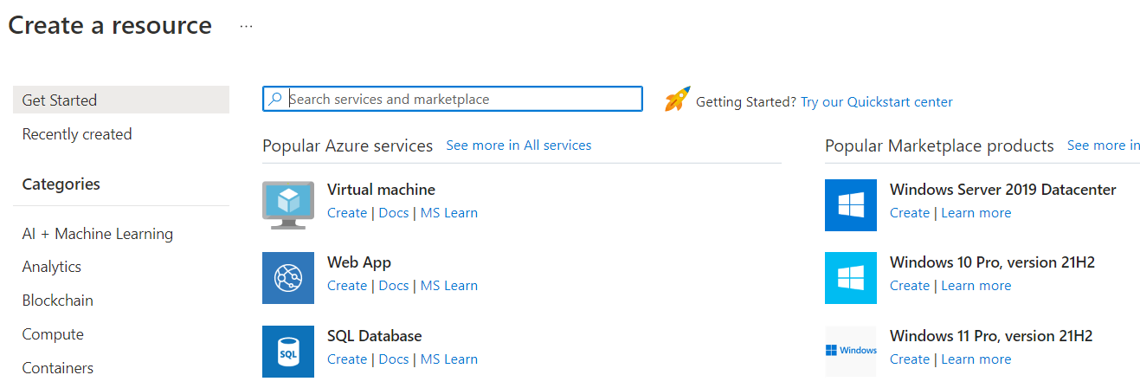

1. In search services and marketplace type “Resource group”

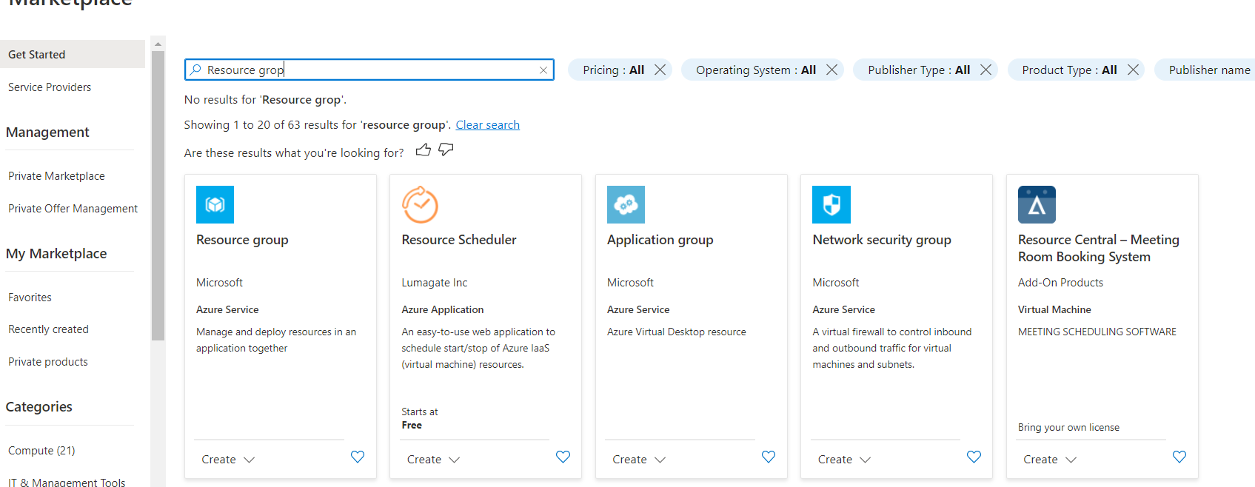

1. Click on “Resource group”.(displays this page)

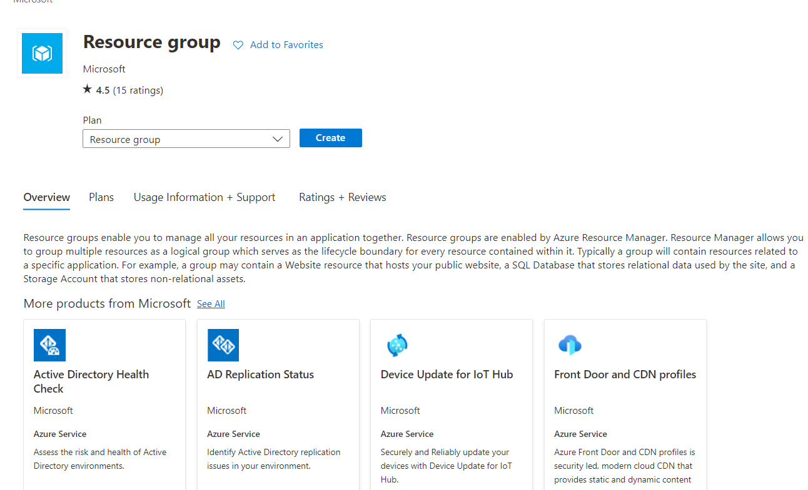

1. Click on **create**(displays this page)

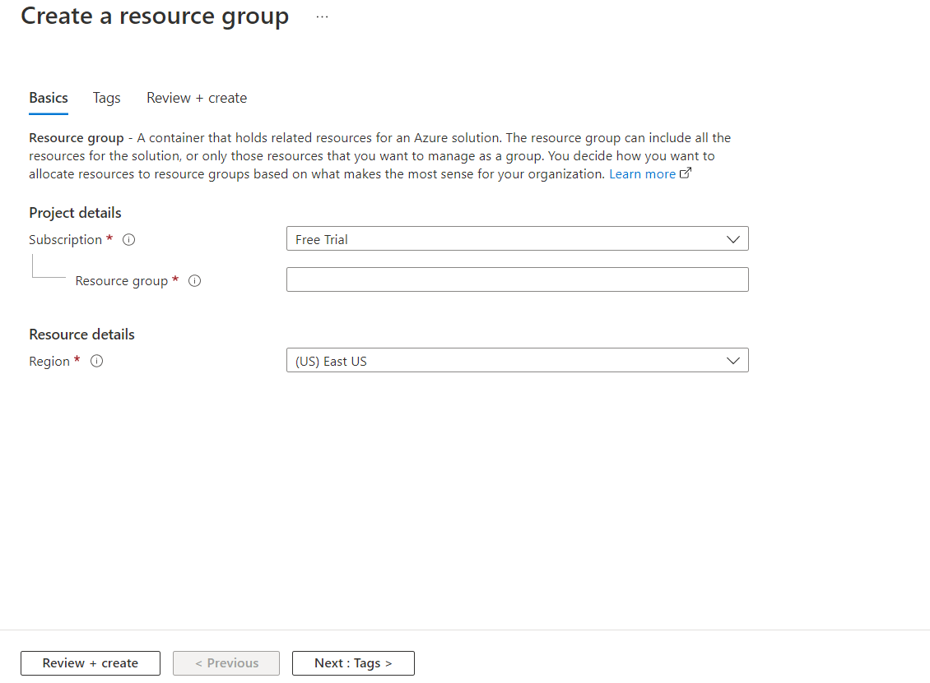

1. Give the Resource group name.

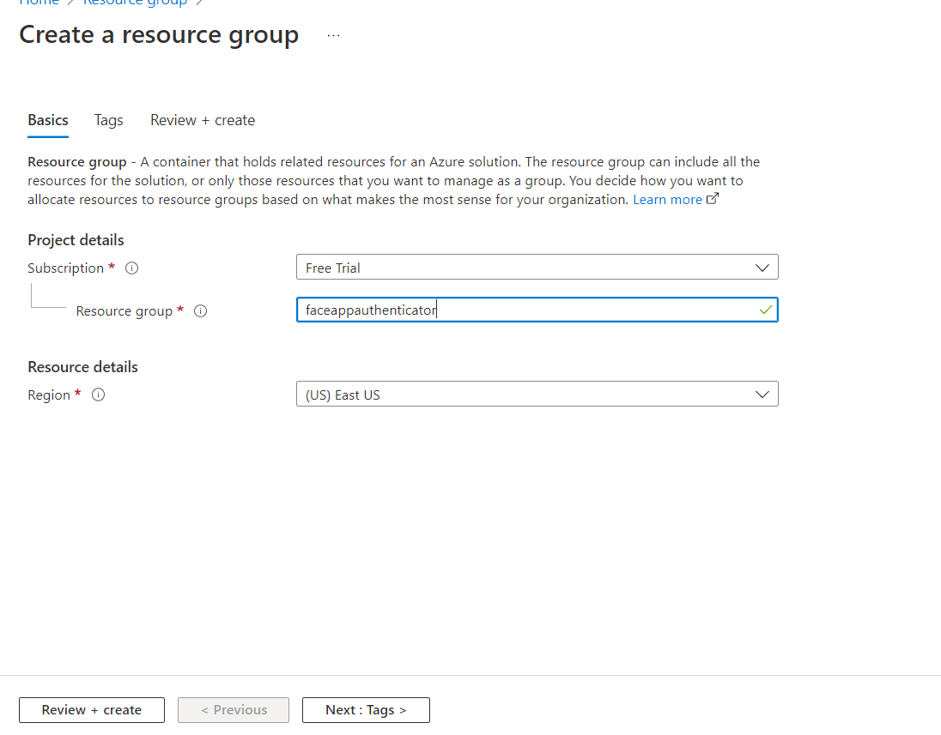

1. Click on Next:Tags>, again click on Next:Review+Create>
2. After Validation passed click on “Create”.

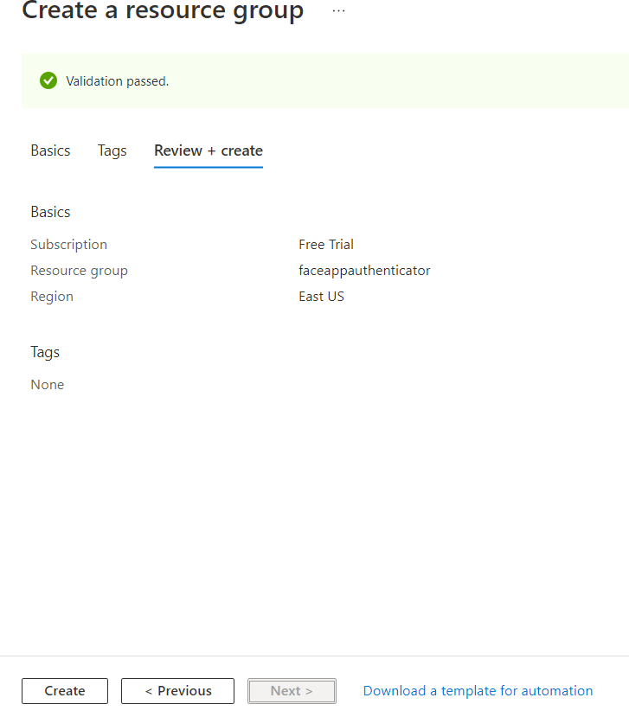

1. After we will get like this.

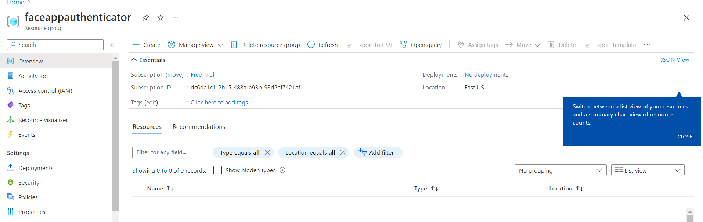

1. Create a Container Registry to build a docker.

To create.

1. Click on create

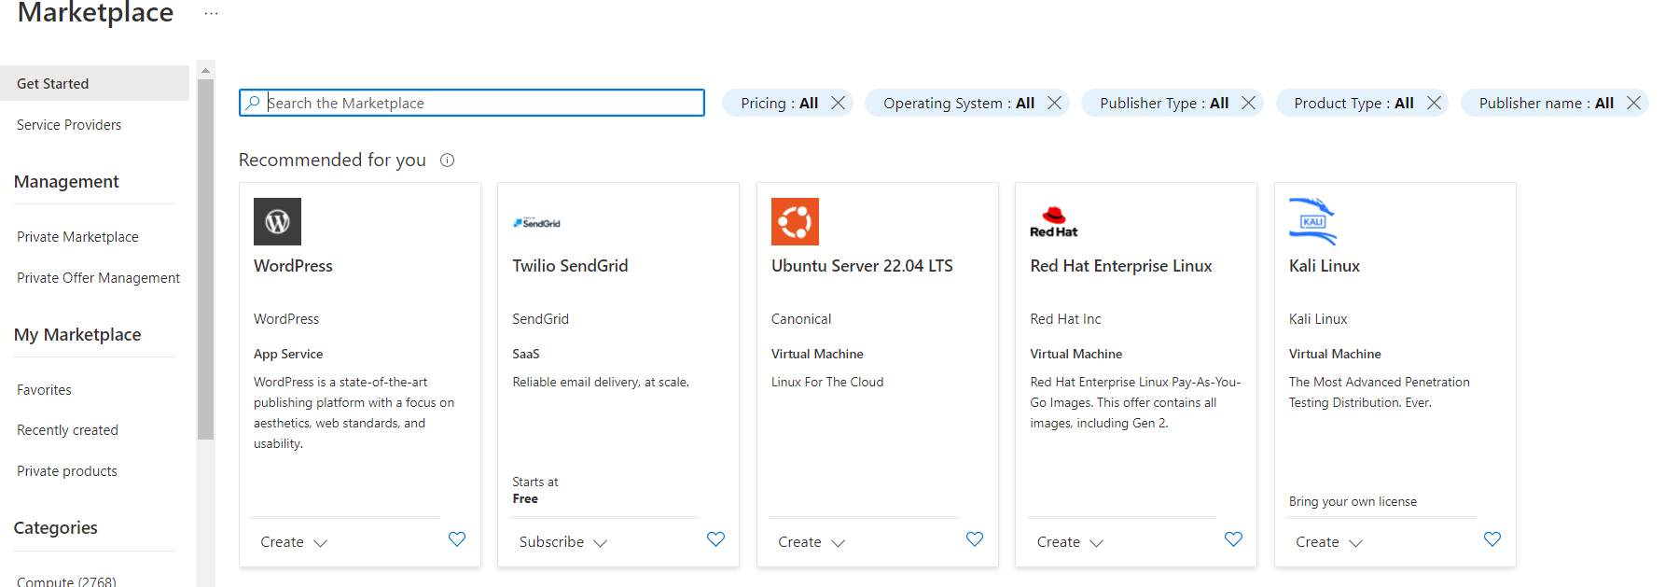

1. In search Marketplace search for “Container registry”.

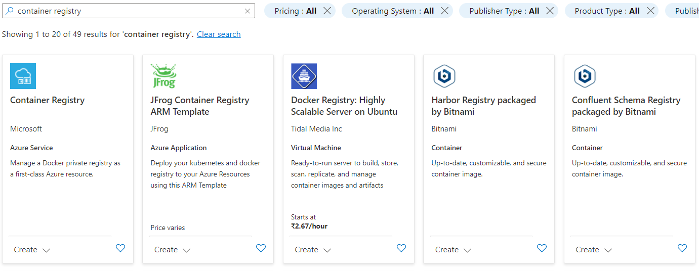

1. Click on “Container Registry”.(After clicking displays like this)

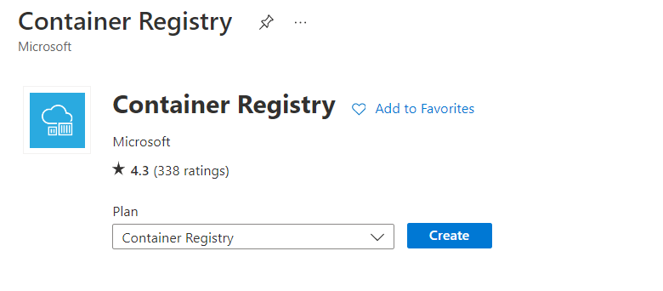

1. Click on Create.(After click on create displays like this)

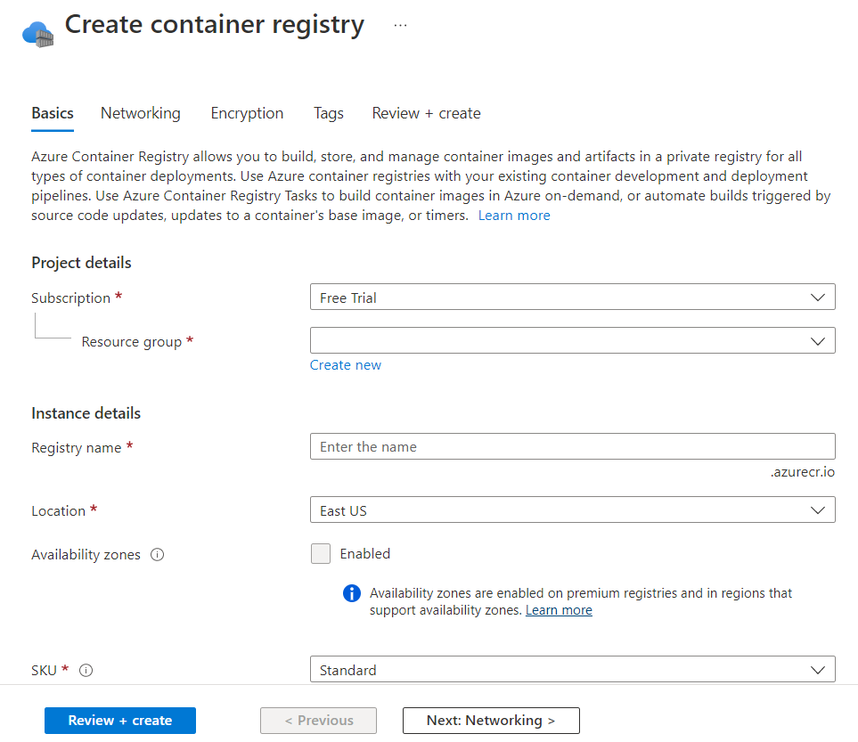

1. Fill the resource group and registry name

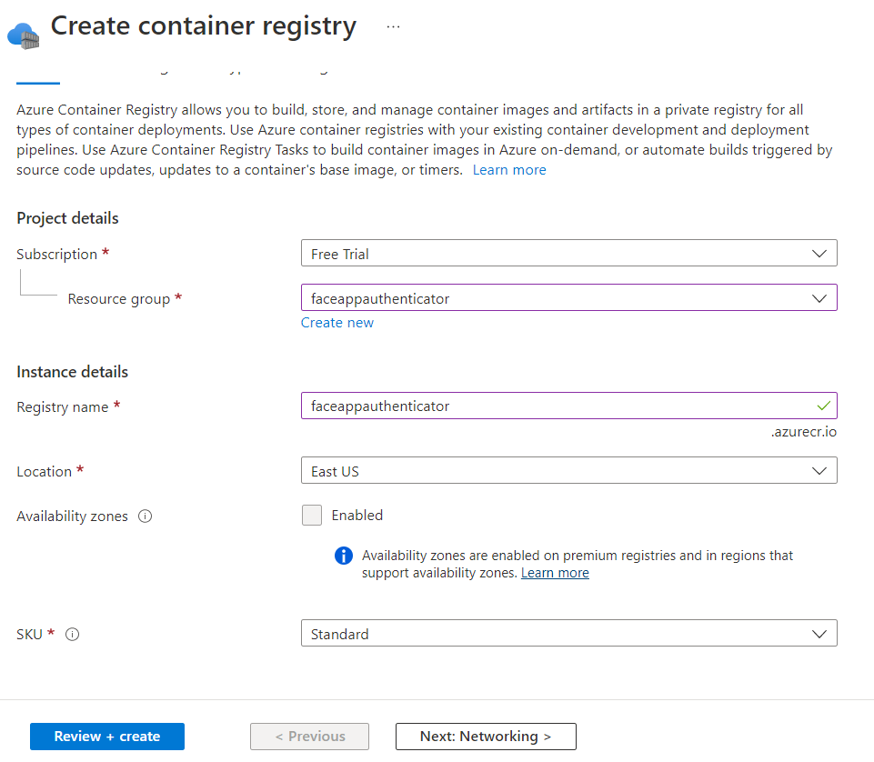

1. Click on Next:Networking, again click on Next:Encryption, again click on Next:Tags, again click on Next:Review+Create>>

(Finally displays like this)

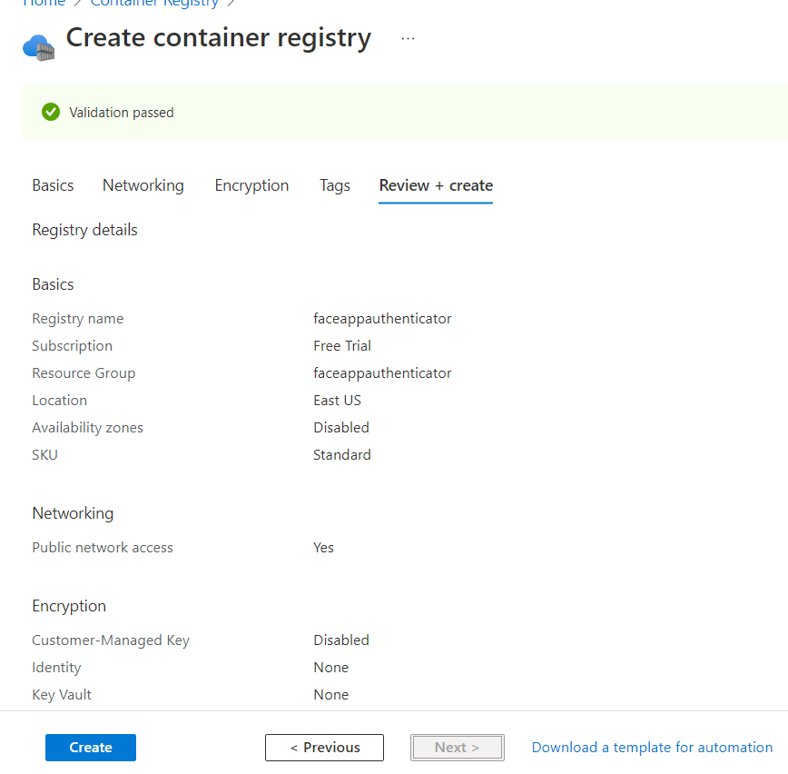

1. Finally click on “Create”

(finally after clicking on create it will displays like this)

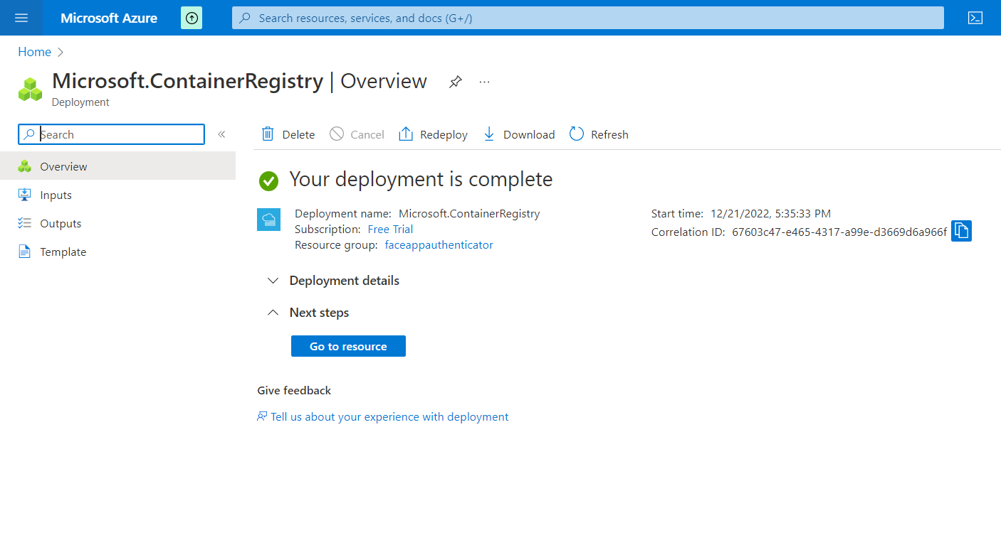

1. Since we are registering in to private registry we need username and password.

To get username and password, perform below steps.

1. Intially go to created container registry.
2. In settings click on Access keys.

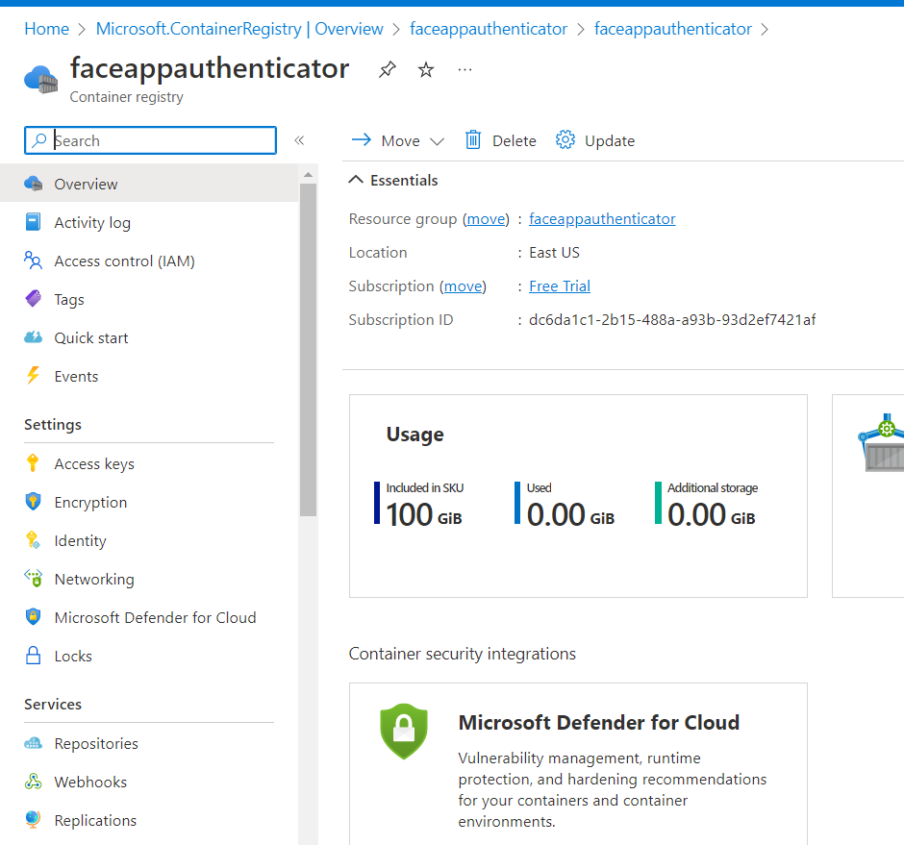

1. After clicking on Access keys,

c.1) Enable the Admin user.

c.2) copy the username, password’s, Login server, Registry name, then paste some where.(this will be used in future purpose)

13. How to build the application.

Just click on Quickstart

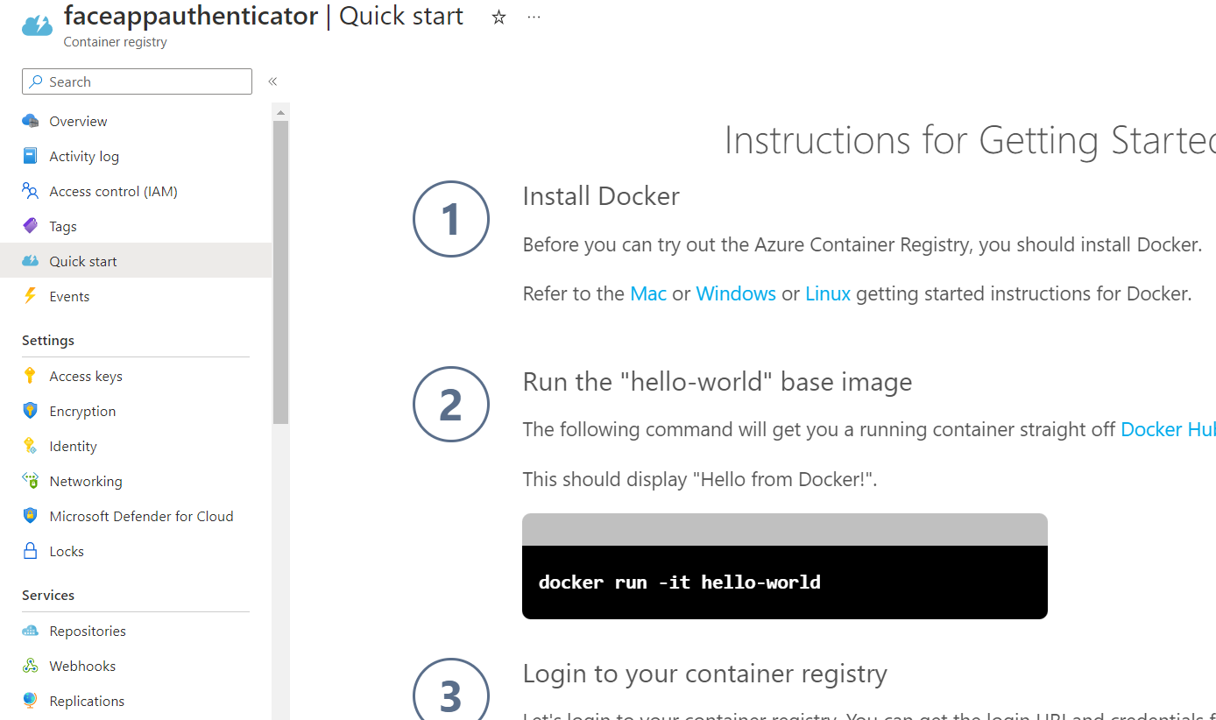

By seeing QuickStart just type below commands.

1. docker login faceappauthenticator.azurecr.io

* Then give the username and password(These 2 will get from 12.c point above we saved)
* After giving username and password we should get Login Succeedd.

1. docker build -t faceappauthenticator .
2. docker tag faceappauthenticator faceappauthenticator.azurecr.io/ faceappauthenticator

(NOTE:HERE REPLACE THE hello-world WITH faceappauthenticator

1. docker push faceappauthenticator.azurecr.io/ faceappauthenticator
2. After executing above command the docker is pushed to registry

How to check?

->In services =>Go to Repositories=>now we can see the created app click on this then we can see the latest image tag.

14. Now we will create a “New resource”.

a. In search type Web App then we can see like this,

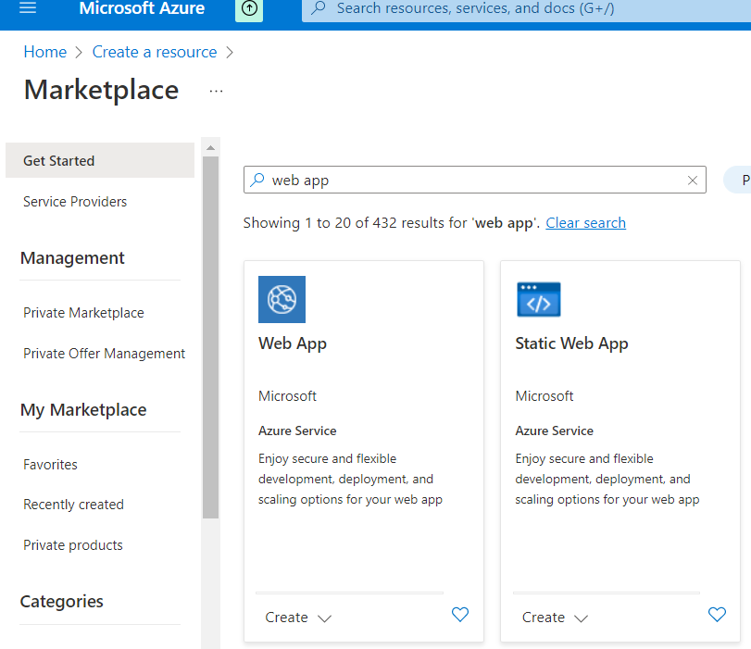

b. click on Web App

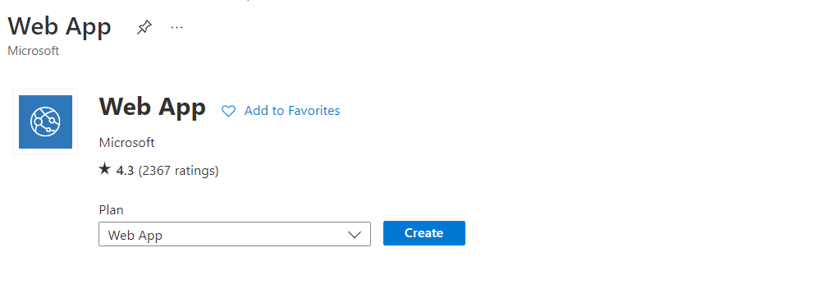

c.click on create

d. Give the Reource group, Give Name, click on Docker Container,

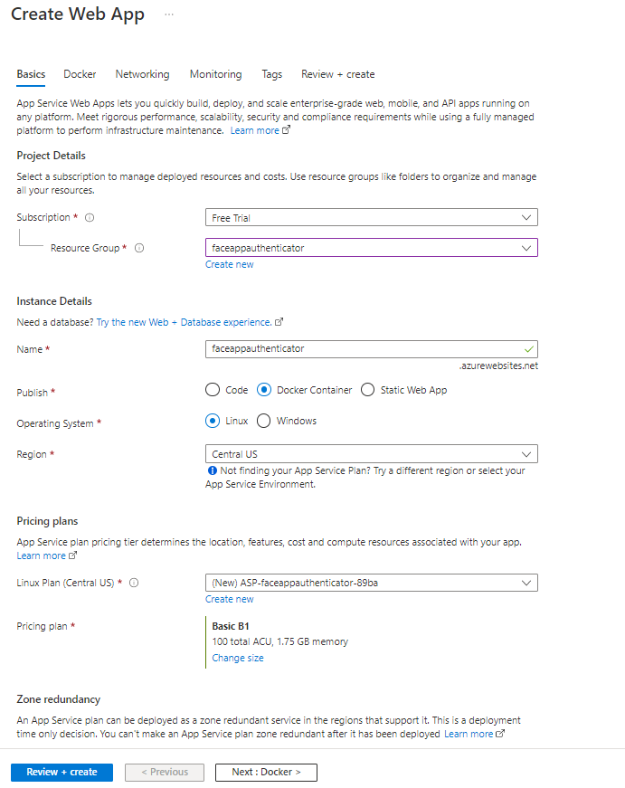

1. then click on Next:Docker.
2. Options=>Single container only,, here we will get image name automatically after pushing the docker image to container registry

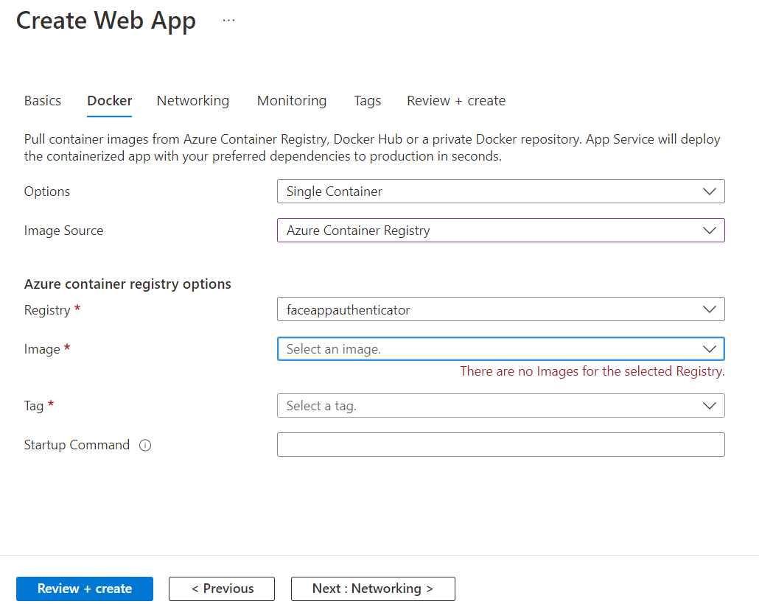

1. Click on Next:Networking,,, click on Next:Monitoring,,, click on Next:Tags,,, click on Next:Review+Create,,,
2. At last click on Create

15. Click on GoToResource.

16. Now we need to change some configurations.

How to change perform below steps?

1. In settings=> Go to Configuration.
2. In Configuration click New application Settings.

=>application settings are nothing but environment variables.

Give below environment variables.

1. WEBSITES_PORT::8000 click on ok.
2. WEBSITES_CONTAINER_START_TIME_LIMIT::30
3. SECRET_KEY = "KlgH6AzYDeZeGwD288to79I3vTHT8wp7"
4. ALGORITHM = HS256
5. DATABASE_NAME = "UserDatabase"
6. USER_COLLECTION_NAME = "User"
7. EMBEDDING_COLLECTION_NAME = "Embedding"
8. MONGODB_URL_KEY = “HERE GIVE THE MONGODB CLOUD URL”
9. Click on save and continue

17. To see our webapp Goto

->Overview=>click on Restart=>then copy the URL and paste it in chrome then we can see our application.

18. How to delete the Resource group.

Click on Home=> Go to Resource Groups or search Resource Groups=>Go to created Resource Group=>Then click on “Delete resource group”.