QA TEST REPORT
Product Team Hub
Web Application Quality Assurance Review

CONFIDENTIAL — FOR INTERNAL USE ONLY
Application URL: https://cohort-frontend-tacj.onrender.com
Credentials Tested: admin@accredian.com / admin123
This comprehensive QA report outlines the findings from a manual exploration of the application portal. The application was tested for functionality, user interface consistency, and responsiveness.

Review Summary
The app has a clear structure and a modern UI, and the general dashboard concept comes through well. but is not production-ready in its current state.
The two most critical issues are the broken global search which returns no results on any page and the complete lack of login separation between the Admin and User portals, which constitutes a privilege escalation vulnerability. These must be fixed before anything else.
Beyond that, directly navigating to /admin/All Cohorts or /admin/Staff Management via URL unexpectedly logs the admin out, mobile responsiveness is severely broken with the sidebar taking over the screen, and a raw JSON error is being exposed directly in the asset viewer instead of a clean message.
UI-side, the collection card thumbnails are broken, asset card buttons are visually too heavy, and the All-Cohorts table lacks any visual separation between batch rows making it hard to scan.
Bottom line: Prioritise the auth vulnerability and search fix immediately. Session, mobile, and UI issues to follow in the next cycle.

2. Bug Tracker

🔴 Critical Issues
- Search Functionality is Broken - Issue: The global search bar in the header fails to show any results across all listing pages (Cohorts, Instructors, Programs).
- No Login separation between the admin and the user portal- There is no role-based separation enforced between the Admin Portal and the User Portal login flows. This has resulted in two distinct but related issues.
The first issue is that a standard user is able to successfully log into the Admin Portal by clicking the admin login button and entering their regular user credentials. The system does not reject them despite them not holding an admin role. The second and more serious issue is that when admin credentials are entered through the User Portal login flow, the system grants full administrative access, meaning a user who knows admin credentials can bypass the intended admin login route entirely and gain elevated privileges through what should be a restricted, lower-access entry point.
Impact: The impact is significant. This is not just a UX confusion issue - it constitutes a privilege escalation vulnerability. Any person with knowledge of admin credentials can gain full administrative access without ever using the Admin Portal. This must be resolved before any production release.

🟠 Major Issues
- Session Instability / Auto-Logout - Issue: Navigating directly to /admin/All Cohorts or /admin/Staff Management via the URL bar immediately logs the admin out and drops them back to the login screen. All other dashboard routes work fine when accessed the same way, so this is isolated to these two paths.
The auth or route guard logic on these two routes is likely failing silently and defaulting to a logout instead of serving the page. The fix is to audit their route guard implementation, align it with the working routes, and ensure failed checks redirect to login with the destination saved — rather than killing the session entirely.

- Mobile Responsiveness is Severely Compromised - Issue:
The sidebar does not automatically collapse into a hamburger menu. Instead, it forcefully occupies over 50% of the screen width, completely squishing the main dashboard content.
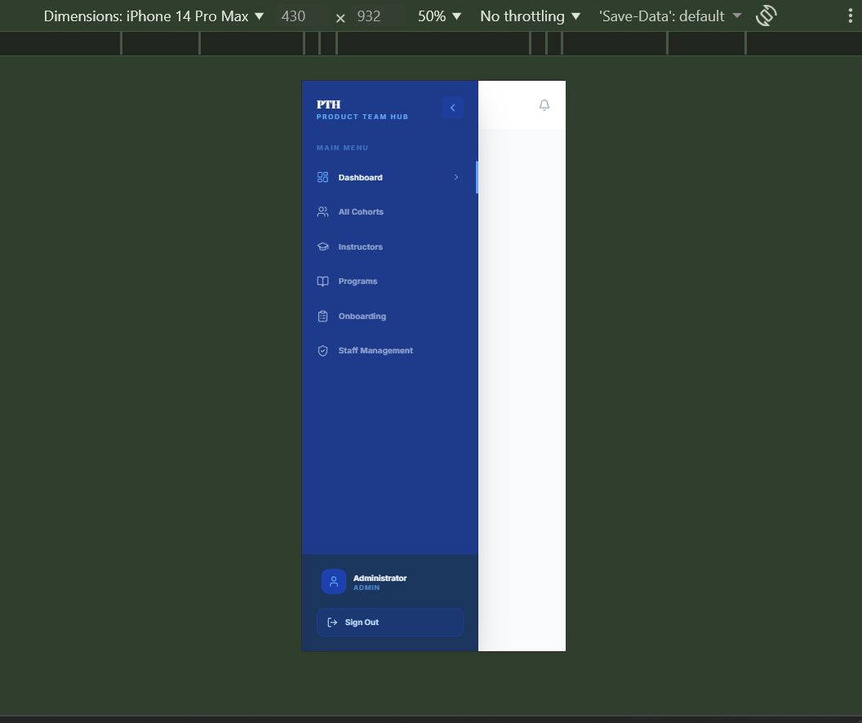

And once the sidebar is manually closed, there’s no option to open it again as seen below:
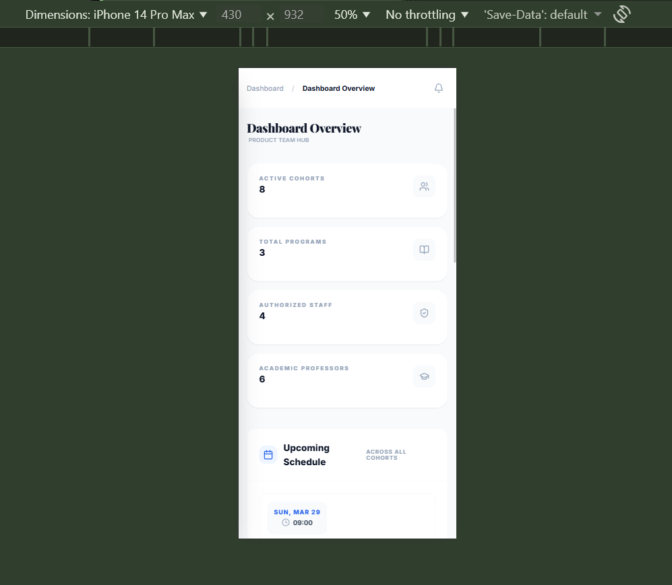

🟡 Minor UI/UX Issues
Global Placeholder Typo - Issue: The search bar displays “Search batches…” globally. This is confusing when a user is on the “Instructors” or “Programs” page where they are clearly not searching for “batches”.
Recommendation: Change this to dynamically reflect the current page context (e.g., “Search instructors…”).

- Slow Loading Times Across All Sections: Most of the sections of the application takes noticeably longer than expected to load. Whether navigating between pages or waiting for data to appear, there is a consistent lag that makes the app feel sluggish throughout. This is likely a combination of the app not being fully optimized and the hosting platform taking time to spin up after periods of inactivity. Needs to be looked into before the app goes live to ensure a smoother experience for end users.

3. UI/UX Aesthetic Recommendations
1. Collection Cards: Broken Thumbnails & Typography Inconsistency
The collection cards have two visual issues that undermine the overall polish of the page.
(a)The card thumbnails are rendering as broken images — showing a generic file icon on a flat grey placeholder instead of a meaningful preview or intentional empty state. This looks unfinished and erodes trust in the interface, especially on a page that's likely a first touchpoint for users.
(b)The card titles are being truncated too aggressively - "CONTE..." and "SESSIO..." - giving users no way to identify what the collection actually is without clicking into it. Combined with the ALL CAPS label styling, the cards feel visually heavy and harder to scan than they should be.
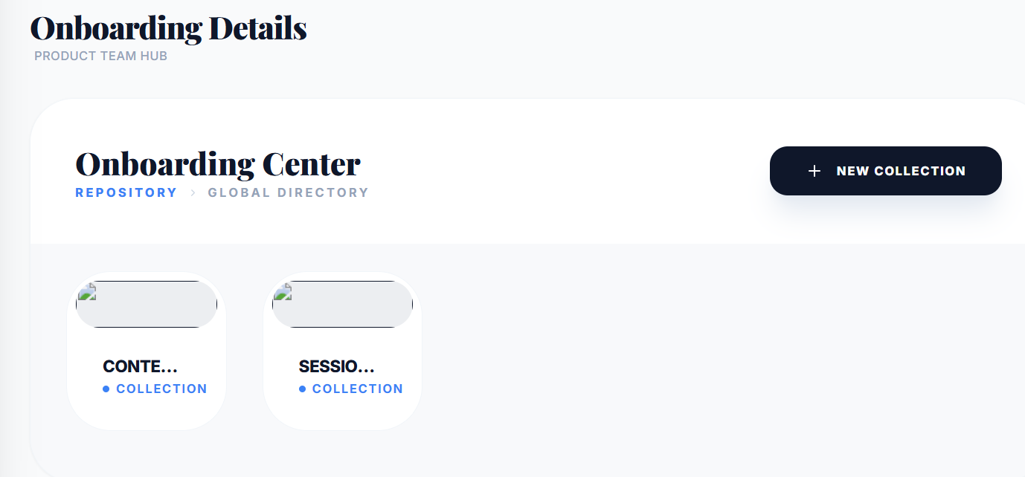

2.Asset Cards: Button Styling & Label Readability: The "INSPECT" and "VISIT" buttons are visually too heavy for the card size. The thick black pill buttons dominate the card and pull focus away from the asset itself — especially when every single card has one. A lighter button style (outlined or a softer fill) would feel more proportionate and less aggressive.
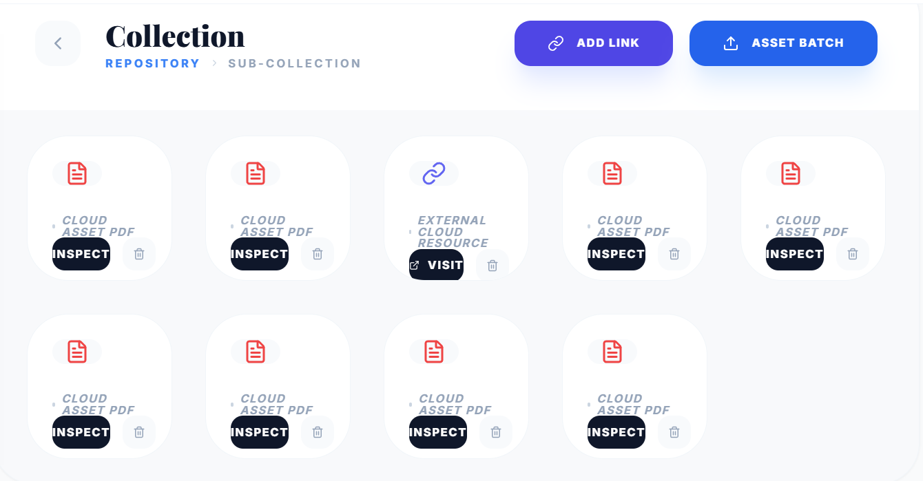
The delete icon (trash) sits right next to the action button with no visual separation. On a small card, this creates a mild but real risk of accidental deletion — worth adding a little breathing room or a subtle divider between the two.

- Raw JSON Error Exposed on Asset Inspect : When inspecting a local archive asset, the viewer displays a raw JSON error response directly on screen:
{"error":"File not found on disk. The file may have been uploaded on a different environment."}
The app is dumping a raw JSON error directly into the UI instead of handling it gracefully. Even after the storage issue is fixed in the backend, this error handling should be addressed. A user should never see a raw {"error":"..."} string, they should see a clean, human-readable message like "This file couldn't be loaded. Please contact your administrator."
Suggested fixes:
- Backend/DevOps: migrate file storage to a persistent, environment-agnostic solution so uploaded files are accessible regardless of which server instance is running.
- Frontend: add proper error handling on the asset viewer so API error responses are caught and displayed as a friendly message, never as raw JSON.
- All Cohorts Table: No Visual Separation Between Batch Rows: The table has no clear visual boundary between batches, causing the terms from one batch to bleed visually into the next. At a glance, it reads as one long continuous list, making it genuinely difficult to tell where "IITK AI FOR LEADERS Batch 3 (JAN)" ends and where "IITG AI For Leaders Batch 2(July)" begins. The "Not assigned" entries scattered across multiple rows with no grouping anchor make this worse.
