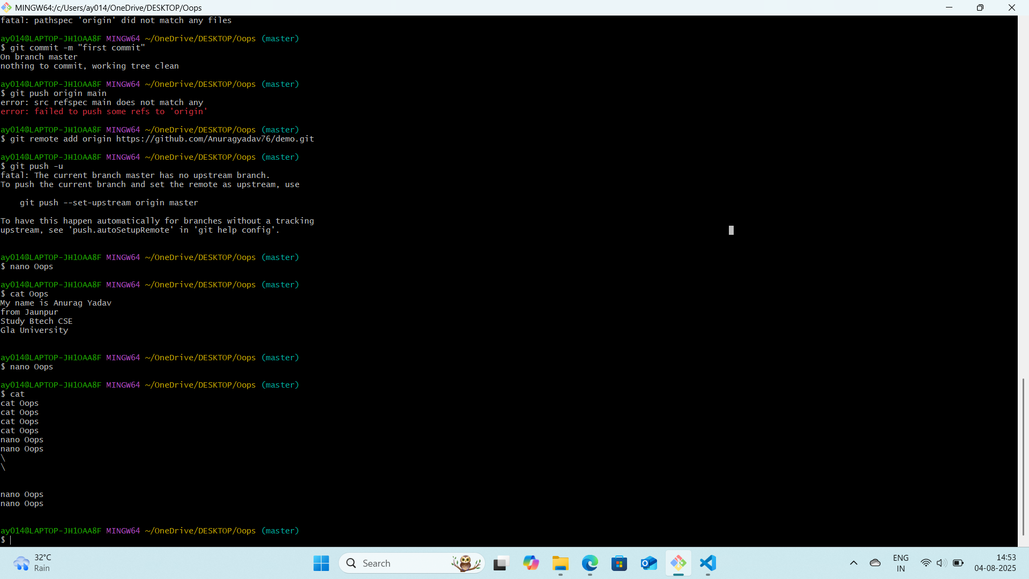

Ls command = List the contents of a directory
Cd command = Change the current working directory
Pwd = Prints the current working directory
Cat = Displays the content of a file

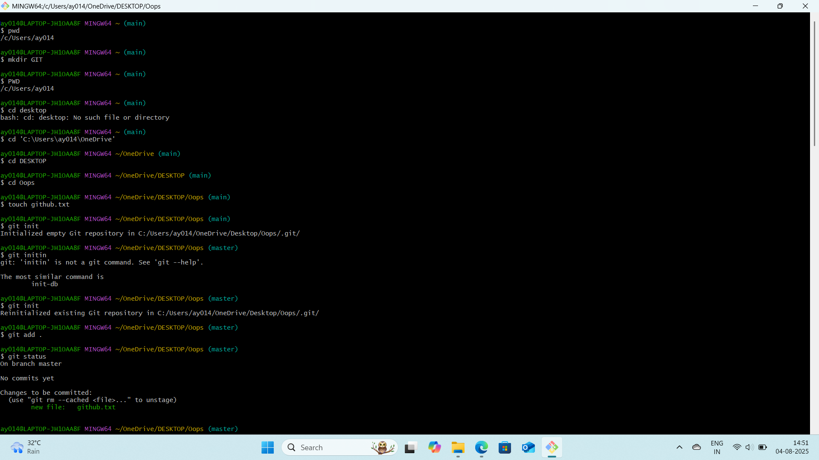

Init command = init is always assigned PID1, making it the root of the processes.

