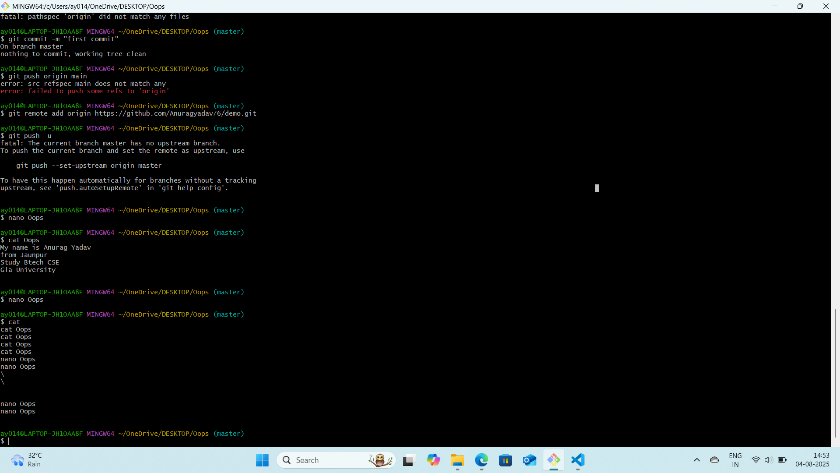

Ls command = List the contents of a directory

Cd command = Change the current working directory

Pwd = Prints the current working directory

Cat = Displays the content of a file

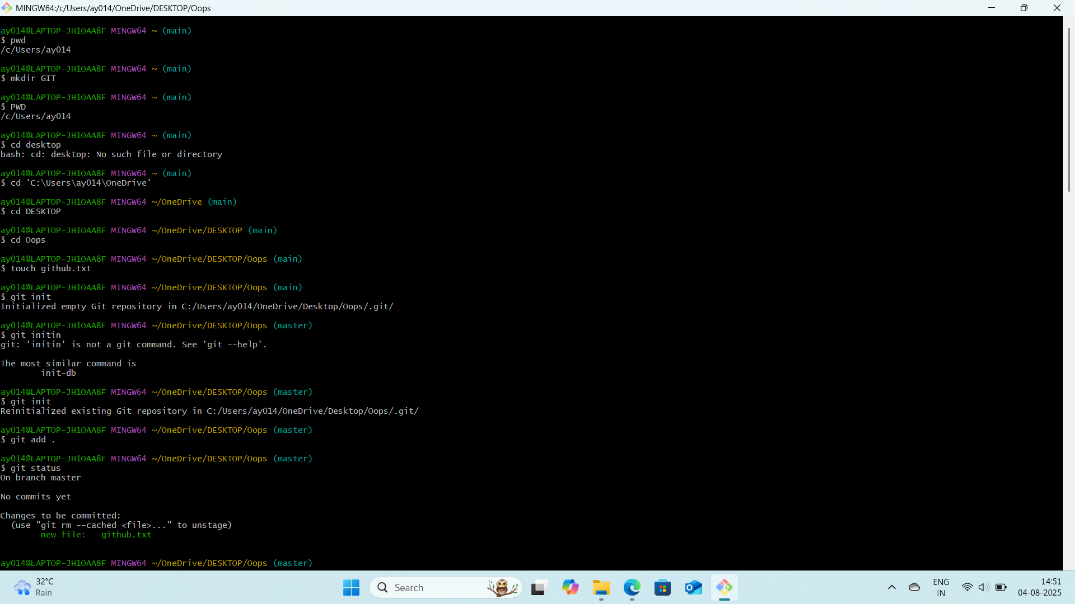

Init command = init is always assigned PID1, making it the root of the processes.