EXPERIMENT 1b

IMPLEMENTATION OF CRISP-DM USING CREDIT CARD FRAUD DETECTION DATASET

Aim
To implement the CRISP-DM (Cross Industry Standard Process for Data Mining) methodology by analyzing a credit card fraud detection dataset using Python and Pandas.

Algorithm

Step 1: Business Understanding
Define the objective of analyzing the credit card transaction dataset to identify fraudulent transactions and understand transaction patterns.

Step 2: Data Understanding
Import the dataset and examine its structure, column names, data types, and summary statistics.

Step 3: Data Preparation
Check for missing values and duplicate records. Prepare the transaction data for analysis by checking and converting relevant columns into appropriate data types.

Step 4: Modeling
Perform basic analysis to identify transaction patterns, calculate transaction statistics, and analyze the distribution of fraudulent and non-fraudulent transactions.

Step 5: Evaluation
Evaluate the results by comparing fraudulent and legitimate transactions and interpreting important transaction characteristics.

Step 6: Deployment
Present the analyzed results and insights for understanding credit card fraud patterns and supporting fraud detection decisions.
Program:
import pandas as pd
import numpy as np

data = pd.read_excel("C:/Users/palan/Downloads/credit_card_fraud.xlsx")

data.head()
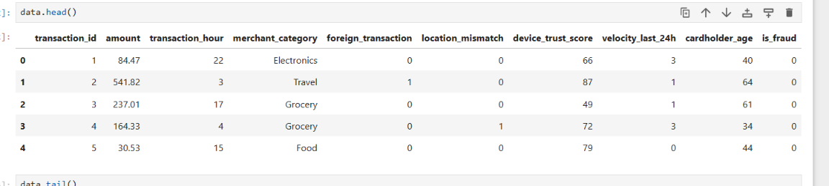
data.tail()
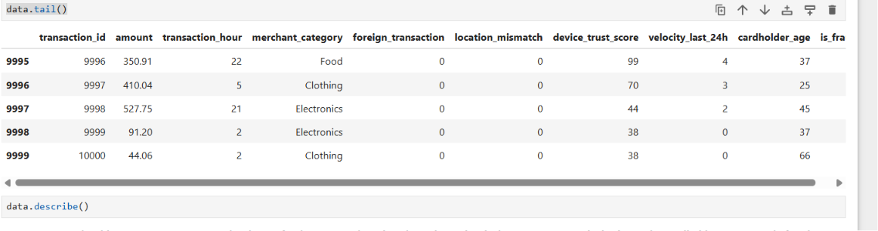
data.info()
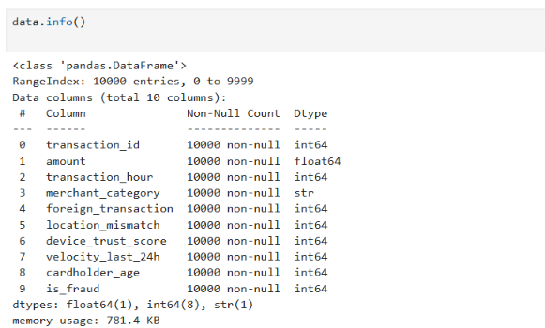

data.describe()
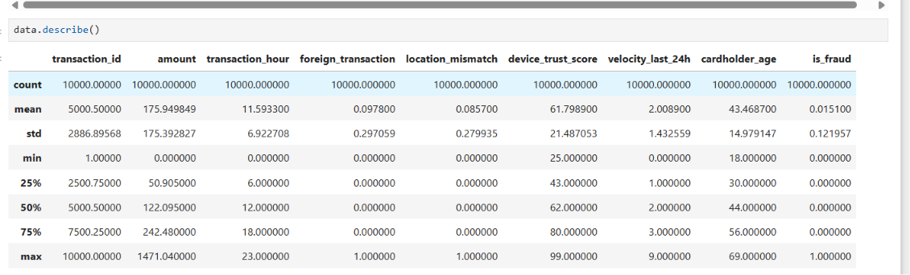

data.isnull().sum()
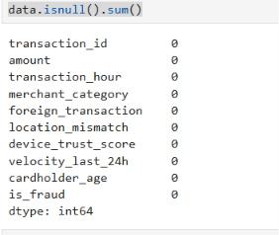
data.duplicated().sum()
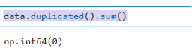
data['is_fraud'].value_counts()
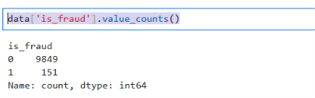

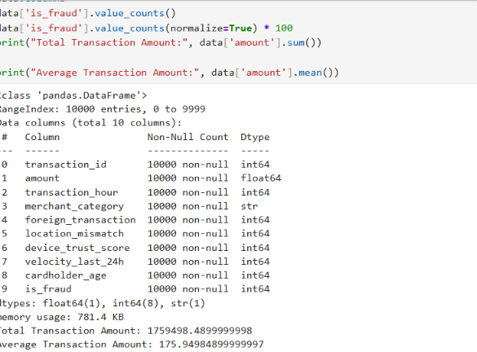

Result
Thus, the CRISP-DM methodology was successfully implemented on the Credit Card Fraud Detection dataset. The dataset was imported, understood, prepared, analyzed, evaluated, and the results were presented successfully using Python and Pandas. The analysis helped identify fraudulent and legitimate transactions and provided insights into transaction amounts, merchant categories, foreign transactions, location mismatches, device trust scores, and other factors associated with credit card fraud.

