**Observations :**

1) From the given JSON file (Coords.txt file), we have noticed that the coordinates of **Peripherals and Major roads** were missing.

Total no. of warehouses = 134

No. of warehouses in Peripherals = 92

No. of warehouses in Major roads = 28

No. of warehouses visible in website = 134 - (92 + 28)

= 134 - 120

= 12

Therefore, we have observed only 12 warehouses.

2)Mapping of the regions:

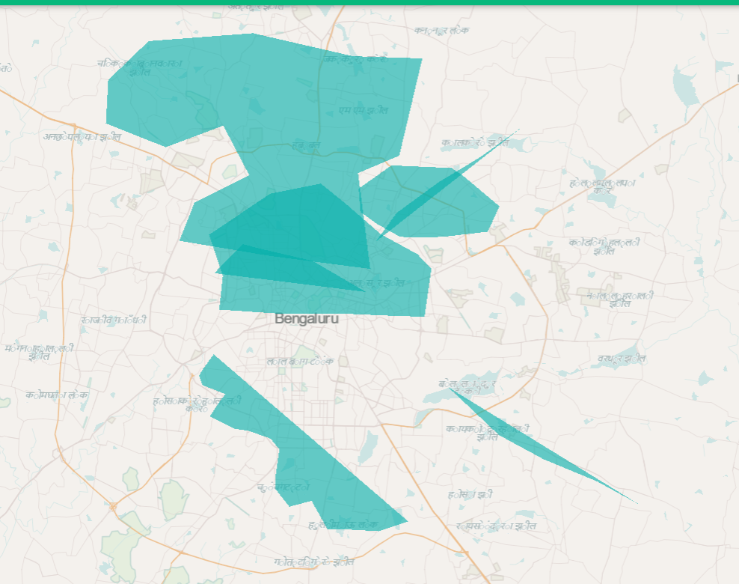

The **Southern and Western** region does not overlap with any other regions.

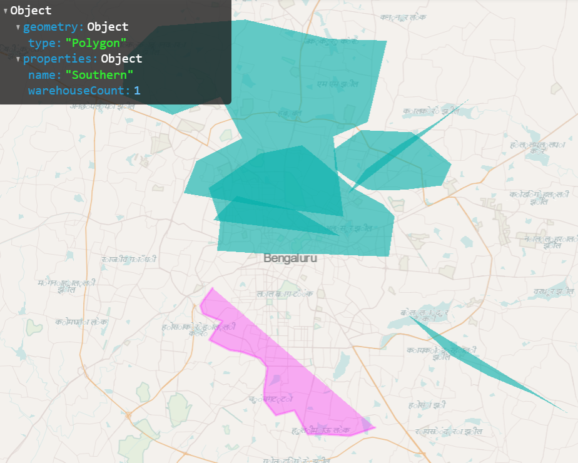

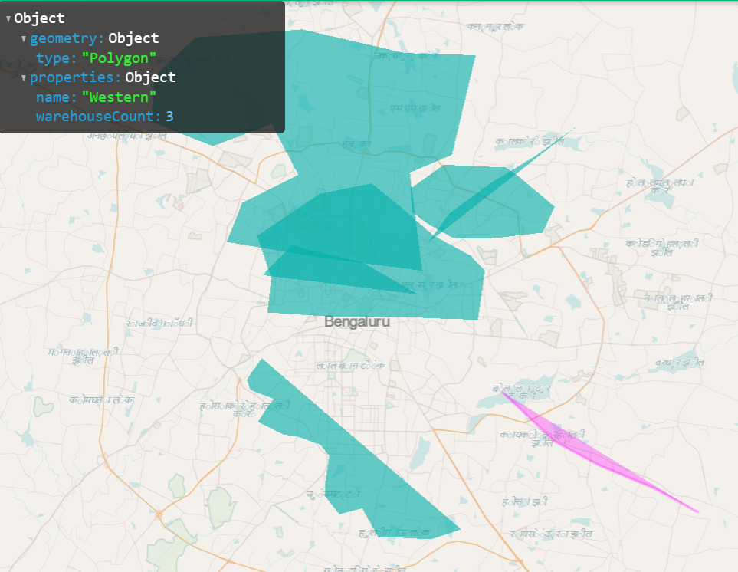

3) We have analysed that the North Eastern region and Eastern region were overlapped with each other.

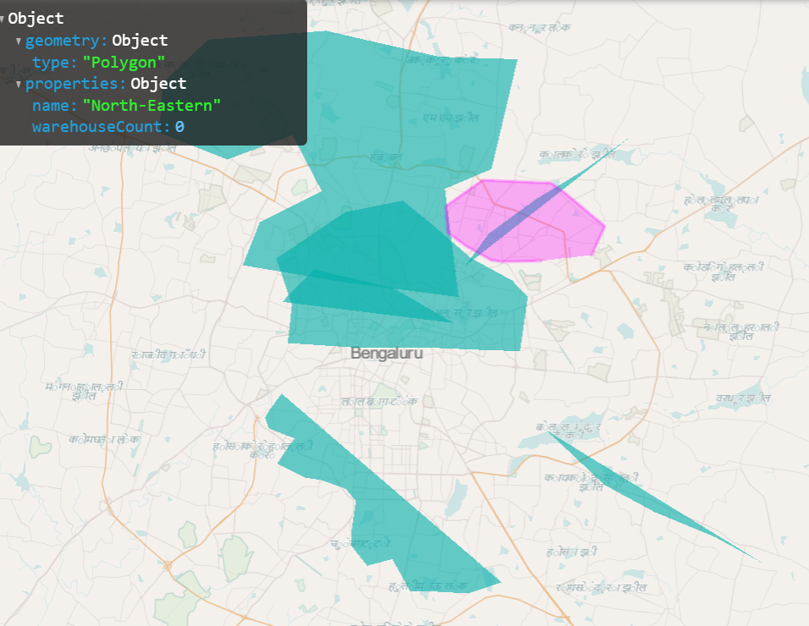

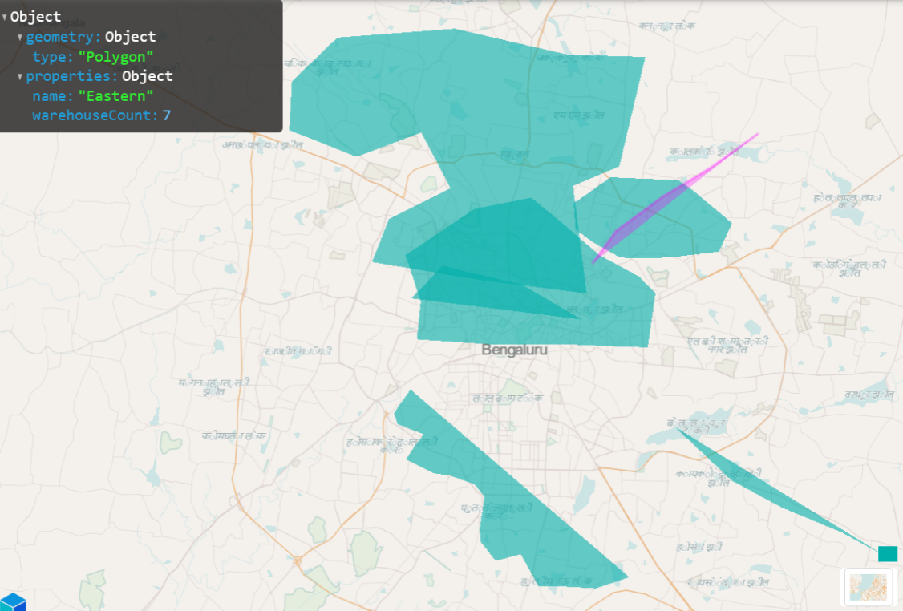

4) The regions Northern, Central and South Eastern overlapped each other whereas the South Eastern region was completely encapsulated into Central region.

