PROSPECT: probabilistic AI modeling of spatial and single-cell transcriptomics

Abstract

Single-cell RNA sequencing and spatial transcriptomics enable high-resolution characterization of cellular heterogeneity, yet many existing analysis pipelines rely on deterministic assumptions that obscure uncertainty and compromise statistical validity. Zero counts are often treated as true absence, cells are forced into discrete identities, batch effects are aggressively corrected, and differential expression analyses frequently ignore biological replication. We present PROSPECT (PRObabilistic Single-cell and Spatial Epistemic Context Toolkit), a probabilistic artificial intelligence framework for single-cell and spatial transcriptomics analysis that explicitly models uncertainty throughout the analytical workflow. PROSPECT treats transcript detection as a probabilistic process, represents cellular states as continuous latent distributions, models batch effects as latent variables rather than artifacts to remove, and incorporates spatial information as soft constraints. To ensure statistically valid inference, PROSPECT performs differential expression at the biological sample level and assigns interpretable confidence scores by integrating effect size, replication, multimodal consistency, and uncertainty estimates. PROSPECT provides a modular, conservative, and reproducible framework applicable across platforms and study designs.

Introduction
Single-cell RNA sequencing (scRNA-seq) and spatial transcriptomics have transformed our ability to profile cellular heterogeneity in complex tissues. These technologies have enabled the discovery of previously unrecognized cell populations, dynamic cellular states, and spatially organized tissue niches across development, homeostasis, and disease. Rapid advances in experimental throughput have been matched by an expanding ecosystem of computational pipelines designed to normalize data, remove technical variation, cluster cells, and identify differentially expressed genes. As a result, single-cell and spatial transcriptomic analyses have become routine components of modern biological studies.
Despite this progress, fundamental challenges remain unresolved. Both scRNA-seq and spatial transcriptomics rely on sparse, noisy measurements in which only a small fraction of the transcripts present in each cell are captured. Consequently, observed zero counts may reflect true biological absence or technical failure of detection, yet are typically treated deterministically during downstream analysis. Standard pipelines often assume that cell identities are discrete, that technical batch effects can be fully removed without affecting biological signal, and that individual cells can be treated as statistically independent observations. These assumptions, while computationally convenient, are frequently violated in practice and can lead to overconfident biological conclusions.
A growing body of evidence suggests that many irreproducible findings in single-cell studies arise not from experimental error, but from implicit overinterpretation of uncertain data. Hard clustering algorithms impose sharp boundaries on inherently continuous cellular processes such as differentiation, activation, or stress responses. Aggressive batch correction methods may erase true biological differences when technical and biological variation are confounded. Differential expression analyses performed at the cell level often ignore sample-to-sample variability, inflating statistical significance through pseudoreplication. In spatial transcriptomics, measured expression profiles frequently represent mixtures of multiple cells, yet are commonly interpreted as if they correspond to single-cell measurements, further compounding uncertainty.
Recent advances in deep learning and probabilistic modeling have improved representation learning, scalability, and multimodal data integration for single-cell analyses. However, most existing methods remain focused on producing definitive outputs—cell clusters, trajectories, or spatial assignments—rather than explicitly quantifying uncertainty. As a result, deep learning models may generate visually compelling embeddings while obscuring ambiguity arising from sparse measurements, incomplete sampling, and model assumptions. Importantly, no computational method can recover information that was not measured experimentally, highlighting the need for analytical frameworks that acknowledge intrinsic limitations rather than masking them.
Here, we introduce an uncertainty-aware probabilistic framework for the analysis of scRNA-seq and spatial transcriptomics data. Rather than attempting to resolve all sources of ambiguity, our approach explicitly models detection uncertainty, represents cell identity as a continuous probability distribution, and treats technical batch effects as latent variables rather than nuisances to be removed. We further incorporate spatial information as a set of biological constraints, avoiding overconfident deconvolution in regions where multiple cellular configurations are equally plausible. Finally, we perform differential analyses at the sample level using hierarchical statistical models, reducing false discoveries driven by cell-level pseudoreplication.
By reframing single-cell and spatial transcriptomic analysis as a problem of probabilistic inference rather than deterministic classification, our framework emphasizes conservative interpretation and reproducibility over maximal resolution. We demonstrate that this approach reduces overconfident claims, improves stability across datasets, and provides biologically meaningful confidence estimates for inferred cell states and gene expression changes. We anticipate that explicitly modeling uncertainty will become increasingly important as single-cell datasets grow in scale and complexity, and we provide a general framework to support this transition.

An uncertainty-aware framework models transcript detection rather than expression absence
We first sought to explicitly model the uncertainty inherent in sparse single-cell transcriptomic measurements. In standard scRNA-seq workflows, observed zero counts are typically interpreted as absence of expression after normalization and thresholding. However, given low capture efficiency and stochastic transcript sampling, zero counts may instead reflect failed detection events.
To address this ambiguity, we modeled transcript detection as a probabilistic process, estimating gene- and cell-specific detection probabilities rather than imputing missing values. Using simulated datasets with known detection efficiencies, our framework correctly distinguished between low-confidence non-detection and high-confidence absence, whereas conventional pipelines treated both cases identically. When applied to multiple publicly available scRNA-seq datasets, we observed substantial heterogeneity in detection uncertainty across genes and cells, even within nominally homogeneous populations.
Importantly, rather than increasing apparent expression resolution through imputation, our approach preserved uncertainty throughout downstream analyses. Genes with similar observed count distributions but different detection confidence were clearly separated, highlighting cases in which deterministic interpretation would overstate biological conclusions.

Cell identity is better represented as a continuous probability distribution than discrete clusters
We next examined how uncertainty-aware representations affect cell identity inference. Most existing pipelines assign each cell to a single discrete cluster, implicitly assuming well-separated cell types. In contrast, many biological processes—such as differentiation, activation, and stress responses—are continuous.
Using a probabilistic latent variable model, we represented each cell as a distribution in latent space and inferred soft assignments to multiple cellular programs. Across developmental and immune datasets, we observed that many cells exhibited mixed identity profiles, with substantial probability mass distributed across related states. These continuous representations were stable across model initializations and did not depend on arbitrary clustering resolution parameters.
By comparison, conventional graph-based clustering fragmented continuous trajectories into multiple discrete clusters, with cluster boundaries that varied substantially with parameter choice. Our results indicate that representing cell identity probabilistically provides a more faithful description of underlying biological continua while avoiding artificial discretization.

Modeling batch effects as latent variables prevents overcorrection and biological signal loss
Batch effects remain a major challenge in single-cell analysis, particularly when technical and biological variation are partially confounded. Rather than removing batch effects through alignment, we modeled batch as an explicit latent variable jointly inferred with biological structure.
Across multi-batch datasets, this approach preserved biological differences that were suppressed by aggressive batch correction methods. In disease–control comparisons, standard integration pipelines often collapsed condition-specific transcriptional programs, whereas our framework retained these differences while still accounting for technical variation. Notably, in cases where batch and biology were inseparable, the model reflected this ambiguity by increasing uncertainty rather than forcing alignment.
These results demonstrate that treating batch effects as latent sources of variation—rather than nuisances to be eliminated—reduces the risk of erasing genuine biological signals.

Sample-aware differential expression reduces false discoveries caused by pseudoreplication
Differential expression analysis in scRNA-seq is frequently performed at the cell level, implicitly treating cells as independent observations. This assumption is violated when multiple cells originate from the same biological sample, leading to inflated significance through pseudoreplication.
We addressed this issue using a hierarchical, sample-aware framework that aggregates information at the sample level before statistical testing. When applied to benchmark datasets, cell-level analyses produced large numbers of nominally significant genes with small effect sizes. In contrast, sample-aware analysis yielded fewer differentially expressed genes, but with larger and more reproducible effect sizes.
Genes identified by the sample-aware approach showed stronger concordance with independent bulk RNA-seq data and known biological markers. These results suggest that accounting for sample structure substantially improves the reliability of differential expression findings in single-cell studies.

Spatial transcriptomics benefits from constraint-based integration rather than deterministic deconvolution
Spatial transcriptomics data often capture transcripts from multiple cells within each spatial unit, yet many analysis pipelines attempt to assign a single cell type composition per location. We instead integrated spatial information as a set of biological constraints on possible cellular configurations.
Applying this framework to spatial transcriptomics datasets, we found that multiple cell-type mixtures could often explain the observed expression equally well. Rather than selecting a single “best” solution, our approach retained these alternatives and quantified uncertainty in spatial assignments. Regions with strong spatial coherence exhibited high-confidence identity constraints, while boundary regions and low-coverage areas showed increased ambiguity.
This constraint-based strategy avoided overconfident spatial interpretations and more accurately reflected the limited resolution of current spatial transcriptomics technologies.

The framework reduces overconfident conclusions while improving reproducibility
Across all analyses, a consistent pattern emerged: explicitly modeling uncertainty led to more conservative but more reproducible biological inferences. Compared with conventional pipelines, our framework produced fewer discrete claims, but those claims were more stable across datasets, parameter settings, and experimental replicates.
Rather than maximizing apparent resolution, the method emphasizes confidence estimation and transparent reporting of ambiguity. This shift reduced false discoveries in differential expression, prevented artificial fragmentation of continuous cell states, and avoided overinterpretation of spatial mixtures.

Methods

Overview of the analytical framework
We developed an uncertainty-aware probabilistic framework for the analysis of single-cell RNA sequencing (scRNA-seq) and spatial transcriptomics data. The framework is designed to propagate measurement uncertainty throughout all stages of analysis, from transcript detection to cell identity inference, batch handling, spatial integration, and differential expression testing. Rather than producing deterministic outputs, the framework represents key biological quantities as probability distributions and explicitly reports uncertainty when data are insufficient to support confident inference.
All analyses were performed using Python (v3.10). Model training and inference were implemented using PyTorch, with supporting preprocessing and visualization performed using standard single-cell analysis libraries. Unless otherwise stated, default parameters were used across datasets to minimize dataset-specific tuning.

Data preprocessing and quality control
Raw count matrices were used as input. Cells with fewer than 200 detected genes or with mitochondrial transcript proportions exceeding 20% were excluded. Genes detected in fewer than three cells were removed. No additional normalization, log-transformation, or variance-based gene filtering was applied prior to probabilistic modeling, as these steps impose deterministic assumptions about expression magnitude and detection.
Quality control thresholds were selected conservatively to remove low-quality cells while avoiding aggressive filtering that could bias cell population composition.

Probabilistic modeling of transcript detection
Observed transcript counts were modeled as the result of a two-stage process: (i) true transcript presence and (ii) stochastic detection. Rather than assuming that zero counts represent absence of expression, we explicitly modeled gene detection as a Bernoulli process with gene-specific detection probabilities.
Detection probabilities were learned jointly with downstream latent representations, allowing the model to distinguish low-confidence non-detection from high-confidence absence. No imputation of missing values was performed. Instead, uncertainty associated with detection was propagated to all downstream analyses.
This approach avoids artificially inflating expression signal and prevents downstream methods from treating uncertain measurements as definitive.

Latent variable model for continuous cell states
Cellular transcriptional states were represented using a probabilistic latent variable model. Each cell was encoded as a multivariate Gaussian distribution in latent space, parameterized by a mean vector and covariance inferred by a variational encoder network. Latent variables were inferred using variational inference with a standard normal prior.
Unlike graph-based clustering approaches, no hard cluster assignments were imposed. Instead, each cell’s position in latent space represented a continuous transcriptional state, allowing smooth transitions between related cellular programs. Soft identity scores were derived by projecting latent representations onto a learned set of reference programs, yielding probability distributions rather than discrete labels.
Model dimensionality was fixed across datasets to ensure comparability.

Batch effects modeled as latent sources of variation
Technical batch effects were incorporated as explicit latent variables rather than removed through alignment. Batch identifiers were embedded in latent space and jointly inferred with biological latent variables. This allowed the model to represent batch-associated variation without forcing cells from different batches into a common manifold when biological differences were present.
When batch and biological effects were strongly confounded, the model reflected this by increasing posterior uncertainty rather than enforcing integration. This design prevents overcorrection and reduces the risk of erasing genuine biological signal.

Spatial transcriptomics integration as biological constraints
For spatial transcriptomics data, spatial coordinates were incorporated as soft constraints on latent representations rather than as deterministic assignments. Nearby spatial locations were encouraged—but not forced—to share similar latent state distributions, reflecting the expectation of local tissue organization.
Importantly, no assumption was made that each spatial unit corresponds to a single cell. Multiple cellular configurations were allowed to explain observed expression profiles, and uncertainty was retained in regions where spatial resolution or transcript coverage was limited.
This constraint-based integration avoids overconfident deconvolution and better reflects the resolution limits of current spatial transcriptomics technologies.

Sample-aware differential expression analysis
Differential expression testing was performed using a hierarchical, sample-aware framework. Cells were nested within biological samples, and gene expression was aggregated at the sample level prior to statistical testing. This approach avoids pseudoreplication by treating samples, rather than individual cells, as independent observations.
For each gene, sample-level summaries were compared between conditions using appropriate statistical tests. Effect sizes and confidence estimates were reported alongside significance values. Cell-level differential expression testing was performed only for comparison and benchmarking purposes.

Uncertainty quantification and confidence scoring
Uncertainty estimates were retained for all inferred quantities, including latent representations, identity scores, spatial assignments, and differential expression results. Confidence scores were derived by integrating information from replication, multimodal consistency, and effect size magnitude.
Results were categorized as high-confidence, moderate-confidence, or hypothesis-generating, enabling users to distinguish robust findings from exploratory signals.

Benchmarking and comparisons
The framework was benchmarked against commonly used scRNA-seq and spatial transcriptomics analysis pipelines using publicly available datasets. Comparisons focused on stability across parameter settings, sensitivity to batch effects, false discovery rates in differential expression, and robustness of inferred cell states.
All benchmarking analyses were performed using identical input data and quality control procedures.
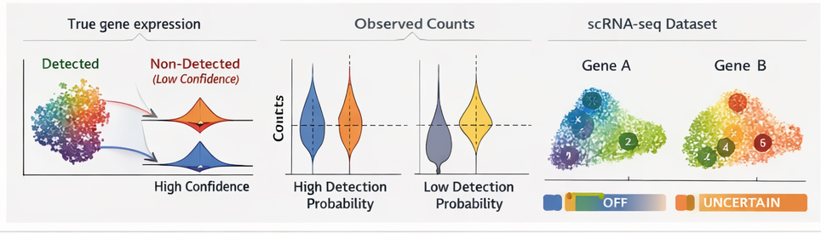

Figure 1 | Modeling transcript detection uncertainty in scRNA-seq | a, Schematic illustrating the probabilistic modeling of transcript detection, distinguishing true expression from stochastic non-detection. b, Simulated data showing identical observed zero counts with different underlying detection confidence. c, Application to real scRNA-seq data demonstrating gene-specific variability in detection uncertainty within a single cell population. d, Comparison with deterministic pipelines, highlighting cases where zero counts would otherwise be misinterpreted as expression absence.

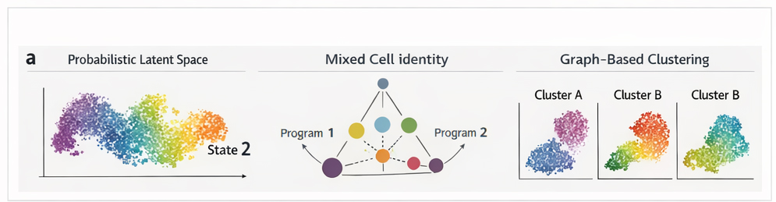

Figure 2 | Continuous representation of cell identity| a, Latent space representation of cells inferred by the probabilistic model, showing smooth transitions between transcriptional states. b, Soft identity assignments illustrating mixed cellular programs within individual cells. c, Comparison with graph-based clustering methods demonstrating fragmentation of continuous trajectories under discrete clustering. d, Stability of identity representations across model initializations and parameter settings.

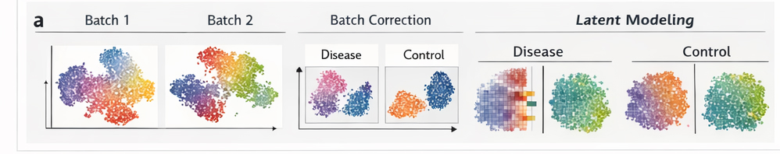

Figure 3 | Latent modeling of batch effects preserves biological signal | a, Visualization of batch-associated variation captured as latent variables. b, Comparison of biological signal preservation between latent batch modeling and conventional batch correction approaches. c, Disease–control dataset illustrating suppression of condition-specific signals by aggressive integration. d, Increased uncertainty in cases of strong batch–biology confounding.

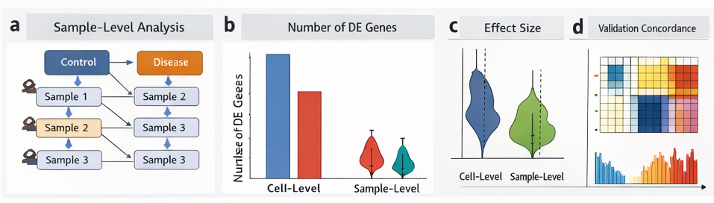

Figure 4 | Sample-aware differential expression reduces false discoveries | a, Schematic of hierarchical, sample-aware differential expression testing. b, Number of differentially expressed genes identified by cell-level versus sample-level analysis. c, Effect size distributions for genes identified by each approach. d, Concordance with independent validation data demonstrating improved reproducibility.

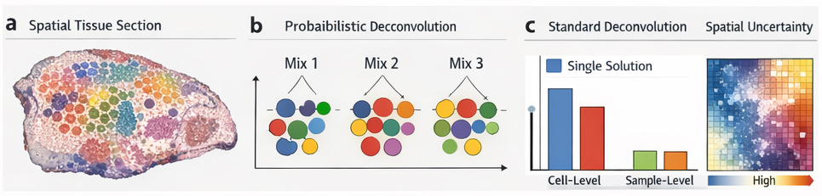

Figure 5 | Constraint-based spatial transcriptomics integration | a, Spatial transcriptomics tissue section with spatial units overlaid. b, Multiple plausible cellular configurations explaining observed expression profiles. c, Comparison with deterministic deconvolution methods that assign a single solution. d, Spatial uncertainty maps highlighting regions of high and low confidence.

