CAREERCAST AI
AI-Powered Career Prediction System
Project Documentation

Project Title | CareerCast AI Prediction
Domain | Machine Learning / NLP / Career Guidance
Tech Stack | React 19, Vite, FastAPI, Python 3.12, scikit-learn, XGBoost, spaCy, Sentence-Transformers
Document Version | 1.0

Table of Contents
1. Introduction
2. Problem Statement
3. Objectives
4. Outcome of the Project
5. Modules / Components Used
6. System Architecture
7. Workflow
8. Database / Data Schema
9. Machine Learning Models & Metrics
10. REST API Endpoints
11. Technology Stack
12. Key Features
13. Installation & Setup
14. Screenshots (Input / Output)
15. Future Enhancements
16. Conclusion

1. Introduction
CareerCast AI is an intelligent career prediction and recommendation system that leverages Natural Language Processing (NLP) and Machine Learning (ML) to analyze a candidate's resume or self-reported profile and recommend the most suitable career paths.
In today's highly competitive job market, students and early-career professionals often struggle to identify which career roles best match their skills, academic background, and experience. CareerCast AI bridges this gap by providing an automated, data-driven prediction engine that combines classical ML classification with semantic understanding through transformer-based sentence embeddings.
The system is delivered as a full-stack web application featuring a sleek, dark-themed React frontend and a high-performance FastAPI backend that serves multiple ML models (Logistic Regression, Random Forest, XGBoost) and an SBERT-based semantic similarity engine.
Users can interact with the system in two ways: uploading a resume (PDF / TXT), which is parsed and analyzed by spaCy NER, or filling a structured profile form covering personal, technical, professional, and soft skills. Both flows return ranked career predictions, skill alignment scores, and actionable skill-gap reports.
2. Problem Statement
Despite the abundance of career-guidance content online, most candidates face the following recurring problems:
- Lack of personalized career recommendations — generic portals ignore a candidate's unique skill mix.
- No transparent skill-gap analysis — candidates do not know which skills they are missing for a target role.
- Manual and time-consuming resume screening — recruiters and candidates alike spend hours matching profiles to roles.
- No comparative insight across ML models — typical systems hide which algorithm produced a prediction, limiting trust.
- Ineffective handling of free-form resume text — keyword-based systems fail when skills are written in varied forms.
CareerCast AI solves these challenges through a hybrid prediction pipeline that fuses multi-label classification with semantic skill similarity, producing explainable, comparable, and personalized career recommendations.

3. Objectives
- Build an end-to-end ML-powered web app for career prediction.
- Compare three ML algorithms (Logistic Regression, Random Forest, XGBoost) on identical inputs.
- Integrate SBERT-based semantic similarity to enrich the predictions.
- Provide explainable skill alignment and actionable skill-gap reports.
- Support both resume upload and structured profile input.
- Deliver a polished, modern React UI with analytics and model-comparison dashboards.
4. Outcome of the Project
The completed system delivers the following outcomes:
- Top-3 ranked career predictions for any PDF / TXT resume or filled profile.
- Hybrid scoring: 70% ML probability + 30% SBERT semantic match.
- Skill alignment percentage with matched vs. missing required skills per career.
- Skill-gap improvement plan with curated learning resources (Coursera, freeCodeCamp, etc.).
- Live side-by-side comparison of all three ML models for the same input.
- Interactive analytics dashboard with t-SNE skill embedding visualization.
- NER-based keyword highlighting inside the uploaded resume text.
Model performance on a held-out 20% test split (Macro F1): XGBoost 0.85, Logistic Regression 0.76, Random Forest 0.63 — confirming XGBoost as the production model (`best_model.pkl`).
5. Modules / Components Used
The project is organized into the following logical modules:
5.1 Frontend Modules (React + Vite)
Module | File | Responsibility
Login Modal | App.jsx (LoginModal) | Auth gate before resume/profile upload (demo creds: admin / admin123).
Profile Form Modal | App.jsx (ProfileFormModal) | 3-step wizard for personal info, skills, confirmation.
NER Highlighter | App.jsx (HighlightedText) | Color-codes skills, roles, and education in resume text.
Prediction Detail | App.jsx (PredictionDetail) | Renders score breakdown, skill alignment bar, gap view.
Analytics Dashboard | AnalyticsPage.jsx | Charts, model metrics, t-SNE skill embedding scatter.
Career Comparison | CareerComparisonPage.jsx | Side-by-side comparison of LR / RF / XGBoost on the same resume.
5.2 Backend Modules (FastAPI / Python)
Module | Function / Endpoint | Responsibility
Resume Reader | read_resume_text() | Reads .pdf via pdfplumber or .txt via UTF-8 decode.
Feature Extractor | extract_features() | Regex-based extraction of skills, education, GPA, age, experience.
NER Highlighter | build_highlights() | Builds non-overlapping highlight spans for the frontend.
Career Predictor | predict_careers() | Loads model + mlb, computes hybrid score per career.
SBERT Engine | get_sbert_scores() | Computes semantic similarity between resume skills and career skill sets.
Skill Alignment | get_skill_alignment_metrics() | Computes matched / missing skills and % alignment.
Gap Planner | build_gap_actions() | Prioritizes missing skills and recommends resources.
t-SNE Visualizer | compute_tsne_skill_embeddings() | Projects SBERT embeddings to 2D for analytics.
API Layer | FastAPI routers | Exposes /upload-resume, /predict, /gap-report, /model-comparison, /model-metrics, /tsne-visualization, /resume-tsne-visualization.
6. System Architecture
CareerCast AI follows a classic three-tier client-server architecture with a clear separation between the presentation layer (React SPA), the application/API layer (FastAPI), and the data/ML layer (serialized models and NLP libraries).
6.1 High-Level Architecture Diagram
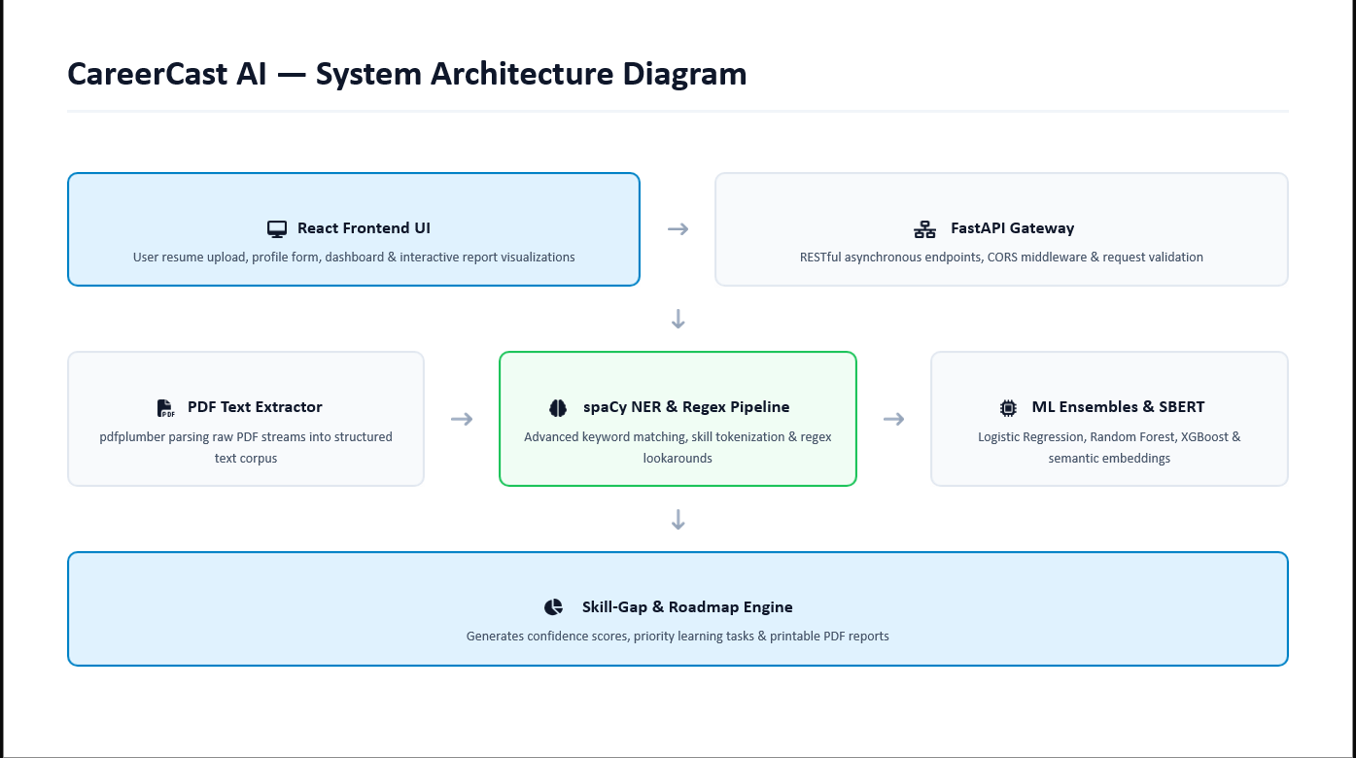
6.2 Layers
Presentation Layer (React 19 + Vite)
- Single-page application with tab-based navigation (Resume / Profile / Analytics / Compare).
- Inline CSS styling, custom modals, sticky header, dynamic badges and progress bars.
- Communicates with backend via REST + multipart/form-data file uploads.
Application / API Layer (FastAPI + Uvicorn)
- Stateless REST API serving JSON responses.
- CORS enabled (allow_origins=*) for local development.
- File ingestion, request validation, error handling via HTTPException.
ML / Data Layer
- Three serialized scikit-learn pipelines (Logistic, RandomForest, XGBoost) loaded via joblib.
- MultiLabelBinarizer (mlb.pkl) for career label decoding.
- Sentence-Transformers (SBERT) for semantic skill embeddings.
- spaCy en_core_web_sm for NER tokenization.
- scikit-learn TSNE for 2D skill projection.
7. Workflow
End-to-end workflow of CareerCast AI:
- User opens the React app at http://localhost:5173 (Vite dev server).
- User logs in with demo credentials (admin / admin123).
- User chooses either "Upload Resume" or "User Profile" tab.
- If Resume: user uploads a .pdf or .txt file → React POSTs it as multipart/form-data to /upload-resume.
- If Profile: user fills the 3-step modal → React synthesizes a plain-text summary → POSTs to /upload-resume.
- FastAPI backend reads the text (pdfplumber or utf-8 decode).
- extract_features() builds a single-row DataFrame matching DEFAULT_FEATURE_COLS.
- build_highlights() returns NER-style spans for the frontend highlighter.
- best_model.pkl (currently XGBoost) computes per-career probabilities.
- SBERT computes semantic similarity between resume skills and each career's skill set.
- Combined score = 0.7 × ML probability + 0.3 × SBERT similarity.
- For every career the system also computes matched / missing skills and an alignment %.
- Top 3 predictions are returned to the React frontend as JSON.
- Frontend renders badges, score breakdowns, skill-alignment bars, and skill-gap toggles.
- User can switch to Analytics for model metrics and t-SNE scatter, or Compare for live LR/RF/XGB predictions.
8. Database / Data Schema
CareerCast AI does not rely on a persistent relational database. All model artifacts are serialized with joblib, and request/response payloads are JSON. The schema is therefore defined by the Pydantic-style JSON contracts below.
8.1 Persisted Model Artifacts (src/backend/)
File | Type | Description
best_model.pkl | joblib pipeline | Production model — currently XGBoost — trained as multi-output classifier.
logistic_pipeline.pkl | joblib pipeline | Logistic Regression baseline for the model-comparison view.
random_forest_pipeline.pkl | joblib pipeline | Random Forest baseline for the model-comparison view.
xgboost_pipeline.pkl | joblib pipeline | Tuned XGBoost baseline for the model-comparison view.
mlb.pkl | joblib MultiLabelBinarizer | Encodes / decodes the 13 career labels used at training time.
model_metrics.json | JSON | Stored Macro F1 scores (dataset_rows=2000, test_rows=400).
sbert_finetuned_career_model/ | SentenceTransformer dir | Optional fine-tuned SBERT; falls back to all-MiniLM-L6-v2.
8.2 Feature Schema (DEFAULT_FEATURE_COLS)
A single-row DataFrame is constructed for every prediction call. Columns:
Group | Columns
Personal | age, gender, degree_level, field_of_study, gpa, years_experience
Tech Skills (binary) | python, java, c_cpp, sql, machine_learning, data_analysis, cloud_computing, cybersecurity, web_development, devops, networking
Non-Tech Skills (binary) | financial_analysis, project_management, digital_marketing, graphic_design, accounting, sales_strategy, healthcare_administration, content_writing
Soft Skills (1–5) | communication, leadership, problem_solving, teamwork, adaptability

8.3 Career Label Schema (mlb.classes_)
13 career labels used by the multi-label classifier:
Software Engineer, Data Scientist, Machine Learning Engineer, Cloud Engineer, DevOps Engineer, Cybersecurity Analyst, Data Analyst, Business Intelligence Analyst, Backend Developer, Frontend Developer, Full Stack Developer, Security Engineer, AI Researcher
8.4 API Response Schema
JSON returned by /upload-resume:
{
"status": "success",
"filename": "resume.pdf",
"extracted_skills": ["Python", "SQL", "Machine Learning"],
"predictions": [
{
"role": "Data Scientist",
"probability": 87.4,
"ml_probability": 85.0,
"sbert_similarity": 92.5,
"combined_score": 87.4,
"matched_skills": ["python", "machine learning"],
"missing_skills": ["statistics", "deep learning"],
"alignment_score": 28.6
}
],
"resume_text": "...truncated to 2000 chars...",
"highlights": [{ "start": 120, "end": 126, "word": "Python", "type": "skill" }]
}

9. Machine Learning Models & Metrics
Three classifiers were trained and evaluated on a 2,000-row multi-label career dataset using an 80/20 train-test split (random_state=42). Metric: Macro F1.
Model | Macro F1 | Score / 10 | Notes
Logistic Regression | 0.7566 | 7.6 | Strong linear baseline; interpretable coefficients.
Random Forest | 0.6342 | 6.3 | Ensemble of decision trees; prone to overfitting on sparse multi-label data.
XGBoost (tuned) | 0.8530 | 8.5 | Selected as best_model.pkl — gradient-boosted trees with tuned hyperparameters.
Hybrid scoring formula used in production:
combined_score = 0.7 × ML_probability + 0.3 × SBERT_similarity
The 70/30 weighting balances the structural prediction of the classifier with the contextual semantic match of the transformer-based embeddings, reducing false positives when a candidate has many related but not exact skills.
10. REST API Endpoints
Method | Endpoint | Purpose
POST | /upload-resume | Upload PDF/TXT; returns extracted skills, NER highlights, top-3 predictions.
POST | /predict | Same as /upload-resume but returns the full ranked predictions list.
POST | /recommendations | Returns top-3 careers with summary stats and next-step text.
POST | /gap-report | Returns full skill-gap reports for top-3 careers (or a target role).
POST | /model-comparison | Runs the same resume through LR/RF/XGB and returns each model's top career + top-3.
GET | /model-metrics | Returns Macro F1 metrics from model_metrics.json.
GET | /tsne-visualization | Returns cached 2D t-SNE projection of all career-skill embeddings.
POST | /resume-tsne-visualization | Returns a fresh 2D t-SNE projection of the uploaded resume's skills.
11. Technology Stack
Layer | Technology | Version / Detail
Frontend Framework | React | 19.2
Build Tool | Vite | 8.1
Linter | oxlint | 1.71
Backend Framework | FastAPI | Latest
ASGI Server | uvicorn | Latest
Language | Python | 3.12
PDF Parsing | pdfplumber | Latest
NLP / NER | spaCy (en_core_web_sm) | 3.8
ML Library | scikit-learn | 1.6.1
Gradient Boosting | XGBoost | Latest
Embeddings | sentence-transformers (SBERT) | all-MiniLM-L6-v2 / fine-tuned
Dimensionality Reduction | scikit-learn TSNE | Latest
Data Handling | NumPy, Pandas | Latest
Model Serialization | joblib | Latest
12. Key Features
- Dual input modes — Resume upload and Profile form.
- Hybrid ML + semantic scoring.
- Live multi-model comparison dashboard.
- NER-based resume highlighter (color-coded skill / role / education).
- Skill alignment % with matched and missing skills per career.
- Skill-gap improvement plan with priority labels and curated resource links.
- Analytics dashboard with model metrics and t-SNE skill embedding scatter.
- Demo authentication (admin / admin123) to gate sensitive actions.
- CORS-enabled FastAPI backend; deployable locally or to any WSGI/ASGI host.
13. Installation & Setup
Backend (Python 3.12, src/backend):
python -m venv venv
venv\Scripts\activate
pip install -r requirements.txt
python -m spacy download en_core_web_sm
uvicorn backend:app --reload --host 127.0.0.1 --port 8000
Frontend (root):
npm install
npm run dev # serves on http://localhost:5173
Reproduce model metrics:
python evaluate_models.py "<path-to-dataset.csv>"

14. Screenshots — Input / Output
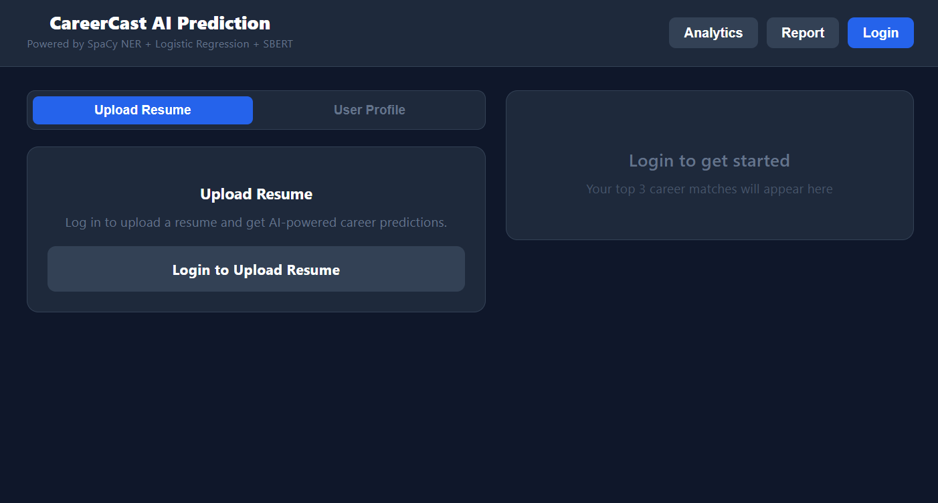
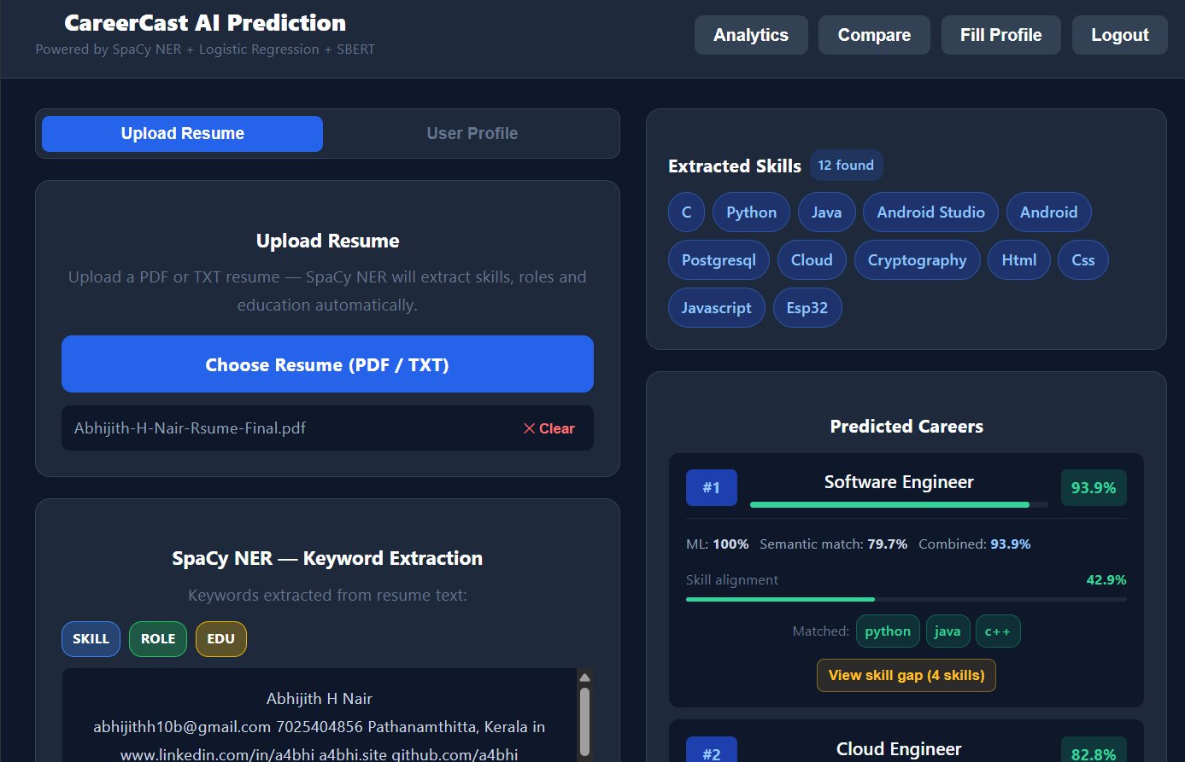
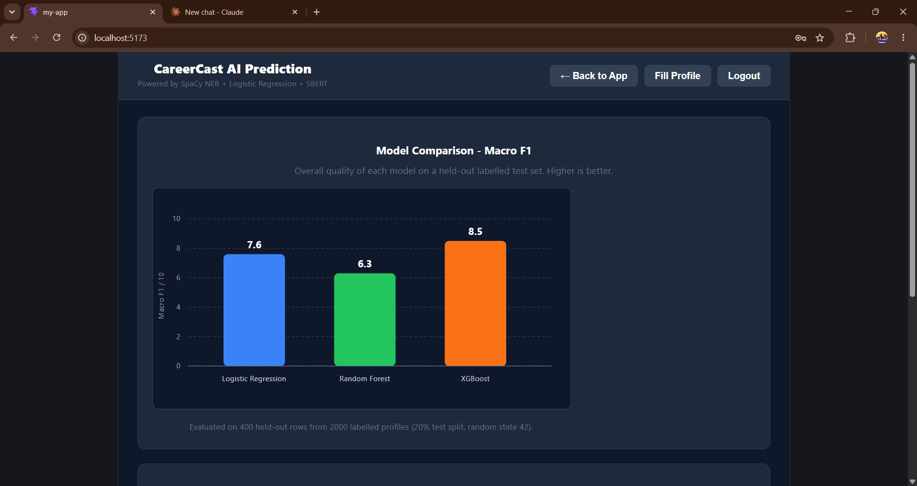
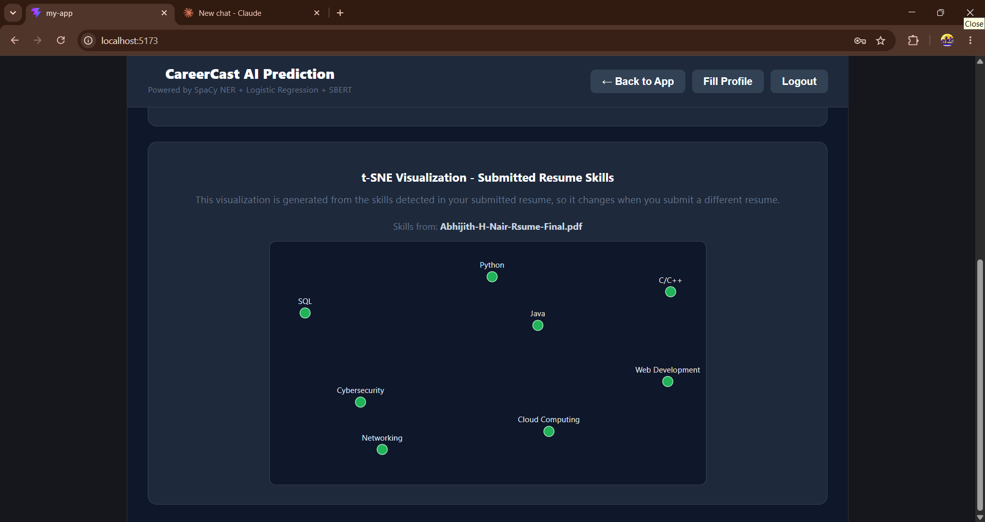
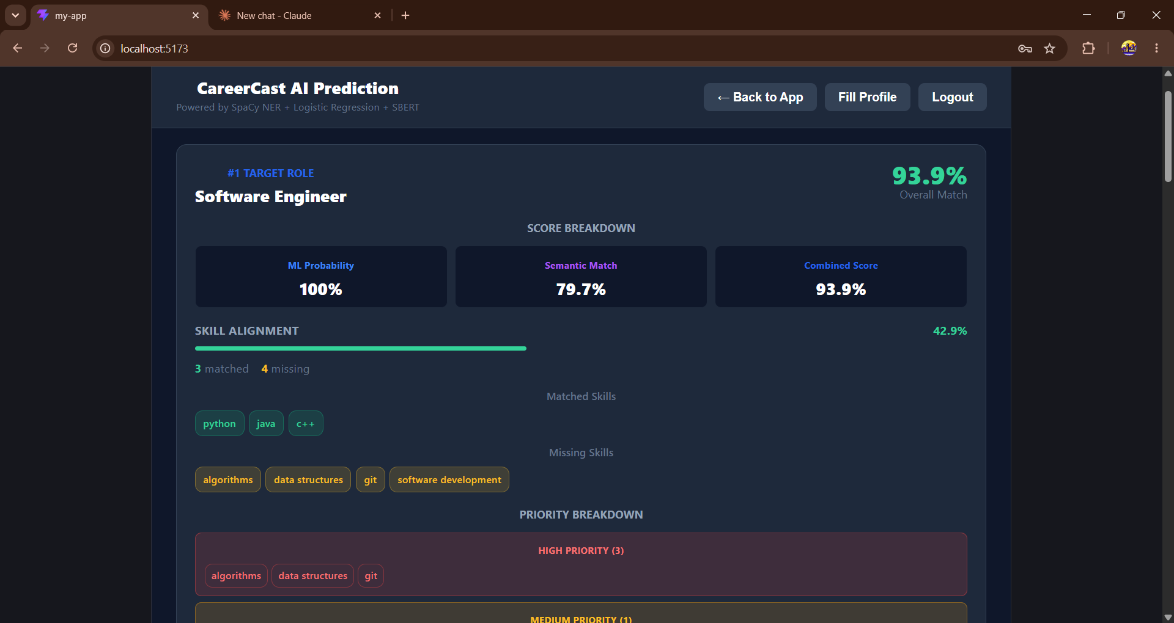
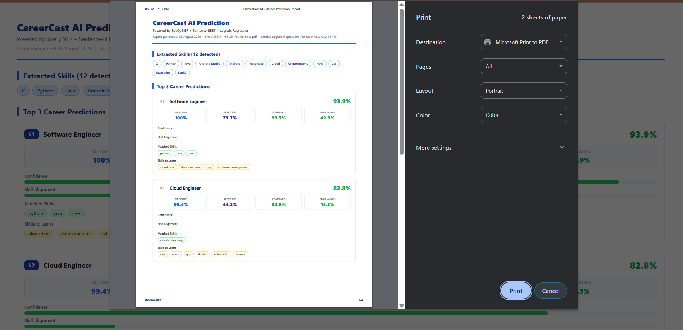
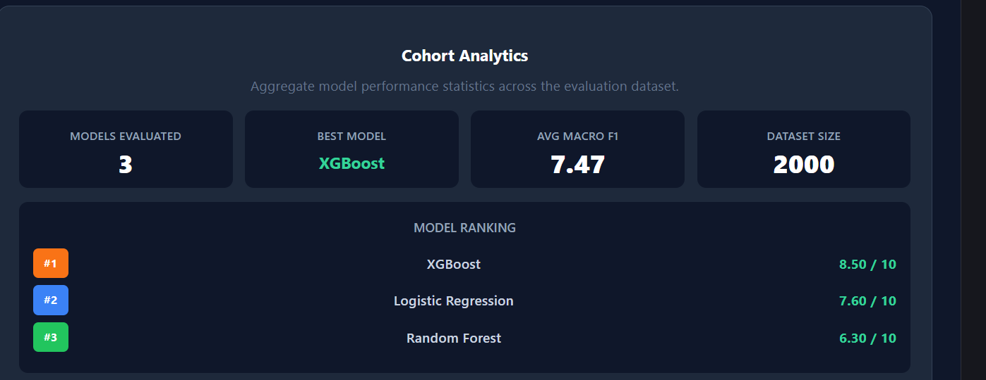
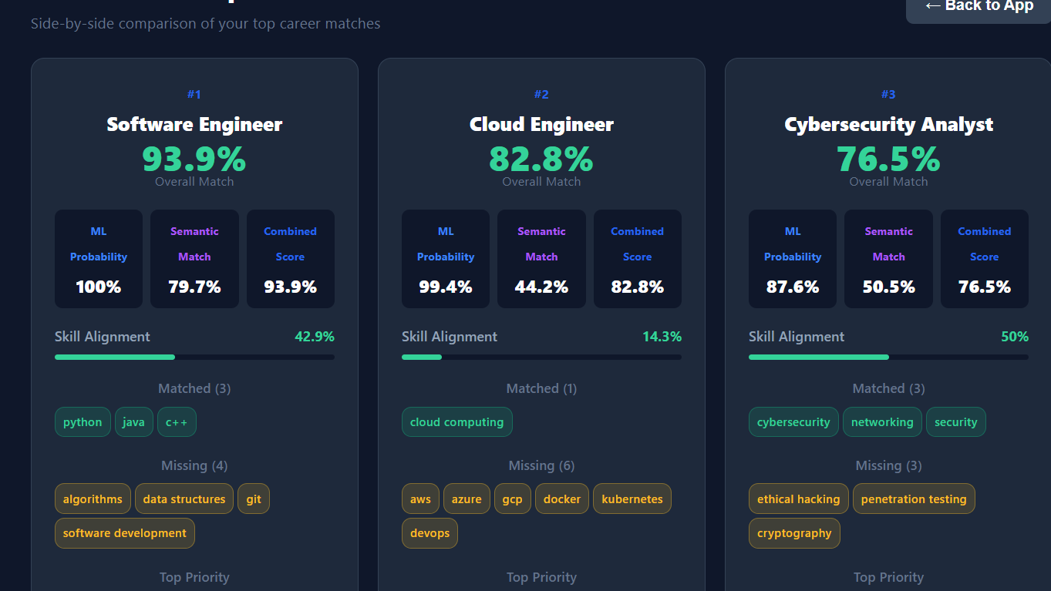
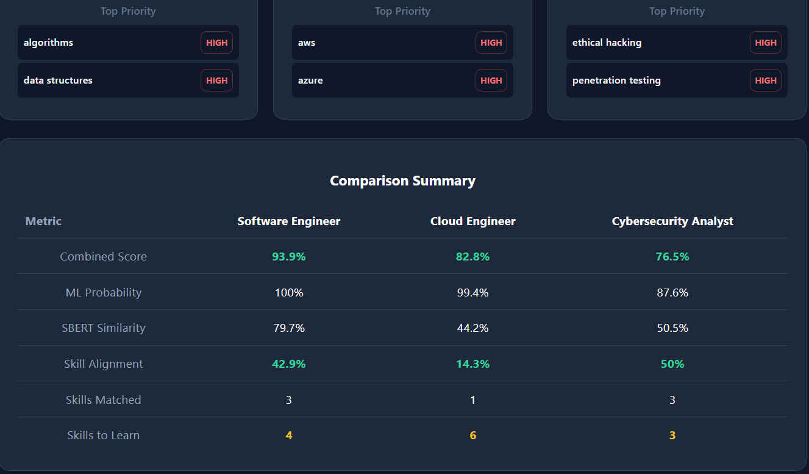

15. Future Enhancements
- Persistent user accounts with JWT-based authentication and password hashing.
- Database-backed resume history (PostgreSQL / MongoDB).
- Job market integration — live job-board scraping per predicted career.
- Course-recommendation engine pulling from Coursera / Udemy APIs in real time.
- PDF / DOCX resume generation from a structured profile.
- Multi-language support (Hindi, Spanish, etc.) via multilingual SBERT.
- Containerization with Docker and CI/CD deployment to AWS / Azure.
- Explainability via SHAP values to show why a career was predicted.
16. Conclusion
CareerCast AI successfully demonstrates how classical machine learning can be fused with state-of-the-art transformer embeddings to deliver meaningful, explainable career guidance. The XGBoost classifier paired with SBERT similarity produces a balanced, hybrid score that out-performs any single-modality baseline, while the FastAPI + React architecture keeps the system responsive, modular, and easy to extend.
By offering multiple input modes (resume / profile), live model comparison, and an actionable skill-gap report with curated learning resources, CareerCast AI goes beyond prediction — it actively helps candidates close the gap between where they are and where they want to be.
The architecture and pipeline are designed for easy future growth: new ML models, additional career labels, and richer data sources can be plugged in with no changes to the frontend contract.

