Experiment No: 1

Aim: To study any Two e-commerce website

Theory:

Describe any two commercial web sites. You can choose sites that you know well, or any other ones, as long as they are commercial, i.e. sell products or services. You need to specify the following about each of the sites
- Give the site's URL and a brief description of the organization it represents and goods and/or services that it offers. List main parts of the sites (s.a. product page, page for documentation for the products, consumer forums, etc). Also mention if the site requires a membership (i.e. if you need to register to enter or to browse some pages).
Ans:
-URL: www.sennheiser.com and www.mivi.com
-Sennheiser is a brand that sells audio accessories and products such as earphones, headphones, gaming wear, etc.
-Mivi is a brand that sells similar products, including earphones, headphones as well as power cables.
-Surprisingly, the Sennheiser website does not require the user to log into their website, and the website allows bookings directly, without ID/Password.
-Mivi website does require the user to log into their website, and the website allows bookings directly, without ID/Password.
-Both websites require the email ID of the purchaser to forward the invoice copy
-Main parts (Sennheiser)
- Product list page
- Product information page
- Payment page
- Help page
- Customer Support page
- Meet the company
- Press
-Main parts (Mivi)
- Registration page
- Product list page
- Product information page
- Payment page
- Help page
- Describe the functionality of the site:
  - Does it offer a list of products which is easy to browse?
-Yes. Both the websites provide lists based on newly updated products and showcase their best products.
  - Does it offer a search engine, if yes, what kinds of requests can it handle? Is it convenient to use?
-Yes. It is a simple search engine that searches the products. It is quite comfortable and can handle requests; however, it doesn’t come up with suggestions.
  - Does it provide a shopping cart (or a shopping basket), what functions does it have, is it easy to add, delete, and change products?
-Yes. Both the websites provide a shopping cart and it is easy to add, delete and change products from cart. Also we can change quantities of items in cart.
  - Is the order form flexible enough to allow different options of payments, a shipping address other than your own, etc?
-Yes. Both the websites provide a 2 way- a. Card payment and b. Cash on Delivery. Also for gift item delivery one can provide receiver’s address and delivery date. This service is free of cost. Also one can change his shipping address.
  - Does the security message gets displayed when you submit the form (you don't need to type in your credit card number, just something to make the form go through).
-Yes. It asks for valid internet password.
  - If there is a membership, what kind of information is required to register?
-It provides simple registration form with Login name, password, address(country, state, city, landmark and pin code)and phone number.
  - Is there a customer support section? Does the site publish customer reviews or feedback? Is yes, is it well organized and easy to browse?
-Yes, there is provision for customer feedback as well as complaint form but it doesn’t display user reviews.
- Rank the implementation of the site: does it provide all functionality that customers need, or would you suggest adding or changing something?
-Since it provides almost all functionalities that customer needs, it is very good site. There is no any suggestion.
- How would you rank the graphic design of the site
-This site is well-designed with the help of images. So content is easy to understand.
- What is your overall opinion of the site: did you like it, would you come back to it or recommend it to a friend?
-This site is having variety of items, good to browse and provide good security. So I would like to shop from this site and also recommend it to friend.
If the two web sites that you have chosen offer similar products or services, you might want to include comparison in your answer.
- Design homepage for website
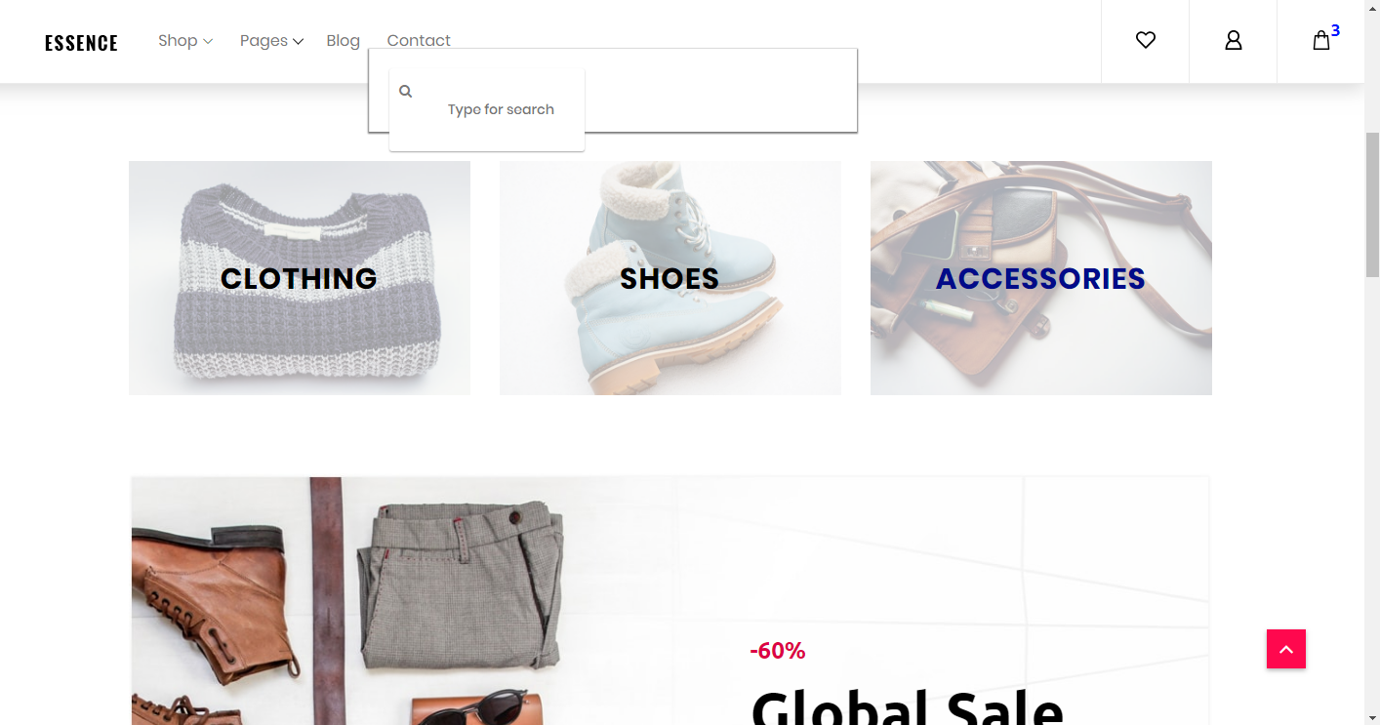
This is the homepage with various products range.
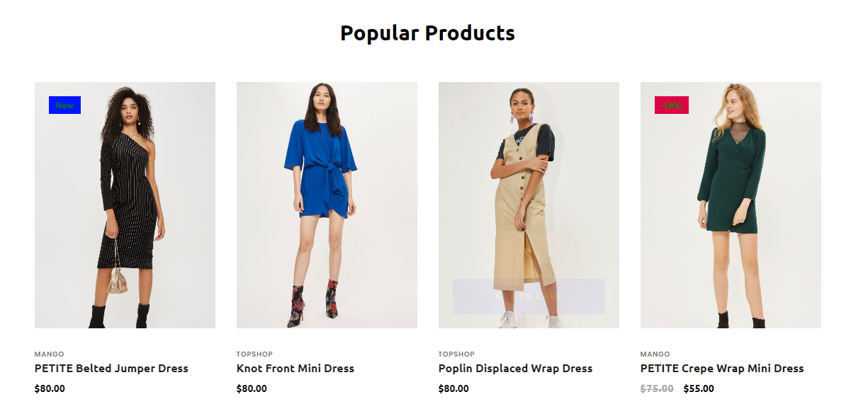
This part shows the popular products of the website.

This is the cart of the website which shows the detailed invoice of the website.
The website can be set up with additional payment methods. However we intend to make use of cash on deliveries.

The ecommerce website intends to allow customers to purchase clothing online. This website will have the following amenities:
- Shopping cart
- Various products
- Shows new collections
- Shows recommended
- Allows the user to checkout without logging into the website
- Allows various payment options such as e-wallet, bank payments, credit cards, CoD, etc.
Conclusion: Thus we have designed a website allowing purchase of products over the internet. This ecommerce website allows the user to see all the products categorized as well as shows recommended options. Also, the user does not require logging in before making a purchase. Payments can be made through various methods as well.

