1. Draw a star schema using the tables (and their variables) in our database.

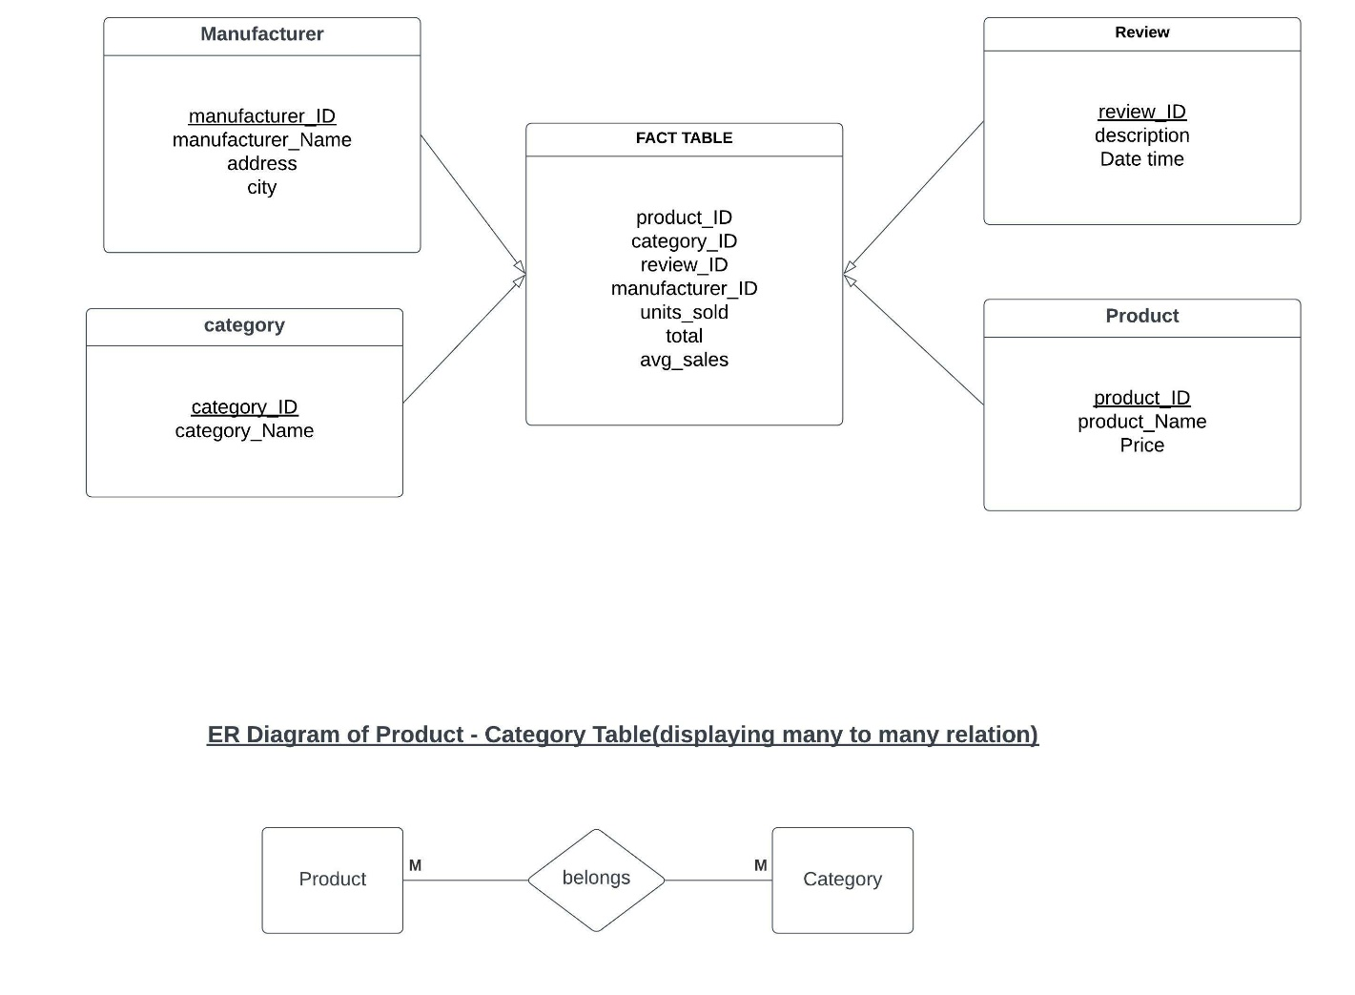

2. Why is there point in using star schema even if it means data redundancy? Explain your answer briefly.

As, we can fetch the details from the problem statement the main motto of creation the database is mostly to serve customers and their queries with ease at minimum cost possible. Star-schema offers much simpler join-logic to retrieve data compared to other two.

Second reason being with normalisation number of joins required to connect different data tables increases and which in turn demands more sophisticated systems for database design thus increases the cost and complexity of the relational data. To tackle all this problem a simple star schema is sufficient for simplified business reporting logic as in this case this schema is sufficient for report about the product period-over-period.

Third reason is that data collected on the basis of star schema would have redundancy and decreases the efficiency, but this could be tackled using “Query performance gains” that is star schemas can provide performance enhancements for read-only reporting applications when compared to highly normalized schemas.

Also, aggregation operations are some of the basic operations which are performed on all kinds of situation while dealing with the data, so simpler queries against a star schema can result in improved performance for aggregation operations.

Star schemas are used by all OLAP systems to build proprietary OLAP cubes efficiently; in fact, most major OLAP systems provide a ROLAP mode of operation that can use a star schema directly as a source without building a proprietary cube structure.

Above mentioned are some of the reasons which makes star-schema more suitable compared to others for our given test case.