


Module Code & Module Title
CS6P05NI Project
Proposal

5% Individual Coursework
Submission: Final Submission
AY 2025 2026
Academic Semester: Autumn Semester 2025

Credit: 30 Credit Year Long Module

Student Name: Anurodh Prasain
London Met ID: 23047512
College ID: np01cp4a230012
Assignment Due Date: Wednesday, December 3, 2025
Assignment Submission Date: Wednesday, December 3, 2025
Internal Supervisor: Rubin Thapa
External Supervisor: Mero Raja Prasad Pradhan
I confirm that I understand my coursework needs to be submitted online via MST Classroom under the relevant module page before the deadline for my assignment to be accepted and marked. I am fully aware that late submissions will be treated as non-submission and a mark of zero will be awarded.
Table of Contents
Introduction 5
1.1. Problem scenario 6
1.2. The Project as a Solution — Worklynk 7
1.3. Why Worklynk is Valuable for Nepal 8
2.1. Academic/Research & Documentation Objectives (appendix see more) 10
2.2. System/Functional Objectives (Appendix see more click) 11
Expected Outcomes and Deliverables 12
3.1. Expected Outcomes 12
3.2. Project Deliverables 12
Project risks, threats and contingency plans 13
Methodology 16
5.1. Considered Methodologies (Appendix) 16
5.1.1. Waterfall model: 16
5.1.2. Scrum (Agile Framework) 17
5.2. Proposed Methodology: Hybrid Agile-Waterfall Model 19
Resource Requirements 21
6.1. Hardware Resources 21
6.2. Software Resources 21
6.3. External Access/Services 22
Work Breakdown Structure 22
Milestones 24
Project Gantt Chart 25
Conclusion 26
Bibliography 27

Table of Figures
Figure 1: Global Workforce Distribution 2025 (Quantumrun Foresight, 2025). 5
Figure 2: Growth in Numbers of Freelancers (2017 - 2022) (Khanal, 2024). 6
Figure 3: Waterfall Model (Kirvan, 2024). 16
Figure 4: Kanban Board. (Drumond, 2025) 18
Figure 5: WBS. 23
Figure 6: Milestone Chart. 24
Figure 7: Gantt Chart. 25

Table of Tables
Table 1: Project risks, threats and contigency plans. 15
Table 2: Hardware Resources. 21
Table 3: Software Resources. 22

Introduction
The global freelancing and gig-economy has expanded significantly in recent years as businesses increasingly outsource project-based work to independent contractors through online platforms. The global freelancing workforce stands at 1.57 billion people out of a total workforce of 3.38 billion, representing 46.6% of all workers worldwide as of 2025. The freelance platform market reached $7.65 billion in 2025 and is projected to grow at a CAGR of 16.66% to reach $16.54 billion by 2030 (Quantumrun Foresight, 2025).
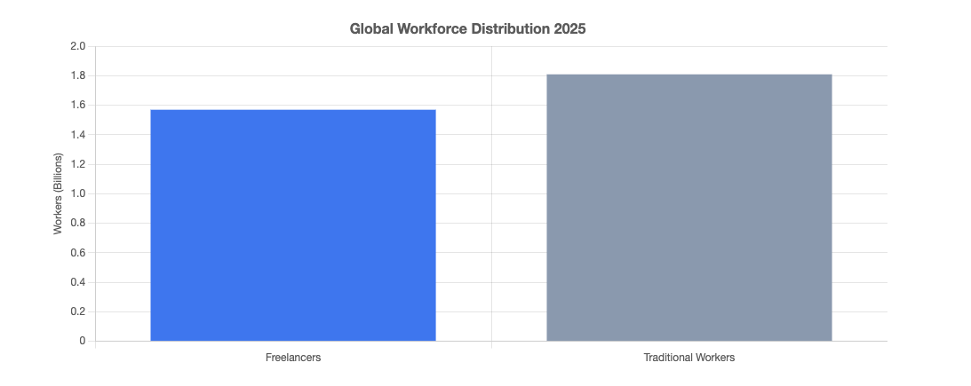
Figure 1: Global Workforce Distribution 2025 (Quantumrun Foresight, 2025).
For countries like Nepal, the expansion of the gig economy presents an opportunity to tap into global demand. Indeed, a study on Nepal’s evolving employment dynamics reveals that the gig economy is becoming a visible feature of the Nepal market, especially for youth, urban professionals, and those seeking flexible work arrangements. Currently contributing approximately 6 percent to the national GDP (Ministry of Federal Affairs and General Administration, 2025).
Furthermore, there has been a sharp rise in Nepal’s digital services export and freelancing work. Between 2017 and 2022, the number of registered freelancers reportedly rose from around 27,560 to 66,509 — reflecting growing interest in freelancing as a viable career path (Khanal, 2024). This rapid growth underscores a shift in Nepal’s employment landscape and suggests that demand for skilled freelance services is increasing, both domestically and internationally.

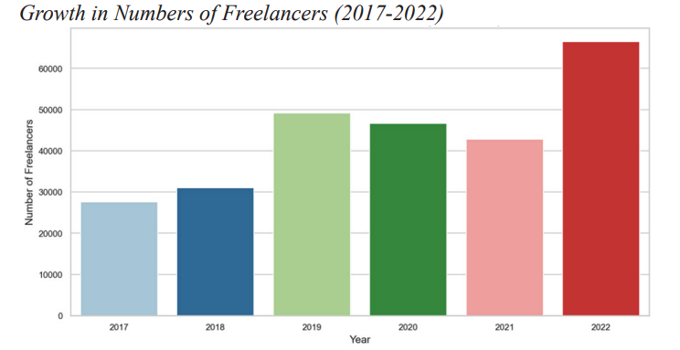
Figure 2: Growth in Numbers of Freelancers (2017 - 2022) (Khanal, 2024).

Problem Statement
Despite this growth, significant structural challenges remain that hinder the full potential of a local freelancing marketplace tailored for Nepal. Some key problems are:
- Lack of organized, Nepal-centric platforms: While many Nepali freelancers engage in global platforms, there is no well-developed Nepal-based platform that integrates discovery, trust, verification, and local regulatory/tax needs — a gap that limits accessibility, especially for newcomers or those less familiar with international freelancing norms. Academic studies on Nepal’s gig economy note that although freelancing has the highest participation rate among gig sectors remain dominant, and long-term sustainability and worker protections are weak (Sagar B.K., 2024).
- Informal structure, legal and social protection gaps: According to a 2025 review on Nepal’s gig economy, many gig workers (including freelancers) operate in a legal grey area: labour laws and social protection mechanisms do not adequately cover gig workers, leaving them without standard employment benefits, job security or social safety nets (Tuladhar, 2025). This lack of formal structure discourages many from committing to freelancing full-time.
- High entry friction and inefficiencies in onboarding and matching: New freelancers often struggle with manual profile creation, lack of verification, unclear trust signals, and difficulty in finding suitable clients. These friction points make it harder for newcomers to compete and earn consistently, especially compared with established international platforms. As noted by Nepalese labour-economy analyses, participation often depends on prior employment status and satisfaction — people already under formal employment are more likely to engage in gig jobs, indicating barriers for fully new freelancers (Sagar B.K., 2024).
- Challenges around payment mechanisms and global freelancing payments for Nepalese: Nepali freelancers working for international clients often face difficulties receiving payments, due to lack of payment gateways, non-availability of services like FonePay, regulatory barriers, foreign-exchange hassles, and tax/compliance uncertainty. This increases friction, discourages participation, and reduces the appeal of freelancing as a stable income stream. Recent Nepali analyses highlight these as major drawbacks (Tuladhar, 2025).

The Project as a Solution — Worklynk
To address the above challenges, I proposed a startup-based freelancing platform called Worklynk, which considers the needs and demands of the Nepal-based freelancers and clients. The design of Worklynk will include:
- Low Barriers to Entry: The platform does not require any form of log-in prior to being able to browse projects and freelancers, which lowers the entry barrier to the platform that would allow potential clients and freelancers to learn about the platform and available opportunities.
- Simple but role-based Onboard: During registration, users choose a role (freelancer or client) with limited information (email, password). It allows posting of a project or applying to be done only with comprehensive profile completion and identity verification (e.g., PAN/VAT), thus refraining from too much accountability.
- Checklist-Gated Programs Staged Proposals: Freelancers are required to fill out certain checklists to be eligible to apply to a project and the qualified applications would be minimal in order to increase the chances of hiring someone.
- Embedded Contract and Project Management: When one hires a contract is uploaded and the execution of the project follows a built-in pipeline interface (like Trello), which integrates the marketplace with management solutions to remove the external coordination.
- Trust & Reputation System: At the end of the project and payment, clients and freelancers evaluate one another. This creates a discoverable reputation history which drives high performance and creates trust.
- Flexible Modular Architecture of the future: The platform follows a modular platform. Though the first version is based on the core matching and project management, the architecture is planned with payment gateways, escrow, invoicing, and tax modules, which will be integrated smoothly in the future to expand the business to financial services.
- Planned Automated Profiling: To further automate the onboarding process, in a later release we will introduce automated CV/ resume parsing, where skills and experience are automatically extracted out of the uploaded documents to remove the bottleneck of creating a profile manually.

Why Worklynk is Valuable for Nepal
Worklynk will specifically respond to the specific opportunities and challenges of the emerging freelance economy in Nepal and value will be generated to all the participants.
- Accesses a Fast-Maturing Market: Worklynk will take advantage of the fact that Nepalis are interested in freelancing in significant numbers and their numbers have increased dramatically since 2017, when the number of Nepali freelancers was about 27,500, to over 66,500 in 2022 (Khanal, 2024). The platform is a specific local channel through which this growing pool of talent can be directed.
- Closes a Significant Structural Vacuity: Gig economy in Nepal does not have any formalization and streamlined platforms at present (Ministry of Federal Affairs and General Administration, 2025). Worklynk addresses this specific need directly by establishing a secure, open, and organized ecosystem, which prioritizes local conformity and user safety, which is a critical gap in the market.
- Makes access democratic and encourages inclusiveness: Worklynk actively seeks to attract younger users, fresh graduates, and rural freelancers, by reducing entry barriers, including the ability to look through projects without an account, and a straightforward entry signup. The approach works in democratizing the economic prospects other than the conventional urban professional centers.
- Improves Productivity and develops Trust: Worklynk is also designed to enhance the whole freelancing lifecycle. The platform mitigates mismatches and onboarding on the platform through features such as checklist-gated applications and inbuilt project management tools. This translates to increased success rates of projects and hence trust is created and repeat involvement to the platform is promoted.
- Establishes a Platform of Full-Cycle Freelance Economy: The site has a modular design, which is a strategic future investment in the freelance in Nepal. It offers a scalable infrastructure to add important services such as payment processing, escrow, and contract enforcement, which are significant issues of concern to the Nepalis dealing with local and foreign consumers.
Considering the spread of the freelance/gig economy around the world and in Nepal in particular and obvious structural gaps in existing applications, there is a strong incentive to consider a well-developed, Nepal-specific platform. The solution proposed by Worklynk will help to bridge this gap by providing a full package of solutions, i.e. discovery and onboarding, project execution and trust building, and thus allow freelancers and clients in Nepal to communicate effectively, safely, and equitably. This contributes to the fact that the proposed project is not only timely, but also socially and economically applicable in the environment of the changing labour market in Nepal.

Aims and Objectives
The main aim of the project is to design and develop a web-based freelancing platform that fits the Nepalese market, that is, Worklynk, which will allow the user to experience a safe, transparent and convenient space to connect freelancers and clients that will allow the project to be managed efficiently, communication be trusted, and payment be handled without any unfairness using modern web technologies.
This objective is reflected by the need to solve the current inefficiency in the freelance hiring in Nepal by providing a more localized, scalable and technically sound solution.

Academic/Research & Documentation Objectives
These objectives align with academic requirements such as analysis, documentation, SDLC deliverables, and theoretical justification.
- To conduct a detailed analysis of Nepal’s freelance ecosystem, including platform gaps, user pain-points, trust barriers, and regulatory challenges supported by credible research and evidence.
- To model the system requirements formally by producing complete Software Requirement Specification (SRS), including functional requirements, non-functional requirements, use-case models, and dataflow/process diagrams.
- To design a structured database and system architecture using appropriate design methodologies (ER diagrams, normalized schema, modular service architecture, workflow diagrams).
- To evaluate and justify an appropriate SDLC methodology suitable for developing a multi-role freelancing platform with phased deliverables.
- To develop and document system prototypes (low-fidelity and high-fidelity wireframes) for validating user flows such as onboarding, project browsing, bidding, contract execution, and project management pipeline.
- To produce complete project documentation, including SRS, SDS (Software Design Specification) (UML diagrams), test cases, test reports.

System/Functional Objectives
These objectives relate to the actual implementation and features of the Worklynk system.
- To develop a public access browsing system that allows users to view freelancers and projects without authentication.
- To implement a two-role user onboarding flow (Freelancer / Client) with minimal sign-up and extended profile completion triggered only when posting or applying for a project.
- To integrate PAN/VAT verification into the profile-completion workflow to increase trust and legitimacy among clients and freelancers.
- To implement a CV-Upload system with automated parsing (PDF extraction of skills, experience, education, and relevant data) to reduce onboarding friction and improve profile quality. (If not in MVP, move to future enhancement but still counted as an objective.)
- To design and develop a project-posting module with detailed requirement listings, checklists, milestones, budget range, and delivery timeline.
- To implement structured bidding and proposal submission, allowing freelancers to apply only if they meet all checklist items and upload a proposal document (PDF).
- To design an integrated real-time communication system (chat module) for freelancer–client interaction before contract finalization. (Priority feature; fallback to message-based communication if real-time is future enhancement.)
- To create a contract system, where clients and freelancers finalize terms (pricing, schedule, payment plan, deliverables) and store it securely.
- To integrate project-management board, enabling task creation, assignment, progress tracking (To-Do → In-Progress → Review → Done).
- To implement a rating and feedback mechanism after contract completion and final delivery to build trust and marketplace transparency.
- To ensure system security, reliability, and usability, applying authentication, authorization, input-validation, secure file handling, and UX-focused design.

Project Objectives
- The goal of the study is to examine the current freelancing ecosystem in Nepal based on the available platforms and determine constraints around trust, transparency of payments, and local accessibility.
- To create a scaled system architecture which will provide different user roles, such as freelancers, clients, and administrators, and provide secure authentication and authorization systems.
- To build the backbones of core freelancing functionality such as user registration, profile management, project posting, proposal submission, and contract management.
- To introduce a secure payment and transaction process that ensures the transparency between freelancers and clients and to minimize the number of conflicts connected with the payments.
- To develop and deploy an easy to use and responsive user interface that will optimize the usability on various devices and will help to increase the overall user experience.
- To add reporting and monitoring capabilities that enable administrators to monitor activities within the platform and provide policy adherence.
- To verify and ensure that the system is reliable, secure, and functional by testing and conducting usability tests prior to the final deployment.

Personal Objectives
Besides the goals that are project-oriented, this project will ensure that the following personal learning objectives are attained:
- To enhance useful competencies in full-stack web development, especially with contemporary frameworks and technologies that are pertinent to industry standards.
- To have practical experience in system design and architecture with database design, API development, and scaling of the application.
- To implement the principles of software engineering, and the development methodology acquired throughout the course to a project setting.
- To enhance the problem solving and analytical ability through solving really technical and design issues faced during the development.
- To improve the skills in project management and documentation, it is necessary to make sure that the development progress is matched with the planned schedules and academic requirements.

Background and Literature Review

About the End User / Client
The main end-users of the Worklynk platform include the freelancers and clients working in Nepal, such as students, isolated practitioners, startups, and small-to-medium enterprises that an interest in project-based digital services. Freelancers need to have good access to job opportunities, effective payment structure and reliable clients whereas clients need access to skilled professionals, effective communication channels and efficient implementation of projects.
Besides freelancers and clients, system administrators represent a major stakeholder group that handles user validations, dispute, moderator of the platform and general system control. The system is thus set to comply with the functional and non-functional needs of all the three user roles to foster trust, accountability and seamless platform activities.

Understanding the Project
Worklynk is an online freelance model that aims at providing a secure and effective connection between the freelancers and clients in a localized Nepalese scenario. The project is aimed at solving the common problems of the current freelancing platforms, such as the absence of trust, proper verification procedures, ambiguous contractual enforcement, and project visibility.
The system allows clients to place projects, maintain applications, negotiate contracts and track the progress of projects and freelancers to view projects, place proposals, handle projects and deliver work in a structured workflow. Worklynk also seeks to create a clear, trustworthy and easy to use freelancing platform, by integrating role-based access control and administrative supervision, and Kanban-style project management.

Review of Similar Projects
An analysis of the available freelancing sites was done to determine industry practices, strengths and limitations guiding the design of Worklynk. The selected contenders that will be compared include Upwork, Fiverr, and Guru because they are popular international systems of freelancing that operate based on different business models.

Upwork
Upwork is an internationally known freelancing site that has got full functionality that includes posting projects, handling proposals, time tracking, milestones payments and escrow services. It assists with organized client-freelancer relationships with the help of contracts and conflict resolution systems.
Upwork provides challenges to the Nepalese users, despite the technical strength, high service rates, verification procedures and global competition. These are some of the reasons why new or locally resident freelancers can hardly be visible and find projects.

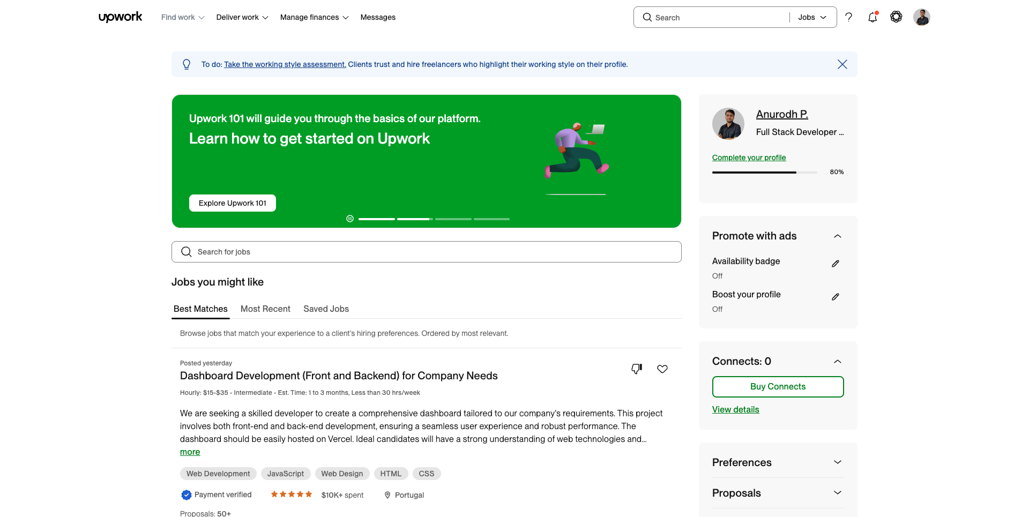
Figure 3: Upwork.

Fiverr
Fiverr is based on a marketplace model of service-based freelancing where the freelancer purchases service (gigs) instead of bidding on a project. The platform is known to be used in fast work and short-term interaction as it has inbuilt messaging, order tracking, and review systems.
Nevertheless, Fiverr lacks flexibility as the strict system of gigs does not allow complex or long-term projects. The platform also offers a limited level of client-based project control, low transparency of verification, and does not support sophisticated project management tools, which makes it not so suitable to organize the professional cooperation.
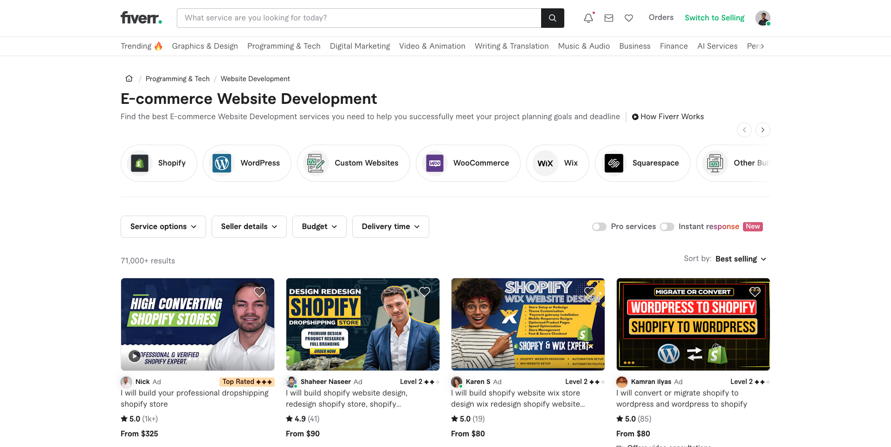
Figure 4: Fiverr.

Guru
Guru is a freelancing platform that underlines the importance of long-term and professional relations and structured work contracts on a global level. It has workrooms, milestones payments, contract negotiation as well as freelancer performance tracking.
Although Guru operates superior cooperation tools to Fiverr, it still has some barriers to access amongst Nepalese freelancers, such as the complexity in collecting payments, the difficulty of currency exchange, and the absence of local supports.

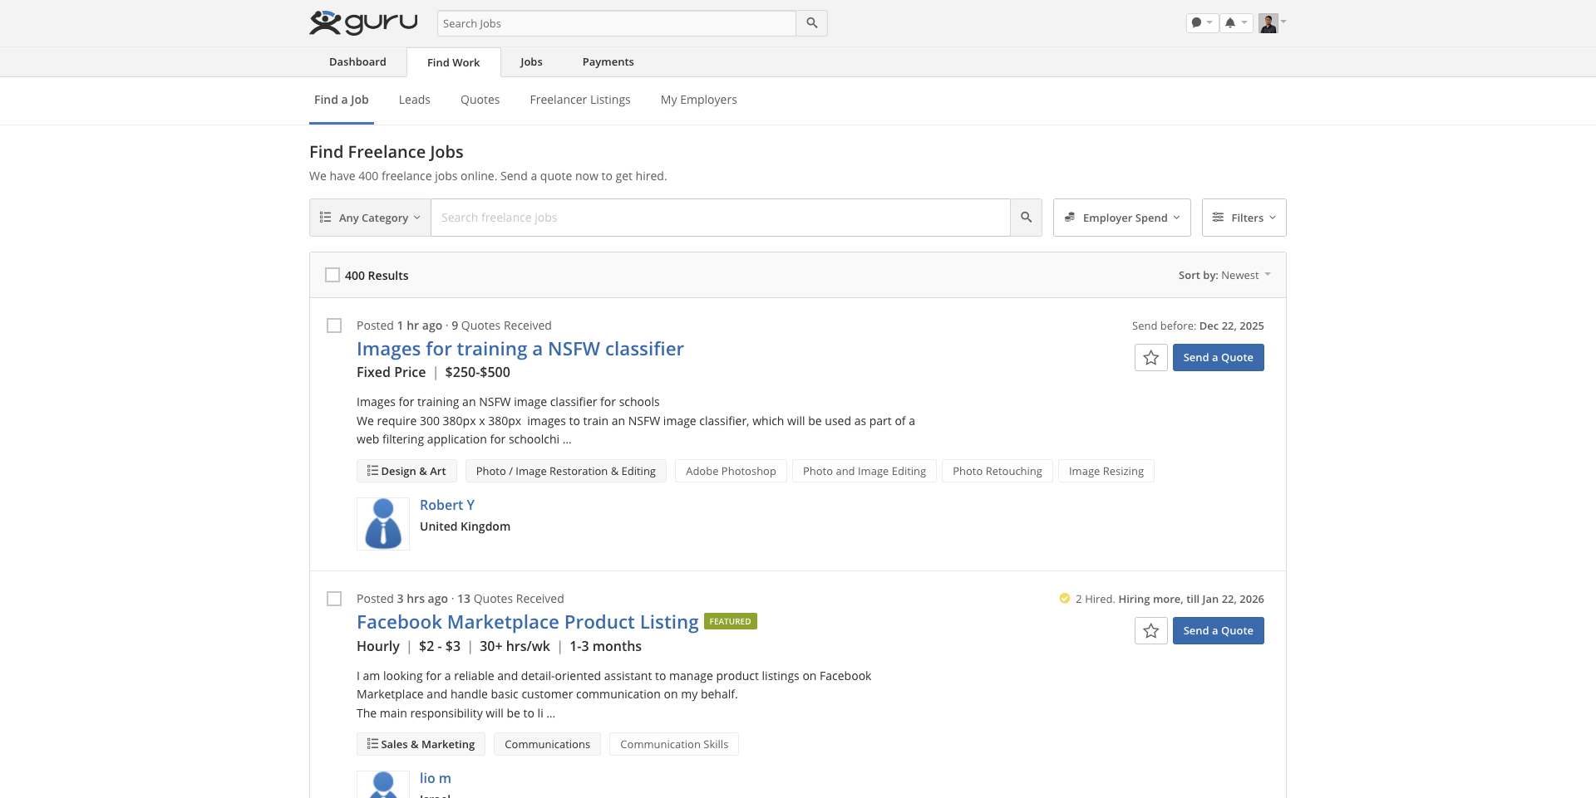
Figure 5: Guru.

Comparison Table of Similar Projects

S.N. | Feature Category | Upwork | Fiverr | Guru | Worklynk (Proposed)
1. | Market Focus | Global freelancing platform | Global service-based freelancing platform | Global freelancing platform | Nepal-focused freelancing platform
2. | Project Posting & Management | Advanced project posting and management | Gig-based service listings | Advanced project posting and management | Advanced project posting and management for clients
3. | Create/Edit/Delete Projects | Supported | Not applicable (gig-based) | Supported | Supported
4. | Budget Fine Line and Scope Control | Available with milestones | Fixed gig pricing | Available with milestones | Available with detailed budget definition
5. | View and Manage Applications | Supported | Not applicable | Supported | Supported with approval and rejection
6. | Direct Freelancer Approach | Supported | Limited via gig inquiry | Supported | Supported with direct messaging
7. | Bookmark Freelancers | Supported | Not supported | Supported | Supported
8. | User Profile Completion | Supported | Supported | Supported | Supported
9. | User Verification Mechanism | Government ID based verification | Platform-based seller verification | Government ID based verification | PAN/VAT based verification
10. | Verification Status Tracking | Available | Limited availability | Available | Available with admin control
11. | Project Browsing | Supported | Gig browsing only | Supported | Supported
12. | Eligibility Checklist before Proposal | Not available | Not available | Not available | Available
13. | Proposal Submission and Withdrawal | Supported | Not applicable | Supported | Supported
14. | Proposal Status Tracking | Available | Not applicable | Available | Available
15. | Bookmark Projects | Supported | Not supported | Supported | Supported
16. | Messaging System | Real-time messaging | Real-time messaging | Real-time messaging | Real-time messaging with admin monitoring
17. | File Sharing in Chat | Supported | Limited support | Supported | Supported
18. | Contract Creation and Negotiation | Supported | Not supported | Supported | Supported
19. | Contract Acceptance and Cancellation | Supported | Order-based cancellation | Supported | Supported
20. | Admin Monitoring of Communication | Not available | Not available | Not available | Available
21. | Project Management Approach | Time-based tracking | Order-based workflow | Milestone-based tracking | Kanban-based project management
22. | Task Creation and Tracking | Supported | Not supported | Supported | Supported
23. | Task Stage Movement | Limited support | Not supported | Supported | Supported
24. | Project Timeline Control | Supported | Limited control | Supported | Supported
25. | Dispute Raising and Resolution | Supported | Supported | Supported | Supported with admin decision
26. | Project Closure Workflow | Supported | Automatic order completion | Supported | Supported with admin approval
27. | Rating and Review System | Mutual rating system | Buyer–seller rating system | Mutual rating system | Mutual rating system with admin visibility
28. | User Management by Admin | Limited control | Limited control | Limited control | Comprehensive control
29. | Dispute Management by Admin | Available | Available | Available | Available
30. | User Suspension or Disable | Supported | Supported | Supported | Supported
Table 3: Comparison Table of Similar Projects.

Comparison Analysis of Comparable Projects.
The relative comparison of Upwork, Fiverr and Guru point out that the global freelancing sites offer good technical infrastructures, which are not entirely matched with the requirements of the Nepalese freelancers and customers. Upwork and Guru have well-organized contracts, payment protection, and resolution of disputes but have deficiencies in high service fees, lack of localization, and accessibility issues among the users with developing regions.
The gig-based method of Fiverr is the easiest in terms of short-term transactions but is not flexible when it comes to long-term and intricate projects. Its inadequate project management and the lack of workflows that are based on negotiations makes it less suitable to professional project-based cooperation.
The review reveals that there is a large disconnect between international platforms and the local needs of Nepalese freelancing system. Worklynk will fill this gap by integrating high-end project management capabilities with the localized verification by submitting PAN/VAT and eligible proposal submission and Kanban-driven task tracking.
Moreover, Worklynk also initiates the full administrative control, such as monitoring of chats, dispute management, control of the contracts, and regulated project closure. The features discuss the typical freelancing issues like disagreements, misunderstanding, and failure to deliver a project which are poorly managed by the existing sites.
Altogether, this discussion confirms the importance of Worklynk as a localized but feature-rich freelancing service that is easy to access, transparent, and technically sound, thus warranting the development as a final year project.

Development Methodology
An appropriate Software Development Life Cycle (SDLC) process is a necessity in terms of organized development, foreseeable results, and quality work. In the case of Worklynk, three approaches were considered Scrum, Waterfall, and Hybrid Agile-Waterfall. When considering the scope of the project, academic needs, documentation amount of work, and anticipated iterative development, Hybrid Agile-Waterfall model is chosen as the proposed methodology.

5.1. Considered Methodologies (Appendix)

5.1.1. Waterfall model:
The Waterfall model is a linear, sequential approach to the software development lifecycle (SDLC) that's popular in software engineering and product development. It uses a logical progression of SDLC steps for a project, similar to the direction water flows over the edge of a cliff. It sets distinct endpoints or goals for each phase of the development process. Those endpoints or goals can't be revisited after their completion (Kirvan, 2024).
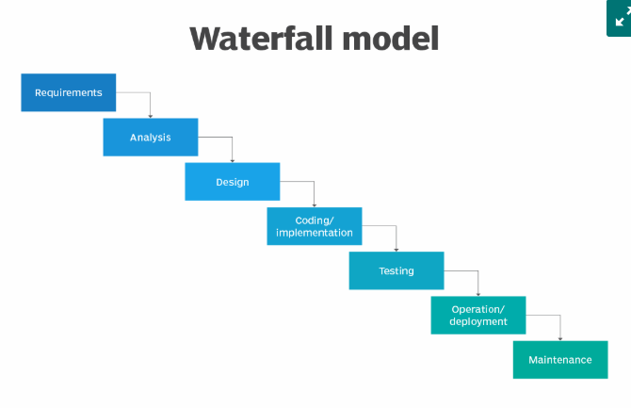
Figure 6: Waterfall Model (Kirvan, 2024).

Consideration Justification: The Waterfall model was viewed as a possibility since the focus on detailed and upfront documentation and a strict and stepwise nature of the form work well with the explicit deliverables and the submissions in stages that the FYP model demands.

Reason for Rejection
The Waterfall model was viewed as a possibility since the focus on detailed and upfront documentation and a strict and stepwise nature of the form work well with the explicit deliverables and the submissions in stages that the FYP model demands.
- Lack of Flexibility to Refinement: The functionality of Worklynk like the Kanban like project board and the bidding module should undergo iterative refinement with prototyping and testing. The strict nature of the Waterfall design is very expensive and hard to integrate such feedback once the design is finished.
- Late-Risk Discovery: Testing between the system as a whole is done after the system is complete. This exposes the project to the occurrence of major integration or architecture failures towards the end of the project schedule with a high risk of failure within the academic time frame.
- No Working Increments: This model does not generate a working product until the very end, and thus does not provide a chance to verify core functionalities and demos to conduct initial assessments.

5.1.2. Scrum (Agile Framework)
Scrum is an Agile project management framework that helps teams organize and oversee their work through values, principles, and practices. Scrum encourages teams to learn through experience, self-organize while working on a problem, and reflect on their successes and failures to continuously improve (Drumond, 2025).

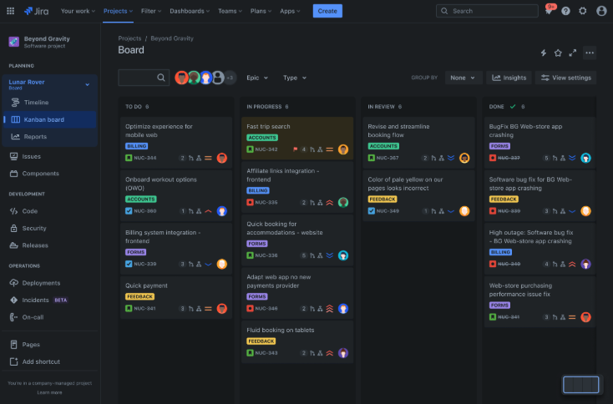
Figure 7: Kanban Board. (Drumond, 2025)

Consideration Justification: The application of Scrum was deemed appropriate because the system is complex and needs to be iterated to provide a fast and frequent feedback. It is best suited to projects whose requirements are likely to change dynamically, which is consistent with the possibility of refining the features of Worklynk.

Rationale for Rejection (Appendix)
In spite of its advantages, Scrum is not the best solution to this Final Year Project because of the following reasons:
- Conflict with Upfront Documentation Requirements: The FYP requires the presentation of full documentation prior to the main development stage, which includes full Software Requirements Specification (SRS), UML diagrams, and ERDs. The requirement that Scrum employs is in direct opposition to the need of definite and upfront deliverables.
- Unrealistic Team-Based Organization Scrum is intended to work with teammates who have specific roles (Scrum Master, Product Owner). As an individual developer, it is not feasible to simulate such roles and hold daily stand-ups, which do not provide the administrative overhead with the desired collaborative value.
- The inflexibility of the checkpoint deliverables of an FYP (proposal, SRS, final report) needs a consistent scope and known deliverables, which is incompatible with the Scrum-flexible backlog and adaptive scope.

5.2. Proposed Methodology: Hybrid Agile-Waterfall Model
Agile Waterfall Hybrid is a midway approach to Agile and Waterfall methods, which make use of the benefits of both methodologies. Since the agile and waterfall methodologies have their pros and cons, ruling out one in favour of the other would not be a sensible approach. There has been a significant growth in the trend of using this hybrid agile methodology for a lot of reasons (Aims, 2025).
Proposed Process Summary
Phase 1: Waterfall (Structured Planning and Design):
- RS Creation and Requirement Analysis.
- System Design (UML, ERD, Architecture Diagrams)
- Output: Finished, satisfactory documentation according to the FYP.
Phase 2 - Agile (Iterative Development and Testing):
- Sprint 1: User Authentication and Public Browsing.
- Sprint 2: Management and verification of profile.
- Sprint 3: Project Posting and Bidding Module.
- Sprint 4: Kanban Board and Contract Management.
- Sprint 5: Rating System, Admin Dashboard.
- Deliverable: A complete tested platform that is developed on controllable bits.

Justification as the Ideal Fit
- Hybrid model is the best option to be chosen to work on the Worklynk project due to the following reasons:
- Meets Academic Requirements: The first stage of the Waterfall phase is a guarantee that all the required documentation (SRS, SDS, diagrams) is done and finalized in advance, which fits the FYP submission requirements perfectly.
- Facilitates Adaptive Development: The following Agile sprints permit the iterating construction, integrating, and testing of complicated modules. This approach helps to reduce the technical risks at early stages and enables the practical refinement of the features without contravening the pre-established project scope.
- Best used in Solo Development: It has a well-organized roadmap to adhere to and yet flexible enough in implementation without the burdensome task of simulating a complete Scrum team.
- Favors an MVP-Centric Strategy: It is a model that helps to focus on the creation of the core Minimum Viable Product (MVP). The optional advanced features, like more sophisticated CV parsing, can either be put to the backlog and implemented much later, provided time permits, or duly prioritized and implemented.

Resource Requirements

6.1. Hardware Resources
Resource | Description & Justification
Laptop/PC (i5/i7, 8–16GB RAM) | Required for running development servers, databases, IDEs, and testing multiple modules concurrently.
Smartphone (Android/iOS) | Needed for mobile responsiveness testing and prototype validation.
Storage (SSD 256GB+) | For storing project files, datasets, dependencies, and backups.
Table 5: Hardware Resources.

6.2. Software Resources

Software | Description & Importance
VS Code | Primary development environment for frontend & backend coding, debugging, and version control integration.
Node.js + Express.js | Backend runtime and framework for building RESTful APIs, authentication, and business logic.
NextJS | Frontend framework for building dynamic and responsive user interfaces and dashboards built on top of React.
PostgreSQL | NoSQL database for storing flexible data models like user profiles, projects, and contracts.
Git & GitHub | Version control system for tracking code changes, collaboration, and project backup.
Docker | Containerization platform for consistent development and deployment environments (optional for future scaling).
Postman | API testing tool for debugging endpoints and ensuring backend functionality.
Figma | UI/UX design tool for creating wireframes, prototypes, and visual designs before implementation.
Table 6: Software Resources.

6.3. External Access/Services
- Availability of PAN/VAT verification protocols of IRD Nepal (manual or API-based).
- Access to Nepal Rastra Bank policies to learn the limitation of payment (to improve in the future).

Work Breakdown Structure
A WBS is a project management tool used in visual representation and partitions a project into smaller manageable and structured components in a hierarchical manner. It begins with the general objective on the top and breaks the project down into small tasks and deliverables. The levels are inter-relational as each level is linked to the levels above it and how the single tasks benefit the bigger deliverable. Such a hierarchical perspective assists a team to plan, administer, and track intricate work more efficiently (Figma, 2025).
Projects in a WBS are organized in three levels:
- Level one is one that indicates the whole project or ultimate deliverable and gives a high description of the purpose of the project.
- The middle level, level two, divides the project into significant deliverables or phases that should be fulfilled to accomplish the key objective.
- Level three and further lower levels will subdivide each deliverable into finer tasks and work packages of each individual or team.

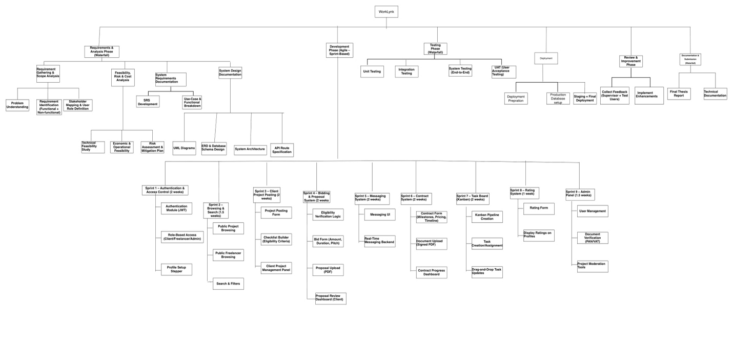
Figure 8: WBS.

Milestones
A milestone chart is a horizontal chart that marks the most important steps of your project. Each milestone your team achieves brings you closer to completing the project. Besides keeping your team motivated, a milestone chart is also a great way to show project stakeholders how your project is progressing. In this article, we cover how to create a milestone chart and how you can use it to celebrate milestones with your team (Asana, 2025).
For this project, milestones are aligned with the Hybrid Agile–Waterfall methodology, ensuring that Waterfall-driven documentation phases and Agile-driven sprint cycles are monitored effectively.
Each milestone below corresponds to the completion of a major set of activities from the WBS and marks a clear deliverable or phase transition.

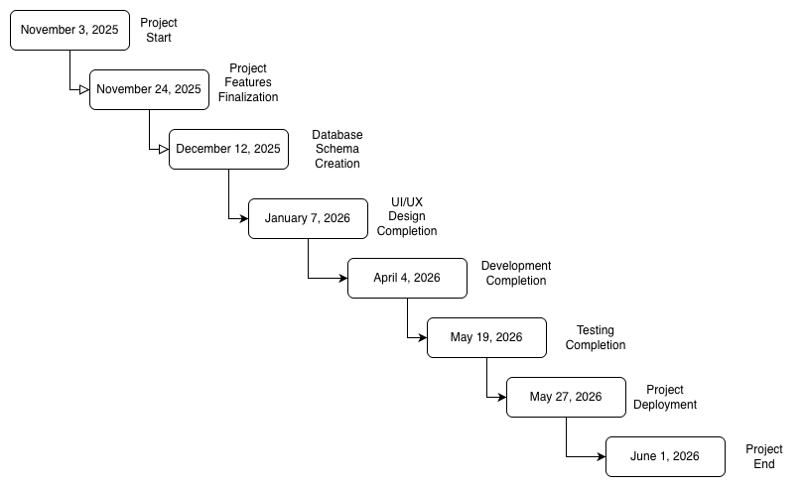
Figure 9: Milestone Chart.

Project Gantt Chart
A Gantt chart, commonly used in project management, is one of the most popular and useful ways of showing activities (tasks or events) displayed against time. On the left of the chart is a list of the activities and along the top is a suitable time scale. Each activity is represented by a bar; the position and length of the bar reflects the start date, duration and end date of the activity (Gantt, 2025).
See Gantt Chart.
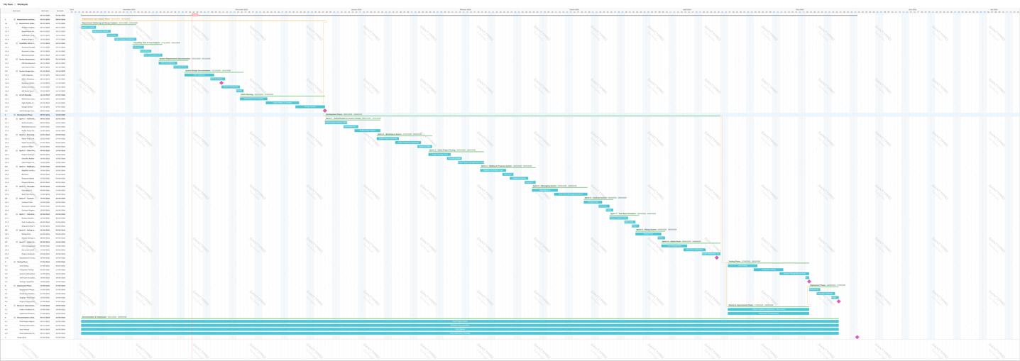
Figure 10: Gantt Chart.

Conclusion
Worklynk is the proposed project that is designed to fill an essential gap in the freelancing and project-based work environment in Nepal by introducing a centralized, structured, and verification-centered platform. The proposal gives a solid background on why a comprehensive solution is required through the thorough examination of the current issues that include fragmented service channels, no trusted relations between clients and freelancers, and the unstructured flow of services through project posting to the ultimate delivery. All the identified goals, objectives, and anticipated outcomes prove that Worklynk will not just facilitate the process of effective project matchmaking but also bring about professional standards due to such functionality as PAN/VAT checks, structured bidding, contractual agreements, Kanban-style task management, and built-in rating systems.
The selected Hybrid methodology of Agile-Waterfall would provide a systematic yet flexible development approach that would be compliant with academic norms of initial documentation upfront but allows the iterative development of the procedure through sprints. The Work Breakdown Structure, milestones, and Gantt-aligned roadmap support the possibility of delivering the project on time within the academic time-period even more. The determination of identified risks and contingency plans also points to the preparedness of the project to real challenges in the world during the implementation.
In general, the proposal is a clear, well-informed, and implementable concept of the development of a powerful freelancing and project management platform, which would suit the conditions in Nepal. On successful completion, Worklynk is supposed to provide a high-value digital solution, which will improve trust, transparency, and efficiency in the digital employment industry-increasing Nepal, and meet all the academic, technical, and operational needs of the Final Year Project.

Bibliography
Payoneer Team, 2024. Payoneer. [Online]
Available at: https://www.payoneer.com/resources/business/the-payoneer-2023-freelancer-insights-report
[Accessed 22 November 2025].
Quantumrun Foresight, 2025. Quantumrun Foresight. [Online]
Available at: https://www.quantumrun.com/consulting/freelancing-statistics/
[Accessed 22 November 2025].
Ministry of Federal Affairs and General Administration, 2025. The Gig Economy Revolution in Nepal: Analyzing Challenges and Opportunities for Digital Governance, Kathmandu: www.mofaga.gov.np/prashasanjournal.
Khanal, B. P., 2024. Information Technology in Nepal: History and Current Status, Kritipur: Central Campus, T.U., Kritipur.
Sagar B.K., N. D. S. B., 2024. From Traditional Employment to Gig Work: Analyzing Labor Dynamics in Nepal's Emerging Gig Economy, Kritipur: CEDA/TU.
Tuladhar, A., 2025. Nepal Economic Forum. [Online]
Available at: https://nepaleconomicforum.org/the-present-and-future-of-gig-economy-in-nepal/
[Accessed 22 November 2025].
Kirvan, P., 2024. Tech Target. [Online]
Available at: https://www.techtarget.com/searchsoftwarequality/definition/waterfall-model
[Accessed 27 November 2025].
Drumond, C., 2025. Atlassian. [Online]
Available at: https://www.atlassian.com/agile/scrum
[Accessed 26 November 2025].
Aims, 2025. Aims. [Online]
Available at: https://aims.education/agile-waterfall-hybrid-finding-midway/
[Accessed 27 November 2025].
Figma, 2025. Figma. [Online]
Available at: https://www.figma.com/resource-library/work-breakdown-structure/
[Accessed 28 November 2025].
Asana, 2025. Asana. [Online]
Available at: https://asana.com/resources/milestone-chart
[Accessed 29 November 2025].
Gantt, 2025. Gantt. [Online]
Available at: https://www.gantt.com/
[Accessed 29 November 2025].

