**SMART INTERVIEW SYSTEM**

Project id – 18-046

Software Requirement Specification

A.M.C.A.B. Abeysinghe – IT15094414

T.W.A.P. Madushan – IT15103178

S.S. Seneviratne - IT15034014

B.A.P.N. Vikum - IT15132192

Sri Lanka Institute of Information Technology

Sri Lanka

May 2018

# Declaration

We declare that this is our own work and this proposal does not incorporate without acknowledgement any material previously submitted for a degree or diploma in any other university or Institute of higher learning and to the best of our knowledge and belief it does not contain any material previously published or written by another person except where the acknowledgement is made in the text.

|  |  |  |
| --- | --- | --- |
| Name | Student ID | Signature |
| A.M.C.A.B. Abeysinghe | IT15094414 |  |
| T.W.A.P. Madushan | IT15103178 |  |
| S.S. Seneviratne | IT15034014 |  |
| B.A.P.N. Vikum | IT15132192 |  |

The above candidates are carrying out research for the undergraduate Dissertation under my supervision.

……………………………………………

Supervisor

(Dr. Darshana Kasthurirathne)

……………………………………………

Date

Table of Contents

Declaration ii

1. Introduction 1

1.1 Purpose 1

1.2 Scope 2

1.3 Definitions, Acronyms and Abbreviations 3

1.4 Overview 3

2. Overall Descriptions 5

2.1 Product perspective 5

2.1.1 System interfaces 6

2.1.2 User interfaces 6

2.1.3 Hardware interfaces 10

2.1.4 Software interfaces 11

2.1.5 Communication interfaces 11

2.1.6 Memory constraints 11

2.1.7 Operations 12

2.1.8 Site adaptation requirements 12

2.2 Product functions 12

2.3 User characteristics 18

2.4 Constraints 18

2.5 Assumptions and dependencies 19

3. Specific Requirements 20

3.1 External interface requirements 20

3.1.1 User interfaces 20

3.1.2 Hardware interfaces 24

3.1.3 Software interfaces 24

3.1.4 Communication interfaces 25

3.2 Classes / Objects 26

3.3 Performance requirements 26

3.4 Design constraints 27

3.5 Software system attributes 27

3.5.1 Reliability 27

3.5.2 Availability 28

3.5.3 Security 28

3.5.4 Maintainability 28

4. References 29

**List of Figures**

Figure 1: Main interface 6

Figure 2 : Login 7

Figure 3 Register new user 8

Figure 4 Interviewer Interface 8

Figure 5 Result interface 9

Figure 6 User profile 10

Figure 7: High level architecture diagram 13

Figure 8 : Use case diagram 14

Figure 9: Overview 20

Figure 10 : Class diagram 26

**List of tables**

Table 1: Abbreviations 3

Table 2 Login 15

Table 3 User Registration 15

Table 4 Start interview 16

Table 5 Display result 16

Table 6 Edit user profile 17

Table 7 View summery of all sessions 17

Table 8 : Login interface table 21

Table 9 : Register interface table 21

Table 10 : Main interface table 22

Table 11 : Interviewing interface table 22

Table 12 : Result interface table 23

Table 13 : User profile interface table 24

# Introduction

## Purpose

The purpose of this SRS is to give a good understanding of the smart interviewer system, question generation, answer validation, reinforcement learning and facial and voice recognition. Functional and non-functional requirements of the entire system will be discussed throughout this document, the key areas of all four categories; smart interview question, question generation, answer validation and reinforcement learning and facial and voice recognition will be discussed throughout the document.

The special features of the smart interviewer system, question generation, answer validation and reinforcement learning and facial and voice recognition. and the details of the question preparation process will be elaborate, validating the answers given by the user, identifying the difficulty levels of the user and will capture the features that can be specify the user or to identify separately from the other users.

Furthermore, the interface used in the development process, the dependency assumptions used in the implementation process and the technologies will be elaborate throughout the report. Answer validation, voice and facial recognition, reinforcement learning and question generation are thee four key categories that the software can be breakdown in to. A bigger picture of the entire project will expound with the combination of all four categories such as; smart interviewer system, question generation, answer validation and reinforcement learning and facial and voice recognition.

There won’t be any frequent changers as usual in the report and the discussion, since it carries the guiltiness of software development. The project goes as a progressing research therefore changers requested can be done with fail resourcing after conducting a formal discussion.

## Scope

The report describes the major part of the four categories; smart interviewer system, question generation, answer validation and reinforcement learning and facial and voice recognition. Furthermore, the designs, concepts and the implementation tactics that are being used throughout the research on completing the software that compiled with the key four categories; smart interviewer system, question generation, answer validation and reinforcement learning and facial and voice recognition are also focused in the report. The main expectation of the final output of this research project is to improve and develop the skill level of the people who are plaining to face an interview in the future while creating a real scenario of an interview to help the people to overcome from anxiety, nervousness and the scariness on facing interviews.

The system also leads to reduce the time that an interviewee should spend on preparation of question to get trained for the interview that they are hoping to face in the future. The confidence level of a person will increase as the system have the ability to create a real scenario of an interview. The feedback that will be provided as the output of the system or the end result of the system that will be developed at the end of the research will give the opportunity for the user to have a clear understanding on their strengths and weaknesses. With the help of the final output provided by the system the user will get the opportunity to identify and to gain a clear understanding on the strengths and weakness of the user. Therefore, the final output of the system will be helpful for the user to improve on their weaknesses and to develop their strengths.

The four components; smart interviewer system, question generation, answer validation and reinforcement learning and facial and voice recognition are mainly involved in question generation process. The end expectation of this system is to develop and generate questions that will be useful for the user to add more value on their talents that can be used at the interview to gain best results with more confidence.

## Definitions, Acronyms and Abbreviations

|  |  |
| --- | --- |
| AI | Artificial Intelligent |
| NLTK | Natural Language Toolkit |
| GUI | Graphical User Interface |
| OS | Operating System |
| SRS | Software Requirement Specification |
| CV | Curriculum Vitae |
| XML | Extensible Markup Language |
| IDE | Integrated Development environment |
| US | United State |
| DX | directx |
| VGA | Video Graphics Array |
| ML | Machine learning |
| NN | Neural Network |
| SVM | Support Vector Machine |
| GPU | Graphical Processor Unit |

Table 1: Abbreviations

## Overview

The SRS document consists of functional and non-functional requirements, limitations, interfaces and the steps that are to be followed in the smart interviewer system

A basic idea of the outcome of the smart interviewer system is discussed in the second section and an accurate idea of the smart interviewer system will be given in the second section. A wide area of key points will be described throughout the document. In this section system is elaborated in a lower level. At the beginning of the section all the software which are similar to the smart interviewer system will be compared and elaborated. Internal features such as graphical user interfaces and external features such as hardware requirements are also described in the section. Users and their privileges are also discussed in this section. This section ends after elaborating the assumptions and dependencies.

Third section consists of functional and non-functional requirements of the system. Smart interviewer will fall under object-oriented programming, therefore these concepts are also being described in this section.

The references of the resources which were used to prepare this document is stated in the section four.

# Overall Descriptions

Here we discuss about overall process of the entire project. Here we describe the connection between user interfaces as well as basic functionalities thereof. Here we describe technologies and techniques for developing the system.

People use poor methods to prepare for the interviews. The system developed at the end of this project will generate questions that are appropriate for real situations. The Smart Interviewer system met four components, such as: Face and speech recognition, reinforcement learning, question generation and answer validation. Deep learning, data management and preparation are closely linked in the implementation of the system. The final output of the system will be user-friendly system. The main goal of our system is to prepare the interviewee to get a good grade at the right interview session.

## Product perspective

Before we start the project we have done research to identify similar system has implemented before. But we could not find a similar system to our system. 80 people were participated for our research and they really wanted a system for their future purposes. We could not find high quality standard system in the internet. There are some applications those applications only test the theoretical aspects and knowledge of the interviewee. Considering theoretical aspect is not worth enough. In actual situation interviewers consider lot of aspects when giving marks for interviewees. So neglecting user actions emotions the way he talk at the interview is weak point of the current implemented application. Most of the applications ask questions and the questions are displayed on the screen and the give limited time to answer for the question. But actually will not feel actual interview scenario when using the application. But our system acts as a game. Most of the time interviewer tries to defeat the interviewee. So interviewees’ goal should be maintaining a good score at the interview.

There are some systems implemented by different companies called virtual assistants. Apple, Google, Samsung, IBM have implemented virtual assistants they will make conversations with user and they can make interesting continuous conversations. They only answer for the questions that user asked. They cannot creatively think and ask questions. But our system has that ability. Avatar start the conversation and keep continue up to maximum 1 hour.

Apple products have their virtual assistant called “siri” and it is developed using deep learning, tagging, noise reduction engine, voice biometric, voice recognition, speech compression engine, user interface, STT and TTS. But AI could not understand the users’ question AI is not going to continues the conversation.

“Smart Interview” is a creative idea and innovative product to the world. Although there are some question-generating software that do not exactly give what should be done in an interview process. Therefore, the intelligent interviewer will develop into an innovative product.

### System interfaces

Facial expressions vary from person to person and it is best to use learning methods. Keras is a deep Python learning library that supports neural folding networks. It can also run without problems on CPU and GPU. Keras is compatible with the Python language and can be easily changed. Kears can start TensorFlow. There are so many prepared questions in the ontology. System will randomly select the question and ask from the user. The google text to speech will help to convert the prepared questions to vocal questions. And also system will convert the user speech to text for check the validation of the answer.

### User interfaces

* Home page

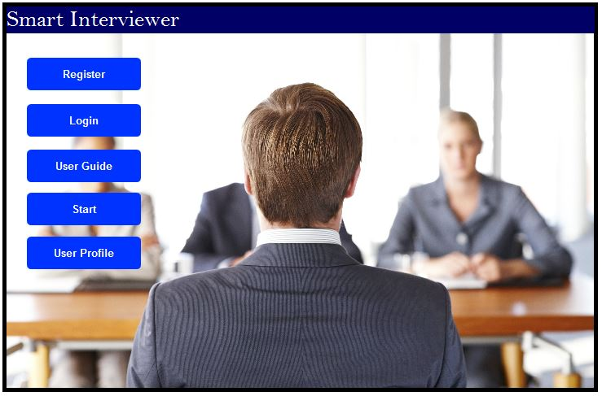

Figure 1: Main interface

In the home page basic functions are displayed and it is easy for user. Home page is very simple and it is user attractive interface. Simple interface always keep the attraction of the user. Most commonly use functions are added to the home interface.

* Login

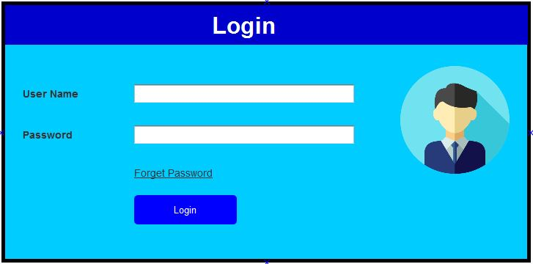

Figure 2 : Login

If the user wants to start the interview first, first log in to the system. The username is unique among people. Passwords can have letters, numbers and symbols. If the user forgets the password, the user simply clicks on the forgotten password link and the system will restore the account by asking three questions. Once you have the correct answer to all the questions, the system will allow you to access the account.

* Register new user

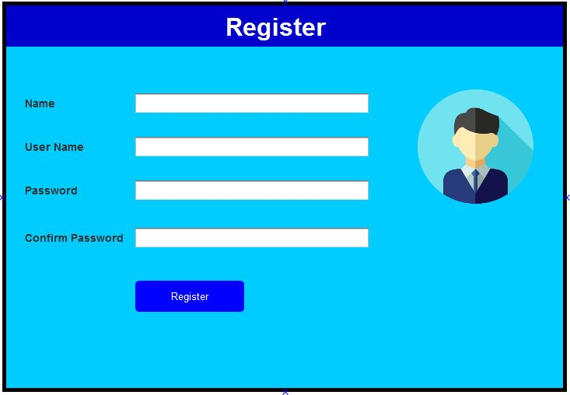

Figure 3 Register new user

Before you loge into the system you should create an account. You can upload your photo to the system and it appears on the user profile. User must enter valid details to the system and username should not be existing one in the system. If there is an existing username in system will prompt a message and ask user to enter another username. After filling the user details correctly he will be able to register to the application.

* Interviewer interface

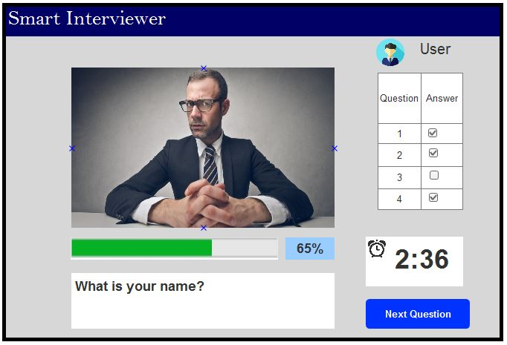

Figure 4 Interviewer Interface

This is an important interface and an interview process that takes place here. There is an avatar, which asks questions based on the regional user of the expert. According to the response, the interviewer will express their feelings. The interviewer verbally expressed his problem and showed it on the screen. The system will allocate time to answer questions. If the respondent answers the question quickly and retains more time, go to the next question by clicking on the "Next question" button. The remaining time and response questions are displayed on one side of the interface. The progress bar will show the progress of answering questions. The progress of the relevant session is saved in the database.

* Result interface

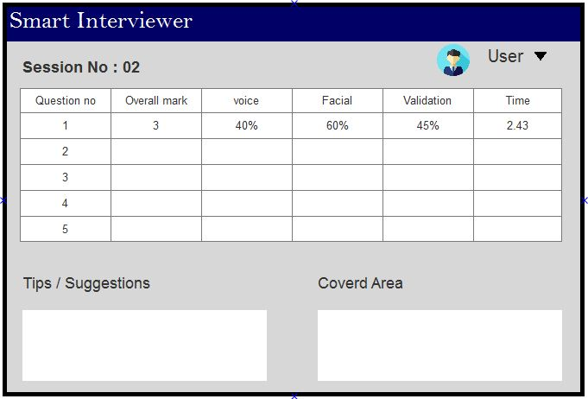

Figure 5 Result interface

The detailed results table based on the session will be shown to the user. It shows the voice, the face, the verification, the time and the general score of each question. In the same interface system, some tips will be presented to improve the interviewers' difficulties in the interviews

* User Profile

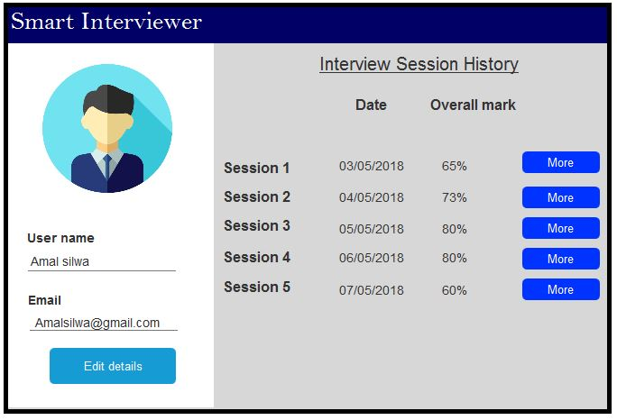

Figure 6 User profile

For user convenience, the general details and user profile details are displayed in a single interface. If the user wants to update the details of the user's profile, they must first enter the username and password. When user click “Edit details” button then he will be asked to enter the password. So this method improves the security side of the system. If it is a valid system, it allows users to edit user profiles. The "More" button directs the user to the results table.

### Hardware interfaces

In the smart interview system it mainly use three hardware devises to take raw data and output data again to the user. As the devices, we use web camera, microphone and the speaker.

To identify the facial expressions, we use web camera. The speaker is used to asking question process and it is a result of text to speech conversion. Microphone is used for detect the voice cuts given from user then speech to text conversion and used for answer validation process.

### Software interfaces

The following software interfaces are used to develop emotion recognition part of the project.

* Python language & python libraries
* Tensorflow
* Unity
* Pycharm
* XML files
* NLTK
* Neo4j

### Communication interfaces

The system is designed as client server system, so for the server part handle it wants a internet connection. So the stable and fast internet connection should be there in running the application. To make the network, we use router connection.

### Memory constraints

In memory usage basically it uses memory space to update the data and contain the saved data. For updating, save new user data, update the CV and user details, interview session details etc. Saved data means the data sets that used in facial and voice recognition. This is a declaration of memory constraint in software and tools.

Note: these are the minimum requirements

|  |  |  |
| --- | --- | --- |
| **Software** | **RAM** | **External storage** |
| NLTK | 1GB | 2-3GB |
| Neo4j | 2GB | 10GB (SATA) |
| PyCharm | 2GB | 4GB |

### Operations

Basically there are two type of users in the system. They are registered user and unregistered user. System breaks activities with authenticate with type of user that can do.

* Registered User
* Can logging to the system.
* Can be able to start interview.
* Can give facial and vocal data to the system.
* Create user accounts.
* Can see the result of users performance.
* Can access to see the result of previous sessions.
* Guest user
* Only few activities can do.
* Can see the features, functions and documentations.

### Site adaptation requirements

The system is designed to run on Windows platforms. So we use windows related software, installation modules and other supporting features that related to windows operation system. In implementation, it wants to make it for suitable for windows platform. So in build up, need to aware of installation models, features etc.

Because of the English language is worldwide common used language, we use it to implementation and design the interfaces. It increase the usability and user friendly. In future developers can easily understand the system.

## Product functions

In this section describe the main functions and the sub functions that interconnect with the other functions. They are connected to each other. Some function output can may be the input parameters for another function. The combination of those things gives a complete working system.

Mainly there are four main functions and other functions are related to that functions. They are,

* Facial and vocal expressions recognition
* Generating questions
* Answer validation
* Set difficulty level for knowledge areas

To show the functionalities in graphical way, we use high level architecture diagram and use case diagram. High level architecture diagram shows the overall system behavior and the use case diagram shows the functionalities.

**2.2.1 High level architecture diagram**

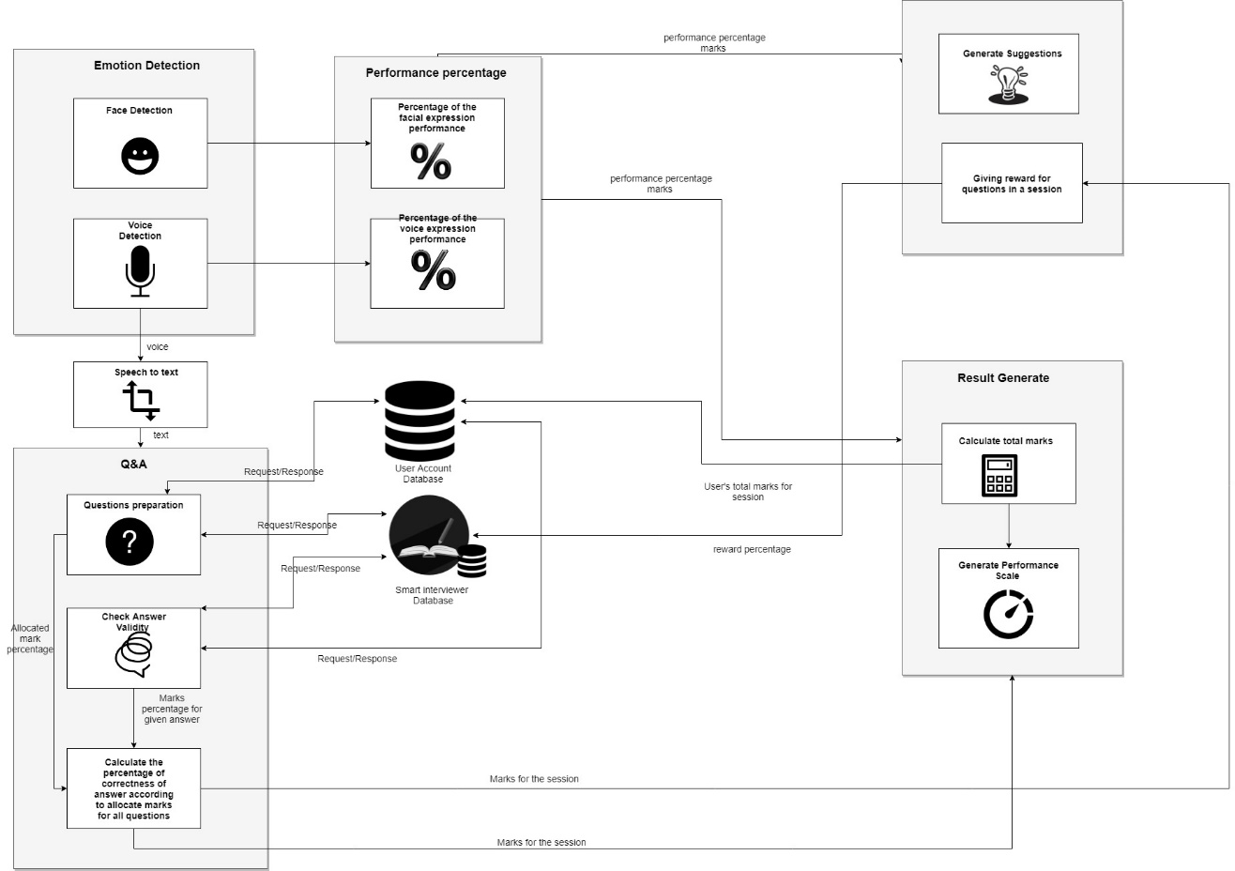

Figure 7: High level architecture diagram

**2.2.2 Use case diagram**

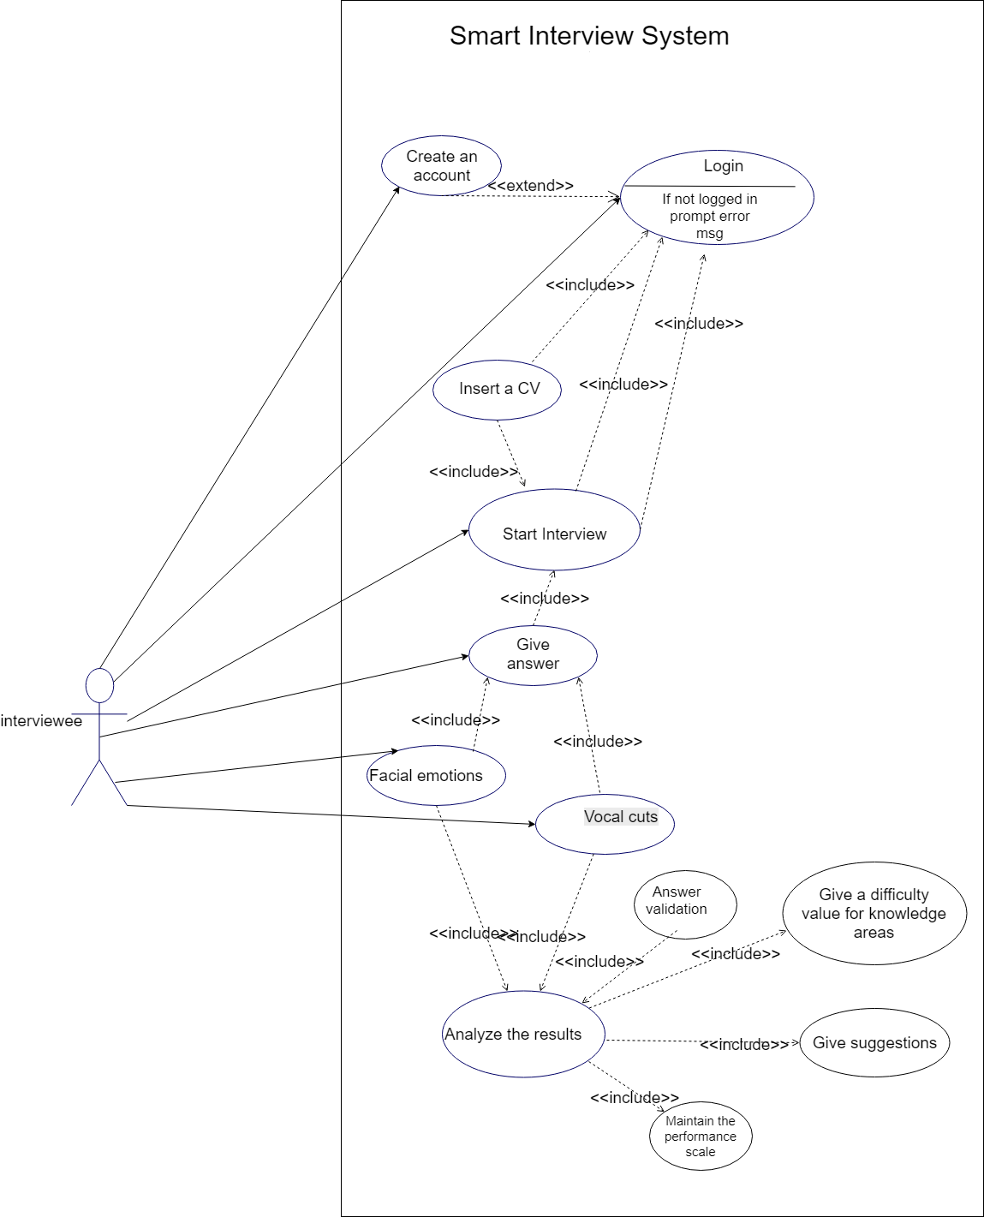

Figure 8 : Use case diagram

**2.2.3 Use case scenarios**

|  |  |
| --- | --- |
| Use Case ID | 01 |
| Use Case Name | Login |
| Description | Login in to the system (only registered user) |
| Actor | User |
| Preconditions | User is a registered user |
| Main Flow | 1. Enter the username 2. Enter the password 3. Enter Login button |
| Post Conditions | User entered details validation |
| Extensions | - |

**Table 2 Login**

|  |  |
| --- | --- |
| Use Case ID | 02 |
| Use Case Name | User Registration |
| Description | Register a user as new user |
| Actor | User |
| Preconditions | User is new to system |
| Main Flow | 1. Enter the user personal details  2. Press register button |
| Post Conditions | Loading the home page |
| Extensions | - |

**Table 3 User Registration**

|  |  |
| --- | --- |
| Use Case ID | 03 |
| Use Case Name | Start the interview session |
| Description | Start the interview session (register user only) |
| Actor | User |
| Preconditions | User has to logged to the system |
| Main Flow | 1. Enter the correct user details.  2. Select the features you are going to face for the interview.  3. Save the details  4. start the interview |
| Post Conditions | Load the result page. |
| Extensions | - |

**Table 4 Start interview**

|  |  |
| --- | --- |
| Use Case ID | 04 |
| Use Case Name | Result display |
| Description | After completing a interview session results are generated |
| Actor | User |
| Preconditions | Finish a session |
| Main Flow | 1. user face a interview session 2. give facial expressions 3. give vocal expressions 4. finish the interview session |
| Post Conditions | Can logout the system or try another session |
| Extensions | - |

**Table 5 Display result**

|  |  |
| --- | --- |
| Use Case ID | 05 |
| Use Case Name | Edit the user profile details |
| Description | Registered user wants to update user profile. |
| Actor | User |
| Preconditions | Logging the system |
| Main Flow | 1. Enter into user profile 2. Click update button 3. Make updates 4. Save details |
| Post Conditions | Load the home page |
| Extensions | - |

**Table 6 Edit user profile**

|  |  |
| --- | --- |
| Use Case ID | 06 |
| Use Case Name | View session summary |
| Description | View the user progress. |
| Actor | User |
| Preconditions | User must do one or more interviews. |
| Main Flow | 1. Enter to the system.  2. Click user profile.  3. Right-hand side system will all sessions with overall marks |
| Post Conditions | Redirect to the application home page. |
| Extensions | - |

**Table 7 View summery of all sessions**

## User characteristics

This software is suitable for any person it does not matter the age. School students, university students, professionals, job seekers will be able to use the software and can get lot of benefits. System is having user-friendly UI so users love to use the software. The system is more suitable for people feeling shy and fear at a interview. Sometimes interviewees fail interviews because of small weak point. But they don’t know the weak point and they think they have faced the interview very well. If those types of persons fails number of times in interviews they will be fed up with facing interviews any more. By using this kind of software system give some clues to identify weak points.

Some interviewees are not good in communication and they do lot of mistakes when communicating with others. Most of the time users unable to express their ideas to interviewers correctly and clearly because of having lack of knowledge. If interviewees won’t practice before using this kind of application he will be losing great opportunity. Users will be able to take an idea about the memory capacity. Because system is checking validity of the answer and display the result to user.

Basically we target the IT related persons for the software. IT field is a large field and it is having lot of job opportunities. IT people should learn more than one programming language when going to the industry. After sending the CV sometimes companies suddenly call interviewees for interviews. If the user has included that he knows two programming languages, interviewers ask questions from both the languages. Like this kind of situation system will help user to recall the knowledge regarding particular languages.

## Constraints

1. Regulatory policies

* The system is designed to run in the windows operating system. So user has the basic knowledge of using windows.
* User need to have a knowledge to install the application.

1. Interface to other applications

* The system will be an interface and guidance to other application designs like speech practices, viva sessions, presentations etc.

1. Higher-order language requirements

* English language is used to create GUIs and other details.
* Because it is a worldwide language.

1. Reliability requirements

* In generating results, it used algorithms to fit all the situations and it common to all. So user can keep the reliable on the results.

1. Safety and security considerations

* In using the system there are two main users; Registered user and unregistered user.
* Some actions/activities are limited for the users
* The details are secured because it is run in account format and the user have a username and password to access the application.

## Assumptions and dependencies

* Basically we target IT student and IT professionals.
* The platform is highly considerable for run the application. Currently it will run on windows 10 platform.
* If current dataset is not sufficient we will be using large dataset, it improves the accuracy of the system
* If the precision of the results is low or the SVM algorithm go down, we will use another algorithm to classify the facial images. That will be k-means algorithm
* Most of the courtiers use English but some other countries use different languages. We will expand and convert the system to other languages.
* The system will be expanded for school students who face discourse debates and students who need to improve their communication skills and integrate into society

# Specific Requirements

## External interface requirements

### User interfaces

**In this section it gives the explanation about the interfaces that related to the all the functionalities in the system. The interfaces are used by in different situations and different activities. System uses that interfaces to manage the functionalities, deliver output and make interconnection with other interfaces.**

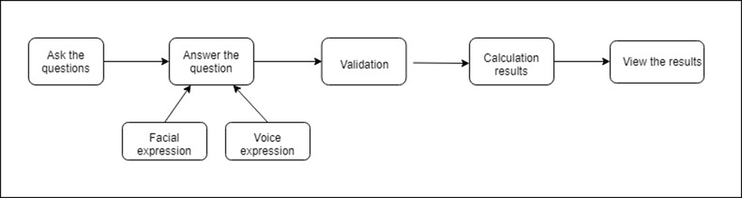

Figure 9: Overview

This is an overview of overall system with the interfaces. After the user register in the system, user gets the user name and password. Then user become a registered user and can access to work with the system. In interview process when the system ask a question user have to answer it. The facial and vocal expressions detected during the interview. The given answer will check with the ontology and acording to correctness of the answer marks will be allocated. Then the all marks are calculated for a final mark for a question and after the finishing interview session user get a final mark.

* Login interface

|  |  |
| --- | --- |
| **Name of item** | Login Interface |
| **Description of purpose** | This interface is used by the registered user to login to the system. |
| **Source of input or destination of input** | Username and password |
| **Valid range, accuracy and/or tolerance** | N/A |
| **Units of measure** | Feedback Time |
| **Timing** | Feedback Time |
| **Relationships to other inputs/outputs** | N/A |
| **Screen formats/organization** | Full screen |
| **Window formats organization** | Full screen |
| **Data formats** | String |

Table 8 : Login interface table

* Register interface

|  |  |
| --- | --- |
| **Name of item** | Register Interface |
| **Description of purpose** | User uses this interface to create an account. |
| **Source of input or destination of input** | Name, Username, Password and confirm password. |
| **Valid range, accuracy and/or tolerance** | N/A |
| **Units of measure** | Feedback Time |
| **Timing** | Feedback Time |
| **Relationships to other inputs/outputs** | N/A |
| **Screen formats/organization** | Full screen |
| **Window formats organization** | Full screen |
| **Data formats** | String |

Table 9 : Register interface table

* Main interface

|  |  |
| --- | --- |
| **Name of item** | Main Interface |
| **Description of purpose** | The options of the systems are viewed in this interface. |
| **Source of input or destination of input** | Mouse click. |
| **Valid range, accuracy and/or tolerance** | N/A |
| **Units of measure** | N/A |
| **Timing** | Closed when a option is selected. |
| **Relationships to other inputs/outputs** | N/A |
| **Screen formats/organization** | Full screen |
| **Window formats organization** | Full screen |
| **Data formats** | N/A |

Table 10 : Main interface table

* Interviewing interface

|  |  |
| --- | --- |
| **Name of item** | Interviewing Interface |
| **Description of purpose** | Interview session is conducted using this interface. |
| **Source of input or destination of input** | Voice inputs and face inputs. |
| **Valid range, accuracy and/or tolerance** | N/A |
| **Units of measure** | N/A |
| **Timing** | Until the interview session finishes. |
| **Relationships to other inputs/outputs** | N/A |
| **Screen formats/organization** | Full screen |
| **Window formats organization** | Full screen |
| **Data formats** | String |

Table 11 : Interviewing interface table

* Result interface

|  |  |
| --- | --- |
| **Name of item** | Result Interface |
| **Description of purpose** | The final result of the interview is displayed in this interface. |
| **Source of input or destination of input** | N/A |
| **Valid range, accuracy and/or tolerance** | N/A |
| **Units of measure** | N/A |
| **Timing** | User close the window. |
| **Relationships to other inputs/outputs** | N/A |
| **Screen formats/organization** | Full screen |
| **Window formats organization** | Full screen |
| **Data formats** | String |

Table 12 : Result interface table

* User profile interface

|  |  |
| --- | --- |
| **Name of item** | User Profile Interface |
| **Description of purpose** | History and the user details are displayed in this interface. |
| **Source of input or destination of input** | N/A |
| **Valid range, accuracy and/or tolerance** | N/A |
| **Units of measure** | N/A |
| **Timing** | User close the window. |
| **Relationships to other inputs/outputs** | N/A |
| **Screen formats/organization** | Full screen |
| **Window formats organization** | Full screen |
| **Data formats** | N/A |

Table 13 : User profile interface table

### Hardware interfaces

In our system we use microphone, web camera and speaker as external devices to get the inputs for the system.

* Microphone – Get the user’s answer to speech to text conversion
* Speaker – Ask questions after the text to speech conversion
* Camera – Detect the facial expressions

### Software interfaces

• Python language

* Used the latest version for windows of Python – 3.6.5.

• Pycharm

* IDE used to develop the python based language.

• Neo4j

* It is a graph database that contains a data storage in spread in wide area.
* The data can retrieval in simple and easily so the performance is good when work with Neo4j.
* When we comparing with the relational database model it takes less storage to store a large amount of data.

### Communication interfaces

For this project we are using client server system. System retrieves information form the web. System retrieves information from ontology as well as trusted web pages. Fast and strong internet connection is required for run the application without problems. Router is needed for making client server system.

## Classes / Objects

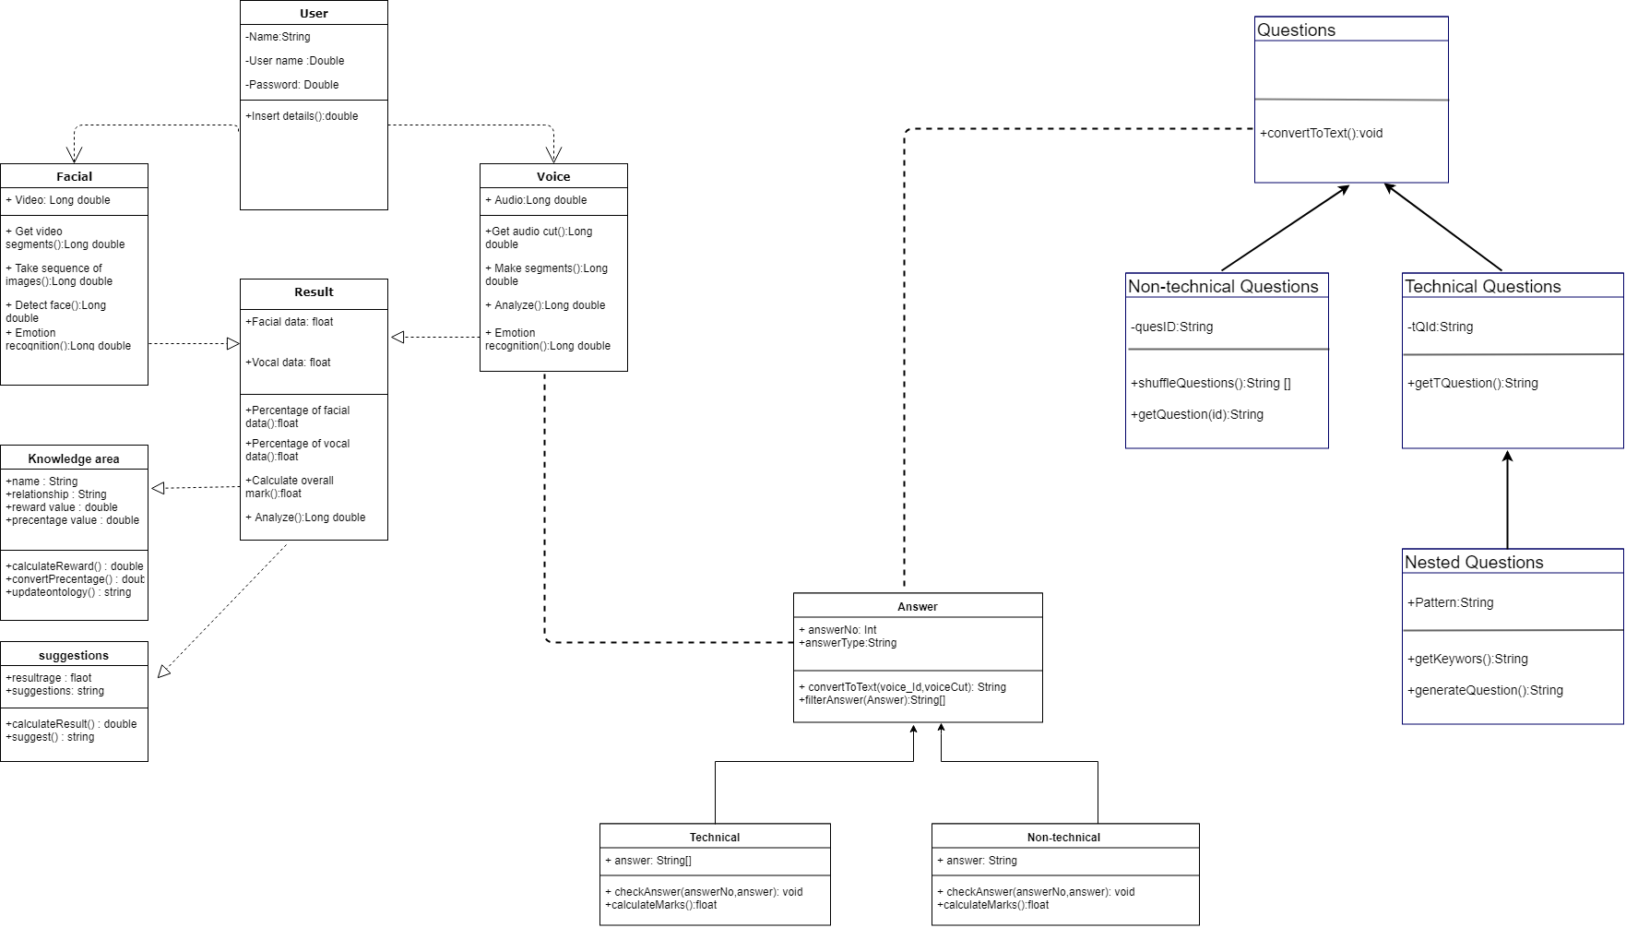

Figure 10 : Class diagram

## Performance requirements

Essentially after user start the interview, prepared question will ask from the user by system. Each question will have maximum of 3 minutes to give the answer. Sometimes user will give answers early if so the system will identify that and answer checking and emotion analyze will happen.

When the analyzing the user emotions it should not get more than 30 seconds it should done very quickly. Because the next answer will ask within 30 seconds. The next process is the answer validation and it is dividing the given time; maximum 4 seconds to convert answer voice to text and 4 seconds to filter words and 20 seconds to check the answer and 2 seconds to calculate marks. Next process is the question preparation process and it should happen within 30 seconds. These 3 processes should happen parallel wise. Otherwise system performance will decrease and user will not get the real experience. Finally, the rewording process will happen. There are calculations to done after the interview session. To done these processes at least 2GB RAM is required.

## Design constraints

The development team advised to prepare a User Interface that not annoy the users in any ways and consider there are users who has experienced in computer technologies and who have not experienced in the computer technologies. The following requirements are required to success the user friendly UI.

* UI should be simple for everyone, yet should covered every features.
* UI color combination should be not annoy user eyes.
* UI should not be unattractive or make user uncomfortable.
* UI should be user friendly for everyone.

## Software system attributes

### Reliability

To secure the system reliability development team use few methods. First thing is users can trust the system to give their privacy. For that system is using user profiles to login and do their practices. Any other users cannot access another user history or results. Next method is before start the interview system is preparing the ontology according to the user specialization. The reason behind this method is sometimes internet connection cannot be stable. For maintain the system reliability, the interview process cannot failed in middle of the process. Because of already created ontology the interview process can continue without any interruptions. Also the algorithms use for the system are well-developed for the give most accurate results.

### Availability

To secure the system availability, development team use few methods. First method is that make checkpoints when user facing the interview. If anytime, any system failure happens system will automatically restart and start from the checkpoint. It will make sure of the availability of the system. Also user will not lose user’s marks from the any interruptions.

### Security

To secure the security of the system development team use several methods. First thing is that user have to login to the system with user’s user name and password. Because of that any other person cannot access user results history it keeps user’s privacy. The other method is that user details are stored in the user’s PC because of that any other person cannot know about user private details. Also the user password will be encrypted for login or the registration process.

### Maintainability

In the future system may have to do changes or upgrade for the better versions. To do that system maintainability must be secured. To do that developer team use several methods to make sure that system maintainability possible in the future. First thing is the system developed under the well-structured design pattern. Also the developer team develop the system under the model view controller framework. Because of the well-organized structure, system will be easy to maintain in the future.

# References

1. D. Li, J. Du, and S. Yao, “Research on Computer Science Domain Ontology Construction and Information Retrieval,” pp. 603–608, 2011.
2. B. B. Duarte, V. E. S. Souza, A. L. de C. Leal, R. A. Falbo, G. Guizzardi, and R. S. S. Guizzardi, “Ontological Foundations for Software Requirements with a Focus on Requirements at Runtime,” *Appl. Ontol.*, vol. 3, p. (accepted for publication), 2017.
3. C. Technology and U. Teknikal, “Quran Ontology : Review on Recent,” *J. Theor. Appl. Inf. Technol.*, vol. 96, no. 3, pp. 568–581, 2018.
4. T. J. Lampoltshammer and S. Wiegand, “Improving the computational performance of ontology-based classification using graph databases,” *Remote Sens.*, vol. 7, no. 7, pp. 9473–9491, 2015.
5. M. Buerli and C. Obispo, “The Current State of Graph Databases,” *Dep. Comput. Sci. Cal Poly San Luis Obispo*, 2012.
6. Y. Ding and S. Foo, “development . Part 1 – a review of ontology generation,” *J. Inf. Sci.*, pp. 1–23, 2002.
7. Snehal Shivaji Patil and S.A.Uddin, “Research Paper Selection Based On an Ontology and Text Mining Technique Using Clustering\n\n,” *Jce*, vol. 17, no. 1, pp. 65–71, 2015.
8. T. P. Lillicrap *et al.*, “Continuous control with deep reinforcement learning,” 2015.
9. J. He *et al.*, “Deep Reinforcement Learning with a Natural Language Action Space,” 2015.
10. U. Issn, “Literature review about Neo4j graph database as a feasible alternative for replacing RDBMS,” vol. 18, no. 2, pp. 135–139, 2015.
11. P. R. Dachapally, “Facial Emotion Detection Using Convolutional Neural Networks and Representational Autoencoder Units,” 2017.
12. D. L. Spiers, “Facial emotion detection using deep learning,” 2016.
13. V. Mayya, R. M. Pai, and M. M. Manohara Pai, “Automatic Facial Expression Recognition Using DCNN,” *Procedia Comput. Sci.*, vol. 93, no. September, pp. 453–461, 2016.