GENERATIVE AI | CAPSTONE PROJECT 2026
VeriDoc
A PDF question-answering system that verifies its own answers

NAME | Anuruddha Paul
ROLL NUMBER | 2328072
BATCH | GENAI 2026
SUBMITTED TO | Mr Sachin
DATE | 30 September 2026

Project links
Source code: https://github.com/AnuruddhaPaul/VeriDoc
Live app: https://veridoc-bgemx43smyhzo9wqhnaibd.streamlit.app
Project folder (Google Drive): [to be added before submission]

1. Problem Statement
Many people now ask a chatbot questions about a document instead of reading it: an employee handbook, a rental contract, a company policy. Most of these tools use retrieval-augmented generation (RAG): they find the passages closest to the question and let a language model write an answer from them. The weak point is what happens when the document does not contain the answer. A model that is eager to help can fill the gap with a believable guess, and the reader has no way to tell a sentence that came from page 3 from one that the model made up. For a leave policy or a contract clause, a wrong answer that sounds sure of itself can cost real money or time.
VeriDoc attacks that specific problem. It does not just answer; it checks each claim in its own answer against the retrieved text before showing it, and it says “Not found in the document” when the document does not back the claim.
Domain | Question answering over user-supplied PDF documents (demonstrated on an employee handbook)
Users | People who rely on PDF chatbots for handbooks, policies and contracts and need to trust the answer
Problem | RAG chatbots can answer confidently even when retrieval missed, and readers cannot separate grounded statements from invented ones
Success criteria | At least 90% of answerable questions answered correctly; at least 90% of unanswerable questions refused; every claim shown as supported carries a page number and a quote that can be found word for word in the document

A number that can be tested. Of the 40 questions used in this project (22 development + 20 held-out, of which 20 have no answer in the document), the target is that 18 or more of the 20 unanswerable questions get a refusal instead of an answer. Section 9 reports what was actually measured.

2. Objectives and Scope
The objectives are written so that each one can be checked with a number. Targets were set before the final runs and are reported against in Section 13.
# | Objective (measurable) | How it is measured
O1 | Answer at least 90% of answerable questions correctly | Answer rate on the two question sets (Section 9)
O2 | Refuse at least 90% of unanswerable questions | Abstain rate: no answer shown
O3 | Every answer marked “grounded” is correct (grounded precision of at least 95%) | Share of “grounded” answers that are correct
O4 | A verifier failure is never shown as “grounded” (fail closed) | Unit tests for bad JSON and crashes
O5 | Offer a verifier that runs locally, with no second API call, and compare it with the LLM verifier | Ablation: answer rate, latency, API calls
O6 | Keep the project reproducible: at least 20 automated tests that run offline, and a public app | pytest result; hosted link

In scope | Out of scope
• Text PDFs (one or several)  • Single-question answers with citations  • Per-claim verification and evidence display  • Comparison of LLM and NLI verifiers  • Baseline mode with checking switched off | • Scanned PDFs that need OCR  • Multi-turn conversation memory  • Deciding whether the document itself is true  • Tables, charts and images inside PDFs  • Documents in languages other than English

3. Solution and Features
VeriDoc is a web page where a person uploads one or more PDFs, asks questions, and gets an answer together with proof of where each part came from. What the user can do:
- Upload and ask. Drop in a PDF (or load the built-in sample handbook) and type a question.
- See a trust badge. Each answer is labelled Grounded, Partly grounded, Not grounded, Not found, or Unverified, in a matching colour.
- Read a claim-by-claim check. The answer is split into single facts. Each fact gets a tick or a cross; a tick shows the source number and the page.
- See the evidence. The retrieved passages are listed with page and similarity, and the exact sentence that supports a claim is highlighted.
- Get a straight refusal. If the document does not contain the answer, the app says so, and for clearly off-topic questions it does not even call the language model.
- Choose the checker. Switch between the LLM verifier, the local NLI verifier, or Off (plain RAG) to compare them, and optionally swap in a “typical chatbot” prompt for the comparison.
- Tune it. Sliders for the number of retrieved passages and for the off-topic cutoff.

4. Tech Stack
Technology | Purpose in this project | Why it was chosen
PyMuPDF | Extracts text from each PDF page | Fast, pure pip install, gives text blocks per page so every chunk keeps an exact page number
Sentence-Transformers (all-MiniLM-L6-v2) | Turns chunks and questions into 384-number vectors | Small (about 90 MB), runs on CPU, free, and no text leaves the machine for embedding
ChromaDB | Stores vectors and finds the nearest chunks (cosine) | Runs inside the Python process, so there is no database server to host or pay for
Groq API, openai/gpt-oss-120b | Writes the answer from the sources and, in one mode, checks it | Free tier and very fast responses. It replaced Llama-3.3-70B, which Groq had retired (Section 11)
cross-encoder/nli-deberta-v3-small | Local entailment model for the NLI verifier | Small enough for CPU, needs no API call, and gives a numeric score for each claim
Streamlit | The web interface and the server in one | A full UI in plain Python; no separate front end or back end to build
pytest | 25 offline tests, using a scripted fake LLM and a hashing embedder | Tests run in seconds with no internet or API key, so they can be run on every change
Playwright (Chromium) | Drives the real app to capture the screenshots | Scripted, repeatable screenshots at a fixed window size instead of manual captures
Streamlit Community Cloud | Public hosting of the app | Free, deploys straight from a GitHub repository, and stores the API key as a secret

5. Knowledge Base and Data
The document
To test refusal honestly, the document must contain facts that no language model could know. So the test document is a fictional “Northwind Robotics Employee Handbook”, created for this project with a short script (sample_docs/make_sample_pdf.py) using PyMuPDF. It has 5 pages, one topic per page: leave, remote work, travel and expenses, information security, and benefits and learning. Every number in it (25 days of annual leave, a 600 USD stipend, 14-character passwords and so on) is invented. If the system states a fact that is not in these five pages, it can only have come from the model’s imagination.
Chunking and retrieval
Setting | Value | Reason
Chunk size | about 350 tokens | Large enough to hold a whole policy section, small enough to be specific
Overlap | about 60 tokens | A fact sitting on a chunk boundary is not lost
Boundaries | sentence-aware; never across pages | Every citation gets an exact page number
Embedding | all-MiniLM-L6-v2, normalised | Cosine similarity equals a dot product
Chunks produced | 5 (one per page) | Each page is shorter than 350 tokens, so a page is one chunk
top-k | 4 | The best four chunks go to the generator
Off-topic cutoff | 0.15 (cosine) | If even the best chunk scores below this, no LLM call is made

Honest limitation. With only 5 chunks and top-k = 4, retrieval sends about 80% of the whole document to the model on every question. Retrieval is therefore easy in this test, and the results say little about how the system copes with a 200-page PDF. That is a limit of the evaluation, not of the design.

The question sets
Set | Answerable | Unanswerable | Notes
Development (eval/questions.json) | 12 | 10 (8 in-domain but absent, 2 off-topic) | Used while building and diagnosing
Held-out (eval/questions_heldout.json) | 10 (paraphrased) | 10 (6 near-miss, 4 in-domain absent) | Written before the final runs; run once with settings frozen

A “near-miss” question sits right next to something the handbook does say, for example the international meal limit when only the domestic limit is given. These are the questions where a careless model is most tempted to guess.

6. System Architecture
Figure 6.1 shows the whole system. Ingestion happens once per PDF; the query lane runs for every question. The two diamonds are the two places where the system can stop early and refuse; the red boxes are those exits.
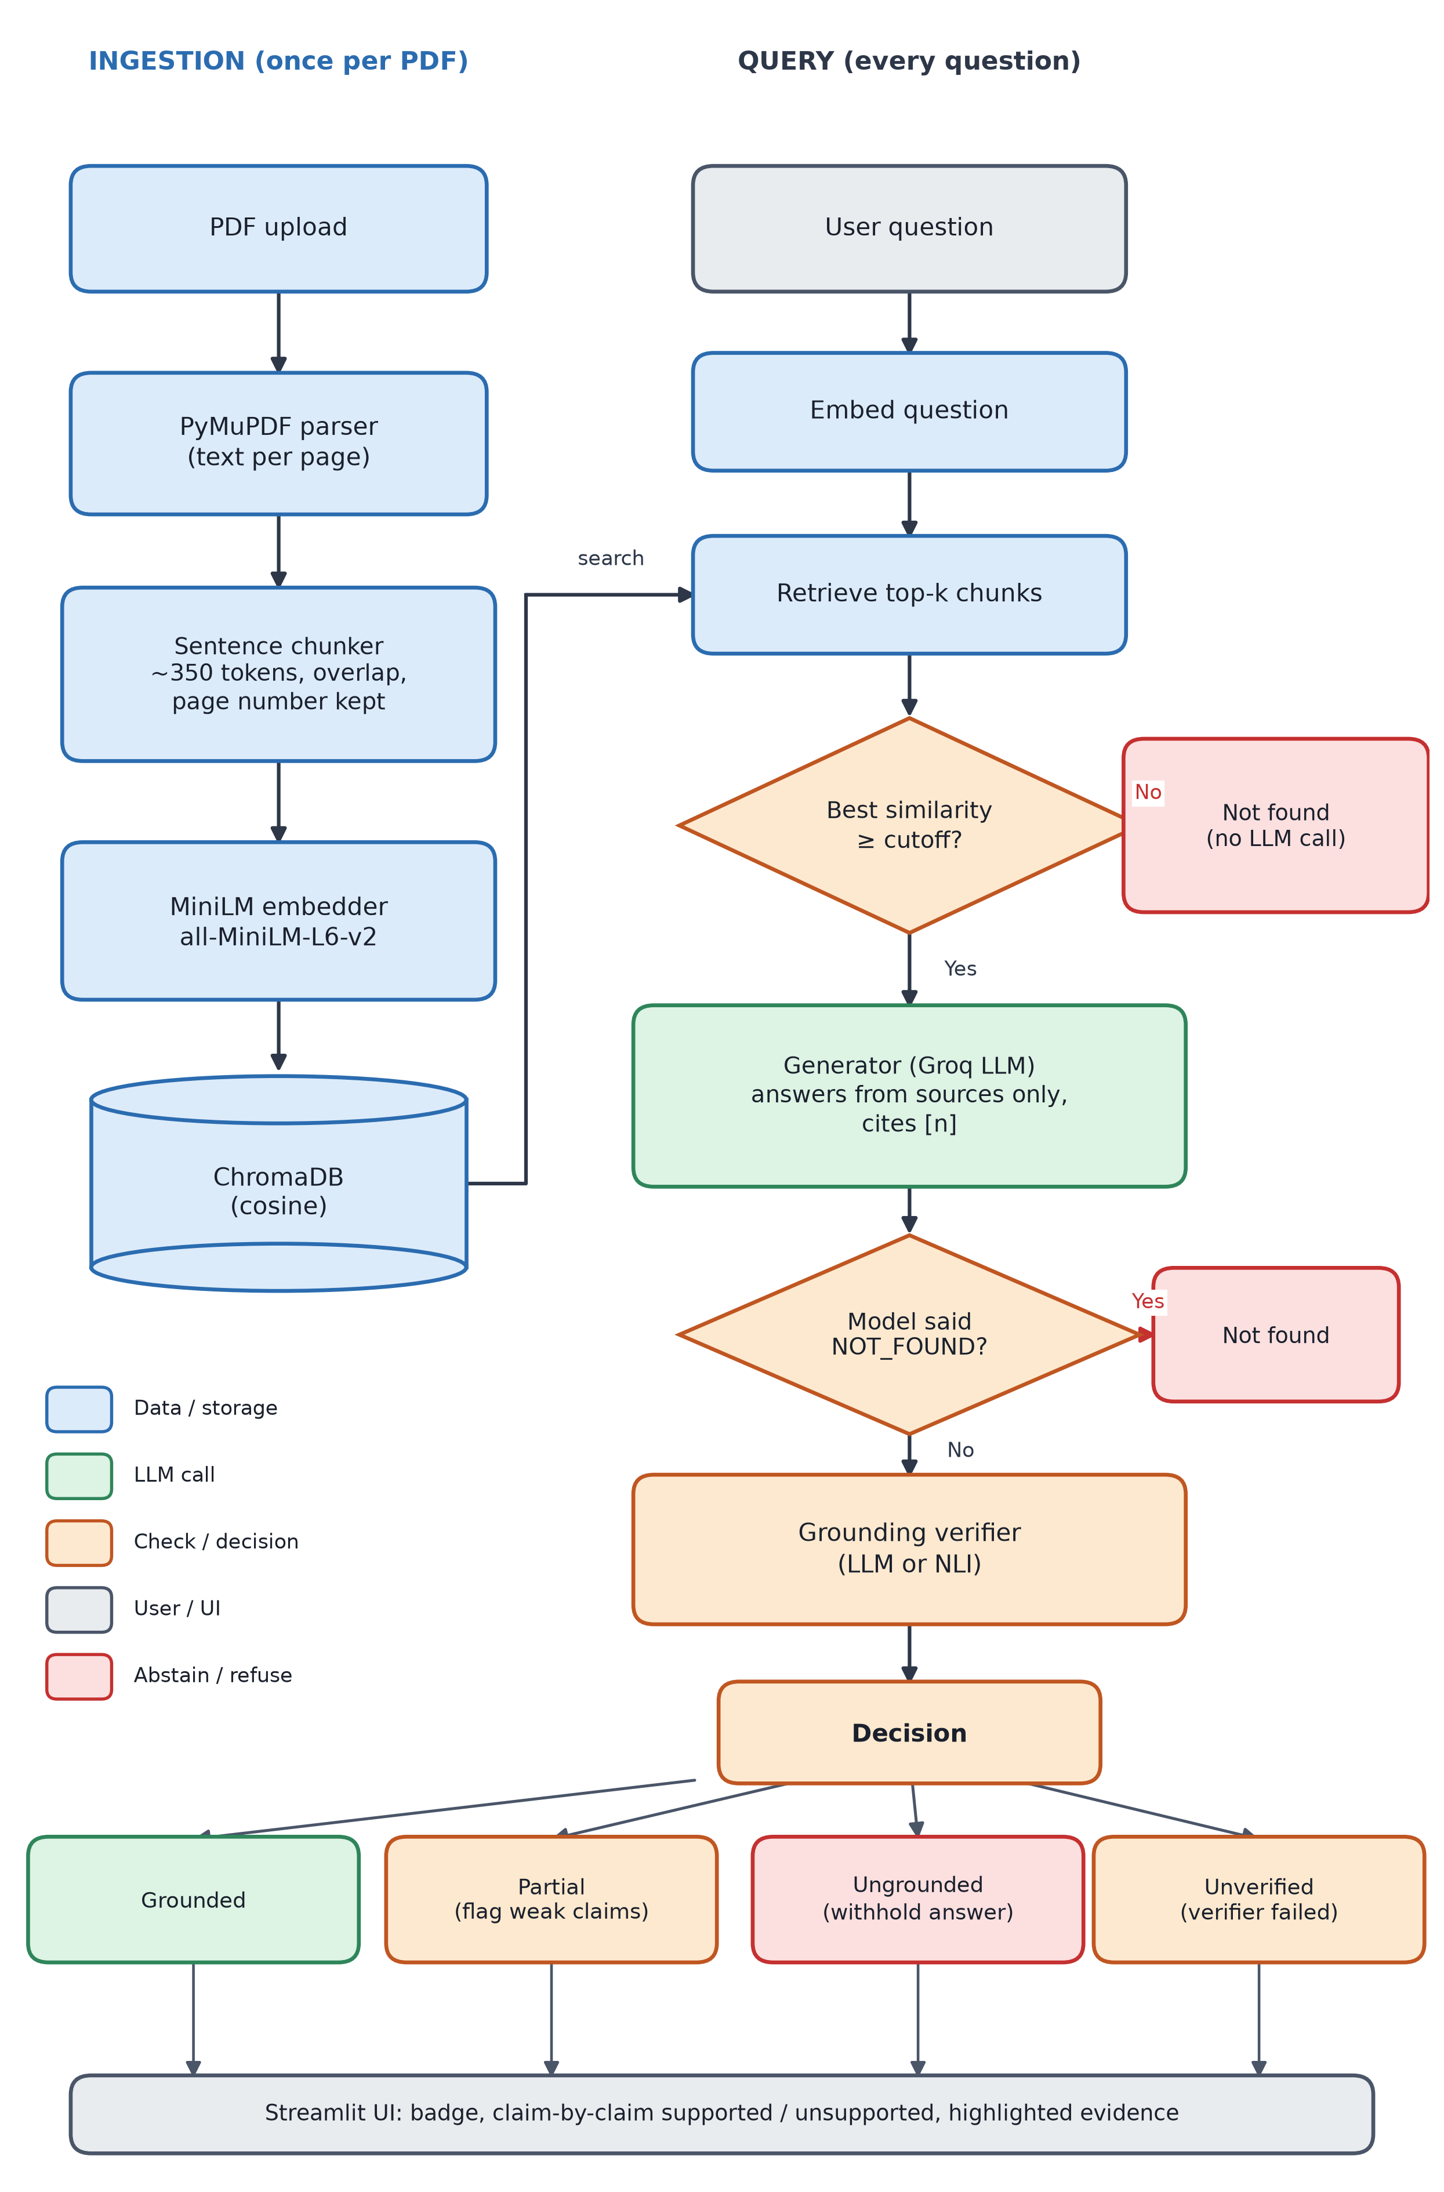
Figure 6.1: System architecture. Blue = data and storage, green = LLM call, orange = check or decision, grey = user or UI, red = refusal.
One request from start to finish. Take the question “How many days of annual leave do full-time employees get?” (a real run from the live tests). The question is embedded with the same MiniLM model and the four nearest chunks are fetched; the best has similarity 0.61, well above the 0.15 cutoff. The generator receives only those chunks and replies “Full-time employees receive 25 days of paid annual leave per calendar year [1].” The verifier splits that into one claim, cites source 1 and quotes “All full-time employees receive 25 days of paid annual leave per calen…”. Code confirms the quote really is in chunk 1, so the claim stays supported, all claims are supported, and the UI shows a green Grounded badge with page 1.
Now the question “What is the capital of France?”. The best similarity is −0.03, below the cutoff, so the system answers “Not found in the document” without calling the model at all.
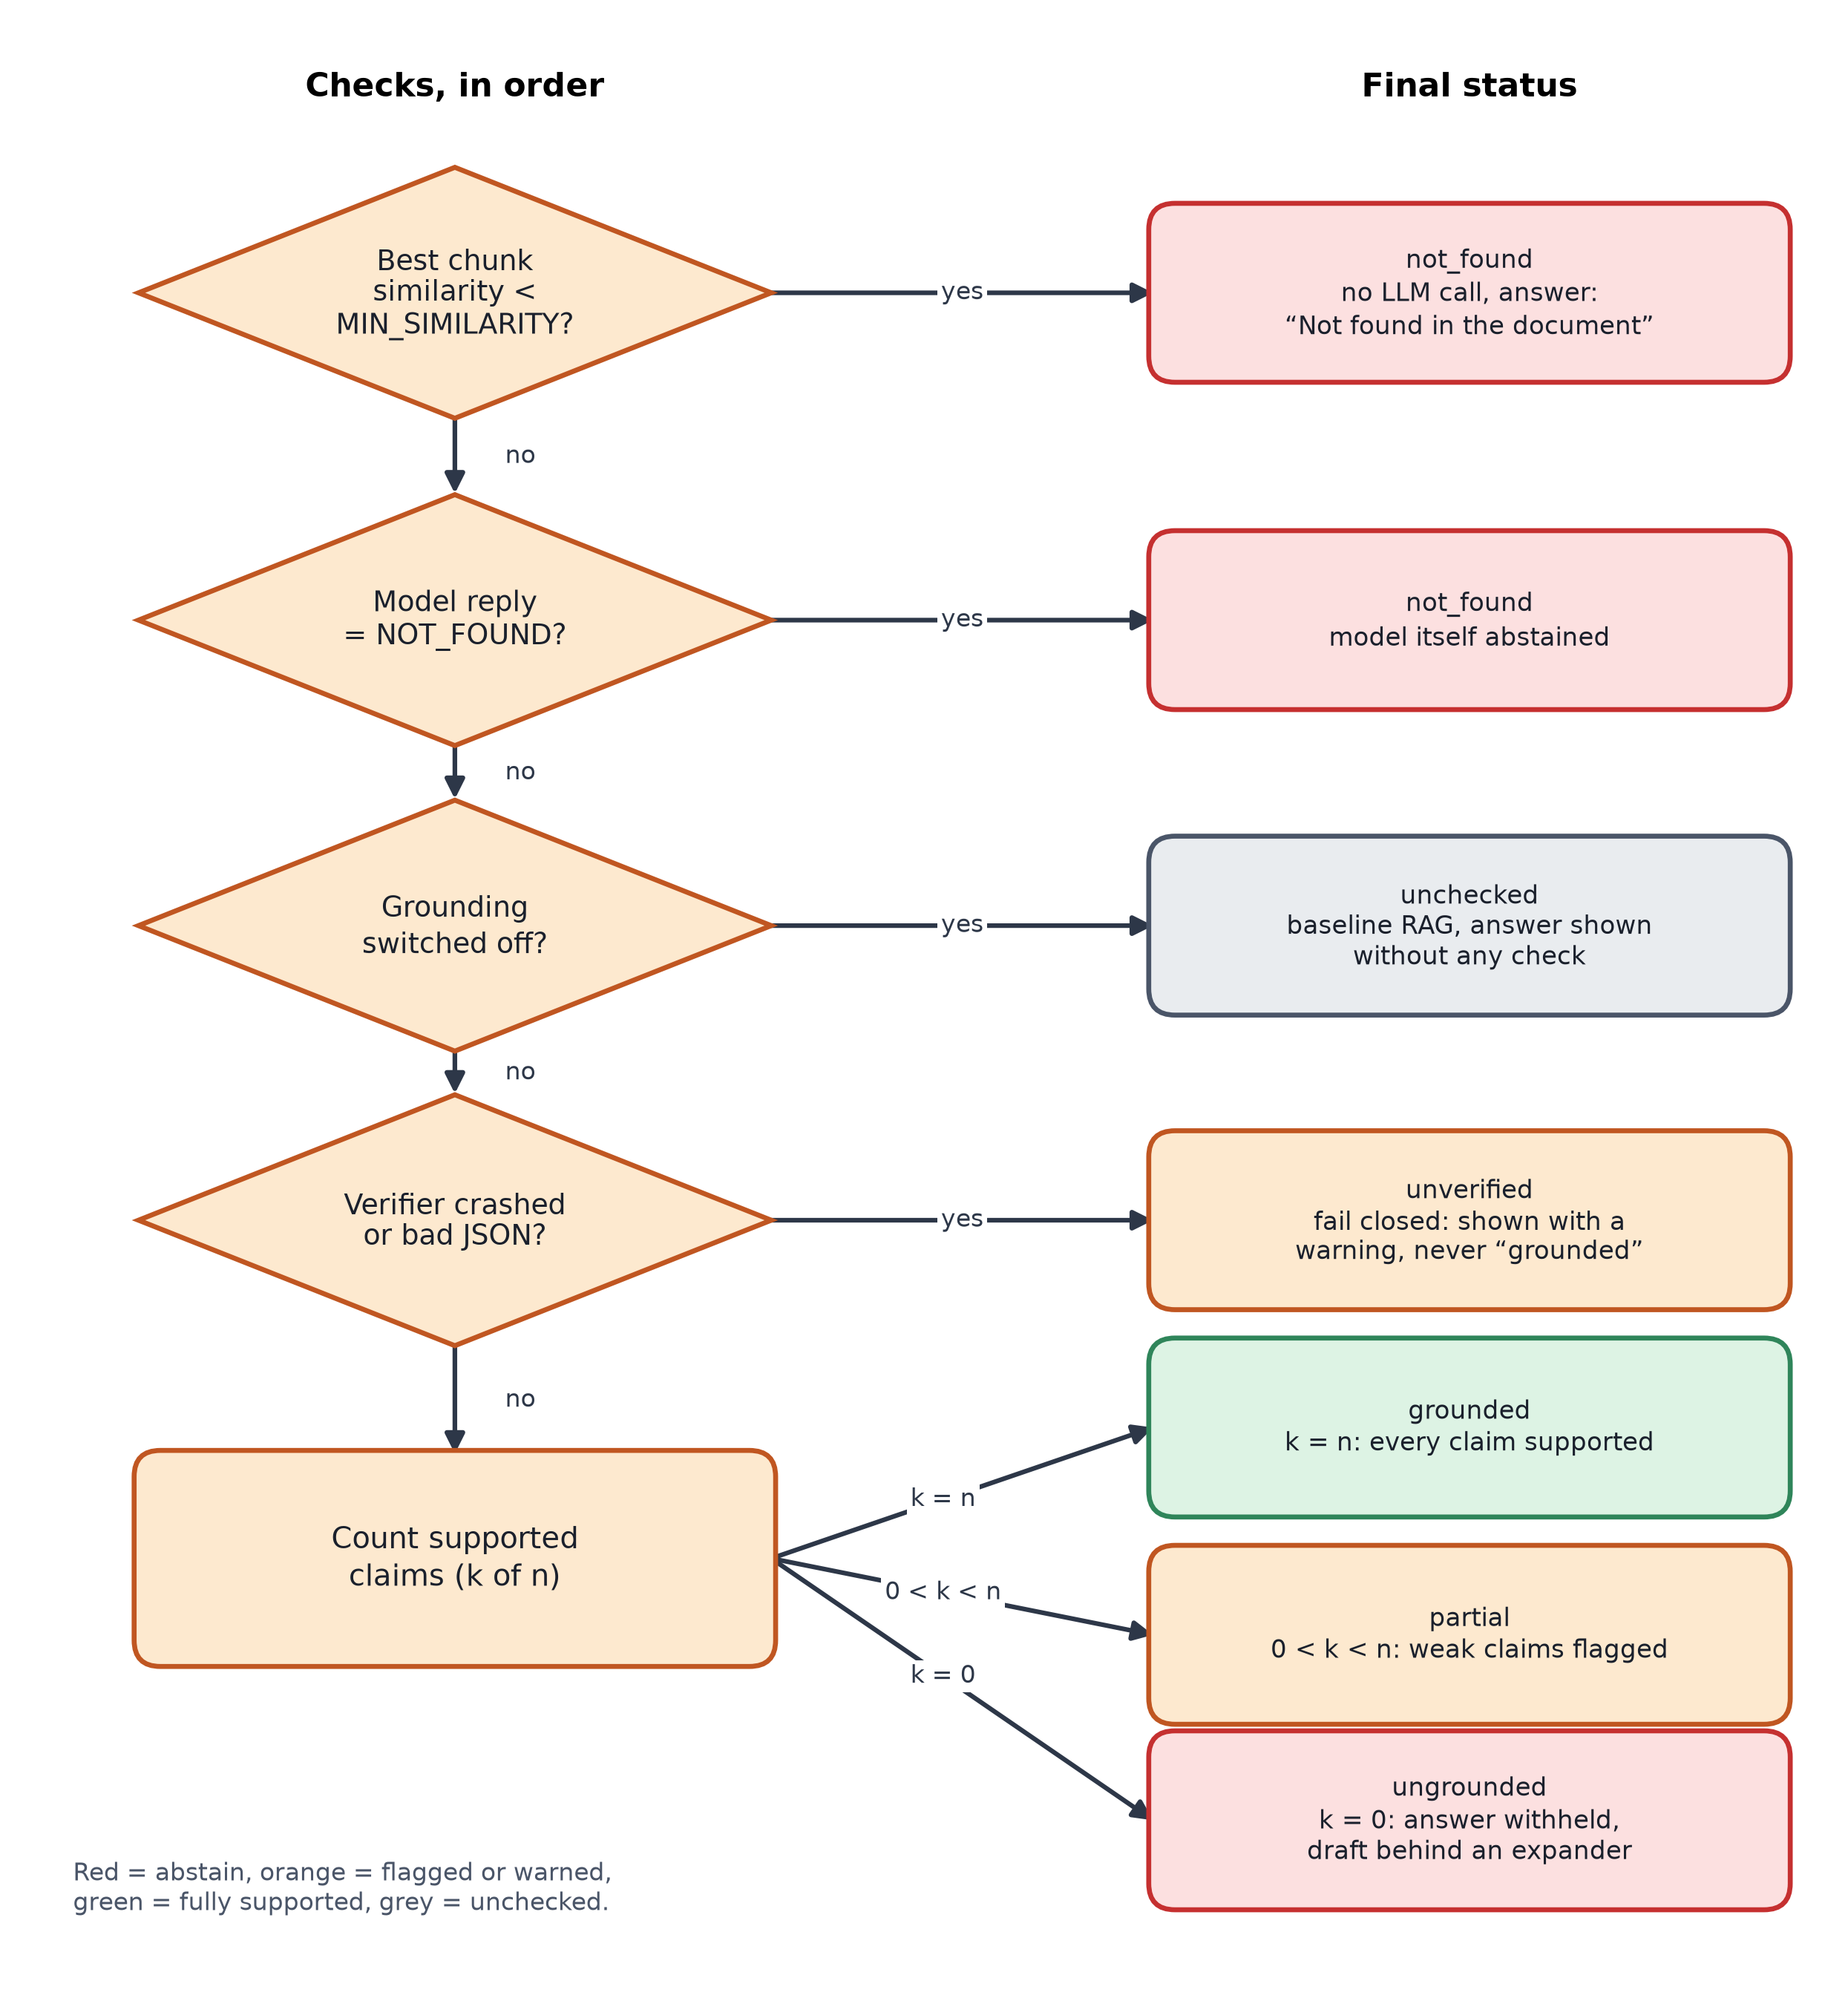
Figure 6.2: Decision logic in pipeline.py. The checks run top to bottom; the first one that fires decides the status. k is the number of supported claims and n the number of claims.
The order matters. The cheap similarity check comes first so off-topic questions cost nothing. Verifier failure comes before the count of supported claims so that a broken checker can never produce a “grounded” label. This is the fail-closed rule (objective O4).

7. Implementation Highlights
7.1 The verifier cannot simply assert support
A second language model checking the first is only as trustworthy as its own honesty. So the LLM verifier is not allowed to just say “supported”. Each supported claim must name a source and give a short quote, and ordinary code then checks that the quote appears in that source (ignoring case and punctuation). An invented quote or a wrong source number turns the claim into unsupported.
Excerpt from veridoc/grounding.py (abridged)
def quote_in_text(quote: str, text: str) -> bool:
"""True if every '...'-separated segment of `quote` appears verbatim in `text`."""
haystack = _normalise(text)
segments = [_normalise(s) for s in re.split(r"\.{3}|\u2026", quote)]
segments = [s for s in segments if s]
return bool(segments) and all(s in haystack for s in segments)

# inside LLMVerifier.verify():
if supported and (rank is None or not quote_in_text(quote, retrieved[rank - 1].chunk.text)):
supported = False # claimed support without checkable evidence

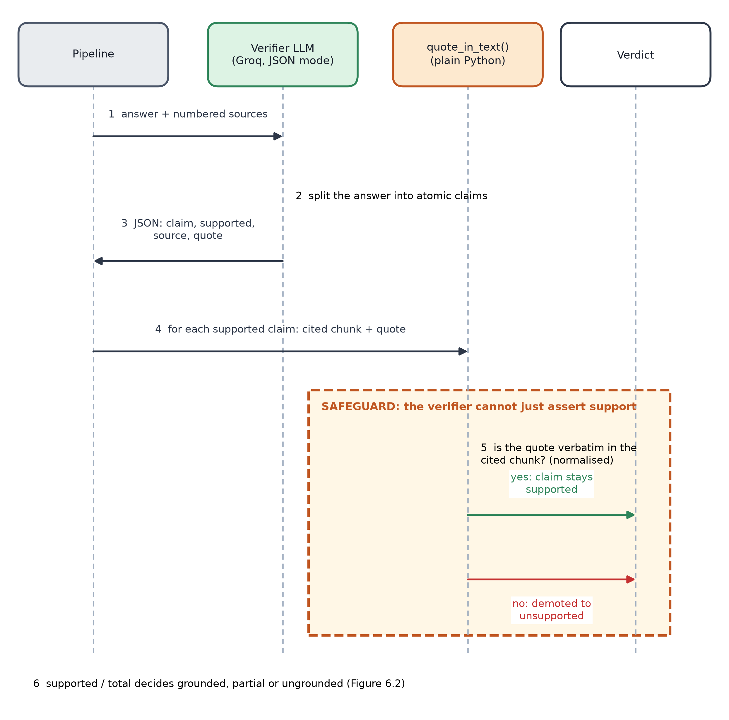
Figure 7.1: LLM verifier sequence. The dashed orange box is the safeguard: the quote check is plain code, not another model opinion.
7.2 The similarity gate and the fail-closed decision
Excerpt from veridoc/pipeline.py (abridged)
if not retrieved or retrieved[0].score < self.min_similarity:
return Result(question, NOT_FOUND, NOT_FOUND_MESSAGE, ...) # no LLM call at all
...
try:
report = self.verifier.verify(draft, retrieved)
except VerificationError:
return Result(question, UNVERIFIED, draft, ...) # fail closed, never "grounded"
...
if report.supported_count == len(report.verdicts): status = GROUNDED
elif report.supported_count == 0: status = UNGROUNDED # answer withheld
else: status = PARTIAL

7.3 Scoring single sentences for the NLI verifier
The NLI model was first given only three-sentence windows of each chunk as evidence. In the live test the same claim scored 0.998 against the one sentence that states it, but 0.002 once a neighbouring sentence was added to the evidence. The fix is to offer every single sentence as well as the windows and keep the best score.
Excerpt from veridoc/grounding.py, NLIVerifier._windows (abridged)
out.extend((rank, s) for s in sentences) # every single sentence
if self.window > 1: # plus sliding multi-sentence windows
for i in range(0, max(1, len(sentences) - self.window + 2), max(1, self.window - 1)):
out.append((rank, " ".join(sentences[i : i + self.window])))

8. Testing and Results
Automated tests. 25 tests pass in about 4 seconds with no internet and no API key. They use a scripted fake language model and a deterministic hashing embedder, plus a headless run of the whole Streamlit script. The original suite had 21 tests; 4 were added during live testing, one for each real bug described in Section 11. The NLI test was confirmed to fail when its fix is removed. One earlier bug was caught by the original tests: the model’s refusal NOT_FOUND was not recognised because the underscore was compared literally.
The table lists the checks that matter most, including the ones that failed.
Input | Expected | Actual | Status
Unit test: invented quote from the verifier | Claim demoted to unsupported | Demoted | Pass
Unit test: verifier returns bad JSON / crashes (3 cases) | Status unverified, never grounded | unverified | Pass
Unit test: best similarity below cutoff | Not found, zero LLM calls | Not found, 0 calls | Pass
Live: first Groq call with llama-3.3-70b-versatile | Model replies | HTTP 404 model_not_found (retired) | Fail, fixed by switching to gpt-oss-120b
Live: NLI, claim vs two-sentence evidence | High entailment (claim is stated) | 0.002 (0.998 for the single sentence) | Fail, fixed with single-sentence evidence + test
Live: annual leave question, LLM verifier | Grounded, 25 days, quote from page 1 | Grounded; quote verified | Pass
Live: “What is the bereavement leave policy?” | Not found | Not found (model said NOT_FOUND, similarity 0.43) | Pass
Live: “What is the capital of France?” | Not found, no LLM call | Not found; similarity −0.03 | Pass
First full eval run (before output clean-up) | About 90%+ answered | NLI verifier answered 42%; baseline 83% | Fail: model output had odd spaces and 【 】 citations; scorer missed “three” vs 3. Both fixed
Baseline (grounding Off, typical prompt): “How many stock options do new hires receive?” | Guessed answer, to show the problem | Polite refusal: handbook does not mention stock options | Hypothesis not confirmed (no hallucination seen)
Typical prompt + LLM verifier on a correct refusal | Passes through as Not found | Marked Not grounded (5 of 8), Partial (2), Grounded (1) | Known weakness, not fixed
NLI: “...reported to the security team within 2 hours” | Supported | Entailment 0.068, rejected | Known weakness of the small NLI model
Groq free-tier daily token cap reached mid-project | App keeps working | HTTP 429; a run crashed | Fail, fixed: automatic fallback model + test

Live demo script. In the running app I asked: two answerable questions (annual leave with the LLM verifier; minimum password length with the NLI verifier); one unanswerable question with the normal settings (bereavement leave); the same bereavement question and a stock-options question with grounding off and the typical-chatbot prompt; the bereavement question again with the typical prompt plus the LLM verifier; and one off-topic question (capital of France). The screenshots in Section 10 are from these runs. A partly-grounded status did occur naturally in the typical-prompt evaluation (2 of 8 questions), but not in my manual demo, so there is no screenshot of it; a unit test covers it.

9. Evaluation and Metrics
Method
Each configuration was run over the same questions against the same document. Answerable questions are marked correct if the shown answer contains every expected fact (for example “25”), after normalising spaces and turning number words such as “three” into digits. Unanswerable questions are marked “answered” if any answer text is shown; a refusal, or an answer withheld by the verifier, counts as abstaining. All calls use temperature 0 and the same generator, openai/gpt-oss-120b with low reasoning effort. Only the grounding check differs between rows.
Metric | Meaning
Answer rate | Answerable questions where a correct answer was shown (higher is better)
Abstain rate | Unanswerable questions where no answer was shown (higher is better)
Hallucination rate | Unanswerable questions where an answer was shown (lower is better)
Grounded precision | Of answers labelled fully grounded, the share that were correct

Results
Development set (12 answerable, 10 unanswerable), final run:
Configuration | Answer rate | Abstain rate | Hallucination rate | Grounded precision | Time (s)
Baseline RAG (no check) | 100% (12/12) | 100% | 0% (0/10) | n/a | 58
LLM verifier | 100% (12/12) | 100% | 0% (0/10) | 100% | 156
NLI verifier | 92% (11/12) | 100% | 0% (0/10) | 100% | 99

Held-out set (10 answerable, 10 unanswerable), run once with settings frozen:
Configuration | Answer rate | Abstain rate | Hallucination rate | Grounded precision | Time (s)
Baseline RAG (no check) | 100% (10/10) | 100% | 0% (0/10) | n/a | 66
LLM verifier | 100% (10/10) | 100% | 0% (0/10) | 100% | 159
NLI verifier | 80% (8/10) | 100% | 0% (0/10) | 100% | 86

First run on the development set (before the output-formatting and scorer fixes), kept for honesty:
Configuration | Answer rate | Abstain rate | Hallucination rate | Grounded precision | Time (s)
Baseline RAG (no check) | 83% (10/12) | 100% | 0% (0/10) | n/a | 73
LLM verifier | 83% (10/12) | 100% | 0% (0/10) | 83% | 183
NLI verifier | 42% (5/12) | 100% | 0% (0/10) | 83% | 95

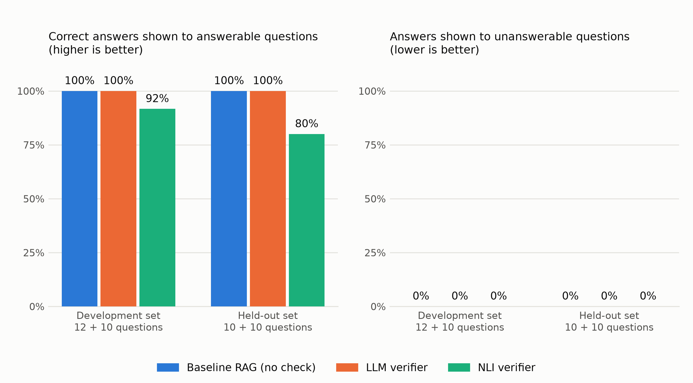
Figure 9.1: Answer rate (left) and hallucination rate (right) for the three configurations on both question sets. All values are read from the evaluation result files.
What the numbers say
- Refusal worked on every configuration: 0 of 20 unanswerable questions received a fabricated answer, on both sets, including 6 near-miss questions. With 0 events in 20 trials, the 95% upper bound on the true rate is still about 14%, so this is encouraging but not proof.
- The LLM verifier kept the baseline’s answer rate (100% on the held-out set) and every answer it marked grounded was correct (grounded precision 100%).
- The NLI verifier was stricter and lost answers: 92% on the development set and 80% on the held-out set. It refused correct answers, so objective O1 is not met for the NLI verifier on held-out data. When I re-ran the three refused questions afterwards (on the fallback model, so the wording of the answers differed), two were accepted, so some misses depend on how the answer is worded. One claim (“reported to the security team within 2 hours”, while the source says “laptop or phone”) scored only 0.013 and 0.068 in two separate checks.
- The baseline did not hallucinate, which does not support the assumption the project started from. With this generator, the strict prompt, and a five-page document, plain RAG already refused correctly.
Extra experiment: a typical chatbot prompt
To test whether the grounding layer helps when the generator is less careful, the strict prompt was replaced with a plain “use the context to answer” prompt, on the development set only (the held-out version of this run was stopped by the free-tier token cap).
Configuration | Answer rate | Unanswerable answered (automatic count) | Grounded precision
Typical prompt, no check | 100% | 80% | n/a
Typical prompt + LLM verifier | 100% | 30% | 100%

The automatic count is misleading here, so I read all 10 answers. In the no-check row, all 8 in-domain answers were polite refusals such as “the handbook does not specify any stock-option grant”, and the 2 off-topic questions hit the similarity cutoff. By hand, there were 0 real hallucinations out of 10. The verifier lowered the automatic count from 80% to 30% only by withholding or flagging correct refusals (5 withheld, 2 partial, 1 marked grounded). This shows a real weakness: a refusal is a negative statement, and the verifier is built to find a quote that supports a positive claim.
Ablation: baseline vs LLM verifier vs NLI verifier
 | Baseline | LLM verifier | NLI verifier
Extra API calls per answered question | 0 | 1 (second Groq call) | 0 (runs locally)
Time for the 22 development questions | 58 s | 156 s | 99 s
Time per question (average) | 2.6 s | 7.1 s | 4.5 s
Evidence shown | Sources only | Claim, source, verbatim quote | Claim, best sentence, score
Main risk | No check | Costs tokens; rejects refusals | Brittle on wording; loses answers

The NLI time includes loading the model once (about 6 s after the first download of about 40 s). The LLM verifier is the slowest because it is a full extra model call, but it explains itself with a quote. The NLI verifier is free to run and private, but in these tests it was the least reliable.
Tuning and limits
No thresholds were tuned. MIN_SIMILARITY (0.15), NLI_THRESHOLD (0.5) and top-k (4) are the original values. Between the first and final development runs I changed only things that were bugs: the output clean-up, the scorer, and the NLI evidence windows. The held-out set was written before those final runs and evaluated once. The limits are real: 22 + 20 questions is a small sample, one fictional 5-page document, one generator model, and the development questions were seen while diagnosing. The runs used one model; per-question model names were not recorded, and a fallback model was only added afterwards.

10. Screenshots
All screenshots are of the real running app at a 1400 px wide window, captured by a script (docs/take_screenshots.py). The sidebar API-key box is not shown because the key is loaded from the environment. The small grey line under some answers names the model; a few later screenshots show gpt-oss-20b because the free-tier daily token limit of the main model was reached and the app switched automatically.
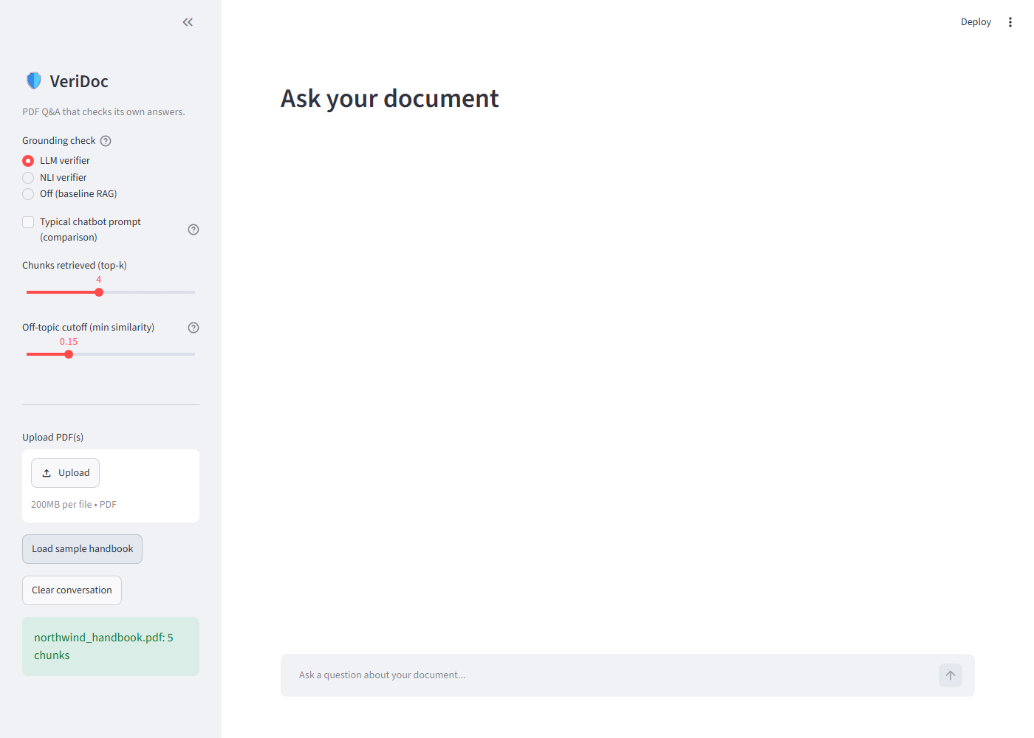
Figure 10.1: App home with the sample handbook loaded (5 chunks indexed) and the grounding controls in the sidebar.
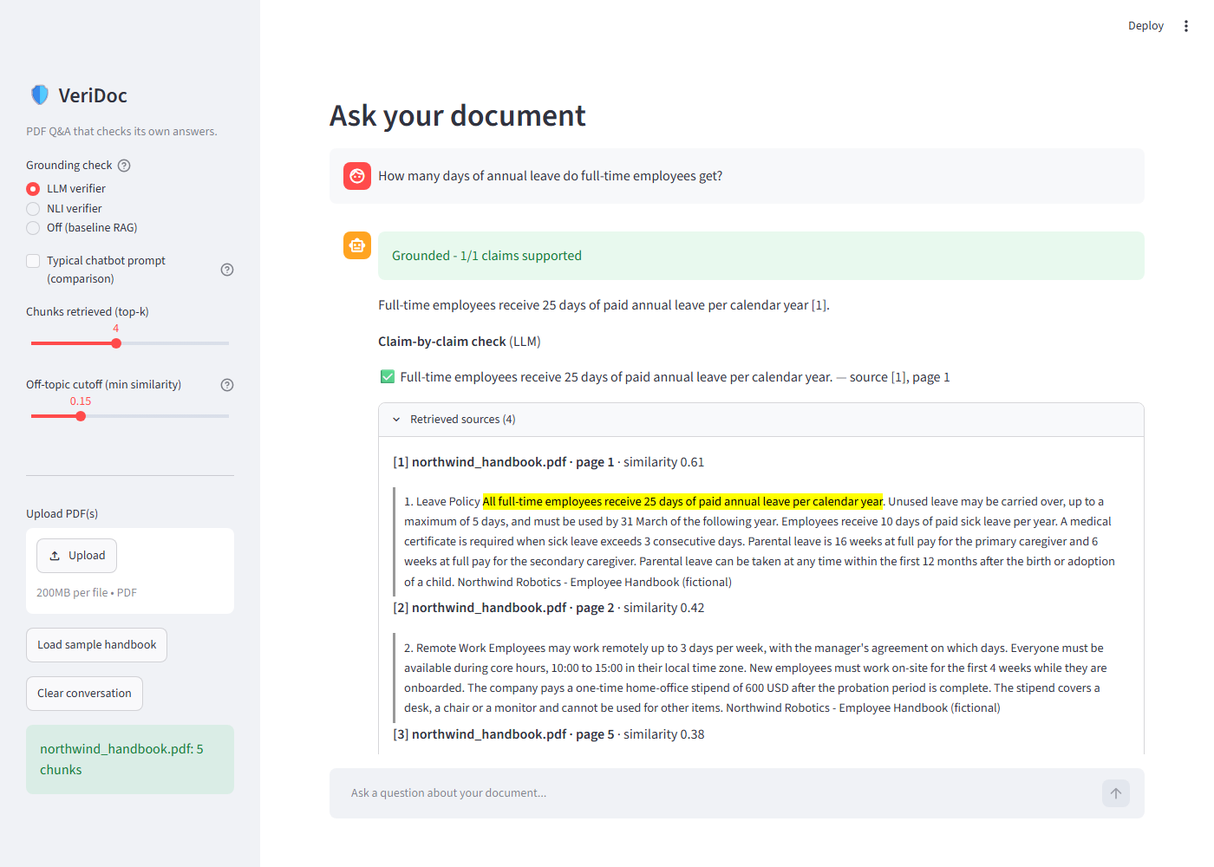
Figure 10.2: A grounded answer. The badge, the claim-by-claim tick with source and page, and the retrieved source with the supporting sentence highlighted in yellow.
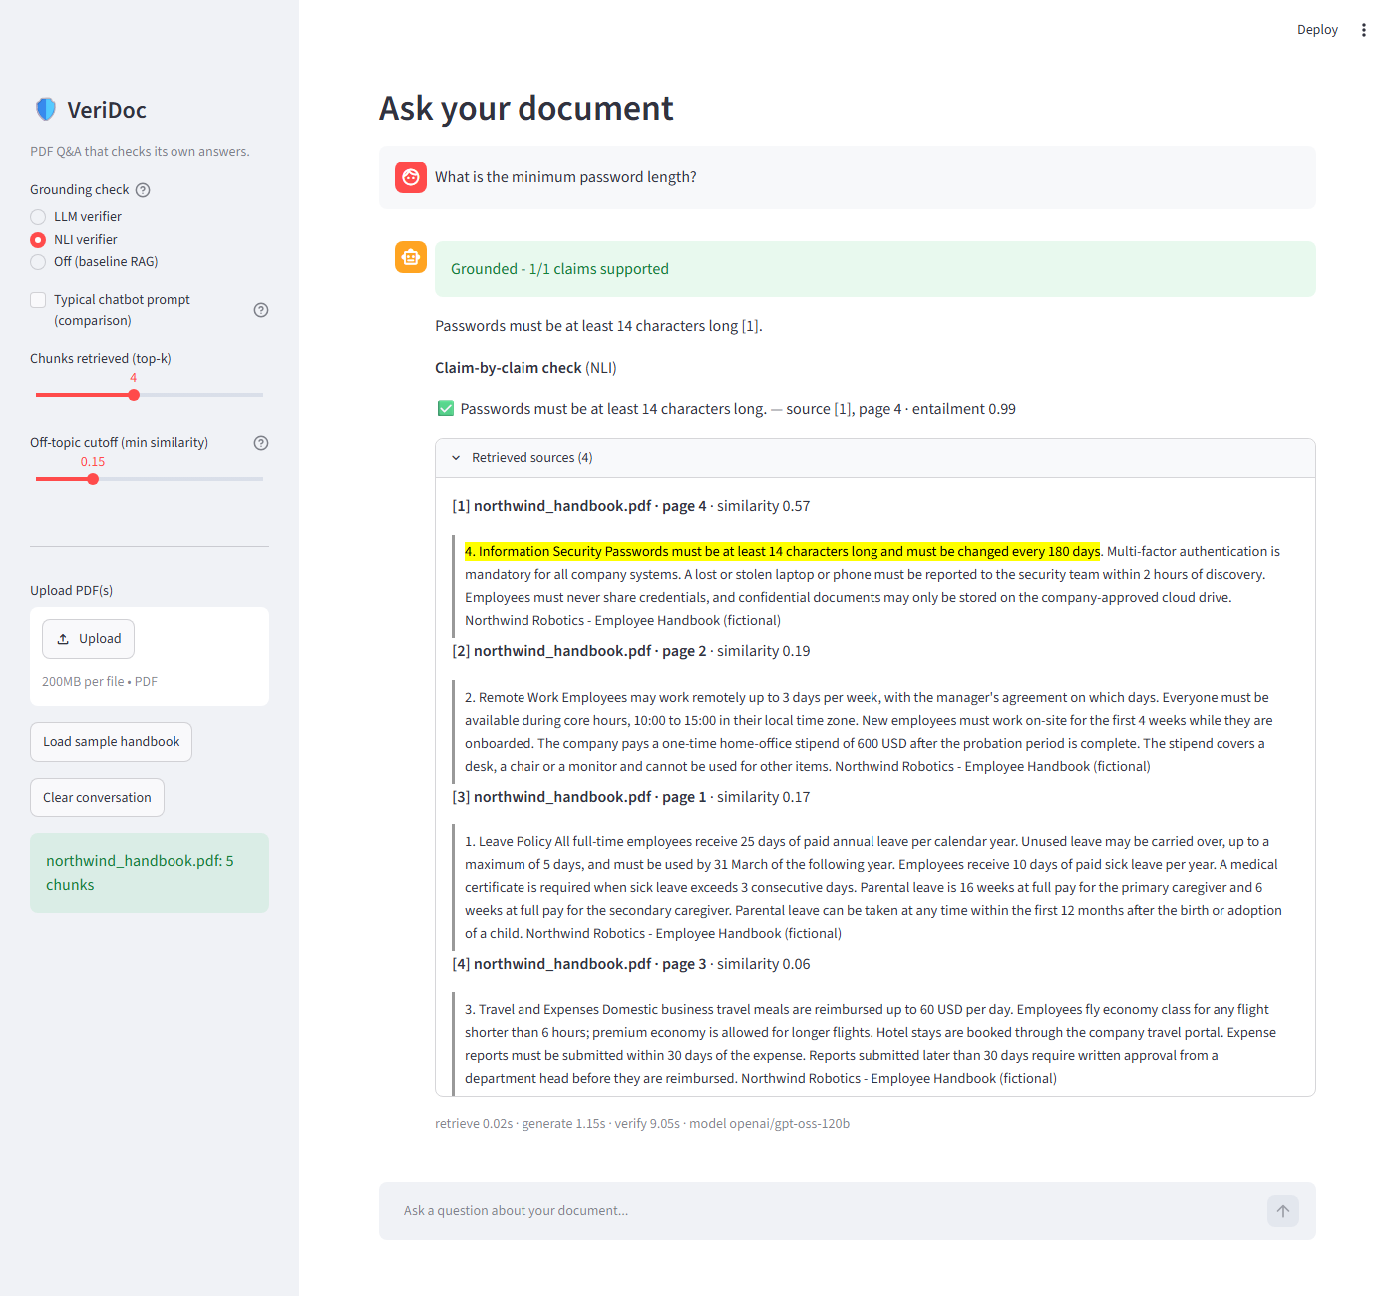
Figure 10.3: The NLI verifier on “minimum password length”: the claim is supported with entailment 0.99, and the same evidence sentence is highlighted.
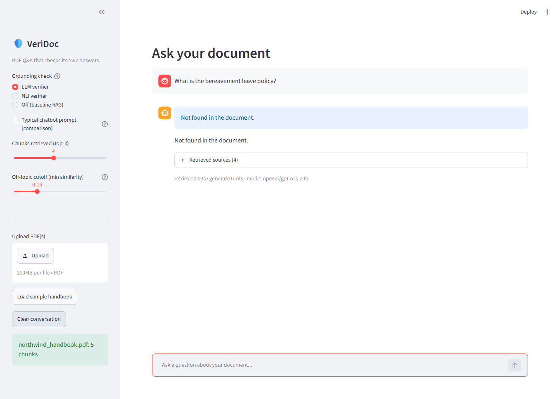
Figure 10.4: A question the document does not answer (bereavement leave). The model returned NOT_FOUND and VeriDoc shows “Not found in the document”.
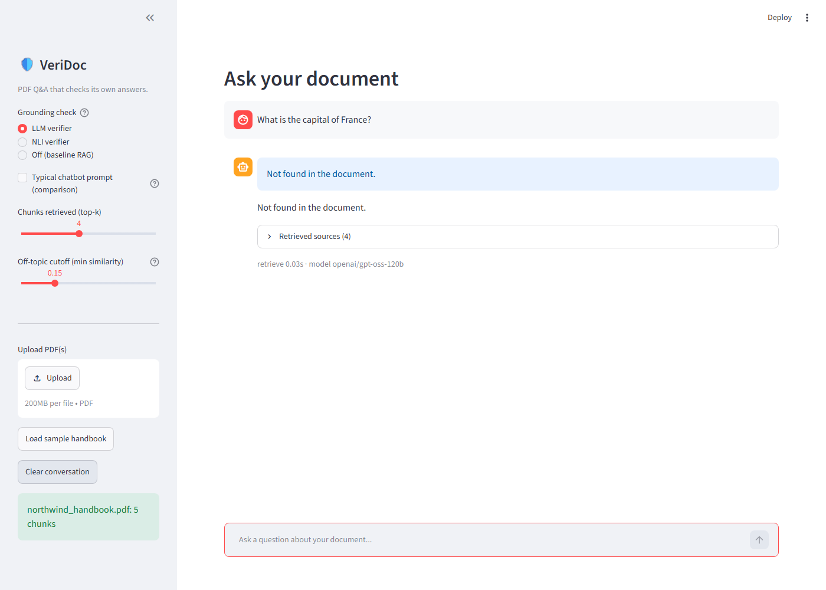
Figure 10.5: An off-topic question. Similarity was below the cutoff, so the model was never called.
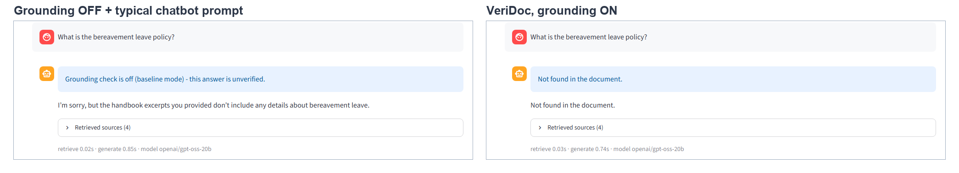
Figure 10.6: The same unanswerable question with grounding off and a typical prompt (left) and with VeriDoc (right). In this run the plain chatbot also refused, so it did not hallucinate; the difference is that the left answer is labelled unverified.
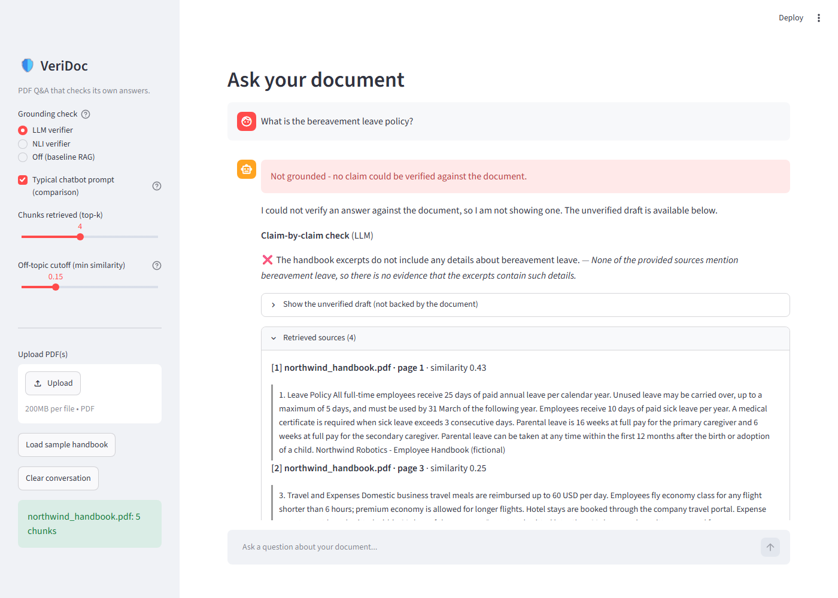
Figure 10.7: A limitation. With the typical prompt and the LLM verifier, a correct refusal is marked “Not grounded” because a negative statement has no quote to back it.

11. Challenges and Learnings
Problem I hit | How I solved it
The model’s refusal NOT_FOUND was not recognised: the check compared text literally and the underscore broke it (caught by the unit tests). | Compare only the letters, case-insensitively, and added a test.
Some PDFs deliver one text block per visual line, so joining blocks with blank lines cut sentences in half. | Join blocks with a new paragraph only after a finished sentence or a short heading.
A bare list number such as “1.” was treated as the end of a sentence. | Re-attach a lone number to the text that follows it.
The Groq model in the brief (Llama-3.3-70B) returned HTTP 404 – it has been retired. | Listed the models my key can use, tested JSON mode on the candidates, and switched the default to openai/gpt-oss-120b. It spends hidden reasoning tokens, so I set low reasoning effort.
The NLI model gave 0.002 for a supported claim when the evidence had two sentences. | Also score each single sentence; kept the best score. Verified in a regression test.
The model wrote narrow no-break spaces (U+202F) and 【 1 】 style citations. They broke sentence splitting, the NLI model and my scorer, which produced a misleading first result (NLI answered 42%). | Normalise model output right after generation; make the scorer accept number words and Unicode spaces. Re-ran everything.
The free tier of Groq allows 200,000 tokens per day per model. My evaluation runs used it up and one run crashed with HTTP 429. | Added an automatic fallback to another model when the daily cap is hit, recorded which model answered, and added a test. Ran the last experiment only on the development set.
My expectation was wrong: the baseline did not hallucinate. | Reported it as it is, added the typical-prompt experiment, and read the answers by hand instead of trusting the automatic metric.
A file was truncated when my edit script failed on Windows’ default text encoding. | Restored the file from git and used UTF-8 explicitly. A reminder to commit often.
The GitHub login stored on the machine had expired, so pushes failed. | Committed locally and asked for a fresh sign-in.

What I learned. A plausible design idea should be tested against a baseline before believing it: on this setup the baseline was already good, so the honest value of VeriDoc is visibility (page numbers, quotes, per-claim marks) and a safety net, not a measured drop in hallucinations. Real model output is messier than test data, so invisible characters and formatting habits matter. And small NLI models are brittle on paraphrase.

12. Future Improvements
- Treat refusals as valid. Detect when an answer only says the document lacks the information and skip claim verification, which removes the false “Not grounded” cases seen in Figure 10.7.
- A harder test. Evaluate on a long real PDF (50+ pages) so retrieval is actually selective, with more questions and a weaker generator, to see whether verification reduces hallucination there.
- Fine-tune the NLI verifier on question-and-answer pairs from handbooks, or try a larger NLI model, to fix its trouble with numbers and paraphrase.
- OCR support for scanned PDFs, and multi-turn memory so follow-up questions work.
- Cross-page chunking for facts that continue across a page break, and saved sessions in a database such as Supabase.

13. Conclusion
VeriDoc is a working PDF chatbot that shows, for every answer, which claims the document supports, on which page, with which exact words. It refuses when the document has no answer and refuses without calling the model when the question is clearly off-topic. It has two verifiers that can be compared, an offline test suite, and a public interface.
Objective | Result | Met?
O1: answer at least 90% of answerable questions | Baseline and LLM verifier: 100% on both sets. NLI verifier: 92% (development), 80% (held-out) | Yes for baseline and LLM; No for NLI on held-out
O2: refuse at least 90% of unanswerable questions | 100% on all configurations and both sets | Yes
O3: grounded precision of at least 95% | LLM and NLI verifiers: 100% on both sets | Yes
O4: verifier failure never shown as grounded | 3 unit-test cases (bad JSON, garbage, crash) give unverified | Yes
O5: local verifier compared with LLM verifier | Done (Section 9); the local one is cheaper but less reliable | Yes
O6: at least 20 offline tests and a public app | 25 tests pass. Live app: https://veridoc-bgemx43smyhzo9wqhnaibd.streamlit.app | Tests: yes. App: see Section 14

The main lesson is that the evaluation was harder to get right than the system: fixing invisible output problems, keeping a held-out set, and reading answers by hand changed the conclusion from “baseline hallucinates, VeriDoc fixes it” to “the baseline is already careful here, and VeriDoc adds transparency, with its own weaknesses”.

14. References and Links
Project links
Source code | https://github.com/AnuruddhaPaul/VeriDoc
Live app | https://veridoc-bgemx43smyhzo9wqhnaibd.streamlit.app
Google Drive folder | [to be added before submission]

Libraries and services used
- PyMuPDF documentation: https://pymupdf.readthedocs.io
- Sentence-Transformers documentation: https://www.sbert.net
- ChromaDB documentation: https://docs.trychroma.com
- Groq API documentation: https://console.groq.com/docs
- Streamlit documentation: https://docs.streamlit.io
- Playwright for Python: https://playwright.dev/python
Papers and models
- Lewis, P. et al. (2020). Retrieval-Augmented Generation for Knowledge-Intensive NLP Tasks. NeurIPS.
- Reimers, N. and Gurevych, I. (2019). Sentence-BERT: Sentence Embeddings using Siamese BERT-Networks. EMNLP.
- Wang, W. et al. (2020). MiniLM: Deep Self-Attention Distillation for Task-Agnostic Compression of Pre-Trained Transformers. NeurIPS (basis of all-MiniLM-L6-v2).
- He, P., Gao, J. and Chen, W. (2021). DeBERTaV3: Improving DeBERTa using ELECTRA-Style Pre-Training with Gradient-Disentangled Embedding Sharing. arXiv:2111.09543 (basis of cross-encoder/nli-deberta-v3-small).
- Williams, A. et al. (2018). A Broad-Coverage Challenge Corpus for Sentence Understanding through Inference (MultiNLI). NAACL-HLT. The kind of data NLI cross-encoders are trained on.

