package com.anpc8232.Assignment;

public class Employee

{

// Declare member variables as protected

protected int id;

protected int age;

protected String name;

protected boolean isPermanent;

// Main method

public static void main(String[] args)

{

// Create an instance of Employee

Employee emp = new Employee();

// Assign values to the variables

emp.id = 1;

emp.name = "John Doe";

emp.isPermanent = true;

// Try to assign a floating-point value to 'age' and observe the error

// emp.age = 35.5; // This will cause a compilation error

// Correct the error by casting the float value to int

emp.age = (int) 35.5; // Casting to int removes the decimal part

// Print the result

System.out.println("Successfully started");

}

}

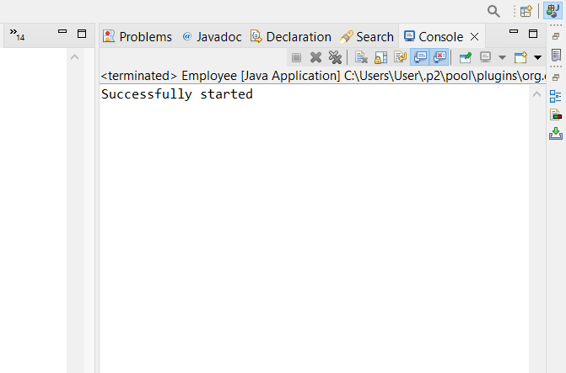

Assignment-2

* Create a new class Employee
* Add member variables: id and age of type int, name of type String and is Permanent of type boolean
* Now assign values 35.5 to age; See the error message.
* How can you avoid this error? Correct the error by casting.
* Make all the members protected
* Add a main method to it. Print message "Successfully started