package com.anpc8232.Assignment;

public class Student

{

//Memory variables

private String studentName;

private String collegeName;

private int sudentID;

//Main method

public static void main(String[] args)

{

System.out.println("Successful");

}

}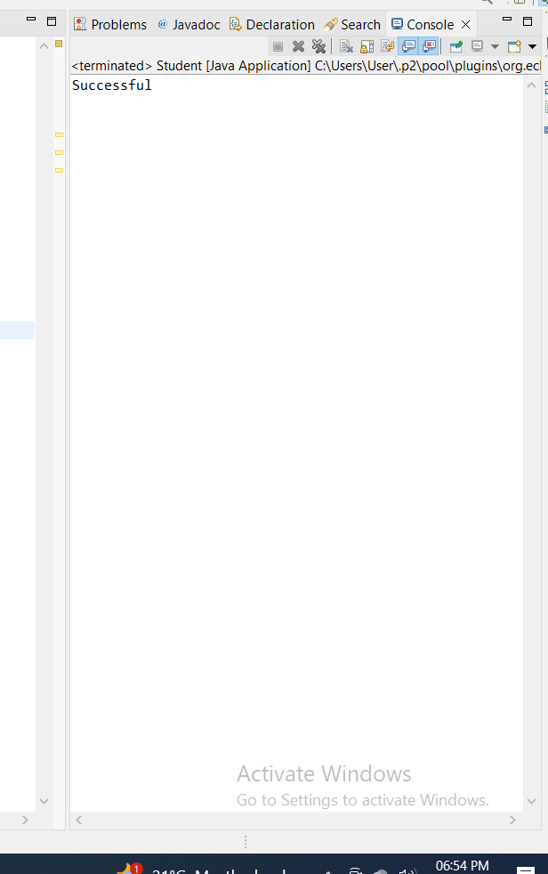

Assignment-1.

* Create a class Student in Student.java then add member variables studentName, collegeName of type String
* Add a member variable studentID of type int
* Make all the member variables as private.
* Add a main method. And print a message "Successful".
* Compile the class
* Run the class
* (Follow Coding convention)