**WebSage-Bot: AI-Powered Web Scraping and Question Answering System**

**Table of Contents**

1. Introduction
2. Installation
3. Modules
   * 3.1 Web Scraping
   * 3.2 Embedding Generation
   * 3.3 FAISS Vector Database
   * 3.4 Generative AI
   * 3.5 Gradio User Interface
4. API Endpoints
5. Technologies
6. Output
7. Conclusion

**1. Introduction**

WebSage-Bot is an AI-powered application designed to scrape web content, generate embeddings, and provide intelligent responses to user queries. By combining modern web scraping techniques, machine learning models for text representation, and generative AI, WebSage-Bot offers a seamless interface for users to interact with information retrieved from the web.

**2. Installation**

To use WebSage-Bot, users need to install several libraries that facilitate web scraping, data processing, and AI functionalities. These libraries include BeautifulSoup for web scraping, Sentence Transformers for generating text embeddings, FAISS for efficient similarity search, and Gradio for creating an interactive user interface. Installation can be accomplished using the Python package manager, pip.

**3. Modules**

**3.1 Web Scraping**

The web scraping module is responsible for fetching content from specified webpages. It utilizes libraries such as BeautifulSoup to parse HTML and extract relevant text, typically from paragraph tags. This module ensures that users can access and utilize information from a variety of sources on the internet efficiently.

**3.2 Embedding Generation**

Once the content is scraped, it is converted into vector embeddings using models from the Sentence Transformers library. These embeddings serve as numerical representations of the text, capturing semantic meanings. This module allows the system to perform similarity searches and efficiently retrieve relevant content based on user queries.

**3.3 FAISS Vector Database**

FAISS (Facebook AI Similarity Search) is used to store and manage the vector embeddings. This module enables rapid retrieval of similar items by utilizing high-dimensional vector space techniques. The FAISS index allows WebSage-Bot to quickly find the most relevant content based on the embeddings, enhancing the speed and efficiency of query responses.

**3.4 Generative AI**

The generative AI module employs a model, such as GPT-2, to create human-like responses based on the context retrieved from the vector database. This module interprets the user’s query and generates coherent answers, enriching the user experience by providing not just data retrieval but also interpretative responses.

**3.5 Gradio User Interface**

Gradio serves as the user interface for WebSage-Bot, enabling users to interact with the application easily. It provides input fields for users to enter URLs for scraping and questions for querying the generated content. The Gradio interface simplifies user interaction and enhances accessibility to the underlying AI functionalities.

**4. API Endpoints**

WebSage-Bot exposes two main API endpoints:

* **Load Data**: Accepts a URL, scrapes the content, and stores it in the vector database.
* **Query Data**: Accepts a user question, retrieves relevant data, and generates an answer using the generative AI model.

These endpoints facilitate the primary operations of the application, allowing users to load data from the web and query it seamlessly.

**5. Technologies**

WebSage-Bot is built using a variety of technologies, including:

* **Python**: The primary programming language used for development.
* **BeautifulSoup**: A library for web scraping and HTML parsing.
* **Sentence Transformers**: For creating text embeddings.
* **FAISS**: For efficient similarity search in high-dimensional spaces.
* **GPT-2**: A model for generating human-like text responses.
* **Gradio**: For building interactive web applications easily.

**6.Output**

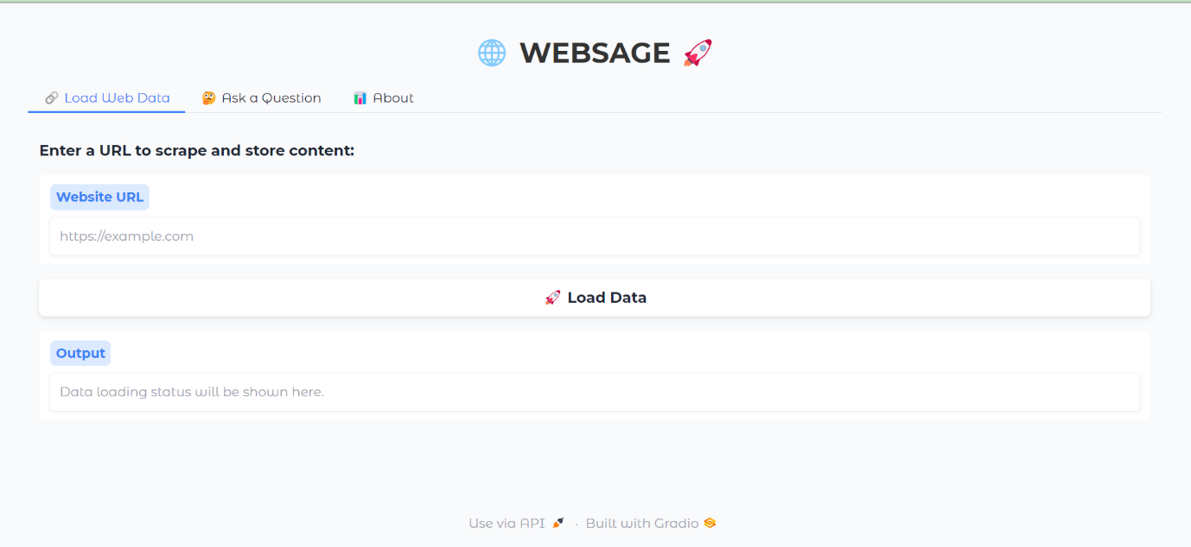

1. **Conclusion**

WebSage-Bot combines various advanced technologies to provide a robust solution for web scraping and AI-based question answering. Its modular structure allows for easy maintenance and scalability, making it an excellent tool for accessing and interpreting information from the web effectively.