Draw the Incident Response Life Cycle Diagram and Describe Each Phase with a Real-Life Example (Twitter Bitcoin Scam – 2020)

Aim
To study the Incident Response Life Cycle and understand how organizations prepare for, detect, contain, eradicate, recover from, and learn from cybersecurity incidents using the Twitter Bitcoin Scam (2020) as a real-world example.

Objectives
- Understand the six phases of the Incident Response Life Cycle.
- Study the Twitter Bitcoin Scam (2020).
- Learn the activities performed during each response phase.
- Understand how proper incident response minimizes business impact.

Introduction
Incident Response (IR) is a structured approach used by organizations to identify, analyze, contain, eradicate, recover from, and learn from cybersecurity incidents. Following the NIST Incident Response framework enables organizations to reduce damage, restore services quickly, and improve their overall security posture.
In July 2020, attackers used social engineering to compromise Twitter employees and gain access to internal administrative tools. They hijacked high-profile accounts including Elon Musk, Bill Gates, Apple, Barack Obama, Jeff Bezos, and others to promote a fake Bitcoin giveaway. Thousands of users sent cryptocurrency to attacker-controlled wallets before Twitter stopped the attack.

Incident Response Life Cycle Flow Chart
INCIDENT RESPONSE LIFE CYCLE
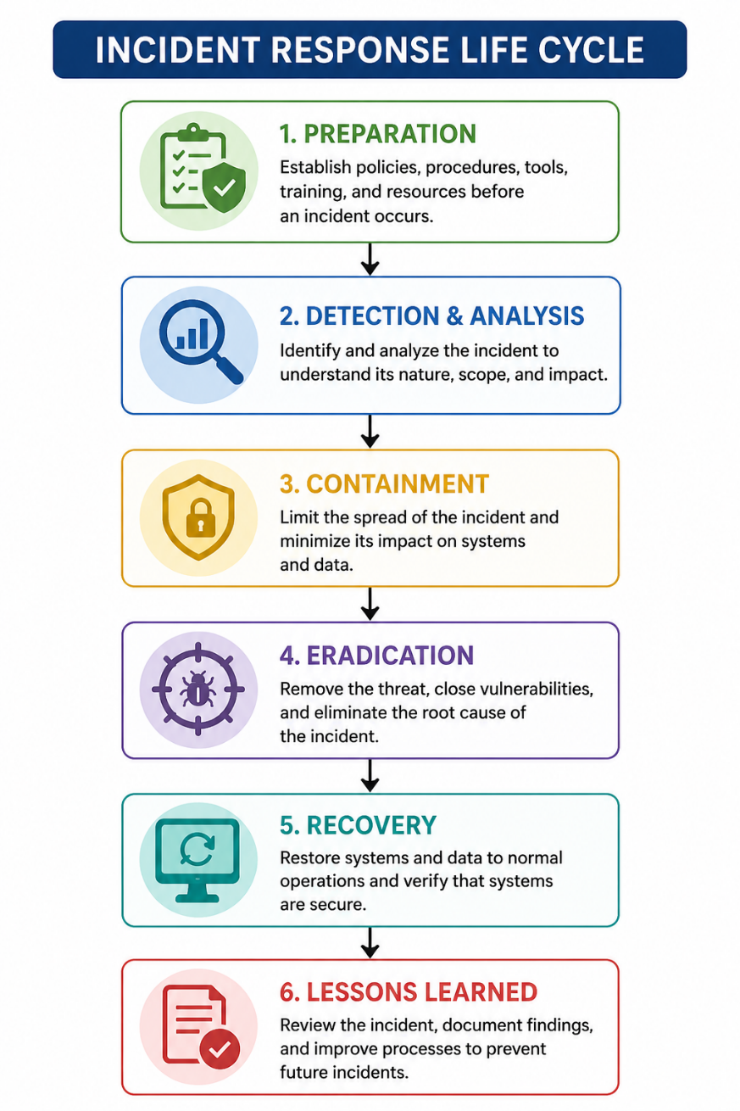

Real-Life Scenario
Attack Name: Twitter Bitcoin Scam (2020)

Overview
Attackers used phone-based social engineering to trick Twitter employees into revealing credentials. They accessed Twitter's internal administration panel and took control of several verified accounts.
The attackers posted messages promising to double any Bitcoin sent to a specific wallet.
Thousands of users believed the tweets and transferred cryptocurrency to the attackers.
Twitter temporarily locked verified accounts while the incident response team investigated the breach.

1. Preparation

Definition
Preparation involves implementing security policies, employee awareness training, multi-factor authentication (MFA), incident response plans, access control, and continuous monitoring before an attack occurs.

Real-Life Example
Twitter already had security monitoring and incident response teams. However, additional employee awareness against social engineering could have reduced the likelihood of credential theft.

2. Detection & Analysis

Definition
Security teams identify suspicious activities using logs, SIEM, endpoint monitoring, user reports, and forensic analysis.

Real-Life Example
Twitter noticed multiple verified accounts posting identical Bitcoin scam messages within minutes. Internal monitoring confirmed unauthorized use of administrative tools.

3. Containment

Definition
Containment limits the spread of the attack while preserving evidence for investigation.

Real-Life Example
- Locked compromised accounts
- Disabled tweet posting for verified accounts
- Revoked attacker sessions
- Restricted access to internal administration tools

4. Eradication

Definition
Eradication removes the attacker's access, fixes vulnerabilities, resets credentials, and strengthens security.

Real-Life Example
- Reset employee passwords
- Revoked compromised tokens
- Removed unauthorized administrator access
- Investigated insider access paths
- Strengthened authentication procedures

5. Recovery

Definition
Recovery restores normal business operations after verifying systems are secure.

Real-Life Example
- Verified accounts regained control.
- Normal tweeting functionality resumed.
- Security monitoring continued to ensure attackers no longer had access.

6. Lessons Learned

Definition
Organizations review the incident, identify weaknesses, update policies, improve training, and strengthen defenses.

Real-Life Example
Twitter implemented:
- Stronger employee verification procedures
- Additional security awareness training
- Better privilege management
- Improved monitoring of internal administrative tools
- Enhanced access control policies

Observation
Phase | Observation
Preparation | Employee security awareness is essential against social engineering.
Detection | Monitoring quickly identified unauthorized tweets.
Containment | Locking accounts prevented further misuse.
Eradication | Compromised credentials and attacker access were removed.
Recovery | Services resumed after validating system security.
Lessons Learned | Stronger access controls and training reduced future risk.

Result
The Incident Response Life Cycle demonstrates how organizations can effectively prepare for, detect, contain, eradicate, recover from, and learn after cybersecurity incidents. The Twitter Bitcoin Scam highlights the importance of employee awareness, multi-factor authentication, privileged access management, and continuous monitoring in preventing social engineering attacks.

