**HTML & CSS**

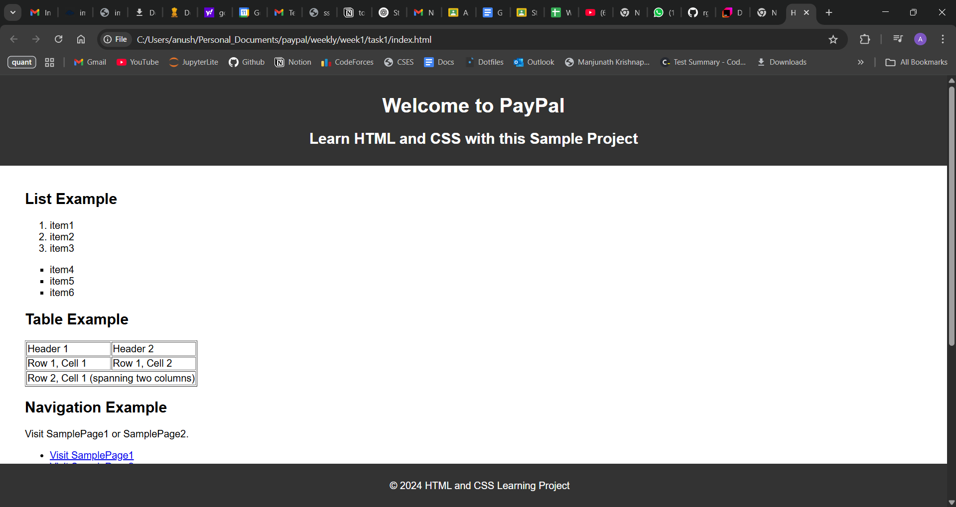

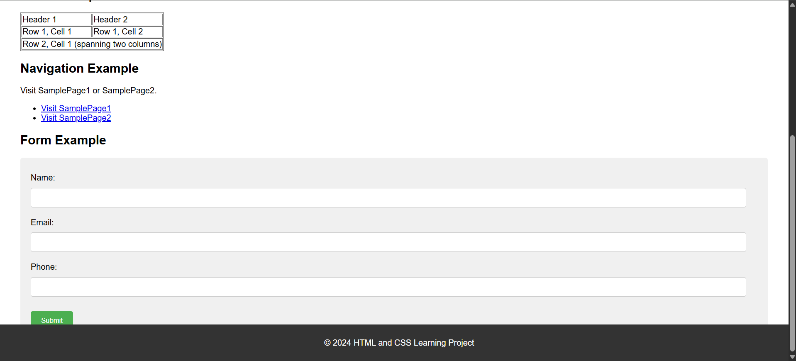

Code added to rg-assignments repo (link below)

**Git and IntelliJ**

1. What is the use of the git add command?

Ans: The git add command stages changes in the working directory for the next commit. It tells Git which files to include in the commit. Basically, marks files or changes from “working directory” to the “staging area” also called the index.

1. Write the command to create a branch “feature-group”.

Ans: git branch feature-group

1. What is a pull request? Write the steps involved in creating a pull request.

Ans: A pull request (PR) is a way to propose changes you have made in a separate branch or fork to be merged into another branch, usually the main branch (main or master) of a repository Steps: push your branch to GitHub, go to the repo on GitHub, click "Compare & pull request" and choose base and compare branch, write a message, then click "Create pull request”.

1. How do you add collaborators?

Ans: Go to the repository on GitHub, click on “Settings” > “Collaborators”. Then enter the GitHub username or email and click "Add collaborator”.

1. What is the command used to commit our changes in github repo?

Ans: git commit -m "Commit message”

1. Create a github account and repository to save all your assignment tasks. Example repository name: rg-assignments

Link: <https://github.com/Anush2004/rg-assignments>

1. Install IntelliJ IDE. Create a simple java project displaying “Hello World!!”and share the screenshot.

