ASSIGNMENT – 05
DEVOPS
Project Requirements Specification
Large Online Shopping System
Group Members
Name | Student ID
Sobuj Hosen | e2403514
Anush Gotame | e2401841

Development Methodology: Scrum

1. Introduction
The Large Online Shopping System is intended to provide customers with a convenient platform for discovering products, managing a shopping cart, completing purchases, making online payments, tracking orders, and giving product feedback. The system also supports sellers, administrators, customer support staff, payment services, and delivery services.
Scrum is selected as the development methodology because requirements can change during development, the project owner expects regular demonstrations, and the system can be delivered incrementally. Development is organized into two-week Sprints, followed by demonstration and feedback.

2. Stakeholders and User Needs
The following stakeholder groups are identified from the assignment requirements. Their needs guide the functional and non-functional requirements of the system.
Stakeholder | Role | Main Needs
Customers | Purchase products | Easy login, fast search, clear product information, easy checkout, secure payment, order tracking, reviews
Administrators | Manage and control the system | Manage users, products, orders, sellers, payments, and reviews
Sellers | Sell products through the platform | Add/update products, manage prices and stock, receive orders, monitor sales
Payment Service Provider | Process online payments | Secure and reliable payment processing and accurate transaction information
Delivery/Courier Service | Deliver products | Accurate customer/delivery information, order details, and delivery status
Customer Support Staff | Help customers | Access relevant customer and order information
Project Owner/Customer | Define business goals | Reliable system, demonstrations, feedback, successful delivery
Development Team | Design, develop, test, maintain | Clear requirements, prioritized tasks, manageable workload, maintainable software

2.1 Main User Needs
- The system should be easy to use.
- Customers should be able to search for products quickly.
- Product information should be clear and accurate.
- Customers should easily manage their shopping cart.
- The checkout process should be simple.
- Online payments should be secure.
- Customers should be able to track their orders.
- The system should be reliable and available.
- Customers should be able to give product reviews.
- Personal and payment information should be protected.

3. Overall Application Requirements

3.1 Functional Requirements
ID | Requirement
FR1 | Users can register and log in.
FR2 | Customers can search for products.
FR3 | Customers can filter and sort products.
FR4 | Customers can view product details.
FR5 | Customers can add and remove products from the cart.
FR6 | Customers can change product quantities.
FR7 | Customers can enter delivery information.
FR8 | Customers can place orders.
FR9 | Customers can make online payments.
FR10 | Customers can view previous orders.
FR11 | Customers can track orders.
FR12 | Customers can give product ratings and reviews.

3.2 Performance Requirements
- Product searches should return results quickly.
- The system should support many users and products without major slowdown.
- Cart and checkout operations should respond quickly.
- Database queries should be efficient for product and order operations.

3.3 Usability Requirements
- The interface should be simple and easy to learn.
- Navigation and product information should be clear.
- The checkout process should be straightforward.
- The system should work on computers, tablets, and phones.
- Error messages should be clear and understandable.

3.4 Reliability and Availability
- The system should be available most of the time.
- Orders and important customer data should not be lost during normal operation.
- The system should handle errors safely and provide recovery mechanisms.
- Regular backups should support recovery of important data.

3.5 Security
- User accounts must be protected through authentication.
- Passwords and personal information must be stored securely.
- Customers should access only their own personal information and orders.
- Administrative functions must be restricted to authorized users.
- Payment and communication with external services should use secure mechanisms.

3.6 Maintainability
- The application should have a clear modular structure.
- Code should be understandable and easy to modify.
- Documentation and testing should support maintenance.
- New features should be possible without major changes to unrelated modules.
- Version control should be used for project files and development work.

3.7 Compatibility and Integration
- The system should support modern web browsers.
- The interface should work across desktop and mobile devices.
- The system should integrate with online payment services.
- The system should support delivery/courier information and status.
- Email or notification services may be used for relevant customer updates.
- The application should use a suitable product, inventory, user, and order database.

3.8 Constraints
- The project is developed within limited time and resources.
- Scrum is used as the selected development methodology.
- A database is required for persistent system information.
- Online payment depends on an external payment service.
- Delivery tracking may depend on an external delivery service.
- Privacy and security requirements must be respected.
- Available budget and technical resources may limit implementation choices.

4. Logical Subsystems
Subsystem | Purpose / Responsibilities | Inputs | Outputs
User Management | Accounts, registration, login, and user information | Registration/login details | Account status and authenticated session
Product Management | Products, prices, stock, and product information | Product data and seller updates | Product catalogue information
Shopping Cart | Selected products and quantities | Product selections and quantities | Cart contents and total
Checkout & Payment | Checkout, delivery details, and payment | Cart, customer, delivery, and payment data | Order/payment result
Order & Delivery | Orders and delivery status | Order and delivery information | Current order status
Review System | Ratings and product reviews | Rating and review data | Published review
Administration | System-wide management | Authorized admin actions | Updated users, products, orders, and reviews

4.1 Subsystem Requirements
Subsystem | Functional Responsibilities | Key Non-Functional Requirements
User Management | Register/login, manage user details, authenticate users | Secure authentication; protect personal data
Product Management | Create/update/view product information and stock | Accurate product data; efficient search and updates
Shopping Cart | Add/remove products and change quantities | Fast response; correct totals and persistent cart state
Checkout & Payment | Collect delivery data, place order, process payment | Secure communication; reliable transaction handling
Order & Delivery | Store orders and show delivery status | Reliable order data; timely status updates
Review System | Submit and display ratings/reviews | Controlled review access; clear presentation
Administration | Manage users, products, orders, sellers, payments, reviews | Role-based access; secure administrative functions

5. Quality Function Deployment (QFD)
QFD connects stakeholder/customer needs to technical requirements. Importance values are assigned on a 1–5 scale, where 5 represents the highest priority.
Customer Need | Importance | Technical Requirement | Priority
Easy to use | 5 | Responsive and clear user interface | High
Fast product search | 4 | Optimized database/search operations | High
Clear and accurate product information | 4 | Reliable product database and validation | High
Easy cart management | 4 | Simple cart module and correct quantity/price handling | High
Simple checkout | 5 | Streamlined checkout workflow | High
Secure online payments | 5 | Secure payment integration and protected communication | Critical
Order tracking | 4 | Reliable order and delivery-status integration | High
Reliable and available system | 4 | Error handling, backup, recovery, and availability controls | High
Product reviews | 3 | Review management and access control | Medium
Protection of personal/payment information | 5 | Authentication, authorization, encryption, secure data handling | Critical

QFD conclusion: security, usability, performance, and reliability receive the strongest attention. Secure payment and protection of personal information are critical because they directly affect customer trust.

6. Use-Case Diagram
The use-case diagram identifies the main actors and their interactions with the Large Online Shopping System.
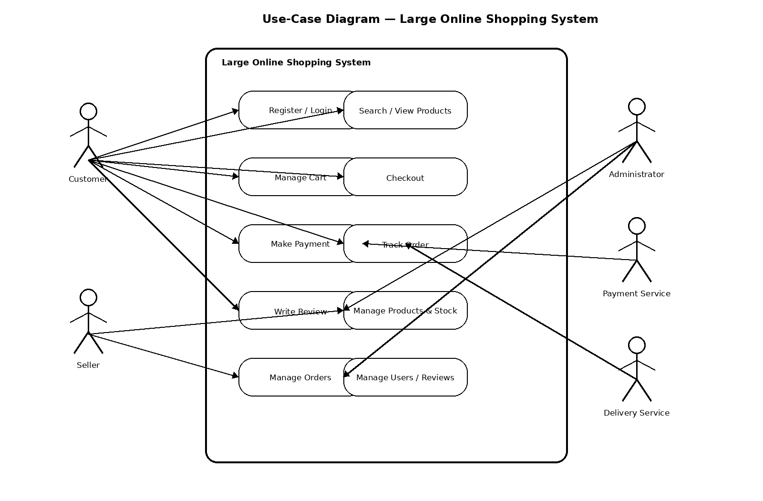
Figure 1. Use-case diagram of the Large Online Shopping System.

7. Sequence Diagram
The sequence diagram shows a typical customer purchase flow: login, product search, cart management, checkout, stock checking, payment processing, order creation, and confirmation.
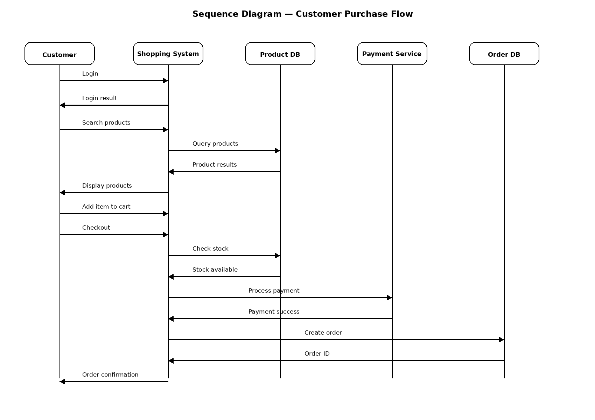
Figure 2. Sequence diagram for the customer purchase flow.

8. Scrum Development Plan
The project follows Scrum with two-week Sprints. Each Sprint includes planning, implementation, testing, demonstration, feedback, and adaptation. The Product Backlog is updated as priorities change.
Sprint | Main Features | Expected Result
Sprint 1 | User registration/login and product search | Working login and search features
Sprint 2 | Product details and shopping cart | Product information and cart operations
Sprint 3 | Checkout and online payment | Order placement and payment flow
Sprint 4 | Order tracking and product reviews | Tracking and review features

8.1 General Scrum Cycle
- Plan the Sprint and select prioritized backlog items.
- Build and integrate the selected features.
- Test the implemented functionality.
- Demonstrate the increment to the project owner/customer.
- Collect feedback and identify changes.
- Adapt the Product Backlog and repeat in the next Sprint.

9. Conclusion
The Large Online Shopping System requirements define the needs of customers, sellers, administrators, external services, support staff, the project owner, and the development team. The specification covers functional requirements together with performance, usability, reliability, security, maintainability, compatibility, integration, and project constraints. The system is divided into logical subsystems and prioritized using QFD. The use-case and sequence diagrams describe the main interactions, while the Scrum plan provides an incremental four-Sprint development approach with regular demonstrations and feedback.

