# Chinook Database
- Profiling of Database
- Tables in Chinook Database
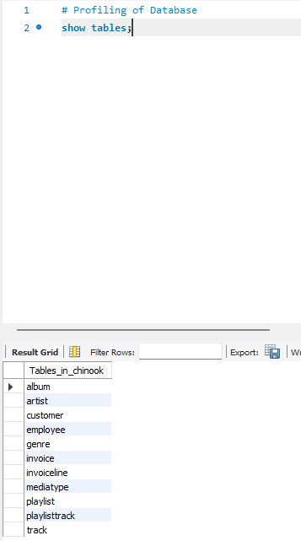
- Looking at the number of rows per tables
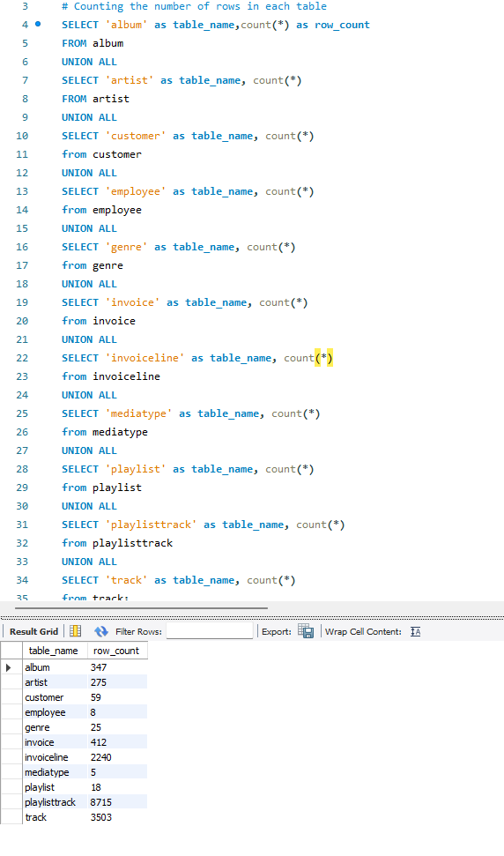
- Looking at the column profiling
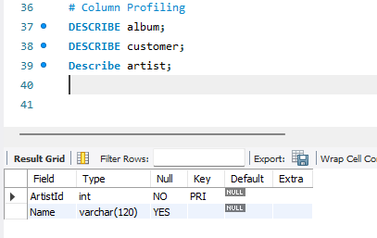
- Looking at the artist and album table
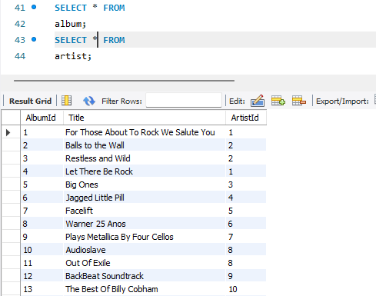
- Counting the number of albums per artist
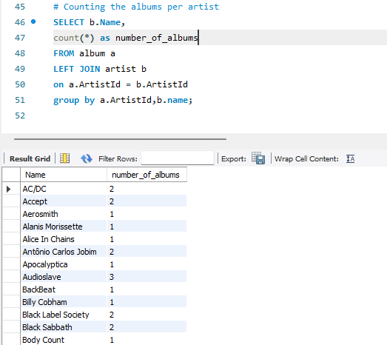
- Looking at customer and employee table
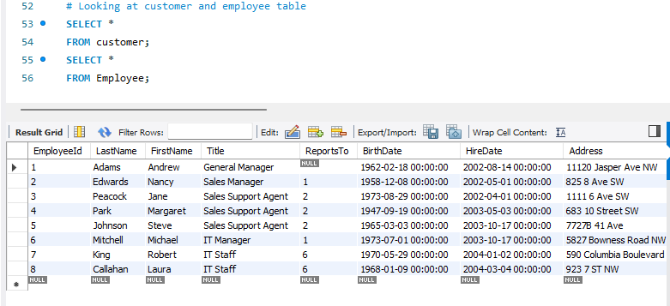
- Counting the number of customers per each sales representative
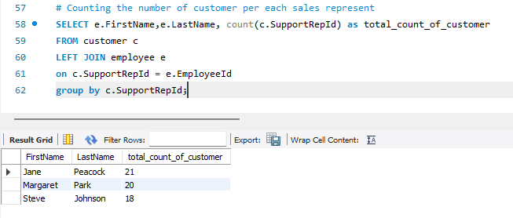
- Looking at customer total bill
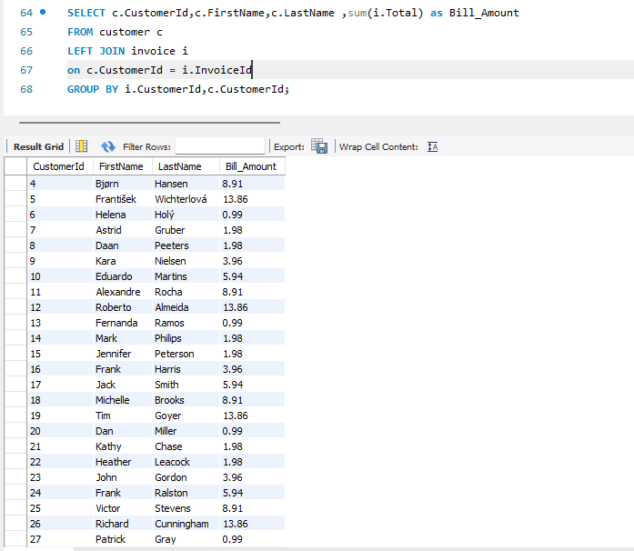
- Looking at total price sell of track with track name
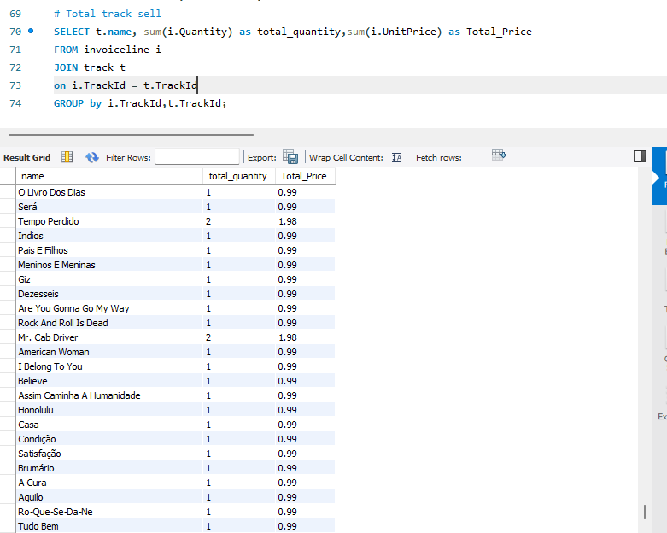
- Total Revenue Generated by each country sort by highest
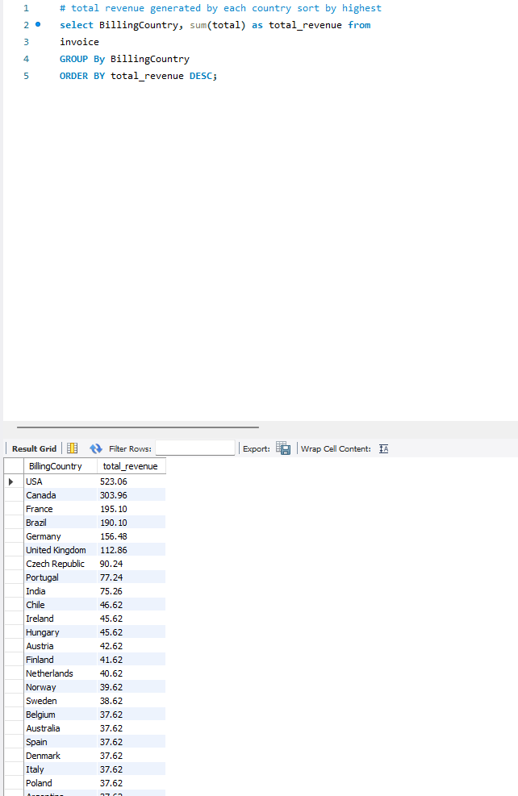
- Average Invoice Value per Customer
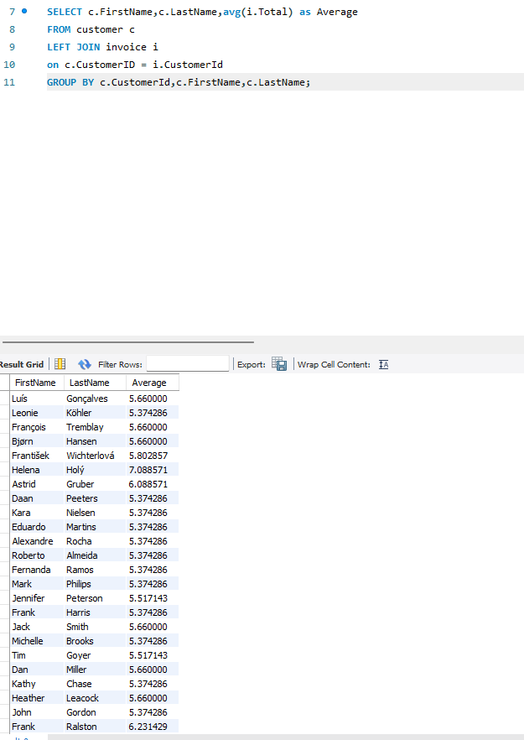
- Top 3 Highest Number of Invoice with Customer name
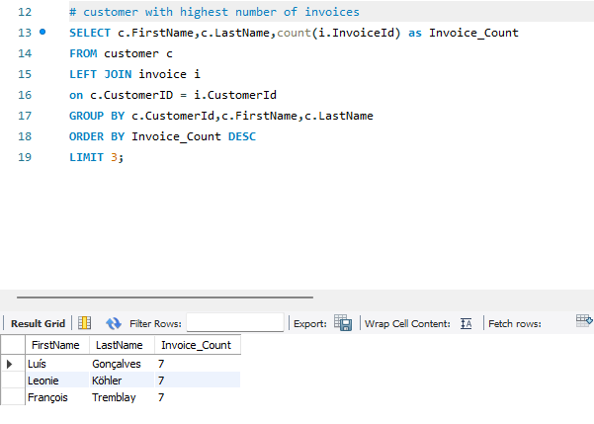
- Showing the invoice total of customer with support sales name and customer name
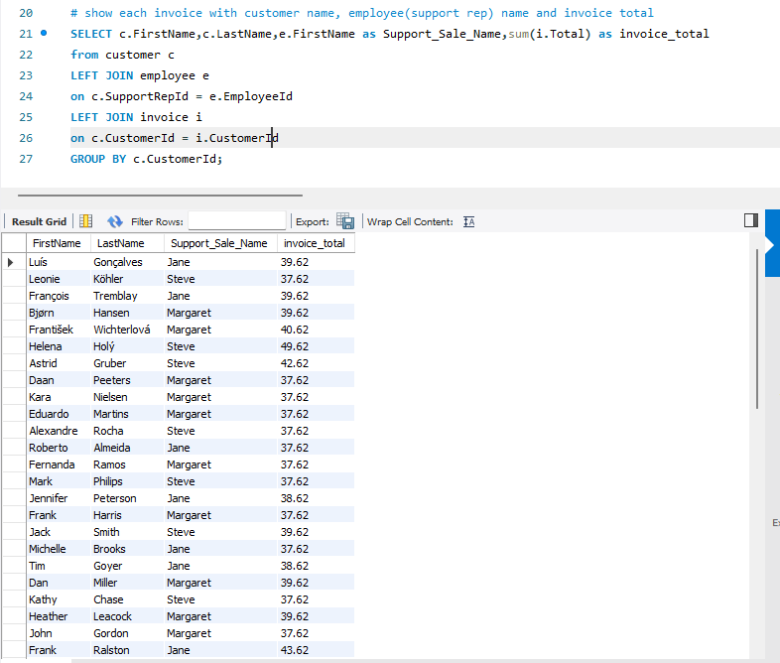
- Total Sales generated by each sales representative
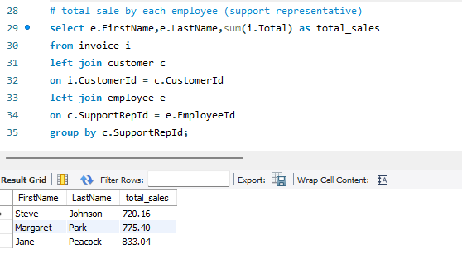
- Artists and their track using CTE
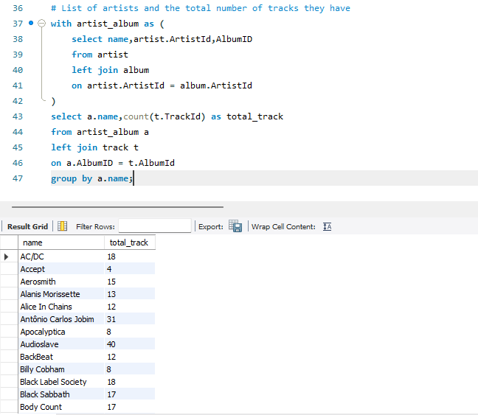
- Countries that have 5 or more customers
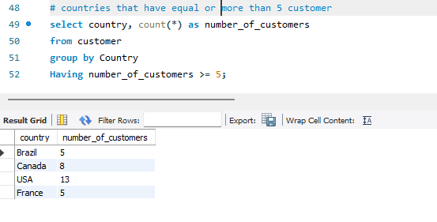
- Genres generated more than $100 in sales
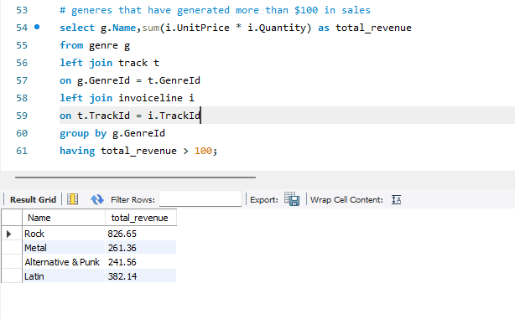
- Customers who have spent more than average customer spending
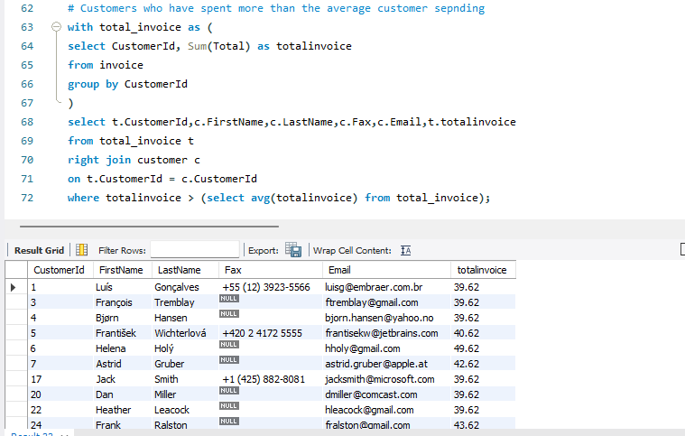
- Top selling track by total Quantity sold
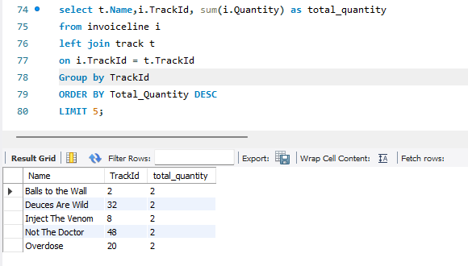
- Which Genre Sales most in USA?
