EXCEL

- Filtration Using Filter Tab in Data
- The longest movie in data sort by largest to smallest
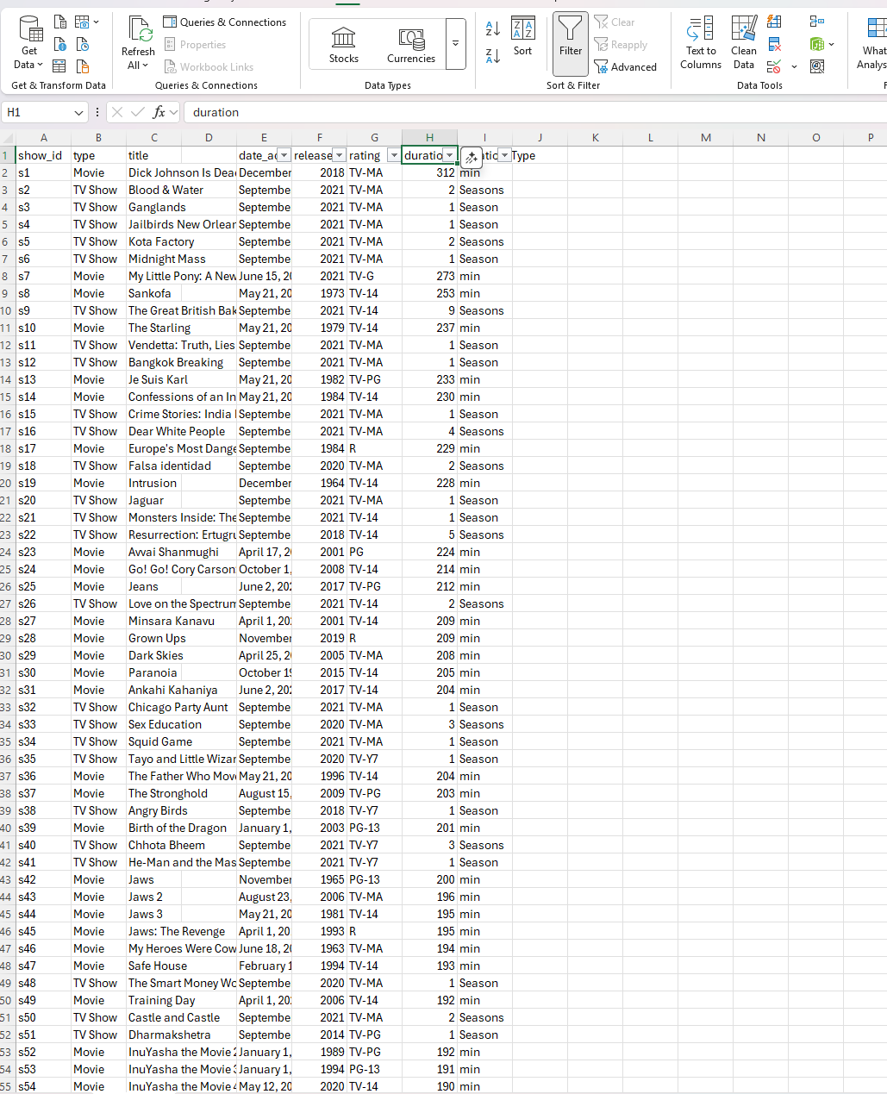
- Sort by Smallest to largest
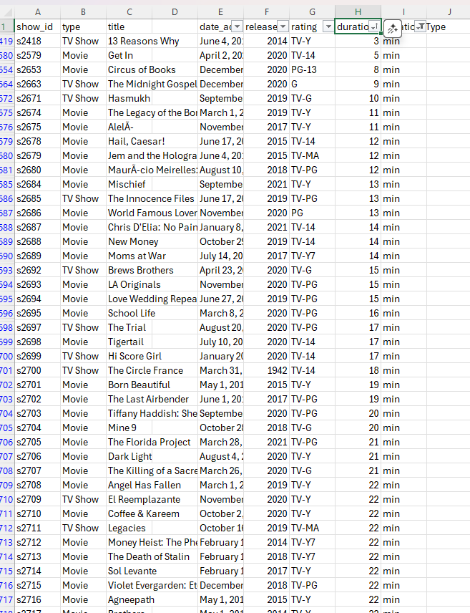
- SUM, Average and Max
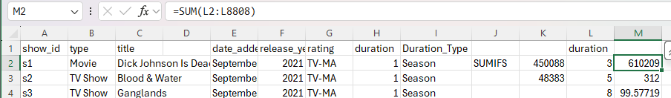
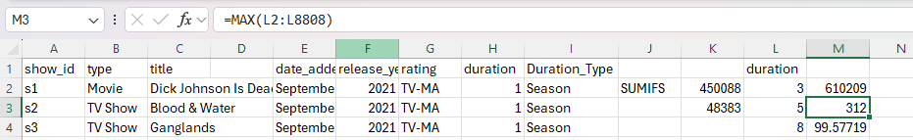
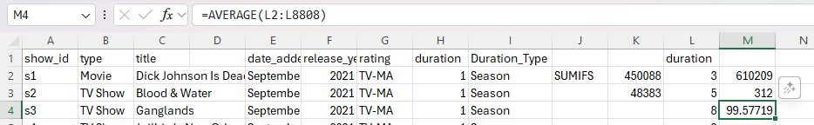
- IF, IF-AND, and IF-OR
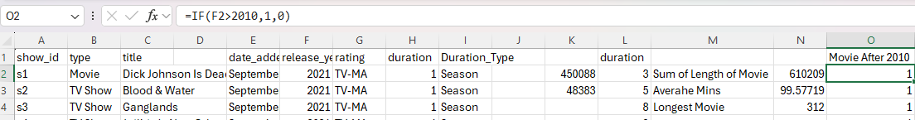
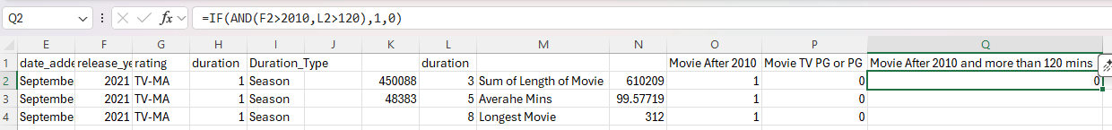
- SUMIFS for Multiple Condition
Checking the column movie or not and adding the minutes.
Checking the number of movies and series after 2021 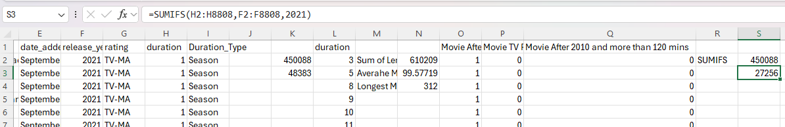

COUNTIFS
Counting the number of movie release after 2020
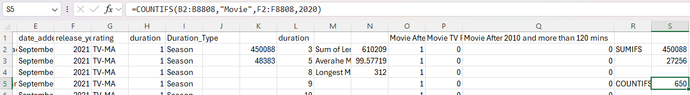

Unique, Left, Right Function
Finding Unique things in column like SQL distinct
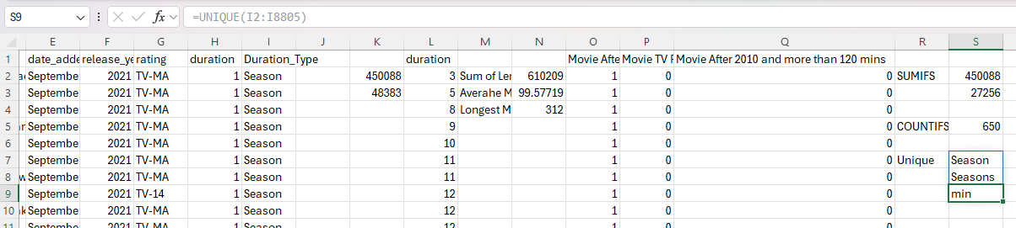
Left Display the unique text or number from left side of column
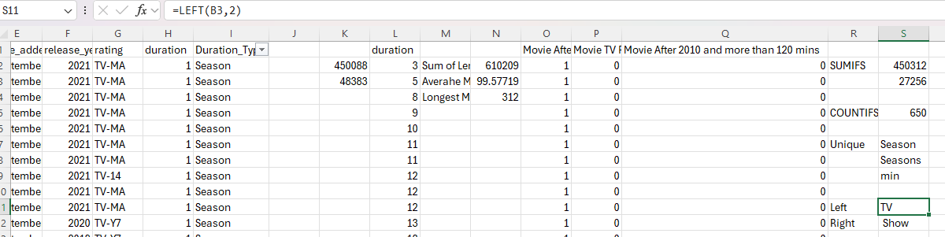
Right Show the Unique text from right side of column
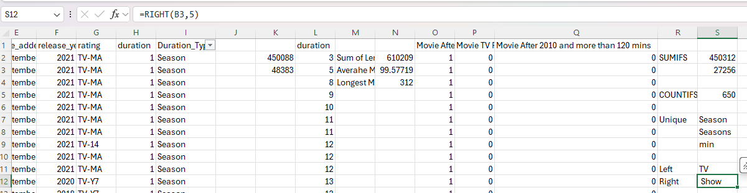

VLOOK For Finding the Specific Columns Name based on Value
Trying the find Name of Movie on Array with Specific Name of Columns
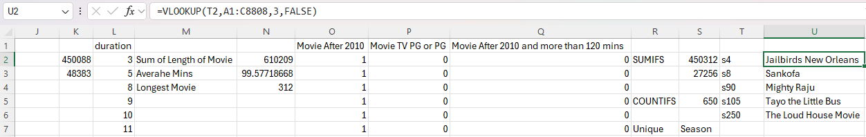
Trying to find the date of release of movie
