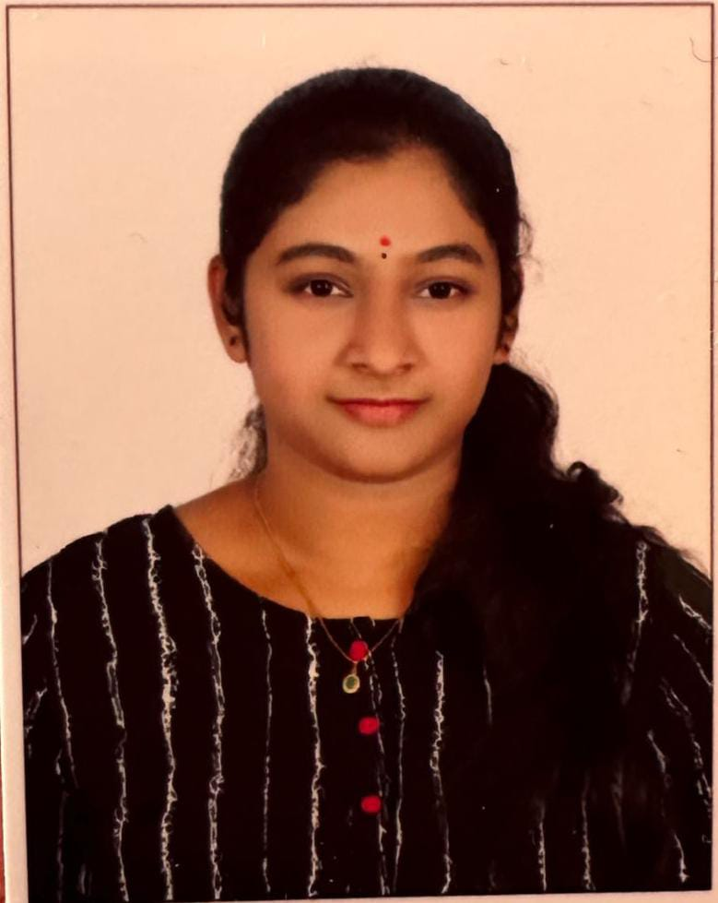

EDUCATION
Bachelors in Computer Science Engineering | Vardhaman College of Engineering -College
Session: 2021-2025| Score: 7.5 CGPA

Intermediate (Telangana State Board of Intermediate Education)
|Narayana Junior College
Session: 2018-2019 | Percentage: 90%

Matriculation/SSC | Sri Chaitanya School
Session: 2016-2017 | Percentage: 93%

INTERSHIPS
SALES FORCE | Virtual Intern
October 2023 - January 2024
Salesforce Supported Virtual Internship as a Developer.
Performed activities on developer designs , implemented customized solutions within the Salesforce platform and lead customer relationship management (CRM) system.

PROJECTS
Achieving Mastery : The role of quizzes in learning and assessment
Objective : Implementation of a quiz platform and made a detailed analysis which is mainly useful for the college students and unemployed youth to master their technical knowledge.
Web application : Using HTML, CSS and JavaScript ( Tools like React , AngularJS) for backend Application server, Nodejs, MySQL.
March 2024 - June 2024
Bluetooth Enabling robotic device using Arduino
Objective : Implementation of a remote device based on IOT based open source platform such as Arduino and it can be helpful in various alerting and monitoring systems.
Iot basedtools such as Arduino , Jumper Wires,HC Bluetooth module , L298N motor driver
April 2023 - July 2023

ACADEMIC ACHIEVEMENTS
Certification for soft skills training in college
Certification for Cybersecurity workshop in college

CERTIFICATIONS & AWARDS
Wadhwani Foundation - JobReady Employability Skills
Great Learning certification - Front End Development HTML
LinkedIn Learning certification - Generative AI : The evolution of thoughtful Online Search
EXTRA CURRICULAR & CO-CURRICULAR ACHIEVEMENTS
Achieved a silver medal in badminton at state level competition
Instagram blog page on Food reviews and recommendations

EXTRA CURRICULAR & CO-CURRICULAR ACHIEVEMENTS
Leetcode: Solved easy and medium level problems on DSA
Hackerrank score 3.3/5.0

ASIREDDYPALLI ANUSHA
Address: H-No : 3-12/14/V/502 , Vinayaka Arcade, Sri Lakshmi nagar colony, LBnagar, Hyderabad
E-mail: ar7072778@gmail.com
Phone: +91 9618877178
LinkedIn:Asireddypalli Anusha
Git: Anusha-2807

CAREER OBJECTIVE
A well-organized, creative and goal-oriented graduate possessing excellent communication, problem-solving and leadership skills with a flair to explore suitable avenues in Computer Science Engineering while developing advanced projects with efficiency and quality.

TECHNICAL COMPETENCIES
C++ | JAVA | PYTHON | SQL

INTERPERSONAL SKILLS
Team Leadership | Management & Coordination | Decision Making

INTERESTS & HOBBIES
Writing | Blogging | Painting | Travelling | Reading | Gardening

LANGUAGES KNOWN
English | Hindi | Telugu | French

PERSONAL DETAILS
Mother's
Name : A.Madhavi
Father’s Name: A.Bal Reddy

