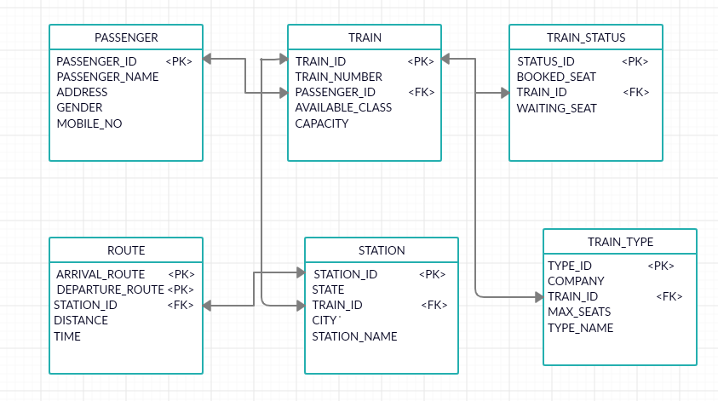

**TYPE OF KEY** PASSENGER_ID –NATURAL KEY <PK> PRIMARY KEY

ARRIVAL_ROUTE - NATURAL KEY <FK> FOREIGN KEY

DEAPARTURE_ROUTE -NATURAL KEY

STATION_ID – NATURAL KEY

TYPE_ID-SURROGATE KEY

TRAIN_ID - SURROGATE KEY

STATUS_ID – SURROGATE KEY

**FOREIGN KEY RELATIONSHIP**

For PASSENGER and TRAIN table PASSENGER_ID acts as Foreign key in TRAIN table

For TRAIN and TRAIN_STATUS table TRAIN_ID acts as Foreign key in TRAIN_STATUS table

For TRAIN and STATION table TRAIN_ID acts as Foreign key in STATION table

For TRAIN and TRAIN_TYPE table TRAIN_ID acts as Foreign key in TRAIN_TYPE table

For ROUTE and STATION table STATION_ID acts as Foreign key in ROUTE table

**TYPES OF SYSTEM**

PASSENGER : CUSTOMER AND PEOPLE SYSTEM

TRAIN : CORE ENTERPRISE SYSTEM(ERP)

TRAIN_TYPE : PRODUCT AND PRESENCE SYSTEM

TRAIN_STATUS : TECHNICAL OPERATION SYSTEM

STATION : EXTERNAL SOURCE

ROUTE : EXTERNAL SOURCE