PHASE 2
Backend Development & Configuration

1. Objective
Configure the ServiceNow backend components required for the Laptop Request application, including Update Set, Custom Application, Table, Approval Relationship and Record Producer.

2. Update Set Creation
- Open All > System Update Sets > Local Update Sets.
- Click New.
- Name the update set HR Onboarding Application.
- Set State to In Progress.
- Enter Release Date and Short Description as required.
- Submit and make the update set Current before development.
Local Update Set and Current Update Set.
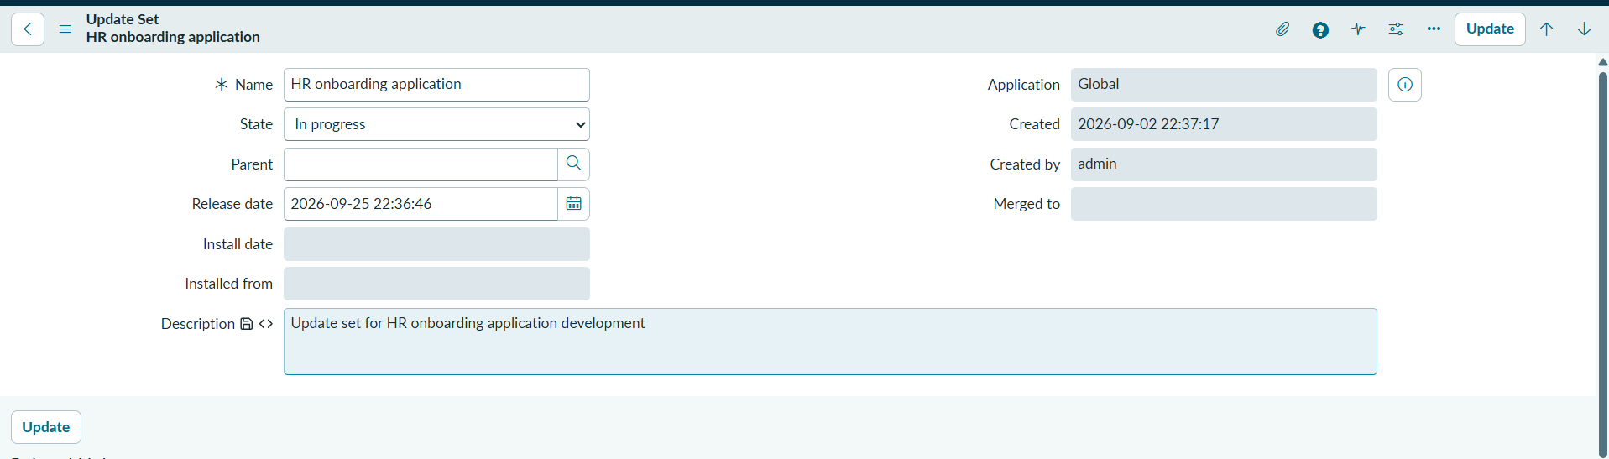
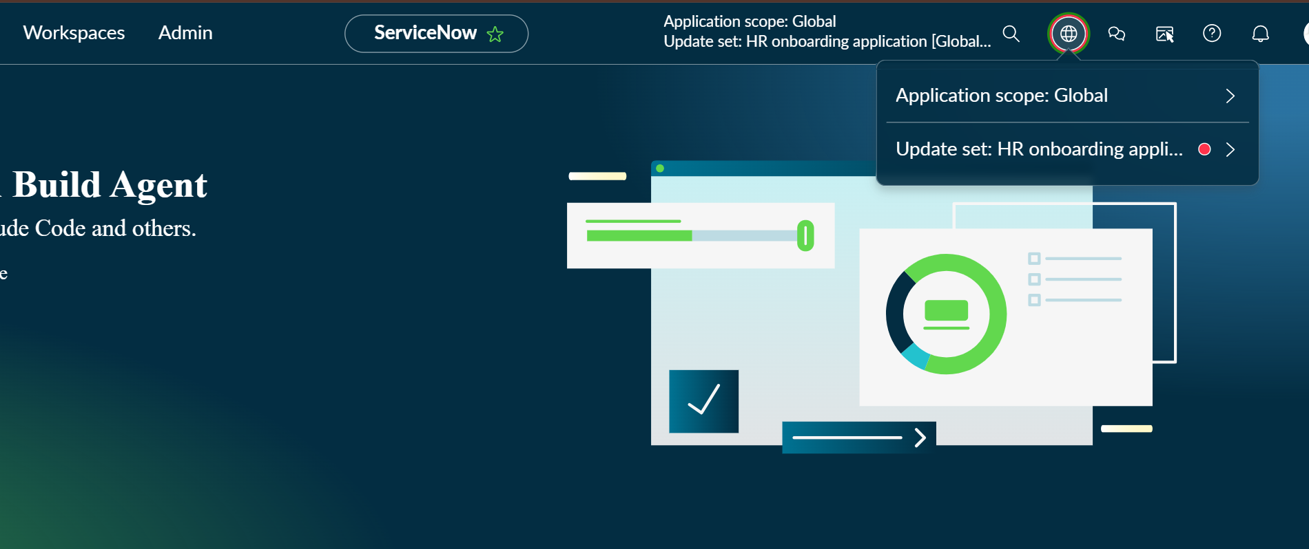

3. Custom Application Creation
- Open All > ServiceNow Studio.
- Create a new application.
- Application Name: Project Application.
- Select a scoped application.
- Continue and create application artifacts within the scope.
Project Application in ServiceNow Studio.
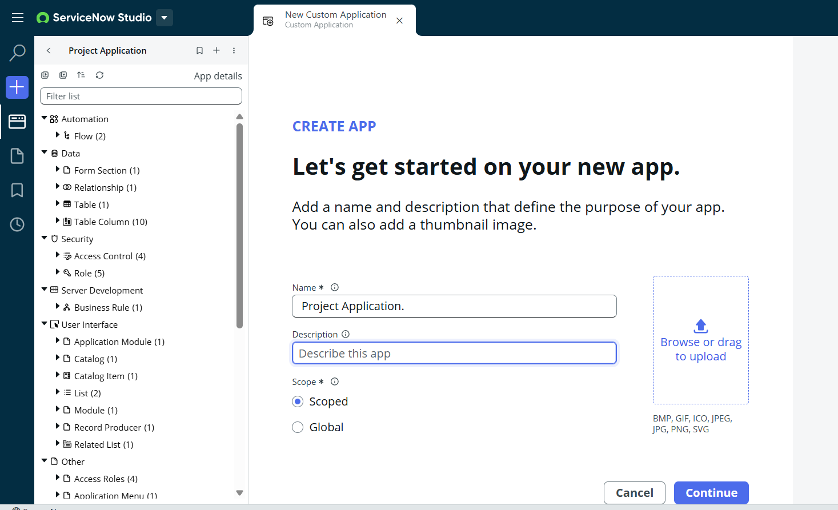

4. Laptop Request Form Table
Create the custom Laptop Request Form table and configure the required reference, choice, date/time, string and auto-number fields.
Configuration | Value
Table | Laptop Request Form
Requester | Reference to User
Manager | Reference to User
Request Type | Basic / Advance
Status | Pending Approval / Approved / Rejected
Reason | Software Development / Personal Use / Other
Laptop Request Form table and its fields.
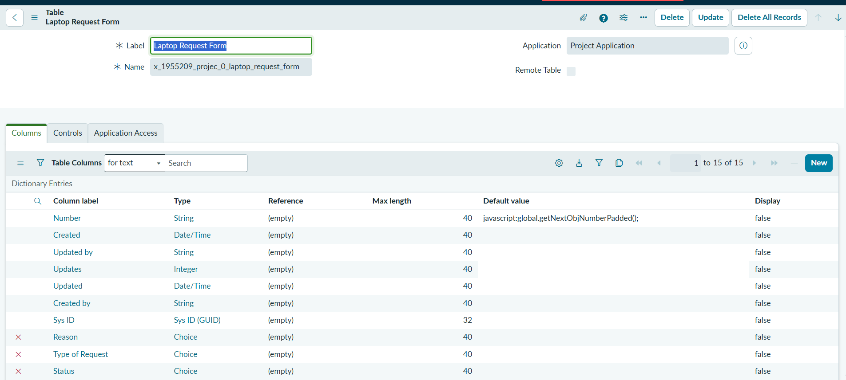
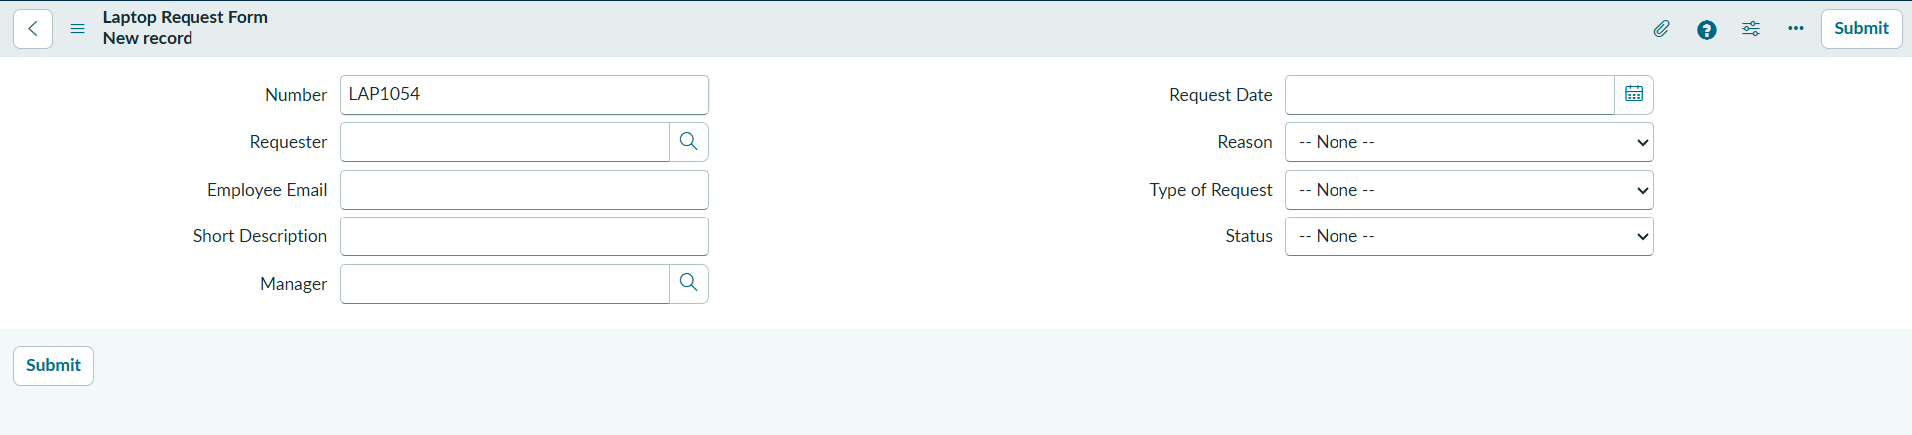

5. Approval Table Relationship
The Laptop Request Form is related to sysapproval_approver so that manager approval records can be associated with the request.
- Navigate to Relationship configuration and click New.
- Name: Laptop Request.
- Applies to: Laptop Request Form.
- Queries from: Approval table / sysapproval_approver.
- Configure the relationship script as required by the implementation.
- Open Laptop Request Form configuration and add the relationship.
- Verify the approval records appear as a related list.
Relationship definition and Approval related list.
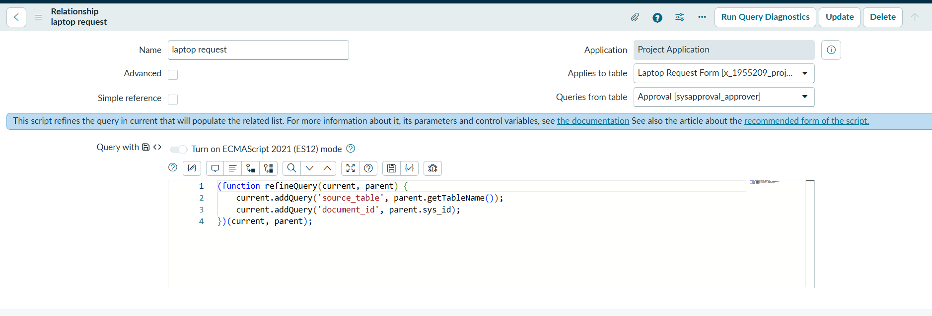
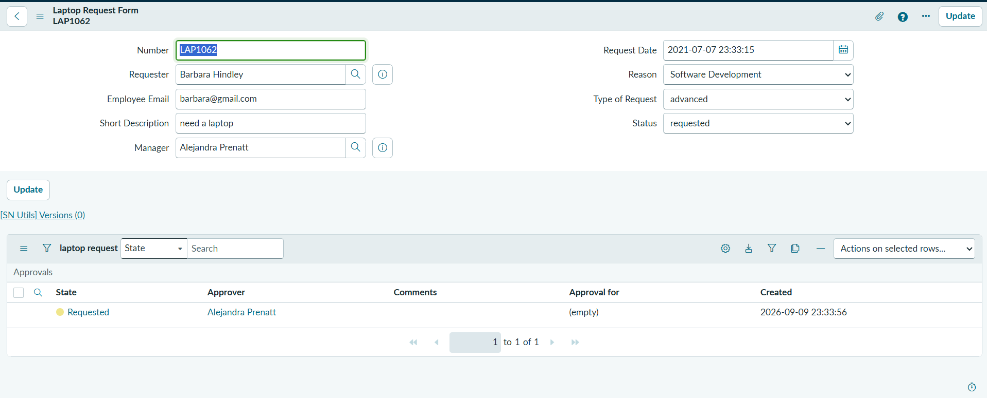

6. Record Producer Configuration
- Navigate to Service Catalog > Catalog Definitions > Record Producers.
- Click New.
- Name: Laptop Request.
- Target Table: Laptop Request Form (u_laptop_request_form).
- Add variables matching the required table fields.
- Map each variable to the corresponding target field.
- Create/associate Employee Service Catalog and category Service.
- Save and test the Record Producer.
Configuration | Value
Record Producer | Laptop Request
Target Table | Laptop Request Form
Catalog | Employee Service Catalog
Category | Service
Purpose | Employee-facing request submission
Record Producer, variables and field mapping.
