PHASE 3
Workflow Development & Execution

1. Objective
Automate the laptop request lifecycle using Flow Designer so that manager approval, status updates, notifications and IT handoff occur with minimal manual intervention.

2. Flow Trigger
Setting | Value
When | Record is Created
Table | Laptop Request Form (u_laptop_request_form)
Purpose | Start approval process immediately after submission
Flow Designer trigger configuration.
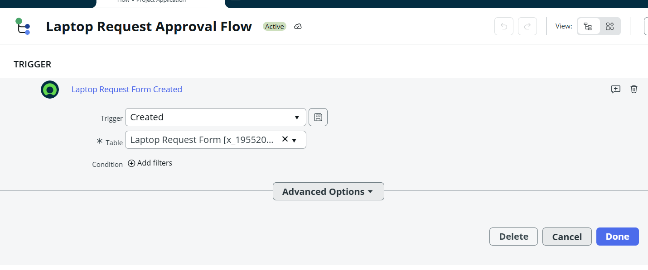

3. Subtask 1 – Initialize Request & Set Default Status
Action: Update Record. Set Status to Pending Approval. This ensures every new request begins in a controlled state.
Update Record action setting Pending Approval.
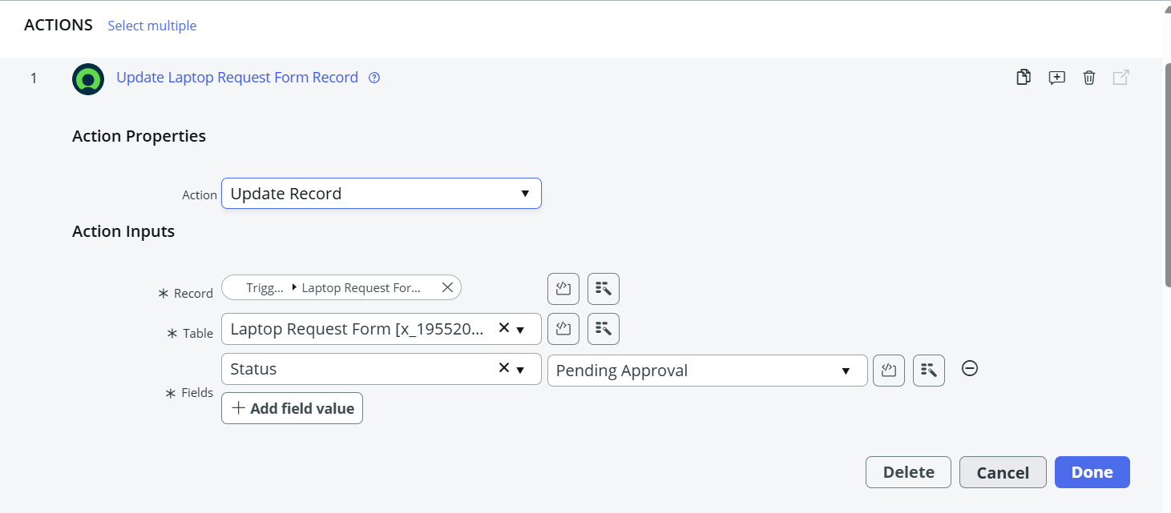

4. Subtask 2 – Manager Approval Request
Action: Ask for Approval. The Manager reference field is used as the approver and the flow waits for Approval or Rejection.
Setting | Value
Approval Type | User
Approver | Manager reference field
Record to Approve | Trigger Record
Wait For | Approval or Rejection
Expected behavior: a sysapproval_approver record is created, the manager is assigned as approver, and the manager receives an approval notification.
Ask for Approval action.
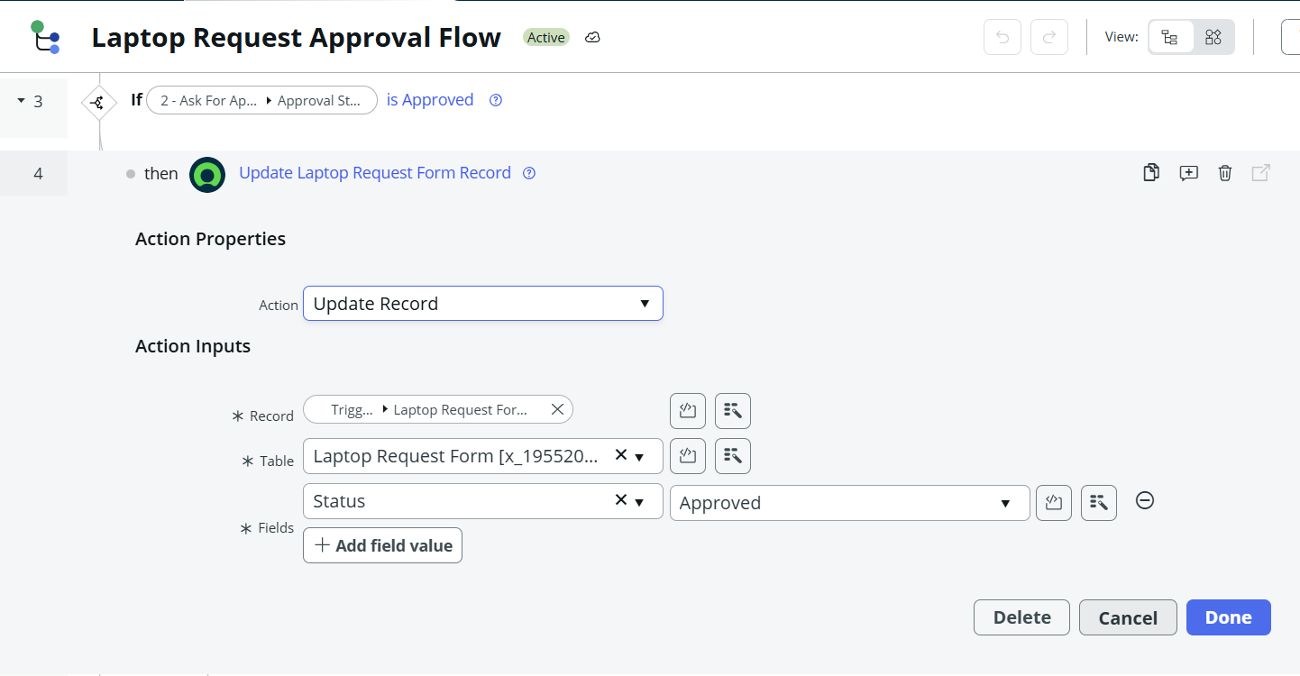

5. Approval Notification
Element | Content
Recipient | Manager / Approver
Subject | Laptop Request Approval Required
Details | Request Number, Requester, Type, Reason
Action | Approve / Reject
approval email notification configuration.
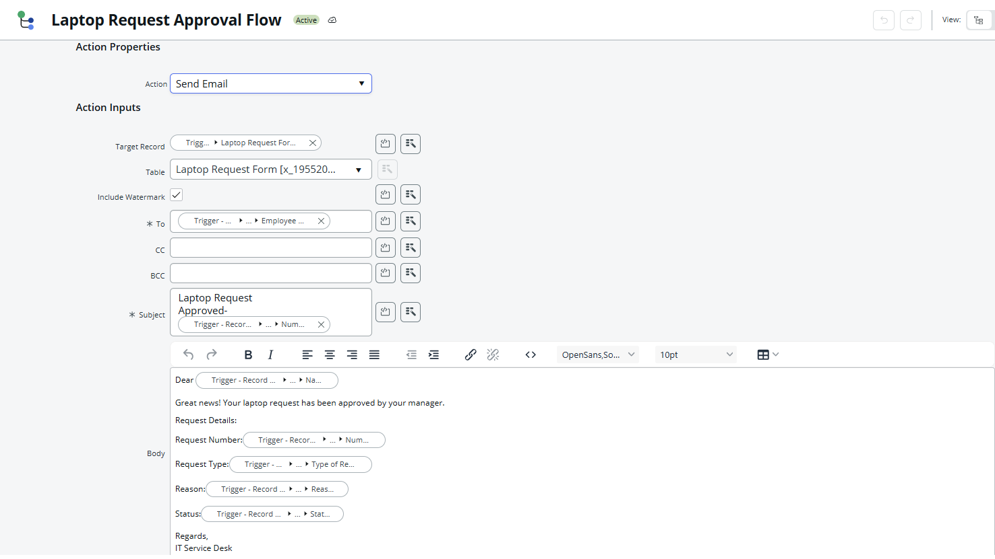
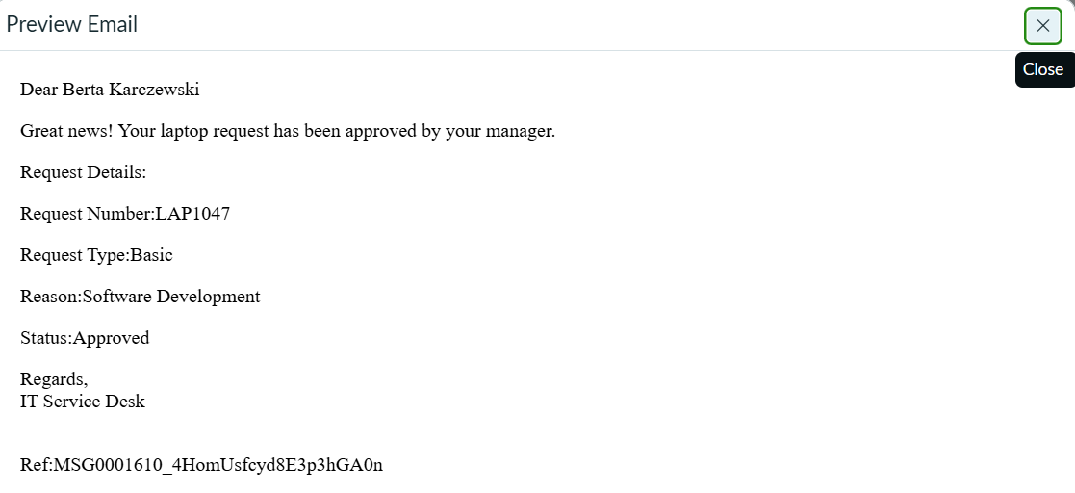

6. Subtask 3 – Approval Decision Handling
Use an If / Else branch to evaluate the approval result.
Decision | Status | Requester Notification
Approved | Approved | Laptop Request Approved
Rejected | Rejected | Laptop Request Rejected; include rejection reason when available
If/Else approval decision logic.
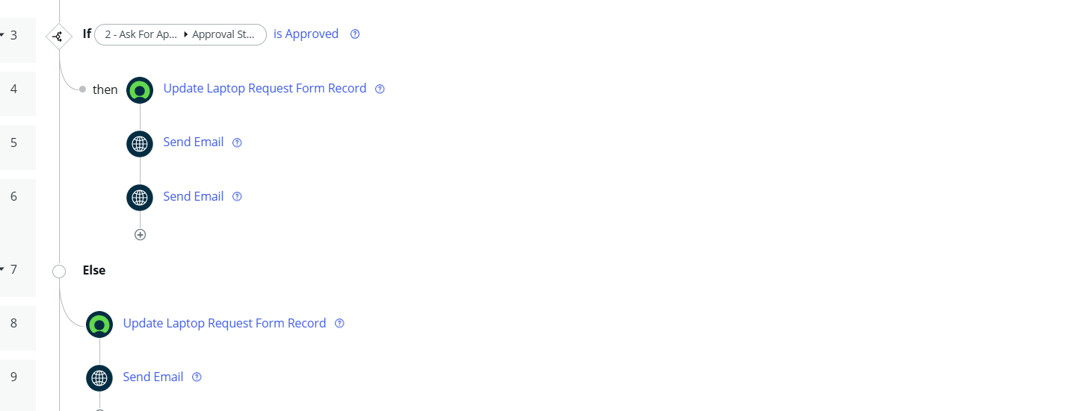

7. Subtask 4 – Optional IT Notification
After approval, use Send Email to notify the IT team that laptop provisioning can begin.
post-approval IT notification.
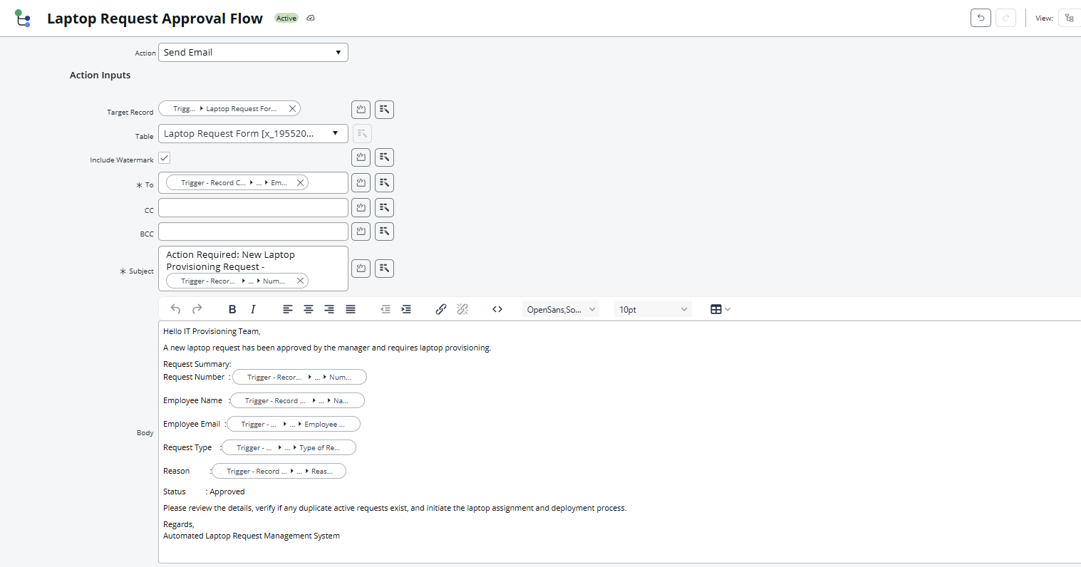

8. Flow Lifecycle Summary
Record Created → Pending Approval → Manager Approval → Approved / Rejected → Employee Notification → IT Fulfillment for approved requests.

