***Dissertation on***

**“MEDICAL HANDWRITTEN PRESCRIPTION RECOGNITION”**

*Submitted in partial fulfilment of the requirements for the award of degree of*

**Bachelor of Technology**

**in**

**Computer Science & Engineering**

**UE19CS390A – Capstone Project Phase - 1**

***Submitted by:***

|  |  |
| --- | --- |
| **Anusha M**  **Rajarajeshwari M**  **S Sneha**  **Spoorthi R** | **PES2UG19CS054**  **PES2UG19CS316**  **PES2UG19CS344**  **PES2UG19CS500** |

*Under the guidance of*

|  |
| --- |
| **Prof. Evlin Vidyulatha**  Professor  PES University |

**January - May 2022**

**DEPARTMENT OF COMPUTER SCIENCE AND ENGINEERING**

FACULTY OF ENGINEERING

**PES UNIVERSITY**

(Established under Karnataka Act No. 16 of 2013)

Electronic City, Hosur Road, Bengaluru – 560 100, Karnataka, India



**PES UNIVERSITY**

(Established under Karnataka Act No. 16 of 2013)

Electronic City, Hosur Road, Bengaluru – 560 100, Karnataka, India

**FACULTY OF ENGINEERING**

**CERTIFICATE**

*This is to certify that the dissertation entitled*

**“MEDICAL HANDWRITTEN PRESCRIPTION RECOGNITION”**

*is a bonafide work carried out by*

|  |  |
| --- | --- |
| **Anusha M**  **Rajarajeshwari M**  **S Sneha**  **Spoorthi R** | **PES2UG19CS054**  **PES2UG19CS316**  **PES2UG19CS344**  **PES2UG19CS500** |

In partial fulfilment for the completion of sixth semester Capstone Project Phase - 1 (UE19CS390A) in the Program of Study -Bachelor of Technology in Computer Science and Engineering under rules and regulations of PES University, Bengaluru during the period Jan. 2022 – May. 2022. It is certified that all corrections / suggestions indicated for internal assessment have been incorporated in the report. The dissertation has been approved as it satisfies the 6th semester academic requirements in respect of project work.

|  |  |  |
| --- | --- | --- |
| Signature  Prof. Evlin Vidyulatha  Professor | Signature  Dr. Sandesh B J  Chairperson | Signature  Dr. B K Keshavan  Dean of Faculty |

**External Viva**

|  |  |
| --- | --- |
| **Name of the Examiners**  **1.** __________________________  **2. __________________________** | **Signature with Date**  __________________________    **__________________________** |

**DECLARATION**

We hereby declare that the Capstone Project Phase - 1 entitled **“Handwritten Medical Prescription Recognition”** has been carried out by us under the guidance of Prof. Evlin Vidyulatha, Professor and submitted in partial fulfilment of the course requirements for the award of degree of **Bachelor of Technology** in **Computer Science and Engineering** of **PES University, Bengaluru** during the academic semester January – May 2022. The matter embodied in this report has not been submitted to any other university or institution for the award of any degree.

|  |  |  |
| --- | --- | --- |
| **Anusha M**  **Rajarajeshwari M**  **S Sneha**  **Spoorthi R** | **PES2UG19CS054**  **PES2UG19CS316**  **PES2UG19CS344**  **PES1UG19CS500** |  |
|  |  |  |
|  |  |  |
|  |  |  |

**ACKNOWLEDGEMENT**

**I would like to express my gratitude to Prof. EvlinVidyulatha, Department of Computer Science and Engineering, PES University, for her continuous guidance, assistance, and encouragement throughout the development of this UE19CS390A - Capstone Project Phase – 1.**

**I am grateful to the Capstone Project Coordinators, Dr.Sarasvathi V, Associate Professor and Dr. Sudeepa Roy Dey, Assistant Professor, for organizing, managing, and helping with the entire process.**

**I take this opportunity to thank Dr. Sandesh B J, Professor & Chairperson, Department of Computer Science and Engineering, PES University, for all the knowledge and support I have received from the department. I would like to thank Dr. B.K. Keshavan, Dean of Faculty, PES University for his help.**

**I am deeply grateful to Dr. M. R. Doreswamy, Chancellor, PES University, Prof. Jawahar Doreswamy, Pro Chancellor – PES University, Dr. Suryaprasad J, Vice-Chancellor, PES University for providing to me various opportunities and enlightenment every step of the way. Finally, this Capstone Project could not have been completed without the continual support and encouragement I have received from my family and friends.**

**ABSTRACT**

The automatic interpretation of handwritten documents is one of the popular research areas over the last few decades. It has a huge scope because of its practical applications in certain fields such as automatic reading of addresses, bank check processing, handwritten text recognition filled on forms and medical prescriptions. Reading a doctor’s handwritten prescription is a challenge that most patients and some pharmacists face. In some cases, these may lead to negative consequences due to wrong deciphering of the prescription. It would always be helpful to double check before taking any medicine. It would be impossible in certain situations to decipher a doctor's prescription. The reason why doctor’s prescriptions are difficult to decipher is that doctors make use of latin abbreviations and medical terminologies that most people don't understand. This project demonstrates how we would be developing a system that can recognize handwritten English medical prescriptions.

**TABLE OF CONTENTS**

|  |  |  |
| --- | --- | --- |
| **Chapter No.** | **Title** | **Page No.** |
|  | **INTRODUCTION** | **01** |
|  | **PROBLEM DEFINITION** | **02** |
|  | **LITERATURE SURVEY** | **03** |
|  | **DATA**  4.1 Overview  4.2 Dataset | **16** |
|  | **SYSTEM REQUIREMENTS SPECIFICATION** | **18** |
| **6.**  **7.** | **SYSTEM DESIGN (detailed)**  **PARAMETERS** | **21**  **28** |
| **8.** | **CONCLUSION OF CAPSTONE PROJECT PHASE - 1** | **30** |
| **9.** | **PLAN OF WORK FOR CAPSTONE PROJECT PHASE - 2** | **32** |
| **REFERENCES/BIBLIOGRAPHY** | | **33** |
| **APPENDIX A DEFINITIONS, ACRONYMS AND ABBREVIATIONS** | | **34** |
|  | |  |

**LIST OF FIGURES**

|  |  |  |
| --- | --- | --- |
| **Figure No.**  **1** | **Title Page No.**  **Prescription Sample 02** |  |
| **2**  **3**  **4**  **5**  **6**  **7** | **The IAM dataset 17**  **High Level Design 21**  **Sample input 22**  **Steps involved in preprocessing 23**  **Sample segmentation 24**  **Sample feature extraction 24** |  |
|  |  |  |

**CHAPTER-1**

**INTRODUCTION**

The current era is the era of digitalization, where everything is digital now. With the advancement in this era, especially in the area of machine learning, NLP, text processing, etc., digitalization of hand-written text especially like handwritten medical prescription has its own scope.

Such a Task of hand-written text recognition is basically categorized into two main types i.e., online and offline mode of recognition. The main focus in the proposed model in this project is offline mode of recognition where the complete text is initially fed into the model as input and recognized.

Handwritten text recognition is a challenging problem because handwriting differs from person to person and may lead to certain misconceptions while understanding a different person’s handwriting. Apart from that, it is hard to store handwritten documents in an efficient manner. Accessing through these documents is also time consuming. The consequences of this problem are adverse when we consider handwritten medical prescription recognition. When a drug or dosage of a drug is misinterpreted, it has negative impacts on a patient's life. By converting these documents into digital format, it would not be necessary to preserve them and carry them during regular visits to the doctor. It would help pharmacists and patients in recognising the drug name which prevents misinterpretation due to the use of Latin terms and medical terminologies in the prescription.

Handwritten medical prescription recognition task mainly uses an image which has handwriting as input and converts it into digital format. This task will be broken down into several sub tasks which involve pre-processing, segmentation, training and finally testing the model. The project has certain assumptions while taking the input. A few of which would be that the input image does not have a coloured background. The input handwritten text will be in English language.

The model would be incapable of recognising the text written in other languages.

**CHAPTER-2**

**PROBLEM DEFINITION**

In many scenarios, we often come across many medical prescriptions written by the doctors for the patients which are not very easy to understand. In some cases, even the experienced pharmacists find it difficult to interpret these prescriptions and issue the wrong medicines to the patients. What if these prescriptions are in such a way that is easily understood by each and everyone of us? Yes, here comes our project into the picture. This project is all about converting the handwritten medical prescriptions into a digitalised form which would be understandable and could be easily interpreted by each and everyone of us.

The objective is to develop an ML model for hand-written medical prescription recognition system using neural networks that trains the model on individual characters extracted from training samples so that all words that may or may not part of training examples as well as words that are joined-up or written in cursive can also be recognized.

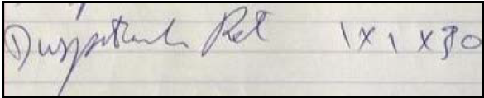

Fig. 1 : Prescription Sample

**CHAPTER-3**

**LITERATURE SURVEY**

1.Natural Language Parser for Physician’s Handwritten Prescription

Author : S. Butala, A. Lad, H. Chheda, M. Bhat and A. Nimkar

In the online approach, this paper discusses a system that simplifies the process of comprehension of handwriting by the methods for handwritten recognition with the help of OCR techniques. According to the authors, the proposed system contributes in creating a system that will take the printed form and then align them and parse and format them using formatting tools and also to explore the utilization of OCR techniques in the medicine field.

The authors of the paper has also made certain background and literature survey on

* Optical Character Recognition(OCR) : It involves a bit of programming and helps in transforming printed material and pictures into digitized frames with the goal of tending to be controlled by machine.
* Hidden Markov Models : It is used for identification of unconstrained handwriting such as cursive with the help of statistical techniques.
* Neural Networks : In the back end, the segregation and recognition of text plays a vital role which can be achieved with the help of neural networks.

The authors of the paper proposed a system which does online prescription recognition in two sections :

1. Online Character Recognition : It involves

* Input Acquisition
* Character Segmentation
* Preprocessing
* Normalization
* Digitization

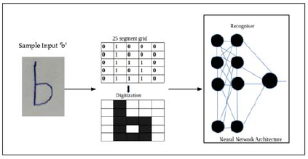

* Classification
* Formatting
* Post Processing

1. Formatting of the Prescription :

In this phase, the output of the classification process is printed on the physician pad of the online prescription stored in the server in a particular location. Also handling errors and improvement of accuracy of printed documents has also been achieved here.

Limitations :

* The ratio of train to test data split is 10:1
* Overfitting of data
* No proper testing

2. Medical Handwritten Prescription Recognition Using CRNN

Authors: R. Achkar, K. Ghayad, R. Haidar, S. Saleh and R. Al Hajj

* This paper shows how artificial neural networks can be used to demonstrate handwritten medical prescription recognition.
* The paper clearly explains how handwritten medical prescriptions are being recognized and converted into digital format using the CRNN model.
* They have mentioned that out of all kinds of recognitions like document level, word level and character level, line level recognition is the best.
* The input is an image of the handwritten medical prescription.
* Here, CNN is used for developing a representation from the two dimensional image that has been provided as input.
* RNN basically works on sequence predictions.
* CRNN is a hybrid model which is a combination of both RNN and CNN networks.
* Usually the medicine names are short, therefore the training is done on shorter texts.
* They have trained the model in three phases.
* In the first phase, they have trained the model using normal handwritten texts, in the second phase, they have trained the network using cursive handwritten texts and finally in the third phase they have used the medical prescription.
* Training the network in this manner has given good accuracy scores and also the model has identified appropriate medicine names.
* The network is composed of 13 convolution layers and 3 bi-directional LSTM layers.
* In order to introduce non-linearity, they have used ReLU as an activation function.
* The architecture involves prescriptions as input which is fed to convolutional layers.
* The output of the convolution layer is fed as input to affine or fully connected layers and finally to bi-directional RNN.
* They have mentioned in the paper that a minimum of 10,000 data is required to train the network. Certain parameters like learning rate, epoch value and batch size have been set in the initial training.
* The learning rate was being set to 0.0001 initially. It was changed to 0.0005 before the network was trained on medical prescription.
* A log file was being generated to keep track of the values after every epoch to identify if the training is showing any improvement or not.
* In the 198th epoch they realized that further training the model is not showing any improvement. So they stopped after 198 epochs.
* For testing, different prescriptions were taken that were not used during the training process and the network predicted the text in those new prescriptions.
* The algorithm was designed to learn small texts since the medical drug names are usually small.
* The algorithm could also automatically segment any paragraphs into smaller texts.

Limitations:

* The work was solely focused on character recognition from medical prescription.
* Since the proposed model is a hybrid of CNN and RNN, the network complexity is increased.

Conclusion:

* The proposed network has achieved an accuracy score of 95%.
* They observed a great difference between the weights that were used during the training of normal text and medical prescriptions.

3. Medical Handwritten Prescription Recognition and Information Retrieval using Neural Network.

Authors : U. Shaw, Tania, Mamgai and I. Malhotra

In this paper the author has explained how neural network technology is used especially to detect medicine names and translate them to a digital one.

* This uses a Neural Network with three layers which includes an input layer, multiple hidden layers and an output layer is used. The inspiration for the working of this NN is obtained from the human brain where the activation unit replicates the neurons for transmitting the information from one neuron to another.
* In this approach, 785 activation units are used in an input layer , 25 activation units are used in the hidden layer and 10 activation units are used in the output layer. Here, the selection of the number of activation units for the input layer is determined by the dimensions of the image.
* The labels and features are extracted from the dataset loaded with the help of the pandas library function and is scaled into a range of [0,1] for easy computation. These features which are extracted are then fed into the neural network for assigning appropriate weights.This mechanism is known as forward propagation.
* The process called back propagation is done in order to reduce the errors over the layers and also to minimize the cost function. So, retracing of the neural network in backward propagation is done.
* Results :
* This proposed model gives an accuracy of about 94.49% over the training set and about 80.72% over the test set.
* Limitations :
* The major problems faced in this research paper is the handwritten prescription dataset of medicine was not available.
* It also focuses on obtaining a dataset consisting of poor handwriting style of the practitioner.
* It is also noticed that wrong interpretation of letters is done due to certain resemblance. For example, ‘5’ is interpreted as ‘S’.
* This paper also aims at making a more accurate model by using deep neural networks with different activation functions in future.

4. Doctor’s Cursive Handwriting Recognition System Using Deep Learning

Author : L. J. Fajardo, Nino Joshua Garlit, Cia Demise Tomines, Mideth B. Abisado, Joseph Marvin R. Imperial, Ramon L. Rodriguez, Bernie S. Fabito

This paper specifies how Deep Convolutional Recurrent Neural Network is developed inorder to identify the text in the prescription image written by the doctors and show the readable text of the cursive handwriting.

* This research paper has two models which are evaluated on the basis of experiments conducted using normalization based on a model built on the Convolutional Recurrent Neural Network rather than the Convolutional Recurrent Neural Network alone.
* The pre-processed data used here were trained using the combined deep learning algorithm which includes deep CNN and RNN .
* This paper makes a comparison based on the performance of two models. These models are the normal CRNN and model-based normalisation scheme CRNN. The researchers did this by computing their accuracy, F1-score and aggregated accuracy.
* From the above results, it is concluded that CRNN with model-based normalisation scheme performs better than the normal CRNN.
* With an accuracy of 76% obtained from CRNN(with model-based normalisation scheme), the researchers have built a mobile application with this model.
* The Rectified Linear Unit (ReLU) activation function as it works better than the sigmoid and tanh activation functions.
* A stack of 13 convolutional layers were used. These were followed by 256 units of 3 bidirectional LSTM layers.
* At the end of BLSTM, the forward and backward outputs were combined .
* Also, the training process was increased by adding batch normalisation after each convolutional layer .
* Results :
* This proposed model has achieved 76% training accuracy.
* This model was implemented successfully as a mobile application after achieving 72% accuracy on the validation set. The validation has a total of 540 images of the handwritten medical prescriptions.
* Limitations :
* This study shows that some of the characters in the image were mistaken for the other characters. For example, for crocin 500, it was interpreted as crocin S00.
* Also, certain characters were duplicated which are evident due to issues in encoding.

5. Medical Prescription Recognition using Machine Learning

Author : E. Hassan, H. Tarek, M. Hazem, S. Bahnacy, L. Shaeen and W. H. Elashmwai

The author of the paper has built a system that provides a solution for both the patient and pharmacist . This is done through a mobile application that recognizes handwritten prescriptions and returns a digital text and dosage of the prescribed medicine.

The authors of this paper have proposed a system that identifies the medicines name and dosages for the collected dataset.

Here the preprocessing techniques used involves

* Image subtraction
* Noise reduction
* Image resizing

Once the above is done, the pre-processed image undergoes certain processing techniques for classification and feature extraction through Convolutional Neural Networks.

Later, to the images obtained which are with low accuracy OCR techniques will be applied. This happens in the post processing stage inorder to identify the medicine name by comparing the result with names of all the medicine that is present in the dataset.

Advantages :

* The proposed system tested on multiple real life cases and finally gave an accuracy of 70% using Convolutional Neural Network. 75% accuracy was obtained on the training set and 50% accuracy was obtained on the test set.
* There’s a diversity in the dataset used as prescriptions were collected from multiple hospitals and doctors with different specifications.

Limitations :

* According to the authors of the paper, the proposed system faced certain hardware limitations that stopped the system from working well and accurately.
* It also has a limitation of the image being captured to be taken from a camera phone with high camera resolution.
* The photos should be taken from an appropriate position and also the angle must be zoomed , in order to ensure that the image which is a scanned copy is clear and the content and text of the images are clearly visible.

1. Handwriting recognition: State of the art and future trends

Authors: G. Dimauro, S. Impedovo, G. Pirlo and A. Salzo

* The paper mainly focuses on the trending research that is being done in the areas of handwritten text recognition systems.
* This explains the new trends in this field.
* The paper explains both offline and online data acquisition techniques.
* In offline acquisition, data can be collected through optical scanners.
* The preprocessing techniques provide the data in a portable form which can be later used during the training process.
* Compared to other fields of pattern recognition, few problems were observed majorly during handwritten text preprocessing.
* A few of them were, overlapping of text with non-textual strokes, identification of text from noise etc.
* Another problem that would appear is thinning. It is one of the inference problems of singular regions.
* They have adopted two methods for character and numeric recognition.
* The first method was pattern matching, which depends upon the features used and method of feature extraction.
* The second method was structural analysis.
* On considering the recognition of cursive handwriting, the most profitable way to get a flexible model is one line acquisition.
* They have concluded that the current handwritten recognition systems were able to achieve very high performance, sometimes better than humans.
* There are certain fields where the performance of recognition needs to be improved. Especially in cases like tax form and bank cheque recognition.

**CHAPTER-4**

**DATA**

* As there isn’t any dataset available on the internet, we would be collecting the prescriptions from the doctors. The target is to collect the prescriptions from at least 50 doctors.
* The dataset must at least consist of 1800 images of the prescriptions.

Considering our faculty’s advice, we decided to start with an ordinary handwritten text dataset and extend it to handwritten medical prescriptions.

**4.1 : Dataset used**

The IAM dataset.

**4.2 : Overview**

* The IAM Handwritten text database contains datasets of English text that is written in hand that can be used to build and evaluate handwriting recognizers.
* The dataset was first published at the ICDAR conference(1999). An HMM-based recognition framework for handwritten text was modelled and published using this database at the ICPR (2000).

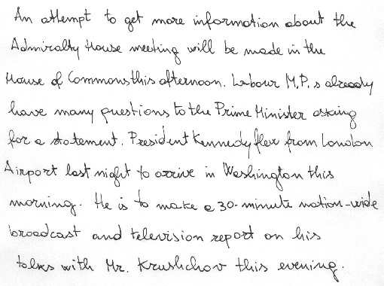

Fig. 2. IAM Dataset

**4.3 : Dataset Link**

<https://fki.tic.heia-fr.ch/databases>

**CHAPTER-5**

**SYSTEM REQUIREMENTS**

**5.1 : Product Features:**

Once the model is deployed, users can directly feed the handwritten text image(normal or medical prescription) into the system and it’ll be converted into digital text and given to the user.

**5.2 : Software requirements:**

* Python libraries
* Tensorflow
* Neural network
* Windows 9/10/11
* System with minimum 4GB RAM

**5.3 : Hardware requirements:**

* Camera to capture the medical prescription which is fed as input the network
* GPU (provided by Google Colaboratory)

**5.4 : Functional requirements:**

* The system should be capable of recognising if the input passed is an image and should process only image input.
* It should display an error message when the input does not meet the required specifications.
* It should be capable of identifying the handwritten text from the input and should convert it into digital format and display the same to the user.
* It should provide a certain accuracy and should predict accurate results.
* The quality of the identified output must be good.
* When the input has a different background, it should be able to recognize text from that.
* When the input has different font size or font style, it should be able to deal with it without throwing errors.

**5.5 : Non-functional requirements:**

* Performance: The system should work with good accuracy
* Functionality: The software will deliver all the functional requirements mentioned.
* Availability: The system will recognize only the handwritten text from the input.
* Flexibility: It will allow the user to input the image effortlessly.

**5.6 : General Constraints, Assumptions, and Dependencies:**

* The input image captured should be taken from a camera phone with high camera resolution.
* The system on which the model is loaded should have at least 8GB of RAM because the trained model can have a size of utmost 1GB.

**5.6.1 : Risks:**

* If the RAM is less, the model might crash.

**CHAPTER-6**

**HIGH LEVEL DESIGN**

The design of the Handwritten text recognition model consists of primarily 5 phases as shown in fig.3.

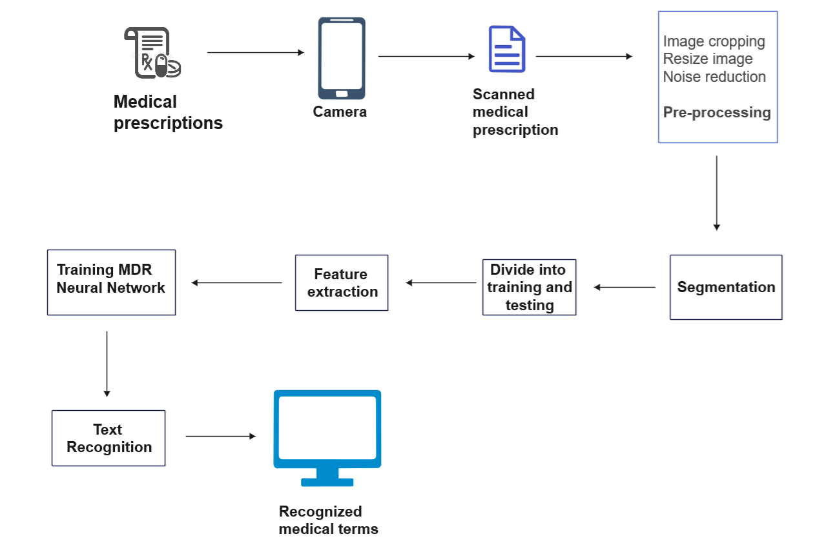

Fig.3 : High level design

**6.1 : Image Acquisition :**

- Collection and organization of dataset

- Importing the dataset

- Original image to grayscale image conversion

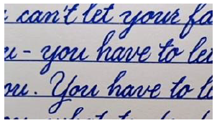



fig. 4 : sample input

**6.2 : Pre-Processing :**

-Once the dataset is fed, pre-processing of this raw data is an important phase where the motive is to clean the raw data into an understandable form before training and testing of the model.

-This is one of the critical stage in model building because the scanned image not only contains the name of the medicines and its dosages but also contain other irrelevant information such as the hospital’s name, hospital’s logo and also certain confidential information such as name of the patient, age, gender and other informations like the doctor who treated that particular patient. Thus, in order to retrieve the required information, this phase of model building has to be done with utmost accuracy.

- In this phase also the image background, objects in the background have to be removed.

Preprocessing includes 5 steps, they are:

-size centering and normalization

-missing points interpolation

-smoothing

-slant correction

-resampling of points.

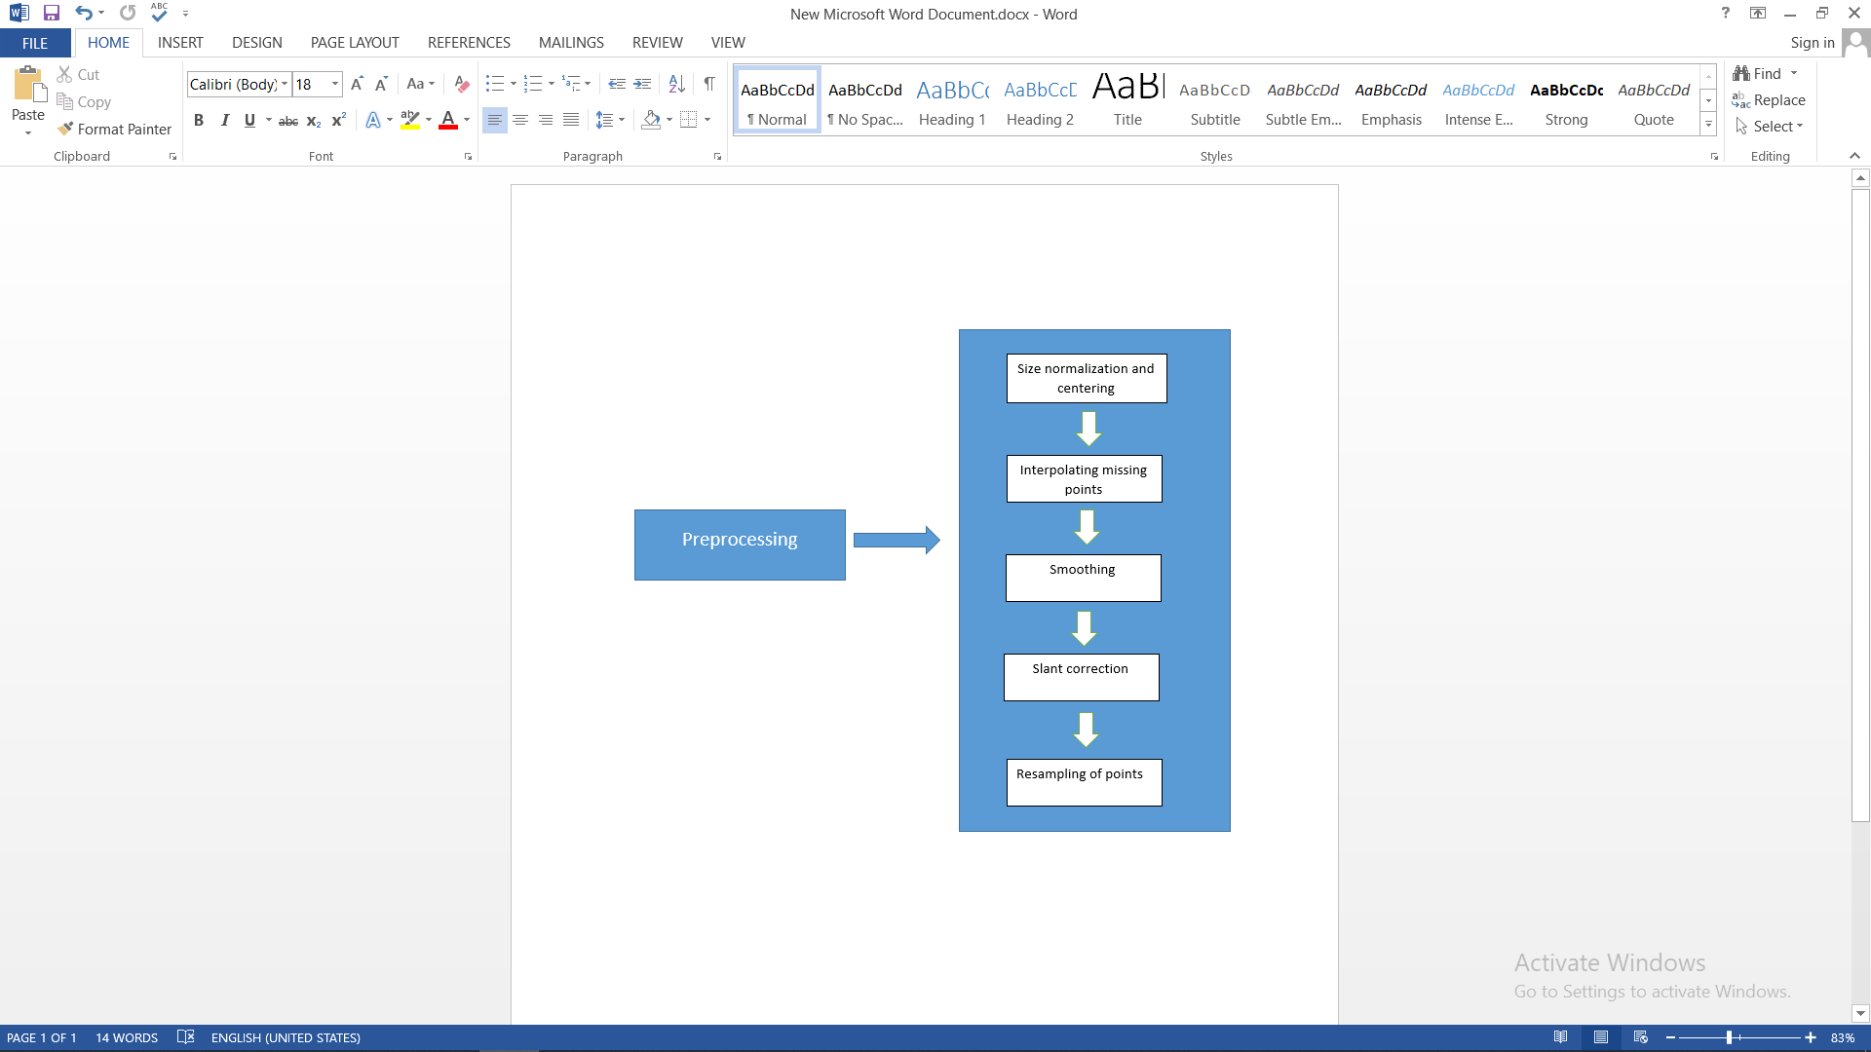

Fig. 5 : Preprocessing steps

* Size **normalization** and centering is done using **Keras**, a deep learning python library.
* High speed of handwriting often results in missing points. Hence, methods like **B-spline interpolation** can be used to interpolate missing points as it is more flexible.
* **Smoothing** method is used to remove the jitter effect or the shaky effect in the handwriting.
* **Slant correction** and normalization slant is required to correct the shape of input handwritten characters. As most of the writer's handwriting is bent to left or right directions, slant correction and normalization is important for handwriting recognition. For this, **run-length based technique** is used.
* **Resampling of points** means that the points that are listed should be equidistant from neighbouring points as far as possible. It means that the original data points are the basis for the calculation of new data points.

**6.3 : Segmentation :**

* This step is the **heart** of the model.
* Segmentation uses histogram approach.
* Here, the text is divided into lines, lines are divided into words and words are divided into characters.
* In the first step, row histogram is used so that lines are segmented and from each row, column histogram is used to extract words.
* As the last step, characters are extracted from words.
* Now, this data is given for modeling.

We have preferred the segmentation approach as this method can be easily extended to higher levels of processes.

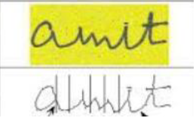

fig. 6 : sample segmentation

**6.4 : Extraction of Feature :**

* Here, the aim is to extract a set of features that maximizes the accuracy of recognizing the text and increases the recognition rate.
* In our project feature extraction mainly involves extracting the medical drug names from the prescription.
* Actual training (for train dataset) and recognition (for test dataset) is done in this phase.

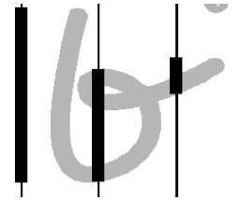

fig. 7 : sample feature extraction

* Model to be used : We are planning to use a multi-dimensional Recurrent Neural Network (MDRNN) for our project. MDRNN is currently used for handwritten text recognition. They bring the benefits of RNN to multidimensional data.
* Advantages of RNN :
* RNN can process large set of inputs
* Even if the input size increases, the model size remains the same.
* Compared to other existing algorithms, RNN produces predictive results in sequential data.

**6.5 : Post-processing :**

* Once the desired output is obtained it has to be presented to the client in an appropriate format, which in our case is storing it in text format.

**CHAPTER-7**

**PARAMETERS**

**7.1 : Novelty :**

There’s no existing system that can recognize both normal handwritten text and slanted medical prescription together. We try to combine these two major sectors into a single system.



**7.2 : Performance :**

* In this project our motive is to not just achieve better results but also to reduce the training time of the model.
* Recent literature surveys on Handwriting recognition stated that usage of neural networks trains the model faster than any other traditional models and also makes the model robust

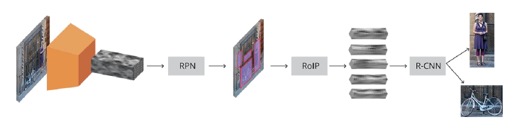

**CHAPTER-8**

**CONCLUSION OF CAPSTONE PROJECT PHASE 1**

1. **Problem statement selection :**

* In the current era, handwritten text recognition is one of the hottest fields in ML. We have extended our problem statement to be further useful by extending it to a handwritten medical prescription recognition system that has been chosen as the main capstone deliverable.
* Various researches and methodologies were done to get into the right problem statement.

1. **Literature surveys :**

* Many latest and useful literature papers were studied to understand the methods (that are both traditional and latest) that are used to perform the above mentioned task.
* The conclusions and results from these literature surveys are posted above in the literature survey section.
* We noticed certain drawbacks of the models that were used in those papers.

1. **Design and Analysis :**

* The high level design, external interface diagram and use case diagram for the chosen problem statement has been designed.

1. **Dataset :**

* We tried searching for a handwritten medical prescription dataset but we could not find any that could be considered for our project. Considering our faculty’s advice, we decided to start with an ordinary handwritten text dataset and extend it to handwritten medical prescriptions.

1. **Design Approach :**

* On studying various design approaches an efficient approach has been finalized at the end.
* We have decided that it would be appropriate to use a MRNN (Multidimensional Recurrent Neural Network) for this project.

Thus, we conclude that almost 20% of the work is being done in phase 1.

**CHAPTER-9**

**PLAN OF WORK FOR CAPSTONE PROJECT PHASE 2**

1. **Dataset finalization :**

* Although a dataset has been chosen now, we try to extend the same for medical prescription recognition by adding certain real-time medical prescriptions.

1. **Model for single character recognition :**

* First, we will try to build a model that can recognize a single character (input also being a single character).On this model, Various segmentation and preprocessing technologies will be tested in order to arrive at better techniques. Here, we will be more specific on the algorithm that will be used in our project.

1. **Extending the model from single character to complete text recognition :**

* The model that is obtained from the above section will be extended to recognize a complete text. We will also try to build a model that can recognize and handle words which are not part of training examples.

**REFERENCES**

[1] R. Achkar, K. Ghayad, R. Haidar, S. Saleh and R. Al Hajj, "Medical Handwritten Prescription Recognition Using CRNN," 2019 International Conference on Computer, Information and Telecommunication Systems (CITS), 2019, pp. 1-5, doi: 10.1109/CITS.2019.8862004

[2] S. Butala, A. Lad, H. Chheda, M. Bhat and A. Nimkar, "Natural Language Parser for Physician’s Handwritten Prescription," 2020 International Conference on Emerging Trends in Information Technology and Engineering (ic-ETITE), 2020, pp. 1-7, doi: 10.1109/ic-ETITE47903.2020.325.

[3] E. Hassan, H. Tarek, M. Hazem, S. Bahnacy, L. Shaheen and W. H. Elashmwai, "Medical Prescription Recognition using Machine Learning," 2021 IEEE 11th Annual Computing and Communication Workshop and Conference (CCWC), 2021, pp. 0973-0979, doi: 10.1109/CCWC51732.2021.9376141.

[4] L. J. Fajardo et al., "Doctor’s Cursive Handwriting Recognition System Using Deep Learning," 2019 IEEE 11th International Conference on Humanoid, Nanotechnology, Information Technology, Communication and Control, Environment, and Management ( HNICEM ), 2019, pp. 1-6, doi: 10.1109/HNICEM48295.2019.9073521.

[5] U. Shaw, Tania, R. Mamgai and I. Malhotra, "Medical Handwritten Prescription Recognition and Information Retrieval using Neural Network," 2021 6th International Conference on Signal Processing, Computing and Control (ISPCC), 2021, pp. 46-50, doi: 10.1109/ISPCC53510.2021.9609390.

[6] Dimauro, Giovanni & Impedovo, S. & Pirlo, Giuseppe & Salzo, A.. (2006). Handwriting recognition: State of the art and future trends. 10.1007/3-540-63791-5_1.

|  |
| --- |
| **APPENDIX A DEFINITIONS, ACRONYMS AND ABBREVIATIONS**  ACRONYMS:  OCR - Optical Character Recognition  CNN - Convolutional Neural Network  RNN - Recurrent Neural Network  CRNN - Convolutional Recurrent Neural Network  MRNN - Multi-dimensional Recurrent Neural Network  ReLU - Rectified Linear Unit  LSTM - Long Short Term Memory  BLSTM - Bidirectional Long Shortest Term Memory  GPU - Graphics Processing Unit  RAM - Random Access Memory |