**Question 1:**

**What is the optimal value of alpha for ridge and lasso regression? What will be the changes in the model if you choose double the value of alpha for both ridge and lasso? What will be the most important predictor variables after the change is implemented?**

Answer:

One should decide the optimal value of alpha where we get good train and test r2 score through graphs below for Ridge and Lasso

Graph for Lasso:

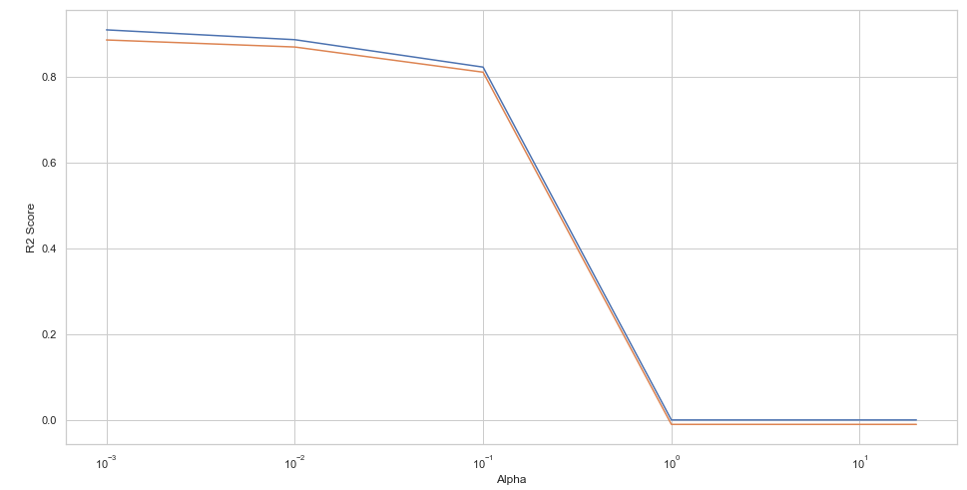

From the above graph, our model is performing better at alpha 0.001 where we have good train and test score of 0.908 and 0.891 respectively

Graph for Ridge:

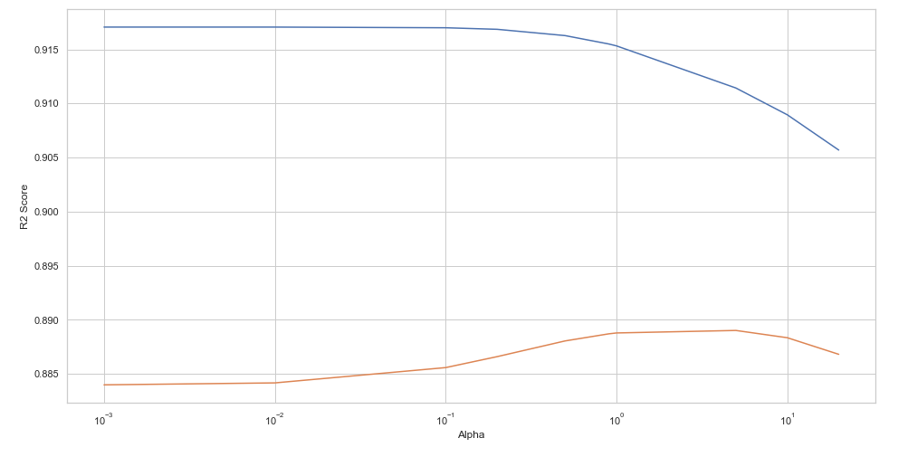

From the above graph of Ridge our model is performing better from 0.9 to 5, but at alpha value of 5 our test score is performing better with the train score

Even though we double the value of alpha for Ridge and Lasso Lasso model is more stabilized and gives almost the same variables in top five or top ten out of important predictor variables, when compared with Ridge.

The Top most predictor for Lasso and Ridge before and after alpha is doubled:

**At optimal alpha 0.001 when alpha is doubled i.e; at 0.002**

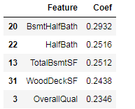 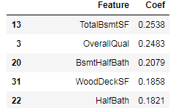

**For Ridge**

**At optimal alpha at 5 at alpha equal to 10**

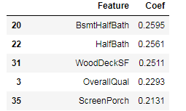 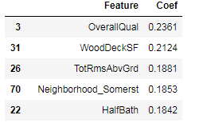

**Question 2:**

**You have determined the optimal value of lambda for ridge and lasso regression during the assignment. Now, which one will you choose to apply and why?**

Answer: I will choose Lasso Model when compared with Ridge by considering following points:

1. Lasso Model has good train and test score (0.908 and 0.891 respectively) as test score is predicted good with good accuracy when compared with Ridge Model(train score 0.91 and 0.88 test score).
2. Lasso Model will sparse the features, that is it is making unimportant features coefficients to zero value, which gives optimal features and indirectly used for feature selection.
3. Lasso model is more stabilized as when we double the alpha value it is giving the same top five features with change in the positions where as Ridge has some change in top five predictors when the alpha value is doubled.

Lasso is the best Model obtained in the Assignment.

**Question 3:**

**After building the model, you realized that the five most important predictor variables in the lasso model are not available in the incoming data. You will now have to create another model excluding the five most important predictor variables. Which are the five most important predictor variables now?**

Answer:

When we dropped the top five important predictors and created a new model our top five predictors of Lasso are as below for the same alpha value obtained (0.001) are:

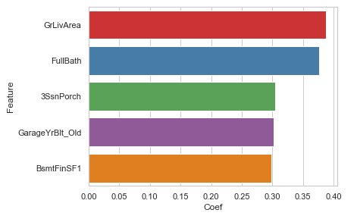

The obtained predictors have more influence because their coefficients are increased when compared with the actual.

**Question 4**

**How can you make sure that a model is robust and generalisable? What are the implications of the same for the accuracy of the model and why?**

**Answer:**

The Model is said to be more Robust and generalisable only when it is stable for the changes in the input (low variance) and with good accuracy on the unseen data with what it is trained for (simply indicates that the model shouldn’t be overfitted on the training data)

In terms of accuracy, the model should predict or perform well and equally good on train and test (unseen) data.

Accuracy of both the models should be equal on both Train and Test data for the creating the Robust Model which is more generalisable.