**TO-DO LIST APP**

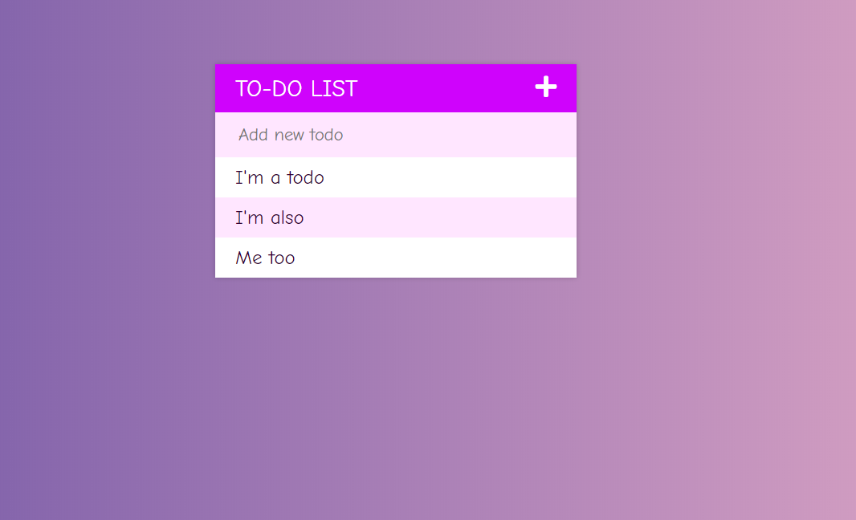

Add new to-do & make it simple.