Project Based Learning Report on

Incident Analysis and Hotspot Identification for Security Provision against Women Harassment in Public Spaces
MASTER OF COMPUTER APPLICATIONS
OF
VISVESVARAYA TECHNOLOGICAL UNIVERSITY

By
Aman Yadav[1BY25MC012]
Anusha K[1BY25MC017]
II Semester

Under the Guidance of
Dr. M.Sridevi
Faculty, Department of MCA

Department of MCA
BMSITM
Bengaluru-560119



Department of Master of Computer Applications
(Accredited by NBA, New Delhi)

BMS Institute of Technology & Management
(Autonomous Institution under VTU)
Bengaluru – 560119
July-2026
BMS INSTITUTE OF TECHNOLOGY & MANAGEMENT
(Autonomous Institution under VTU)
Bengaluru – 560119

Department of MCA
(Accredited by NBA, New Delhi)

VISION
To emerge as a leading department in computer applications, producing skilled professionals equipped to deliver sustainable solutions.
MISSION
Facilitate effective learning environment through quality education, industry interaction with orientation towards research, critical thinking and entrepreneurial skills.

Programme Educational Objectives (PEOs)

PEO 1: Excel in IT career by developing sustainable solutions that drive industry growth and societal progress
PEO 2: Adapt themselves to evolving domain requirements
PEO 3: Exhibit leadership skills and progress in their chosen career path

BMS INSTITUTE OF TECHNOLOGY & MANAGEMENT
(Autonomous Institution under VTU)
Bengaluru – 560119

Department of MCA
(Accredited by NBA, New Delhi)

Programme Outcomes (POs)
PO 1: Apply knowledge of mathematics, programming logic and coding fundamentals for solution architecture and problem solving.

PO 2: Identify, review, formulate and analyse problems for primarily focusing on customer requirements using critical thinking frameworks.

PO 3: Design, develop and investigate problems with an innovative approach for solutions incorporating ESG/SDG goals.

PO 4: Select, adapt and apply modern computational tools such as development of algorithms with an understanding of the limitations including human biases.

PO 5: Function and communicate effectively as an individual or a team leader in diverse and multidisciplinary groups using methodologies such as agile.

PO 6: Use the principles of project management such as scheduling, work breakdown structure and be conversant with the principles of Finance for profitable project management.

PO 7: Commit to professional ethics in managing software projects with financial aspects. Learn to use new technologies for cyber security and insulate customers from malware.

PO 8: Change management skills and the ability to learn, keep up with contemporary technologies and ways of working.
ABSTRACT

Ask any woman which streets she avoids after dark and she will have an answer straight away. Usually the reason is something very ordinary. A stretch with no working streetlight. Nobody around. No shop open, no police outpost nearby. Our problem statement started from that observation, because this kind of information exists but nobody has put it on one map. SafeHer is our attempt at doing this for Bengaluru. We took OpenStreetMap (OSM) data and scored roughly 46,424 streets spread over 53 Bruhat Bengaluru Mahanagara Palike (BBMP) areas to get an infrastructure baseline. Along with that we made a crowdsourcing platform where a woman can mark, without giving her name, how a street felt to her, or that something happened there, and her GPS fixes the place.
Four deliverables came out of this. The mobile app first, built on Expo and React Native, with four tabs, Home, Report, Map and Emergency SOS. Then a public website in Next.js so that someone who does not want to install an APK can still report from the browser, check the community map or find helpline numbers. Third is the admin portal, kept behind a password, where we track OSM statistics and can see generated demo data separately from real community reports. And underneath everything is one Supabase PostgreSQL database. Row-level security is switched on there, so an anonymous person can insert a report but the public can read only approved rows. For scoring we settled on nine weighted factors, police presence, hospitals, bus stops, lighting, CCTV, crowd proxies, commercial activity, night amenities and the road class. Each street ends up in one of three bands, Safe, Moderate or Unsafe.
One thing should be clear at the start. This report is about Phase 1, meaning data collection plus a working demonstration. The exploratory data analysis is not finished. K-Means or any other clustering has not been run yet either. Both are planned for the next phase and we are not claiming them here.
Keywords: Women’s street safety, OpenStreetMap, Crowdsourcing, SafeHer, BBMP, Supabase, Expo, Next.js, Bengaluru, Anonymous reporting

Table of Contents
1. INTRODUCTION 10
1.1 Project Description 10
1.2 Background 10
1.3 Motivation 10
1.4 Problem Statement 11
2. LITERATURE SURVEY 12
2.1 Background Study 12
2.2 Existing System 12
2.3 Limitations of Existing System 12
2.4 Proposed System 12
2.5 Advantages of Proposed System 13
2.6 Feasibility Study 13
2.6.1 Technical Feasibility 13
2.6.2 Operational Feasibility 14
2.6.3 Economic Feasibility 14
2.7 Tools and Technologies Used 14
2.8 Hardware and Software Requirements 14
3. SOFTWARE REQUIREMENTS SPECIFICATION 15
3.1 Users / User Roles 15
3.1.1 Objectives 15
3.2 Assumptions and Dependencies 15
3.2.1 Assumptions 15
3.2.2 Dependencies 16
3.3 Functional Requirements 16
3.4 Non-Functional Requirements 16
4. SYSTEM DESIGN 18
4.1 System Architecture 18
4.2 System Perspective 19
4.3 Context Diagram 19
5. DETAILED DESIGN 20
5.1 Data Flow Diagram – Level 0 20
5.2 Data Flow Diagram – Level 1 21
5.3 Use Case Diagram 22
5.4 Activity Diagram – Emergency SOS 23
5.5 Sequence Diagram – Report Submission 24
6. IMPLEMENTATION 25
6.1 Implementation Methodology 25
6.2 Dataset and Feature Description 25
6.3 Module-wise Implementation 26
6.3.1 Mobile Application 26
6.3.2 Web User Portal 26
6.3.3 Web Admin Portal 26
6.3.4 Supabase Backend 26
6.4 Key Code Snippets 26
6.5 Visuals 27
7. SOFTWARE TESTING 37
7.1 Testing Methodology 37
7.2 Unit Testing 37
7.3 Test Cases and Results 37
8. RESULTS AND DISCUSSION 38
8.1 Deliverables Achieved 38
8.2 Dataset Outcomes 38
8.3 Platform Behaviour 38
8.4 Discussion and Limitations 38
9. CONCLUSION 39
10. FUTURE ENHANCEMENTS 40
11. BIBLIOGRAPHY / REFERENCES 41
APPENDIX A: SUSTAINABLE DEVELOPMENT GOALS (SDG) 42
APPENDIX B: PROJECT SYNOPSIS 43
B1. INTRODUCTION 43
B2. OBJECTIVES 45
B3. LITERATURE SURVEY 47
B4. EXISTING SYSTEM 48
B5. PROPOSED SYSTEM 49
B6. MODULES IDENTIFIED 50
B7. HARDWARE AND SOFTWARE REQUIREMENTS 52
B8. SDG ALIGNMENT 54
B9. WORK BREAKDOWN STRUCTURE 55
B10. REFERENCES 57

LIST OF FIGURES

Particulars | Page No.
Fig. 2.1: Existing systems versus proposed SafeHer approach | 13
Fig. 4.1: High-level system architecture of SafeHer | 18
Fig. 4.2: System context diagram | 19
Fig. 5.1: Data flow diagram – Level 0 | 20
Fig. 5.2: Data flow diagram – Level 1 | 21
Fig. 5.3: Use case diagram | 22
Fig. 5.4: Activity diagram – Emergency SOS flow | 23
Fig. 5.5: Sequence diagram – anonymous report submission | 24
Fig. 6.1: SafeHer Home – area status and call to report | 27
Fig. 6.2: SafeHer Home – how it works and community summary | 28
Fig. 6.3: Report wizard – Step 1 location confirmation | 29
Fig. 6.4: Report wizard – Step 2 feeling or incident choice | 30
Fig. 6.5: Report wizard – incident type selection | 31
Fig. 6.6: Report wizard – optional details and factors | 32
Fig. 6.7: Report submission success screen | 33
Fig. 6.8: Safety Map with filters and community pins | 34
Fig. 6.9: Emergency SOS – call and live location share | 35
Fig. 6.10: Emergency SOS – helpline directory | 36
Fig. B9.1: Project Schedule – Gantt Chart | 56

LIST OF TABLES

Particulars | Page No.
Table 2.1: Hardware and Software Requirements | 14
Table 3.1: Functional Requirements | 16
Table 3.2: Non-Functional Requirements | 17
Table 6.1: OSM safety scoring factor weights | 25
Table 6.2: Bengaluru OSM dataset summary metrics | 25
Table 7.1: Test Cases and Results | 37
Table B7.1: Hardware Requirements | 52
Table B7.2: Software Requirements and Tools Used | 52

1. INTRODUCTION

1.1 Project Description
SafeHer joins two halves. The offline half is the OSM baseline, where we query Overpass for the roads and nearby points of interest inside each of the 53 BBMP bounding boxes, and then every street gets a safety score. The online half is the reporting flow. A user opens the app, the GPS suggests her locality, she confirms it, picks whether the place feels safe or unsafe or whether something actually happened, maybe adds a detail or two, and submits. No name, no login.
There are two ways in for citizens. The app is the main one since it has proper GPS and the SOS features. The website is the fallback, it opens in any browser and needs no installation. On our side we keep an eye on OSM coverage and the incoming reports from the admin portal. Honestly, the whole focus this phase was getting trustworthy data and screens people can actually use. Final hotspot statistics were never the goal yet.

1.2 Background
Whatever paper we read on urban safety said some version of the same thing, that risk and the fear of crime pile up at certain spots and certain hours. They do not spread evenly over a city. Police records are limited too, they hold only what someone reported, and street-level detail is mostly missing. OSM turned out to be handy here because it already stores lamps, bus stops and amenities that work as rough stand-ins for safety conditions. And the crowdsourcing side has been proven elsewhere, people do rate places when their privacy is safe and the effort is a few taps.
BBMP wards solved a boring but real problem for us, how to slice the city. The same ward boxes drive the dataset generation and the area label shown on the phone. So when GPS lands in a ward, the user just sees a familiar name. We never store a movement trail.

1.3 Motivation
Three gaps motivated this work:
• An SOS-only app helps in the moment, but it remembers nothing. Next week another woman walks the same street with no warning.
• Analysis notebooks sitting offline give a woman on the road no way to add what she experienced back into the map.
• Closed government datasets go stale, and a student team cannot refresh them. OSM plus anonymous reports we can regenerate any time.
So we paired the two. A scored street dataset anyone can audit, and on top of it simple reporting and SOS. Phase 1 then produces reusable data and a demo that actually runs.

1.4 Problem Statement
To design and implement a Phase-1 data-collection system that can:
• Pull street and amenity attributes from OSM for the Bengaluru BBMP areas, and publish the scored street dataset.
• Let anyone report safe, unsafe or incident, anonymously, with GPS attached, from phone or browser.
• Show the community marks on an OpenStreetMap-based map with filters.
• Give SOS helplines and location sharing when it matters.
• Give admins one view holding OSM metrics plus Generated and Real community signals, separately labelled.
• Keep finished EDA, clustering and anything resembling predictive policing out of this phase's claims.

2. LITERATURE SURVEY

2.1 Background Study
For background we leaned on the GIS crime-mapping books, Chainey and Ratcliffe mainly, which show how to map where events pile up and how hotspots get detected. Environmental criminology gave us the link between lighting, guardianship, land use and fear. OSM keeps appearing in urban analytics work wherever official spatial data is missing or late, so using it was not a stretch. Safetipin made crowdsourced safety audits familiar in India, and their experience shows citizen ratings capture a feeling of safety that police numbers never record.

2.2 Existing System
• Apps like bSafe do SOS, trusted contacts and evidence recording. City-wide street scoring is not their business.
• Notebooks and dashboards can score a city offline, but a woman standing on the street cannot report into them.
• Complaint portals log an incident after it happened. Day-to-day route decisions get no help from them.

2.3 Limitations of Existing System
• SOS without a growing dataset leaves nothing for the next person on that street.
• An offline OSM analysis with no app in front of it is unusable for a normal citizen.
• Forcing identity on every report scares away exactly the disclosures that matter here.
• Proprietary safety scores cannot be audited, which is a problem in an academic setting.

2.4 Proposed System
Our answer joins five pieces. The OSM street score anyone can recompute for the BBMP boxes. Anonymous feeling and incident reports, throttled per device. One backend serving both the app and the website. SOS with helplines and location share. And an admin portal where demo data and real submissions never get mixed up.
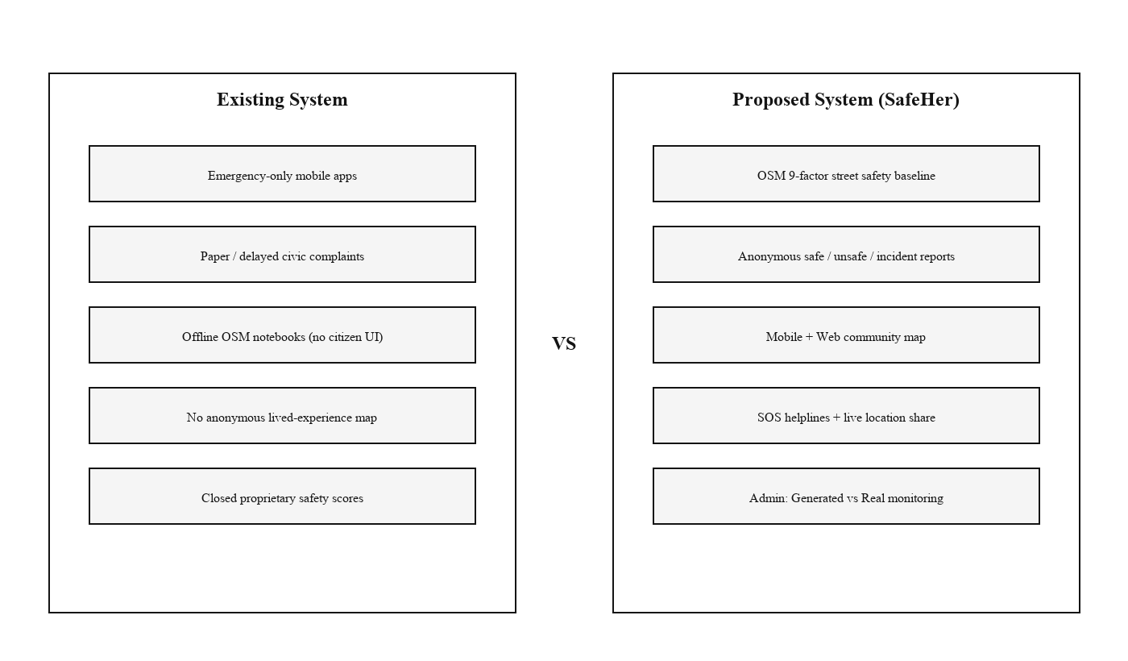
Fig. 2.1: Existing systems versus proposed SafeHer approach

2.5 Advantages of Proposed System
• Nine factors, all visible, so we can defend the score in front of faculty or a civic partner.
• App plus website means even someone who will not install an APK can take part.
• Insert anonymously, read only approved rows. Contribution and moderation both stay possible.
• Demo pins are labelled as demo. Nobody gets misled during an evaluation.
• SOS and the map are useful from day one, while the dataset quietly grows.

2.6 Feasibility Study

2.6.1 Technical Feasibility
Nothing exotic sits in the stack. Python with Overpass and pandas makes the dataset. Expo and React Native produce the Android build. Next.js runs the website, Supabase stores everything with RLS on. All of it fits on our laptops and free tiers, so feasibility was never really in doubt.

2.6.2 Operational Feasibility
For a citizen the cost is one location permission and a few taps. The admin logs in with a password and gets the dashboards. And since Phase 1 needs no hookup to hospital or police systems, the whole thing stays in our hands.

2.6.3 Economic Feasibility
We paid for nothing. OSM is open, Expo and Next.js are free, Supabase has a free tier that was enough. The spend was our time and the phones we already own. For academic work that settles the economic question.

2.7 Tools and Technologies Used
• Programming: Python 3.x, TypeScript / JavaScript
• Mobile side: Expo (SDK ~54) with Expo Router, React Native, AsyncStorage
• Web side: Next.js 16 App Router, React 19, Tailwind CSS, Leaflet with react-leaflet, Recharts
• Backend: Supabase, meaning PostgreSQL, RLS and RPC, accessed with the anonymous key
• Data work: the Overpass API plus pandas, street exports in Excel and JSON
• Maps: OSM tiles, rendered in a WebView on mobile and through Leaflet on the web

2.8 Hardware and Software Requirements
Table 2.1: Hardware and Software Requirements
Category | Requirement
Processor | Intel i5 / AMD Ryzen 5 or higher (development)
RAM | 8 GB minimum (16 GB recommended for dataset builds)
Storage | 5 GB free for Node modules, Android SDK, and dataset files
Operating System | Windows 10/11 (team development); Android 10+ for field tests
Software | Node.js 20+, Python 3.10+, Expo CLI / EAS, Android Studio SDK
Cloud | Supabase project; optional Vercel hosting for web
Libraries | pandas, requests, @supabase/supabase-js, Leaflet, Recharts

3. SOFTWARE REQUIREMENTS SPECIFICATION

3.1 Users / User Roles
• Citizen / woman traveller — files feeling or incident reports, browses the community map, uses SOS.
• Admin / project researcher — logs in to the admin portal, checks OSM KPIs and the community analytics.
• Developer / student team — keeps the dataset scripts, schema and clients alive.

3.1.1 Objectives
1. Build the OSM extraction and scoring pipeline for the Bengaluru BBMP boxes.
2. Put out the scored street dataset in Excel and JSON, labelled Safe, Moderate or Unsafe.
3. Ship the mobile tabs, Home, Report, Map, SOS.
4. Ship the web routes, reporting, map, emergency, community summary.
5. Store anonymous reports in Supabase with the area label, rate-limited per device.
6. Keep Generated demo data and Real reports separated in the admin portal.
7. Write down the Phase-1 limits plainly. EDA and clustering are not claimed.
About scope. This is a single-team prototype meant for data collection and demonstration. Production login for citizens, hospital integration, finished hotspot analytics, city-wide rollout, none of that is part of Phase 1.

3.2 Assumptions and Dependencies

3.2.1 Assumptions
• People will grant location permission when they report or use SOS.
• Bengaluru's OSM coverage is dense enough for a meaningful baseline.
• Device-level rate limiting on anonymous reports is an acceptable ethics posture for a prototype.
• One admin password in the environment file. Fine for a college demo, obviously not real identity management.

3.2.2 Dependencies
• Overpass API availability for dataset regeneration.
• The Supabase project must be reachable and the anon key configured in both clients.
• OpenStreetMap tile service for map rendering.
• An Android phone or emulator for field tests, any modern browser for the web.

3.3 Functional Requirements
Table 3.1: Functional Requirements
ID | Requirement
FR1 | The system shall fetch OSM highways and POIs per BBMP bounding box and compute street safety scores.
FR2 | The system shall classify streets into Safe, Moderate, or Unsafe using documented thresholds.
FR3 | The mobile app shall resolve GPS to a BBMP area name for display and storage.
FR4 | The system shall accept anonymous safe / unsafe / incident reports with optional factors.
FR5 | The system shall store reports in Supabase and expose approved reports to community maps.
FR6 | The system shall rate-limit submissions per device to reduce spam (approximately five per hour).
FR7 | The map shall filter pins by All / Safe / Unsafe / Incidents and show area context.
FR8 | The SOS module shall list helplines and support calling plus location sharing.
FR9 | The admin portal shall require a password session before dashboard access.
FR10 | The admin analytics view shall distinguish Generated (synthetic) from Real reports.
FR11 | The web site shall allow reporting and map use without citizen login.
FR12 | The community summary shall aggregate counts useful for Home and Community screens.

3.4 Non-Functional Requirements
Table 3.2: Non-Functional Requirements
ID | Requirement
NFR1 | Usability: report flow completable in under one minute for the minimal path.
NFR2 | Privacy: no citizen account; coordinates used for area naming, not public tracking profiles.
NFR3 | Security: RLS enforces insert rules and approved-only public reads; admin via HttpOnly-style session cookie.
NFR4 | Reliability: clients degrade gracefully when GPS or network is unavailable (refresh / retry messaging).
NFR5 | Maintainability: shared BBMP area definitions between Python pipeline and TypeScript clients.
NFR6 | Performance: map should remain interactive for hundreds of community pins on mid-range phones.
NFR7 | Transparency: scoring weights and methodology visible in admin Methodology pages.
NFR8 | Portability: Android APK via Expo; web via modern Chromium/Firefox/Safari browsers.

4. SYSTEM DESIGN

4.1 System Architecture
The design is layered, client, server, and an offline data-science piece at the side. Mobile and web clients both write reports to Supabase and read community data from it. The admin OSM dashboards do not query anything live, they read static JSON we generate from the dataset. When the baseline needs refreshing, the Python Overpass pipeline reruns and produces fresh Excel and JSON.
The main blocks are these:
1. OSM Dataset Pipeline — Overpass queries, the nine-factor scoring, Excel and JSON export.
2. Supabase Backend — reports table plus the area_safety view, the community_summary RPC and the RLS rules.
3. Mobile Application — Expo tabs, Home, Report, Map with WebView Leaflet, SOS.
4. Web User Portal — the landing page, the report form, map and emergency pages, community dashboard.
5. Web Admin Portal — password middleware in front, then OSM KPIs, analytics, search, areas and the methodology page.
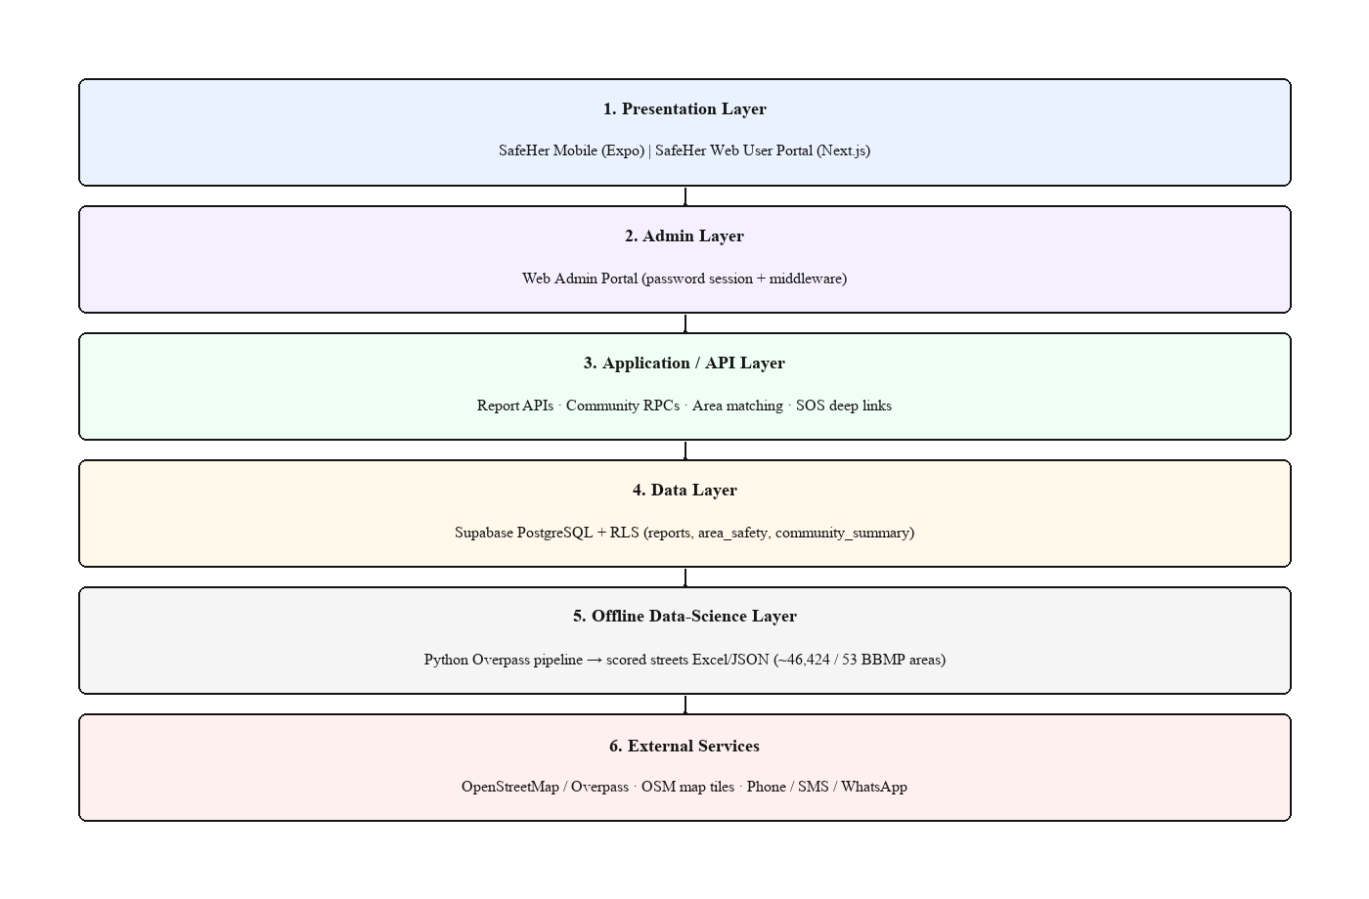
Fig. 4.1: High-level system architecture of SafeHer

4.2 System Perspective
If you look at it as a product, SafeHer is a sensing tool for the city. Early on the crowdsourced volume is thin, so the infrastructure score carries the map. As reports come in, the picture of each place gets richer. In the admin view the generated pins exist only so demos do not show an empty map, and the real pins tell us if people actually use the thing. We also kept the ML analytics fully out of this phase's boundary, on purpose, so nobody can accuse the architecture of claiming more than it does.

4.3 Context Diagram
Around the system stand the citizen, the admin, OpenStreetMap with its Overpass API, the Supabase cloud, and the phone's own call, SMS and WhatsApp channels which come into play during SOS. SafeHer sits between all of them. Map tiles in, reports stored, emergency deep links fired, and at no point does a citizen need an account.
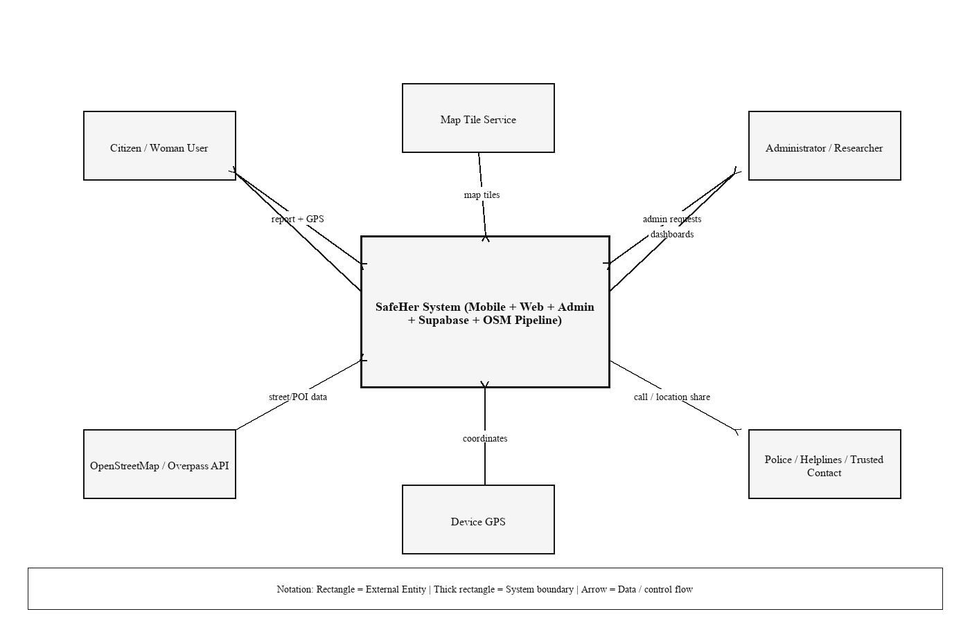
Fig. 4.2: System context diagram

5. DETAILED DESIGN

5.1 Data Flow Diagram – Level 0
Level 0 is simple. The citizen gives a location and a report choice, SafeHer keeps the approved data and answers with map and summary views. The admin gives credentials and receives analytics. On the side, the offline pipeline takes OSM data and outputs scored streets.
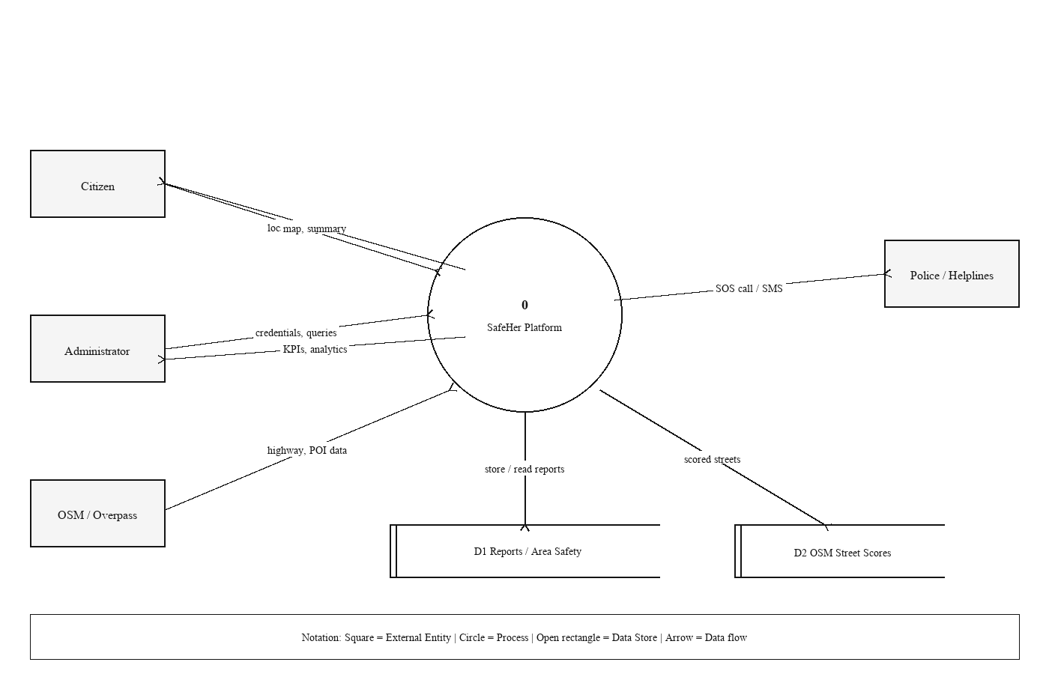
Fig. 5.1: Data flow diagram – Level 0

5.2 Data Flow Diagram – Level 1
Level 1 opens the box. Inside there is area matching, report validation and insert, community aggregation, the OSM scoring, and the admin session check. Three stores hold state, the reports table, the static street JSON, and the trusted contact saved locally on the phone.
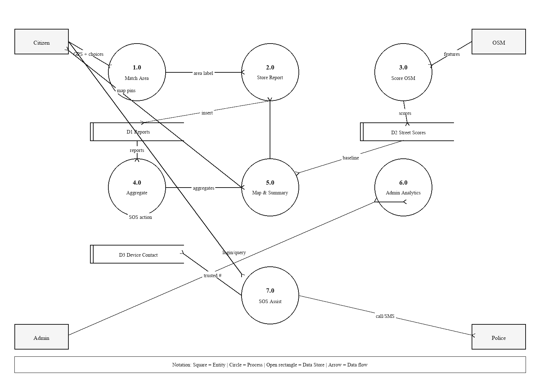
Fig. 5.2: Data flow diagram – Level 1

5.3 Use Case Diagram
A citizen can confirm her location, submit a feeling report, submit an incident report, browse the safety map, call a helpline, and share live location. The admin logs in, views the OSM dashboard, inspects community analytics, searches streets and areas, and reads the methodology page.
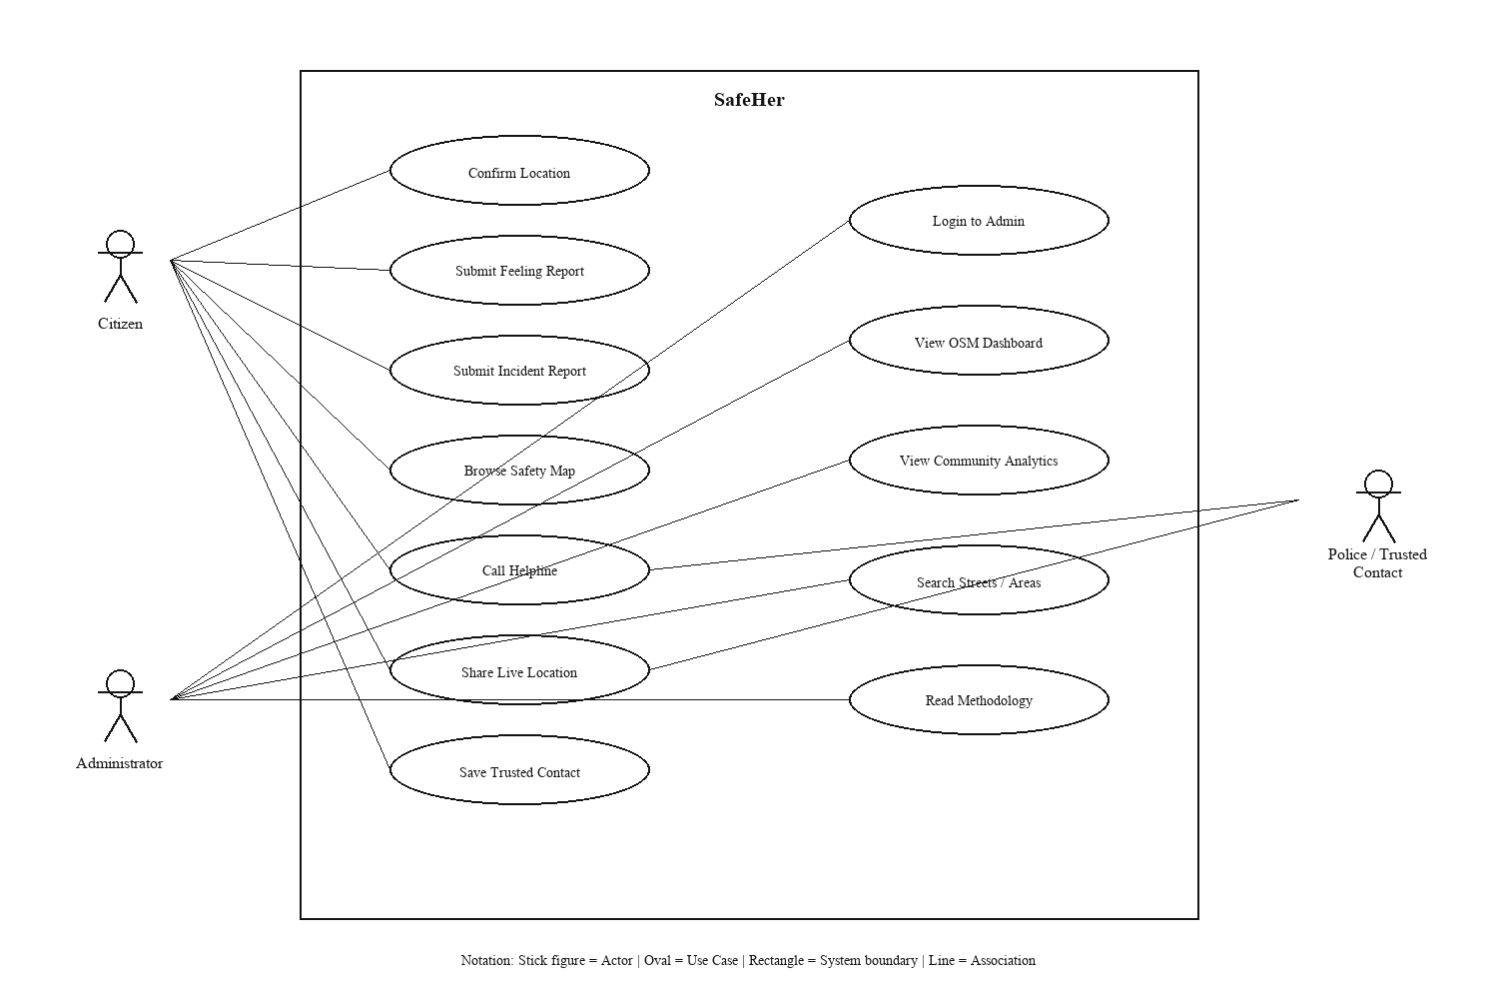
Fig. 5.3: Use case diagram

5.4 Activity Diagram – Emergency SOS
SOS starts on the Emergency tab. Refresh GPS if needed. Then one of three routes, call 112 with location attached, fire the SMS to police at 100, or pick one of the helpline cards. If live tracking is on, coordinates keep updating so a share can be repeated. The trusted contact number stays on the phone, we never upload it.
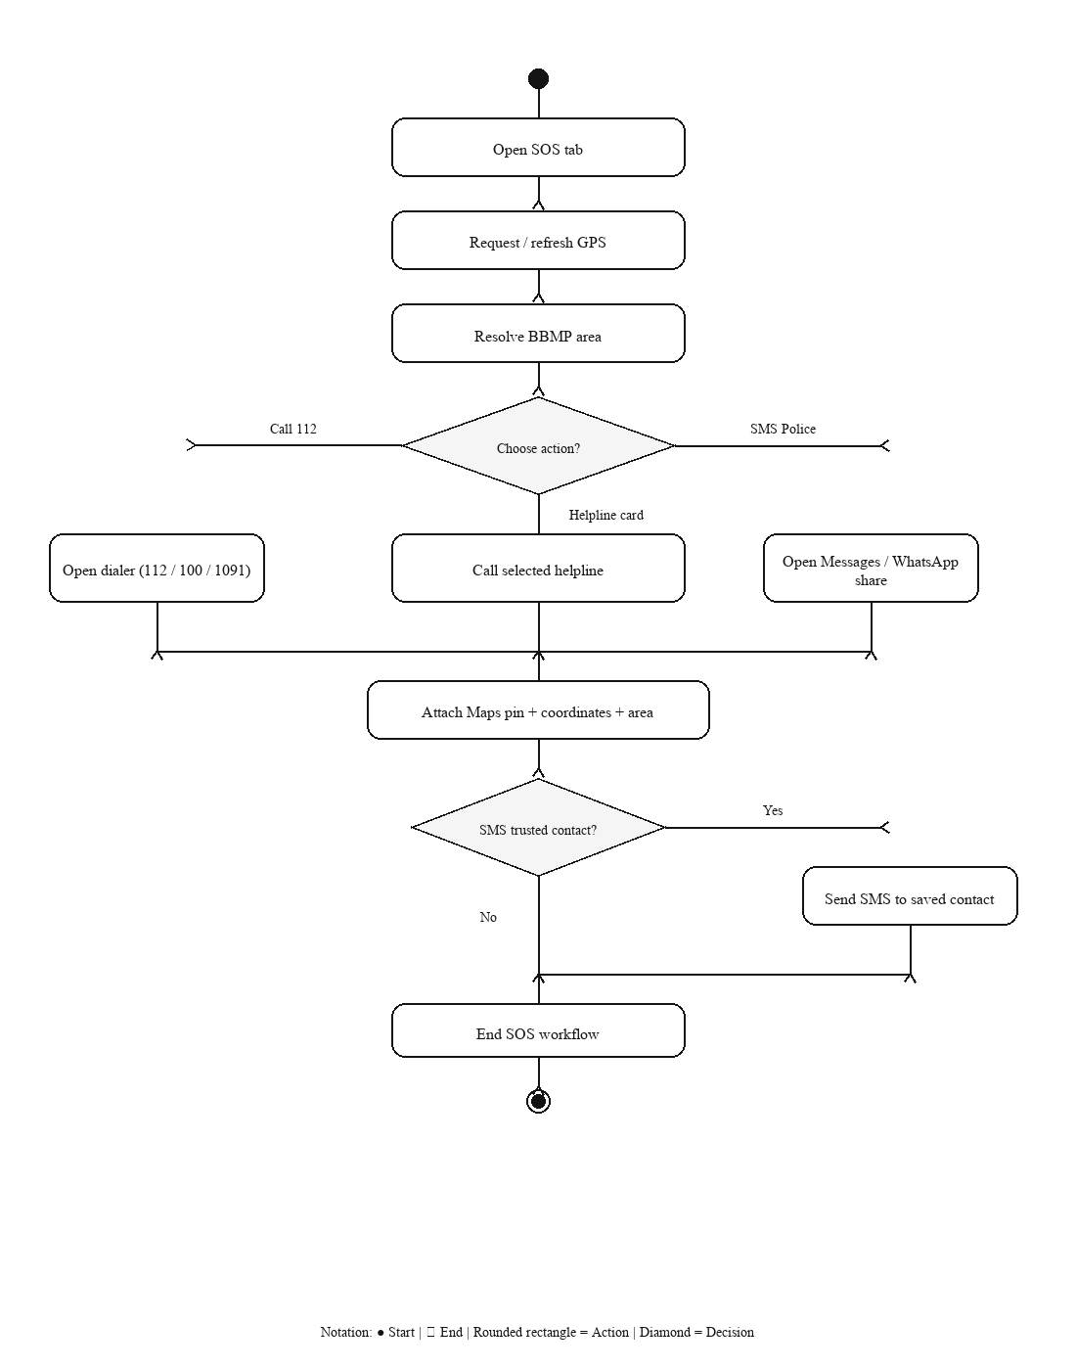
Fig. 5.4: Activity diagram – Emergency SOS flow

5.5 Sequence Diagram – Report Submission
A report travels from the UI to the area matcher, then through the Supabase client where the RLS policies decide if the insert is allowed, and optionally the community summary refreshes at the end. When the insert lands, the user sees a thank-you screen with two links, the map or another report.
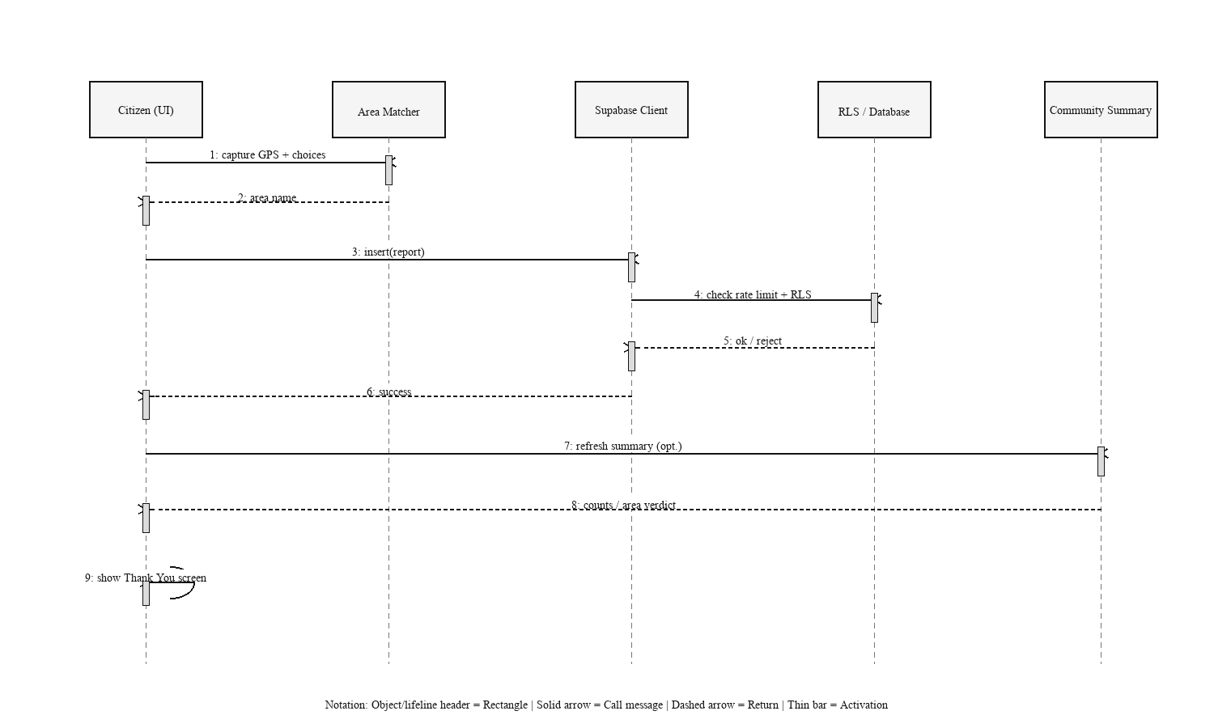
Fig. 5.5: Sequence diagram – anonymous report submission

6. IMPLEMENTATION

6.1 Implementation Methodology
Work ran in four streams side by side. Stream one was the OSM pipeline and checking that scores made sense. Two was the Supabase schema with its RLS policies and RPC functions. Three, the Expo app. Four, the Next.js portals for users and admin. One decision saved us repeatedly, the BBMP boxes live in shared TypeScript and Python definitions, so an area is called the same thing offline and on the phone.

6.2 Dataset and Feature Description
We cut Bengaluru into the 53 BBMP boxes. For every box the Python script asks Overpass for the road geometries and the nearby POIs, police stations, hospitals, bus stops, CCTV nodes, lamps and similar amenities. Distances and presence flags then feed the weighted score.
Table 6.1: OSM safety scoring factor weights
Factor | Weight
Police proximity | 0.20
Hospital proximity | 0.15
Bus stop proximity | 0.15
Lighting indicators | 0.15
CCTV presence | 0.10
Crowd / activity proxies | 0.10
Commercial activity | 0.05
Night amenity indicators | 0.05
Road class | 0.05

Table 6.2: Bengaluru OSM dataset summary metrics
Metric | Value
Total streets scored | 46,424
BBMP areas covered | 53
Safe streets | 7,855
Moderate streets | 33,431
Unsafe streets | 5,138
Average safety score | 5.78
Dataset generation date | 2026-05-24

6.3 Module-wise Implementation

6.3.1 Mobile Application
In the app, Expo Router gives four tabs. Home shows the area verdict and shortcuts. Report is a wizard with steps. Map is Leaflet running as HTML inside a WebView, filters included. SOS holds the helplines, the trusted contact and the call-and-share helpers. Submissions go through the anon Supabase client, and a device id lets us rate-limit without accounts.

6.3.2 Web User Portal
On the web, the public side has the landing page, the report form, the map, the emergency page and the community dashboard. That dashboard shows demo records and live approved reports together, but labelled, so an evaluator always knows which is which.

6.3.3 Web Admin Portal
Admin login compares against ADMIN_PASSWORD and drops a session cookie. Next.js middleware checks the cookie on every admin route. Street KPIs come from static OSM JSON, the community analytics, search and area views come from Supabase, and a methodology page spells out the scoring.

6.3.4 Supabase Backend
One row in reports holds the coordinates, the area name, is_safe, the rating, the factor booleans, a comment, time_of_day, device_id, status, report_kind and incident_type. Under RLS anyone may insert anonymously, but reading returns approved rows only. Two RPCs sit alongside, one serving the community summary and one counting what a device sent recently.

6.4 Key Code Snippets
Illustrative weighted scoring (Python pipeline):
weights = {
"police": 0.20, "hospital": 0.15, "bus": 0.15,
"lighting": 0.15, "cctv": 0.10, "crowd": 0.10,
"commercial": 0.05, "night": 0.05, "road": 0.05,
}
score = sum(component(row, k) * w for k, w in weights.items())
level = "Safe" if score >= 7 else "Moderate" if score >= 4 else "Unsafe"
The insert call from the client looks like this:
await supabase.from("reports").insert({
lat, lon, area_name, is_safe, rating,
report_kind, incident_type, device_id, status: "approved",
});

6.5 Visuals
What follows is not a mockup. These are captures from the Android build, going through Home, Report, Map and SOS one by one.

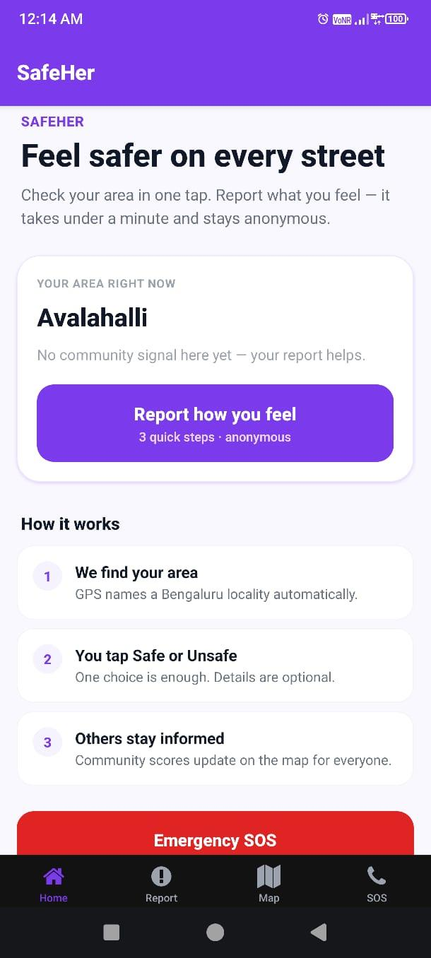
Fig. 6.1: SafeHer Home – area status and call to report
Home screen of the app. 'Feel safer on every street' on top, the detected area below it, Avalahalli in this capture, and the purple button that starts an anonymous report. Scroll a little and Emergency SOS appears. Tabs run along the bottom, Home, Report, Map, SOS.

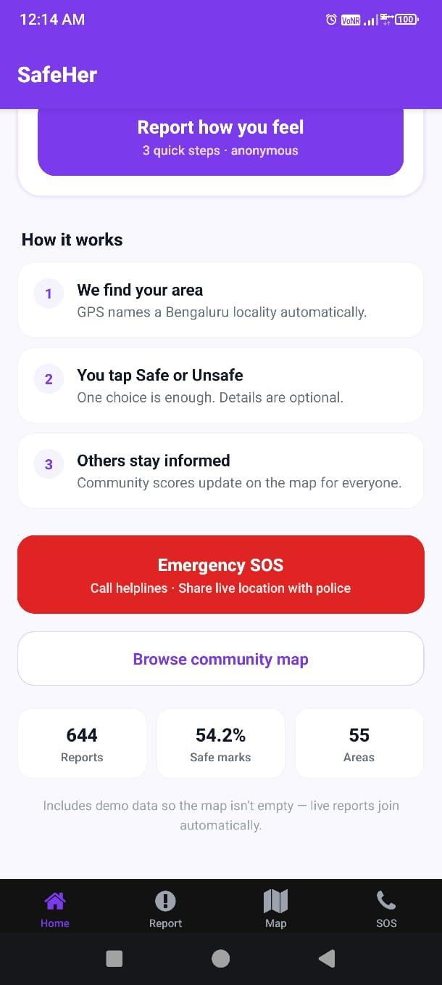
Fig. 6.2: SafeHer Home – how it works and community summary
Home again after scrolling. The three 'How it works' steps, the SOS block with helpline and location share, the community map link, and the counters at the bottom, reports, safe marks, areas.
Note that demo data is included so the map isn’t empty.

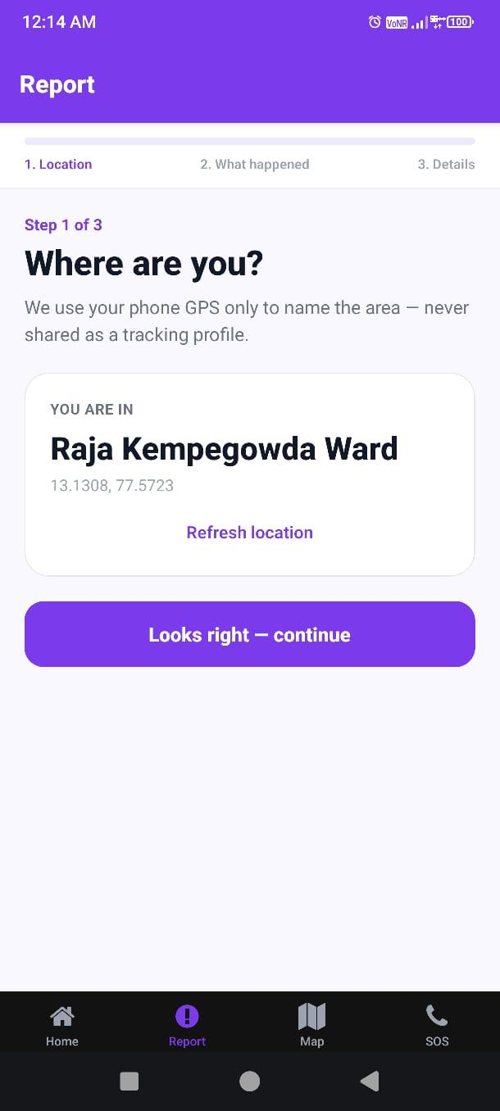
Fig. 6.3: Report wizard – Step 1 location confirmation
Wizard step one. GPS has resolved Raja Kempegowda Ward, coordinates below the name. Two choices, refresh the location or accept with 'Looks right — continue'. Note the line about GPS, we only use it to name the area, tracking is off the table.

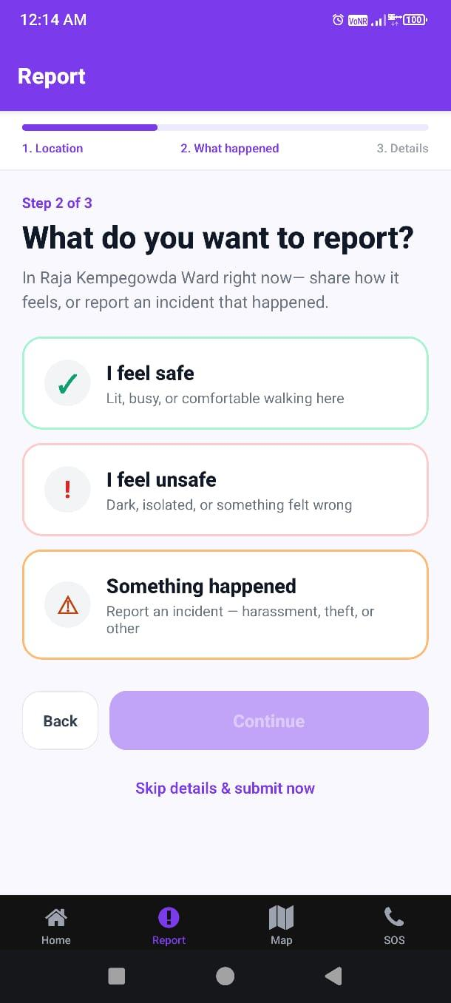
Fig. 6.4: Report wizard – Step 2 feeling or incident choice
Step two. Three options, I feel safe, I feel unsafe, Something happened, each with a one-line hint. Back and Continue below, and the impatient can hit 'Skip details & submit now'.

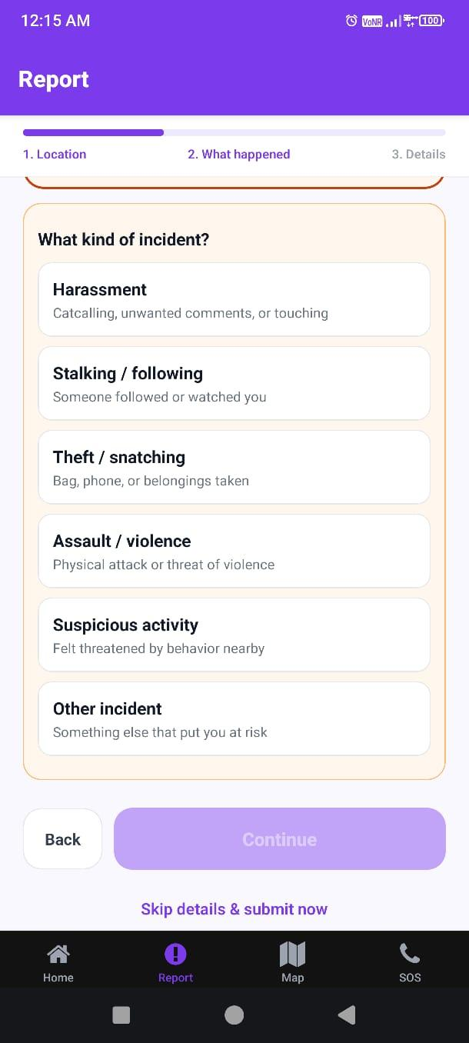
Fig. 6.5: Report wizard – incident type selection
If 'Something happened' was picked, this screen asks what kind. Harassment, stalking or following, theft or snatching, assault or violence, suspicious activity, or something else.

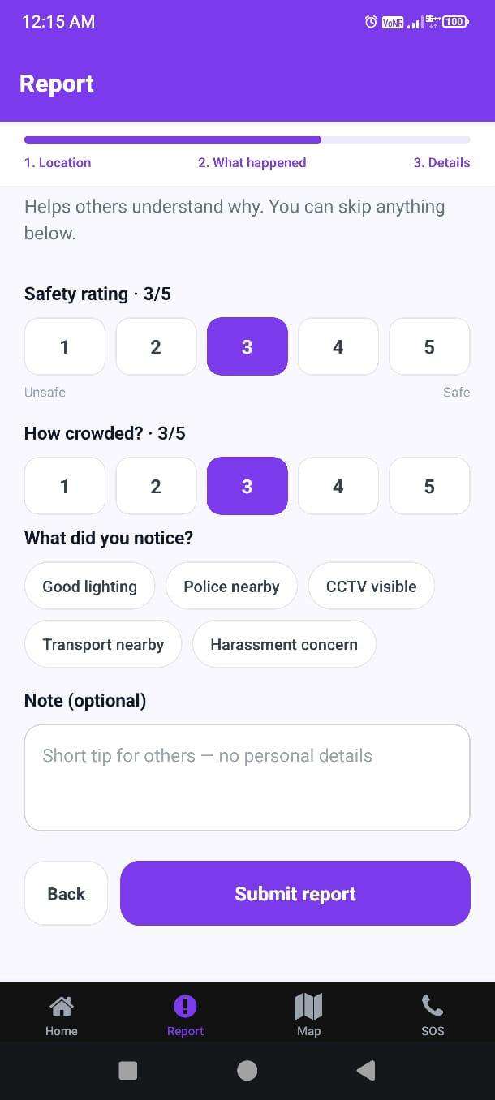
Fig. 6.6: Report wizard – optional details and factors
The details step, everything optional. Rating from 1 to 5, crowd level, the quick tags for lighting, police, CCTV, transport and harassment concern, plus a free-text note. Skip all of it if you like, then Submit report.

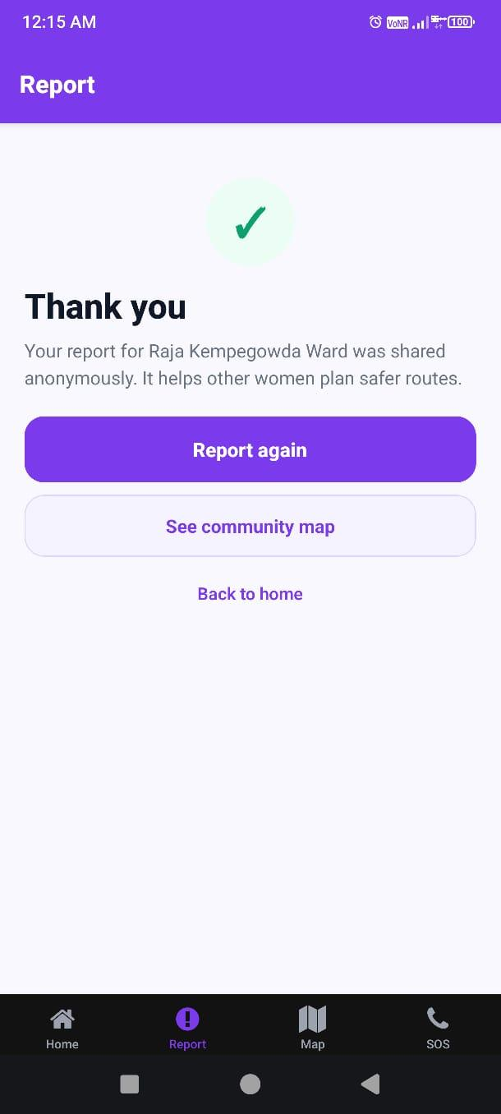
Fig. 6.7: Report submission success screen
Saved. The screen confirms the ward's report went in anonymously and offers three ways out, Report again, See community map, Back to home.

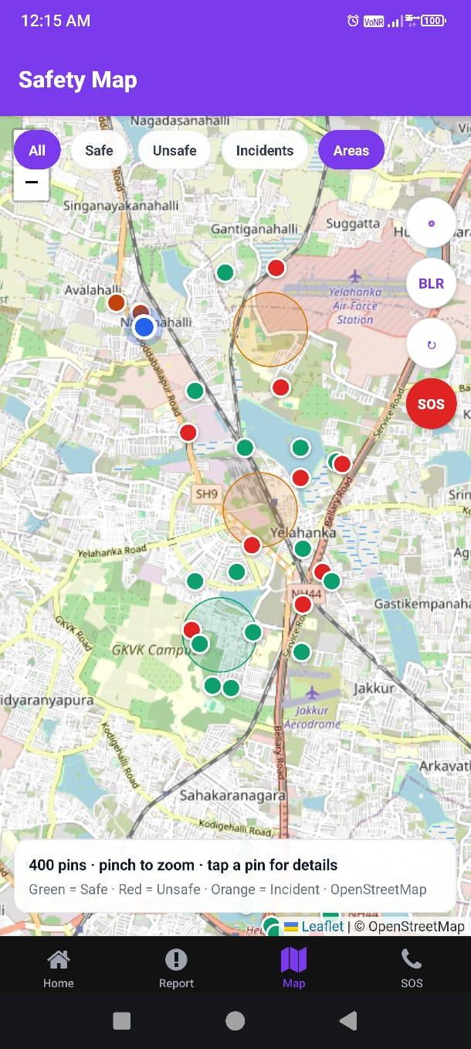
Fig. 6.8: Safety Map with filters and community pins
The Map tab. OpenStreetMap centred on the user, green pins safe, red unsafe, orange incidents. Filters along the top, All, Safe, Unsafe, Incidents, Areas. The red SOS button floats on the map the whole time.

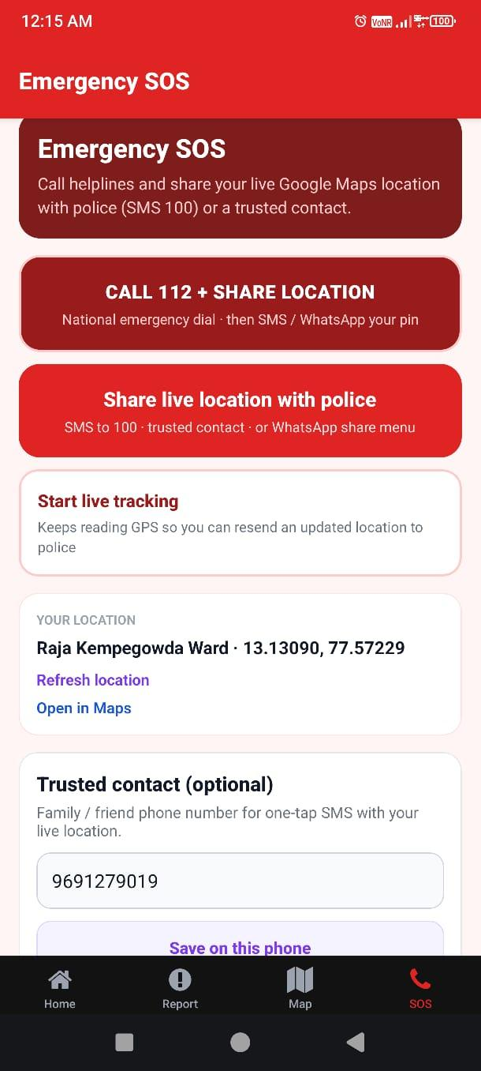
Fig. 6.9: Emergency SOS – call and live location share
The SOS hub. Call 112 with location attached, SMS the live location to police at 100, start live tracking, see the current ward and coordinates. A trusted contact can be saved too, it stays on the phone.

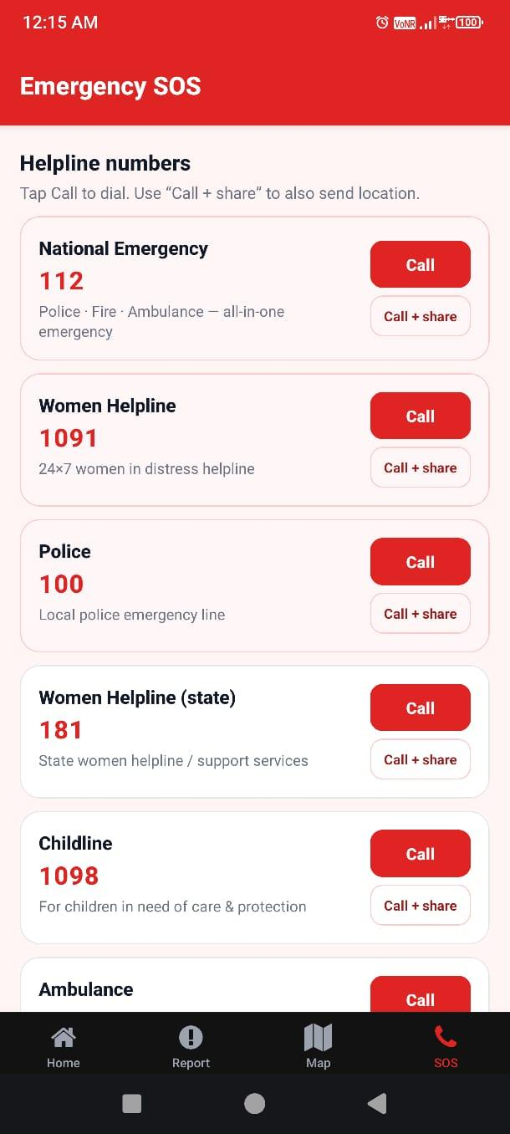
Fig. 6.10: Emergency SOS – helpline directory
All the helplines in one list, 112, 1091, 100, 181, 1098 and the ambulance. Each card has plain Call, or Call + share which sends the location along.

7. SOFTWARE TESTING

7.1 Testing Methodology
Our testing was a mix. Manual runs on Android phones, quick smoke tests of the website in a browser, SQL sessions to poke at the RLS rules, and scripts comparing the Python scoring against the TypeScript helper. The critical paths got the attention, submit a report, filter the map, dial and share from SOS, and the admin gate.

7.2 Unit Testing
Unit-wise we checked three things, that a point lands in the right BBMP box, that the level thresholds cut where they should, and that the weights sum to what the methodology says. The conversion scripts got a simpler check, the counts in the Excel had to equal the counts in the JSON that the admin UI reads.

7.3 Test Cases and Results
Table 7.1: Test Cases and Results
TC ID | Test Case | Expected Result | Status
TC01 | GPS resolves to a BBMP area name on Home | Named area shown (or clear empty state) | Pass
TC02 | Submit minimal safe report without details | Thank-you screen; row in Supabase | Pass
TC03 | Submit incident with type Harassment | Stored with report_kind=incident | Pass
TC04 | Map filter Unsafe hides safe pins | Only unsafe/incident-relevant pins remain | Pass
TC05 | SOS Call 112 opens dialer | tel: intent launched | Pass
TC06 | Share location composes SMS/Maps link | Share sheet or SMS with coordinates | Pass
TC07 | Admin without cookie blocked from /admin/dashboard | Redirect to login | Pass
TC08 | Admin with valid password reaches dashboard | OSM KPIs visible | Pass
TC09 | Rate limit after repeated inserts | Further inserts rejected by RPC/policy | Pass
TC10 | Public select cannot read pending/rejected rows | Only approved visible on map APIs | Pass

8. RESULTS AND DISCUSSION

8.1 Deliverables Achieved
So what does Phase 1 actually hand over. The scored street corpus for the BBMP areas. The app and the website, both working. Supabase persistence with RLS protecting anonymity. The admin portal. And Chapter 6 has the proof, the wizard, the filters and the helplines photographed on a real phone.

8.2 Dataset Outcomes
Of the 46,424 streets, the bulk sits in Moderate. No surprise, a model built on proximity to amenities will hedge toward the middle, and we would rather that than pretend to predict crime. The interesting slice is the Unsafe minority. Those corridors have weak infrastructure signals, and those are the places where future reports from real users will add the most.

8.3 Platform Behaviour
Two small choices did a lot of work. Anonymity plus optional fields keeps a report down to a few seconds. And the synthetic pins, clearly disclosed in the UI, mean a demo never shows a blank map while real reports merge in automatically. Saying this openly matters, in the viva and to any civic partner.

8.4 Discussion and Limitations
We are careful about what we do not claim. Report volume is still small. OSM factors approximate lived experience, they do not replace it. Clustering has not been executed as a finished analysis. And a shared admin password would not survive outside a classroom. None of that undercuts the phase though. The goal was a dual data-collection architecture, and it stands, ready for the EDA and hotspot work to plug into.

9. CONCLUSION
This project set out to build the Phase-1 platform for women's street safety data in Bengaluru, and that is what SafeHer is. An OSM baseline anyone can audit, anonymous reporting on phone and web, community maps, SOS help, and an admin portal watching it all. Usable today, extendable tomorrow.
If there is one lesson, it is that open geographic data and careful crowdsourcing fit inside a student timeline, provided you resist inflating the analysis. The next phases have their platform. EDA, clustering for hotspot candidates, and stronger moderation can all build on what is documented here.

10. FUTURE ENHANCEMENTS
1. Finish the EDA on real reports joined against the OSM street attributes.
2. Run K-Means and DBSCAN over the joined data, shortlist hotspot candidates, and validate them properly.
3. Add moderated heatmaps and day-versus-night views once real volume justifies them.
4. Retire the shared password, bring in role-based auth with audit logs.
5. Consider a verified volunteer role for on-ground audits.
6. Cache tiles offline and queue reports when the network drops.
7. Sit with women students for structured usability rounds, then fix the SOS flow accordingly.
8. Look for partners who can legally share anonymised official statistics to validate our proxies.

11. BIBLIOGRAPHY / REFERENCES
- Chainey, S., & Ratcliffe, J. (2005). GIS and Crime Mapping. Wiley.
- OpenStreetMap Wiki — https://wiki.openstreetmap.org/
- Overpass API Documentation — https://dev.overpass-api.de/
- Expo Documentation (SDK 54) — https://docs.expo.dev/
- Next.js Documentation — https://nextjs.org/docs
- Supabase Documentation — https://supabase.com/docs
- Leaflet — https://leafletjs.com/
- React Native Documentation — https://reactnative.dev/
- United Nations Sustainable Development Goals — https://sdgs.un.org/goals
- Safetipin — https://safetipin.com/ (crowdsourced safety audit reference)
- BBMP / Bengaluru civic geographic references used for ward bounding-box design.

APPENDIX A: SUSTAINABLE DEVELOPMENT GOALS (SDG)
Our project ties into the UN's Sustainable Development Goal 5 on Gender Equality. That goal is about women and girls getting equal rights, opportunities and, importantly here, safety.
Violence against women, public or private, is one of the things SDG 5 wants ended. Two pieces of the goal touch our work directly:
- Target 5.2 — stop every form of violence against women and girls. Street harassment and unsafe public places, transport included, fall squarely under it.
- Indicator 5.2.2 — counts women and girls facing sexual violence from someone who is not a partner, noting where and in what situation it happened.

APPENDIX B: PROJECT SYNOPSIS

B1. INTRODUCTION
Walk through any crowded Indian city and the problem is visible. Women deal with harassment on streets, in buses, near markets, in parks. The harm is physical sometimes, psychological almost always, and the response many women choose is to simply travel less. Fewer classes attended, job offers turned down for the commute, evenings avoided. A city that makes half its people plan around fear is losing something, and that is the concern this project starts from.
The research says these incidents have geography. Sherman called the pattern hotspots back in 1989, crime gathering at particular addresses rather than scattering. Chainey and Ratcliffe then showed how GIS can surface those patterns from incident data and turn them into preventive decisions.
Apps exist, of course. bSafe will raise an SOS and share your live location. My Safetipin crowdsources ratings and scores places. Useful, both of them, but both wait for the user to act in the moment. They are reactive by design.
Prevention is the missing piece. Hardly any deployed system digs into past incident data to work out where trouble concentrates. The tools for that, clustering, spatial analysis, cheap compute, all exist now. There is no technical excuse anymore.
So that became our gap. Analyse incident records, find the hotspots, paint the unsafe zones on a map anyone can read. A commuter picks a better route. A police planner sees where patrols are thin. Same data, two uses.
There is also the SDG 5 angle, the UN goal on ending violence against women and making public spaces genuinely open to them. A preventive, data-first system is a small contribution in that direction, but a real one.

B2. OBJECTIVES
Put simply, the aim is a system that studies harassment incidents in public spaces and marks out the high-risk zones early enough for prevention to mean something.
Breaking that down, the objectives are:
- To study incident data on harassment of women — collect the records, place, time, incident type, and pull the patterns out of them.
- To locate high-risk zones (hotspots) — find where the reports stack up. Those places get named, mapped and prioritised.
- To use spatial analysis methods — borrow from GIS to see how geography shapes risk.
- To present unsafe zones clearly — maps and heatmaps, because a colour gradient communicates faster than a table ever will.
- To detect hotspots through clustering — K-Means and similar methods group nearby incidents on their own, no manual marking.
- To examine time and place together — day or night matters as much as where. The system reads both.
- To assist prevention and urban planning — lighting, patrols, cameras. The findings say where they should go.
- To support SDG 5 (Gender Equality) — evidence that reduces violence against women serves the goal directly.

B3. LITERATURE SURVEY
We are not the first here. Plenty of research connects technology, spatial analysis and women's safety.
Chainey and Ratcliffe's 2005 book is the standard reference for crime mapping with GIS. Their point, made repeatedly, is that mapping the geography of offences lets authorities move before the next incident, not after.
Sherman got there earlier. His 1989 study showed crime concentrating at specific places, and the word he used, hotspots, is the one everybody still uses. Every detection technique since leans on that finding.
Nehme and colleagues, 2017, focused on women specifically. Lighting, crowd levels, the character of a place, all of it shapes both actual safety and the feeling of it. That matched our intuition and shaped our factor list.
Among products, My Safetipin does crowdsourced safety scores for places, bSafe does emergencies, SOS and live tracking.
Reading it together, one gap repeats. Deployed systems react, they rarely predict, and historical data mostly sits unused. Nobody has quite joined spatial analysis, clustering and visualisation into an early-warning picture.
That is the thread we picked up, clustering plus analysis for hotspot detection, prevention over reaction.

B4. EXISTING SYSTEM
The current market for women's safety tools is basically emergency response on a smartphone.
The pattern repeats across apps. SOS alert, live location, notify the chosen contacts. bSafe does it with one action. My Safetipin stands apart a bit, scoring places on lighting, crowd and user feedback rather than just handling the emergency.
Google Maps and the like are brilliant at navigation and place search. Safety analysis simply is not what they were built for.
Useful as they are, the limitations are hard to ignore:
- Reactive nature — help arrives after the incident. Prevention is not on offer.
- Manual triggering — the woman must press the button herself, in precisely the moment she may be unable to.
- No data analysis — yesterday's incidents teach these apps nothing.
- No prediction — no app will tell you which street to avoid tomorrow.
- Internet dependence — no signal, no safety net.
- Nothing for planners — the city learns nothing it can act on.
Add these up and the conclusion writes itself. Emergency support alone is not enough. A system should study the data and expose unsafe areas before anyone is standing in one. That is the idea our proposed system is built on.

B5. PROPOSED SYSTEM
Our system flips the order. Instead of waiting for an emergency, it reads incident records and flags risky areas first.
Collection comes first, coordinates, time, category for each incident. Then cleaning. Bad rows out, gaps handled, formats aligned. Boring work, but every result downstream depends on it.
K-Means does the heavy lifting for hotspot detection. Incidents that sit close together on the map get clustered, and a dense cluster is a hotspot, plain and simple.
Then the drawing. Heatmaps turn incident density into colour, dark where it is bad, light where it is not. A person with zero technical background reads it in seconds.
Spatial analysis in the GIS sense runs through everything, and time rides along with place. Where risk gathers, and when, both come out.
The payoff is preventive. She checks the map and takes the other road. The corporation sees where lighting money should go. The police see where patrol routes are thin. One dataset, several users.
The short version, we moved the emphasis from reacting to anticipating. Find the risky areas early, plan the city better.

B6. MODULES IDENTIFIED
We broke the system into modules, one per stage, raw data at one end, decisions at the other.
The project has the following modules:
B6.1 Data Collection Module
Collection first. Incident records come in with coordinates, timestamps, categories. Public datasets, reports, or simulated data where needed.
B6.2 Data Preprocessing Module
Then preprocessing. Real data arrives messy, gaps, duplicates, stray errors. This module cleans it and shapes it for analysis. Skip this and everything after it lies.
B6.3 Analysis Module
The analysis module looks for frequencies, time-of-day movement, distribution across regions. The patterns start showing here.
B6.4 Clustering Module
Clustering runs K-Means over the coordinates, nearby incidents merge into groups, hotspots fall out.
B6.5 Visualization Module
Visualisation turns it into maps and charts, and above all heatmaps, intensity showing risk at a glance.
B6.6 Reporting Module
Reporting closes the pipeline, summaries of the hotspots and patterns, packaged for whoever must act on them.

B7. HARDWARE AND SOFTWARE REQUIREMENTS
Hardware-wise this project asks for very little. Ordinary machines, free software, that is all.
B7.1 Hardware Requirements
Any standard PC handles development and execution. Table 7.1 has the specifics.
Table B7.1: Hardware Requirements
Sl. No. | Component | Specification
1 | Computer / Laptop | Standard desktop or laptop system
2 | RAM | Minimum 4 GB (8 GB recommended)
3 | Storage | At least 10 GB free disk space
4 | Processor | Intel i3 or higher
5 | Operating System | Windows / Linux / macOS

B7.2 Software Requirements
The software list mixes programming tools, analysis libraries and spatial tech, everything itemised in Table 7.2.
Table B7.2:Software Requirements and Tools Used
Sl. No. | Tool / Technology | Purpose
1 | Python | Primary programming language for data analysis and visualization
2 | Pandas | Data manipulation, cleaning and handling structured datasets
3 | NumPy | Numerical computations and large-array handling
4 | Matplotlib | Generating charts and graphs to visualize patterns
5 | Folium | Interactive map visualization of incident locations and hotspots
6 | K-Means Clustering | Grouping incident locations to detect hotspots
7 | GIS Concepts | Spatial analysis of geographic distribution of incidents
8 | Google Maps | Map visualization and geographic reference
9 | Jupyter Notebook | Interactive environment for code, analysis and documentation
10 | Visual Studio Code | Code editor for development and debugging
11 | QGIS (Optional) | Advanced spatial visualization and professional GIS outputs
12 | Git / GitHub | Version control, backup and collaboration

B7.3 Summary
Python and its libraries carry the analysis, the machine learning brings the clustering, and the GIS concepts keep the whole thing anchored to real geography and to planning use-cases.

B8. SDG ALIGNMENT
SDG 5, the UN's gender equality goal, forms the larger frame around this work. Empowered women and girls, treated equally, safe everywhere, that is the ambition.
Ending violence against women sits at the centre of that goal, and two of its components meet our project head-on:
- Target 5.2, the demand to end all violence against women and girls, street harassment and unsafe public spaces included.
- Indicator 5.2.2, which tracks sexual violence against women by non-partners, broken down by where it occurred.
Prevention is our contribution to that goal. Historical data points at the likely hotspots, spatial analysis confirms them, visuals communicate them.
What follows from that is practical. Better lighting where the map says so. Patrols where they are missing. Cameras that earn their cost. And for an individual woman, a map that helps her pick the safer road tonight.
Awareness on one side, planning on the other, both pushing toward what SDG 5 wants, less violence and safer ordinary days.

B9. WORK BREAKDOWN STRUCTURE
We split the work into phases, each with a deliverable, which kept the timeline honest.
B9.1 Phase 1: Problem Definition and Research (Week 1)
Phase one was study. Pin the problem down, read what exists, note where it fails, shortlist the technologies, spatial analysis and data analytics chiefly.
B9.2 Phase 2: Data Collection (Week 2)
Then data. Incident records from the available sources, location, time, type. The foundation everything else stands on.
B9.3 Phase 3: Data Preprocessing (Week 3)
Cleaning next. Errors out, missing values handled, one consistent format. Analysis is only as good as this step.
B9.4 Phase 4: Data Analysis and Clustering (Week 4)
Then the analysis itself, pattern extraction and clustering, and the hotspots emerge from the grouped points.
B9.5 Phase 5: Visualization (Week 5)
Visualisation follows, maps and charts, heatmaps making unsafe areas readable at a glance.
B9.6 Phase 6: Testing and Result Evaluation (Week 6)
Testing after that. Does it run correctly, does it run fast enough, and do the detected hotspots actually mean anything. We checked all three.
B9.7 Phase 7: Documentation and Presentation (Week 7)
Documentation closes it out, the write-up you are reading and the presentation for the evaluation.
B9.8 Project Schedule (Gantt Chart)
Fig. 9.1 holds the Gantt chart, seven weeks, one row per phase, shaded cells marking the active weeks.
Phase | Task | W1 | W2 | W3 | W4 | W5 | W6 | W7
P1 | Problem Definition & Research
P2 | Data Collection
P3 | Data Preprocessing
P4 | Data Analysis & Clustering
P5 | Visualization
P6 | Testing & Result Evaluation
P7 | Documentation & Presentation
Fig. B9.1: Project Schedule – Gantt Chart

- Active State

B10. REFERENCES
- Spencer Chainey & Jerry Ratcliffe (2005). GIS and Crime Mapping. Wiley Publications.
- Lawrence Sherman (1989). Hot Spots of Crime and Criminal Careers of Places. Criminology Journal, Vol. 27(1), pp. 27–56.
- United Nations (2020). Sustainable Development Goal 5: Achieve Gender Equality and Empower All Women and Girls. Available at: https://sdgs.un.org/goals/goal5
- My Safetipin. Official Website. Available at: https://safetipin.com
- bSafe. Official Website. Available at: https://www.getbsafe.com
- Hannah Nehme et al. (2017). Environmental and Spatial Factors Influencing Women's Safety in Urban Areas. Journal of Urban Studies.

