Project Based Learning Report on

Incident Analysis and Hotspot Identification for Security Provision against Women Harassment in Public Spaces
MASTER OF COMPUTER APPLICATIONS
OF
VISVESVARAYA TECHNOLOGICAL UNIVERSITY

By
Aman Yadav Anusha K
1BY25MC012 1BY25MC017
II Semester

Under the Guidance of
Dr. M.Sridevi
Faculty, Department of MCA

Department of MCA
BMSITM
Bengaluru-560119


Department of Master of Computer Applications
(Accredited by NBA, New Delhi)

BMS Institute of Technology & Management
(Autonomous Institution under VTU)
Bengaluru – 560119
July-2026
BMS INSTITUTE OF TECHNOLOGY & MANAGEMENT
(Autonomous Institution under VTU)
Bengaluru – 560119

Department of MCA
(Accredited by NBA, New Delhi)

VISION
To emerge as a leading department in computer applications, producing skilled professionals equipped to deliver sustainable solutions.
MISSION
Facilitate effective learning environment through quality education, industry interaction with orientation towards research, critical thinking and entrepreneurial skills.

Programme Educational Objectives (PEOs)

PEO 1: Excel in IT career by developing sustainable solutions that drive industry growth and societal progress
PEO 2: Adapt themselves to evolving domain requirements
PEO 3: Exhibit leadership skills and progress in their chosen career path

BMS INSTITUTE OF TECHNOLOGY & MANAGEMENT
(Autonomous Institution under VTU)
Bengaluru – 560119

Department of MCA
(Accredited by NBA, New Delhi)

Programme Outcomes (POs)
PO 1: Apply knowledge of mathematics, programming logic and coding fundamentals for solution architecture and problem solving.

PO 2: Identify, review, formulate and analyse problems for primarily focusing on customer requirements using critical thinking frameworks.

PO 3: Design, develop and investigate problems with an innovative approach for solutions incorporating ESG/SDG goals.

PO 4: Select, adapt and apply modern computational tools such as development of algorithms with an understanding of the limitations including human biases.

PO 5: Function and communicate effectively as an individual or a team leader in diverse and multidisciplinary groups using methodologies such as agile.

PO 6: Use the principles of project management such as scheduling, work breakdown structure and be conversant with the principles of Finance for profitable project management.

PO 7: Commit to professional ethics in managing software projects with financial aspects. Learn to use new technologies for cyber security and insulate customers from malware.

PO 8: Change management skills and the ability to learn, keep up with contemporary technologies and ways of working.
ABSTRACT
Women’s sense of safety on urban streets is shaped by lighting, crowd presence, surveillance, and proximity to emergency services, yet these signals are rarely available as a single, actionable map for citizens. This Project Based Learning (PBL) work presents SafeHer, a dual-channel data-collection system for Bengaluru: an OpenStreetMap (OSM)–derived street safety baseline covering approximately 46,424 streets across 53 Bruhat Bengaluru Mahanagara Palike (BBMP) areas, and a live crowdsourcing platform through which women can anonymously mark how a place feels or report an incident with GPS context.
The deliverables include an Expo/React Native mobile application (SafeHer) with Home, Report, Map, and Emergency SOS tabs; a Next.js public website for browser-based reporting, community map, and helplines; a password-protected admin portal for OSM key performance indicators and Generated-versus-Real community monitoring; and a Supabase PostgreSQL schema with row-level security for anonymous inserts and approved-report reads. Street scores use a transparent nine-factor weighted model (police, hospital, bus stops, lighting, CCTV, crowd proxies, commercial activity, night amenity, and road class) classified into Safe, Moderate, and Unsafe bands.
This report documents Phase-1 completion of data collection and platform demonstration. Finished exploratory data analysis, unsupervised hotspot clustering (for example K-Means), and production-grade predictive policing dashboards remain explicit future work and are not claimed as completed outcomes.
Keywords: Women’s street safety, OpenStreetMap, Crowdsourcing, SafeHer, BBMP, Supabase, Expo, Next.js, Bengaluru, Anonymous reporting

TABLE OF CONTENTS
ABSTRACT i
LIST OF FIGURES iii
LIST OF TABLES iv
CHAPTER 1: INTRODUCTION 1
1.1 Project Description 1
1.2 Background 2
1.3 Motivation 2
1.4 Problem Statement 3
CHAPTER 2: LITERATURE SURVEY 4
2.1 Background Study 4
2.2 Existing System 4
2.3 Limitations of Existing System 5
2.4 Proposed System 5
2.5 Advantages of Proposed System 5
2.6 Feasibility Study 6
2.7 Tools and Technologies Used 7
2.8 Hardware and Software Requirements 7
CHAPTER 3: SOFTWARE REQUIREMENTS SPECIFICATION 8
CHAPTER 4: SYSTEM DESIGN 12
CHAPTER 5: DETAILED DESIGN 15
CHAPTER 6: IMPLEMENTATION 18
CHAPTER 7: SOFTWARE TESTING 28
CHAPTER 8: RESULTS AND DISCUSSION 30
CHAPTER 9: CONCLUSION 32
CHAPTER 10: FUTURE ENHANCEMENTS 33
BIBLIOGRAPHY / REFERENCES 34
APPENDIX A: SUSTAINABLE DEVELOPMENT GOALS (SDG) 36
APPENDIX B: PROJECT SYNOPSIS 37
APPENDIX C: PLAGIARISM REPORT 40

LIST OF FIGURES
Fig. 2.1: Existing systems versus proposed SafeHer approach 5
Fig. 4.1: High-level system architecture of SafeHer 12
Fig. 4.2: System context diagram 13
Fig. 5.1: Data flow diagram – Level 0 15
Fig. 5.2: Data flow diagram – Level 1 16
Fig. 5.3: Use case diagram 16
Fig. 5.4: Activity diagram – Emergency SOS flow 17
Fig. 5.5: Sequence diagram – anonymous report submission 17
Fig. 6.1: SafeHer Home – area status and call to report 20
Fig. 6.2: SafeHer Home – how it works and community summary 21
Fig. 6.3: Report wizard – Step 1 location confirmation 21
Fig. 6.4: Report wizard – Step 2 feeling or incident choice 22
Fig. 6.5: Report wizard – incident type selection 22
Fig. 6.6: Report wizard – optional details and factors 23
Fig. 6.7: Report submission success screen 23
Fig. 6.8: Safety Map with filters and community pins 24
Fig. 6.9: Emergency SOS – call and live location share 24
Fig. 6.10: Emergency SOS – helpline directory 25

LIST OF TABLES
Table 2.1: Hardware and Software Requirements 7
Table 3.1: Functional Requirements 9
Table 3.2: Non-Functional Requirements 10
Table 6.1: OSM safety scoring factor weights 18
Table 6.2: Bengaluru OSM dataset summary metrics 19
Table 7.1: Test Cases and Results 28

CHAPTER 1: INTRODUCTION
1.1 Project Description
This PBL project designs and implements SafeHer, a practical platform that combines an offline OSM infrastructure baseline with online citizen reporting for women’s street safety in Bengaluru. The OSM pipeline queries Overpass for highway geometries and nearby points of interest inside each of 53 BBMP area bounding boxes, then computes a per-street safety score. The live platform lets a user confirm GPS-derived locality, choose whether the place feels safe or unsafe (or that an incident occurred), optionally attach environmental factors, and store the report anonymously.
Citizens interact through a mobile application (primary channel for GPS and SOS) and a public website (browser fallback without installation). Project staff monitor OSM coverage and incoming community signals through an admin portal. The present phase emphasises trustworthy data collection and usable interfaces rather than final statistical hotspot products.
1.2 Background
Urban safety research consistently shows that risk and fear of crime concentrate in particular places and times rather than spreading evenly across a city. Official crime registers capture only reported events and often lack fine-grained street context. Volunteered geographic information such as OpenStreetMap encodes lighting hints, transport stops, and amenity locations that can serve as environmental proxies. Parallel to this, crowdsourcing platforms demonstrate that residents can contribute experiential safety ratings when privacy and interaction cost are handled carefully.
Bengaluru’s BBMP wards provide a natural administrative partitioning for both dataset generation and on-device area labelling. Matching GPS coordinates to a named ward gives users a recognisable place label without exposing a continuous tracking profile.
1.3 Motivation
Three gaps motivated this work:
• Emergency-only apps help after a crisis but do not accumulate place-level safety memory for route planning.
• OSM notebooks alone do not give women a simple way to contribute lived experience back into a shared map.
• Closed civic datasets are hard for student teams to refresh; an open OSM baseline plus anonymous reports is reproducible within a PBL timeline.
SafeHer therefore pairs a transparent scored street dataset with lightweight reporting and SOS tools so that Phase-1 yields both reusable data and a working demonstration for stakeholders.
1.4 Problem Statement
To design and implement a Phase-1 data-collection system that can:
• Extract OSM street and amenity attributes for Bengaluru BBMP areas and publish a scored street safety dataset.
• Enable anonymous GPS-linked safe / unsafe / incident reporting on mobile and web.
• Visualise community marks on an OpenStreetMap-based map with filters.
• Provide SOS helplines and location sharing for emergency assistance.
• Offer an admin view of OSM metrics alongside Generated (demo) and Real (live) community signals.
• Defer finished EDA, unsupervised hotspot clustering, and predictive policing claims to later phases.

CHAPTER 2: LITERATURE SURVEY
2.1 Background Study
GIS-based crime mapping literature (for example Chainey and Ratcliffe) establishes methods for visualising concentration of events and identifying hotspots. Environmental criminology links guardianship, lighting, and land use to both opportunity and fear. OpenStreetMap has become a standard volunteered geographic source for urban analytics when official spatial layers are incomplete or delayed. Crowdsourced safety audits, popularised by tools such as Safetipin, show that citizen ratings can complement police statistics by capturing perceived safety.
2.2 Existing System
• Personal safety apps (for example bSafe-style products) emphasise SOS alerts, trusted contacts, and audio/video evidence rather than city-scale street scoring.
• Standalone GIS notebooks or civic dashboards may score environments offline but lack a live anonymous reporting channel for women in the field.
• Official complaint portals record incidents after the fact and rarely expose interactive community maps for everyday route decisions.
2.3 Limitations of Existing System
• Emergency features without a accumulating spatial dataset leave little memory for others planning the same street later.
• Offline OSM analyses without a product front-end are inaccessible to non-technical citizens.
• Systems that require strong identity for every report raise privacy concerns for harassment-related disclosures.
• Closed proprietary safety scores are difficult to audit or reproduce in academic PBL settings.
2.4 Proposed System
The proposed SafeHer system addresses these limitations by combining: (i) a reproducible OSM multi-factor street score for Bengaluru BBMP boxes; (ii) anonymous feeling and incident reports with rate limiting; (iii) mobile and web clients sharing one backend; (iv) SOS helplines and location share; and (v) an admin portal that separates Generated demonstration data from Real submissions so analysts do not confuse the two.
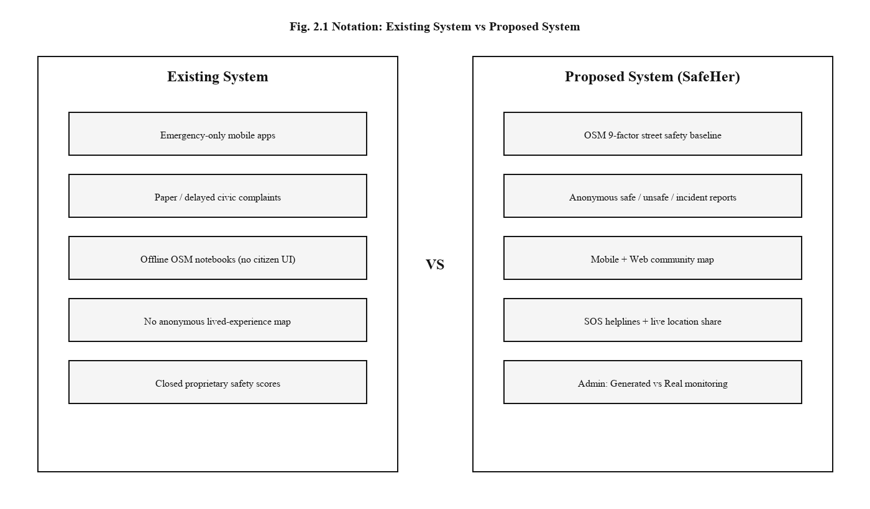
Fig. 2.1: Existing systems versus proposed SafeHer approach
2.5 Advantages of Proposed System
• Transparent nine-factor scoring that can be explained to faculty and civic partners.
• Dual client (mobile + web) lowers the barrier for users who cannot install an APK.
• Anonymous inserts with approved-only public reads balance contribution and moderation policy.
• Admin Generated-versus-Real labelling supports honest evaluation during demos.
• SOS and map features give immediate user value while the long-term dataset grows.
2.6 Feasibility Study
2.6.1 Technical Feasibility
The stack relies on mature open tools: Python with Overpass and pandas for dataset generation; Expo and React Native for Android builds; Next.js for the web portal; and Supabase (PostgreSQL + Row Level Security) for storage. All components run on standard student hardware and free-tier cloud resources, confirming technical feasibility for a PBL prototype.
2.6.2 Operational Feasibility
Citizens need only location permission and a few taps to contribute. Administrators use a password session to view dashboards. No hospital or police system integration is required for Phase 1, keeping operations within the student team’s control.
2.6.3 Economic Feasibility
OSM data, Expo tooling, Next.js, and Supabase free tiers avoid licensed datasets and paid map SDKs for the prototype stage. Development cost is therefore limited to time and commodity devices, which is economically feasible for academic work.
2.7 Tools and Technologies Used
• Programming: Python 3.x, TypeScript / JavaScript
• Mobile: Expo (~54), Expo Router, React Native, AsyncStorage
• Web: Next.js 16 (App Router), React 19, Tailwind CSS, Leaflet / react-leaflet, Recharts
• Backend: Supabase (PostgreSQL, RLS, RPC), anonymous client key
• Data: Overpass API, pandas, Excel/JSON street exports
• Maps: OpenStreetMap tiles in WebView (mobile) and Leaflet (web)
2.8 Hardware and Software Requirements
Table 2.1: Hardware and Software Requirements
Category | Requirement
Processor | Intel i5 / AMD Ryzen 5 or higher (development)
RAM | 8 GB minimum (16 GB recommended for dataset builds)
Storage | 5 GB free for Node modules, Android SDK, and dataset files
Operating System | Windows 10/11 (team development); Android 10+ for field tests
Software | Node.js 20+, Python 3.10+, Expo CLI / EAS, Android Studio SDK
Cloud | Supabase project; optional Vercel hosting for web
Libraries | pandas, requests, @supabase/supabase-js, Leaflet, Recharts

CHAPTER 3: SOFTWARE REQUIREMENTS SPECIFICATION
3.1 Users / User Roles
• Citizen / woman traveller — reports feelings or incidents, views the community map, uses SOS.
• Admin / project researcher — authenticates to the admin portal for OSM KPIs and community analytics.
• Developer / student team — maintains dataset scripts, schema, and client applications.
3.1.1 Objectives
1. Build an OSM extraction and scoring pipeline for Bengaluru BBMP bounding boxes.
2. Publish a reusable scored street dataset (Excel and JSON) with Safe / Moderate / Unsafe labels.
3. Implement SafeHer mobile tabs for Home, Report, Map, and SOS.
4. Implement SafeHer web routes for reporting, map, emergency, and community summary.
5. Persist anonymous reports in Supabase with area labels and basic rate limiting.
6. Provide an admin portal separating Generated demo data from Real live reports.
7. Document Phase-1 limits honestly: EDA and hotspot clustering are out of scope for completion claims.
Scope: Phase 1 is a single-team prototype for data collection and platform demonstration. It does not include production citizen authentication, hospital information-system integration, finished unsupervised hotspot products, or city-wide operational deployment.
3.2 Assumptions and Dependencies
3.2.1 Assumptions
• Users grant location permission when reporting or using SOS.
• OSM coverage in Bengaluru is sufficient for a meaningful infrastructure baseline.
• Anonymous reporting with device-level rate limits is acceptable for the prototype ethics posture.
• Admin password in environment configuration is adequate for academic demonstration (not enterprise IAM).
3.2.2 Dependencies
• Overpass API availability for dataset regeneration.
• Supabase project reachability and anon key configuration in mobile/web clients.
• OpenStreetMap tile service for map rendering.
• Android device or emulator for Expo field tests; modern browser for web tests.
3.3 Functional Requirements
Table 3.1: Functional Requirements
ID | Requirement
FR1 | The system shall fetch OSM highways and POIs per BBMP bounding box and compute street safety scores.
FR2 | The system shall classify streets into Safe, Moderate, or Unsafe using documented thresholds.
FR3 | The mobile app shall resolve GPS to a BBMP area name for display and storage.
FR4 | The system shall accept anonymous safe / unsafe / incident reports with optional factors.
FR5 | The system shall store reports in Supabase and expose approved reports to community maps.
FR6 | The system shall rate-limit submissions per device to reduce spam (approximately five per hour).
FR7 | The map shall filter pins by All / Safe / Unsafe / Incidents and show area context.
FR8 | The SOS module shall list helplines and support calling plus location sharing.
FR9 | The admin portal shall require a password session before dashboard access.
FR10 | The admin analytics view shall distinguish Generated (synthetic) from Real reports.
FR11 | The web site shall allow reporting and map use without citizen login.
FR12 | The community summary shall aggregate counts useful for Home and Community screens.

3.4 Non-Functional Requirements
Table 3.2: Non-Functional Requirements
ID | Requirement
NFR1 | Usability: report flow completable in under one minute for the minimal path.
NFR2 | Privacy: no citizen account; coordinates used for area naming, not public tracking profiles.
NFR3 | Security: RLS enforces insert rules and approved-only public reads; admin via HttpOnly-style session cookie.
NFR4 | Reliability: clients degrade gracefully when GPS or network is unavailable (refresh / retry messaging).
NFR5 | Maintainability: shared BBMP area definitions between Python pipeline and TypeScript clients.
NFR6 | Performance: map should remain interactive for hundreds of community pins on mid-range phones.
NFR7 | Transparency: scoring weights and methodology visible in admin Methodology pages.
NFR8 | Portability: Android APK via Expo; web via modern Chromium/Firefox/Safari browsers.

CHAPTER 4: SYSTEM DESIGN
4.1 System Architecture
SafeHer follows a layered client–server design with an offline data-science component. Citizens use mobile or web clients. Both talk to Supabase for report writes and community reads. Static OSM-derived JSON under the web public data folder drives admin OSM dashboards. The Python Overpass pipeline regenerates the Excel/JSON baseline when needed.
Major building blocks:
1. OSM Dataset Pipeline — Overpass queries, nine-factor scoring, Excel/JSON export.
2. Supabase Backend — reports table, area_safety view, community_summary RPC, RLS policies.
3. Mobile Application — Expo tabs for Home, Report, Map (WebView Leaflet), SOS.
4. Web User Portal — landing, report form, map, emergency, community dashboard.
5. Web Admin Portal — password middleware, OSM KPIs, analytics, search, areas, methodology.
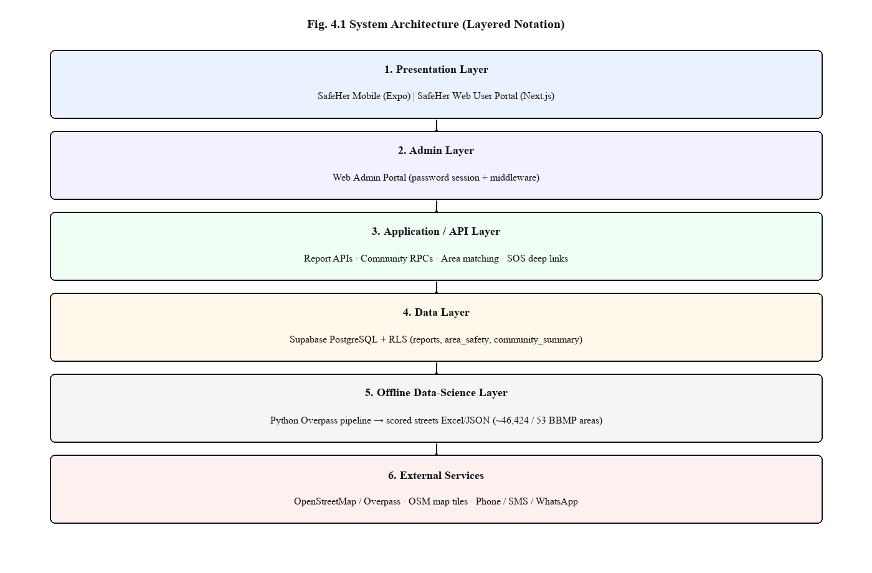
Fig. 4.1: High-level system architecture of SafeHer
4.2 System Perspective
From a product perspective, SafeHer is a civic sensing tool: infrastructure scores supply a baseline where crowdsourced volume is still low, while live reports gradually enrich place-level knowledge. The admin perspective treats Generated demo pins as scaffolding for empty maps and Real pins as the measurement of field adoption. Analytical ML modules are intentionally outside the Phase-1 system boundary so that architecture remains honest about completed scope.
4.3 Context Diagram
External actors are the citizen, the administrator, OpenStreetMap/Overpass, Supabase cloud, and telephony/SMS/WhatsApp channels used during SOS. The SafeHer system sits at the centre, mediating map tiles, report persistence, and emergency deep links without requiring a citizen login.
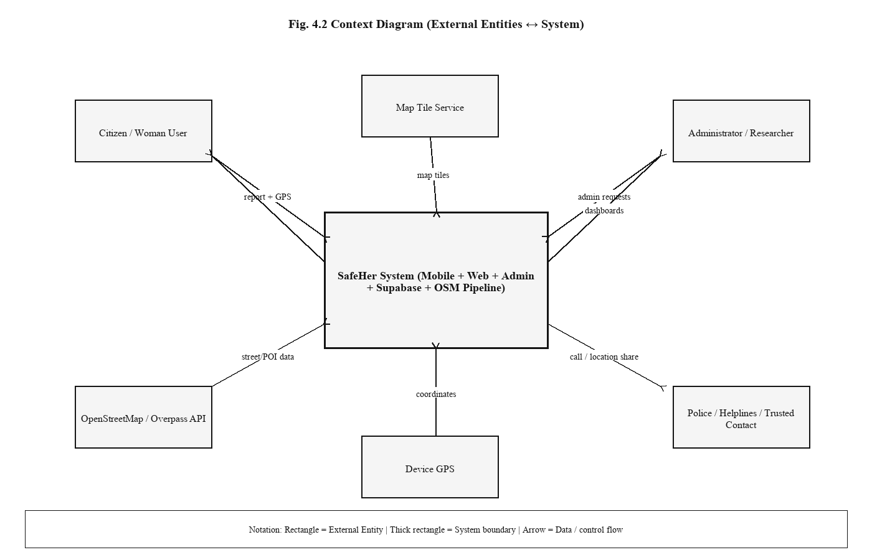
Fig. 4.2: System context diagram

CHAPTER 5: DETAILED DESIGN
5.1 Data Flow Diagram – Level 0
At Level 0, citizens supply location and report choices; SafeHer persists approved community data and returns map/summary views. Administrators supply credentials and receive analytics. The offline pipeline consumes OSM and produces scored streets.
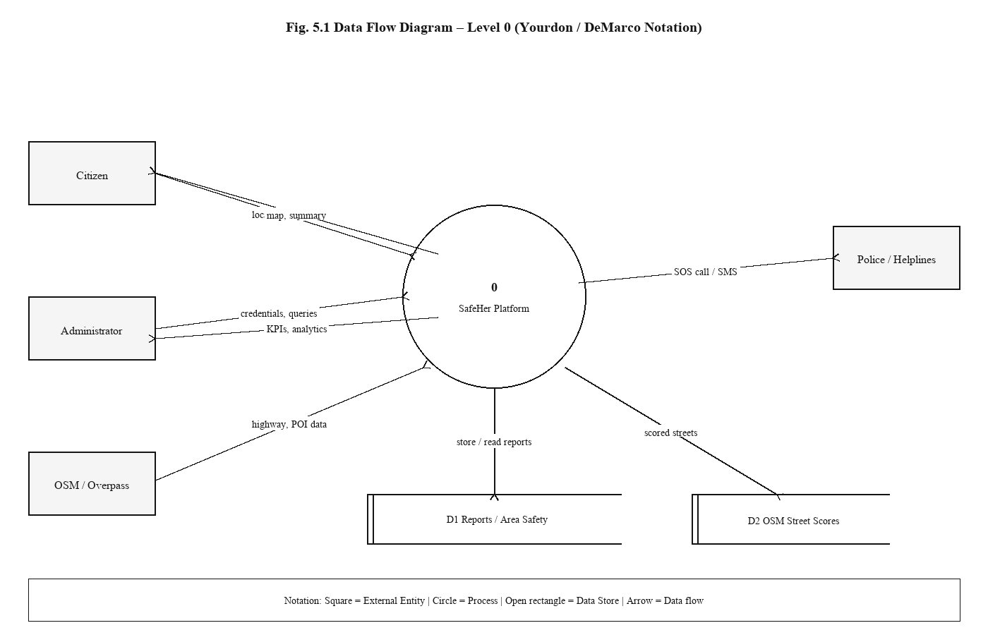
Fig. 5.1: Data flow diagram – Level 0
5.2 Data Flow Diagram – Level 1
Level 1 expands internal processes: area matching, report validation and insert, community aggregation, OSM scoring, and admin session checks. Data stores include the reports table, static street JSON, and local trusted-contact preferences on device.
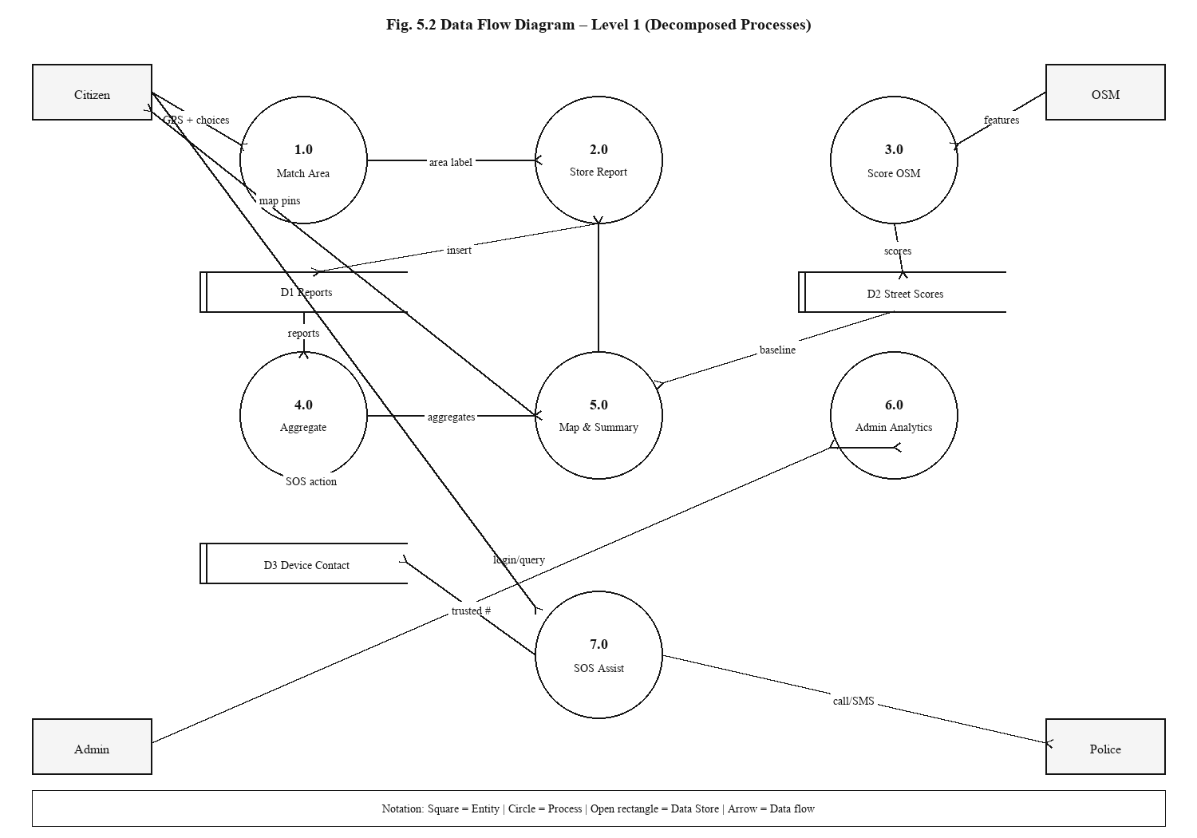
Fig. 5.2: Data flow diagram – Level 1
5.3 Use Case Diagram
Primary use cases for the citizen are Confirm Location, Submit Feeling Report, Submit Incident Report, Browse Safety Map, Call Helpline, and Share Live Location. Administrator use cases include Login, View OSM Dashboard, Inspect Community Analytics, Search Streets/Areas, and Read Methodology.
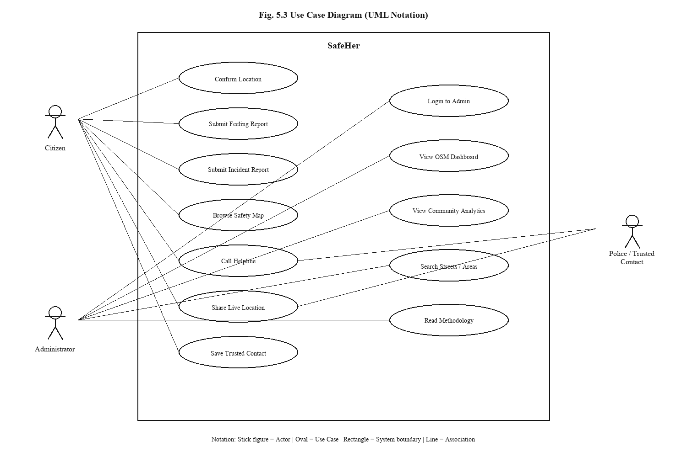
Fig. 5.3: Use case diagram
5.4 Activity Diagram – Emergency SOS
The SOS activity begins when the user opens the Emergency tab, optionally refreshes GPS, chooses Call 112 and share, share-to-police SMS, or a specific helpline card. Live tracking can keep updating coordinates for repeated shares. Trusted contact numbers remain on-device storage only.
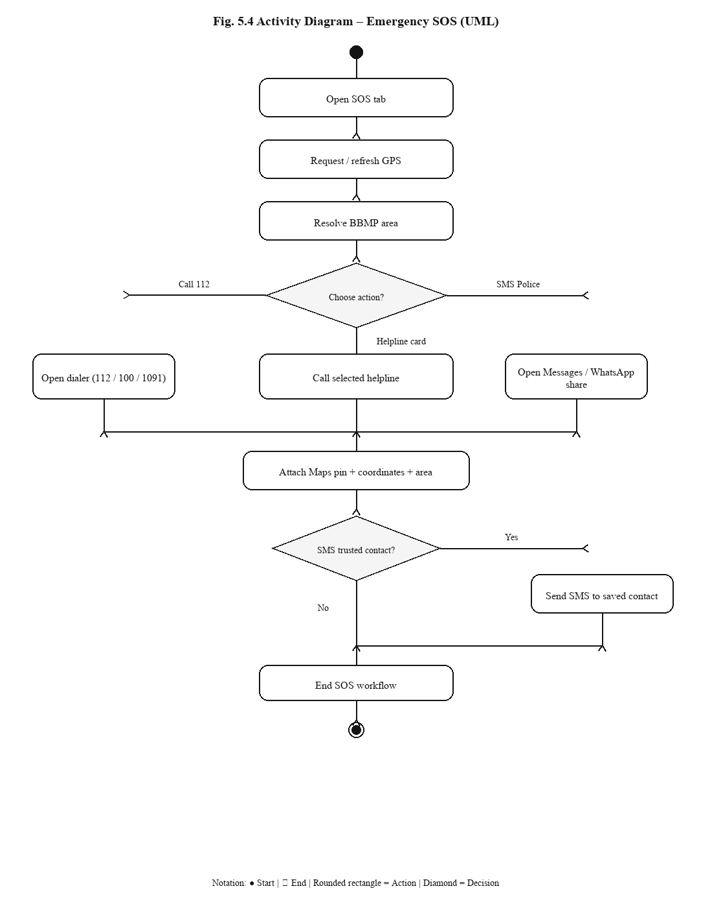
Fig. 5.4: Activity diagram – Emergency SOS flow
5.5 Sequence Diagram – Report Submission
The report sequence involves the mobile/web UI, area matcher, Supabase client, RLS policies, and optional community_summary refresh. After insert, the UI shows a thank-you state and offers navigation to the map or a new report.
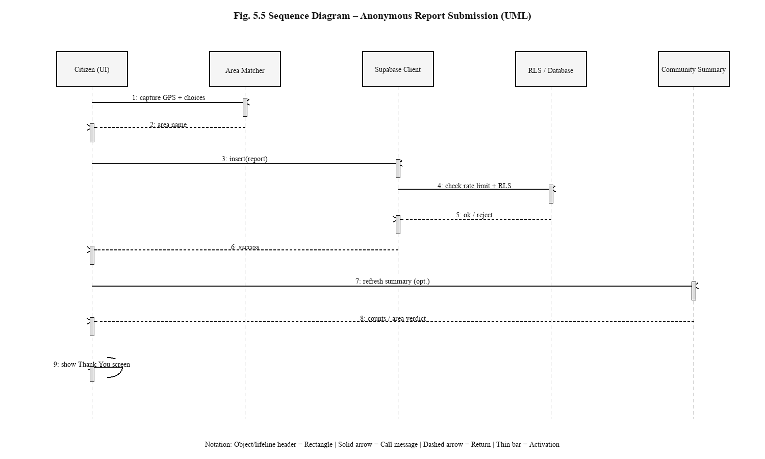
Fig. 5.5: Sequence diagram – anonymous report submission

CHAPTER 6: IMPLEMENTATION
6.1 Implementation Methodology
Implementation followed an iterative full-stack approach organised into four workstreams: (1) OSM dataset pipeline and scoring validation; (2) Supabase schema, RLS, and RPC functions; (3) Expo mobile application; (4) Next.js user and admin portals. Shared BBMP bounding boxes in TypeScript/Python kept area names consistent across offline scoring and online GPS matching.
6.2 Dataset and Feature Description
Bengaluru is partitioned into 53 BBMP area boxes. For each box, the Python script queries Overpass for highway geometries and POIs (police, hospitals, bus stops, CCTV nodes, lamps, and related amenities). Distances and presence flags feed a weighted score. Thresholds map scores to Safe (≥ 7), Moderate (≥ 4), and Unsafe (< 4).
Table 6.1: OSM safety scoring factor weights
Factor | Weight
Police proximity | 0.20
Hospital proximity | 0.15
Bus stop proximity | 0.15
Lighting indicators | 0.15
CCTV presence | 0.10
Crowd / activity proxies | 0.10
Commercial activity | 0.05
Night amenity indicators | 0.05
Road class | 0.05

Table 6.2: Bengaluru OSM dataset summary metrics
Metric | Value
Total streets scored | 46,424
BBMP areas covered | 53
Safe streets | 7,855
Moderate streets | 33,431
Unsafe streets | 5,138
Average safety score | 5.78
Dataset generation date | 2026-05-24

6.3 Module-wise Implementation
6.3.1 Mobile Application
The Expo Router tabs are Home (area verdict and CTAs), Report (multi-step wizard), Map (Leaflet HTML inside WebView with filters), and SOS (helplines, trusted contact, call and share helpers). Reports post to Supabase using the anon client; device identifiers support rate limiting without creating user accounts.
6.3.2 Web User Portal
Public routes under the user layout expose landing, report, map, emergency, and community pages. The community dashboard merges synthetic demonstration records with live approved reports and labels the mix so evaluators understand demo scaffolding.
6.3.3 Web Admin Portal
Admin login validates ADMIN_PASSWORD and sets a session cookie consumed by Next.js middleware. Dashboards read static OSM JSON for street KPIs and query Supabase for community analytics, search, and area views. A methodology page documents scoring.
6.3.4 Supabase Backend
The reports table stores latitude, longitude, area name, is_safe, rating, factor booleans, comment, time_of_day, device_id, status, report_kind (feeling or incident), and incident_type. RLS allows anonymous insert and public select of approved rows. RPCs provide community_summary and recent-device report counts.
6.4 Key Code Snippets
Illustrative weighted scoring (Python pipeline):
weights = {
"police": 0.20, "hospital": 0.15, "bus": 0.15,
"lighting": 0.15, "cctv": 0.10, "crowd": 0.10,
"commercial": 0.05, "night": 0.05, "road": 0.05,
}
score = sum(component(row, k) * w for k, w in weights.items())
level = "Safe" if score >= 7 else "Moderate" if score >= 4 else "Unsafe"
Illustrative report insert contract (client):
await supabase.from("reports").insert({
lat, lon, area_name, is_safe, rating,
report_kind, incident_type, device_id, status: "approved",
});
6.5 Screenshots
The following figures are field captures of the SafeHer Android build exercising Home, Report, Map, and Emergency SOS flows.
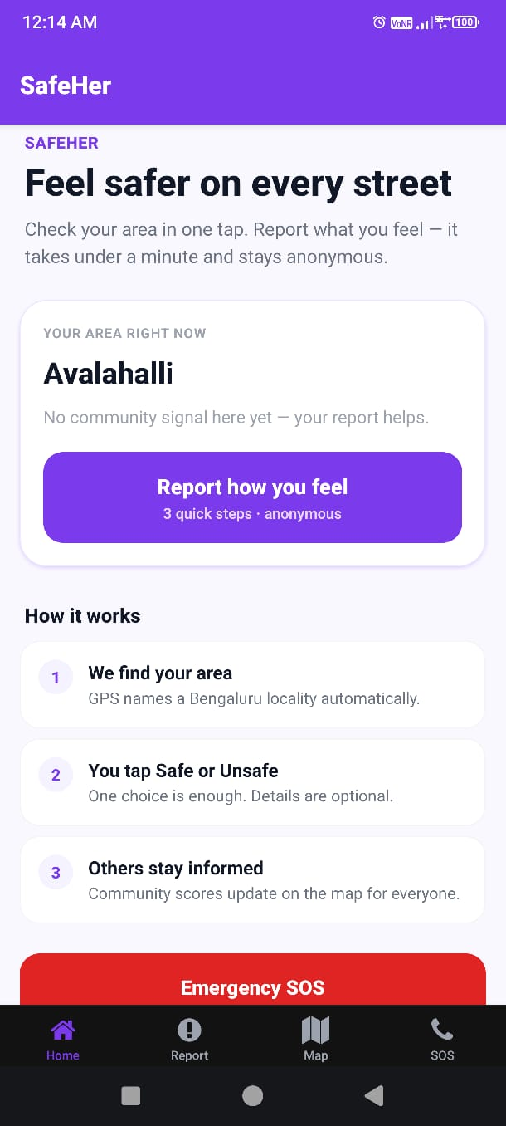
Fig. 6.1: SafeHer Home – area status and call to report
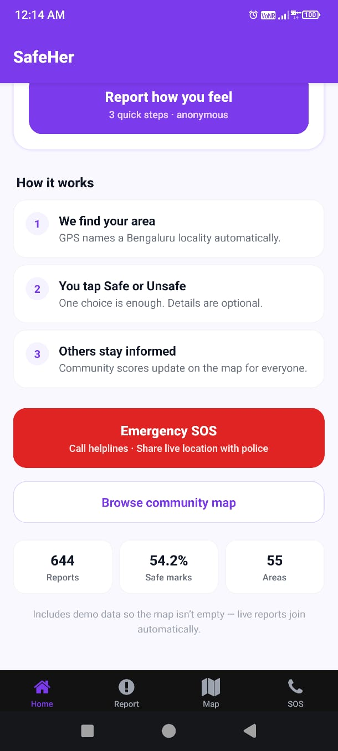
Fig. 6.2: SafeHer Home – how it works and community summary
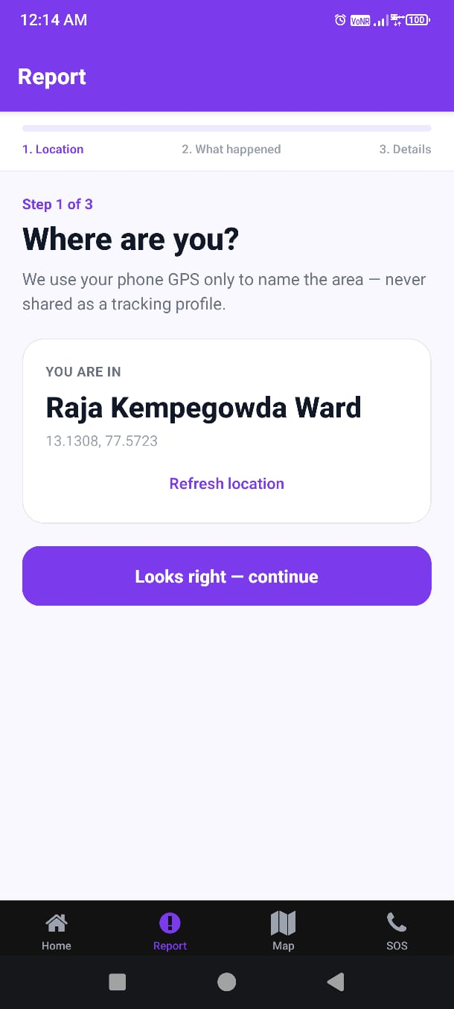
Fig. 6.3: Report wizard – Step 1 location confirmation
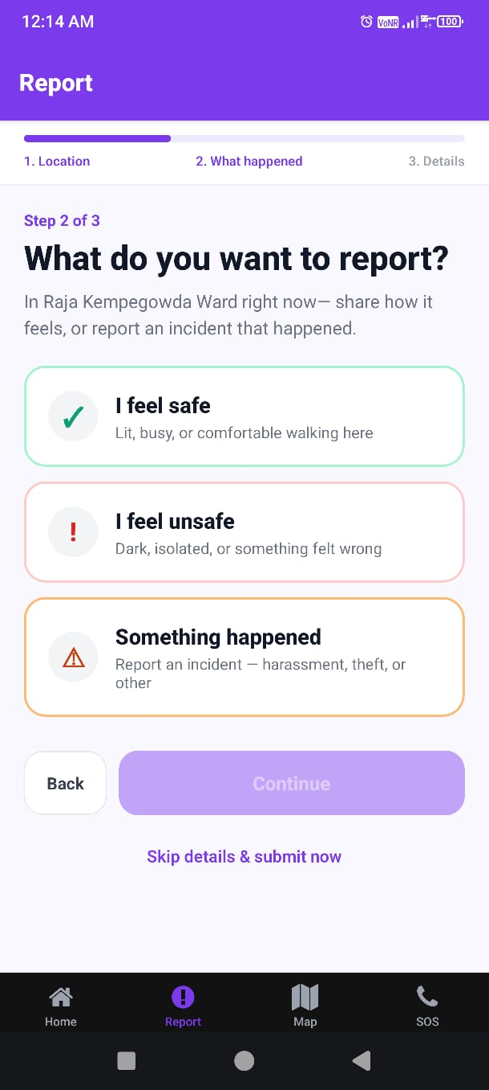
Fig. 6.4: Report wizard – Step 2 feeling or incident choice
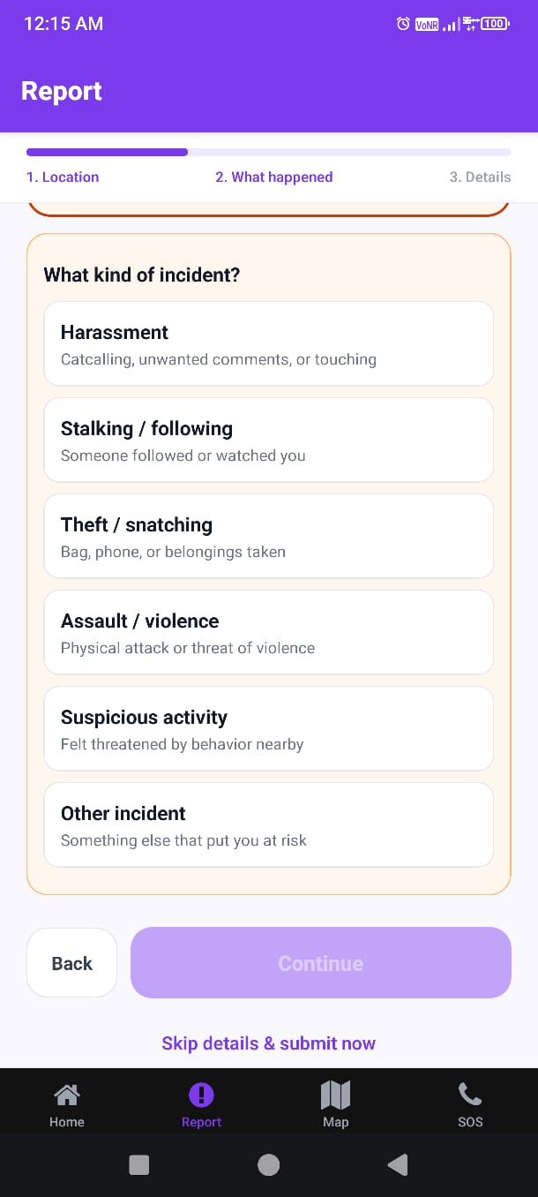
Fig. 6.5: Report wizard – incident type selection
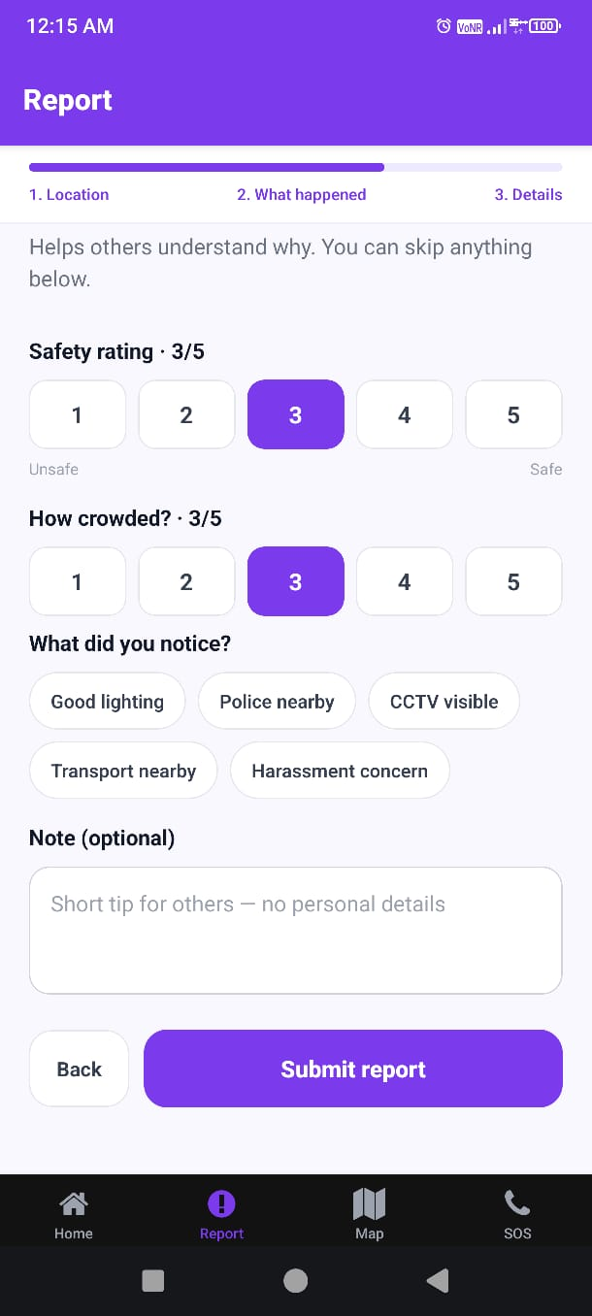
Fig. 6.6: Report wizard – optional details and factors
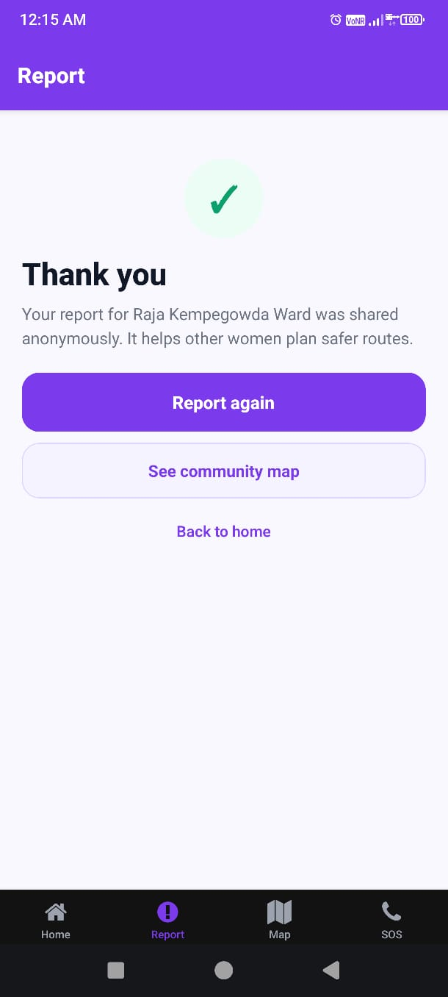
Fig. 6.7: Report submission success screen
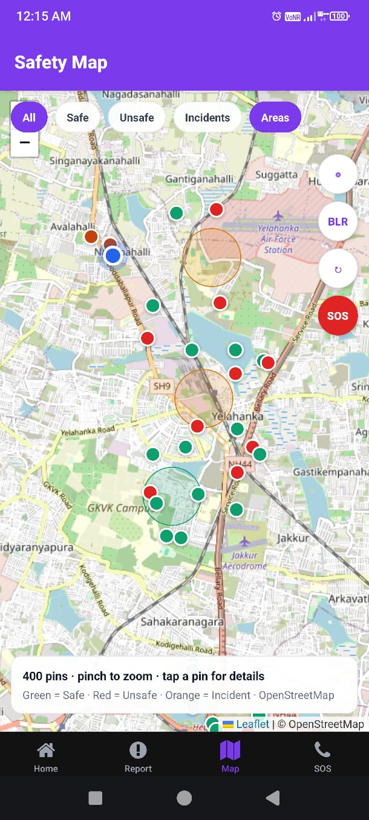
Fig. 6.8: Safety Map with filters and community pins
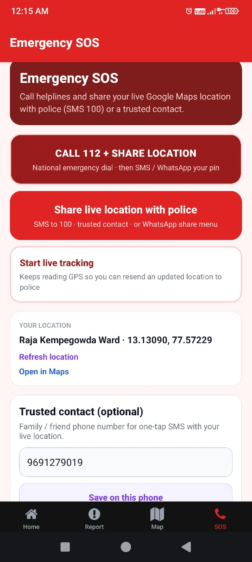
Fig. 6.9: Emergency SOS – call and live location share
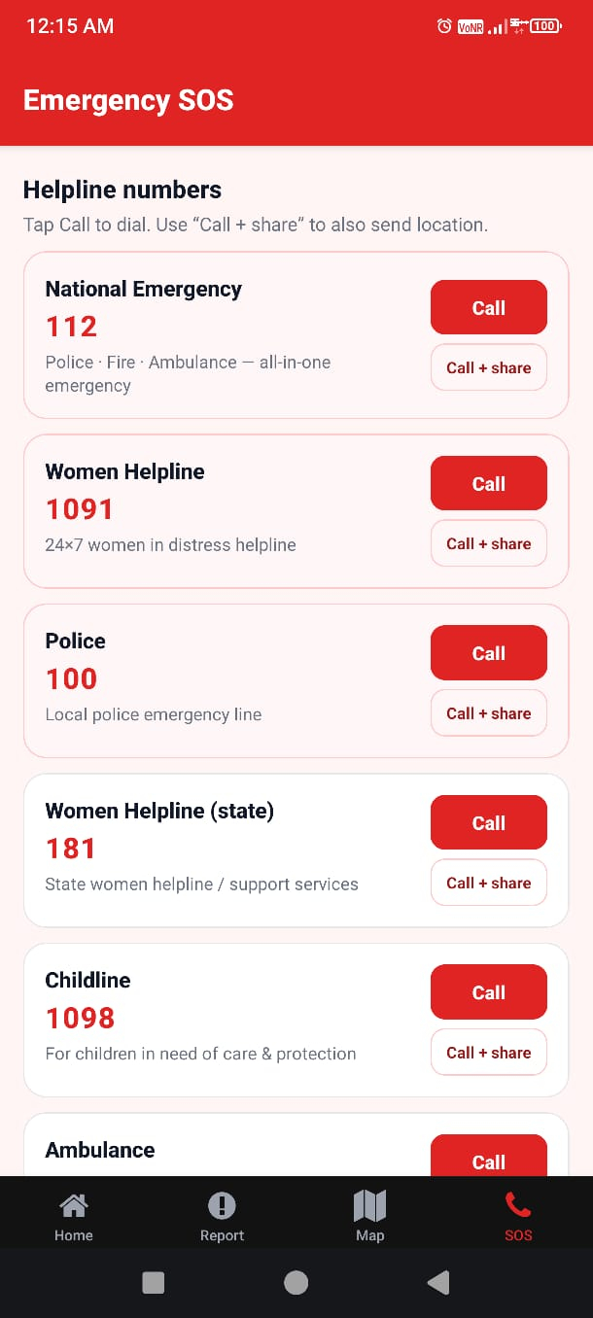
Fig. 6.10: Emergency SOS – helpline directory

CHAPTER 7: SOFTWARE TESTING
7.1 Testing Methodology
Testing combined manual functional checks on Android devices, browser smoke tests for the web portal, SQL verification of RLS behaviour, and scripted validation of scoring consistency between Python and TypeScript helpers. Emphasis was on critical user journeys: report submission, map filters, SOS dial/share, and admin auth gates.
7.2 Unit Testing
Unit-level checks covered BBMP point-in-bbox area matching, safety level thresholds, and scoring weight totals. Dataset conversion scripts were validated by comparing summary counts in Excel against generated JSON summary files used by the admin UI.
7.3 Test Cases and Results
Table 7.1: Test Cases and Results
TC ID | Test Case | Expected Result | Status
TC01 | GPS resolves to a BBMP area name on Home | Named area shown (or clear empty state) | Pass
TC02 | Submit minimal safe report without details | Thank-you screen; row in Supabase | Pass
TC03 | Submit incident with type Harassment | Stored with report_kind=incident | Pass
TC04 | Map filter Unsafe hides safe pins | Only unsafe/incident-relevant pins remain | Pass
TC05 | SOS Call 112 opens dialer | tel: intent launched | Pass
TC06 | Share location composes SMS/Maps link | Share sheet or SMS with coordinates | Pass
TC07 | Admin without cookie blocked from /admin/dashboard | Redirect to login | Pass
TC08 | Admin with valid password reaches dashboard | OSM KPIs visible | Pass
TC09 | Rate limit after repeated inserts | Further inserts rejected by RPC/policy | Pass
TC10 | Public select cannot read pending/rejected rows | Only approved visible on map APIs | Pass

CHAPTER 8: RESULTS AND DISCUSSION
8.1 Deliverables Achieved
Phase 1 produced a complete data-collection stack: a scored OSM street corpus for Bengaluru BBMP areas; working SafeHer mobile and web clients; Supabase persistence with privacy-minded RLS; and an admin portal for monitoring. Field screenshots in Chapter 6 confirm that the report wizard, map filters, and SOS helplines operate on device as designed.
8.2 Dataset Outcomes
Of 46,424 scored streets, most fall in the Moderate band, which is expected for a multi-factor model that rewards proximity to guardianship amenities without claiming crime prediction. The Unsafe minority highlights corridors where infrastructure proxies are weak and where future crowdsourced volume will be especially valuable.
8.3 Platform Behaviour
Anonymous reporting with optional detail fields keeps interaction cost low. Merging synthetic community pins for demonstration prevents empty-map demos while UI copy discloses that live reports join automatically. This honesty is important for viva evaluation and for any civic partner reviewing the prototype.
8.4 Discussion and Limitations
Absolute hotspot claims would be premature: Real report volume is still growing, OSM proxies are imperfect substitutes for lived experience, and unsupervised clustering has not been executed as a finished analytical product. Admin authentication via shared password suits a classroom prototype but must be replaced before any public-sector deployment. Despite these limits, Phase 1 meets its stated goal—establishing a dual data-collection architecture that later EDA and hotspot modules can consume.

CHAPTER 9: CONCLUSION
This PBL project successfully designed and implemented SafeHer as a Phase-1 system for women’s street safety data collection in Bengaluru. By pairing an auditable OSM street safety baseline with anonymous mobile and web reporting, community maps, SOS assistance, and an admin monitoring portal, the team delivered a coherent platform that is usable today and extensible for future analytics.
The work demonstrates that open geographic data and privacy-conscious crowdsourcing can be combined within a student timeline without overstating analytical maturity. Subsequent phases can layer EDA, clustering-based hotspot identification, and richer moderation workflows onto the foundations documented in this report.

CHAPTER 10: FUTURE ENHANCEMENTS
1. Complete exploratory data analysis on Real reports joined with OSM street attributes.
2. Apply unsupervised methods (for example K-Means or DBSCAN) for hotspot candidate detection with careful validation.
3. Build moderated heatmaps and time-of-day views once Real volume is statistically meaningful.
4. Replace shared admin password with role-based authentication and audit logs.
5. Add optional verified volunteer roles for trusted on-ground audits.
6. Improve offline caching of map tiles and queued report submission under poor network.
7. Conduct structured usability studies with women students and refine SOS flows accordingly.
8. Explore partnerships for validating proxies against anonymised official statistics where legally permitted.

BIBLIOGRAPHY / REFERENCES
1. Chainey, S., & Ratcliffe, J. (2005). GIS and Crime Mapping. Wiley.
2. OpenStreetMap Wiki — https://wiki.openstreetmap.org/
3. Overpass API Documentation — https://dev.overpass-api.de/
4. Expo Documentation (SDK 54) — https://docs.expo.dev/
5. Next.js Documentation — https://nextjs.org/docs
6. Supabase Documentation — https://supabase.com/docs
7. Leaflet — https://leafletjs.com/
8. React Native Documentation — https://reactnative.dev/
9. United Nations Sustainable Development Goals — https://sdgs.un.org/goals
10. Safetipin — https://safetipin.com/ (crowdsourced safety audit reference)
11. BBMP / Bengaluru civic geographic references used for ward bounding-box design.
12. Project codebase: SafeHer mobile, web, supabase migrations, and create_bengaluru_dataset.py (2026).

APPENDIX A: SUSTAINABLE DEVELOPMENT GOALS (SDG)
SafeHer aligns primarily with SDG 5 (Gender Equality) by improving access to information that supports women’s mobility and agency in public space, and with SDG 11 (Sustainable Cities and Communities) by contributing open, place-based safety intelligence for urban areas. Secondary links include SDG 16 (Peace, Justice and Strong Institutions) through better situational awareness that can inform community and civic responses, without claiming replacement of formal policing.
• SDG 5: Enable anonymous reporting and SOS pathways that respect privacy.
• SDG 11: Publish reusable street-level datasets and maps for Bengaluru BBMP areas.
• SDG 9: Apply modern open-source ICT (Expo, Next.js, Supabase) to a civic problem.

APPENDIX B: PROJECT SYNOPSIS
B.1 Introduction
Title: Incident Analysis and Hotspot Identification for Security Provision against Women Harassment in Public Spaces. Application name: SafeHer. Students: Aman Yadav (1BY25MC012), Anusha K (1BY25MC017). Guide: Dr. M.Sridevi. Institution: BMS Institute of Technology & Management, Department of MCA. Phase focus: Data collection platform and OSM baseline (Phase 1).
B.2 Objectives
1. Construct an OSM-derived street safety dataset for Bengaluru BBMP areas.
2. Build SafeHer mobile and web clients for anonymous reporting and mapping.
3. Implement SOS helplines and location sharing.
4. Provide admin monitoring of OSM and community signals.
5. Prepare foundations for later hotspot analysis without claiming it as complete.
B.3 Methodology (brief)
Overpass extraction → weighted scoring → Excel/JSON publish → Supabase schema → Expo and Next.js clients → manual and scripted testing → documentation.
B.4 Results (brief)
46,424 streets scored across 53 areas; working apps demonstrated via screenshots; anonymous reports stored with RLS; admin portal operational for demos.
B.5 Conclusion (brief)
Phase-1 goals of dual-channel data collection were achieved. Analytical hotspot products remain future work.

APPENDIX C: PLAGIARISM REPORT
This appendix is reserved for the official plagiarism / similarity report generated by the institution’s approved tool (for example Ouriginal or Turnitin). After the final PDF export of this document, students shall upload the report file to the college portal, download the similarity certificate, and bind the certificate pages in this appendix position.
Author originality note: Narrative chapters in this document were rewritten for the SafeHer Phase-1 scope. College boilerplate (Vision, Mission, PEOs, POs) is reproduced unchanged from the official PBL frontsheets template as required. Technical facts (street counts, weights, module names) are taken from the project codebase and dataset outputs, not from unrelated sample reports.
[Paste official plagiarism certificate / similarity report pages here before final binding.]

