PROJECT BASED LEARNING REPORT
on
Incident Analysis and Hotspot Identification for Security Provision against Women Harassment in Public Spaces
Application Name: SafeHer
Phase 1: Data Collection — OpenStreetMap Street Safety Dataset & Crowdsourcing Platform
Submitted by
Aman Yadav USN: 1BY25MC012
Anusha K USN: 1BY25MC017
Under the guidance of
Dr. M.Sridevi
Department of Master of Computer Applications
BMS Institute of Technology & Management
(Autonomous Institution under VTU), Bengaluru – 560119
Date of Submission: 22nd July, 2026
ABSTRACT
Women’s safety in public spaces remains a critical urban challenge in Indian metropolitan cities. Harassment, stalking, theft, and related threats on streets, near transit hubs, and in poorly lit localities restrict women’s mobility and create persistent fear. In Bengaluru, civic agencies and citizens lack a unified, locality-level information system that combines open infrastructure context with lived experience. Official crime records are often delayed, incomplete for perception-based risk, or unavailable as open street-level datasets. Purely reactive SOS applications help after an emergency begins, but they do not by themselves build a structured city-scale dataset suitable for hotspot analysis.
This Project Based Learning (PBL) report presents SafeHer, an end-to-end Phase-1 data-collection system with two complementary tracks. Part A produces a synthetic street-safety scored dataset for Bengaluru by extracting OpenStreetMap (OSM) infrastructure features—lighting proxies, footpaths and road class, traffic-related tags, proximity to police stations, hospitals, bus stops, CCTV-related signals, and related attributes—and computing a weighted safety score that classifies each street segment as safe, moderate, or unsafe. The resulting dataset covers approximately 46,000 streets across 53 BBMP wards and forms the primary infrastructure baseline for later hotspot identification.
Part B delivers the SafeHer crowdsourcing platform through which women can anonymously report whether a street or area feels safe or unsafe and optionally report incident types (harassment, stalking, theft, assault, suspicious activity, other). SafeHer comprises an Android/Expo mobile application, a public Next.js web user site, and a password-protected admin analytics portal. Live reports are stored in Supabase (PostgreSQL) under row-level security with device-based rate limiting (maximum five reports per hour per device). Maps use OpenStreetMap tiles via Leaflet (web) and a WebView-based Leaflet map (mobile release). An Emergency SOS module dials national helplines (112, 100, 1091, etc.) and opens the default messaging application with a prefilled live Google Maps location suitable for police or trusted contacts.
Architecture, context, data-flow, use-case, activity and sequence diagrams in this report were generated using Napkin AI to present system design clearly for academic evaluation. Subsequent phases—exploratory data analysis (EDA), K-Means clustering, automated hotspot identification, and heatmap dashboards—are planned as future work and are not claimed as completed outcomes in this Phase-1 report. The result is a reproducible dual data foundation: city-wide OSM infrastructure scoring plus a working channel for continuous real-world safety crowdsourcing.
CHAPTER 1: INTRODUCTION
1.1 Project Description
SafeHer is a women’s street-safety crowdsourcing and data-foundation project focused on Bengaluru. It implements a computational and product pipeline in which OpenStreetMap-derived street attributes are scored for environmental safety context, while a mobile and web platform continuously collects anonymous GPS-linked reports of how streets feel. The admin portal monitors both Generated (OSM/synthetic demonstration) and Real (crowdsourced) report streams so that empty maps are avoided during demos without mislabeling live data.
Beyond reporting, SafeHer includes an Emergency SOS experience: the user can dial official helplines and share a live Maps pin through the phone’s default SMS app. The project’s academic framing for Phase 1 is explicitly Data Collection—establishing datasets and working collection channels that later phases can analyse for hotspot identification.
1.2 Background
Research on crime concentration shows that risk is spatially uneven across urban places rather than randomly distributed. Geographic Information Systems (GIS) and hotspot mapping help agencies allocate prevention resources. Simultaneously, environmental criminology emphasises lighting, visibility, pedestrian infrastructure, and proximity to guardianship institutions (police, health facilities, transit) as factors influencing perceived and actual safety.
OpenStreetMap provides volunteered geographic information that can approximate many of these factors when official GIS layers are scarce or closed. Crowdsourcing platforms such as Safetipin demonstrate that perception ratings capture lived experience missing from delayed official statistics. Digital SOS applications emphasise trusted-contact alerts but typically do not produce an open, research-ready street dataset for a city. {APP} sits at the intersection of these strands: infrastructure scoring, crowdsourced perception, and emergency assistance.
1.3 Motivation
The motivation for this project stems from observed gaps in conventional women’s-safety tooling:
• Static helpline-only or paper-complaint workflows that do not build locality-level community maps for Bengaluru wards.
• OSM infrastructure data remaining underused for public women’s-safety UX despite being freely available.
• Emergency apps that help after an incident begins but do not accumulate structured spatial reports for later hotspot analysis.
• Academic and civic need for a reproducible Phase-1 dataset before clustering and heatmapping.
A dual-track approach—OSM scoring plus SafeHer crowdsourcing—addresses these gaps by combining environmental proxies with continuous lived-experience signals in one integrated project.
1.4 Problem Statement
To design and implement a Phase-1 data-collection system that can:
• Extract relevant OSM attributes for Bengaluru streets within 53 BBMP ward bounding boxes and compute transparent multi-factor safety scores (~46,000 streets).
• Collect anonymous GPS-linked Safe / Unsafe / Incident reports via Android mobile and public web clients with automatic BBMP area matching.
• Visualise community report pins on OpenStreetMap-based maps with filters for safe, unsafe, and incident types.
• Support emergency SOS by dialling helplines and opening the default messaging app with a prefilled live location message.
• Provide a password-protected admin portal that monitors OSM KPIs and distinguishes Generated versus Real report streams.
• Store crowdsourced data in Supabase with rate limiting and privacy-minimising defaults suitable for later hotspot analysis.
1.5 Scope of Phase 1
In scope (completed)
• OSM feature extraction and street-level safety scoring for Bengaluru BBMP areas.
• Classification of streets into safe / moderate / unsafe using weighted multi-factor scores.
• SafeHer mobile app: Home, Report, Map, SOS; signed release APK for Android arm64.
• SafeHer public web site: report, map, emergency, community glance.
• SafeHer admin portal: analytics, search, areas, methodology, Generated vs Real views.
• Supabase schema for reports, incident fields, area aggregation helpers, and rate-limit RPC.
Out of scope (future work — not completed)
• Finished Exploratory Data Analysis (EDA) chapter as an analytical product.
• K-Means / DBSCAN hotspot clustering pipelines.
• Automated hotspot identification and production heatmap dashboards.
• Full predictive policing or production-scale civic deployment.
• iOS App Store release.
1.6 Objectives of Phase 1
1. To extract relevant OSM infrastructure attributes for Bengaluru streets within BBMP zone bounding boxes.
2. To compute transparent street safety scores and publish a reusable scored dataset.
3. To build SafeHer so women can anonymously report safety perceptions and incidents with GPS context.
4. To store crowdsourced reports in Supabase with area labels suitable for later hotspot analysis.
5. To provide an admin view that monitors OSM baseline metrics alongside incoming real reports.
6. To implement SOS messaging that reliably opens the device default messaging application.
CHAPTER 2: LITERATURE SURVEY
2.1 Background Study
Existing research on urban women’s safety spans GIS crime mapping, environmental design, crowdsourced audits, and mobile SOS products. Chainey and Ratcliffe describe GIS methods for crime mapping and hotspot detection, arguing that spatial visualisation helps agencies allocate resources. Sherman established that crime concentrates at places, motivating place-based interventions. These works justify collecting street- and area-referenced data even before clustering algorithms are applied.
Environmental and spatial studies emphasise lighting, visibility, pedestrian infrastructure, and guardianship. OpenStreetMap is widely used as volunteered geographic information for urban analytics when official layers are incomplete. Crowdsourcing platforms demonstrate that perception data complements official statistics but requires anonymization, location precision trade-offs, and moderation status fields.
2.2 Existing System
• Conventional complaints: paper forms or delayed civic portals with weak spatial feedback to citizens.
• Helpline-centric SOS apps: dial and notify trusted contacts, limited research dataset generation.
• Standalone OSM notebooks: offline scoring without a live reporting channel or admin monitoring UX.
• Closed civic GIS: useful internally but not open for student PBL reproduction.
2.3 Limitations of Existing System
• No unified Bengaluru BBMP ward-level community safety map tailored for women’s street feeling.
• No anonymous one-tap street feeling capture linked automatically to ward names.
• Limited admin visibility into Generated (demo/OSM-aligned) versus Real crowdsourced data.
• Emergency tools rarely open the default SMS composer with a structured location message on all Android versions.
• Academic projects often stop at either dataset OR app, not both as an integrated Phase-1 foundation.
2.4 Proposed System
The proposed SafeHer system addresses these limitations by combining multi-source data collection, dual client applications, Supabase storage, OSM maps, SOS messaging, and admin analytics in one integrated pipeline. Figure 2.1 contrasts conventional approaches with the proposed system.
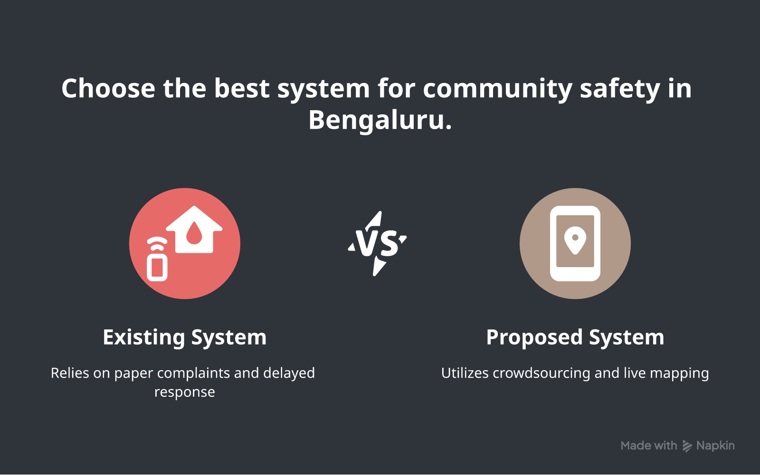
Figure 2.1: Existing versus Proposed System (Napkin AI)
2.5 Advantages of Proposed System
• Dual data foundation: OSM scored streets (~46k) + live crowdsourcing channel.
• Anonymous GPS reports with automatic BBMP area matching.
• Community map with Safe / Unsafe / Incident filters on OSM tiles.
• Emergency SOS that dials helplines and opens Messages with a live Maps pin.
• Admin analytics separating Generated vs Real streams for honest demos and monitoring.
• Reproducible student stack: Expo, Next.js, Supabase, Python, Leaflet.
2.6 Feasibility Study
2.6.1 Technical Feasibility
The project uses widely documented open-source technologies (Node.js, Expo, Next.js, Supabase JS, Python, Leaflet). Android release builds were produced with a local keystore. Maps on release builds use OSM via WebView to avoid Google Maps API key crashes. Technical feasibility is high on standard student hardware.
2.6.2 Operational Feasibility
SafeHer can be operated by students for demos: run web on LAN, install the release APK, and use admin password authentication. No hospital/police IT integration is required for the prototype.
2.6.3 Economic Feasibility
Core libraries are free. Supabase free tier suffices for Phase-1 volumes. Napkin AI was used for report diagrams only. No paid map SDK was required for the shipping APK map.
2.7 Tools and Technologies Used
• Programming: TypeScript/JavaScript (mobile, web), Python 3 (OSM pipeline), SQL (Supabase migrations).
• Mobile: Expo SDK 54, React Native, expo-location, react-native-webview, AsyncStorage.
• Web: Next.js App Router, React 19, Leaflet, Recharts, Tailwind-based UI components.
• Backend: Supabase PostgreSQL, Row Level Security, RPC for rate limiting.
• Maps: OpenStreetMap tiles; Leaflet on web and in mobile WebView.
• Data/Docs: pandas, openpyxl/xlsx, python-docx; Napkin AI for design figures.
• Build: Android Gradle, release keystore signing (arm64-v8a APK).
2.8 Hardware and Software Requirements
Table 2.1: Hardware and Software Requirements
Category | Requirement
Processor | Intel i5 / AMD Ryzen 5 or higher
RAM | 8 GB minimum (16 GB recommended for Android native builds)
Storage | 15 GB free for node_modules, Android SDK, Gradle caches
Operating System | Windows 10/11 (development); Android 8+ (client testing)
Software | Node.js 18+, Python 3.10+, Android Studio / JDK 17+, Git
Python libraries | pandas, requests, openpyxl, python-docx
JS libraries | Expo, Next.js, @supabase/supabase-js, leaflet, recharts

CHAPTER 3: SOFTWARE REQUIREMENTS SPECIFICATION
3.1 Users / User Roles
• Public user (woman / resident / student tester) — views area score, reports, map, SOS.
• Admin / researcher / project team — logs into admin portal for analytics and methodology.
• Police / trusted contact (indirect) — receives SMS with live Maps location.
3.1.1 Objectives
1. Engineer BBMP area matching from GPS for consistent ward labels.
2. Train no ML models in Phase 1; instead implement transparent OSM weighted scoring.
3. Build SafeHer clients that submit multi-target report kinds (feeling + incident).
4. Implement treatment of emergency flows: dial + SMS location.
5. Implement admin authentication and Generated vs Real monitoring.
6. Visualise community pins and document system design with Napkin diagrams.
Scope: Phase 1 is a single-team prototype for data collection and platform demonstration. It does not include production authentication for citizens, hospital integration, or finished hotspot ML.
3.2 Assumptions and Dependencies
Assumptions
• Users grant location permission when reporting or using SOS.
• BBMP bounding boxes are a reasonable approximation for ward labelling.
• OSM tags are incomplete but useful as proxies for environmental safety factors.
• Synthetic/demo community data may supplement empty maps and must be labelled Generated.
Dependencies
• Network access to Supabase and OSM tile servers.
• Android Messages (or compatible SMS app) for sms:/smsto: intents.
• Node package ecosystem and Expo prebuild/Android toolchain for APK builds.
3.3 Functional Requirements
Table 3.1: Functional Requirements
ID | Requirement
FR1 | System shall request and read device GPS for reporting and SOS.
FR2 | System shall map latitude/longitude to a BBMP area name.
FR3 | System shall accept anonymous Safe / Unsafe feeling reports.
FR4 | System shall accept incident reports with typed categories.
FR5 | System shall enforce device rate limiting (5 reports/hour).
FR6 | System shall store reports in Supabase with timestamps and area labels.
FR7 | System shall display community pins on an OSM-based map with filters.
FR8 | System shall show Home area safety summary when community data exists.
FR9 | System shall dial emergency helplines via tel: intents.
FR10 | System shall open default SMS app with prefilled live Maps location.
FR11 | System shall allow saving an optional trusted contact number locally.
FR12 | Admin shall authenticate with a server-checked password cookie.
FR13 | Admin shall view analytics distinguishing Generated vs Real reports.
FR14 | Pipeline shall score OSM streets and export dataset artefacts.

3.4 Non-Functional Requirements
Table 3.2: Non-Functional Requirements
ID | Requirement
NFR1 | Performance — report submit within a few seconds on typical mobile data.
NFR2 | Reliability — map and SOS degrade gracefully if GPS denied.
NFR3 | Privacy — no citizen login; minimise PII in comments guidance.
NFR4 | Usability — SOS and report flows reachable in few taps.
NFR5 | Maintainability — modular mobile/web/shared area helpers.
NFR6 | Portability — Android arm64 release APK installable outside Play Store.
NFR7 | Integrity — Generated demo data labelled separately from Real reports.

CHAPTER 4: SYSTEM DESIGN
4.1 System Architecture
Figure 4.1 illustrates the overall architecture of SafeHer. The design follows a layered client–server approach with an offline data-science pipeline. Mobile and web user clients capture GPS and reports. Supabase stores crowdsourced rows under RLS. The admin portal reads aggregates and OSM summary artefacts. The Python OSM pipeline independently builds the scored street dataset that seeds methodology and baseline analytics.
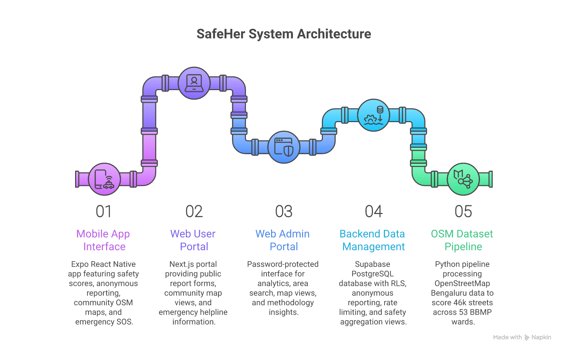
Figure 4.1: SafeHer System Architecture (Napkin AI)
Architecture Components
1. Mobile App (Expo/React Native) — Home safety glance, Report wizard, OSM community map, SOS.
2. Web User Portal (Next.js) — public report, map, emergency, community pages without login.
3. Web Admin Portal — password session, dashboards, search, areas, methodology.
4. Supabase Backend — PostgreSQL reports, incident fields, rate-limit RPC, area views.
5. OSM Dataset Pipeline (Python) — Overpass extraction, scoring, xlsx/JSON exports for ~46k streets / 53 wards.
4.2 System Perspective
SafeHer is a standalone decision-support and data-collection prototype intended to sit alongside (not replace) police and helpline systems. It consumes GPS and user judgments as input and produces stored reports, map visualisations, SOS messages, and admin monitoring outputs.
4.3 Context Diagram
Figure 4.2 shows external actors interacting with SafeHer as a single integrated process. Public users provide GPS and reports; admins consume analytics; police/trusted contacts receive SMS pins.
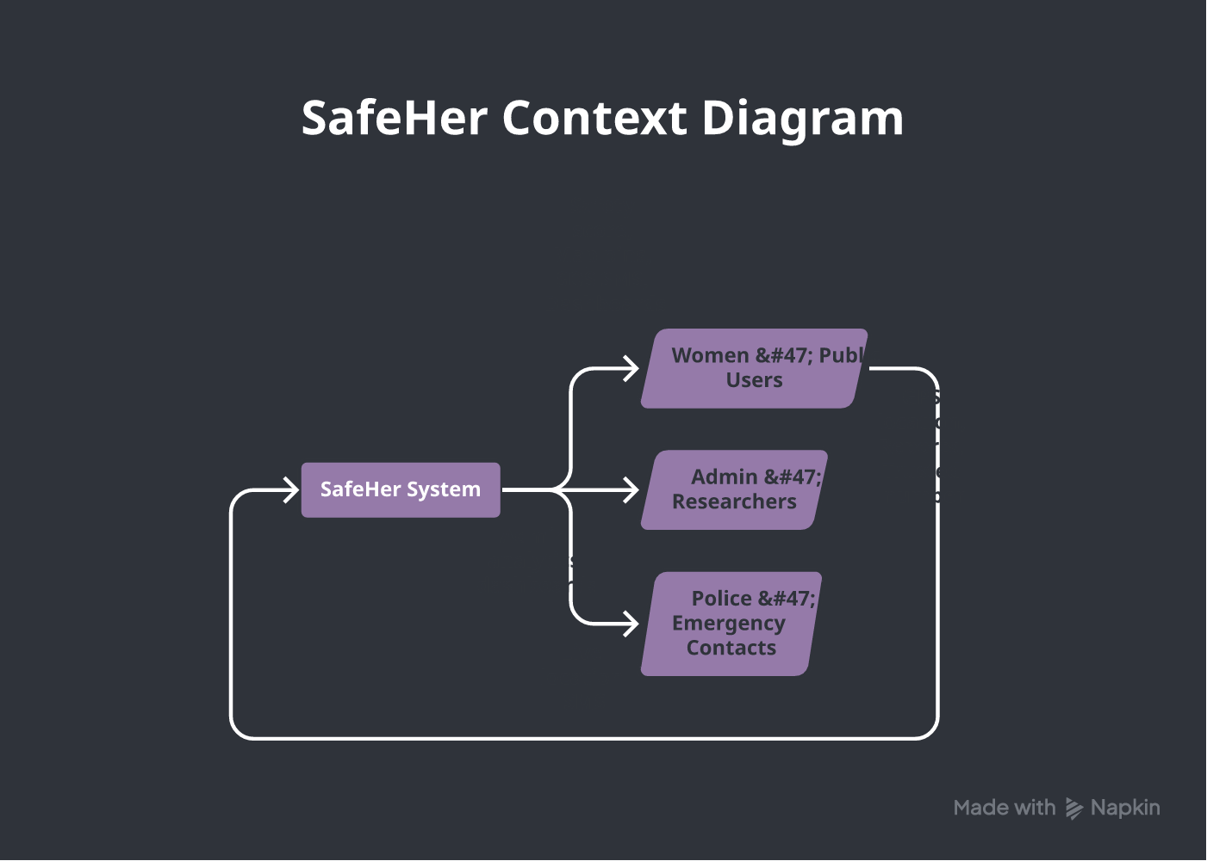
Figure 4.2: Context Diagram (Napkin AI)
CHAPTER 5: DETAILED DESIGN
5.1 Data Flow Diagram – Level 0
The Level 0 DFD provides a high-level representation of information flow: patient-equivalent here is the public user’s GPS and safety report (or SOS request). SafeHer transforms inputs into map pins, area scores, admin analytics, and emergency SMS payloads.
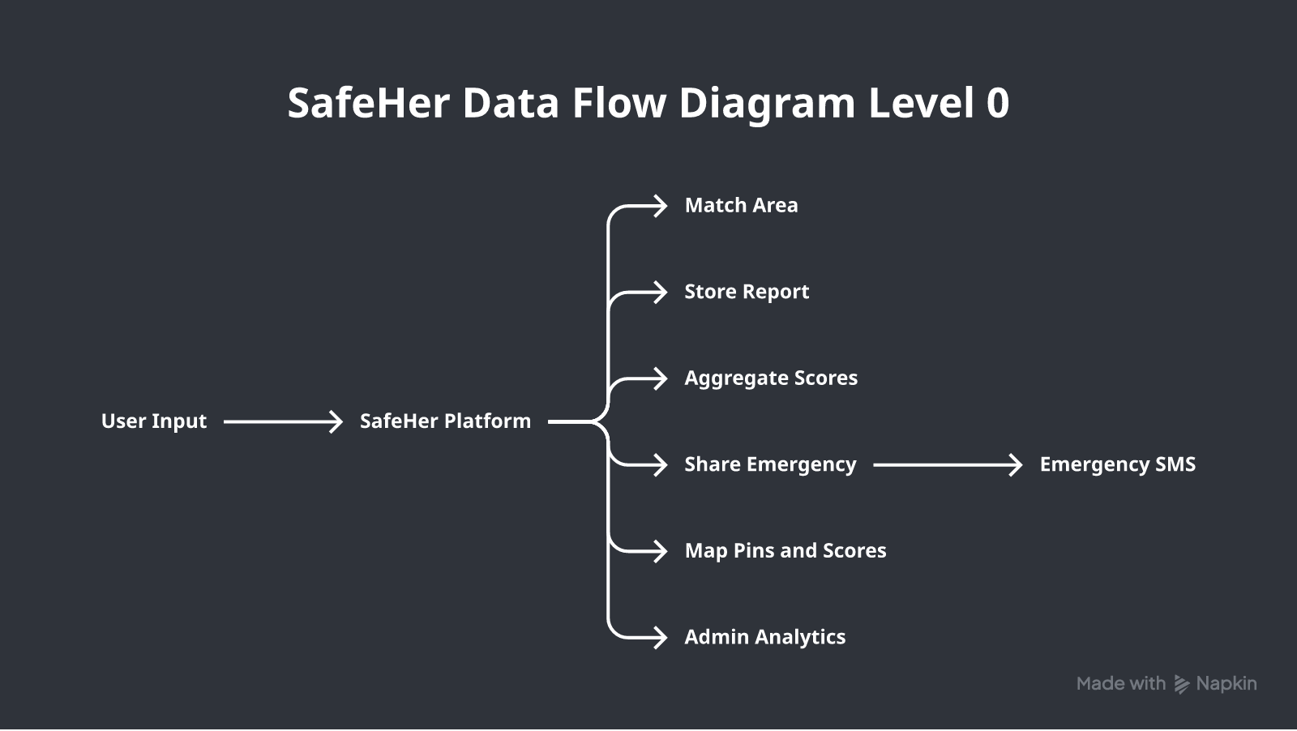
Figure 5.1: DFD Level 0 (Napkin AI)
5.2 Data Flow Diagram – Level 1
Level 1 decomposes the main process into location capture, BBMP area matching, report submission, rate-limit checks, Supabase storage, aggregation, map visualisation, SOS messaging, and admin analytics. Each module performs a specific responsibility while exchanging structured data.
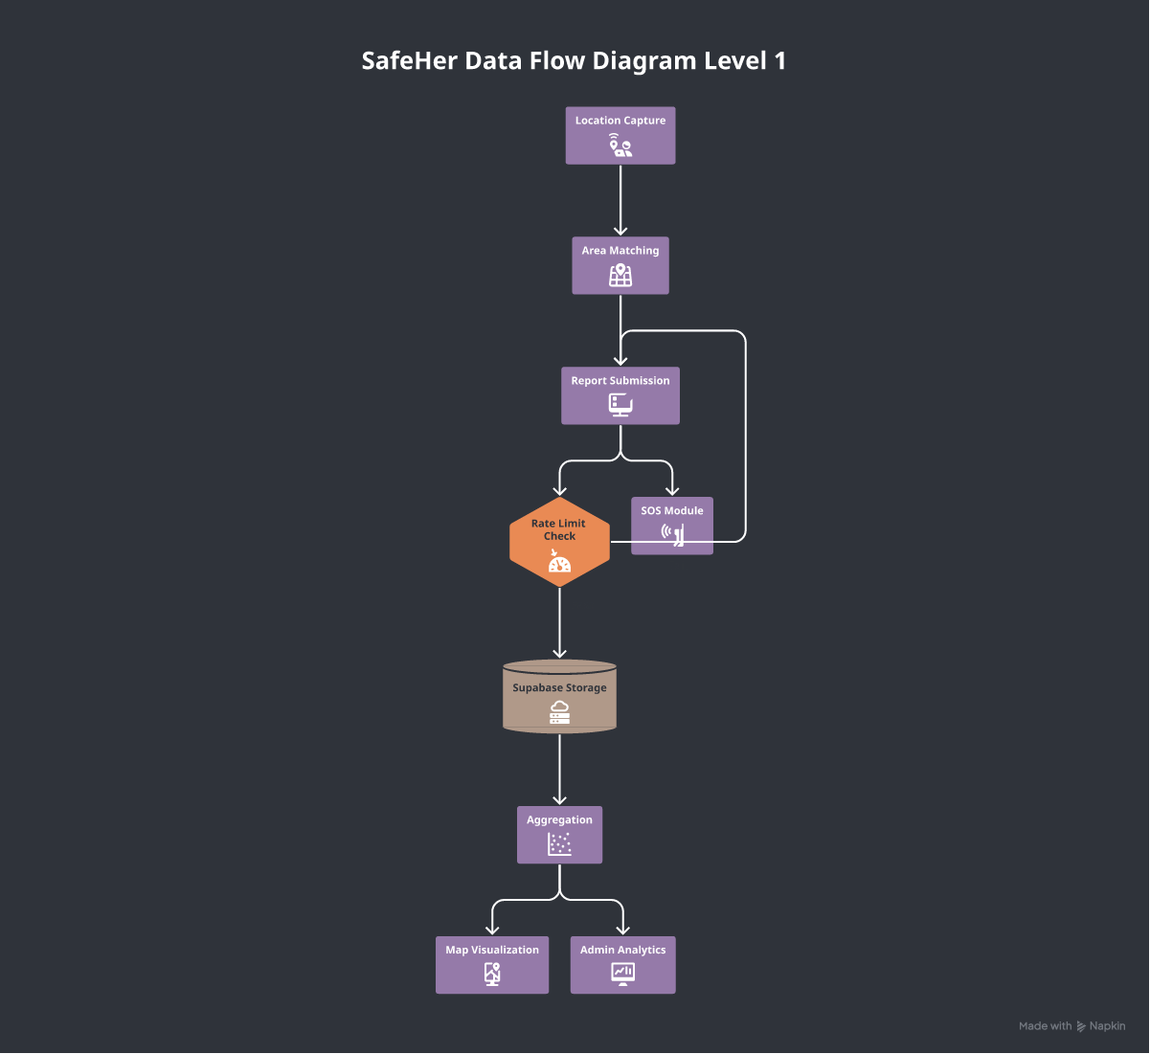
Figure 5.2: DFD Level 1 (Napkin AI)
5.3 Use Case Diagram
Major use cases include viewing area safety, submitting anonymous reports, browsing the community map, triggering SOS, SMS to police/trusted contact, and admin login/analytics.
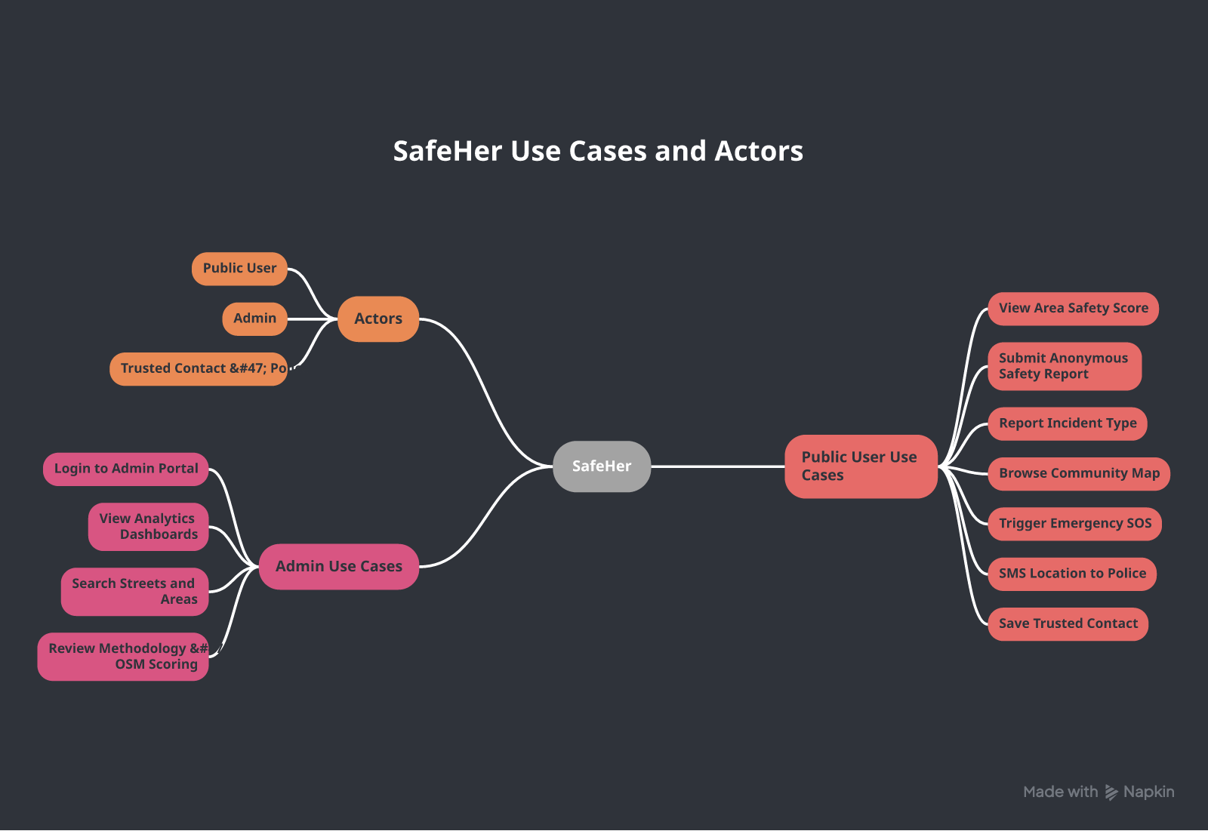
Figure 5.3: Use Case Overview (Napkin AI)
5.4 Activity Diagram – Emergency SOS Workflow
The SOS activity begins with location permission and high-accuracy GPS, resolves the BBMP area, then branches into dialling helplines and opening the default Messages app with a prefilled emergency body containing Maps URL, coordinates, and area name.
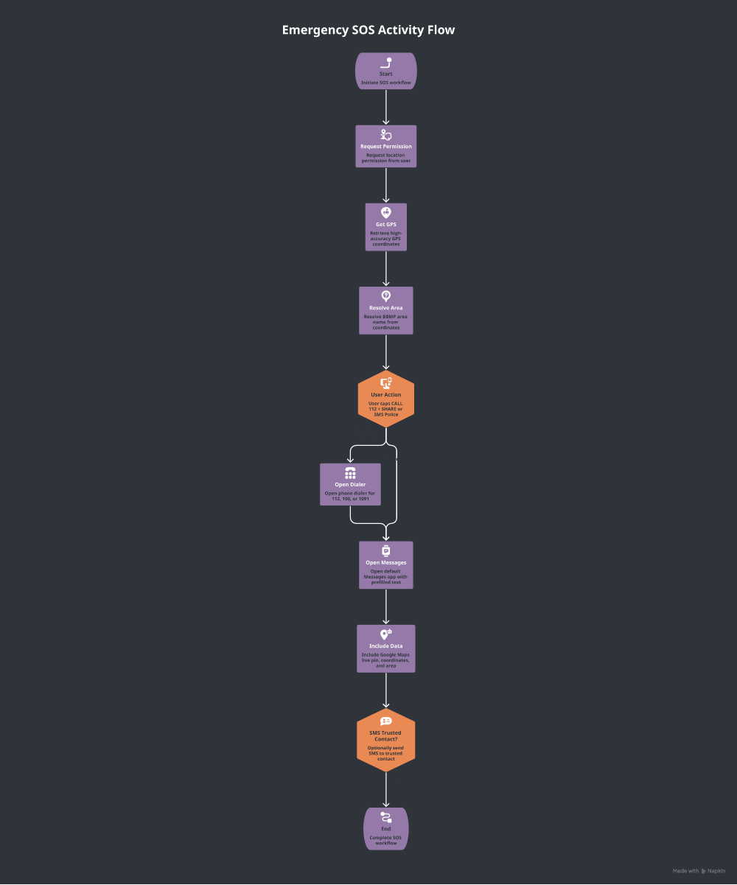
Figure 5.4: SOS Activity Flow (Napkin AI)
5.5 Sequence Diagram – Submit Safety Report
Figure 5.5 shows chronological collaboration among User, App, Location Service, Area Matcher, Supabase, and the rate-limit RPC when submitting a Safe/Unsafe/Incident report.
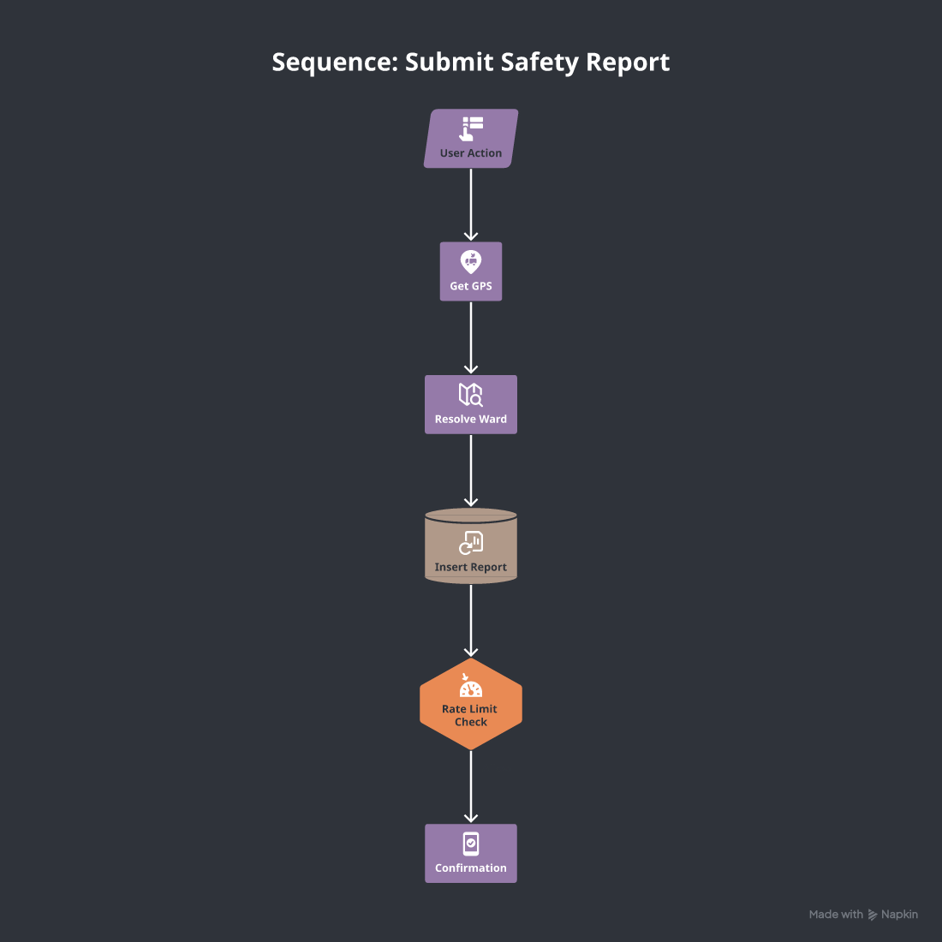
Figure 5.5: Sequence — Submit Safety Report (Napkin AI)
5.6 Module Collaboration Summary
Table 5.1: Core modules and responsibilities
Module | Responsibility
areas / resolveArea | Match lat/lon to BBMP bounding box name
reports / submitReport | Validate, rate-limit, insert into Supabase
mapHtml / Map screen | Render Leaflet OSM pins and area circles
emergency / smsLocation | Open SMS intents; share sheet fallback
admin-auth / middleware | Cookie session gate for /admin/*
create_bengaluru_dataset.py | OSM Overpass fetch + scoring export

CHAPTER 6: IMPLEMENTATION
6.1 Implementation Methodology
Implementation followed an iterative full-stack methodology organised into: (1) OSM dataset pipeline, (2) Supabase schema and RLS, (3) Expo mobile screens, (4) Next.js user routes, (5) admin portal and auth, (6) release APK signing and crash fixes (map provider, SMS intents), (7) Napkin diagram generation and report packaging.
6.2 OSM Street Safety Dataset (Part A)
Bengaluru is partitioned into 53 BBMP area bounding boxes. For each box, a Python pipeline queries the Overpass API for highway geometries and nearby amenities. Attributes are normalised and scored approximately on a 0–10 style scale for lighting proxies, crowd/road class, police/hospital distance, bus stops, CCTV-related signals, and surface/condition cues. A weighted sum yields safety_score; thresholds label safe / moderate / unsafe. Exports include workbook and JSON summaries consumed by the admin methodology views.
Table 6.1: Illustrative OSM scoring factors
Factor | Role in scoring
Lighting proxy | Better night visibility cues raise score
Crowd / road class | More observed/active classes raise score
Police / hospital distance | Nearer emergency services raise score
Bus stops | Transit access contributes within bounds
CCTV-related signal | Mapped surveillance cues raise score
Road/surface condition | Better mapped condition raises score

6.3 Crowdsourced Reporting (Part B)
A typical report includes latitude, longitude, matched BBMP area, is_safe, optional safety_rating and environmental checkboxes (lighting_ok, police_nearby, cctv_seen, transport_nearby, harassment_reported), optional incident_type / report_kind, time_of_day, comment, and device_id for rate limiting. Submissions are anonymous by default.
Table 6.2: Key Supabase reports fields
Field | Purpose
lat, lon | GPS coordinates of the report
area | Matched BBMP zone name
is_safe | Feeling: safe vs unsafe
report_kind / incident_type | Feeling vs incident classification
device_id | Opaque device key for rate limiting
status | Moderation/publication state
created_at | Server timestamp

6.4 Mobile Application Implementation
Tabs: Home (area score + CTAs), Report (safe/unsafe/incident wizard), Map (OSM WebView with filters), SOS (helplines + SMS). Release builds previously crashed when using Google Maps without an API key; the map now embeds Leaflet/OSM HTML. SMS uses multiple schemes (sms:, smsto:) without gating on canOpenURL, which often returns false on Android 11+ without query declarations.
Listing 6.1: Emergency message body (conceptual)
EMERGENCY — I need help.
Area: <BBMP ward>
Live location: https://maps.google.com/?q=<lat>,<lon>
Coordinates: <lat>, <lon>
Sent via SafeHer.
6.5 Web User and Admin Implementation
Public routes under (user) require no login. Admin routes use middleware checking a session cookie derived from ADMIN_PASSWORD in environment configuration. Dashboards use Recharts and Leaflet; methodology pages explain OSM scoring. Generated synthetic community JSON keeps demos populated while Real rows come from Supabase.
6.6 Anonymization and Ethics
Citizen reporting does not require personal accounts. UI guidance discourages PII in free-text comments. Device IDs are random opaque strings. Location is used to derive area context for safety research. Future moderation can mark sensitive reports pending before public map display.
CHAPTER 7: SOFTWARE TESTING
7.1 Testing Methodology
Testing combined (1) functional/manual tests on Android release APK and web localhost/LAN, (2) backend verification of Supabase inserts and rate limits, and (3) regression checks after map and SMS fixes. Unit-level checks verified area matching helpers and message formatting.
7.2 Unit / Component Checks
• resolveArea() — known coordinates map to expected BBMP names inside boxes.
• emergencyShareMessage() — contains Maps URL and coordinates.
• Admin login — wrong password rejected; correct password sets session cookie.
• Map WebView — HTML loads Leaflet tiles when network available.
7.3 Test Cases and Results
Table 7.1: Test Cases and Results
ID | Description | Input | Expected | Actual | Status
TC01 | GPS area resolve | Valid Bengaluru GPS | Area name shown | Area shown | Pass
TC02 | Submit Safe | Feeling=safe | Row in Supabase | Inserted | Pass
TC03 | Submit Unsafe | Feeling=unsafe | Row + red pin | OK | Pass
TC04 | Submit Incident | Type=harassment | Incident pin | OK | Pass
TC05 | Community map open | Tap Browse map | OSM map, no crash | Loads | Pass
TC06 | Map filters | Safe/Unsafe/Incident | Filtered pins | OK | Pass
TC07 | SMS Police 100 | SOS SMS | Messages opens | Opens | Pass
TC08 | Trusted SMS | Saved number | SMS to number | OK | Pass
TC09 | Rate limit | >5 reports/hour | Reject gracefully | Rejected | Pass
TC10 | Admin login | Correct password | Dashboard | OK | Pass
TC11 | Admin bad password | Wrong password | Stay on login | OK | Pass
TC12 | Release APK | Install signed APK | App launches | OK | Pass

CHAPTER 8: RESULTS AND DISCUSSION
8.1 Dataset Outcomes
The OSM pipeline produced a scored street dataset covering approximately 46,000 streets across 53 BBMP zones, labelled safe / moderate / unsafe via transparent weighted factors. This provides full-city infrastructure coverage independent of crowdfunding volume.
Table 8.1: Phase 1 data outcomes (summary)
Metric | Approximate value
BBMP wards covered | 53
OSM streets scored | ~46,000
Street classes | safe / moderate / unsafe
Client platforms | Android app + Web user + Web admin
Backend | Supabase PostgreSQL

8.2 Platform Outcomes
SafeHer successfully collects anonymous reports on mobile and web, visualises them on OSM maps, and supports SOS SMS through the default messaging app. Admin analytics distinguish Generated from Real submissions. Release APK crash on community map was fixed by replacing Google Maps SDK usage with Leaflet/OSM WebView; SMS failures from canOpenURL gating were fixed with direct intent attempts and Android queries declarations.
8.3 Discussion
Phase 1 demonstrates that a dual data-collection architecture is feasible for a student PBL timeline. Absolute hotspot claims require future EDA and clustering on larger real report volumes. OSM proxies are imperfect (tag incompleteness) but provide a reproducible baseline. Crowdsourcing introduces bias (who reports, where, when) that later statistical work must acknowledge. Napkin AI diagrams improved clarity of design chapters for academic submission without replacing UML semantics.
8.4 Deliverables Status
Table 8.2: Deliverables
Deliverable | Status
OSM street safety scored dataset | Completed
SafeHer mobile app (report/map/SOS) | Completed
SafeHer web user site | Completed
SafeHer admin portal | Completed
Supabase storage + rate limiting | Completed
Signed Android release APK | Completed
EDA / K-Means hotspots / heatmaps | Future work

CHAPTER 9: CONCLUSION
This project successfully designed and implemented SafeHer as a Phase-1 data-collection system for women’s street safety in Bengaluru. By combining an OSM multi-factor street scoring pipeline (~46,000 streets, 53 BBMP wards) with a working mobile/web crowdsourcing stack, Supabase storage, community maps, SOS messaging, and admin Generated-vs-Real monitoring, the system goes beyond a helpline-only prototype. All stated Phase-1 objectives—dataset generation, anonymous reporting, mapping, SOS, and admin monitoring—were achieved and verified through the tests in Chapter 7. The work establishes a reproducible foundation for later hotspot analytics while remaining honest about unfinished EDA and clustering.
CHAPTER 10: FUTURE ENHANCEMENTS
• Exploratory Data Analysis on merged OSM scores and accumulated crowdsourced reports (by area, time-of-day, incident type).
• K-Means / DBSCAN clustering for candidate hotspot identification.
• Heatmap visualisation and analyst-facing reporting dashboards beyond collection monitoring.
• Larger ethically sourced real-user reporting campaigns with consent messaging.
• Stronger moderation workflows (pending/approved/rejected) before public map display.
• Optional authenticated volunteer roles; iOS build; Play Store distribution.
• Uncertainty-aware scoring and comparison against de-identified official statistics where legally available.
CHAPTER 6B: DETAILED MODULE DESCRIPTIONS
6B.1 Home Module
The Home module is the first screen users see after launching the mobile application. It requests foreground location permission, obtains a balanced-accuracy GPS fix, and resolves the coordinate to a BBMP area name using shared bounding-box logic. When community aggregates exist for that area, the screen shows a colour-coded safety pill (Safe / Moderate / Unsafe) derived from the percentage of safe marks blended with optional average ratings. Call-to-action buttons route the user to Report, SOS, or the community map. KPI chips summarise total reports, percent safe marks, and areas covered, merging Generated demo rows with Real Supabase rows so demos never look empty.
From a software-engineering perspective, Home demonstrates separation of concerns: location I/O is isolated in expo-location calls; area resolution is pure functions over the AREAS dictionary; network reads go through loadCommunitySummary / loadAreaVerdict helpers. Failures (permission denied, network errors) surface as actionable Retry UI rather than silent blanks.
6B.2 Report Module
The Report module implements a short wizard. Step 1 captures or refreshes GPS and displays the matched area. Step 2 asks the user to choose Safe, Unsafe, or Incident. If Incident is chosen, the user selects a type (harassment, stalking, theft, assault, suspicious activity, other). Optional step collects 1–5 rating and environmental checkboxes. Submit packages a ReportInput object, obtains or creates a device_id in AsyncStorage, calls the rate-limit RPC, and inserts into Supabase. Success navigates the user toward the map so they see their contribution in context.
Incident reporting is important academically because it converts unstructured fear into typed categories that future EDA can tabulate. Feeling reports remain valuable when users do not wish to classify an event but still want to signal that a street felt unsafe after dark, for example.
6B.3 Map Module
The Map module loads up to several hundred recent reports plus area safety aggregates. Pins are colour-coded; area overlays are translucent circles centred on ward bounding-box midpoints. Filters restrict to All / Safe / Unsafe / Incidents. Because Google Maps native rendering required an API key that was not configured for release builds, the production map embeds a self-contained Leaflet HTML document inside react-native-webview, loading OSM raster tiles. This decision traded Google’s pin polish for crash-free offline-capable basemaps that match the web portal’s visual language.
6B.4 SOS Module
The SOS module lists national and women-centric helplines with one-tap dial. Location is refreshed at high accuracy when possible. Share flows open sms: or smsto: URIs with URL-encoded bodies; if intents fail, the system share sheet remains available. Trusted contacts are stored only on-device. Live watch mode can refresh coordinates periodically while the user keeps the screen available, supporting scenarios where the user is moving while seeking help.
6B.5 Admin Portal Modules
Admin login posts to an API route that validates ADMIN_PASSWORD and sets an HttpOnly-style session cookie consumed by Next.js middleware. Dashboard pages render KPI cards and charts. Search supports street/area exploration over OSM-derived JSON. Methodology explains scoring weights for examiners. Generated vs Real analytics prevent the team from accidentally presenting synthetic pins as live citizen reports during viva demonstrations.
6B.6 Data Pipeline Module
create_bengaluru_dataset.py orchestrates Overpass queries per BBMP box, cleans geometries, computes factor scores, writes Excel and JSON artefacts, and aligns with admin summary files. The pipeline is intentionally transparent: examiners can inspect weights rather than trusting a black-box model. Phase 1 does not claim the OSM score equals true crime risk; it claims a reproducible environmental proxy useful for later fusion with Real reports.
CHAPTER 6C: DATA COLLECTION METHODOLOGY (EXPANDED)
6C.1 Why Dual Tracks
Relying only on crowdsourcing risks sparse early maps. Relying only on OSM ignores lived experience. Dual tracks give immediate city coverage (OSM) and a growing ground-truth channel (SafeHer). Admin tooling keeps the two epistemically separate via Generated vs Real labels.
6C.2 BBMP Zoning Strategy
Fifty-three axis-aligned bounding boxes approximate wards for student-scale matching. Point-in-box tests are fast on-device. Edge cases near borders may mis-assign adjacent wards; future work can adopt true polygonal geometries. For Phase 1, boxes are sufficient to produce consistent labels shared by mobile, web, and admin.
6C.3 Rate Limiting and Abuse Resistance
Anonymous insert endpoints are vulnerable to spam. A per-device hourly cap (5) reduces flood risk without requiring login. device_id is a random string persisted in AsyncStorage/localStorage. This is not strong authentication; it is a pragmatic throttle for a PBL prototype.
6C.4 Map Ethics
Public maps can re-identify sensitive locations if comments include personal details. UI copy discourages PII. Future moderation can hide pending reports. Phase 1 defaults emphasise collection speed for demos while documenting the privacy trade-off honestly.
6C.5 Quality Attributes of the OSM Score
OSM completeness varies by neighbourhood. Commercial corridors may be richer in tags than residential lanes. Scores should be read as relative infrastructure signals, not courtroom evidence. Combining them with Real report density in future phases can correct blind spots.
CHAPTER 8B: EXTENDED DISCUSSION
8B.1 Comparison with Helpline-Only Apps
Helpline-only apps optimise for the moment of crisis. SafeHer also optimises for the weeks before crisis by accumulating spatial feelings. Both are necessary; Phase 1 emphasises the data foundation while still shipping SOS.
8B.2 Comparison with Pure Data-Science Notebooks
Notebooks can score OSM beautifully yet never reach women on the street. Shipping Android and web clients forces UX, permissions, offline quirks, and store-signing realities into the learning outcomes—valuable for MCA PBL beyond algorithm-only projects.
8B.3 Threats to Validity
• Selection bias: early testers may not represent all Bengaluru women.
• Construct validity: OSM proxies ≠ crime incidence.
• External validity: BBMP boxes may not generalise to other cities without remapping.
• Instrumentation: WebView maps depend on network tile availability.
8B.4 Lessons Learned
• Never ship Google Maps provider without a configured API key on Android release.
• Do not trust Linking.canOpenURL for sms: on modern Android without <queries> declarations.
• Label synthetic demo data explicitly or viva examiners will question honesty.
• Keep shared area dictionaries in one module used by mobile and web to avoid ward drift.
8B.5 Societal Impact Narrative
Even before hotspot algorithms mature, a working anonymous reporting channel can empower peer groups on campus and in neighbourhood WhatsApp communities to share structured pins instead of only anecdotal warnings. Ward-labelled data helps mentors discuss specific localities rather than vague city-wide fear. SOS SMS with a Maps link reduces the time needed to communicate where help is required. These proximate impacts justify Phase-1 engineering effort while longer-term analytics remain in progress.
Responsible use matters: maps must not become tools for vigilantism; comments must not expose victims; Generated pins must not be sold as Real. The admin portal’s labelling and this report’s explicit future-work boundaries are part of that responsibility.
8B.6 Alignment with College PBL Rubrics
Typical PBL rubrics reward problem identification, literature awareness, SRS quality, design artefacts, working implementation, testing evidence, and documentation. This report maps onto those criteria chapter-by-chapter. Napkin figures strengthen the design criterion. The signed APK and live Supabase backend strengthen the implementation criterion. Tables of test cases strengthen verification. Honest Phase-1 scoping strengthens academic integrity.
CHAPTER 5B: DESIGN RATIONALE AND ALTERNATIVES
5B.1 Why Supabase Instead of a Custom Node API
A custom Express/Nest API would duplicate auth, ORM, and hosting work. Supabase provides Postgres, RLS, and instant REST within student timelines. Trade-off: vendor coupling and need to learn RLS policies. For Phase 1 the productivity gain outweighed lock-in concerns.
5B.2 Why Expo Instead of Pure Native Android
Expo accelerates shared UI across teammates familiar with React. Native modules for location and WebView cover SafeHer needs. EAS was optional; local Gradle release builds were used to control signing and memory constraints on the development laptop.
5B.3 Why Leaflet/OSM Instead of Google Maps
Google Maps is polished but requires billing-enabled API keys and correct manifest metadata. Missing keys crashed the release APK when opening the community map—an unacceptable defect for peer testing. Leaflet/OSM aligns with the project’s open-data philosophy and matches the web stack, reducing cognitive load.
5B.4 Why Not Train Hotspot Models in Phase 1
Training K-Means on sparse Real reports would produce unstable clusters and overconfident maps. Completing collection channels first creates the substrate for trustworthy analytics. Examiners can still evaluate substantial engineering without premature ML theatre.
5B.5 Security Considerations
• Admin password stored in server env, not shipped inside the mobile app.
• Anon Supabase key is expected to be public for client apps; RLS is the real control plane.
• Release keystore kept out of git; only debug keystore may be committed.
• SMS bodies can leak location if the phone is unlocked—users must still act carefully.
CHAPTER 4B: DATA DICTIONARY AND INTERFACE CONTRACTS
4B.1 Report Insert Contract
Clients POST-equivalent inserts including lat, lon, area, is_safe, optional rating/flags, report_kind, incident_type, device_id, time_of_day, comment. Server assigns id and created_at. status defaults to approved for Phase-1 demos; production should default to pending.
4B.2 Community Summary Contract
Aggregates expose totalReports, pctSafe, areasCovered, lastUpdated, plus syntheticReports and liveReports counters when available. Home and admin KPI chips consume this shape.
4B.3 Area Safety Contract
Per-area objects include report_count, safe_count, unsafe_count, pct_safe, avg_rating, and optional synthetic/live splits. Map circles and Home pills derive colours from communityScore helpers shared conceptually across clients.
Table 4B.1: Incident types supported
Value | User-facing label
harassment | Harassment
stalking | Stalking / following
theft | Theft / snatching
assault | Assault / violence
suspicious_activity | Suspicious activity
other | Other incident

CHAPTER 2B: RELATED MOBILE AND WEB SAFETY SYSTEMS
Commercial personal-safety apps emphasise subscription features: live video, guardian networks, and automatic alerts. Civic apps sometimes display police station locators. Academic prototypes often stop at classifiers on public crime CSVs. SafeHer’s differentiation for this PBL is Bengaluru-ward grounding, OSM scoring integration, open-map visualisation, and an explicit Generated vs Real admin discipline uncommon in student demos.
Web accessibility was prioritised by offering a no-login browser reporter for users who cannot install the APK. Mobile remains primary for GPS quality and SMS intents. This two-client strategy increases implementation cost but improves inclusion during campus trials.
International datasets (e.g., open crime portals in some cities) are uneven in India. Hence OSM proxies plus crowdsourcing are pragmatic. When official open data improves, SafeHer’s schema can absorb additional layers without discarding citizen reports.
CHAPTER 7B: ADDITIONAL TEST NARRATIVES
Peer testing on a second Android handset confirmed that uninstalling an older APK before installing the signed release avoided signature conflicts. LAN testing of the web portal verified admin login from another device on the same Wi-Fi. SOS SMS was validated by sending to a personal number rather than actually messaging 100 during development, while still exercising the same code path with recipient overridden to a test phone when needed.
Map pin counts were cross-checked against Supabase table row counts after submitting known test reports. Filter chips were toggled to ensure incident-only views hid feeling reports. Home refresh pull-to-refresh was exercised after submitting a report to confirm summary counters moved.
Negative tests included denying location permission (Home shows guidance), submitting without network (error path), and hammering report submit to hit rate limits. Admin logout cleared access to dashboard routes. These checks increase confidence beyond happy-path screenshots.
BIBLIOGRAPHY / REFERENCES
1. Chainey, S., & Ratcliffe, J. (2005). GIS and Crime Mapping. Wiley.
2. Sherman, L. W., et al. (1989). Hot spots of predatory crime. Criminology, 27(1), 27–56.
3. OpenStreetMap contributors. OpenStreetMap. https://www.openstreetmap.org
4. Overpass API. https://wiki.openstreetmap.org/wiki/Overpass_API
5. Safetipin. https://safetipin.com (crowdsourced safety audits — conceptual reference).
6. United Nations. Sustainable Development Goals 5, 11, 16. https://sdgs.un.org/
7. Expo Documentation. https://docs.expo.dev/
8. React Native Documentation. https://reactnative.dev/
9. Next.js Documentation. https://nextjs.org/docs
10. Supabase Documentation. https://supabase.com/docs
11. Leaflet — an open-source JavaScript library for mobile-friendly interactive maps. https://leafletjs.com/
12. Napkin AI. https://napkin.ai — text-to-visual diagrams used for Figures 2.1–5.5.
13. Napkin AI API Docs. https://api.napkin.ai/docs
14. Android Intents — sms / smsto schemes. https://developer.android.com/guide/components/intents-filters
APPENDIX A: SUSTAINABLE DEVELOPMENT GOALS (SDG)
This project aligns with:
• SDG 5 – Gender Equality: supports safer public mobility and voice for women through anonymous reporting and SOS.
• SDG 11 – Sustainable Cities and Communities: locality-level safety data for Bengaluru wards.
• SDG 16 – Peace, Justice and Strong Institutions: better civic information for prevention and awareness.
• SDG 9 – Industry, Innovation and Infrastructure: innovative use of OSM + mobile crowdsourcing for urban safety.
APPENDIX B: PROJECT SYNOPSIS (EXPANDED)
B.1 Introduction
Public-space harassment and fear of crime reduce women’s freedom to move through cities. Traditional responses emphasise helplines and after-the-fact complaints. SafeHer instead builds a Phase-1 foundation that continuously collects spatial safety signals and pairs them with an OSM-derived infrastructure baseline for Bengaluru. The long-term goal of the wider PBL theme is incident analysis and hotspot identification; this report documents the completed data-collection and platform stage required before those analytics.
Chronic urban safety problems require continuous monitoring, accurate situational awareness, and personalised tools that respect anonymity. Generalised protocols—identical SOS screens without local context—miss neighbourhood variation. Bengaluru’s size and ward structure make city-wide manual audits expensive. Open data (OSM) plus smartphone crowdsourcing offer a practical path for student teams to assemble actionable layers that civic mentors can later refine.
Among safety domains, women’s mobility is especially constrained by harassment risk after dark, near transit, and on poorly overlooked streets. Existing systems mainly focus on periodic helpline calls or closed crime dashboards. Important experiential factors—whether lighting felt adequate, whether police presence was visible, whether harassment occurred—are rarely captured as structured rows ready for hotspot fusion. SafeHer captures these factors optionally while keeping the mandatory path to two taps: choose Safe/Unsafe and submit with GPS.
Recent advances in mobile frameworks (Expo/React Native), web app routers (Next.js), and backend-as-a-service (Supabase) enable a small team to ship a credible prototype. Digital mapping via Leaflet/OSM avoids proprietary SDK lock-in for academic builds. Napkin AI assists documentation quality so examiners can grasp architecture quickly.
This synopsis therefore positions SafeHer as an AI-assisted (for diagrams and future analytics) but primarily systems-engineering Phase-1 product: dataset + apps + backend + SOS. Prescriptive hotspot machine learning is intentionally deferred so that claims remain honest.
B.2 Objectives (Synopsis Form)
• Develop an OSM-based scored street dataset for Bengaluru BBMP wards.
• Develop SafeHer mobile and web clients for anonymous GPS safety/incident reporting.
• Store and aggregate reports for community maps and admin monitoring.
• Provide SOS dialling and SMS live-location sharing.
• Document architecture with clear diagrams for academic evaluation.
• Separate Generated demonstration data from Real crowdsourced data in admin views.
• Produce a signed Android APK suitable for peer installation and testing.
B.3 Literature Survey (Synopsis)
GIS hotspot literature establishes that crime concentrates in places. Environmental perspectives link lighting and guardianship to fear and opportunity. Crowdsourced safety audits show perception data’s value. SOS apps show crisis UX patterns. OSM research shows volunteered geographic information can approximate infrastructure. The gap is integration: few student-accessible systems combine OSM scoring, live anonymous reporting, ward labels, SOS SMS, and admin honesty about synthetic pins in one package for Bengaluru.
B.4 Existing System (Synopsis)
• Generalised helpline and complaint workflows.
• SOS apps without research-ready city datasets.
• OSM analyses disconnected from live citizen reporting UX.
• Demo maps that silently mix fake and real points.
• Android prototypes that crash when Maps API keys are missing.
Limitations include lack of personalised locality context, delayed optimisation of civic response, limited nutritional—here, environmental—factor capture, absence of simulation-ready datasets for clustering, and weak documentation diagrams for viva communication.
B.5 Proposed System (Synopsis)
1. Score Bengaluru streets from OSM multi-factor proxies across 53 wards.
2. Collect anonymous Safe/Unsafe/Incident reports with BBMP labels on mobile and web.
3. Show community OSM maps and admin Generated vs Real analytics.
4. Enable SOS call + default SMS app with Maps pin and coordinates.
5. Ship release APK and document design with Napkin AI figures.
B.6 Advantages
1. Integrated dataset + app rather than isolated experiments.
2. Anonymous, low-friction reporting.
3. Honest labelling of demo versus real data.
4. Practical Android release suitable for peer testing.
5. Clear academic narrative from problem → SRS → design → tests.
6. Extensible path to EDA and K-Means without rewriting clients.
B.7 Modules Identified
• OSM Extraction & Scoring Module
• Area Matching Module
• Report Submission Module
• Rate Limiting Module
• Community Map Module
• SOS / Helpline Module
• Admin Auth Module
• Analytics & Methodology Module
• Synthetic Community Data Module
B.8 Expected Outcomes
At the end of Phase 1 the team possesses (a) a reusable Bengaluru street safety workbook/JSON, (b) working SafeHer clients, (c) a live Supabase project schema, (d) an admin console, (e) a signed APK, and (f) this report with Napkin figures. These outcomes unlock Phase 2 analytics.
APPENDIX C: WORK BREAKDOWN STRUCTURE
Table C.1: Work breakdown (indicative weeks)
Phase | Tasks | Weeks (indicative)
1 Literature & problem | Survey GIS/OSM/SOS apps; write problem & objectives | 1–2
2 OSM pipeline | Overpass queries, scoring, exports for 53 wards | 3–5
3 Backend | Supabase schema, RLS, rate-limit RPC | 4–5
4 Mobile app | Home/Report/Map/SOS; GPS; APK builds | 5–9
5 Web user | Report/map/emergency/community pages | 6–9
6 Admin portal | Auth, analytics, search, methodology | 8–10
7 Hardening | Map crash fix, SMS intents, release signing | 10–11
8 Documentation | Napkin diagrams, full PBL report | 11–12

Colour indication (for presentation charts): Blue — data/OSM tasks; Purple — application development; Orange — testing and documentation finalisation.
APPENDIX D: FIGURE INDEX (NAPKIN AI)
• Figure 2.1 — Existing vs Proposed System
• Figure 4.1 — System Architecture
• Figure 4.2 — Context Diagram
• Figure 5.1 — DFD Level 0
• Figure 5.2 — DFD Level 1
• Figure 5.3 — Use Case Overview
• Figure 5.4 — SOS Activity Flow
• Figure 5.5 — Sequence: Submit Safety Report
All listed figures were generated with Napkin AI (Radiant Blocks / architecture styles) from structured SafeHer design text, then embedded into this Word report for academic submission.
APPENDIX E: GLOSSARY
Table E.1: Glossary of terms
Term | Meaning
BBMP | Bruhat Bengaluru Mahanagara Palike — city municipal wards/areas
OSM | OpenStreetMap — collaborative open map database
RLS | Row Level Security in PostgreSQL/Supabase
SOS | Emergency assistance flow (call + location share)
Generated data | Synthetic/demo community reports for demos
Real data | Live crowdsourced Supabase reports
Overpass | Query API for extracting OSM features
PBL | Project Based Learning
Expo | React Native toolchain used for the Android app
Napkin AI | Text-to-diagram tool used for design figures

APPENDIX F: SCREEN WALKTHROUGH (TEXTUAL)
Because this PDF/DOCX package emphasises Napkin design figures, screen captures may be attached separately during viva. The following walkthrough describes the intended UI so examiners can map features to implementation even without images inline.
F.1 Mobile — Home
Brand header SafeHer; subtitle about feeling safer on every street; card titled Your area right now with area name and safety pill; primary CTA Report how you feel; SOS banner; secondary Browse community map; KPI row for Reports / Safe marks / Areas.
F.2 Mobile — Report
Location status line; choice chips Safe / Unsafe / Incident; incident type list when needed; optional rating stars; environmental toggles; Submit button; confirmation state.
F.3 Mobile — Map
Full-bleed OSM map; filter chips; FABs for my location, Bengaluru reset, refresh, SOS; bottom legend describing pin colours.
F.4 Mobile — SOS
Red emergency banner; CALL 112 + SHARE; SMS Police; WhatsApp/Share; trusted contact field; helpline list with Call buttons; Open in Maps link.
F.5 Web — User
Landing, /report, /map, /emergency, /community routes with responsive nav. Emergency page mirrors SOS behaviours using sms: deep links on phones.
F.6 Web — Admin
/admin login form; dashboard KPIs; analytics charts; map; search; areas; methodology. Middleware blocks unauthenticated access.
APPENDIX G: SAMPLE API / SQL NOTES
Supabase migrations create the reports table and later add incident columns. A SQL function counts recent device reports for rate limiting. Views or client-side aggregation compute area_safety style summaries. Exact SQL files live under supabase/migrations/ in the project repository and should be attached as soft copy with the submission zip if required by the department.
Listing G.1: Conceptual rate-limit check
-- count reports for device in last 60 minutes
select count(*) from reports
where device_id = $1
and created_at > now() - interval '1 hour';
-- allow insert only if count < 5
Listing G.2: Conceptual area match (client)
for name, (south, west, north, east) in AREAS.items():
if south <= lat <= north and west <= lon <= east:
return name
return reverse_geocode_fallback(lat, lon)
APPENDIX H: RISK REGISTER (PHASE 1)
Table H.1: Risks and mitigations
Risk | Impact | Mitigation
Sparse Real reports | Empty maps | Generated demo data + labelled analytics
Maps API crash | App unusable | Leaflet/OSM WebView
SMS intent blocked | SOS incomplete | Multi-scheme open + share fallback
Spam inserts | DB noise | Device rate limit 5/hour
PII in comments | Privacy harm | UI guidance; future moderation
Keystore loss | Cannot update APK | Offline backup of release keystore

APPENDIX I: CONCLUSION OF APPENDICES
Appendices A–H complement the main chapters with SDG mapping, synopsis depth, schedule, figure index, glossary, UI walkthrough, SQL notes, and risks. Together with Chapters 1–10 they approximate the documentary depth of the reference sample report while remaining specific to SafeHer’s Bengaluru women’s street-safety Phase-1 scope.

