***Amazon Clone Website (EBAYZ)***

***Project Report***

***SUBMITTED IN PARTIAL FULFILLMENT REQUIREMENT FOR THE AWARD OF DEGREE OF BACHELOR OF TECHNOLOGY SUBMITTED BY:***

**Group 7**

***Anusha Singh***

***(220641)***

***Anant Upadhyay (220639)***

***Shivanshi Goel (220457)***

***Ayush Gurjar (220466)***

***UNDER THE SUPERVISION OF Dr. P.Prashant***

***SCHOOL OF ENGINEERING AND TECHNOLOGY***

***BML MUNJAL UNIVERSITY Gurugram, Haryana - 122413***



December 2023

# ***Declaration***

We, Anusha Singh, Anant Upadhyay, Shivanshi Goel and Ayush Gurjar, hereby declare that the project "Amazon Clone Website – EBAYZ " completed as part of the Bachelor of Technology (B. Tech) programme at the School of Engineering and Technology, BML Munjal University is an authentic record of our work carried out under the supervision of Dr. P.Prashant. We would like to convey our heartfelt appreciation to Mr. P.Prashant, our instructor, for his invaluable guidance, criticism, and assistance during this endeavor. Your knowledge and experience were invaluable in formulating and completing this report. We would also want to thank our Director, Ms. Swati Munjal, for giving us the opportunity to work on this project and see it through to completion. Through our investigation for this project, we were able to learn new things. We would like to thank everyone who supported and contributed to the creation of this technical report. Everyone's help and contributions are much appreciated. This report would not have been feasible without your support.

All additional items utilised have been properly acknowledged in the project text.

This project was completed in accordance with the curriculum's requirements and limits.

**Abstract**

# EBAYZ, an Amazon-inspired e-commerce clone, blends cutting-edge technologies for a seamless shopping experience. Python ensures efficient backend connectivity, PostgreSQL manages a secure database, and HTML/CSS crafts an intuitive frontend. The addition of an automatic slided navigation bar, powered by JavaScript, enhances user navigation. Features include detailed product listings, a user-friendly shopping cart, dynamic search, and secure login. EBAYZ represents a fusion of technology and user-centric design, poised to redefine the e-commerce landscape.

# EBAYZ represents a testament to the continual evolution of e-commerce, providing a user-centric and technologically advanced platform for online shopping. As the platform evolves, user feedback and ongoing enhancements promise to position EBAYZ as a leading player in the competitive e-commerce landscape.

# ***Introduction***

• In the dynamic landscape of online retail, EBAYZ emerges as a trailblazing e-commerce platform, drawing inspiration from the renowned Amazon model. This innovative platform seamlessly integrates advanced technologies to deliver a user-centric shopping experience. With a powerful technological stack featuring Python for backend connectivity, PostgreSQL for secure database management, and HTML/CSS for an intuitive frontend, EBAYZ sets the stage for a new era in online shopping.

The addition of an automatic slided navigation bar, driven by JavaScript, underscores EBAYZ's commitment to enhancing user navigation and interaction. This amalgamation of cutting-edge technologies forms the foundation for a feature-rich platform designed to cater to the diverse needs of today's online shoppers.

## 1. Background

In the ever-evolving landscape of e-commerce, the genesis of EBAYZ is rooted in a vision to create a platform that transcends the ordinary, offering users an unparalleled online shopping experience. Drawing inspiration from the behemoth that is Amazon, EBAYZ is not merely a clone but a pioneering venture, meticulously designed to harmonize cutting-edge technologies, user-centric design principles, and a commitment to innovation.

The decision to incorporate an automatic slided navigation bar using JavaScript signifies an understanding of the importance of responsive design in an era where users traverse the digital realm through an array of devices. EBAYZ is not just a platform; it's an experience, with features like personalized recommendations, dynamic searches, and a user-friendly shopping cart meticulously curated to elevate the online shopping journey.

**Data Source Links:** The website used as the blueprint for the project.

**Link:** [Ebayz.com - Spend Less & Smile More](http://127.0.0.1:5000/home?email=daff)

### 2. Scope

* The scope of EBAYZ extends far beyond being a mere e-commerce platform; it aspires to become a transformative force in the digital marketplace. Fueled by a robust technological foundation and user-centric design, EBAYZ is poised to carve out a distinctive niche, offering an enriched online shopping experience and setting new standards in the industry.

## *Methodology*

The Waterfall model is universally accepted, and, in this case, we followed the different stages of religious software development. It is a continuous model in which we develop software by following step-by-step instructions for analysis of requirements, design, implementation, testing, integration, and maintenance.

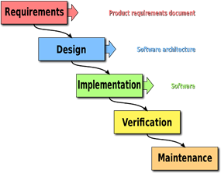

## 

## 

***SYSTEM DESIGN***

# ***Backend Connectivity (Python):***

# Python is employed for seamless server-side operations, ensuring efficient handling of user requests and data processing.

# ***Database (PostgreSQL):***

# PostgreSQL is chosen as the database management system, providing a robust and scalable solution for storing product information, user data, and order details.

# ***Frontend (HTML, CSS):***

# The frontend is developed using HTML and CSS, creating an intuitive and visually appealing user interface.

### 

## *DESCRIPTION OF MODULES OF WEBSITE*

# ***Architecture:***

# EBAYZ adopts a three-tier architecture for scalability and maintainability:

# 

# ***Presentation Tier (Frontend):***

# HTML, CSS for the user interface.

# JavaScript for dynamic client-side interactions.

# 

# ***Application Tier (Backend):***

# Python for server-side logic and backend connectivity.

# 

# ***Data Tier (Database):***

# PostgreSQL for storing and retrieving product data, user information, and order details.

# ***Frontend Design:***

# a. ***Homepage:***

# Featured products, promotions, and personalized recommendations.

# b. ***Product Listings and Details:***

# Display of products with images, descriptions, and pricing information.

# c. ***Shopping Cart:***

# User-friendly interface for adding, editing, and reviewing items in the cart.

# d. ***Search Functionality:***

# Real-time search results with filters for efficient product discovery.

# e. ***Login Page:***

# Secure user authentication for registered users.

# f. ***Cart Page:***

# Summary of selected items with the option to proceed to checkout.

# 3. Backend Design:

# a. ***Python Backend:***

# Handles user requests, business logic, and communicates with the database.

# b. ***PostgreSQL Database:***

# Stores product information, user data, and order details securely.

# 4. ***Security:***

# ***User Authentication:***

# Implements secure login procedures.

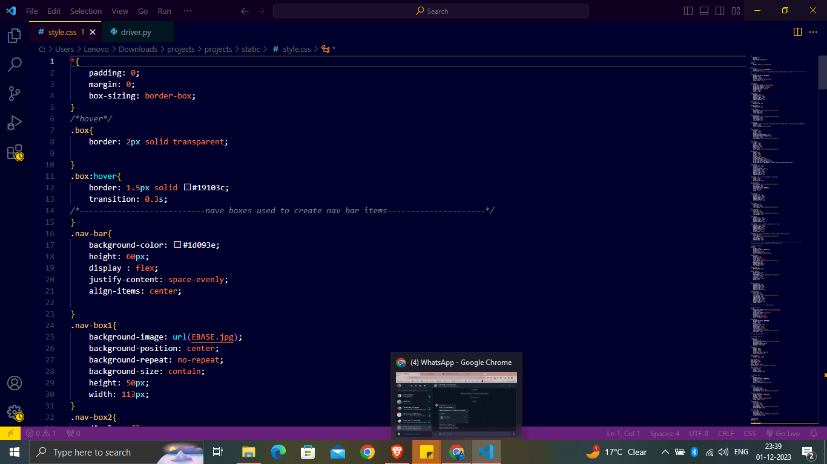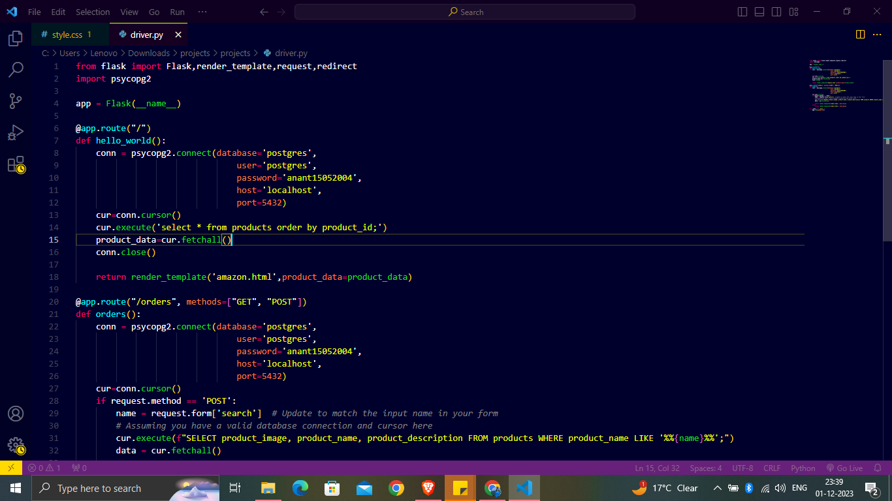**Here we are linking our html file with CSS**

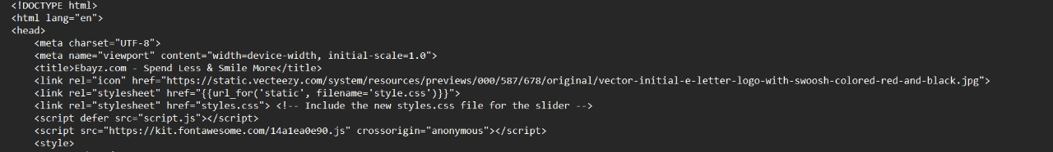

7. ***Future Improvements:***

# ***Payment Integration:***

# Integrates secure payment gateways for transactions.

# ***User Reviews and Ratings:***

# Implements a user feedback system for product reviews.

# ***Recommendation Engine:***

# Enhances user experience with personalized product recommendations.

***USER INTERFACE AND DESIGN***

The practise of creating interfaces in software or computerised devices with a focus on looks or style is known as user interface (UI) design. Designers strive to create designs that are both easy to use and enjoyable for people. UI design often relates to graphical user interfaces, although it also covers voice-controlled interfaces.

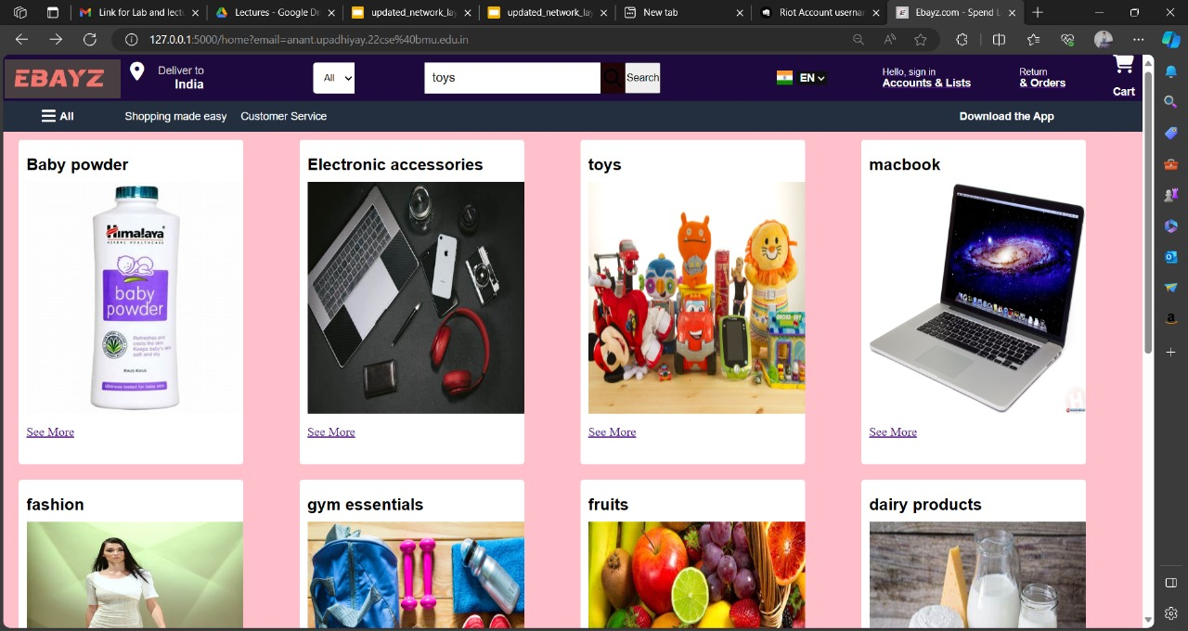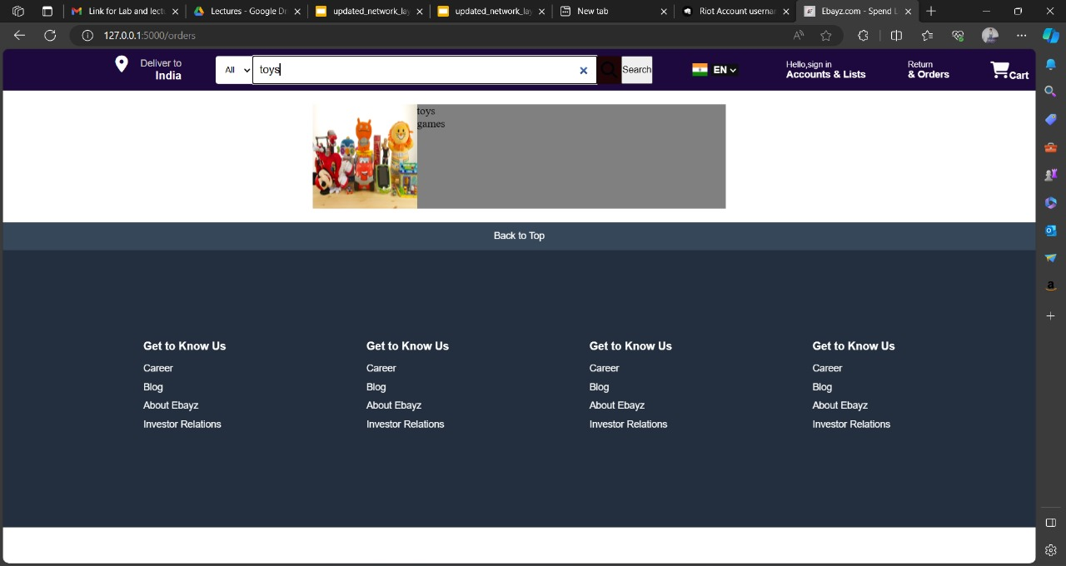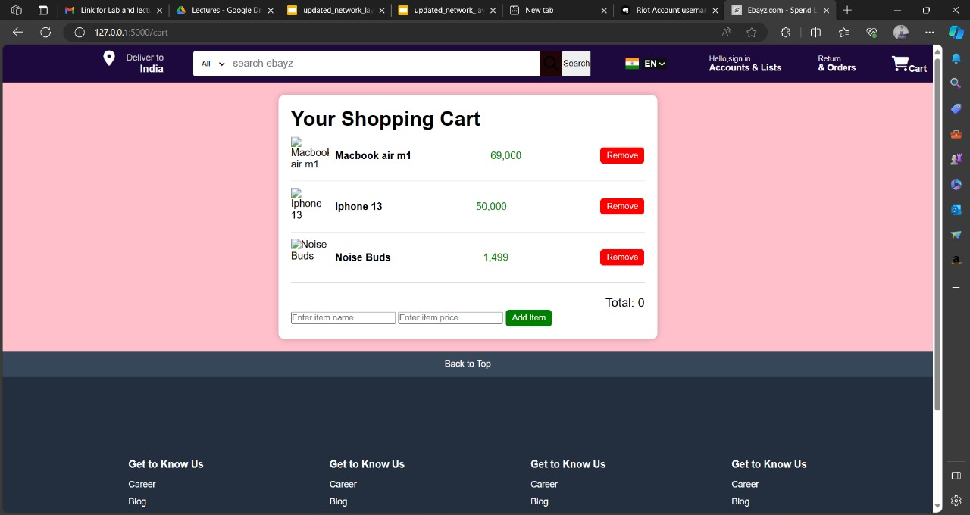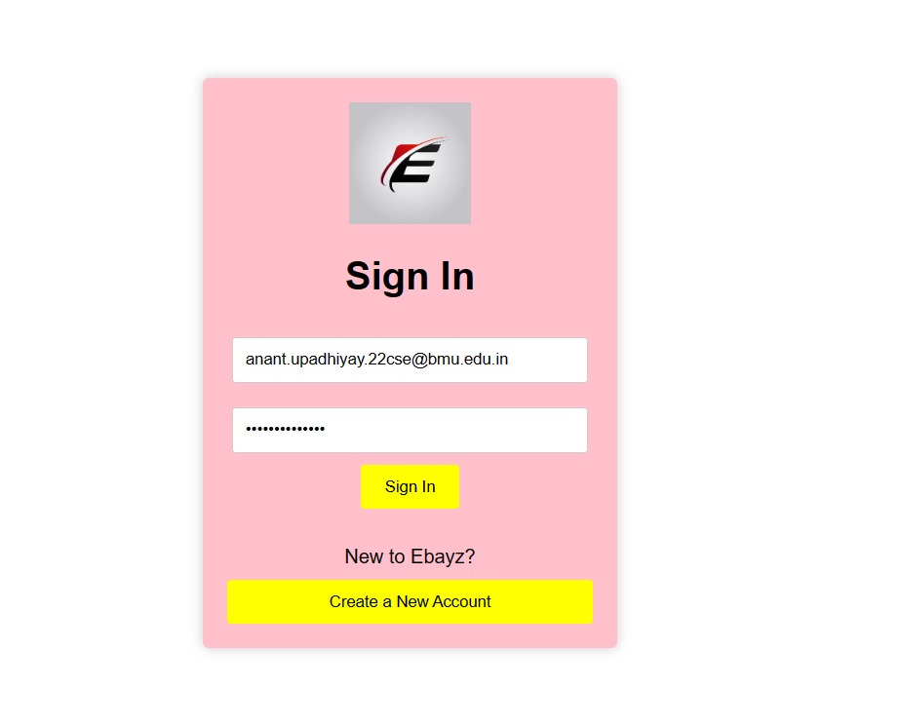

***Future Outlook***

1. Emerging Technologies Integration :EBAYZ envisions incorporating emerging technologies such as artificial intelligence, machine learning, and augmented reality. These advancements will enhance personalized recommendations, optimize user experiences, and introduce innovative features to stay ahead of evolving market trends.
2. Sustainable Practices: Recognizing the importance of environmental sustainability, EBAYZ is committed to adopting eco-friendly practices. This includes optimizing supply chains, reducing carbon footprints, and exploring partnerships with sustainable vendors.
3. Voice and Visual Search Capabilities:As voice and visual search technologies continue to gain prominence, EBAYZ seeks to integrate these capabilities. Users will be able to search for products using voice commands or images, further enhancing the accessibility and convenience of the platform.
4. Augmented Reality (AR) Shopping Experiences: Embracing the immersive potential of augmented reality, EBAYZ envisions AR shopping experiences. Users can virtually try on products, visualize furniture in their homes, or engage in interactive experiences, elevating the online shopping journey.
5. Enhanced Social Commerce Integration: Recognizing the growing influence of social media in e-commerce, EBAYZ explores enhanced social commerce integration. This includes seamless sharing of products, social recommendations, and integration with popular social platforms to create a cohesive online shopping and social experience.
6. Community Building and User Engagement: Beyond transactions, EBAYZ aspires to build a thriving community. User forums, interactive events, and community-driven features will foster a sense of belonging and encourage user engagement beyond the typical buyer-seller relationship.
7. Dynamic Pricing Strategies: Implementing dynamic pricing strategies based on real-time market conditions, user behaviour, and competitor analysis is a strategic focus. This ensures competitive pricing, promotional effectiveness, and responsiveness to market fluctuations.
8. Continuous User Feedback Loop: Establishing a continuous user feedback loop is a priority for EBAYZ. Proactive solicitation of user insights, preferences, and pain points will drive iterative improvements, ensuring the platform remains aligned with user expectations.

In conclusion, the future outlook for EBAYZ is characterized by a commitment to embracing technological advancements, sustainability, and user-centricity. As it navigates the evolving e-commerce landscape, EBAYZ positions itself not just as a platform but as a dynamic force shaping the future of online retail.

# ***CONCLUSION***

In the realm of online shopping, EBAYZ stands as a beacon of innovation, seamlessly blending cutting-edge technologies. From Python-powered backend connectivity to PostgreSQL's robust database management, and the dynamic flair of HTML, CSS, and JavaScript in the frontend, EBAYZ is poised to redefine user experiences.

The integration of an automatic slided navigation bar underscores a commitment to seamless navigation, adapting effortlessly to diverse devices. With an array of features such as personalized recommendations, user-friendly shopping cart functionalities, and a dynamic search system, EBAYZ promises a user-centric journey.