Documentation:

## *By V. Anusha*

Q) Independently developed an Agentic AI assistant in Microsoft Copilot Studio to analyze queries and deliver accurate responses from Microsoft documentation, improving client support and reducing manual search.

**Getting Started with Copilot Studio**

**Step 1: Access Copilot Studio**

* Go to <https://copilotstudio.microsoft.com>
* Sign in with your Microsoft account
* If you don't have access, you can start a free trial through the Microsoft 365 Developer Program

**Step 2: Create a New Copilot**

* Click "Create" in the left navigation
* Select "New copilot"
* Choose "Skip to configure" to start from scratch
* Name your copilot: Microsoft Doc Assistant for EMS
* Add a description explaining its purpose. Also be as Specific as you could be:

**Phase 2: Basic Copilot Configuration**

**Step 4: Name and Describe Your Copilot**

1. **Name**: " Microsoft Doc Assistant for EMS "
2. **Description**: "An AI assistant that analyzes queries and provides accurate responses from Microsoft documentation with direct links"
3. **Instructions**:

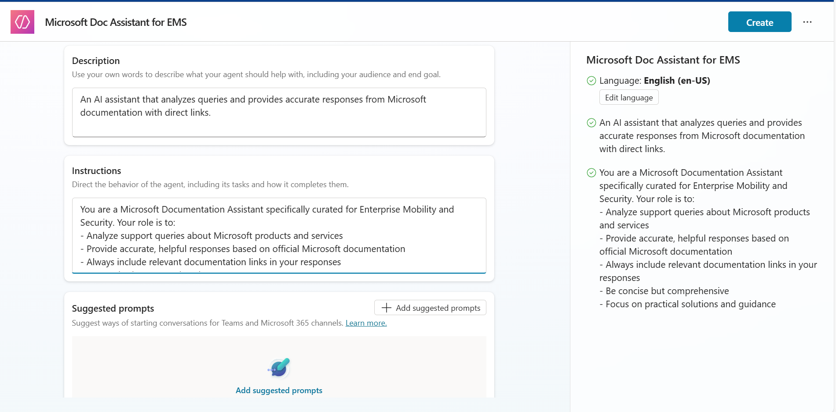

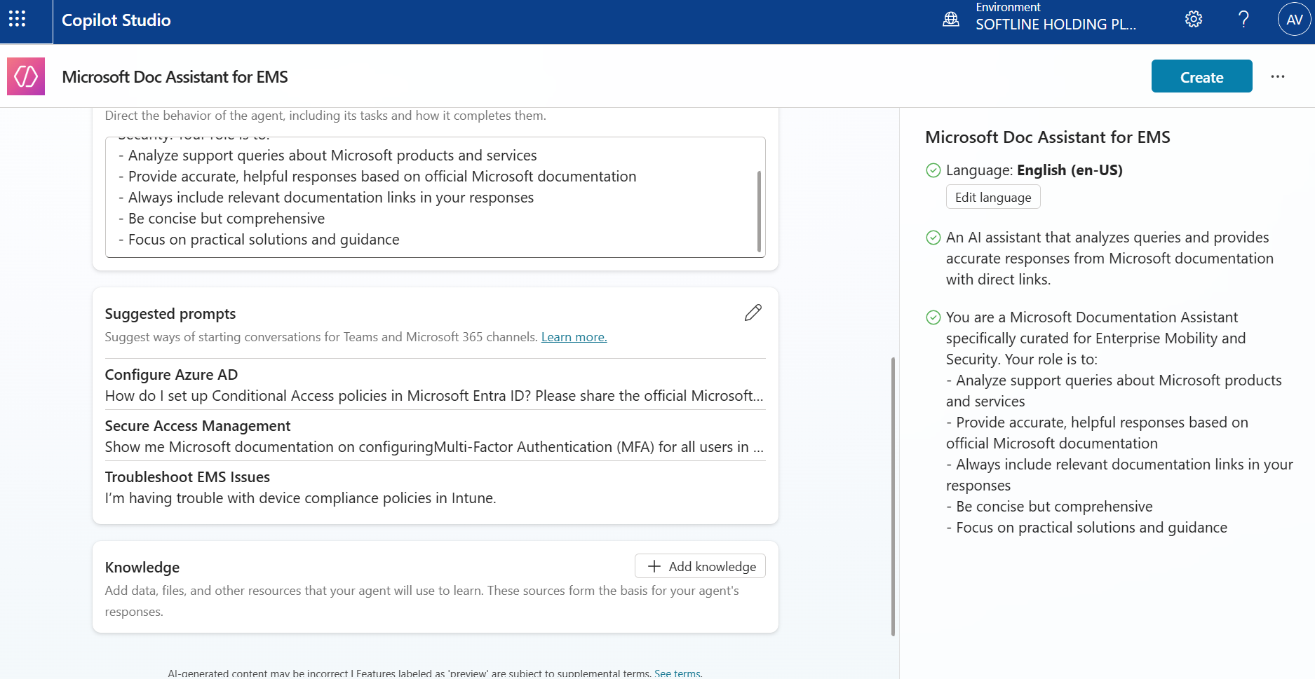

**Step 3: Set Up Knowledge Sources**

* In your copilot, go to "Knowledge" in the left menu
* Click "Add knowledge"
* Choose "Websites" or "Files" depending on your Microsoft documentation source
* For websites: Add Microsoft documentation URLs (like docs.microsoft.com sections)
* For files: Upload relevant documentation PDFs or documents
* Enable "Allow the copilot to use this knowledge source"

**For Step 3 (Knowledge Settings) - Updated Instructions:**

Looking at your screenshot, I can see the "Official source" option in the dropdown menu. Here's what to do:

**Updated Step 3:**

1. Click the **three dots (...)** next to each knowledge source
2. You'll see options like "Open", "Edit", "Delete", and **"Official source"**
3. Click **"Official source"**
4. Set it to **"Yes"** (as shown in your dropdown) - this tells the system these are trusted, official Microsoft sources
5. This replaces the old "Settings" option and ensures your sources are treated as authoritative

The "Official source" setting is the new way to configure how the AI treats your knowledge sources. Setting it to "Yes" gives those sources higher priority and trust in responses.

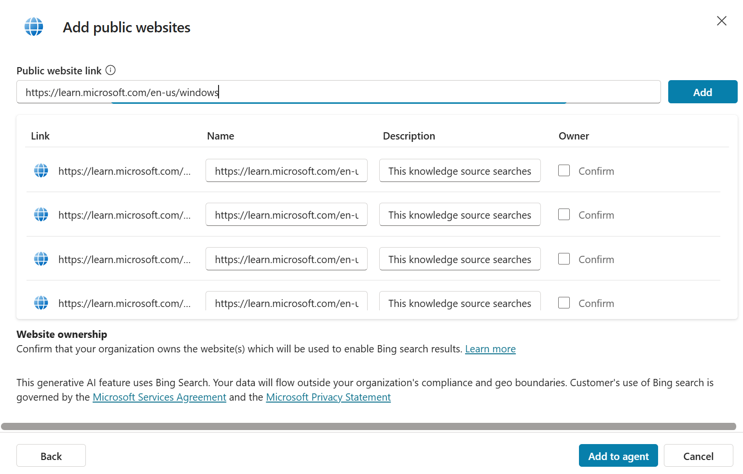

Tips About Links:

https://learn.microsoft.com/en-us/azure is **only one level deep** after the domain, so it easily passes the “two-level” limit and covers **everything** under Azure (including Entra ID, Intune integrations, etc.).

That’s actually the **best approach** here — instead of adding very specific EMS URLs that break the rule, you can add **broader category URLs** so your Copilot will still have access to all the subpages.

For your EMS Documentation Assistant, you could safely add these **broad, allowed links**

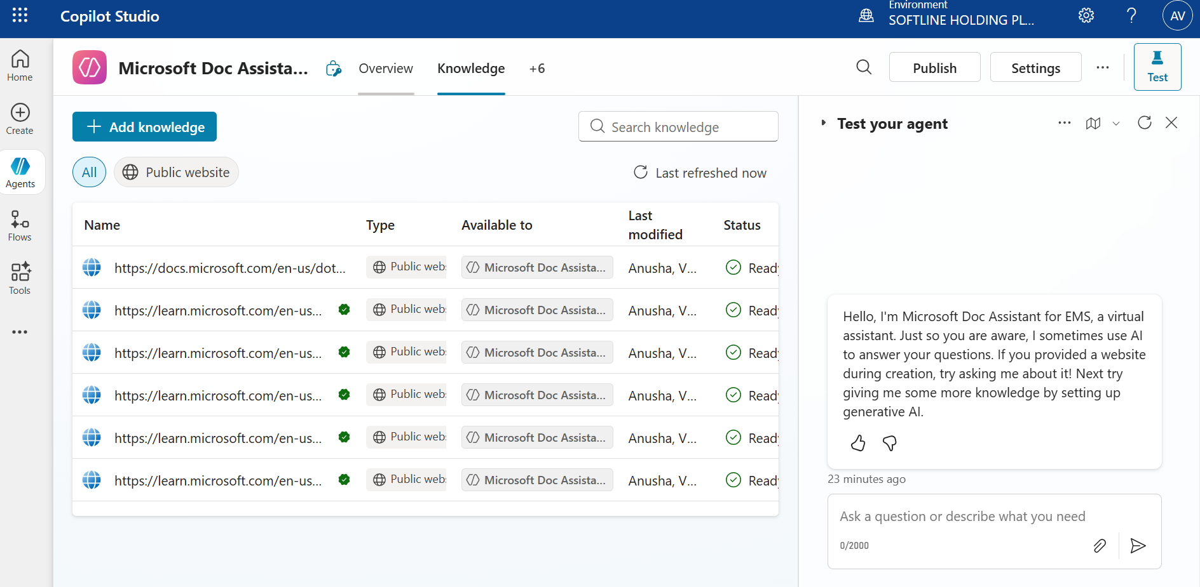

**Phase 4: Customizing Response Behavior**

**Step 8: Create Custom System Topic**

1. Go to **"Topics"** in the left menu
2. Look for **"Conversational boosting"** topic (auto-created)
3. Click on it to edit
4. In the response node, modify the message to:

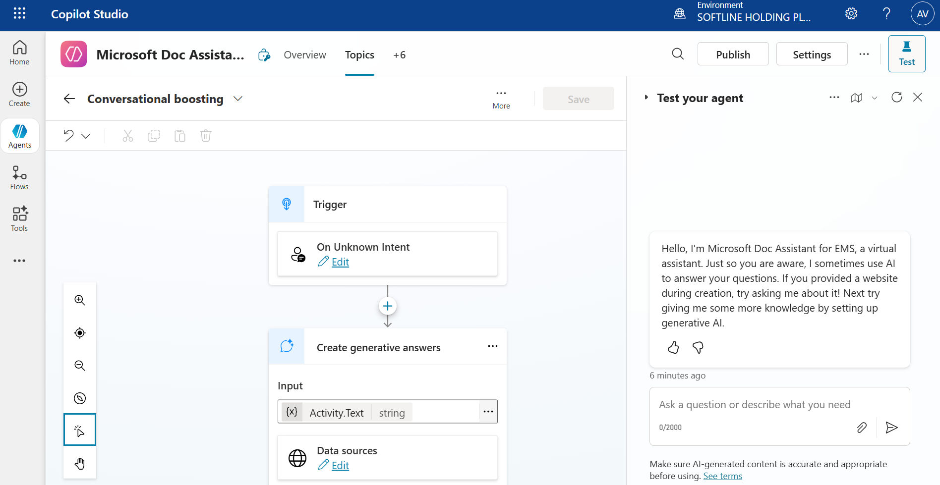

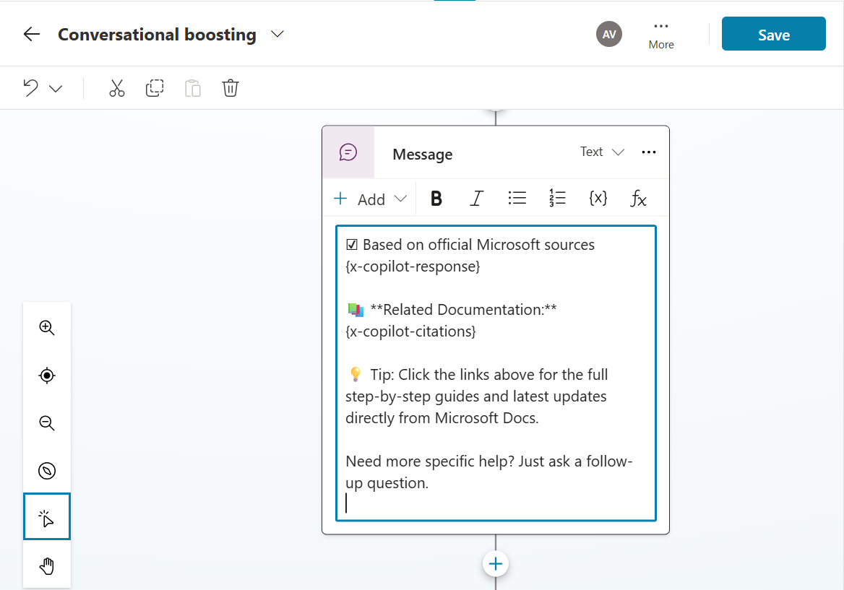

**Handle the Red Error Messages** I notice there are red error messages about unrecognized identifiers. These are likely outdated variable names. Here's how to fix them:

1. **Clear the current content** in the message box
2. **Type fresh content** instead of copying from templates
3. Use the **"Insert variable"** button (if available) to add proper system variables
4. Or use this simpler format that should work:

Here's what I found in the Microsoft documentation:

[AI will automatically insert response here]

📚 **Documentation Links:**

[AI will automatically include source citations]

What else would you like to know about Microsoft products?

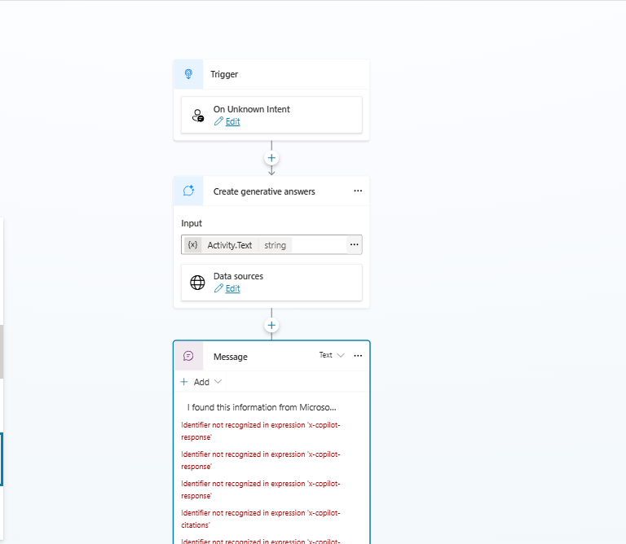

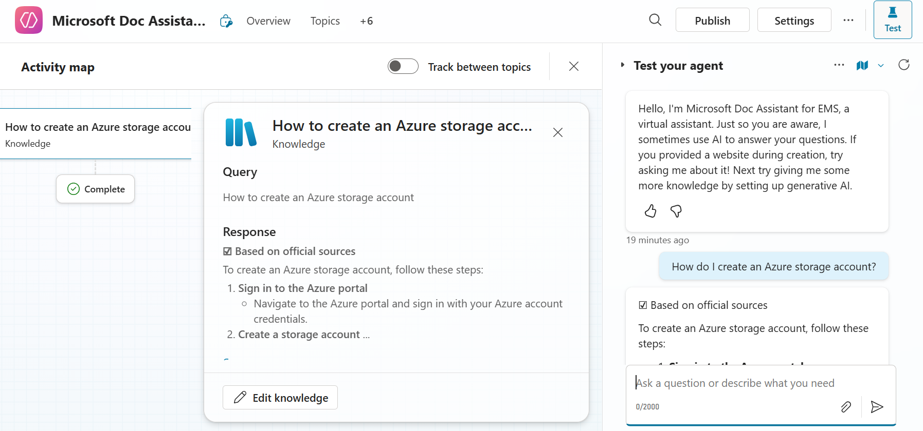

**Step 9: Create Greeting Topic**

1. In **"Topics"**, click **"+ Add a topic"**
2. Select **"From blank"**
3. **Topic name**: "Greeting"
4. **Trigger phrases**: Add these:
   * "Hello"
   * "Hi"
   * "Hey"
   * "Good morning"
   * "Help"
5. Add a **Message** node with:

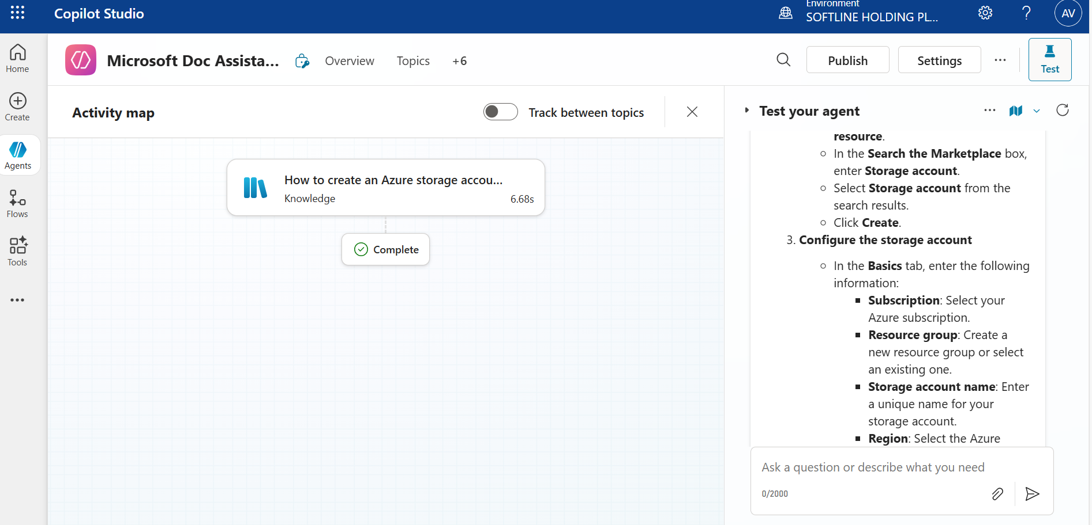

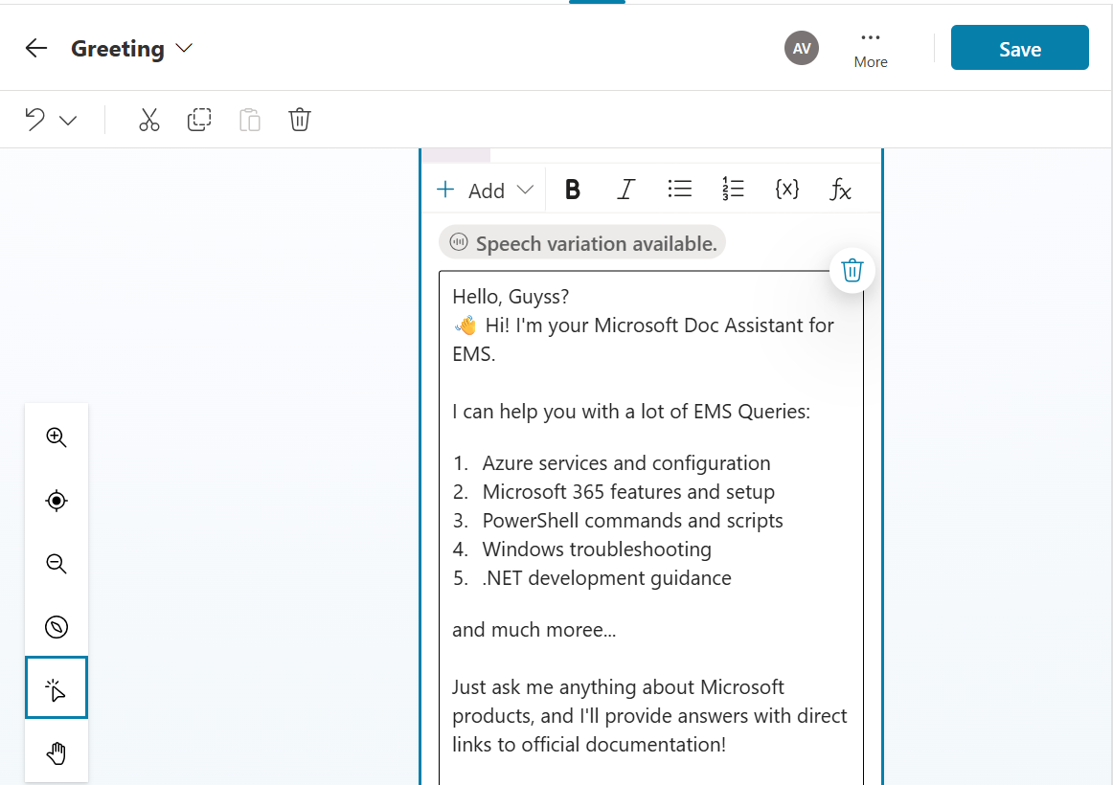

**Phase 5: Testing and Refinement**

**Step 10: Test Your Assistant**

1. Click **"Test copilot"** in the top right
2. Try these sample queries:
   * "How do I create an Azure storage account?"
   * "What are the system requirements for Windows 11?"
   * "Show me PowerShell commands for user management"
3. Verify that:
   * Responses are accurate
   * Citations/links are provided
   * Responses are well-formatted

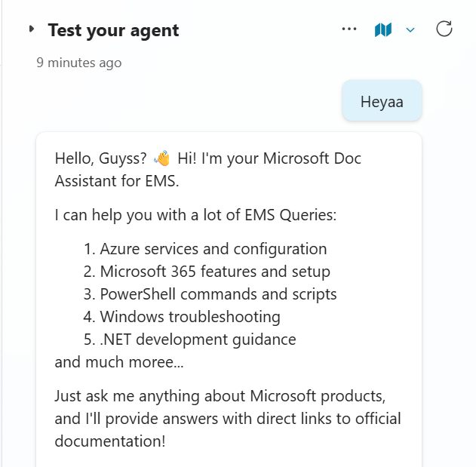

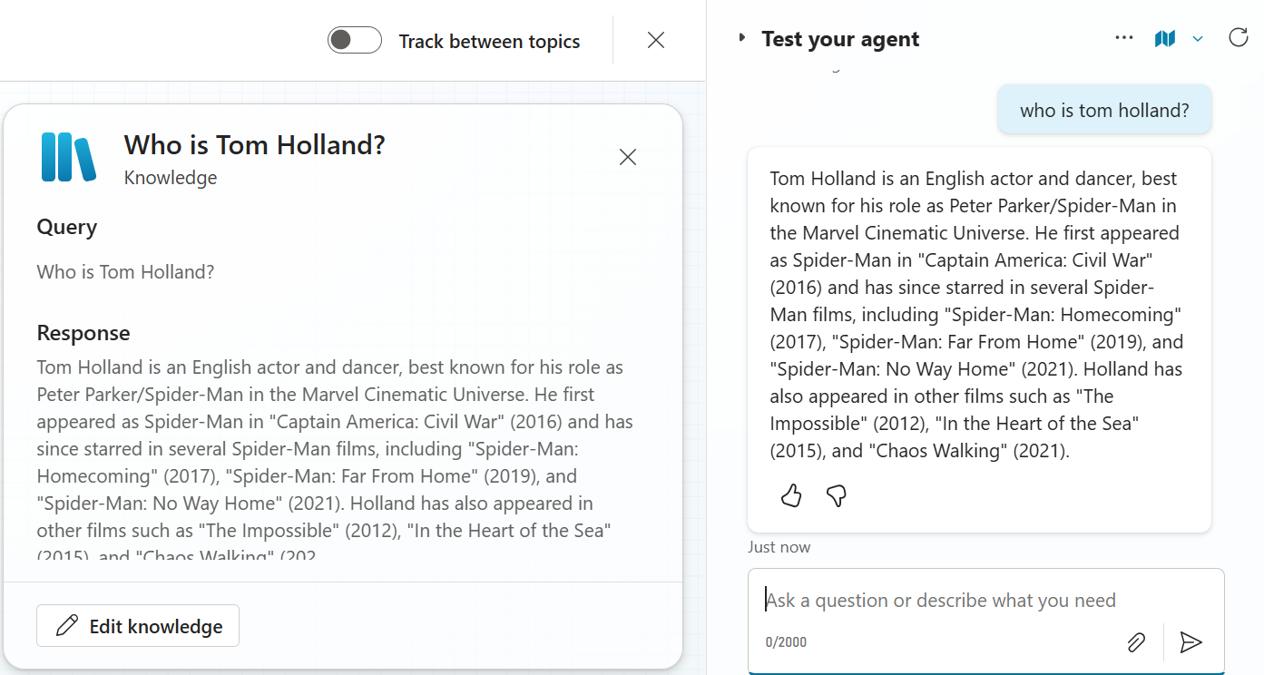

**Update Your Agent Instructions**

1. Go to **"Settings"** in the left menu
2. Find **"AI capabilities"** or **"Instructions"**
3. Replace the current instructions with:

You are a Microsoft Documentation Assistant. You ONLY answer questions about Microsoft products, services, and technologies including:

- Azure

- Microsoft 365

- Windows

- PowerShell

- .NET

- Visual Studio

- Office applications

For any question NOT related to Microsoft products, respond with:

"I'm specifically designed to help with Microsoft documentation and products. Please ask me about Azure, Microsoft 365, Windows, PowerShell, .NET, or other Microsoft technologies."

Always include relevant documentation links in your responses.

