**ANP-C7971**

**Student Name** : Anusha Balasani

**Student ID** :AF0400154

**Project Name** : Telecommunication System

**Telecommunication System**

A **telecommunication system** is a network that helps people communicate and share information over long distances. Here’s its main purpose in simple words:

1. **Talking to People Far Away**: It allows people to make phone calls, video calls, or send messages even if they’re far apart.
2. **Sending Information**: It helps in sending and receiving data like text, images, and videos quickly over the internet.
3. **Connecting the World**: It connects people around the world, making it possible to communicate across countries and continents.
4. **Supporting Services**: It’s used in important areas like healthcare (telemedicine), banking, education (online classes), and emergency services (calling 911).
5. **Helping Businesses**: It allows businesses to work remotely, serve customers, and share important information quickly.
6. **Broadcasting**: It’s used to send TV and radio signals to large audiences.
7. **Monitoring Things Remotely**: It helps to keep track of things like electricity usage, traffic, and machinery from a distance.
8. **Making Services Accessible**: It helps people with disabilities communicate using tools like video calls or voice recognition.
9. **Emergency Communication**: It’s crucial for calling emergency services, like when you need help during an accident.
10. **Enabling New Technologies**: It helps new technologies like the internet of things (IoT) and 5G to work, making life smarter and more connected.

Here is an ER (Entity-Relationship) diagram for the Telecommunication System:

**Entities:**1. **Subscriber**

* Subscriber ID (Primary Key)
* Name
* Phone Number
* Address

2**. Call**

* Call ID (Primary Key)
* Subscriber ID (Foreign Key)
* Call Date
* Call Time
* Called Party
* Call Duration

3. **Message**

* Message ID (Primary Key)
* Subscriber ID (Foreign Key)
* Message Date
* Message Time
* Message Type-
* -Message Content

4. **Billing Cycle**

* Billing Cycle ID (Primary Key)
* Subscriber ID (Foreign Key)
* Billing Date
* Amount

5**. Payment**

* Payment ID (Primary Key)
* Billing Cycle ID (Foreign Key)
* Payment Date
* Payment Method

6. **Network Element**

* Network Element ID (Primary Key)
* Type
* Location

7. **Inventory**

* Inventory ID (Primary Key)
* Equipment Type
* Quantit

-

Subscriber

Call

Message

makes

Network Element

Billing Cycle

Payment

Inventory

has

uses

has

sends

- Message

contains

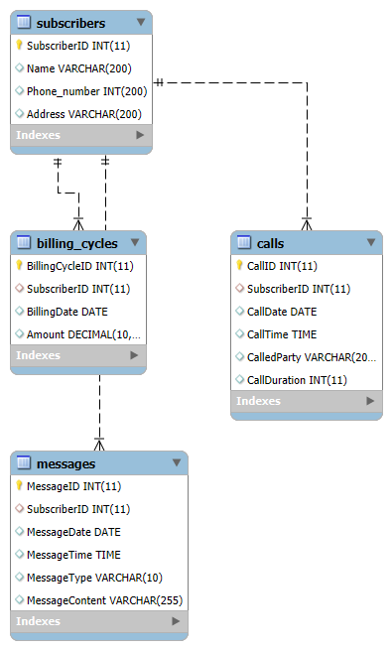

**Reverse Engineering**