MACHINE LEARNING PROJECT • CUSTOMER ANALYTICS

ONLINE RETAIL CUSTOMER SEGMENTATION
RFM ANALYSIS & K-MEANS CLUSTERING ON THE ONLINE RETAIL II DATASET

A Machine Learning project applying RFM analysis and K-Means clustering to the Online Retail II dataset for data-driven customer segmentation.
Project Team
S.No. | Student Name | Student ID
1 | M. Purnasri | 23341A05F0
2 | K. Anusha | 23341A05D3
3 | S. Jyotsna | 23341A05A8
4 | P. Jahnavi | 23341A05J5
5 | K. Neelima | 23341A4258
6 | Ch. Sai Madhuri | 23341A4226
7 | K. Pranathi | 23341A4242

Batch: 2023 – 2027
Course: B.Tech – CSE

Team Members Contribution
The project presentation lists the seven team members and the overall project work but does not assign an explicit individual contribution to each member. The table below therefore presents a suggested contribution allocation, derived from the actual stages of work carried out in the project notebook and presentation, and distributed logically across all team members.
S.No. | Student Name | Student ID | Suggested Contribution
1 | M. Purnasri | 23341A05F0 | Data collection and dataset understanding (Online Retail II source, structure and business context)
2 | K. Anusha | 23341A05D3 | Data inspection and quality analysis (missing values, duplicates, cancellations, data-type issues)
3 | S. Jyotsna | 23341A05A8 | Data cleaning and preprocessing (handling missing Customer IDs, removing duplicates and cancellations, computing TotalAmount)
4 | P. Jahnavi | 23341A05J5 | RFM analysis and customer-level feature creation (Recency, Frequency, Monetary aggregation)
5 | K. Neelima | 23341A4258 | Data visualization and exploratory analysis (country, sales, product and RFM distribution charts)
6 | Ch. Sai Madhuri | 23341A4226 | Feature engineering (log transformation and standard scaling); K-Means implementation, Elbow Method and model evaluation
7 | K. Pranathi | 23341A4242 | Customer segment interpretation, business recommendations, and PPT/documentation/presentation

Note: This allocation is a reasonable proposed division of work based on the stages present in the project files, and not an explicit assignment stated in the source presentation.

Project Introduction

Overview of Customer Segmentation
Customer segmentation is the practice of dividing a company's customer base into groups of individuals who share similar purchasing behaviour, so that marketing, retention and service strategies can be tailored to each group rather than applied uniformly to everyone. In an online retail setting, a single company may serve thousands of customers whose habits differ enormously — some purchase frequently and spend heavily, while others make a single purchase and never return. Treating all of these customers identically wastes marketing budget on customers who are already loyal and fails to identify customers who are quietly drifting away.

Why Transaction-Level Data Is Not Enough
Raw transaction records — one row per invoice line, describing a product, quantity, price and date — describe individual purchase events, not customers. A customer who places one very large order and a customer who places many small orders over two years can look similar or very different depending on which single transaction is examined. Transaction-level data alone therefore cannot answer basic business questions such as which customers are the most valuable, which are genuinely loyal, which have recently engaged, and which have gone quiet and are at risk of churning. Answering these questions requires the transaction history to be aggregated to the level of the individual customer.

How RFM Analysis Creates Customer-Level Measures
RFM analysis addresses this by converting a customer's entire transaction history into three simple, interpretable behavioural measures: Recency (how recently the customer last purchased), Frequency (how often the customer purchases), and Monetary value (how much the customer has spent in total). These three numbers summarise a customer's relationship with the business far more usefully than any single transaction, and they form a natural basis for comparing customers against one another.

How K-Means Clustering Groups Customers
Once every customer is represented by an RFM triple, K-Means clustering is used to group customers who are behaviourally similar into a small number of clusters, without any need for pre-labelled categories. K-Means works by iteratively assigning each customer to the nearest of K cluster centres and then updating those centres, until the assignments stabilise. The output is a partition of the customer base into distinct behavioural groups that can then be interpreted and given business-friendly names.

Business Importance of Targeted Strategies
Once customers are segmented, a business can move from a single, generic marketing strategy to targeted actions for each group — rewarding and retaining its most valuable customers, nurturing customers who are still developing their relationship with the business, and running win-back campaigns for customers who appear to be at risk of churning. This project builds exactly this pipeline for the Online Retail II dataset: transaction data is cleaned, aggregated into RFM features, and segmented using K-Means clustering into four business-friendly customer personas.

2. Problem Statement
The Online Retail II dataset contains over one million large-scale transaction records collected from a UK-based online gift retailer over a two-year period. Each row describes a single product line within an invoice, and by itself says very little about the customer who placed it. Treating every transaction — and by extension every customer — equally hides substantial differences in purchasing behaviour: some customers buy often and spend heavily, while others purchase once and disappear.
Without a systematic way of distinguishing between customers, a business cannot identify:
- Recently active customers, who are currently engaged with the business
- Frequent customers, who purchase repeatedly over time
- High-spending customers, who generate disproportionate revenue
- Loyal customers, who maintain a steady, long-term purchasing relationship
- Developing customers, who are recently active but have not yet built up frequency or spend
- Customers at risk of churn, who have not purchased in a long time and may be lost
The goal of this project is to convert the raw Online Retail II transaction log into customer-level Recency, Frequency and Monetary (RFM) features, and to apply K-Means clustering to those features in order to produce actionable, business-friendly customer segments that can guide targeted marketing and retention strategy. The modelling approach, results and recommendations are presented in the sections that follow.

3. Objectives
- Understand the structure and business context of the Online Retail II dataset.
- Inspect and clean transaction-level data, resolving missing values, duplicates and invalid records.
- Explore sales, product and country-level purchasing patterns.
- Calculate customer-level Recency, Frequency and Monetary (RFM) values from cleaned transactions.
- Handle skewed RFM distributions using an appropriate transformation.
- Standardize RFM features so that they are suitable for distance-based clustering.
- Determine the suitable number of clusters using the Elbow Method.
- Apply K-Means clustering to the scaled RFM features.
- Evaluate clustering quality using the Silhouette Score.
- Interpret the resulting clusters as business-friendly customer personas.
- Recommend targeted marketing strategies for each customer segment.

4. Dataset Overview
The project uses the Online Retail II dataset, which contains transaction-level records from a UK-based online gift retailer, spanning December 2009 to December 2011. Each row corresponds to a single product line within a customer invoice, describing the product, quantity, price, date, customer and country involved in the transaction.
Property | Value
Dataset name | Online Retail II
Business / domain context | Transaction records from a UK-based online gift retailer
Dataset time period | December 2009 – December 2011
Raw transaction rows | 1,067,371
Original / core columns | 8
Countries represented | 43
Unique customers (after cleaning) | 5,878

Core Columns
- Invoice — unique identifier for each transaction/order
- StockCode — unique identifier for each product
- Description — product name
- Quantity — number of units purchased in the transaction line
- InvoiceDate — date and time the transaction occurred
- Price — unit price of the product
- Customer ID — unique identifier for the customer
- Country — country associated with the customer

5. Dataset Inspection and Data Quality
Before any modification, the raw dataset was inspected for quality issues. Nothing was changed at this stage — the dataset was only checked, so that the subsequent cleaning steps could be justified against actual, observed problems.
Issue Checked | Result | Why It Matters
Missing Customer IDs | 243,007 rows are missing a Customer ID | Rows without a Customer ID cannot be attributed to any customer and cannot contribute to RFM features
Duplicate transactions | 34,335 fully duplicate rows were found | Duplicate rows would double-count purchases and inflate Frequency and Monetary values
Negative Quantity / Price | Present in the raw data | Negative values indicate returns rather than genuine sales
Cancellation invoices | Invoices starting with “C” | Cancellations are not completed sales and should not count toward customer value
Data type issues | Invoice stored as a mixed type; InvoiceDate stored as text | Correct types (string Invoice, datetime InvoiceDate) are required for reliable filtering, grouping and date arithmetic

6. Data Cleaning
Based on the data-quality issues identified above, the following cleaning pipeline was applied to the raw transaction data, in order:
- Fix data types — Invoice cast to string; InvoiceDate parsed to a proper datetime.
- Remove duplicates — 34,335 fully duplicated rows dropped.
- Handle missing values — rows missing Customer ID, InvoiceDate, Quantity or Price removed.
- Exclude cancellations — invoices starting with “C” (returns) filtered out.
- Keep valid sales — only rows with Quantity > 0 and Price > 0 retained.
- Engineer TotalAmount — computed as TotalAmount = Quantity × Price, used as the transaction-level Monetary contribution.

1,067,371 raw rows → 779,425 clean transaction rows → 5,878 unique customers
This cleaned, transaction-level dataset — 779,425 valid sales rows across 5,878 unique customers — forms the basis for all subsequent exploratory analysis, RFM feature construction and clustering.

7. Exploratory Data Analysis / Data Visualization
Before constructing RFM features, the cleaned transaction data was explored visually to understand overall sales patterns across countries, time and products.

7.1 Top Countries by Transactions
The number of transactions was counted for each country to identify where purchasing activity is concentrated.
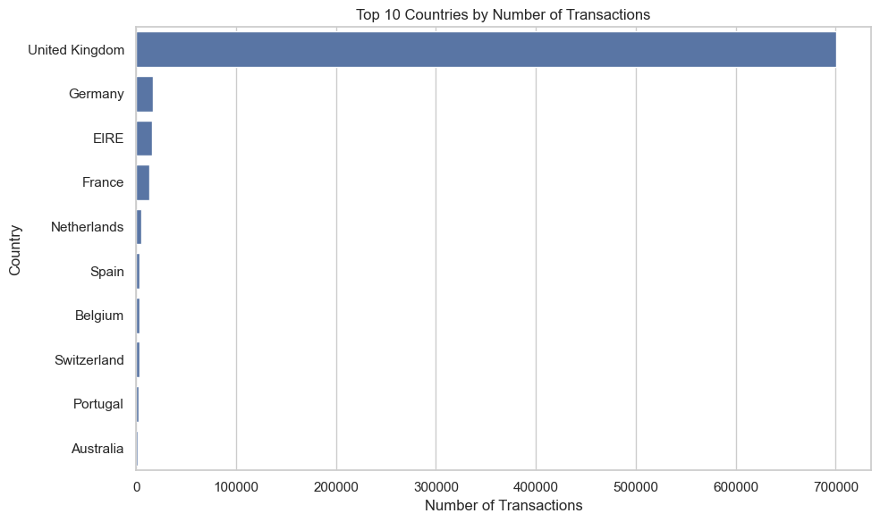
Figure 1: Top 10 Countries by Number of Transactions
- Transaction activity is heavily concentrated in a small number of markets.
- The United Kingdom dominates the dataset with roughly 700,000 transactions.
- The next closest markets (Germany, EIRE, France) each account for a small fraction of the UK's volume.

7.2 Monthly Sales Trend
Total sales value (TotalAmount) was aggregated by month to examine how purchasing intensity changes over the two-year period covered by the dataset.
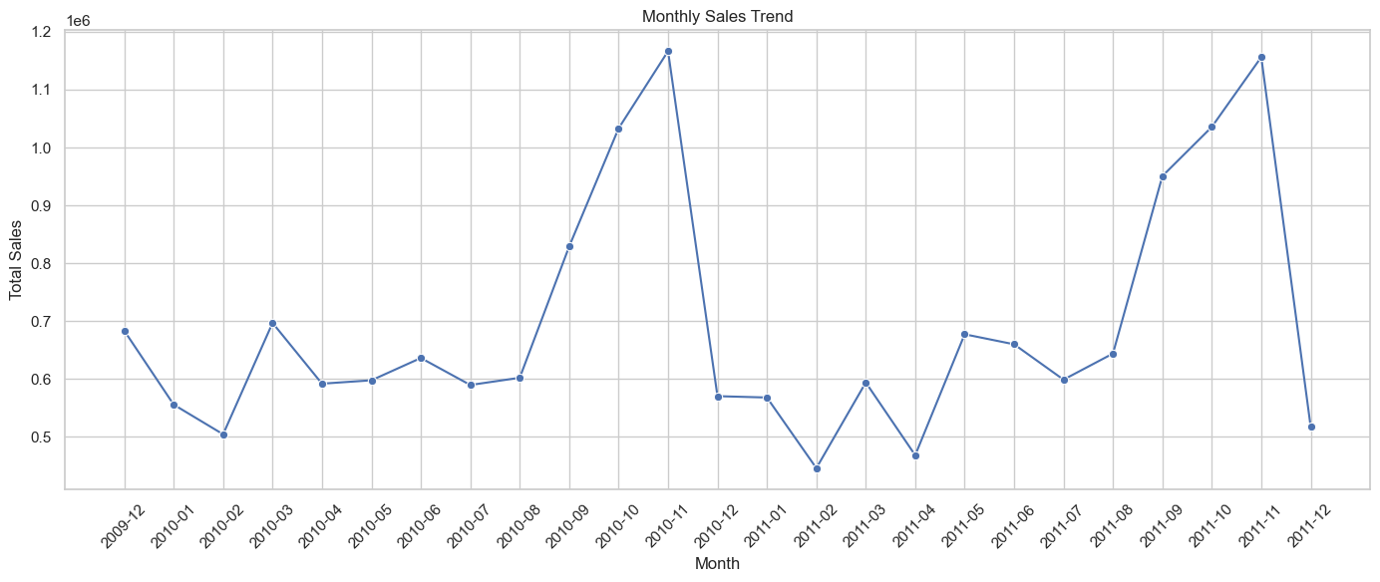
Figure 2: Monthly Sales Trend
- Monthly sales fluctuate noticeably over time rather than remaining flat.
- Sales rise sharply into the October–November period in both 2010 and 2011, indicating year-end seasonality.
- Peak sales consistently occur around October–November, likely reflecting holiday-season purchasing.

7.3 Top 10 Products by Sales
Products were ranked by total sales value (sum of TotalAmount) to identify which items contribute most strongly to overall revenue.
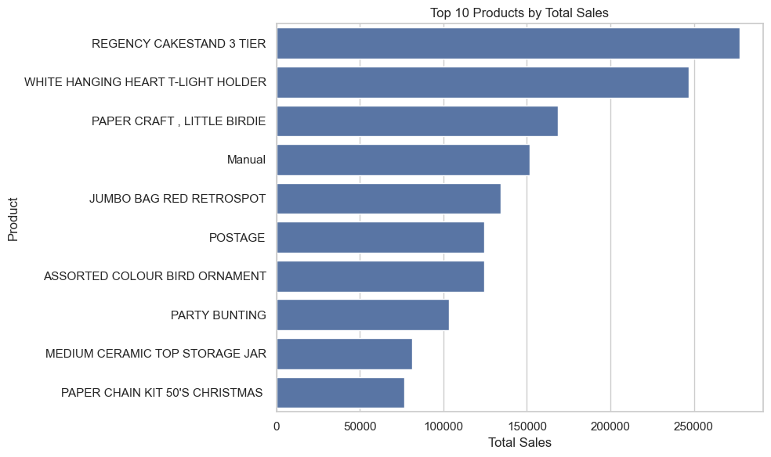
Figure 3: Top 10 Products by Total Sales
- A small group of products contributes disproportionately to total sales value.
- This concentration suggests that a limited product range drives a large share of revenue.

7.4 Quantity vs Price
A sample of transactions was plotted with Quantity against Price to examine the general shape of the transaction-level data and identify potential outliers.
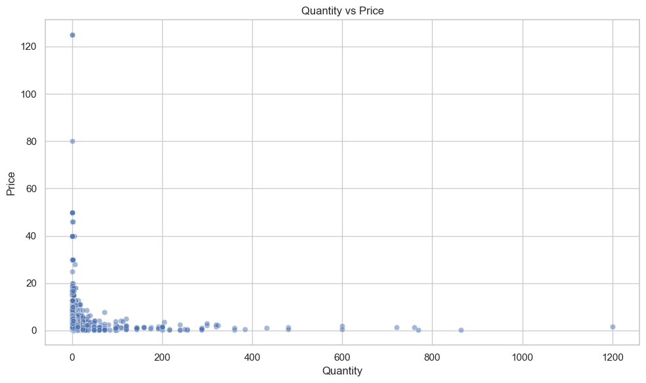
Figure 4: Quantity vs Price (sampled transactions)
- Most transactions are concentrated at low quantities and low prices.
- A small number of transactions sit far outside this main concentration, forming visible outliers.
- This skew and outlier presence motivates the transformation steps applied later, before clustering.

8. RFM Analysis
RFM analysis aggregates each customer's cleaned transaction history into three behavioural measures. These are calculated once per customer, from the 779,425 cleaned transaction rows, using Customer ID as the grouping key.
Measure | Definition | Interpretation
Recency (R) | Number of days since the customer's most recent purchase, measured from a snapshot date one day after the latest invoice date in the data | Lower Recency = more recently active
Frequency (F) | Number of unique orders (invoices) placed by the customer | Higher Frequency = stronger repeat-purchase behaviour
Monetary (M) | Total amount spent by the customer, summed across all their TotalAmount values | Higher Monetary = higher customer value

Transaction-level records are aggregated to the customer level by grouping the cleaned dataset on Customer ID: Recency is computed from the most recent InvoiceDate per customer, Frequency is the count of unique invoices per customer, and Monetary is the sum of TotalAmount per customer. The result is a single RFM row per customer, converting a large transaction log into a compact behavioural profile suitable for clustering.

9. RFM Distribution Analysis
Once the RFM table was constructed, the distribution of each of the three features was examined to understand their shape before transformation and scaling.

9.1 Recency Distribution
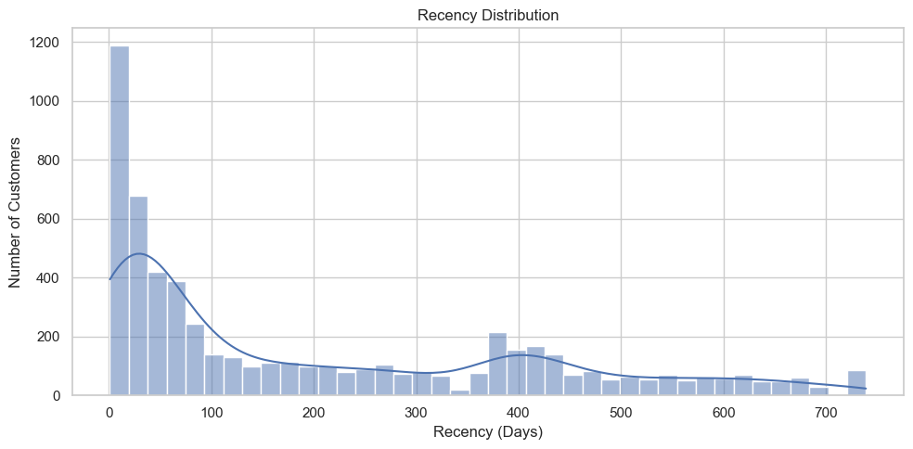
Figure 5: Recency Distribution
- Recency is concentrated at low values, reflecting a large number of recently active customers.
- A long right tail extends toward high Recency values, corresponding to customers who have not purchased in a long time.

9.2 Frequency Distribution
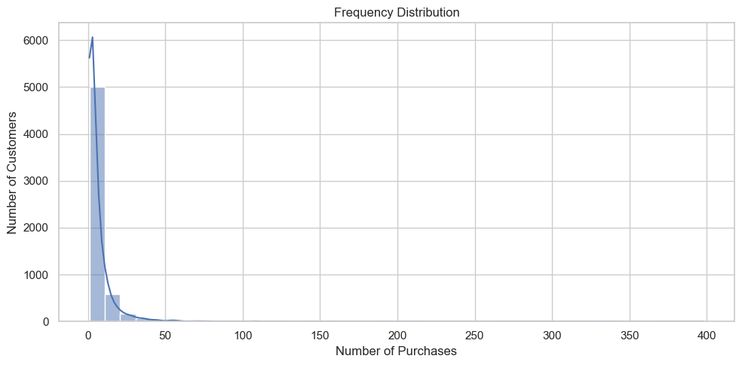
Figure 6: Frequency Distribution
- Most customers have placed a relatively small number of orders.
- Only a smaller group of customers order very frequently, creating a strong right-skew.

9.3 Monetary Distribution
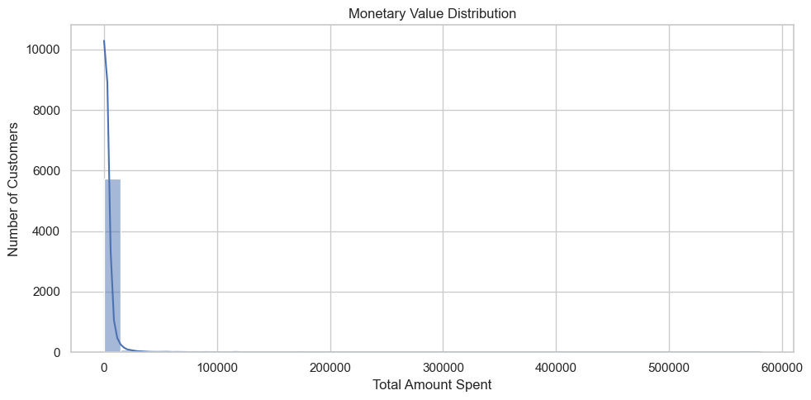
Figure 7: Monetary Value Distribution
- Most customers are concentrated at lower total spending levels.
- A small number of high-value customers create a long right tail in total spend.
All three RFM features are right-skewed, with a small number of extreme values in Frequency and Monetary in particular. Because K-Means relies on Euclidean distance, features with this kind of skew and scale imbalance can dominate the clustering result if left untransformed — this motivates the log transformation and standard scaling applied in the next section.

10. Feature Engineering
Because the raw RFM features are heavily right-skewed, two preprocessing steps were applied before clustering, in sequence.

Log Transformation
The natural-log-plus-one transformation, np.log1p(), was applied to Recency, Frequency and Monetary. This compresses extreme values and reduces the right-skew observed in all three features, without requiring the data to first be shifted to avoid zero or negative inputs.

Standard Scaling
After the log transformation, StandardScaler was applied to place all three RFM features on comparable scales, centering each feature to a mean of 0 and a standard deviation of 1. This step is necessary because K-Means is a distance-based algorithm, and without scaling, a feature such as Monetary (measured in currency units) would dominate the distance calculation over Frequency (measured in order counts).

Raw RFM → Log Transformation → Reduce Skew → Standard Scaling → K-Means Ready
RFM Feature | Mean (after log transform)
Recency | 201.3 days
Frequency | 6.3 orders
Monetary | $2,955.90

11. Choosing the Number of Clusters (Elbow Method)
The Elbow Method was used to select an appropriate number of clusters, K, for the K-Means algorithm. K-Means was trained repeatedly for K = 2 through K = 10 on the scaled RFM features, and the resulting inertia (within-cluster sum of squared distances) was plotted against K.
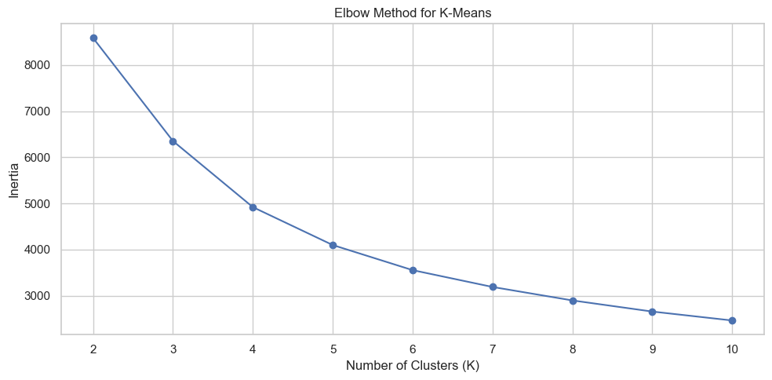
Figure 8: Elbow Method for K-Means (K = 2 to 10)
Inertia always decreases as K increases, so the goal is not the lowest inertia but the point where adding further clusters stops giving a meaningful improvement. In this project, inertia drops sharply from K = 2 to K = 4 and then begins to flatten beyond that point. This bend at K = 4 indicates that four clusters capture the natural structure in customer behaviour without over-fragmenting the customer base, and K = 4 was therefore selected as the final number of clusters.

12. K-Means Clustering
K-Means is an unsupervised clustering algorithm that partitions a set of data points into K groups by iteratively assigning each point to its nearest cluster centroid and then recomputing centroids as the mean of the points assigned to them, until the assignments stabilise. It is well suited to this customer segmentation problem because the goal is to discover natural behavioural groupings in the RFM feature space without any pre-existing labels, and K-Means scales efficiently to the thousands of customers present in this dataset.
Setting | Value
Input features | Log-transformed, standard-scaled Recency, Frequency and Monetary
Algorithm | K-Means
Number of clusters (K) | 4
n_init | 20
random_state | 42

Each of the 5,878 customers was assigned to exactly one of the four resulting clusters based on their position in the scaled, log-transformed RFM feature space.

13. Model Evaluation
The quality of the K-Means clustering was assessed using the Silhouette Score, which measures how similar each customer is to its own cluster compared to the next-nearest cluster. The score ranges from -1 to 1, where higher values indicate clusters that are both internally cohesive and well separated from one another.
Silhouette Score = 0.365
A Silhouette Score of 0.365 indicates reasonably well-separated, cohesive clusters — a solid result for real-world behavioural data, which rarely forms perfectly distinct groups. The score does not indicate perfect separation, and some overlap between adjacent segments (for example, between “Recent / Developing” and “At Risk / Low Value” customers) should be expected.

Cluster Sizes
Cluster | Customers
Cluster 0 | 1,192
Cluster 1 | 1,972
Cluster 2 | 1,249
Cluster 3 | 1,465

14. Customer Segmentation Results
Based on the average Recency, Frequency and Monetary values within each cluster, the four clusters were interpreted and named as follows. This cluster-to-segment mapping is used consistently throughout the remainder of this document.
Cluster | Segment | Customers | Recency | Frequency | Monetary | Interpretation
0 | Champions / High Value | 1,192 | 27.5 days | 19.3 orders | $10,756 | Bought very recently, order often, and spend the most by far
3 | Loyal Customers | 1,465 | 228.3 days | 5.1 orders | $1,957 | Moderate recency with steady order history and solid spend
2 | Recent / Developing | 1,249 | 28.4 days | 3.0 orders | $848 | Recently active but still building frequency and spend
1 | At Risk / Low Value | 1,972 | 395.9 days | 1.4 orders | $318 | Longest time since last purchase, rarely order — in danger of churning

15. Cluster Visualization
The clustering result was visualised in two complementary ways: in the original Recency-versus-Monetary space that business stakeholders can read directly, and in the scaled, log-transformed feature space in which K-Means actually performs its distance calculations.

Recency vs Monetary
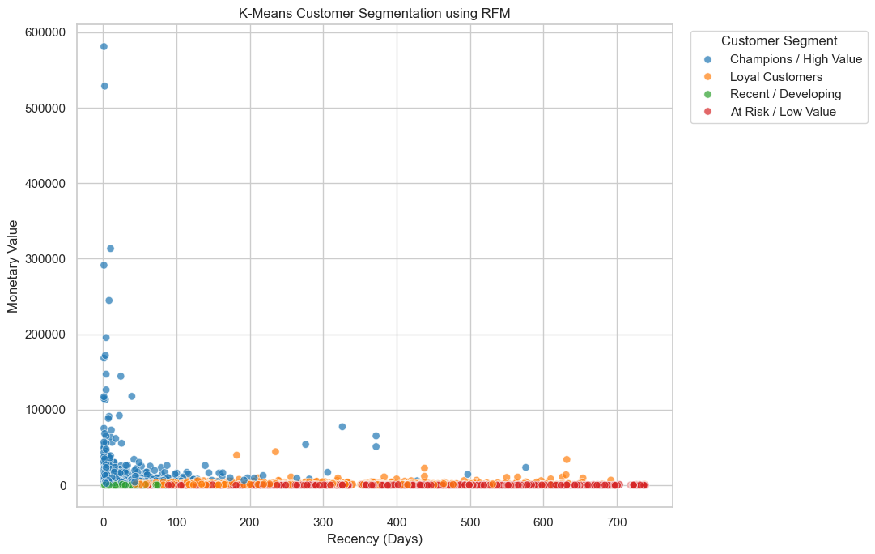
Figure 9: K-Means Customer Segmentation — Recency vs Monetary
Each point represents one customer, plotted by days since last purchase (Recency) against total amount spent (Monetary), coloured by assigned segment. Champions cluster near the origin on the Recency axis with the highest spend, including a number of very high-value outliers. At Risk / Low Value customers form a dense band at high Recency with spend close to zero, while Recent / Developing and Loyal Customers occupy the space in between, distinguished mainly by how long they have been purchasing and how much they have accumulated in spend.

Scaled Feature Space
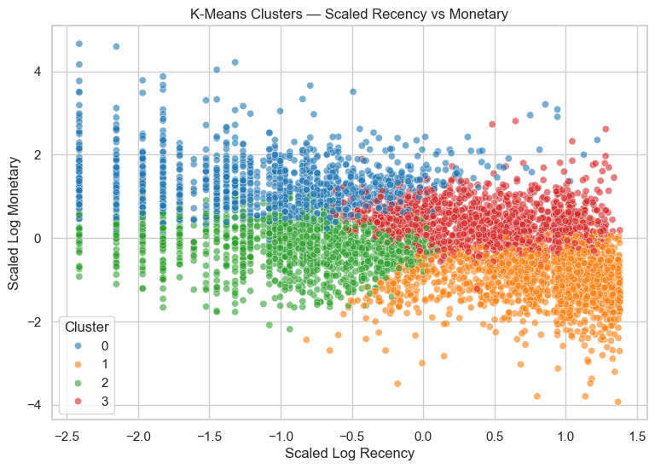
Figure 10: K-Means Clusters — Scaled Log Recency vs Scaled Log Monetary
This second view shows customers in the exact space in which K-Means performs its clustering — after log transformation and standard scaling. Once extreme values are compressed and all features are placed on equal footing, the four segments form largely distinct, non-overlapping regions, which is consistent with the Silhouette Score of 0.365 and supports the interpretation of the clusters as genuinely different behavioural groups rather than an arbitrary split.

16. Business Interpretation
Champions / High Value — customers who have purchased recently, order frequently, and generate the highest monetary value of any segment. They represent the retailer's most valuable and most engaged customers.
Loyal Customers — customers who demonstrate steady purchasing behaviour and solid spending over a longer period, even though their most recent purchase is less recent than that of the Champions segment.
Recent / Developing — customers who are recently active but have not yet built up meaningful order frequency or spend. They represent an early-stage relationship with the business.
At Risk / Low Value — customers with the longest time since their last purchase, the lowest order frequency and the lowest spend. This segment represents the retailer's highest churn concern.

17. Business Recommendations
Customer Segment | Objective | Recommended Strategy
Champions | Retain | VIP rewards, early access to new products
Loyal Customers | Grow | Cross-selling, loyalty points
Recent / Developing | Develop | First-repeat purchase incentives
At Risk / Low Value | Reactivate | Win-back campaigns and discounts

At Risk / Low Value is the largest of the four segments, with 1,972 customers — more than a third of the customer base. This makes reactivation of this segment the single largest re-engagement opportunity identified by the analysis, and a natural priority for win-back marketing spend.

18. Project Workflow
The project follows a clear, end-to-end workflow, from raw transaction records to targeted business recommendations:
Raw Transactions → Data Cleaning → Data Exploration → RFM → Log Transformation → Standard Scaling → Elbow Method → K-Means → Evaluation → Customer Segments → Business Recommendations

19. Conclusion
This project began with 1,067,371 raw transaction rows from the Online Retail II dataset and progressively transformed them into an actionable customer segmentation. The raw data was cleaned to remove duplicates, missing Customer IDs, and cancelled or invalid transactions, producing 779,425 valid transaction rows across 5,878 unique customers. These transactions were aggregated into customer-level Recency, Frequency and Monetary features, which were then log-transformed and standardized to prepare them for distance-based clustering.
The Elbow Method was used to select K = 4 as the appropriate number of clusters, and K-Means clustering was applied to the scaled RFM features, achieving a Silhouette Score of 0.365. The resulting four clusters were interpreted as business-friendly customer personas — Champions / High Value, Loyal Customers, Recent / Developing, and At Risk / Low Value — and each was translated into a targeted marketing strategy, from VIP retention for Champions to win-back campaigns for the At Risk / Low Value segment.
1.07M Transactions → 779K Clean Transactions → 5,878 Customers → RFM → K = 4 → 4 Segments → Targeted Action
Overall, the project demonstrates that RFM analysis combined with K-Means clustering can convert an unwieldy, million-row transaction log into a small number of clear, actionable customer segments, providing a practical foundation for data-driven retention, loyalty and win-back strategy.

20. Future Scope
The following extensions were not implemented in the current project but represent reasonable directions for future work, building on the RFM and K-Means pipeline developed here.
- Periodic re-segmentation of customers as new transactions arrive, so that segments stay current over time.
- Automated customer-segment dashboards for ongoing monitoring by marketing teams.
- Integration of segment outputs with CRM and marketing automation platforms.
- Testing alternative clustering algorithms (for example, hierarchical clustering or DBSCAN) for comparison against K-Means.
- Comparing additional clustering evaluation metrics alongside the Silhouette Score.
- Incorporating additional customer behavioural features beyond Recency, Frequency and Monetary.

21. References
- Online Retail II Dataset — UCI Machine Learning Repository / transaction data used as the source dataset for this project.
- Python — programming language used for all data processing, analysis and modelling.
- Pandas — used for loading, cleaning, and aggregating the transaction-level data.
- NumPy — used for numerical operations, including the log1p transformation.
- scikit-learn — used for StandardScaler, the KMeans implementation, and the silhouette_score evaluation metric.
- K-Means Clustering — unsupervised clustering methodology used to segment customers.
- RFM (Recency, Frequency, Monetary) Methodology — customer-value framework used to construct clustering features.

