Date: 24-11-2025

Name: Bhukya Anusha

Branch: M-tech-EEE- 1st Year

HTNO: 2505B02112

Python Programming Lab Test-1

Set 3
Q1. Implement a Python class for a stack data structure (`push`, `pop`, `peek`). Use GitHub Copilot to generate code, test its handling of edge cases, and explain any improvements made.
(Each question carries 5 marks)

Implementing a Python Stack Data Structure:
A Stack is a Last-In-First-out (LIFO) data structure, often visualized as a stack of plates where the last one added is the first one removed.
The stack is implemented using a python list, which provides O(1) constant-time complexity for append(push) and pop operations at the end of the list.

Input Code:
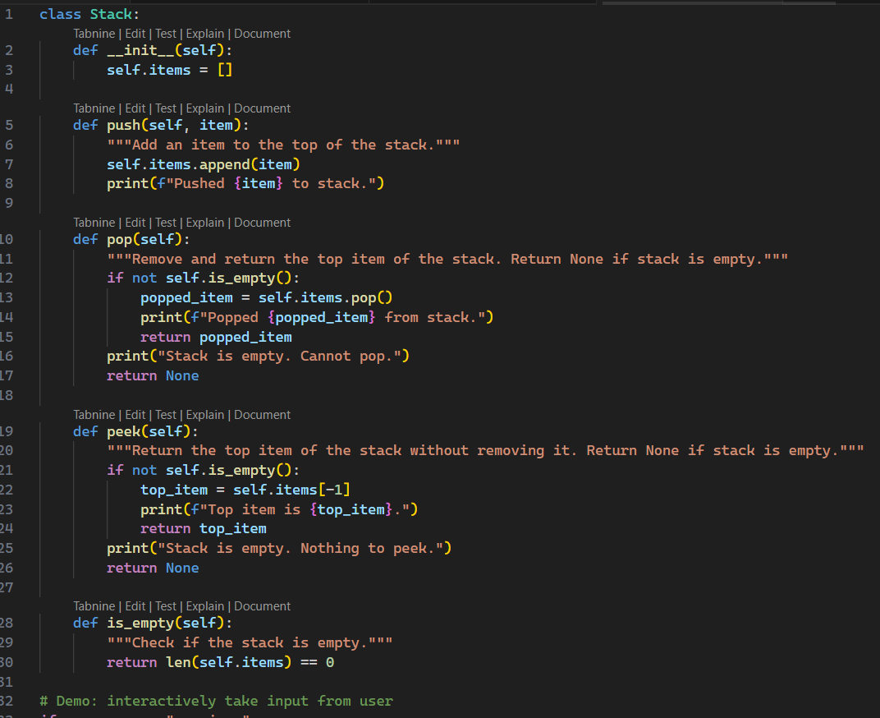
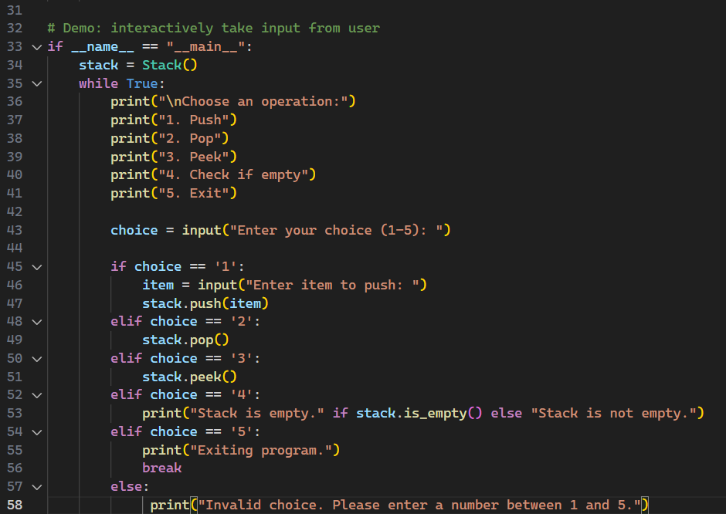

Output Result:
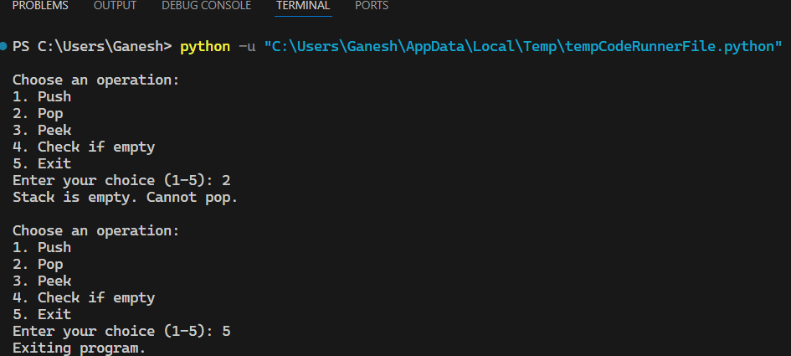

Test Data-2:
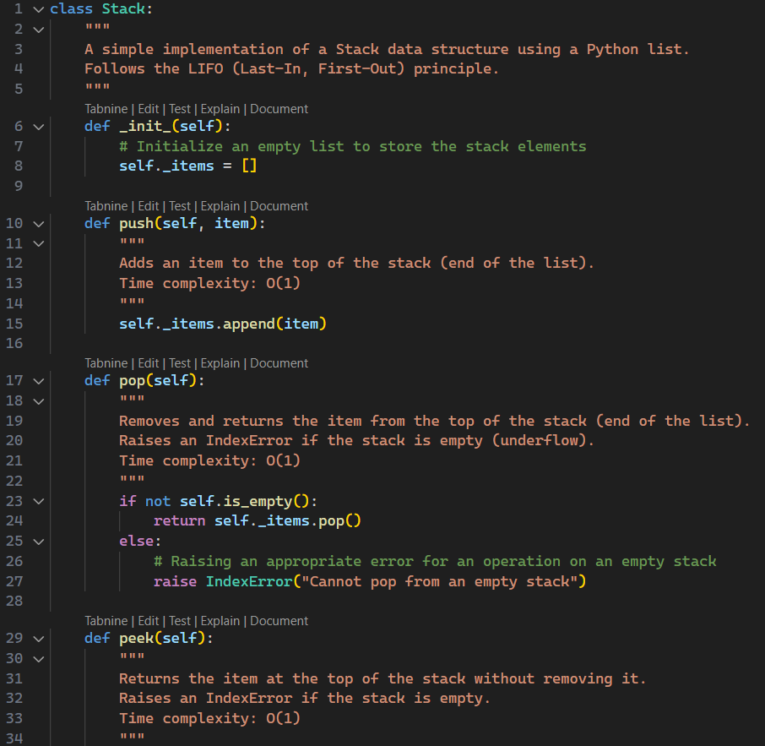
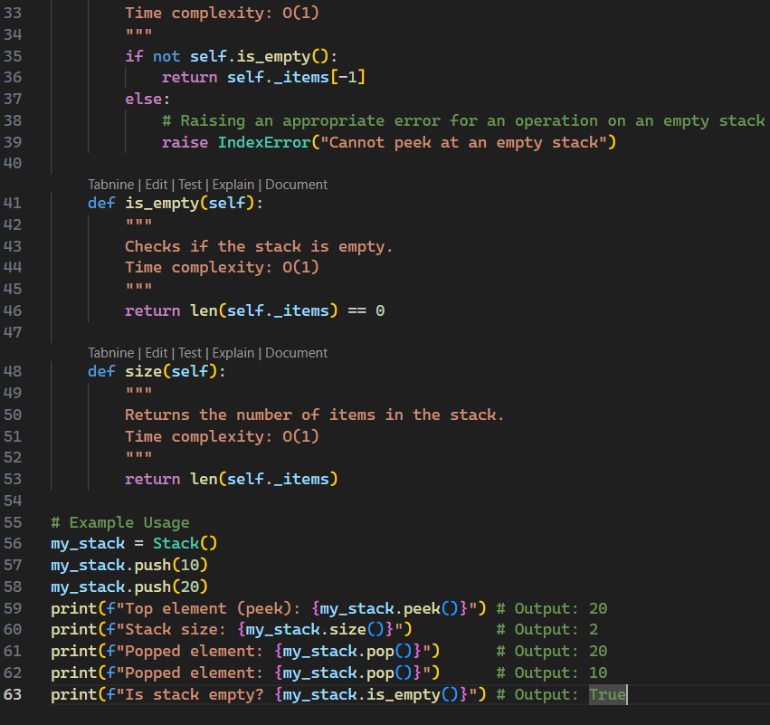
Example Usage: my_stack = Stack()
my_stack.push(10)
my_stack.push(20)
print(f"Top element (peek): {my_stack.peek()}") # Output: 20
print(f"Stack size: {my_stack.size()}") # Output: 2
print(f"Popped element: {my_stack.pop()}") # Output: 20
print(f"Popped element: {my_stack.pop()}") # Output: 10
print(f"Is stack empty? {my_stack.is_empty()}") # Output: True

Edge Case Handling and Testing:
Edge cases are critical for any data structure, especially operations on an empty or full stack.
- POP():
Condition: Empty Stack (Underflow).
Expected Behavior: It should raise an Exception(e.g., IndexError).
Implementation Check: Handled: The pop method checks if not self.is_empty(): and explicitly raises IndexError (“Cannot pop from an Empty stack”) otherwise.

- PEEK():
Condition: Empty Stack.
Expected Behavior: It should raise an Exception(e.g., IndexError).
Implementation Check: Handled: The peek method checks if not self.is_empty(): and explicitly raises IndexError (“Cannot peek at an Empty stack”) otherwise.

- PUSH():
Condition: Empty Stack.
Expected Behavior: It should successfully add the first element.
Implementation Check: Handled: Python’s list append works correctly, making the list non-empty and setting the element as the new top.

- PUSH():
Condition: Full Stack (Overflow)
Expected Behavior: It should either raise an exception or dynamically resize.
Implementation Check: Handled: Python’s list is dynamically sized and automatically handles resizing, preventing a practical overflow for typical limits.

Edge Case Test Code:
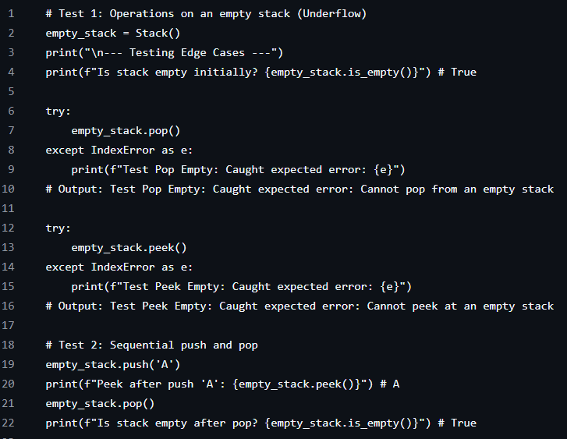

Explanation and Improvements:
- Robust Error Handling: The pop() and peek() methods include explicit checks(if not self.is_empty();) to prevent stack underflow. Instead of letting the list.pop() or indexing raise a generic error, the class catches this condition and raises a descriptive IndexError, which provides a clearer indication of the problem to the user of the class.
- Auxiliary Methods: Added is_empty() and size() methods. It provides a clean way for both the internal methods(pop, pee) and external user code to check the state of the stack.

Q2. Refactor a poorly commented Python function using an AI assistant for automatic documentation. Evaluate clarity and completeness versus manual comments.
(Each question carries 5 marks)

Solution:
The AI-generated documentation in calculate_factorial is definitively superior in both clarity and completeness when compared to the initial poor manual comments in the fact function. It standardizes the code, makes it easy to understand and use, and explains the core logic.
Prompt:
The first function should be a simple loop-based implementation called fact(n) that returns 'Invalid' if the input is negative. The second function should be called calculate_factorial(n) with type hints and a docstring. It should handle negative inputs by returning 'Invalid', handle the base case where 0! = 1, and otherwise compute the factorial using multiplication."

Feature | calculate_factorial (AI-Generated) | fact (Poor Manual)
Function Name | Highly Clear (calculate_factorial) | Poor (fact)
Docstring | Excellent. Provides a summary, defines the mathematical concept (n!), and uses structured sections (Parameters, Returns). | None.
Type Hints | Excellent. Specifies input (int) and output (`int | str`) types.
Inline Comments | Clear. Explain the reason for the code (e.g., # Handle the base case: Factorial of 0 is 1.) | Vague. Only mark sections (e.g., # check, # start, # loop).

Input Code:
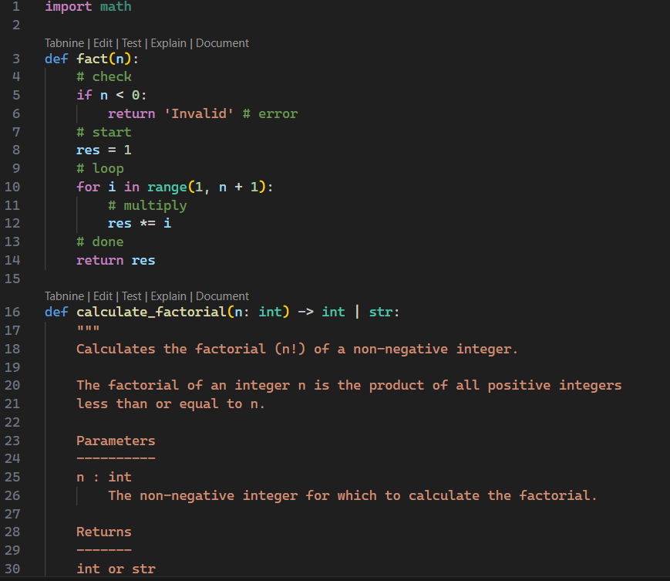
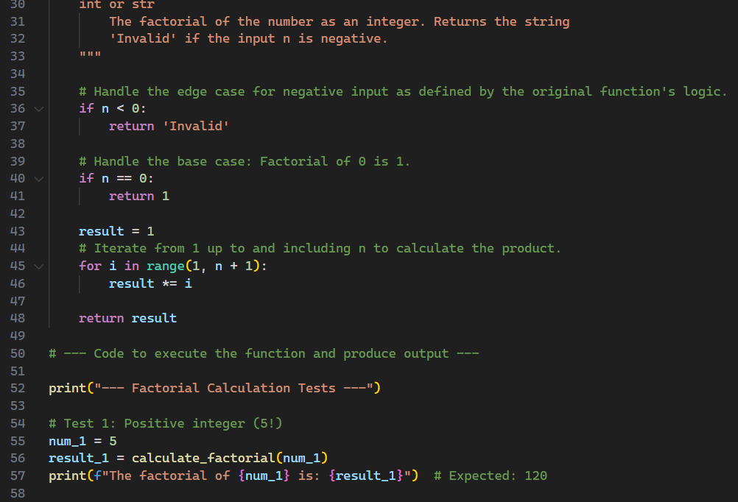
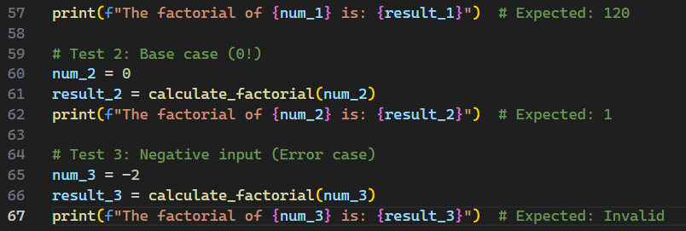

Output Result:
