AIPP LAB 18
Name: ANUSHA BHUKYA
Hall Ticket No.: 2505B02112
Date: 8/12/2025 (Week 7)
_____________________________________________
Completed this Assignment using VS – Gemini Al Integration.
Task 1:
Translate a Simple Program (Python → JavaScript)
CODE:
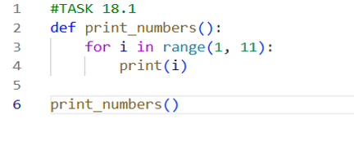
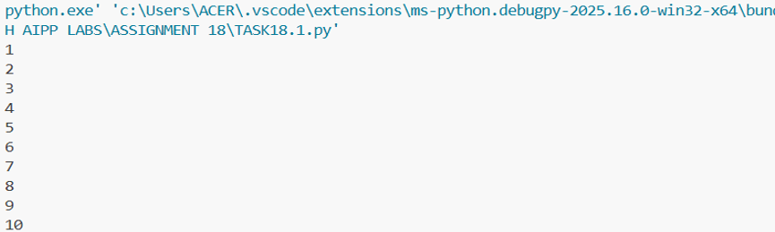

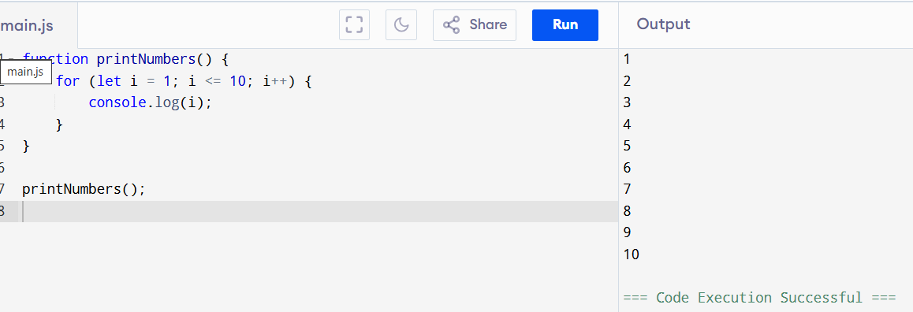
Task 2:
Convert Conditional Statements (Java → Python)
CODE:
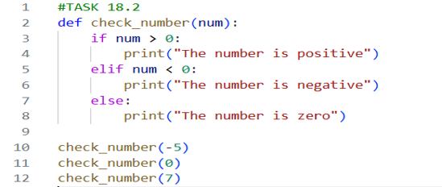
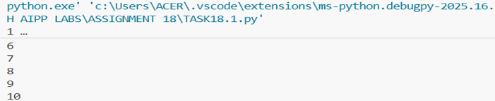
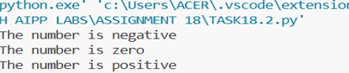
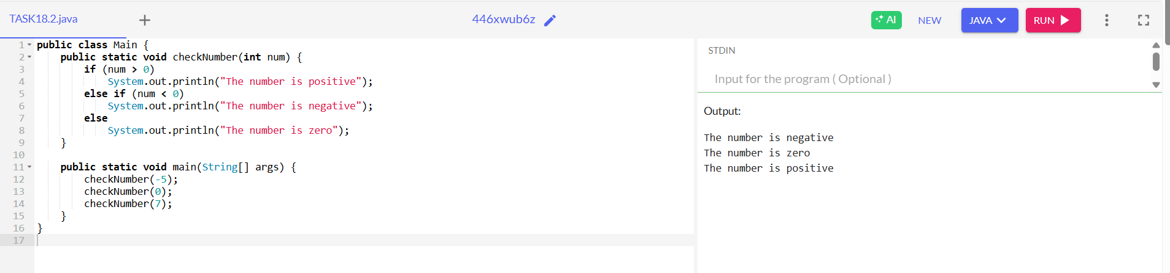
Task 3:
Translate Recursive Function (Python → C++)
CODE:
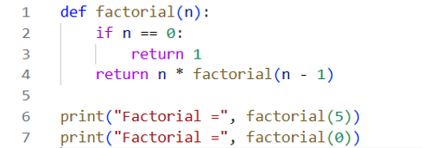
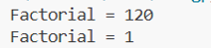
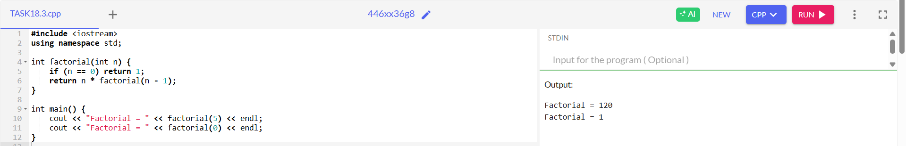
Task 4:
Data Structures with Functions (JavaScript → Python)
CODE:
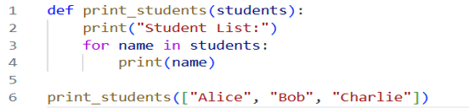
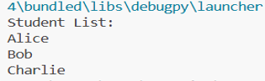
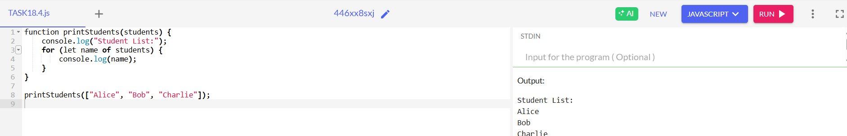
Task 5:
Class & Object Translation (Python → Java)
CODE:

