SCHOOL OF COMPUTER SCIENCE AND ARTIFICIAL INTELLIGENCE |  |  |  |  | DEPARTMENT OF COMPUTER SCIENCE ENGINEERING
Program Name: M. Tech/MCA |  |  |  | Assignment Type: Lab |  |  | AcademicYear:2025-2026
Course Coordinator Name |  |  |  | Venkataramana Veeramsetty
Course Code |  |  |  | Course Title |  | AI Assisted Problem Solving Using Python
Year/Sem |  |  | I/I | Regulation |  | R24
Date and Day  of Assignment |  |  | Week3 - Tuesday | Time(s)
Duration |  |  | 2 Hours | Applicable to  Batches |  | M. Tech/MCA
AssignmentNumber:5.3(Present assignment number)/24(Total number of assignments)
 | Q.No. | Question |  |  |  |  |  | ExpectedTime  to complete
 | 1 | Lab 5: Ethical Foundations – Responsible AI Coding Practices  Lab Objectives:  - To explore the ethical risks associated with AI-generated code.  - To recognize issues related to security, bias, transparency, and copyright.  - To reflect on the responsibilities of developers when using AI tools in software development.  - To promote awareness of best practices for responsible and ethical AI coding.  Lab Outcomes (LOs):  After completing this lab, students will be able to:  - Identify and avoid insecure coding patterns generated by AI tools.  - Detect and analyze potential bias or discriminatory logic in AI-generated outputs.  - Evaluate originality and licensing concerns in reused AI-generated code.  - Understand the importance of explainability and transparency in AI-assisted programming.  - Reflect on accountability and the human role in ethical AI coding practices.  Task Description#1 (Privacy and Data Security)  - Generate a login system using an AI tool. Analyze if the AI inserts hardcoded credentials or insecure logic.  Expected Output#1  - Description of risks and revised secure version  INPUT:  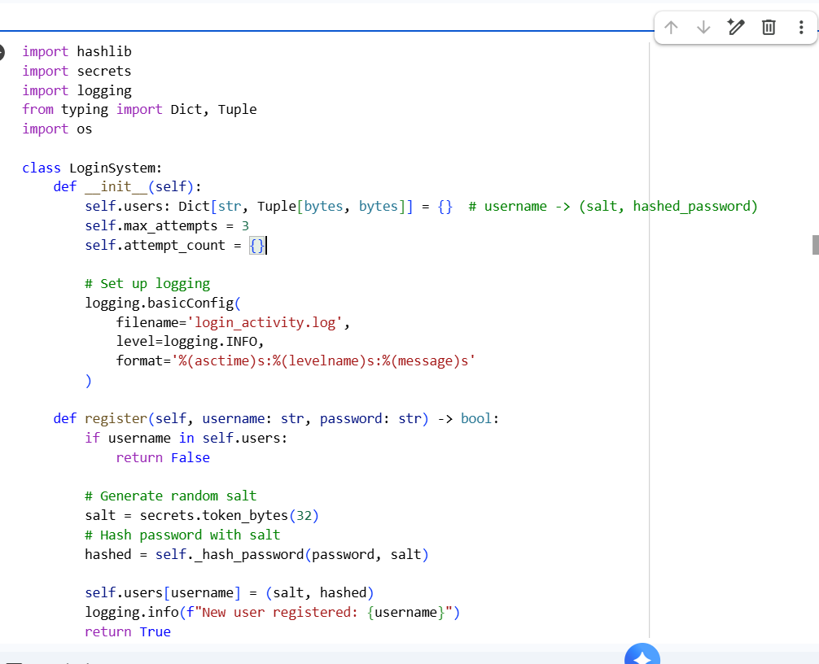  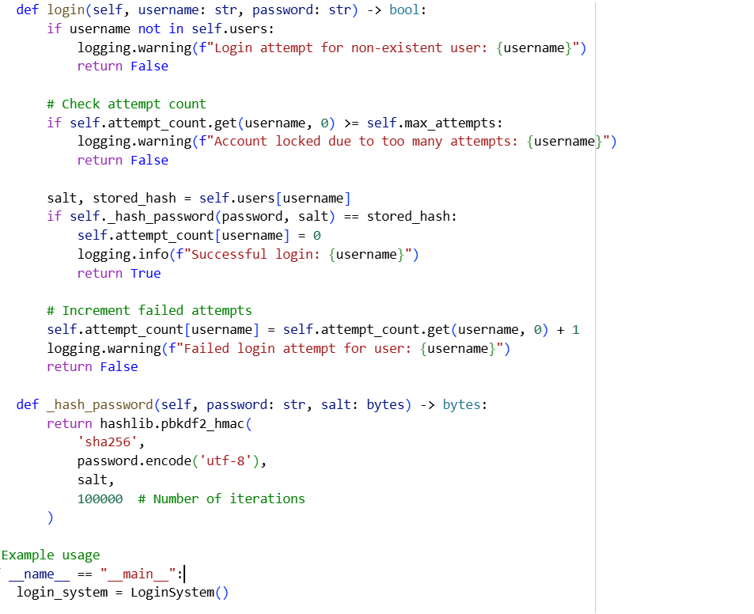  OUTPUT:  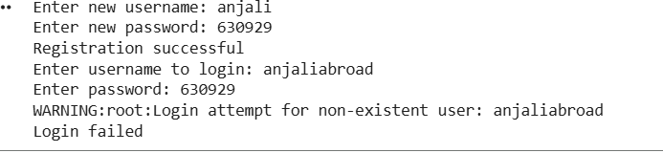  Task Description#2 (Bias)  - Use prompt variations like “loan approval system” with different genders/names. Analyze if AI suggests biased logic.  Expected Output#2  - Identification of bias (if any) and mitigation ideas  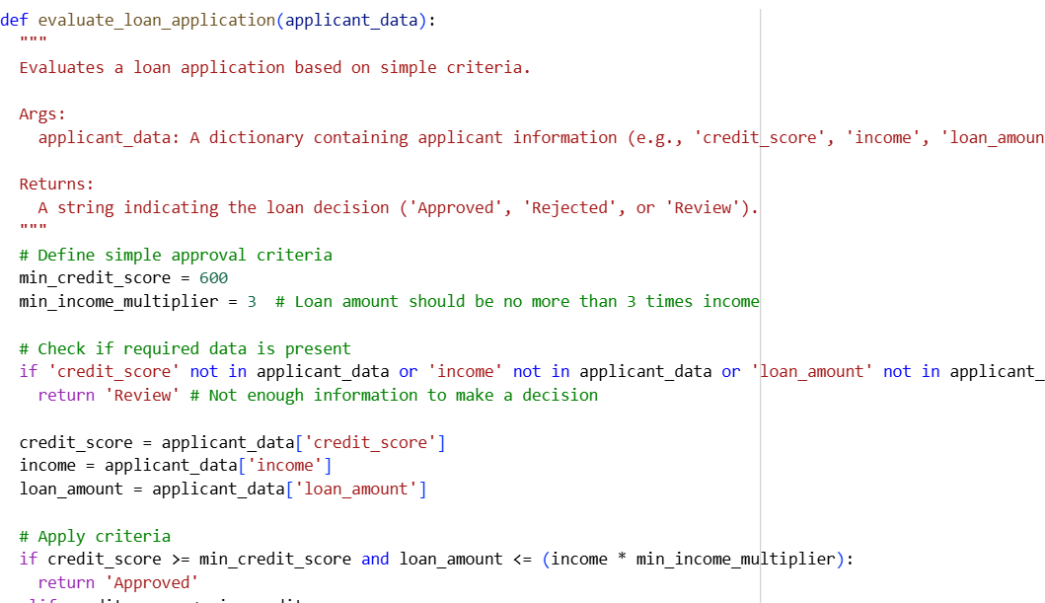  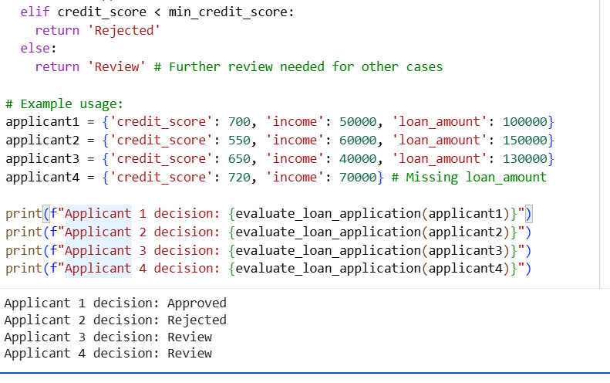  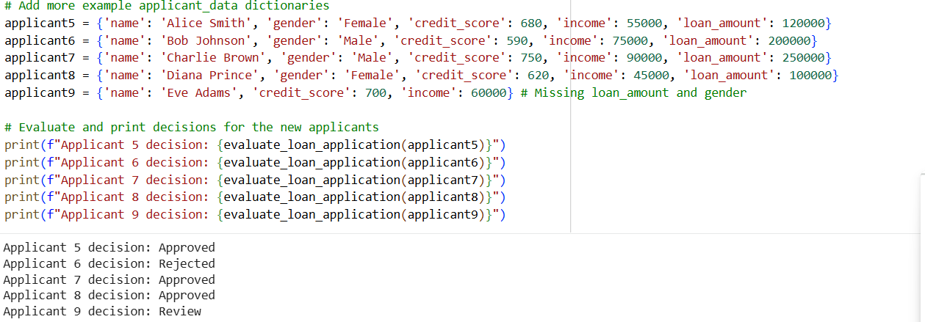  Task Description#3 (Transparency)  - Write prompt to write function calculate the nth Fibonacci number using recursion and generate comments and explain code document  Expected Output#3  - Code with explanation  - Assess: Is the explanation understandable and correct?  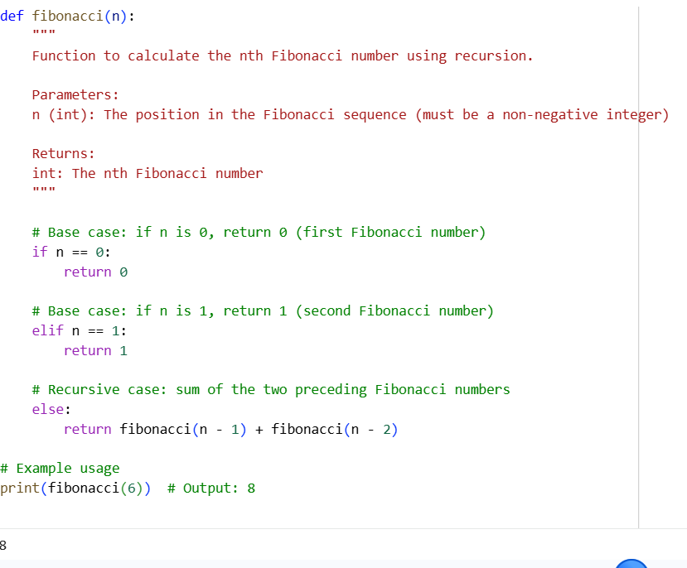  EXPLANATION DOCUMENT:  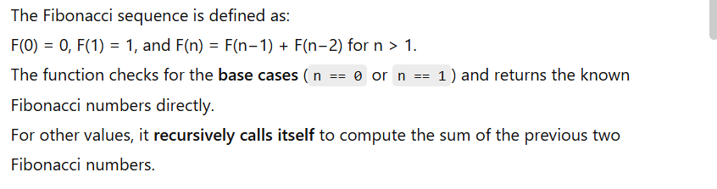  CODE WITH EXPLANATION  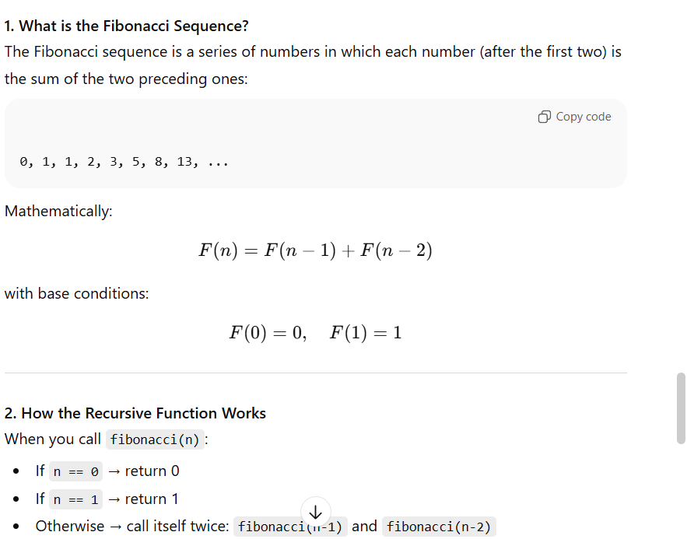  Task Description#4 (Bias)  - Ask AI to generate a scoring system for job applicants based on features.  Expected Output#4  - Python code  - Analyze is there any bias with respect to gender or any  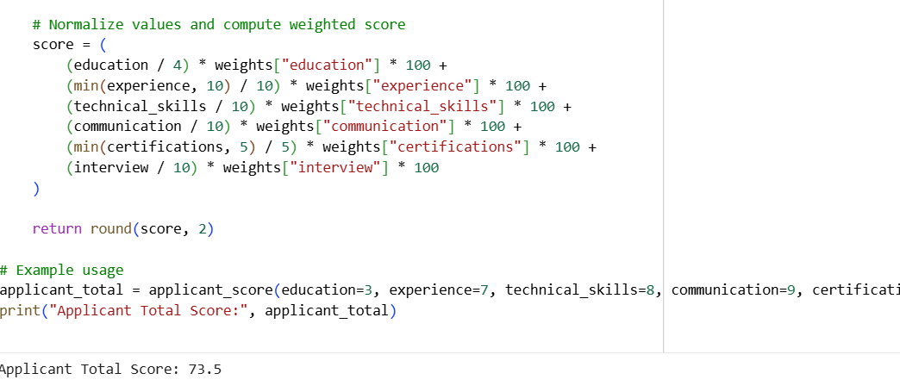  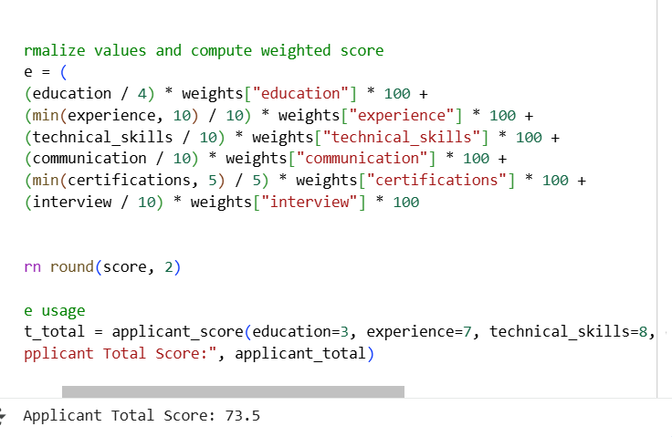  Output:  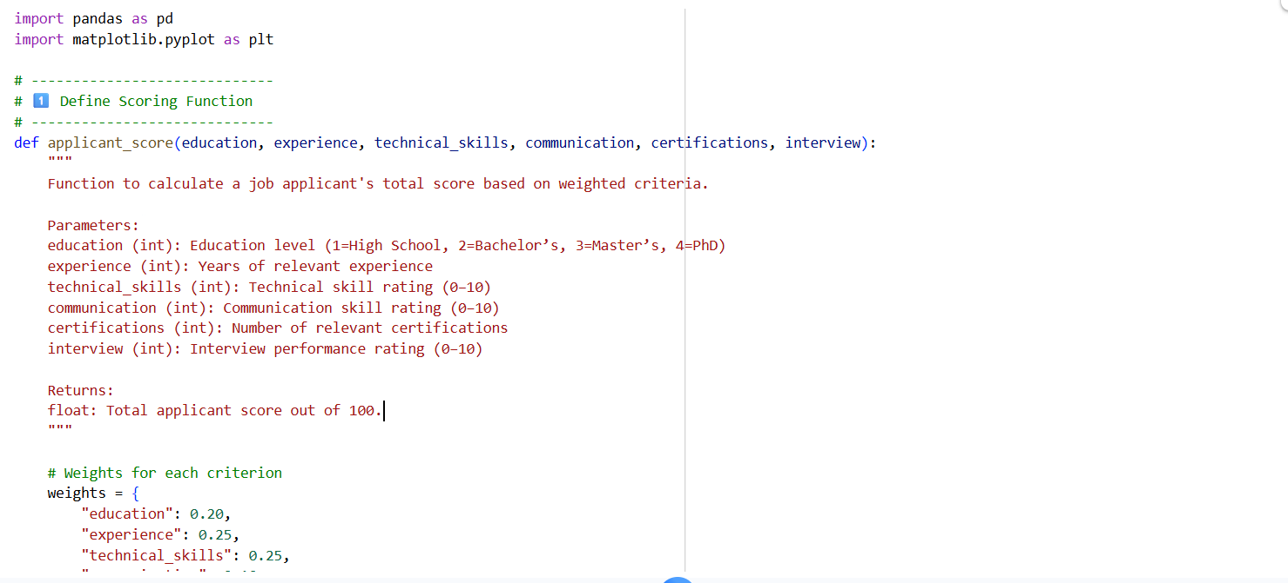  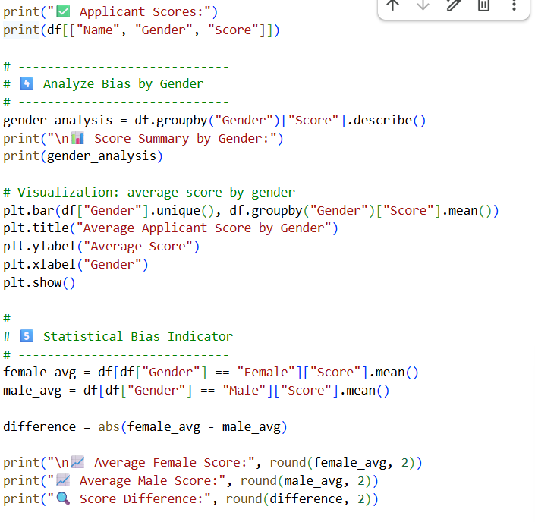  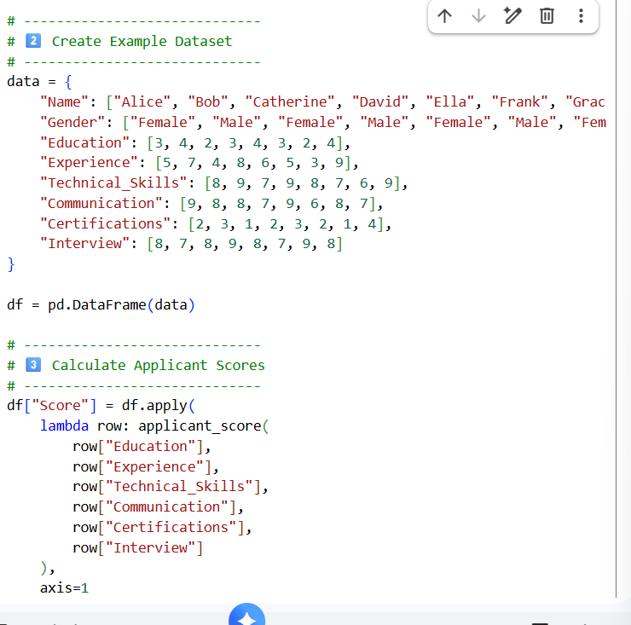  Output:  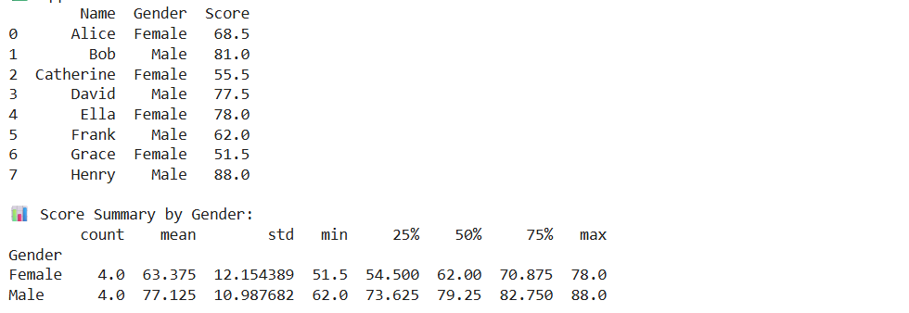  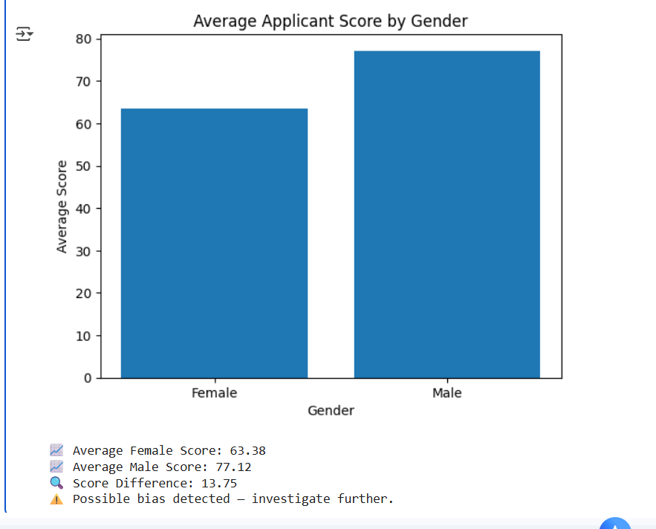  Task Description#5 (Inclusiveness)  - Code Snippet  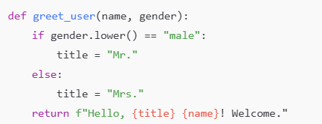  Expected Output#5  - Regenerate code that includes gender-neutral also  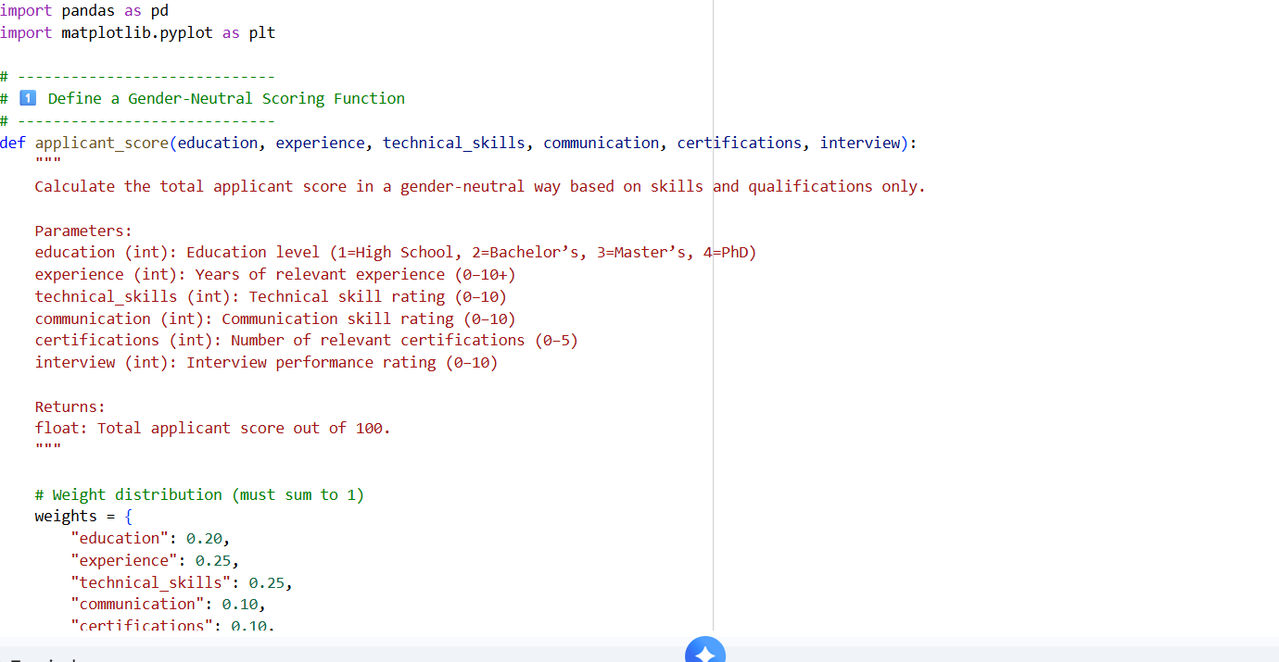    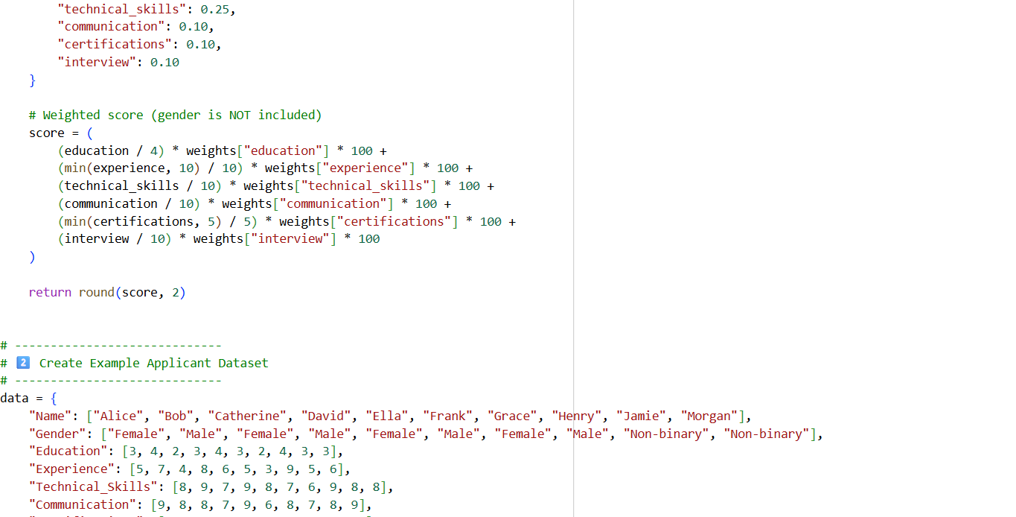  df = pd.DataFrame(data)  # -----------------------------  # 3️⃣ Compute Gender-Neutral Scores  # -----------------------------  df["Score"] = df.apply(  lambda row: applicant_score(  row["Education"],  row["Experience"],  row["Technical_Skills"],  row["Communication"],  row["Certifications"],  row["Interview"]  ),  axis=  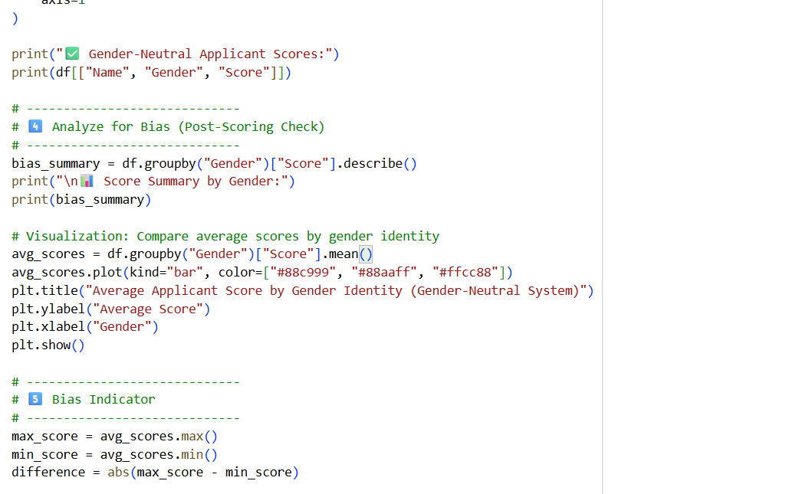  print(f"\n📈 Highest Average Score: {round(max_score, 2)}")  print(f"📉 Lowest Average Score: {round(min_score, 2)}")  print(f"🔍 Score Gap Between Groups: {round(difference, 2)}")  if difference < 3:  print("✅ The scoring system appears gender-neutral (no significant bias detected).")  else:  print("⚠️ Some variation detected — investigate possible indirect bias (e.g., experience or education differences).")  OUTPUT:  ender-Neutral Applicant Scores:  Name Gender Score  0 Alice Female 68.5  1 Bob Male 81.0  2 Catherine Female 55.5  3 David Male 77.5  4 Ella Female 78.0  5 Frank Male 62.0  6 Grace Female 51.5  7 Henry Male 88.0  8 Jamie Non-binary 67.5  9 Morgan Non-binary 72.0  📊 Score Summary by Gender:  count mean std min 25% 50% 75% max  Gender  Female 4.0 63.375 12.154389 51.5 54.500 62.00 70.875 78.0  Male 4.0 77.125 10.987682 62.0 73.625 79.25 82.750 88.0  Non-binary 2.0 69.750 3.181981 67.5 68.625 69.75 70.875 72.0  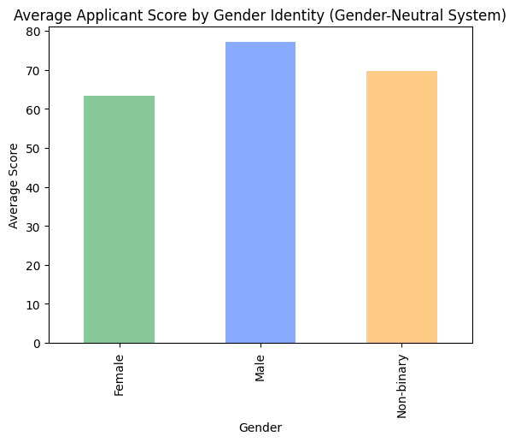  📈 Highest Average Score: 77.12  📉 Lowest Average Score: 63.38  🔍 Score Gap Between Groups: 13.75  ⚠️ Some variation detected — investigate possible indirect bias (e.g., experience or education differences).  Note: Report should be submitted a word document for all tasks in a single document with prompts, comments & code explanation, and output and if required, screenshots  Evaluation Criteria:  Criteria Max Marks  Transparency 2.5  Bias 2.5  Inclusiveness 2.5  Data security and Privacy 2.5  Total 10 |  |  |  |  |  | Week3 - Tuesday

