AIPP LAB 17
Name: ANUSHA BHUKYA
Hall Ticket No.: 2505B02112
Date: 1/12/2025 (Week 6)
_____________________________________________
Completed this Assignment using Google Colab – Gemini Al Integration.
Task 1:
Social Media Data Cleaning
Clean raw social media posts dataset.
Instructions:
- Remove stopwords, punctuation, and special symbols from post text.
- Handle missing values in likes and shares columns.
- Convert timestamp to datetime and extract features (hour, weekday).
- Detect and remove spam/duplicate posts.
CODE:
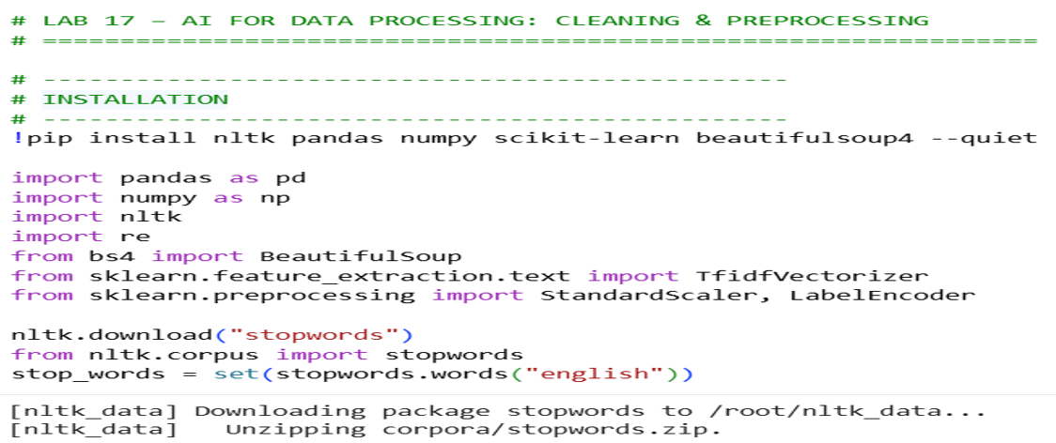
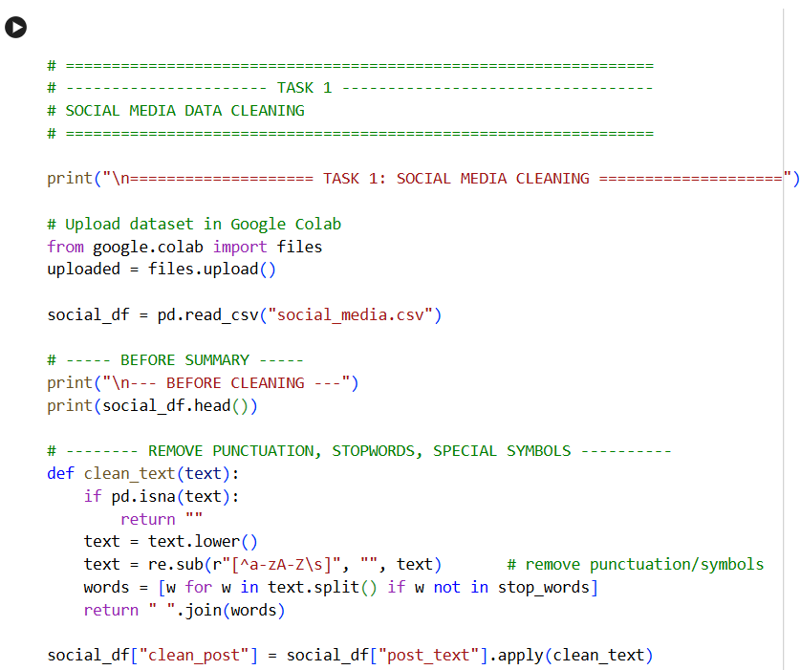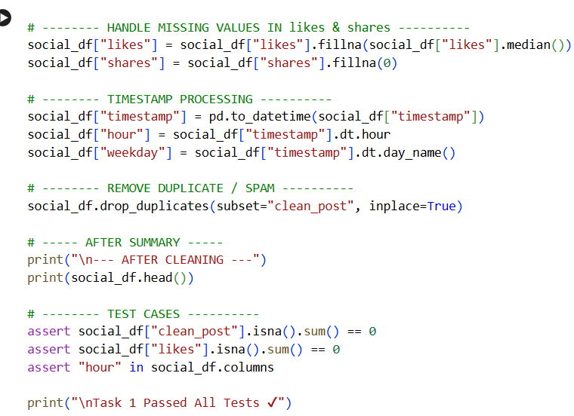
OUTPUT:
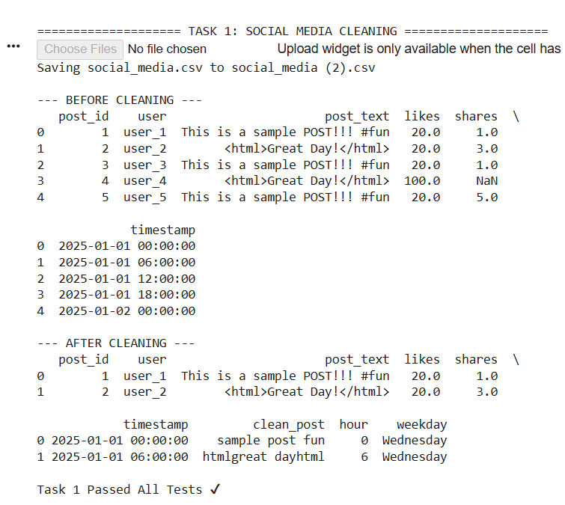
Task 2:
Financial Data Preprocessing
Preprocess a stock market dataset.
Instructions:
- Handle missing values in closing_price and volume.
- Create lag features (1-day, 7-day returns).
- Normalize volume column using log-scaling.
- Detect outliers in closing_price using IQR method.
CODE:
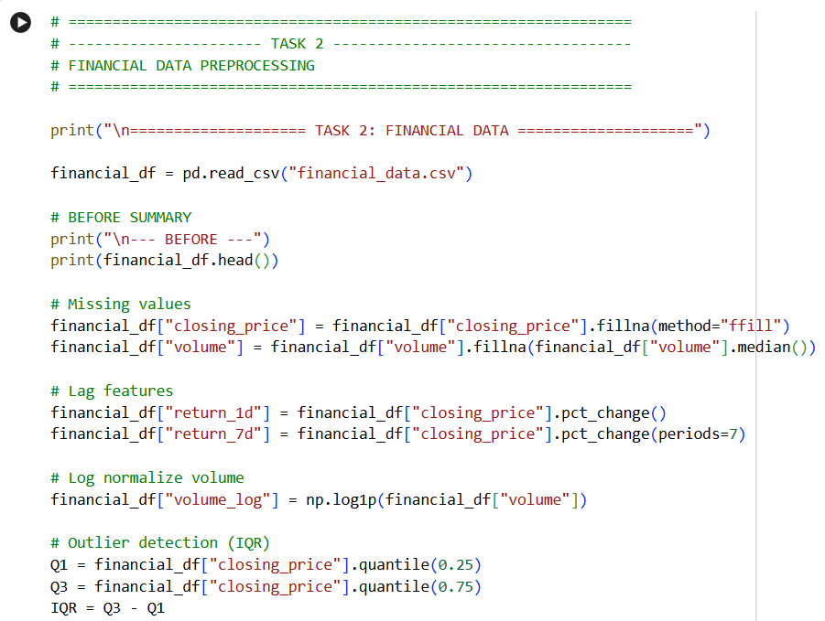
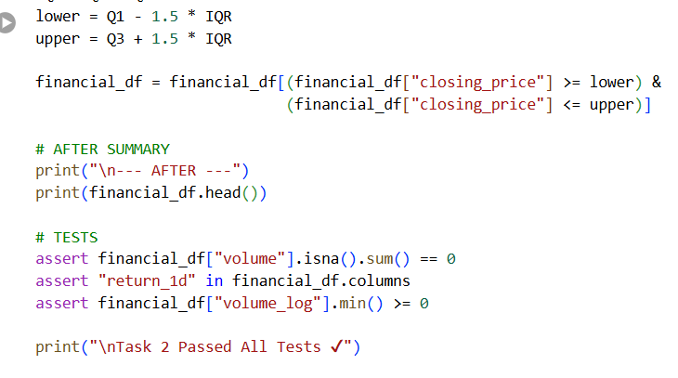OUTPUT:
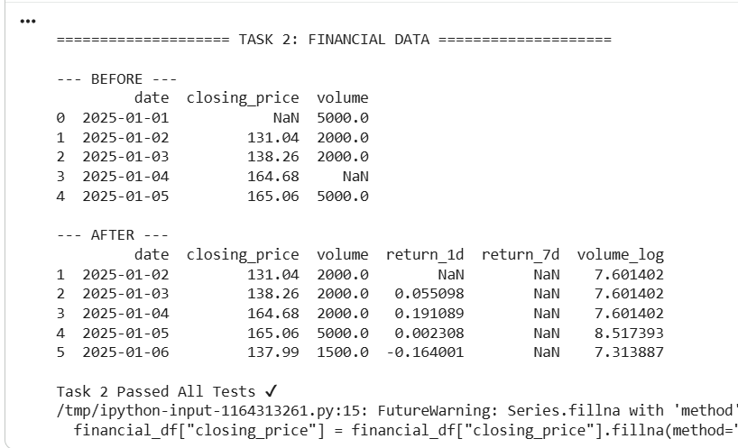
Task 3:
IoT Sensor Data Preparation
Clean and preprocess IoT temperature and humidity logs.
Instructions:
- Handle missing values using forward fill.
- Remove sensor drift (apply rolling mean).
- Normalize readings using standard scaling.
- Encode categorical sensor IDs.
CODE:
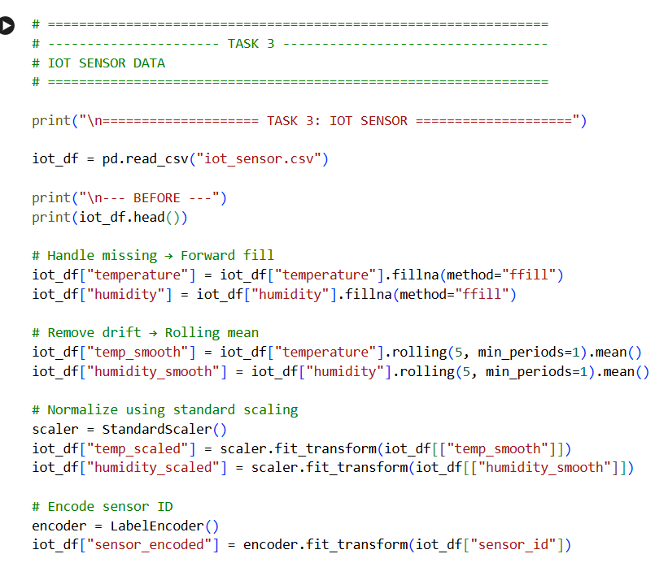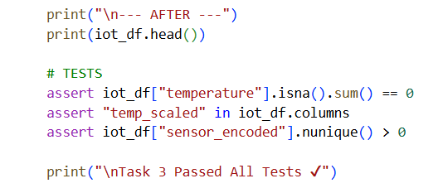

OUTPUT:
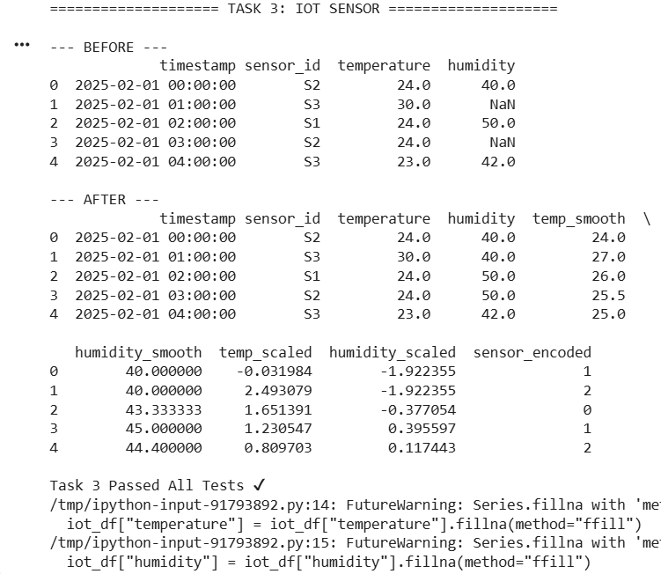
Task 4:
Real-Time Application: Movie Reviews Data Cleaning
A streaming platform wants to analyze customer reviews.
Instructions:
- Standardize text (lowercase, remove HTML tags).
- Tokenize and encode reviews using AI-assisted methods (TF-IDF or
embeddings).
- Handle missing ratings (fill with median).
- Normalize ratings (0–10 → 0–1 scale).
- Generate a before vs after summary report.
CODE:
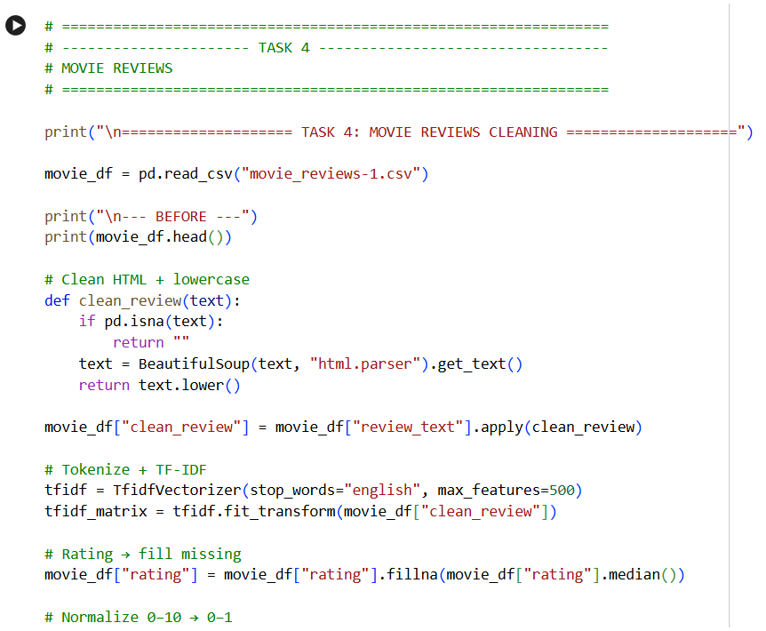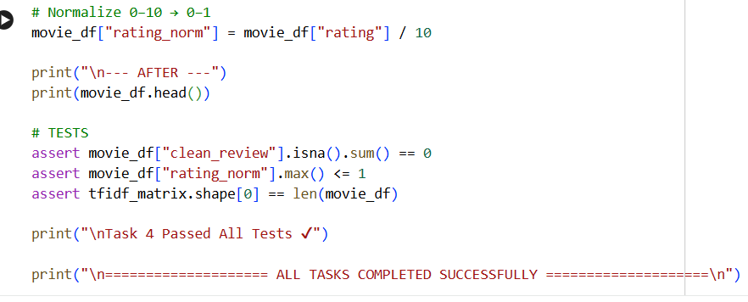OUTPUT:


