Game Design Document

Fill up the following document

1. Write the title of your project.

Surviving in Space

1. What is the goal of the game?

The goal of the game is to collect as many supplies and oxygen tanks by the player as possible to ensure the survival of the player character.

1. Write a brief story of your game.

Kara has been travelling in space for many days. While searching for

new specimens of rocks on planets, she loses connection with her

spaceship. She has a small amount of oxygen with her, and

despearatly needs food supplies and oxygen to survive, while saving herself from the dangerous aliens.

1. Which are the playing characters of this game?

* Playing characters are the ones who respond to the user based on the input from the user.
* Cars, monkeys, dinos, wizards, etc., are the playing characters in the game.

|  |  |  |
| --- | --- | --- |
| Number | Character Name | What can this character do? |
| 1 | Kara, an astronaut | She can move about in space with the help of arrow keys |
| 2 |  |  |
| 3 |  |  |
| 4 |  |  |
| 5 |  |  |
| 6 |  |  |
| 7 |  |  |
| 8 |  |  |

1. Which are the Non-Playing Characters of this game?

* Non-Playing characters are the ones that don't have an action or behavior when the user interacts with the game.
* Hurdles, stones, bananas, coins, etc., are non-playing characters in the game.

|  |  |  |
| --- | --- | --- |
| Number | Character Name | What can this character do? |
| 1 | Supplies | It can randomly come from a direction, it needs to be collected by Kara |
| 2 | Oxygen tanks | It can randomly come from a direction, it needs to be collected by Kara |
| 3 | Aliens | They can come randomly from any way near the player, and she needs to avoid them |
| 4 |  |  |
| 5 |  |  |
| 6 |  |  |
| 7 |  |  |
| 8 |  |  |

Draw your imagination of this game. What does this game look like?

* Draw the game either on your computer or on paper.
* Add images of the game scenes to show each of the playing and non-playing characters at least once.

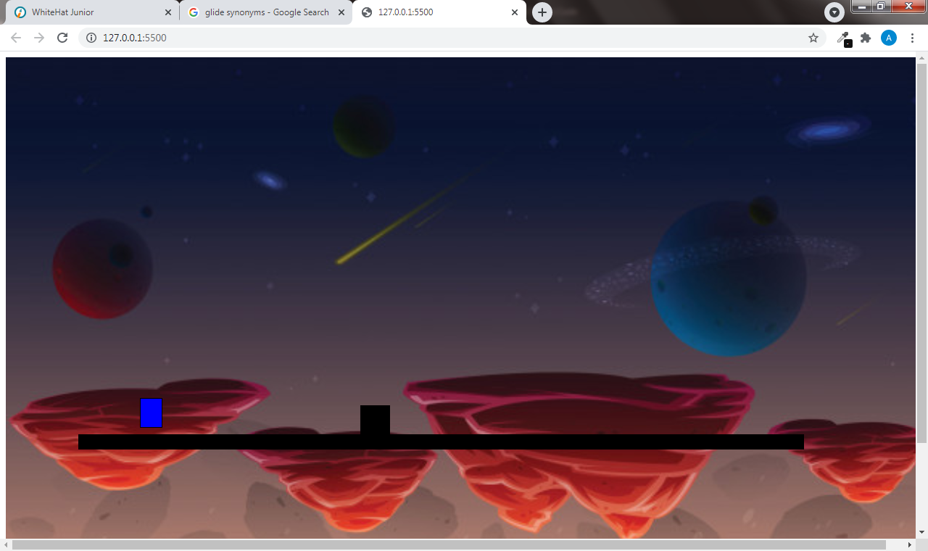

How do you plan to make your game engaging?

I plan to make my game more engaging by increasing the speed and diffculty of the game as it proceeds. I also plan to introduce new obstacles as the game reaches a certain stage.