SupplyPrescript
Closed-Loop Prescriptive Analytics – Supply Chain Performance
Submitted By: Chukka Reddy Anusha | Date: 15 Aug 2026
Professional Data Analysis & Business Intelligence Project Report
Data Analysis Workstream

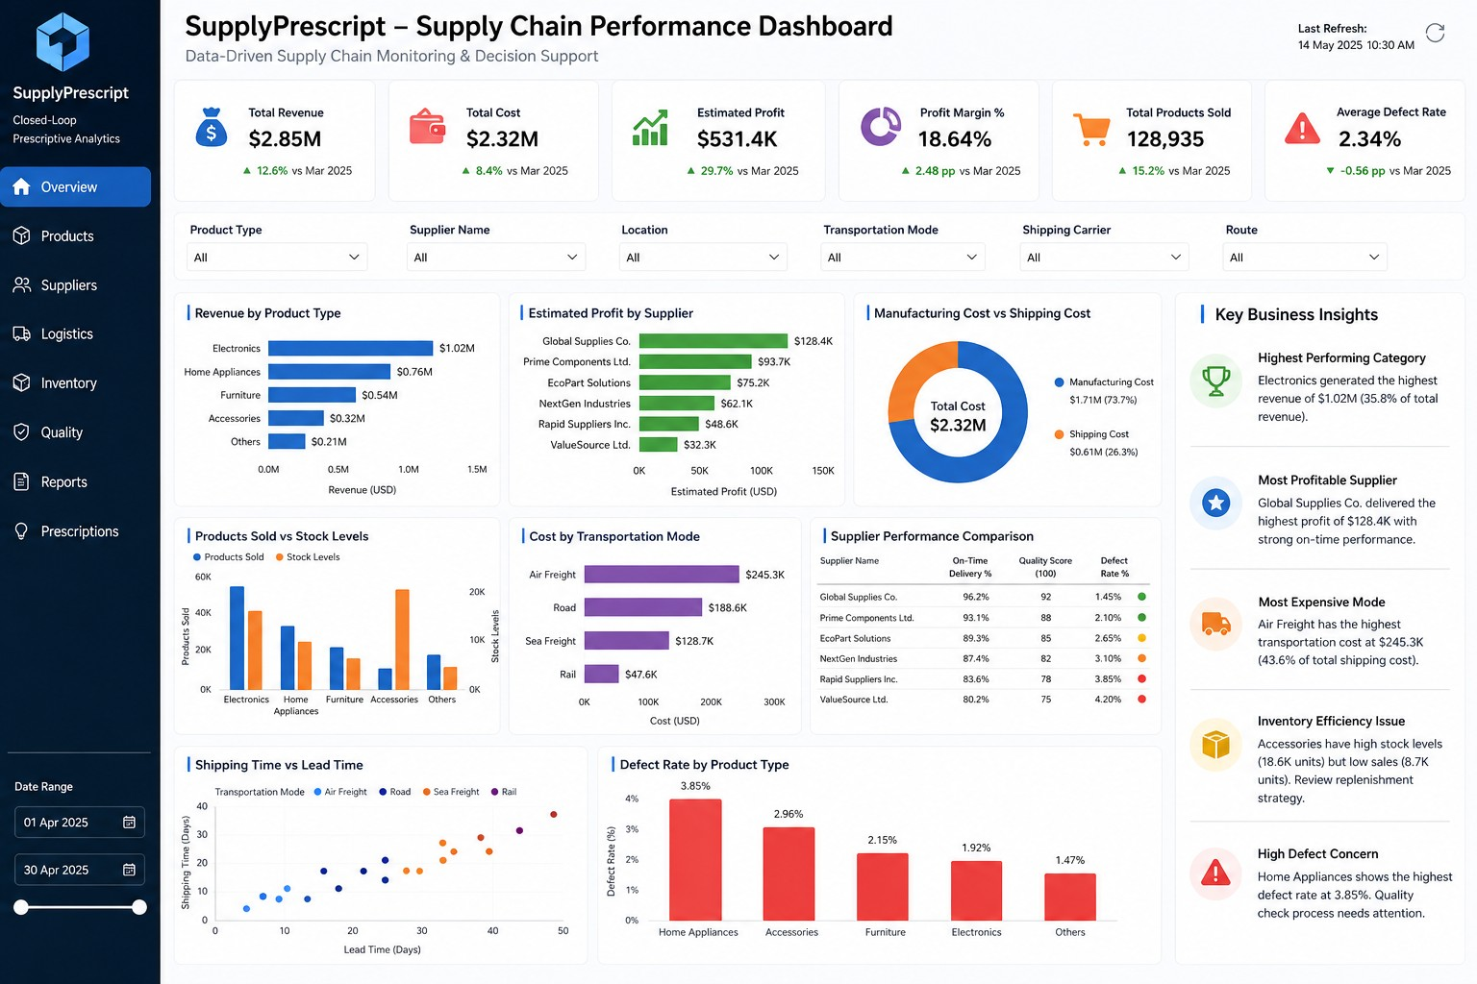
Figure 1. SupplyPrescript – Supply Chain Performance Dashboard

1. Executive Summary
SupplyPrescript is a supply-chain analytics project designed to convert operational data into actionable business insights and decision support. The data-analysis workstream focuses on understanding the structure and quality of the supply-chain dataset, preparing reliable analytical features, identifying relationships among operational variables, and translating the results into business-oriented insights.
The work was organized as a sequence of Jupyter Notebooks so that each stage can be reviewed independently and committed to GitHub as project progress. The completed analysis includes data loading, data cleaning, exploratory data analysis, feature engineering, correlation analysis, and business insights. The outputs are then represented through a Power BI dashboard for management-style monitoring.

Project Objectives
- Understand the supply-chain dataset and its operational variables.
- Clean and prepare the data for reliable analysis.
- Perform exploratory analysis to identify patterns, trends, and unusual values.
- Create meaningful derived features for supply-chain performance analysis.
- Study relationships between numerical variables through correlation analysis.
- Convert analytical findings into practical business insights.
- Present key performance indicators and operational findings through a professional Power BI dashboard.

Expected Value
The overall workflow supports data-driven monitoring of revenue, costs, profitability, inventory, shipping, supplier performance, production, and product quality. It provides a foundation for later predictive and prescriptive components of the wider SupplyPrescript solution.
2. Project Context and Dataset
The project uses a supply-chain dataset provided through Kaggle for analysis and experimentation. The dataset contains operational information covering products, suppliers, inventory, production, shipping, transportation, quality, and cost-related variables.

Key Dataset Attributes
Category | Representative Fields | Business Purpose
Product | Product type, SKU, price, availability | Product-level performance and sales analysis
Sales & Revenue | Products sold, revenue generated | Measure demand and revenue contribution
Inventory | Stock levels, order quantities | Assess inventory position and replenishment
Supplier | Supplier name, location, lead time | Compare supplier performance
Logistics | Shipping time, carrier, route, transportation mode | Study delivery and transportation efficiency
Production | Production volumes, manufacturing lead time | Understand production operations
Cost | Shipping costs, manufacturing costs, route costs | Analyze cost drivers
Quality | Inspection results, defect rates | Monitor product quality and defects

Data Analysis Workflow
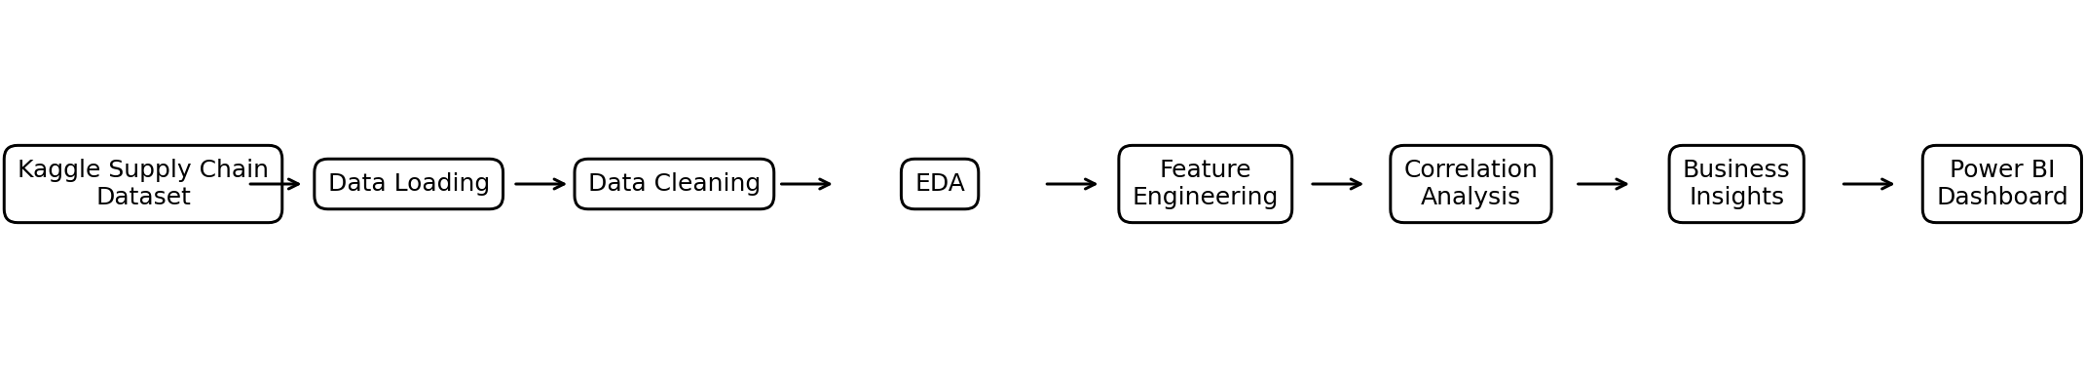
Figure 2. End-to-end workflow used for the data-analysis workstream
The workflow intentionally separates analytical stages. This makes the project easier to maintain, review, reproduce, and connect with the team's machine-learning and dashboard work.
3. Data Analysis Implementation

3.1 Notebook Structure
Notebook | Purpose | Main Outputs
01_data_loading.ipynb | Load and inspect the raw dataset. | Head, info, shape, descriptive statistics
02_data_cleaning.ipynb | Prepare reliable analytical data. | Missing-value checks, duplicates, data-type handling
03_EDA.ipynb | Explore distributions and business patterns. | Summary statistics and exploratory visualizations
04_feature_engineering.ipynb | Create useful derived metrics. | Efficiency, cost, and performance features
05_correlation_analysis.ipynb | Study numerical relationships. | Correlation matrix and heatmap
06_business_insights.ipynb | Translate analysis into business findings. | Key findings and recommendations

3.2 Data Loading
The first notebook establishes the analytical dataset by importing pandas, reading the CSV file, and inspecting its basic structure. The analysis checks the first records, data types, dimensions, and descriptive statistics before any transformation is performed.

3.3 Data Cleaning
- Check for missing values and determine whether they require treatment.
- Identify duplicate records and remove duplicates where appropriate.
- Review column names and data types for consistency.
- Check numerical fields for invalid or unexpected values.
- Prepare a clean dataframe for downstream analysis.

3.4 Exploratory Data Analysis
EDA examines product, revenue, supplier, inventory, logistics, production, cost, and quality variables. Visualizations help reveal high-performing categories, cost concentration, inventory patterns, delivery behavior, and quality concerns.
4. Feature Engineering and Correlation Analysis

4.1 Feature Engineering
Feature engineering converts raw operational fields into metrics that are easier to interpret from a business perspective. For SupplyPrescript, derived measures can be used to compare cost efficiency, sales efficiency, inventory efficiency, and profitability across products, suppliers, and logistics segments.
- Sales efficiency can relate products sold to production volume.
- Inventory efficiency can compare products sold with available stock.
- Total cost can combine relevant manufacturing and shipping cost components where the available fields support it.
- Profit-oriented measures can compare revenue against relevant operational costs.
- Derived metrics should be validated against the original columns before being used in reporting.

4.2 Correlation Analysis
Correlation analysis is used to understand linear relationships among numerical variables. A correlation matrix and heatmap provide a compact view of which variables move together and which variables have weaker relationships. These results help guide feature selection and business interpretation, but correlation is not treated as proof of causation.

Analytical Questions
- Which operational variables have strong relationships with revenue?
- How are production volume and products sold related?
- How do shipping time and lead time move together?
- Are cost variables strongly related to one another?
- Which variables may be useful for later predictive modelling?

Quality Checks
- Validate derived features against raw columns.
- Review extreme values and potential outliers.
- Avoid using leakage-prone variables in future predictive models without validation.
- Keep the analytical notebooks reproducible and clearly documented.
5. Power BI Dashboard
The Power BI dashboard is the visual business-intelligence layer of the project. It consolidates key performance indicators, interactive filters, operational charts, supplier comparisons, logistics analysis, quality metrics, and a business-insight panel into a single management-style view.

5.1 KPI Layer
- Total Revenue – summarizes revenue generated across the selected scope.
- Total Cost – summarizes relevant operational costs.
- Estimated Profit – provides a profit-oriented management measure.
- Profit Margin % – expresses profitability relative to revenue.
- Total Products Sold – monitors sales volume.
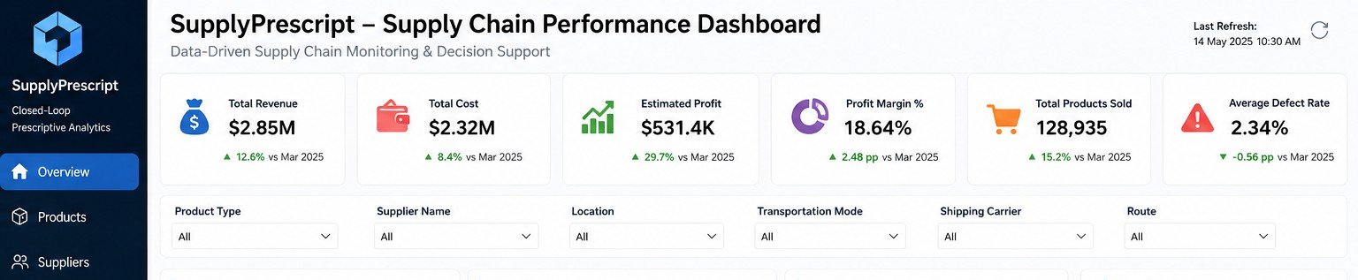
- Average Defect Rate – provides a high-level quality indicator.

Figure 3. KPI cards and interactive filter area from the supplied dashboard

5.2 Interactive Filters
The dashboard includes filters for product type, supplier name, location, transportation mode, shipping carrier, route, and date range. These controls allow users to move from a high-level overview to a more focused operational view.
6. Dashboard Charts and Business Interpretation
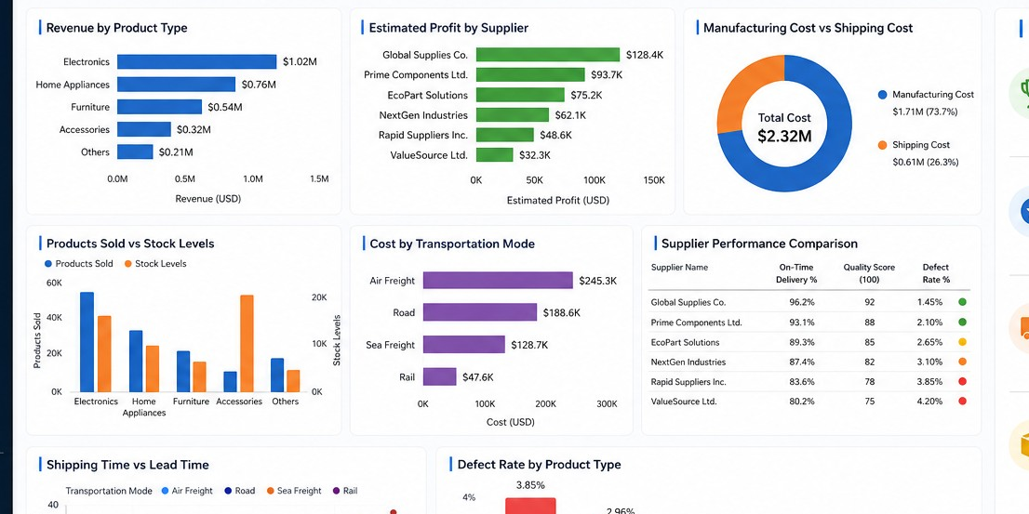
Figure 4. Main analytical charts in the SupplyPrescript dashboard

Charts Included
- Revenue by Product Type – compares revenue contribution across product categories.
- Estimated Profit by Supplier – compares supplier-level profitability.
- Manufacturing Cost vs Shipping Cost – shows the relative contribution of major cost components.
- Products Sold vs Stock Levels – compares demand activity with inventory position.
- Cost by Transportation Mode – highlights logistics cost concentration.
- Supplier Performance Comparison – combines supplier-level operational indicators.
- Shipping Time vs Lead Time – explores the relationship between delivery-related measures.
- Defect Rate by Product Type – compares quality performance across product categories.

Business Interpretation
The dashboard is designed to help a reviewer answer practical questions quickly: Which products generate the most revenue? Which suppliers are more profitable? Which transportation modes are expensive? Where are inventory levels potentially misaligned with sales? Which product categories show higher defect rates? Which supplier and logistics segments require further investigation?
These questions connect the exploratory analysis to management decision support and provide a clear bridge to the project's later predictive and prescriptive analytics components.
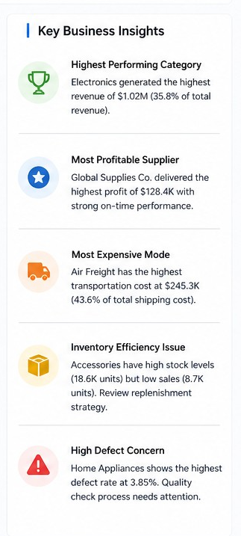
7. Key Business Insights and Recommendations

Figure 5. Business-insight panel from the supplied dashboard

Insight Areas
- Product performance: identify categories contributing the largest share of revenue or sales.
- Supplier performance: compare profitability, delivery performance, quality indicators, and defect rates.
- Transportation cost: identify expensive transportation modes and investigate route-level drivers.
- Inventory efficiency: compare stock levels with sales volume to identify potential overstock or understock situations.
- Quality management: identify product categories with elevated defect rates and prioritize quality review.

Recommended Actions
- Investigate high-cost transportation modes and evaluate alternative logistics strategies.
- Review supplier performance regularly using profitability, delivery, quality, and defect indicators.
- Use sales and stock-level relationships to support better replenishment decisions.
- Prioritize quality investigations for categories with consistently higher defect rates.
- Use the dashboard as a monitoring layer and connect validated analytical features to future predictive models.

8. GitHub and Project Organization
The project is organized so that analytical progress can be demonstrated through separate Jupyter Notebooks. Each notebook represents a meaningful stage of the workflow. GitHub commit history should reflect genuine development activity, with clear commit messages such as 'Completed EDA', 'Added data cleaning', 'Implemented feature engineering', and 'Added business insights'.
- Keep the six analysis notebooks in the repository.
- Include README.md with project purpose, workflow, setup, and outputs.
- Include requirements.txt listing the Python packages required for analysis.
- Place the Power BI dashboard file and preview image in a clearly named dashboard folder if permitted by the project/team rules.
- Do not upload the virtual environment folder.
- Use meaningful commits that accurately represent work completed on each day.

9. Conclusion and Future Scope
The SupplyPrescript data-analysis workstream establishes a structured foundation for supply-chain decision support. Starting from a raw Kaggle dataset, the work progresses through data loading, cleaning, exploratory analysis, feature engineering, correlation analysis, business interpretation, and Power BI visualization.
The resulting dashboard brings together financial, operational, logistics, inventory, supplier, and quality perspectives. This makes the project easier to communicate during reviews and provides a practical interface for stakeholders to investigate supply-chain performance.

Future Scope
- Develop and validate predictive models for relevant supply-chain outcomes.
- Compare baseline models with XGBoost where appropriate to the defined target variable.
- Add feature-importance analysis to explain model drivers.
- Develop an optimization layer that converts predictions into recommended actions.
- Introduce closed-loop feedback so that decisions and outcomes can be monitored over time.
- Deploy or integrate the final analytics pipeline with a production-style dashboard where feasible.

Final Deliverables
Deliverable | Status / Purpose
01_data_loading.ipynb | Dataset loading and initial inspection
02_data_cleaning.ipynb | Data quality and preparation
03_EDA.ipynb | Exploratory analysis and visualizations
04_feature_engineering.ipynb | Derived analytical features
05_correlation_analysis.ipynb | Relationship analysis
06_business_insights.ipynb | Business findings and recommendations
Power BI Dashboard | Interactive performance monitoring
README.md | Project overview and usage information
requirements.txt | Python dependency specification

This report documents the completed data-analysis contribution to SupplyPrescript and provides a professional reference for project reviews, GitHub documentation, and internship submission.

