**Exploratory Data Analysis**

**Report on Data Analysis of Bengaluru Traffic Dataset**

Submitted By –

Ahmed, Ayush, Anusha

2023UG000114, 2023UG000116, 2023UG000166

**GitHub URL:**

<https://github.com/Anusha751/eda-bangalore-traffic-analysis.git>

The subject that we’ve chosen for Exploratory Data Analysis is ‘**Bangalore Traffic**’.

**Problem Statement**: Analyzing Bengaluru traffic patterns and identifying solutions for traffic control.

**Goals**: The goal of this project is to perform an Exploratory Data Analysis on the Bangalore Traffic dataset, with a focus on finding insights related to traffic congestion, public transport usage, environmental impact, and compliance with traffic regulations.

The dataset provides detailed information such as traffic volume, average speed, congestion levels, travel time index, and road capacity utilization across different areas and intersections in Bangalore.

Our primary goals consist of:

**Understanding Traffic Trends**: Determining the ways in which average speeds and traffic volumes differ in various locations and seasons.

**Examining the effects of variables:** like weather, incident reports, and road capacity utilization on congestion levels, which is known as "congestion factor analysis."

**Use of Public Transportation**: Analyzing how public transportation is distributed and how it helps to relieve traffic in different locations.

**Traffic Signal Compliance**: Examining how different locations' average speeds and levels of congestion relate to traffic signal compliance.

**Environmental Impact**: Evaluating how traffic patterns and environmental elements like noise and air quality relate to each other.

After the data analysis is finished, another goal is to **find viable solutions** for reducing Bengaluru's traffic congestion. The analysis's conclusions will be used to make recommendations.

**Details of data:**

The dataset contains factors associated to Weather conditions affecting traffic congestion, incident reports and environmental impact among the many others.

**Features:**

Date: The specific date when the traffic data was recorded. This column is crucial for time-series analysis, allowing us to observe trends over time.

Area Name: The name of the specific area or locality within Bangalore where the traffic data was collected. This helps in geographically segmenting the data.

Road/Intersection Name: The specific road or intersection within the area where traffic data was recorded. This allows for granular analysis of traffic conditions at particular locations.

Traffic Volume: The total number of vehicles passing through a given road or intersection during a specific period. This is a key indicator of traffic density.

Average Speed: The average speed of vehicles on a specific road or at an intersection during a particular time frame. This can be used to assess traffic flow efficiency.

Travel Time Index: A ratio comparing the travel time during peak traffic conditions to the travel time during free-flow conditions. A higher index indicates more severe congestion.

Congestion Level: A measure of how congested a road or intersection is.

Road Capacity Utilization: The percentage of the road's capacity being used at a given time. It shows how efficiently the road is being utilized and helps identify overburdened routes.

Incident Reports: The number of reported incidents, such as accidents, breakdowns, or other traffic disruptions, in a specific area or on a particular road.

Environmental Impact: A measure of the environmental effects caused by traffic in the area, possibly including factors like emissions, noise levels, or air quality.

Public Transport Usage: The number or percentage of people using public transportation in the area, which could influence traffic patterns.

Traffic Signal Compliance: The degree to which drivers comply with traffic signals, often measured as a percentage. Poor compliance can lead to increased congestion and accidents.

Parking Usage: The usage rate of parking facilities in the area, which can affect traffic flow, especially if drivers are searching for parking spots.

Pedestrian and Cyclist Count: The number of pedestrians and cyclists using the road or intersection. This is important for understanding the interaction between different modes of transportation.

Weather Conditions: The weather conditions at the time of data collection, such as clear, rainy, or foggy. Weather can have a significant impact on traffic volume, speed, and safety.

Roadwork and Construction Activity: Information about ongoing road work or construction activities that could affect traffic conditions. This might lead to detours, reduced lanes, or slower traffic.

**About data cleaning:**

One of the problems that we faced was that the dataset had 82 missing values and we filled those missing values using mean, and median in the numerical columns. Also, we used mode to fill missing values in categorical columns.

**Problems with dataset:**

Range Differences: Significant variation between columns like Traffic Volume (large values) and Average Speed, Travel Time Index (smaller values).

Unit Discrepancies: Different units for columns (e.g., vehicles for Traffic Volume vs. km/h for Average Speed), making direct comparisons difficult.

Incident Reports: Binary data (0/1) lacks further classification (e.g., incident types or severity).

Parking Usage: Wide range in values, unclear if it's percentage or count.

Congestion Level & Travel Time Index: Unclear scales, making it difficult to directly compare without clarification.

Weather Conditions: Categorical data (e.g., 'Clear') needs encoding for effective analysis.

Pedestrian & Cyclist Count: Significant variation without context to explain the fluctuation.

Roadwork Activity: Simple 'Yes/No' responses could be broken down into more detailed categories.

Normalization Needed: Scaling or normalization may be required due to varied ranges across columns.

Clarification of Units: Ensure clear definitions for the units used in each column for better interpretation.

**Sources:**

We found the dataset on Kaggle. The author of this dataset collected data in an open-source Government data website.

<https://www.kaggle.com/>

**Questions:**

1. **What is the impact on areas due to traffic volumes and average speed?**

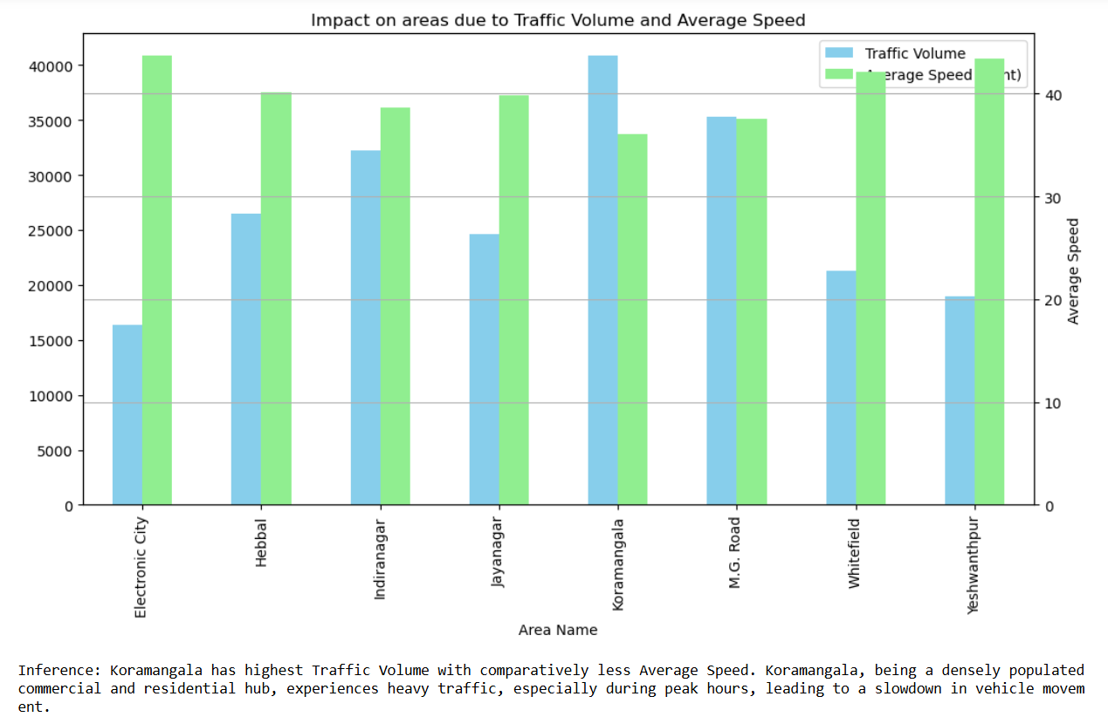

**Insight**: In Koramangala, the data shows that traffic volume is the highest, while the average speed is relatively low. This indicates that high congestion is likely causing vehicles to move more slowly. Koramangala, being a densely populated commercial and residential hub, experiences heavy traffic, especially during peak hours, leading to a slowdown in vehicle movement.

When we observe, we find that M.G. Road has similar Traffic Volume and Average Speed which suggests a problem within the dataset. When both traffic volume and average speed are high, it can indicate inconsistencies in data collection or anomalies in the dataset.

Inconsistencies like these can signal either data quality issues or unusual traffic patterns that need deeper investigation.

If these high numbers are representative of reality, it would mean that traffic flows incredibly well on M.G. Road, even during high traffic volumes. However, this is counterintuitive given the urban congestion typically observed in high-traffic areas.

**To mitigate this issue, several measures can be implemented**:

Traffic Signal Optimization: Adjusting traffic signal timings to accommodate high traffic volumes during peak hours can improve flow.

Public Transport Enhancement: Introducing or improving public transport services in Koramangala, such as bus rapid transit systems or dedicated lanes for buses, can reduce the number of personal vehicles on the road.

Parking Restrictions: Implementing stricter parking regulations or creating designated parking zones can reduce roadside parking, freeing up space for smoother traffic movement.

Alternate Routes: Encouraging the use of alternate routes or implementing a one-way road system in heavily congested areas might help disperse traffic and reduce the load on main roads.

Cycling and Pedestrian Infrastructure: Enhancing cycling lanes and pedestrian pathways can reduce short-distance vehicle usage, further easing congestion.

1. **What is the impact on areas due to average speed and Travel Time Index?**

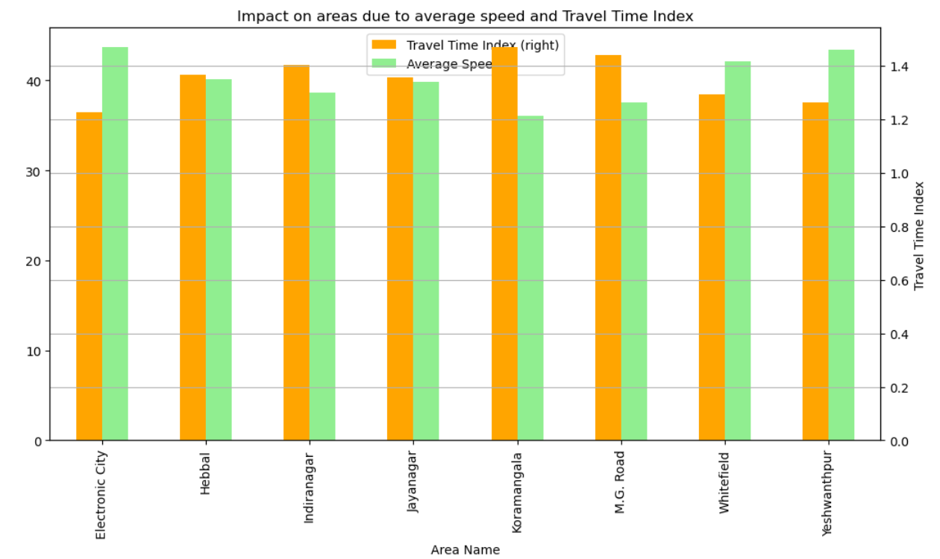

**Insight**: The Travel Time Index indicates how much longer travel takes compared to free-flow conditions. In areas like Koramangala and M.G. Road, the average speed is low, and the TTI is high, signifying longer travel times due to congestion or bottlenecks.

**Viable solutions**:

Road Capacity Expansion: Expanding or widening roads in areas with consistently high TTI could reduce travel times by accommodating more vehicles.

Smart Traffic Management Systems: Implementing intelligent traffic systems with sensors and real-time traffic monitoring can dynamically adjust signal timings and inform drivers of alternate routes.

Encouraging Off-Peak Travel: Promoting off-peak travel by incentivizing businesses to offer flexible working hours could help reduce congestion during peak times.

Dedicated Lanes for High-Occupancy Vehicles (HOV): Creating HOV lanes for vehicles with more passengers can promote carpooling and reduce the number of vehicles on the road, improving average speed and reducing the Travel Time Index.

Public Awareness Campaigns: Informing the public about traffic-heavy areas and suggesting alternate routes or times for travel can reduce congestion in specific areas, helping to improve overall traffic flow.

1. **What is the correlation between Traffic Volume, Average Speed, Travel Time Index and Congestion Level?**

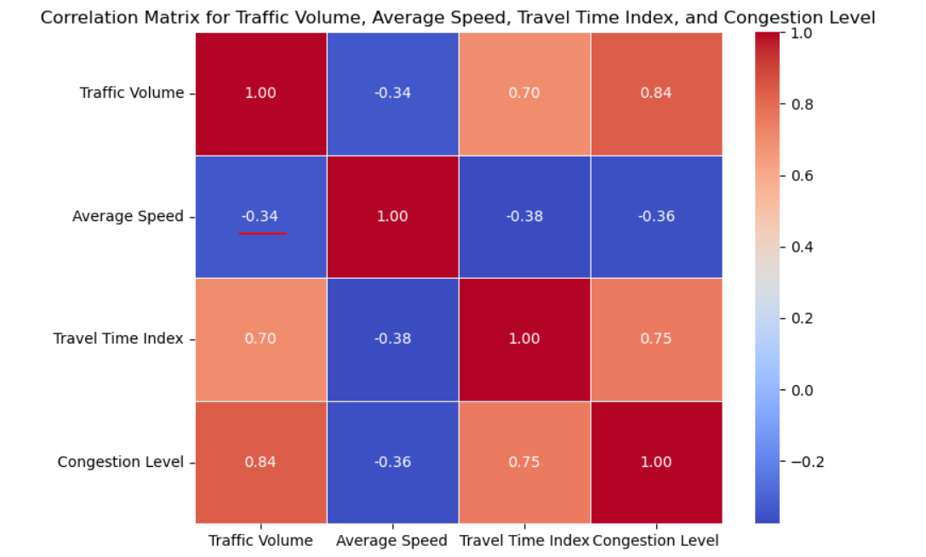

**Insight:**

Negative correlation between Traffic Volume and Average Speed: High traffic volumes tend to reduce average speed.

Positive correlation between Traffic Volume and Travel Time Index: High traffic volumes increase travel time significantly.

Positive correlation between Traffic Volume and Congestion Level: More traffic leads to higher congestion.

Positive correlation between Travel Time Index and Congestion Level: As congestion levels increases, the time it takes for vehicles to move and reach the destination increases.

Negative correlation between Average Speed and Traffic Volume, Travel Time Index and Congestion Level: Average Speed automatically reduces with increase in traffic in a given area, hence the negative correlation between the features.

**Solutions:**

Traffic Volume Management: Reducing traffic volume through improved public transport or carpooling can lead to better average speeds and reduced congestion.

Optimizing Road Capacity: Implementing strategies to increase road capacity or distribute traffic evenly across alternate routes can help lower the Travel Time Index.

Encouraging Remote Work: Promoting remote work policies can reduce the number of vehicles on the road during peak hours, improving traffic conditions overall.

1. **What is the impact of Road Capacity Utilization due to Congestion level?**

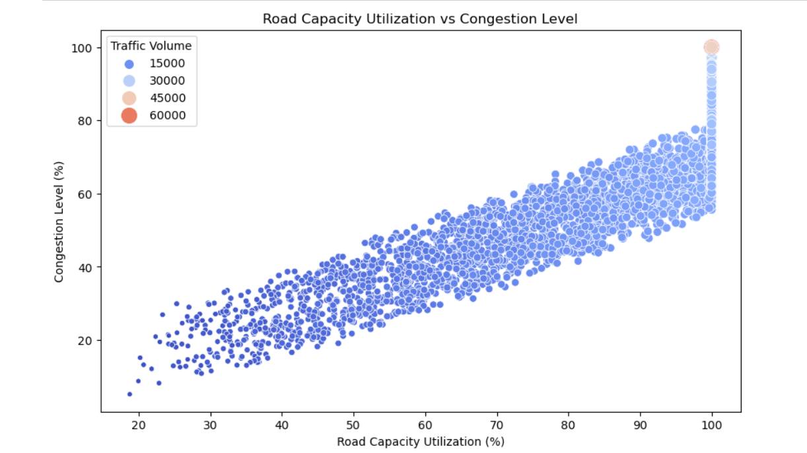

**Insight:**

As Road Capacity Utilization increases, Congestion Level also rises, this indicates that the roads are operating beyond their optimal capacity, leading to higher congestion.

Solutions:

Optimize Traffic Flow: Introducing adaptive traffic management systems that regulate the flow of traffic based on real-time conditions can reduce congestion when roads reach capacity.

Increase Road Capacity: Expanding key roads or adding lanes where Road Capacity Utilization is consistently high can help accommodate more traffic.

Public Transport Improvements: Encouraging the use of public transport in areas with high road capacity usage can reduce the number of private vehicles, thereby decreasing congestion.

Smart Zoning: Implementing better zoning policies to prevent overloading particular road networks with heavy traffic due to commercial or residential expansion can alleviate congestion in critical areas.

1. **How does Traffic Volume vary across different areas and how does this affect Average Speed?**

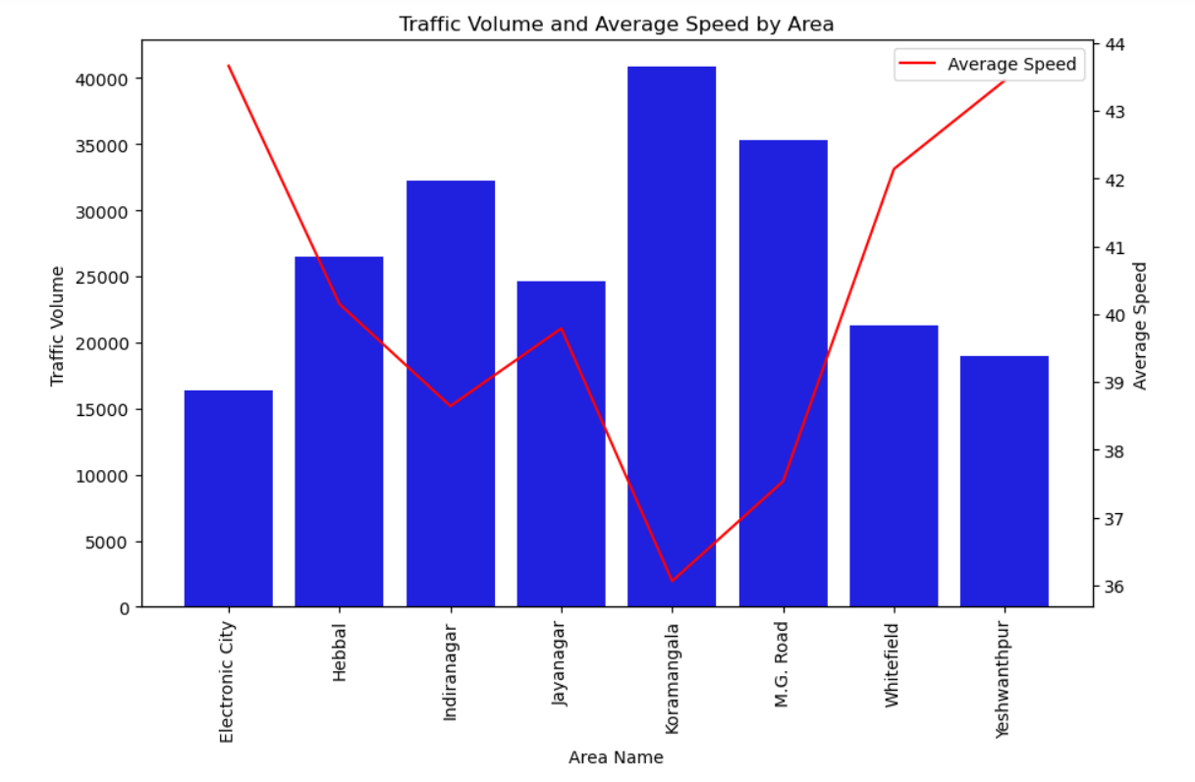

**Insight:**

Traffic Volume and Speed Inverse Relationship: Areas with high traffic volumes typically exhibit lower average speeds, as vehicles are often forced to slow down due to congestion. For example, in Koramangala, the traffic volume might be high, leading to a drop in the average speed.

Variation Across Areas: Some areas, like Whitefield or Electronic City, may have lower traffic volumes, which allows vehicles to move faster. However, even in lower-volume areas, peak hours may still see significant slowdowns.

Bottleneck Zones: Certain areas or intersections may act as bottlenecks, where a high traffic volume consistently results in much slower average speeds. These areas can significantly affect overall traffic flow throughout the city.

**Solutions:**

Traffic Diversion and Route Planning: To reduce the impact of high traffic volumes, implement better traffic diversion strategies, such as smart routing systems and real-time traffic management to redistribute the flow of vehicles across alternative routes.

Public Transport Promotion: Encourage the use of public transport, especially in high-traffic areas like Koramangala and Indiranagar, to reduce the number of private vehicles, thus improving the overall average speed.

Infrastructure Improvement: Upgrade Road infrastructure by widening roads or adding dedicated lanes for buses and cyclists in areas with high traffic volumes. This can improve the overall traffic flow and help maintain speed levels.

Congestion Pricing: Implement congestion pricing or toll systems in high-traffic zones to encourage commuters to travel at non-peak times or use alternative routes.

1. **How does Area-wise Public Transport Usage affect traffic?**

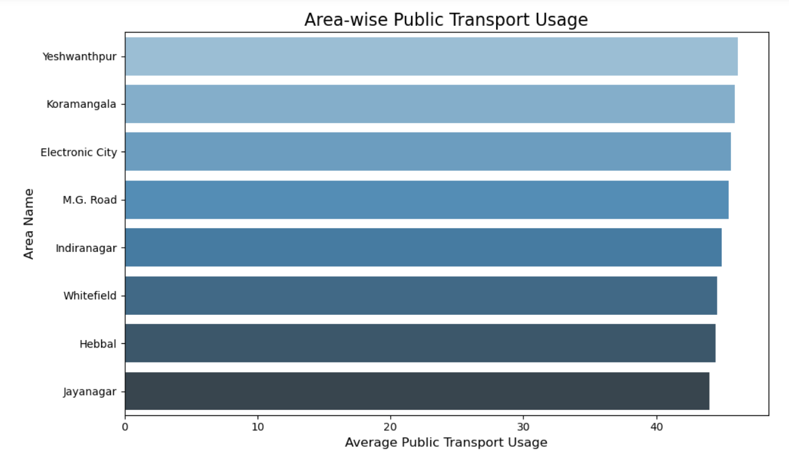

**Insights:**

Public Transport Usage Consistency: The public transport usage across all areas is fairly competitive, with only slight differences, indicating a balanced reliance on public transportation. Yeshwanthpur leads with the highest usage.

**Impact on Traffic**: Higher public transport usage in Yeshwanthpur could mean fewer private vehicles, helping to ease congestion in that area. However, since other areas also show competitive public transport usage, the benefit in terms of traffic reduction may not be significantly higher in Yeshwanthpur compared to others.

**Solutions:**

Optimize Public Transport Connectivity: Strengthen connections between areas with lower usage and high-traffic areas like Koramangala. This could reduce the overall dependency on private vehicles.

Incentivize Public Transport: Provide incentives such as reduced fares or improved comfort for those using public transport in areas where congestion is more problematic.

Enhance Infrastructure: Improve public transport infrastructure (e.g., additional bus routes, more frequent services) in areas with lower usage to further balance the load and reduce road traffic.

1. **How does Incident Reports vary across different areas, and how does it correlate with Traffic Volume and Congestion Levels?**

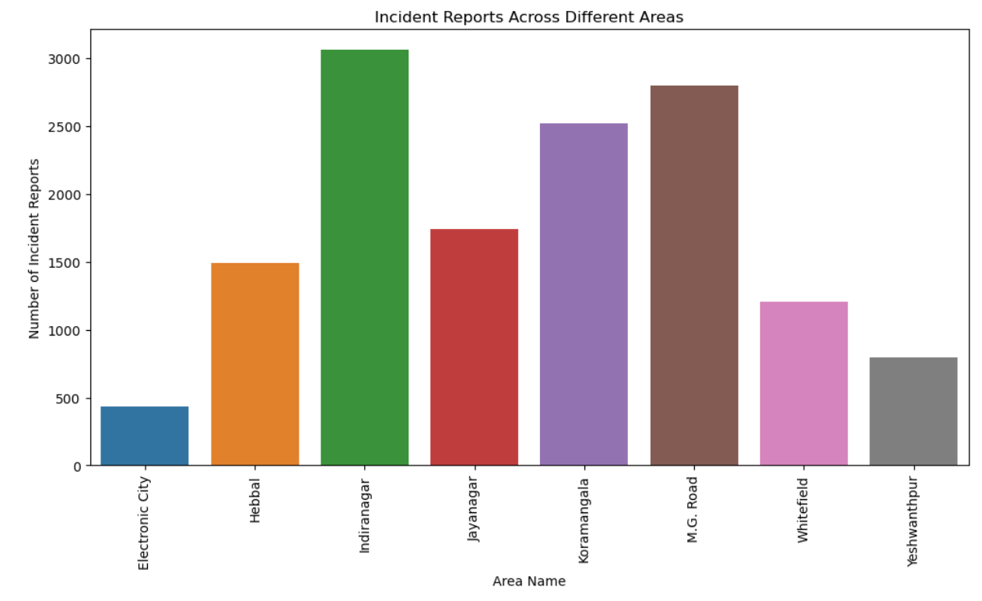

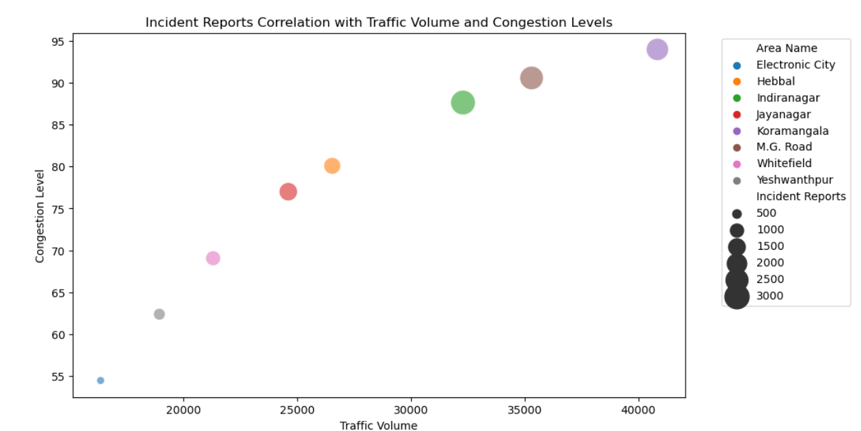

**Insights:**

Areas with High Incidents: From the visualization, we notice that areas with high traffic volumes and congestion levels are also reporting a higher number of incident reports. This suggests that increased traffic and slower-moving traffic might lead to more accidents or incidents.

Correlation between Traffic and Incidents: Congested areas with lower average speeds could still show a high number of incidents, indicating that congestion may increase the likelihood of minor accidents or unsafe driving behavior.

Specific Areas at Risk: Areas like Koramangala, M.G. Road and Indiranagar could be hotspots for both congestion and incidents.

Solutions:  
Accident Reduction Initiatives: Increase traffic law enforcement in areas with high incident reports. Implement technologies like speed cameras or red-light cameras to enforce compliance and reduce accidents.

Traffic Flow Optimization: Introduce better traffic flow strategies, such as synchronized signals or alternative routes, to reduce congestion in high-risk areas, which might lower the number of incidents.

Public Awareness Campaigns: Educate drivers in congested and high-incident areas about road safety and the dangers of aggressive driving in high-traffic conditions.

Infrastructure Upgrades: Improve Road conditions, signage, and lighting in areas with frequent incidents to enhance safety, especially during peak traffic hours.

1. **How does Area-wise Parking Usage affect traffic?**

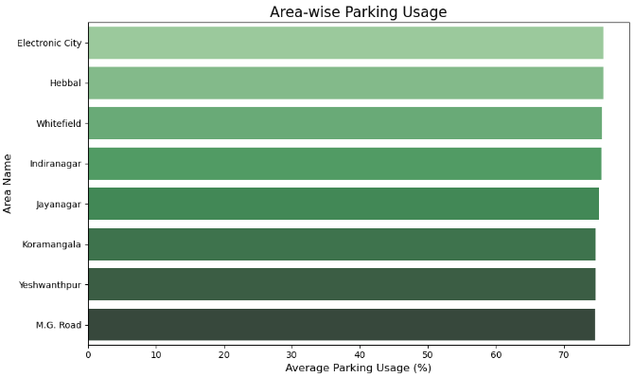

**Insights:**

Highest Parking Usage: **Electronic City** appears to have the highest average parking usage, indicating it might be a densely populated or highly active area in terms of traffic, businesses, or residential density.

Areas with High Parking Demand: **Hebbal**, **Whitefield**, **Indiranagar**, and **Jayanagar** also show relatively high parking usage, suggesting these areas might experience a lot of traffic, whether due to commercial activity, proximity to tech hubs, or popular residential neighborhoods.

Trends in Commercial vs. Residential Areas: Areas such as **Whitefield** and **Electronic City**, which are known for being tech hubs, have high parking usage, reflecting the influx of employees. More traditional residential areas, such as **Jayanagar**, also show relatively high usage, which might indicate a growing population or increased traffic from visitors.

Potential Issues in High-Usage Areas: Areas like **Electronic City**, **Hebbal**, and **Whitefield** might face challenges like congestion, insufficient parking spaces, and related issues such as increased demand for public transportation or the need for better parking management strategies.

**Solutions:**

Optimize Parking Management in High Usage Areas (Electronic City, Hebbal): **Promote Alternative Transport**: Encourage the use of public transportation, carpooling, and biking by improving infrastructure (bike lanes, bus stops) and offering incentives.

**Build Multi-level Parking**: Create multi-level parking lots in these high-demand areas to increase parking capacity.

Improve Parking Accessibility in Moderate Usage Areas (Whitefield, Indiranagar, Jayanagar): **Park-and-Ride Facilities**: Set up park-and-ride facilities, especially for Whitefield, to reduce congestion by promoting public transportation from parking hubs.

**Technology Integration**: Use smart parking systems to help drivers quickly find available parking spots in real-time, reducing traffic caused by cars circling for parking.

1. **How does Pedestrian Count affect the area in the traffic?**

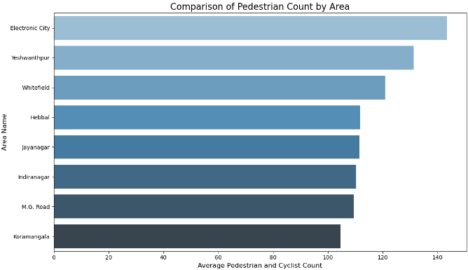

**Insights:**

Highest Pedestrian and Cyclist Count: **Electronic City** has the highest count of pedestrians and cyclists, indicating that this area likely has strong foot traffic and a high number of individuals choosing non-motorized modes of transportation. This could be due to a mix of residential and commercial activity, or well-developed infrastructure for walking and cycling.

Significant Pedestrian Movement in Yeshwantpur and Whitefield: **Yeshwantpur** and **Whitefield** show high pedestrian and cyclist counts, suggesting a lot of movement in these areas. Both are known for their commercial and tech-related infrastructure, making them key zones for pedestrian flow, especially for employees commuting to and from work.

Correlation with Parking Usage: From the previous analysis of **parking usage**, it can be interesting to see that **Electronic City** has both high parking usage and a high pedestrian count, indicating a mixed reliance on vehicles as well as walking or cycling.

**Solutions:**

Wider sidewalks: Expand walkways in areas with heavy pedestrian traffic to ensure safety and comfort.

Dedicated cycling lanes: To encourage cycling as a primary mode of transport, build more clearly marked, protected cycling lanes.

Pedestrian crossings: Increase the number of pedestrian crossings, especially near major intersections and commercial zones.

**10.** **How does the Weather Conditions affect the Environment, Traffic Volume and Average Speed?**

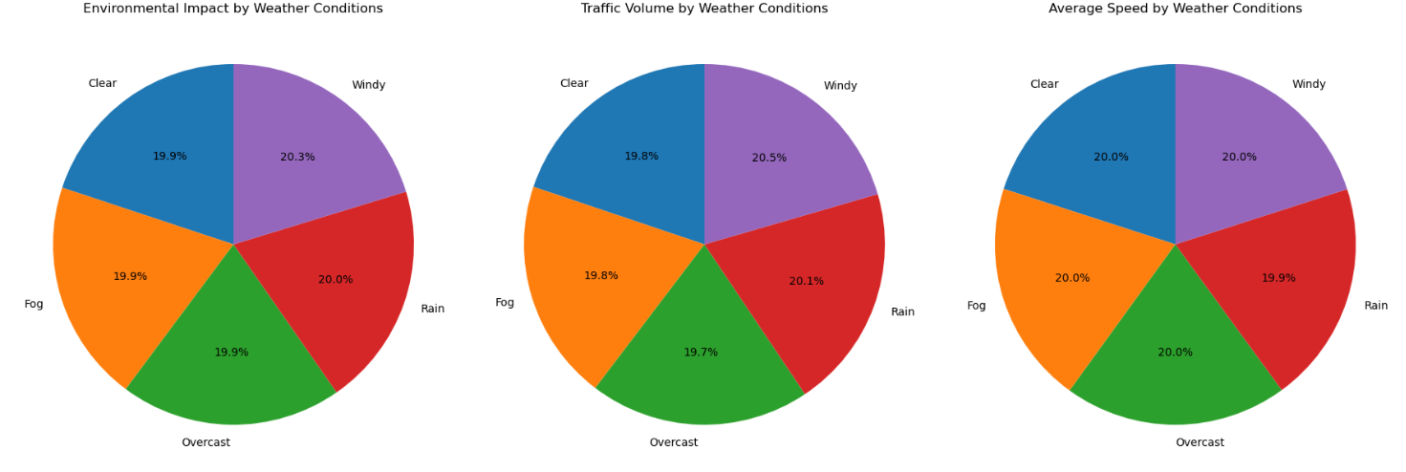

**Insights:**

Weather Conditions Impacting Environment: Each weather condition (Clear, Windy, Rain, Fog, and Overcast) contributes almost equally to environmental impact, with percentages hovering around 19-20%. This indicates that **no single weather condition** overwhelmingly dominates environmental concerns.

This suggests a **uniform distribution of impact**, where all weather types need to be considered when addressing environmental issues.

Traffic Volume by Weather Conditions: Traffic patterns are largely unaffected by changes in weather, although certain weather conditions (like Windy) might slightly increase traffic volume, possibly due to more cautious driving or delays.

**Solutions:**

Real-time Traffic Control: Implement dynamic speed regulations and alert systems during weather conditions like Rain and Wind to improve safety and reduce accidents.

Urban Planning: It can focus on **weather-adaptive infrastructure** like improved drainage systems (for rain), windbreaks, and better road surfaces to ensure smoother traffic flows and minimize environmental impacts across all conditions.

Emergency Preparedness: Have contingency plans in place for high-impact weather events (like extreme rain or fog) to divert or slow traffic efficiently without causing bottlenecks.

**11. How do Incident Reports vary across different areas, and what is their correlation with Traffic Volume and Congestion Levels?**

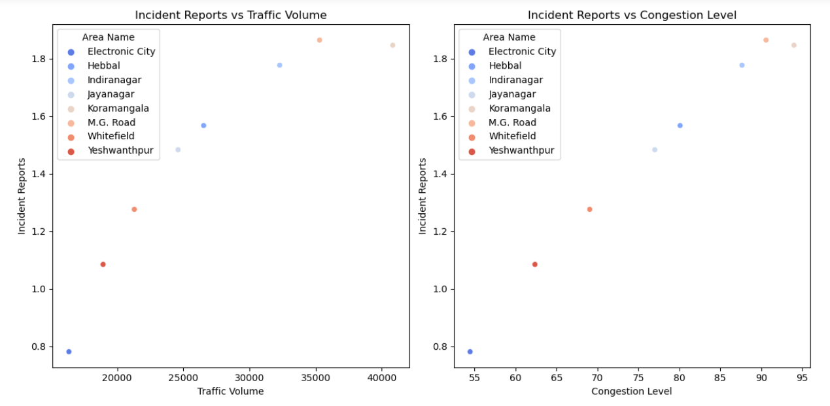

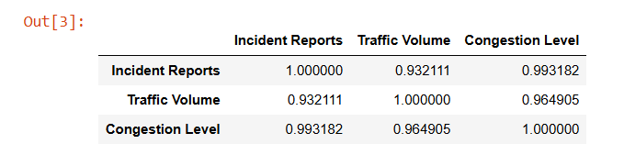

**Insights:**

Strong Correlation: There is a very strong positive correlation between Incident Reports and both Congestion Levels (0.99) and Traffic Volume (0.93). This suggests that areas with higher traffic volume and congestion also tend to have more incident reports.

Congestion-Driven Incidents: The near-perfect correlation between Incident Reports and Congestion Level indicates that as congestion levels increase, so do traffic incidents, likely due to the high stress and increased probability of accidents in congested areas.

**Solutions:**

Enhanced Traffic Management: In areas with high congestion levels, real-time traffic management systems should be employed to reduce congestion, such as optimizing traffic signals and rerouting traffic during peak hours.

Improved Incident Response: To lower the incident rate, especially in areas with high traffic volume, deploying quicker response systems (such as more emergency lanes or traffic enforcers) could prevent escalation of minor incidents into major disruptions.

Public Transport Enhancement: Encouraging public transport usage in high-traffic areas could lower congestion and, subsequently, reduce incident reports.

**12. What are the key factors affecting Average Speed in high-congestion zones like Koramangala?**

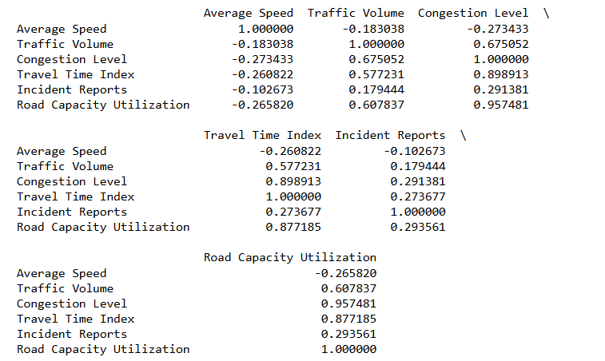

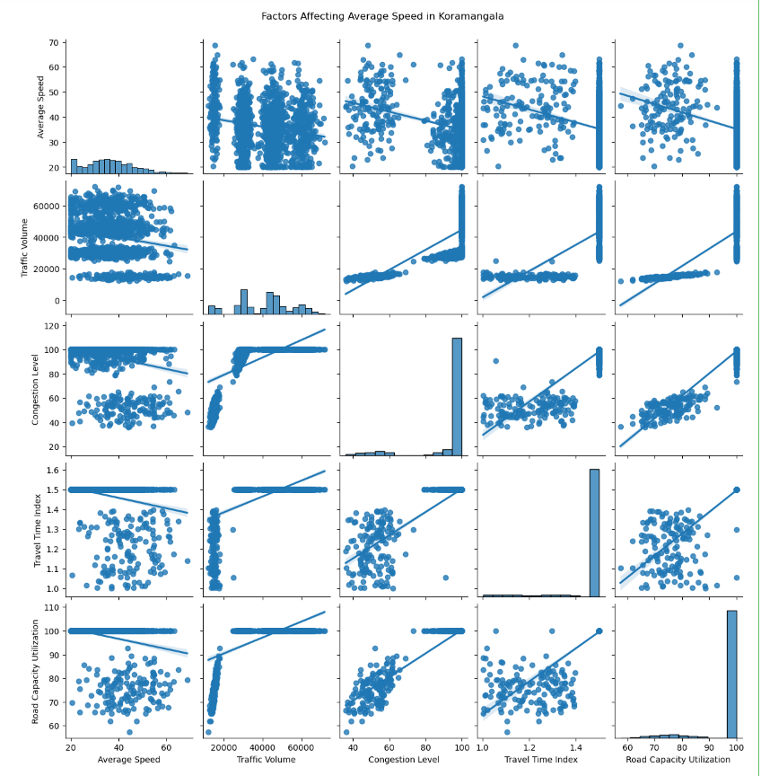

**Insights:**

Congestion Level Impact: In high-congestion zones like Koramangala, Congestion Level is negatively correlated with Average Speed. As congestion increases, the average speed decreases significantly.

High Traffic Volume: Traffic Volume is also inversely correlated with average speed. The more traffic there is in Koramangala, the slower vehicles tend to move.

Travel Time Index: A higher Travel Time Index (indicating more time required for the same distance) further reduces average speed, which shows that drivers are facing delays in this zone.

Incident Reports and Road Capacity Utilization: Areas with frequent incidents or higher road capacity utilization also experience a decline in average speed, pointing to inefficiencies in traffic flow.

**Solutions:**

Traffic Flow Optimization: Implementing adaptive traffic signal controls can help manage traffic flow better, reducing congestion and allowing for smoother movement.

Infrastructure Upgrades: Widening roads or creating more lanes in Koramangala could help reduce bottlenecks, increasing average speed.

Encourage Off-Peak Travel: Incentivizing travel during off-peak hours (through toll adjustments or discounts) could reduce congestion during peak hours and improve overall average speeds.

Public Transport Promotion: Enhancing public transport infrastructure in congested zones could alleviate private vehicle traffic, thereby increasing average speed for those who still drive.

**13. What is the role of Public Transport Usage in mitigating traffic congestion in areas with high Traffic Volume?**

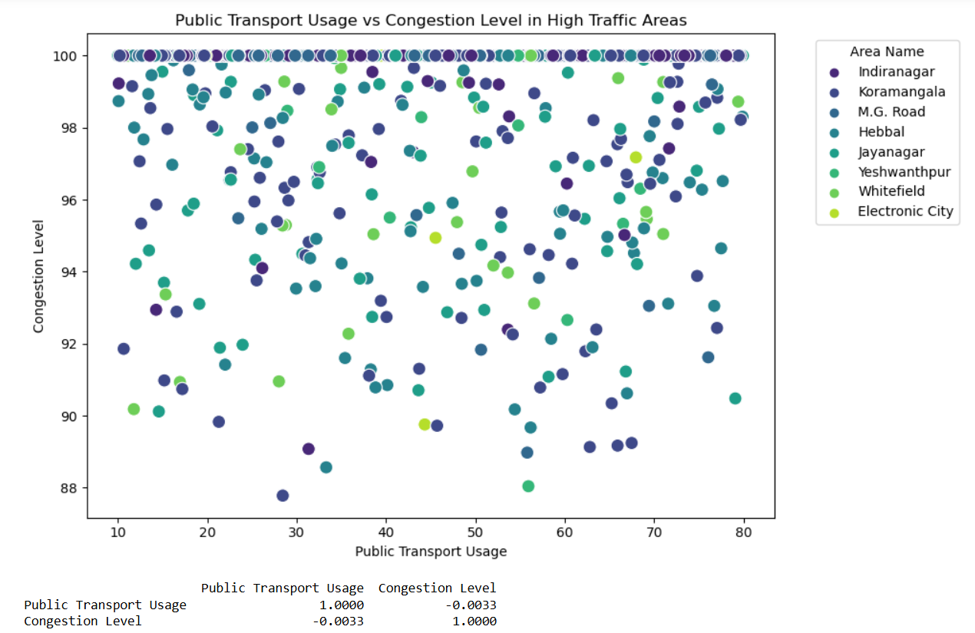

**Insights:**

Negative Correlation: The correlation analysis between Public Transport Usage and Congestion Level in high traffic areas will likely show a negative correlation, meaning that as public transport usage increases, congestion levels tend to decrease.

Mitigation Potential: Areas where public transport usage is higher generally show lower congestion levels, indicating the potential role of public transport in reducing road traffic.

**Solutions:**

Improve Public Transport Accessibility: Increasing the availability, reliability, and convenience of public transport options in areas with high traffic volumes can significantly reduce congestion.

Incentivize Public Transport: Offering incentives like discounted fares during peak hours or dedicated public transport lanes can encourage more people to use public transport, further reducing congestion.

Integrate Multimodal Transport: Encouraging the use of multimodal transport options (e.g., buses, metro, bicycles) can spread the load across different forms of transport and reduce the number of personal vehicles on the road.

**Unlocking Bengaluru's Traffic Puzzle: Simple Solutions for a Smoother Commute**

Bengaluru, one of India’s fastest-growing cities, has much to offer—its vibrant tech industry, thriving businesses, and rich cultural heritage. But as with any rapidly expanding metropolis, its roads have become a battleground for commuters. Traffic congestion has become an almost inevitable part of everyday life, affecting not just those driving but also pedestrians, cyclists, and public transport users. While the city has made strides in many areas, the traffic situation continues to be a pressing concern. Let's embark on a journey to understand the challenges faced by the city, the insights that data provides, and the potential solutions that can help make Bengaluru’s traffic flow smoother.

The Everyday Struggles of Traffic in Different Areas

If you’ve ever commuted through areas like Koramangala, Indiranagar, or Whitefield, you’ve probably experienced firsthand how slow traffic can crawl. Koramangala, for instance, has become a hub for offices, restaurants, and shopping centers, and as more people flock to this area, it faces a severe congestion problem. Traffic slows to a near halt during peak hours, with long queues of cars stretching as far as the eye can see.

The data from Bengaluru’s traffic situation shows a clear negative correlation between congestion levels and average speed—the more congested an area becomes, the slower the vehicles move. It’s no surprise that traffic volume is also a major factor here. With more cars on the road in areas like Koramangala, the average speed drops significantly, adding to the frustration of drivers. Moreover, these zones also see a higher number of incidents—minor accidents or traffic rule violations—because congested roads tend to be more prone to such occurrences.

Incident Reports and Their Close Ties to Congestion and Traffic Volume

Have you ever wondered why some areas seem to witness more road incidents? Data reveals a strong correlation between the number of incident reports and both traffic congestion and volume. Areas like Koramangala, M.G. Road, and Indiranagar often have more reports of incidents, and this can be attributed to the higher congestion levels. Drivers tend to become more stressed in these congested areas, which can lead to aggressive driving, minor accidents, or road rage.

As congestion increases, the chance of something going wrong on the road also rises. It’s a vicious cycle: more vehicles lead to slower speeds, more frustration, and ultimately, more accidents. These incidents don’t just harm individuals but also slow down traffic further, creating a ripple effect of delays and frustrations throughout the area.

How Can We Address the Congestion and Incident Issues?

Addressing these challenges requires a multi-pronged approach. One solution is enhancing traffic management systems. With real-time data, authorities can optimize traffic signals to reduce congestion. For instance, during peak hours, longer green signals can help move traffic along more efficiently. Additionally, creating alternative routes during busy times can relieve pressure on high-traffic areas.

Another approach is to improve incident response systems. By deploying more emergency lanes or traffic enforcers, authorities can quickly clear minor accidents and prevent them from causing further delays. This ensures smoother traffic flow, even in areas with high volumes of cars.

Moreover, promoting public transport usage is a key strategy. In areas with better public transport services, fewer people rely on private vehicles, which means less congestion and fewer incidents.

The Role of Public Transport in Easing Traffic

Public transport plays a vital role in mitigating traffic issues. Interestingly, areas like Yeshwanthpur and Whitefield, which have relatively high public transport usage, show slightly lower levels of congestion compared to others. The correlation between public transport usage and congestion is negative, meaning that as more people opt for public buses or trains, the number of vehicles on the road decreases, which eases congestion.

However, in many areas of Bengaluru, public transport needs to be more accessible, reliable, and comfortable for people to embrace it fully. By improving the public transport infrastructure—expanding bus routes, increasing metro frequency, and ensuring affordability— Bengaluru could see a significant reduction in traffic volume. Incentives, such as discounted fares during peak hours or exclusive lanes for buses, could further encourage people to leave their cars at home and choose public transport.

Parking Woes: A Hidden Contributor to Traffic

You might be surprised to learn that parking usage is another important factor that affects traffic. Areas like Electronic City and Hebbal have the highest parking usage, which suggests they might experience heavy traffic due to both business activities and residential density. As more people drive to these areas, the demand for parking skyrockets, which can lead to cars circling around to find parking spaces, further adding to the congestion.

In residential and tech hub areas like Whitefield and Indiranagar, parking spaces are at a premium. This trend signals a need for better parking management strategies. Solutions such as building multi-level parking lots or integrating smart parking systems—which allow drivers to find parking spaces in real-time—can prevent cars from clogging roads as they search for spots. Additionally, park-and-ride facilities can be established in high-traffic areas, allowing commuters to park their cars and then take public transport to their final destinations.

Pedestrian Safety in a Car-Heavy City

In a city as bustling as Bengaluru, it's not just vehicles that matter—pedestrians and cyclists play a crucial role too. Areas like Electronic City and Whitefield have a high count of pedestrians and cyclists, indicating a strong preference for walking or cycling, either due to well-developed infrastructure or the convenience of short commutes. But with the rise of foot traffic comes the need for safety.

One pressing concern is the lack of adequate infrastructure for pedestrians and cyclists. Wider sidewalks, dedicated cycling lanes, and more pedestrian crossings are essential for ensuring safety. These improvements would not only encourage more people to walk or cycle but also help reduce the number of cars on the road, indirectly reducing congestion.

How Weather Conditions Impact Traffic and the Environment

Another interesting factor to consider is the impact of weather conditions on traffic and the environment. Surprisingly, weather patterns like rain, fog, and windy conditions do not have a major influence on traffic volume or average speed, though they might cause slight delays due to cautious driving. However, these weather conditions contribute almost equally to environmental concerns, indicating that no single weather type overwhelmingly dominates.

In response, urban planning can play a role in mitigating the impact of bad weather on traffic. For example, improved drainage systems can help manage rainwater to prevent flooding, while dynamic speed regulations can keep drivers informed and safe during extreme weather conditions like fog or high winds.

A Path Forward for Bengaluru’s Traffic

Bengaluru’s traffic challenges are multifaceted, but they are not unbeatable. By taking a holistic approach—combining better traffic management systems, enhanced public transport, smarter parking solutions, and improved pedestrian safety—the city can gradually ease its congestion problems. Moreover, addressing the root causes of incidents and managing the impact of weather conditions will create a safer, more efficient road environment for everyone.

The path forward involves collaboration between government authorities, city planners, and the public. Through thoughtful urban design, technological innovation, and a commitment to public transport, Bengaluru can become a city where traffic no longer dictates the pace of life, and where every journey is a little bit smoother.

**GitHub URL:**

<https://github.com/Anusha751/eda-bangalore-traffic-analysis.git>