How to Reverse a String:

1. using for loop and charAt() method

2. using StringBuffer class and reverse function

Interview Questions:

//Reverse a String

//Difference between String and StringBuffer

//Do we have reverse function in String?

🡪There is no reverse function in String because it is a immutable in nature.

We can’t perform too many functions in single String object

reverse() function is not available in String

* Stringbuffer is mutable in nature, we can do changes in same object

reverse() function is available in Stringbuffer

* b.length()-1 --- String starts from '0'; // i!=-1 or i>=0
* String r= " "; // have to declare like this only

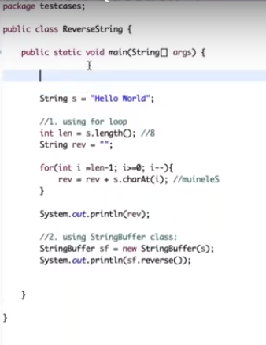

**public** **class** ReverseString {

**public** **static** **void** main(String[] args)

{

// 1st way --- using for loop

**char** a;

//System.out.println("enter a string");

String b = "hello";

System.***out***.println("String is : " +b);

String r= " "; // have to declare like this only

System.***out***.println(b.length());

**for**(**int** i=b.length()-1;i>=0 ;i--) // b.length()-1 --- String starts from '0'; // i!=-1 or i>=0

{

a = b.charAt(i); // charAt(i) -- gives the character at specific index

System.***out***.print(a);

}

System.***out***.println();

**for**(**int** i=b.length()-1;i>=0 ;i--) // b.length()-1 --- String starts from '0'; // i!=-1 or i>=0

{

r = r+b.charAt(i);

}

System.***out***.println("reverse is : "+r);

// 2nd way -- using stringbuffer class

StringBuffer s = **new** StringBuffer(b);

System.***out***.println(s.reverse());

}

}